Project 1: Minesweeper

Software Architecture Document

Version 1.1

Revision History
Date | Version | Description | Author
17/SEP/26 | 1.0 | Created Document | Hannah Prosch
18/SEP/26 | 1.1 | Editing to add the addRestartButton function within the ui.js | Hannah Prosch

Table of Contents
1. Introduction 4
1.1 Purpose 4
1.2 Scope 4
1.3 Definitions, Acronyms, and Abbreviations 4
1.4 References 4
1.5 Overview 4
2. Architectural Representation 4
3. Architectural Goals and Constraints 6
4. Use-Case View 6
4.1 Use-Case Realizations 7
5. Logical View 8
5.1 Overview 8
5.2 Architecturally Significant Design Packages 8
6. Interface Description 10
7. Quality 11

Software Architecture Document

Introduction
This document provides a look into how the Project 1: Minesweeper game was designed and developed by our team, Group 25. Here, we will provide descriptions and diagrams to help the reader better understand this program, how it works, and how the user will interact with it. In this first section, we will define the purpose and scope of the project, as well as defining terms that will be used throughout this project.

Purpose
The purpose of the Software Architecture Document is to provide information on how this project is structured, and to highlight specific aspects of the system. The intended audience of this document is for members of the team who are currently developing the program to use as a reference, and for future teams who may be building upon it by adding new features, or to those who may be providing routine maintenance.

Scope
This document applies to the overall architecture of the Project 1: Minesweeper game, including User Interface, Gameplay Logic, 2-D grid generation, board set up, and the remaining supporting HTML, CSS, and JavaScript components. The aim is to illustrate how these pieces are organized and how they interact to produce the game’s functionality.

Definitions, Acronyms, and Abbreviations
In this document, and within the code, the use of the word “bomb” and “mine” may be used interchangeably to indicate a tile space that contains logic to cause the game to end when selected.
The word “tile” is used to indicate an individual object on the 2-D grid game board that the user is able to place a flag onto, or click to flip or uncover it, revealing either an empty tile, or one with a bomb or mine.
“Uncover” and “flipped” may be used interchangeably to mean that a tile that has not yet displayed what lies beneath it (either a bomb, or perhaps a number indicating the quantity of surrounding bombs).

References
N/A

Overview
The following portions of this document will lay out the program’s architecture, and detail how each of the main components work together. Diagrams have been provided when helpful, to aid in the reader’s understanding. The main architecture will be explored first, followed by the use case view, and the logical view. Finally, the interface description and quality will be touched upon.

Architectural Representation
This project was written with HTML, CSS, and JavaScript, with the main logic and code being written in JavaScript. The following figure shows an overview of these components, and how they work together.
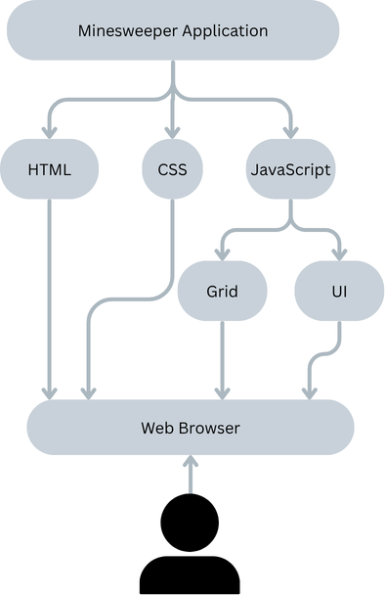
Fig. 1: High level overview of project file components.

From a data flow perspective, these components work together to bring in the input from the user, process that input, and return the appropriate output, according to the game play coded rules.

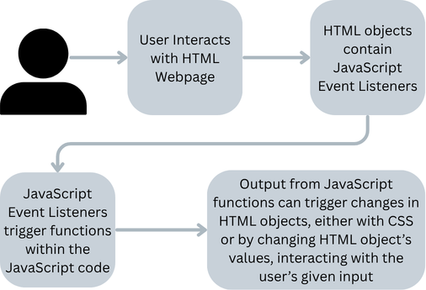
Fig. 2: High level overview of data flow.
As demonstrated in the above diagrams, the user-facing interface is the HTML page via a web browser, and the way they connect to the gameplay logic is through JavaScript. JavaScript uses event listeners to wait for input from the HTML page from the user and will trigger specific functions to run based upon that input. CSS is used to add styling to the HTML page and enhance the visual appeal of the game. It also is used to indicate whether a tile has been flipped, by changing the tile color after it has been flipped.

Architectural Goals and Constraints
One of the main architectural goals that was utilized for this project was efficiency: by combining the familiar programming components of HTML, CSS, and JavaScript, our team was able to build upon pre-existing skills and knowledge to build a project fitting the provided specifications. JavaScript can easily connect to an HTML page to provide the interactivity needed for this project without massive amounts of overhead.
Another architectural goal our project embodies is portability. Because this project utilizes a simple web browser, once hosted, it would not require the user to download any software in order to play the game.
Some architectural constraints that we chose to work within was to implement this project with just HTML, CSS, and JavaScript—no other components were needed. The team decided this because several of our members had prior experience coding with JavaScript. Another constraint is that the Minesweeper game runs on a web browser, as opposed to a command line or another GUI.

Use-Case View
To play our Minesweeper game, the user will first visit the webpage. Upon viewing, the game will prompt the user to specify the number of bombs they would like to use, between 10 – 20, inclusive. Next, the user will select the tile they want to flip by clicking on it.
The first tile flipped is guaranteed to be bomb-free. The program will recursively uncover all adjacent bomb-free tiles. For each of these flipped tiles, if they have at least one bomb in the 8 spaces surrounding it, will display a number. This number symbolizes the number of bombs residing in those 8 surrounding spaces.
Next, the user will either select another tile to flip, or to place flag(s) on any tile. If at any point the user clicks on a space that contains a bomb, the game ends. If a bomb has not been clicked, and there are remaining bomb-free tiles that have yet to be flipped, the game will continue. The winning game condition is when all bomb-free tiles have been flipped, leaving only the bomb tiles un-flipped on the board.
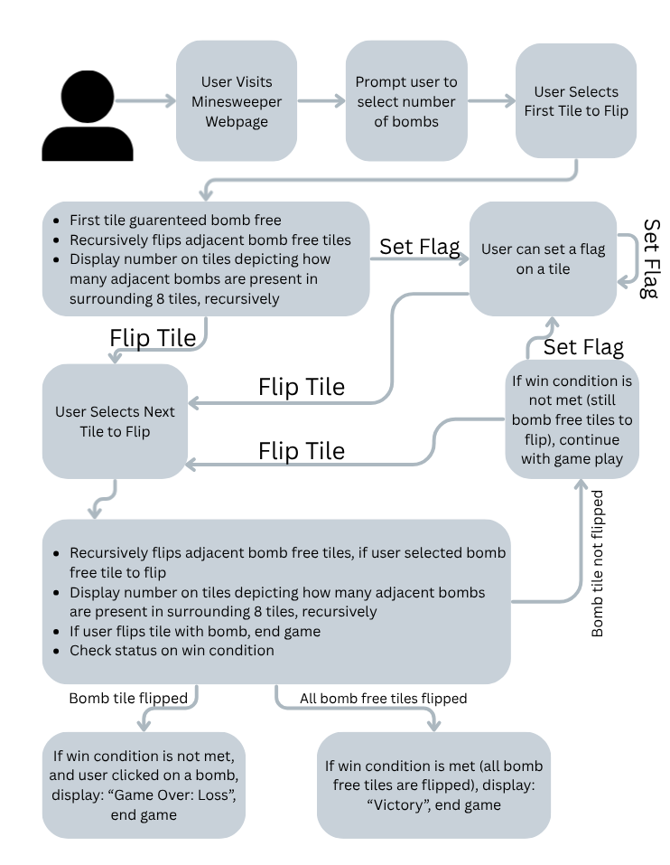
Fig. 3: Diagram featuring user view of game play.
In the following section, we will further explore a specific use-case/scenario of the game play.

Use-Case Realizations
Shortest Game Play is achieved when the user selects their second tile flipped as one that contains a bomb.
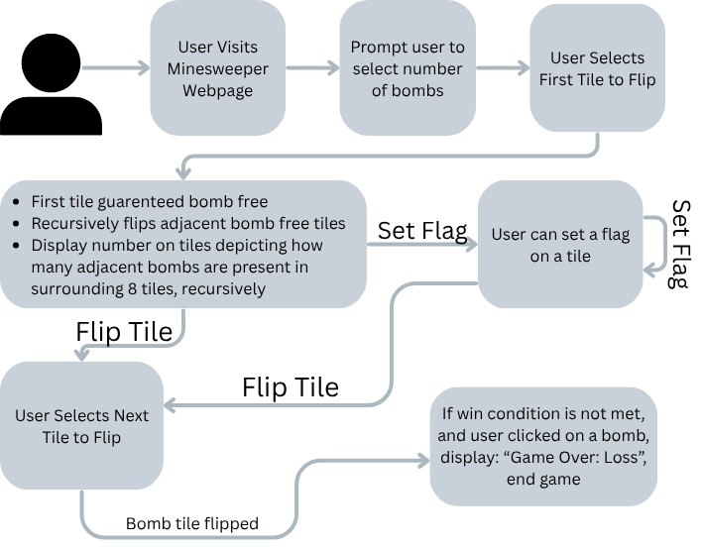
Fig. 4: Shortest Gameplay
Depending upon the number of mines selected by the user upon beginning to play the game, and which tiles are selected to be uncovered, there are numerous use cases that could be generated—this is simply the shortest way, and it results in the game ending after two tiles are selected to be uncovered.

Logical View
JavaScript functions are the heart of the logic in this project. In this section, we will lay out the two JavaScript files, and what the functions within each accomplishes to provide the logic for the game. This allows for a better understanding of how the program is organized internally.

Overview
The logic for this project is divided into two JavaScript files, each with functions that support different aspects of the user interaction and make game play possible. The grid.js file is primarily responsible for the game logic, and the ui.js is primarily responsible for the user interaction.

Architecturally Significant Design Modules or Packages
The following diagram depicts the decomposition of each JavaScript file down into the primary class or functions that each carries.
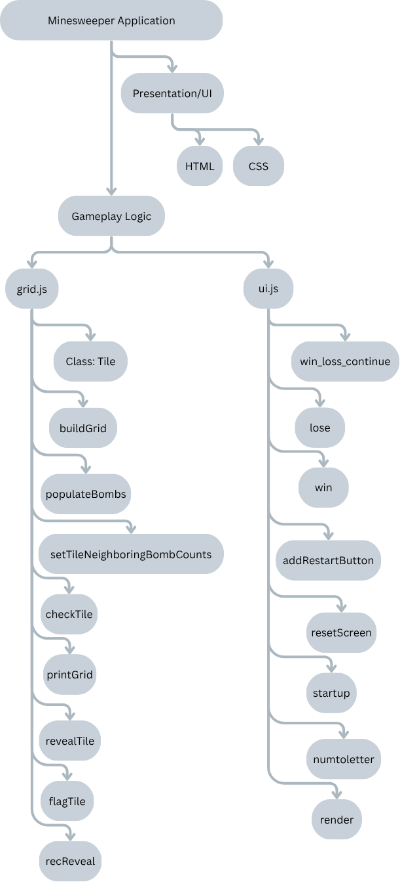

Fig. 5: Architecture of the JavaScript files.

Below is a quick reference, explaining the main responsibility for each of the components within the grid.js file.
grid.js
Name | Type | Responsibility
Tile | Class | Create Tile Object
buildGrid | Function | Sets up Grid
populateBombs | Function | Randomly places bombs on the board
setTileNeighboringBombCounts | Function | Sums number of bombs surrounding tile
checkTile | Function | Checks if there is a bomb under a tile
printGrid | Function | Used for printing/testing grid generation
revealTile | Function | Used for uncovering a tile
flagTile | Function | Sets or removes a flag on a tile
recReveal | Function | Recursively reveals bomb-free tiles, ignoring those already flipped or flagged

A quick reference table for the components of the ui.js file follows:
ui.js
Name | Type | Responsibility
win_loss_continue | Function | Used to communicate gameplay status to user
lose | Function | Notify the user that they lost the game
win | Function | Notify the user that they won the game
addRestartButton | Function | Allows user to restart the game to play again
resetScreen | Function | Resets the screen for the user
startup | Function | Calls functions within grid.js to create the game board
numtoletter | Function | Used to help label the columns and rows for the user
render | Function | Renders the game board, and communicates with grid.js to allow the user to set flags, flip tiles, etc

Interface Description
The screen format for this project is a standard HTML web page accessed through a web browser. The user interacts with the program through valid inputs, which include indicating the number of bombs they want in gameplay, and selecting which tiles they want to place a flag on, or flip.
The input of indicating the number of bombs for gameplay will output a 2-D grid gameboard with the specified number of bombs hidden.
The input of selecting a tile to flag will output a toggle on the flagging action. If the tile is previously unflagged, a flag will be placed on that tile. If the tile is currently flagged, the flag will be removed.

The input of selecting a tile to uncover can produce any of the following outputs, depending on the randomized board and the tile selected:
- If a bomb is uncovered, the game ends—a loss message is output to the user.
- If a tile without a bomb is uncovered, there are three potential outcomes
  - If the tile uncovered has no adjacent spaces that are also bomb free, only that tile will be uncovered. A number appears on the tile, indicating how many bombs reside within the 8 immediate tiles surrounding it.
  - If the tile uncovered has adjacent spaces that are bomb free, those adjacent spaces are also uncovered (done recursively, to also uncover their bomb-free adjacent spaces). If the uncovered spaces do not have any adjacent bombs, they are left blank. If the uncovered spaces do have adjacent bombs, a number appears on their tile, indicating how many bombs reside within the 8 immediate tiles surrounding it.
  - If the tile uncovered is the last remaining bomb-free tile to be uncovered, then the user wins the game, indicated with an output victory message.

Quality
Whenever possible, exact values were not hard-coded, leaving them easier to adjust in future work. One example of this is the size of the 2-D grid. Instead of hard coding it in as a 10x10 grid, parameters could be passed in by the user to specify the size of the board. The game could also be easily updated to prompt the user for more than 10-20 mines, to make the gameplay more challenging. All of these will help the Minesweeper game be extensible in the future.
Given that this program is run on a web browser, once it is publicly hosted, it will easily be portable to use.
Our program is also designed to be easy to maintain, with the separate files with their own responsibilities for UI, gameplay, HTML, and CSS.

