NFL_Week_1

MAJ Daniel Baller

8/27/2019

## Breakdown of predictions.

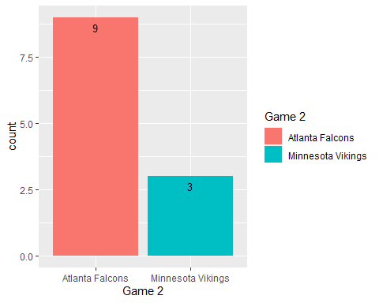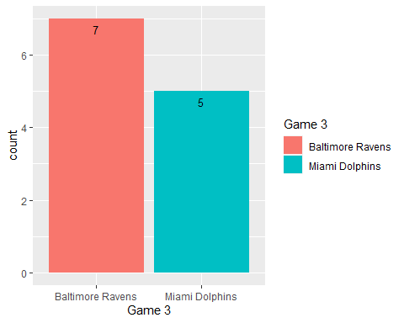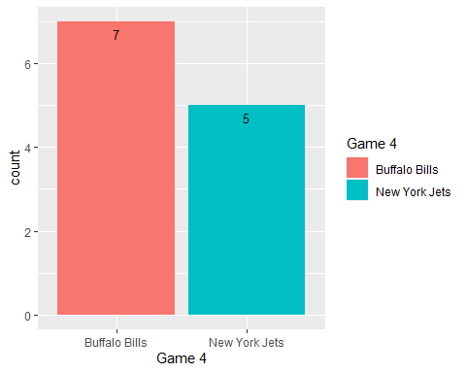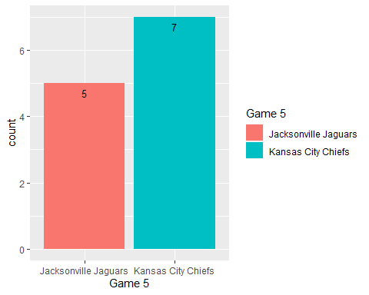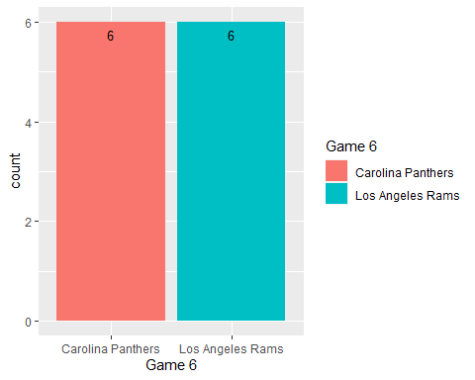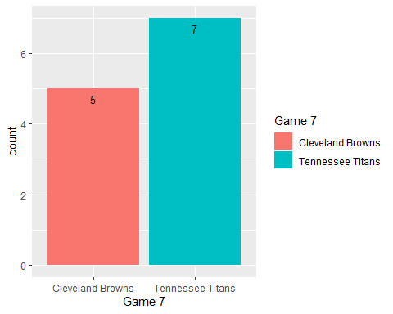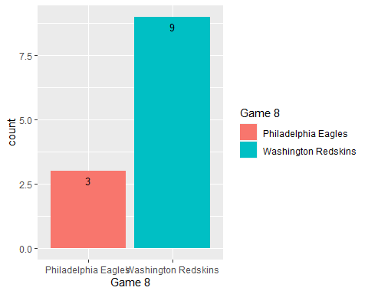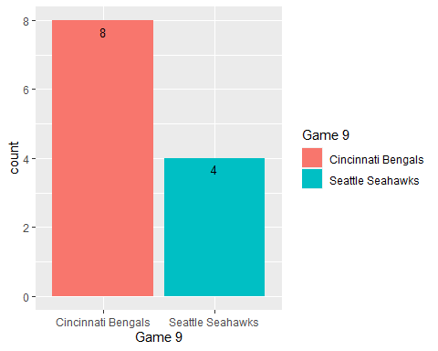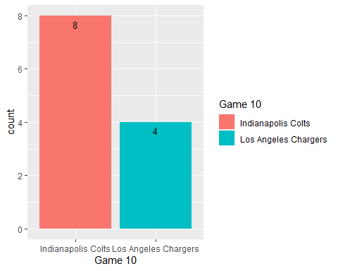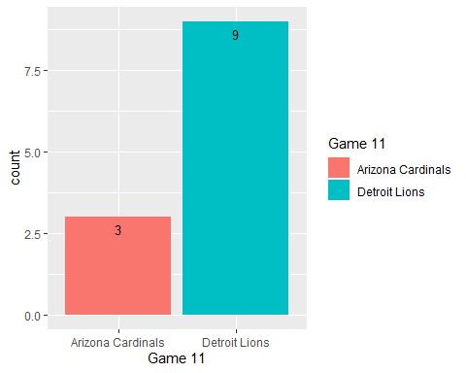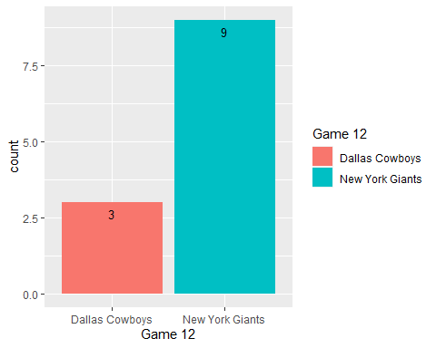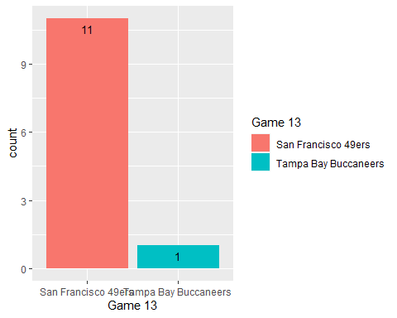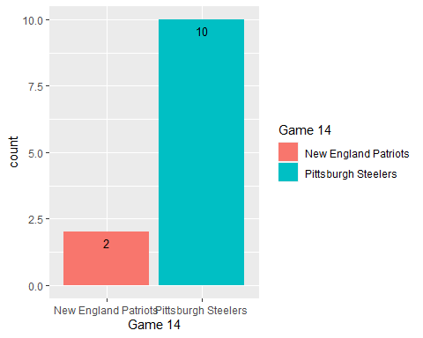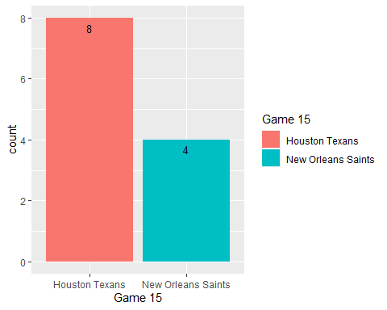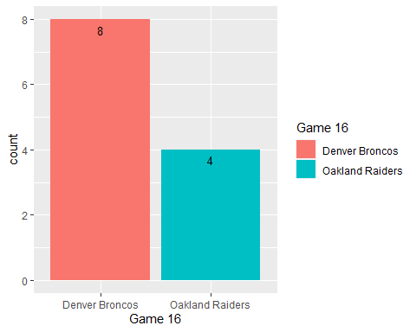

## Predictions

Note that the echo = FALSE parameter was added to the code chunk to prevent printing of the R code that generated the plot.

## # A tibble: 16 x 4  
## Games Prediction Winners Correct  
## <int> <chr> <chr> <chr>   
## 1 1 Green Bay Packers Chicago Bears No   
## 2 2 Atlanta Falcons Atlanta Falcons Yes   
## 3 3 Baltimore Ravens Baltimore Ravens Yes   
## 4 4 Buffalo Bills New York Jets No   
## 5 5 Kansas City Chiefs Kansas City Chiefs Yes   
## 6 6 Carolina Panthers Carolina Panthers Yes   
## 7 7 Tennessee Titans Tennessee Titans Yes   
## 8 8 Washington Redskins Washington Redskins Yes   
## 9 9 Cincinnati Bengals Seattle Seahawks No   
## 10 10 Indianapolis Colts Indianapolis Colts Yes   
## 11 11 Detroit Lions Detroit Lions Yes   
## 12 12 New York Giants New York Giants Yes   
## 13 13 San Francisco 49ers San Francisco 49ers Yes   
## 14 14 Pittsburgh Steelers Pittsburgh Steelers Yes   
## 15 15 Houston Texans Houston Texans Yes   
## 16 16 Denver Broncos Denver Broncos Yes

## [1] "Our win percentage for the week is 0.8125"

## [1] "Our season win percentage so far is 0.8125"

## Individual Predictions