**Show line number on search**

**The Issue**

There was the suggestion of showing the line number next to the content found while searching for some piece of code. When the user uses the search box just appear the file content, not the line where it can be found.

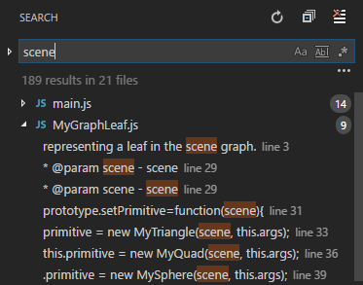 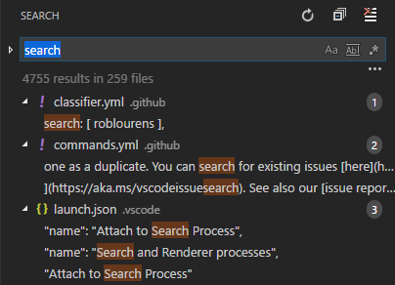

**Requirements**

To reply the issue use case, you just need to access the search bar, type a string and observe the results. The search results will appear, but you will not be able to check the line where it appears.

**Source Code Files**

The following files contain the source of this issue:

* searchResultsView.ts
* searchModel.ts
* searchviewlet.css

Which absolute paths in the project are:

* vscode\vscode\src\vs\workbench\parts\search\browser\searchResultsView.ts
* vscode\vscode\src\vs\workbench\parts\search\common\searchModel.ts
* vscode\vscode\src\vs\workbench\parts\search\browser\media\searchviewlet.css

**Design of the Fix**

**Fix Source Code**

In [src/vs/workbench/parts/search/browser/searchResultsView.ts](https://github.com/Microsoft/vscode/pull/39834/files#diff-d313450926f8bc5cd782c0496526e219) a field named lineNumber was added to IMatchTemplate Interface in order that we could associate this line number to Match class [src/vs/workbench/parts/search/common/searchModel.ts](https://github.com/Microsoft/vscode/pull/39834/files#diff-bb0b2ab9bcad3e3ad3c91df28eaad78b), and later to the Search Renderer class. This way, it was possible that, during the search an additional field was incremented, corresponding to the correct line number associated to the search results.

**Terminal Scroll cursor set on default**

**The Issue**

It was suggested that we change the type of cursor in VScode terminal. Without this change when the mouse cursor is over the scrollbar it assume the shape of an i-beam, the i-beam cursor. But it was pretended that this cursor has the default shape, the arrow shape.

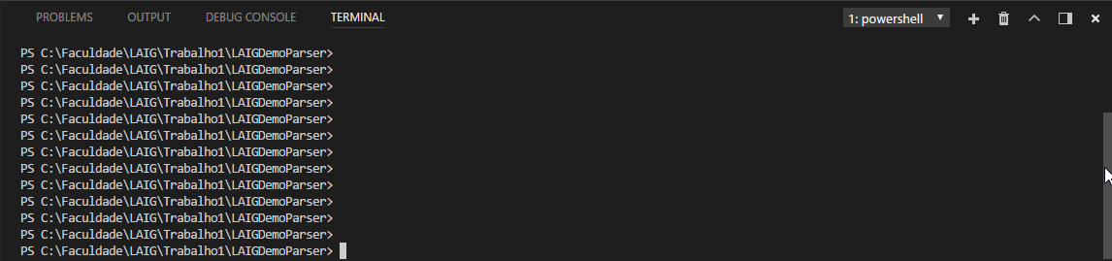

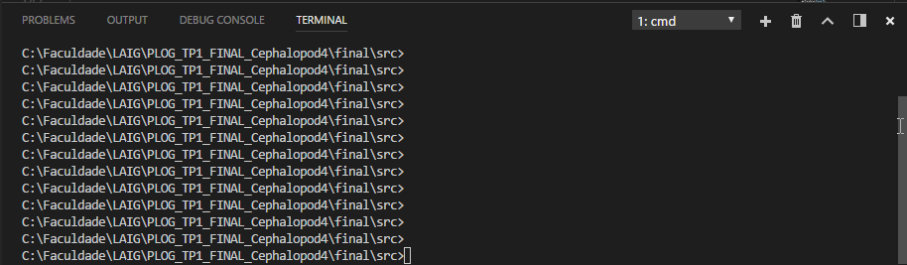

**Requirements**

In order to reply the issue use case, you just need to access the terminal and put the mouse cursor over the scrollbar. The mouse cursor will have the i-beam shape.

**Source Code Files**

The following file contain the source of this issue:

* scrollbar.css

Which absolute paths in the project is:

* [src/vs/workbench/parts/terminal/electron-browser/media/scrollbar.css](https://github.com/Microsoft/vscode/pull/39832/files#diff-1410bec1646437168b3431d48652f0d4)

**Design of the Fix**

To fix the issue we needed to find out where the CSS file relative to the scrollbar was located. Since the issue was related to the terminal we thought that by finding the terminal folder we could easily find the scrollbar CSS file. After finding the folder we just had to find it inside the electron-browse part.

**Fix the issue**

To fix the issue we add to look for the scrollbar code that referenced the situation when the mouse cursor is over the scrollbar. In function .*monaco-workbench .panel.integrated-terminal .xterm:hover .xterm-viewport* we added this line *cursor:default*.