|  |  |  |  |
| --- | --- | --- | --- |
| Location | Health Bar | Mini map | Item List |
| Top Left | 5 | 0 | 0 |
| Top Right | 1 | 3 | 1 |
| Bottom Left | 1 | 0 | 0 |
| Bottom Right | 0 | 0 | 0 |
| On Character | 3 | 0 | 0 |
| Pause Menu | 0 | 2 | 4 |
| Bottom Middle | 1 | 0 | 1 |
| Left Middle | 0 | 0 | 1 |
| Right Middle | 1 | 0 | 1 |
| None | 0 | 6 | 2 |
| Inconsistent | 0 | 0 | 1 |



Relic Hunter Zero

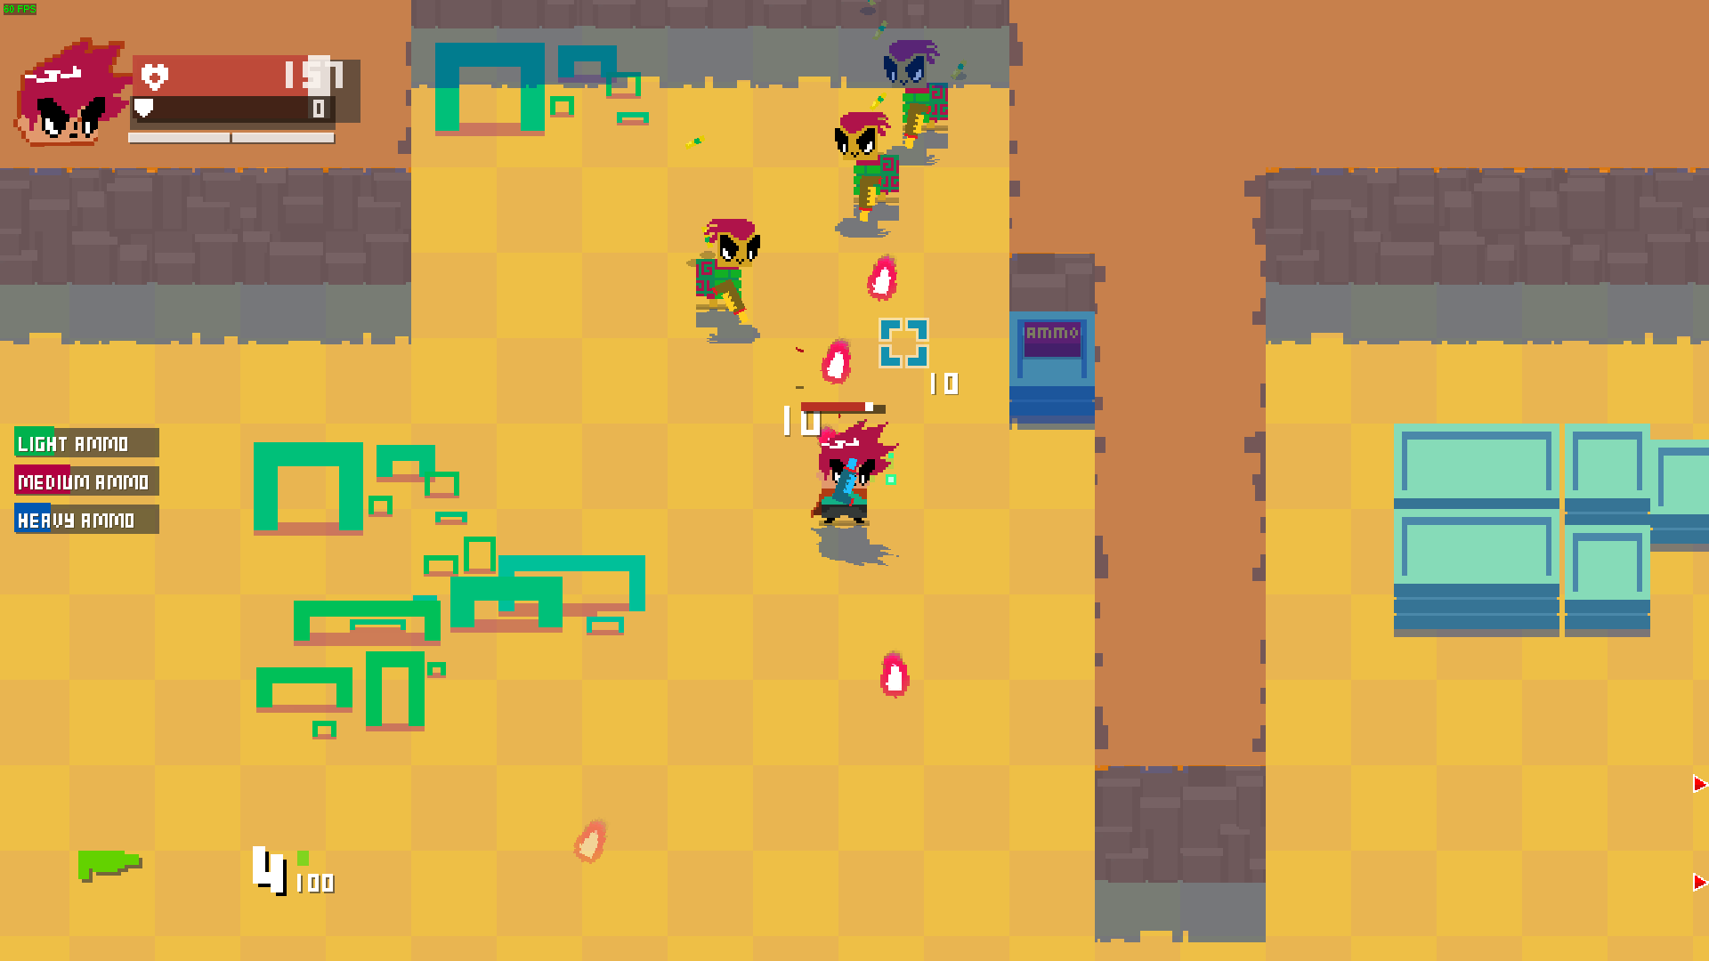

Binding of Isaac

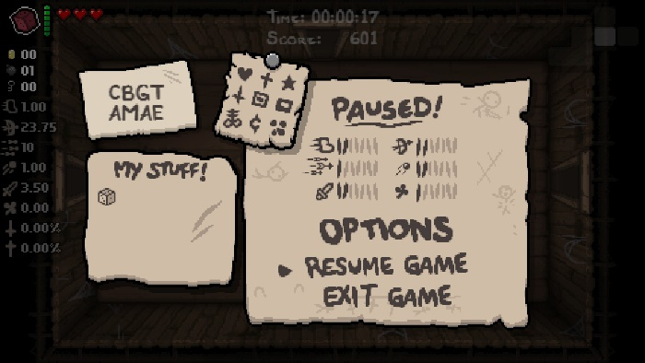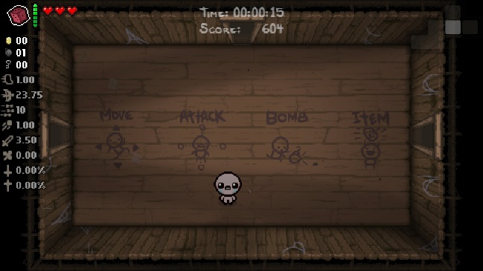

Dungeon of Endless

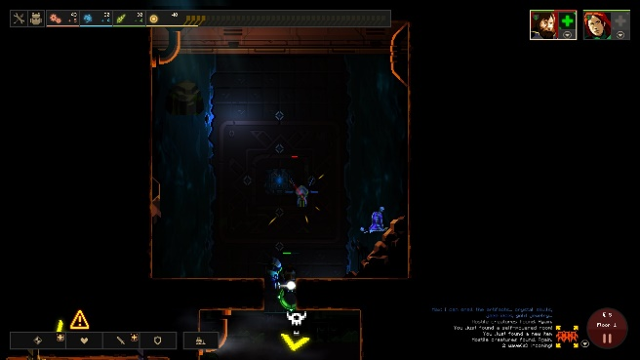

Enter the Gungeon

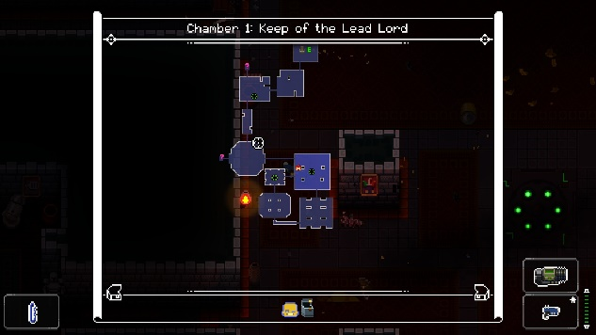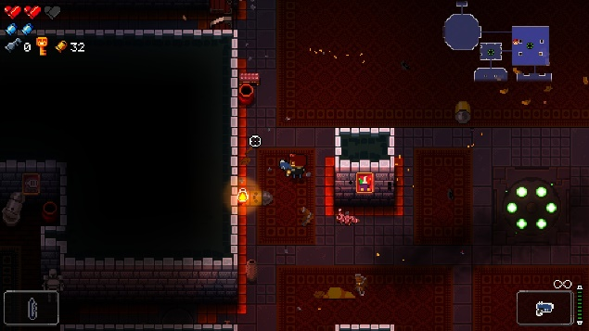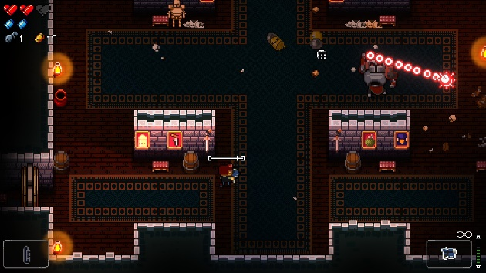

Faster Than Light

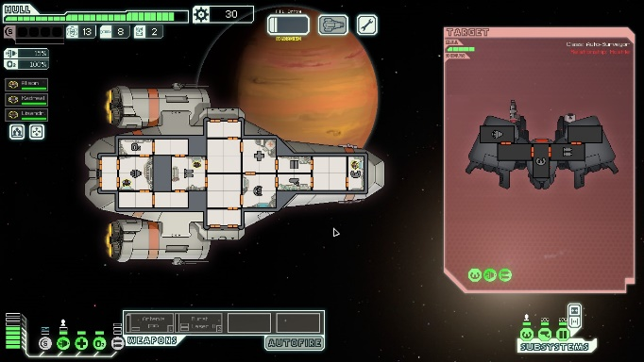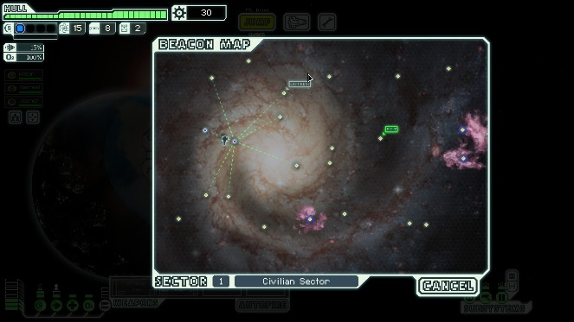

Risk of Rain

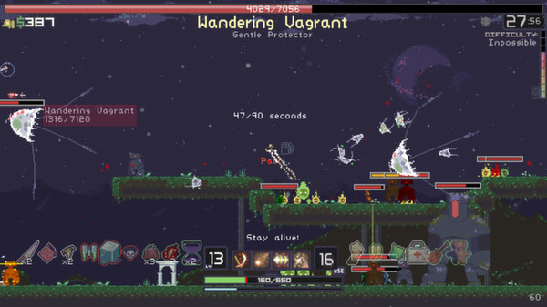

<https://store.steampowered.com/app/248820/Risk_of_Rain/>

Realm of the Mad God

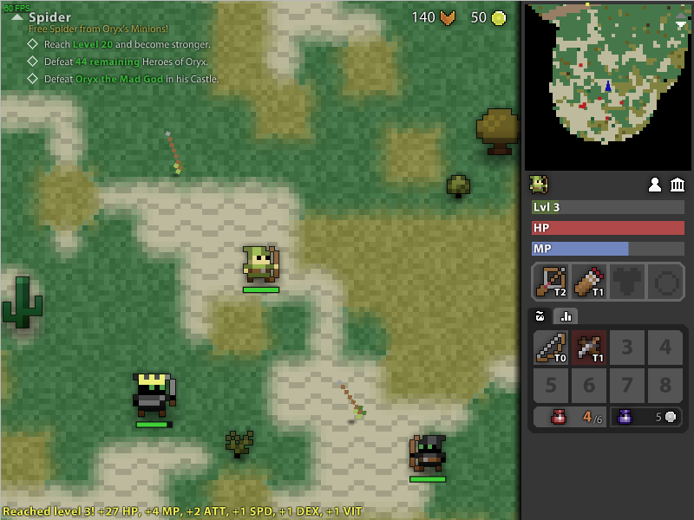

Nuclear Throne

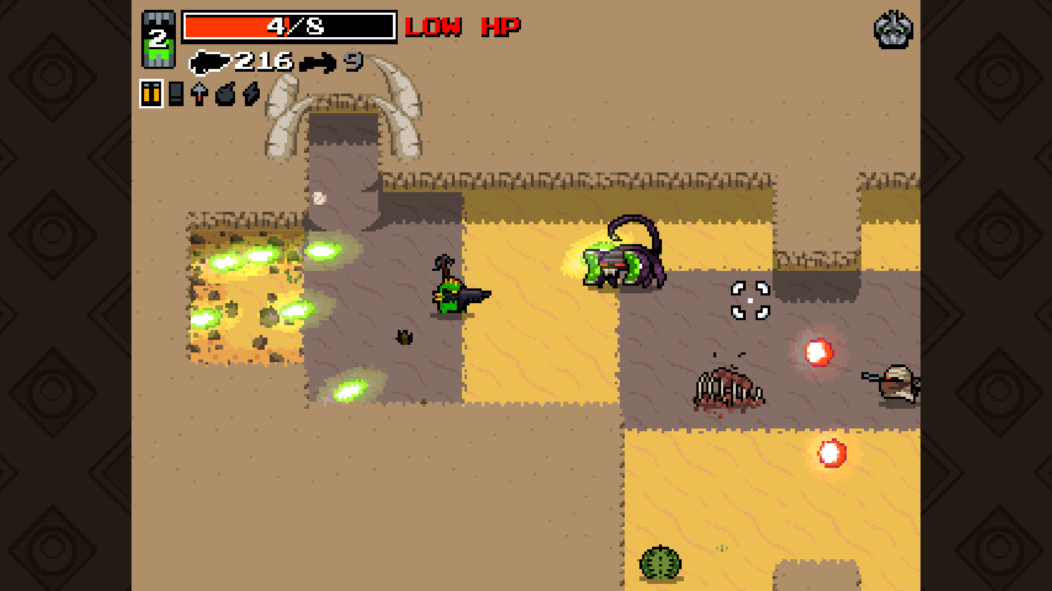

Synthetik

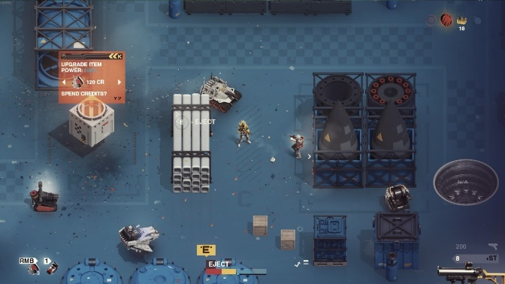

[*https://store.steampowered.com/app/528230/SYNTHETIK_Legion_Rising/*](https://store.steampowered.com/app/528230/SYNTHETIK_Legion_Rising/)

Hades

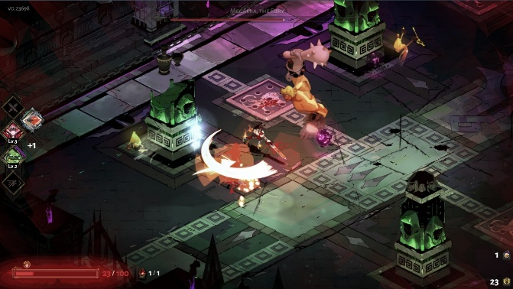

https://store.steampowered.com/app/1145360/Hades/