**Signals and Systems MATLAB HW1 Report**

電機二 B05901030 陳欽安

1. **Use the command stem to plot x1[n] and x2[n]**

●x1[n]:

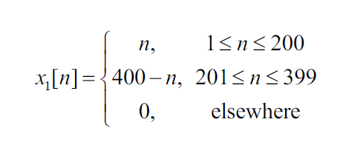

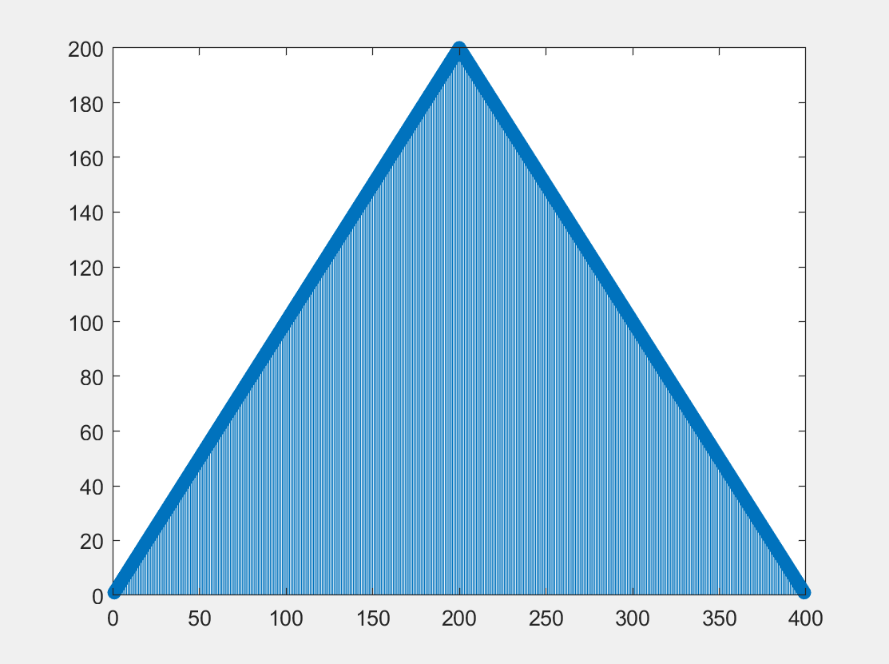

●x2[n]:

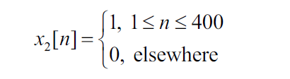

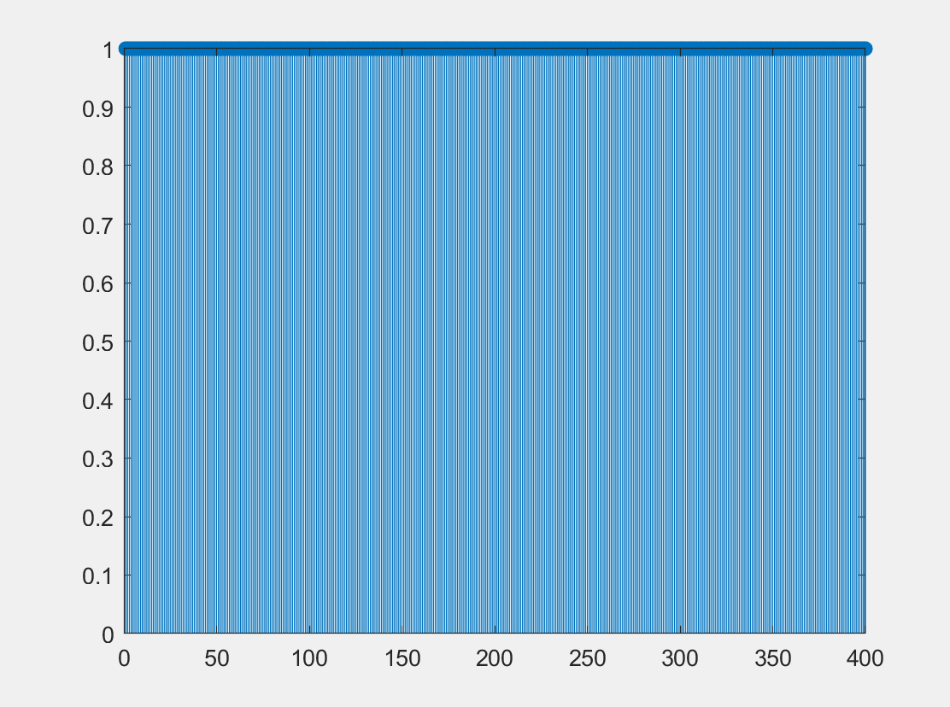

1. **Use the command conv to compute (1) and plot the output y=conv(x1,x2)**

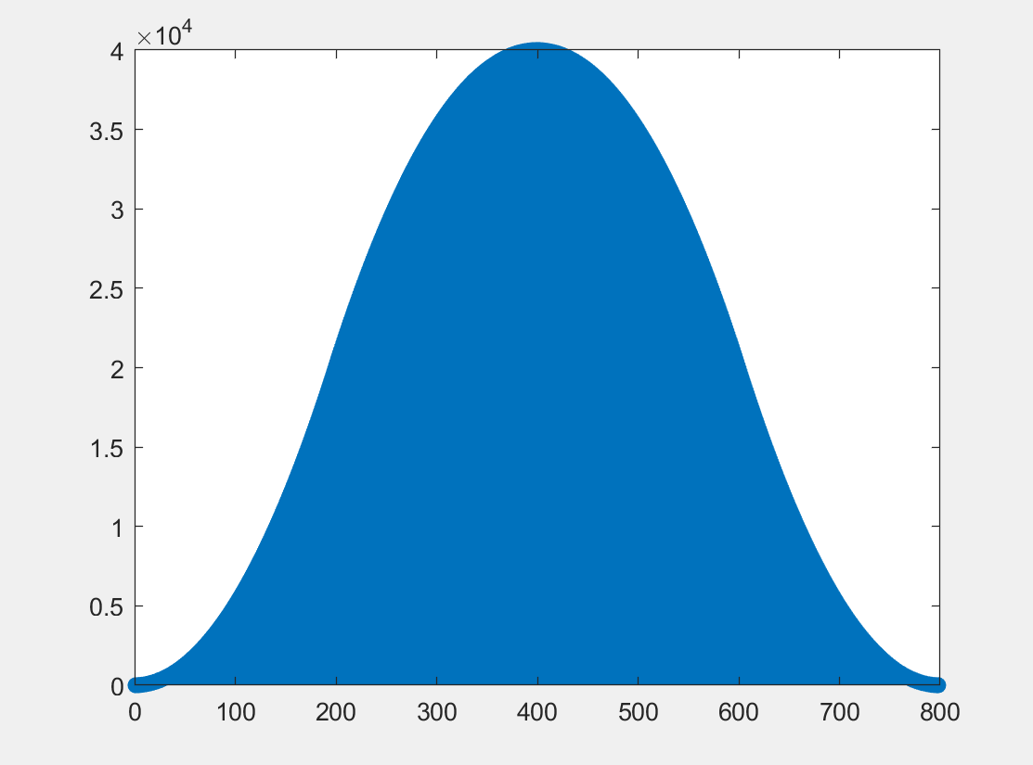

1. **Write a MATLAB function my1conv.m to compute (1) using (2) and plot y=my1conv(x1,x2)，where**

