**Signals and Systems MATLAB HW2 Report**

電機二 B05901030 陳欽安

1. **Plot x[n].** (using the command “stem”)

x[n]:

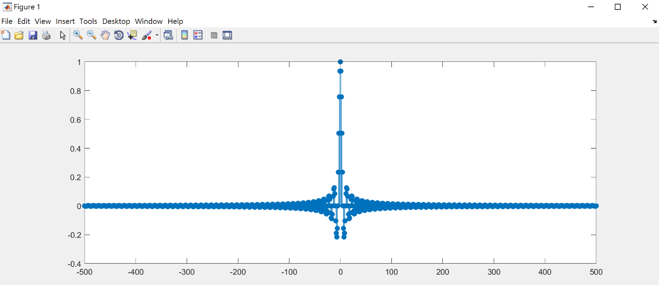

(b) **Plot the magnitude response of the DFT of x during [-N1,N1].**

**The zero frequency should be centered in your plot. Observe the**

**Gibbs phenomenon in (b).**

(using the command “plot”)

DFT of x[n]:

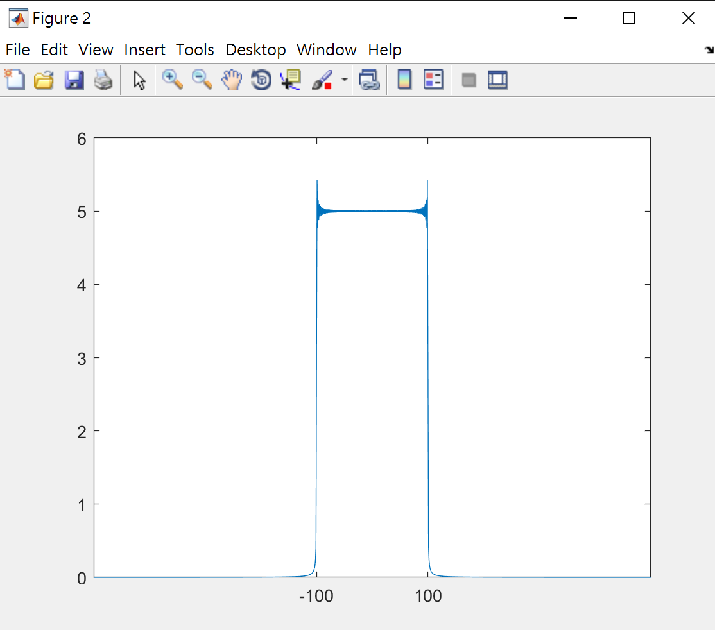

Observing from DFT of x[n], there is Gibbs phenomenon near n=-100 and n=100 (where the overshoot occurs), which is caused by truncation of signals.

2.

(a) **Plot w[n]**. (using the command “stem”)

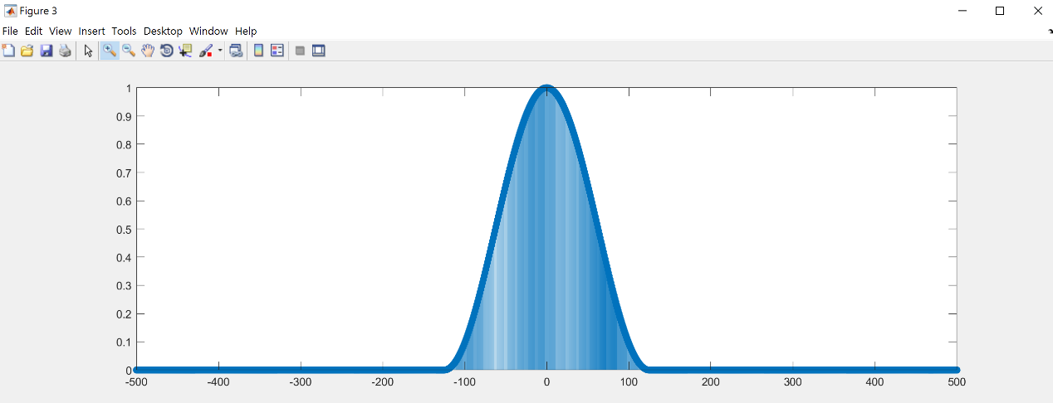

1. **Plot y[n]=x[n]w[n], where x[n] is the signal plotted in 1(a).**

(using the command “stem”)

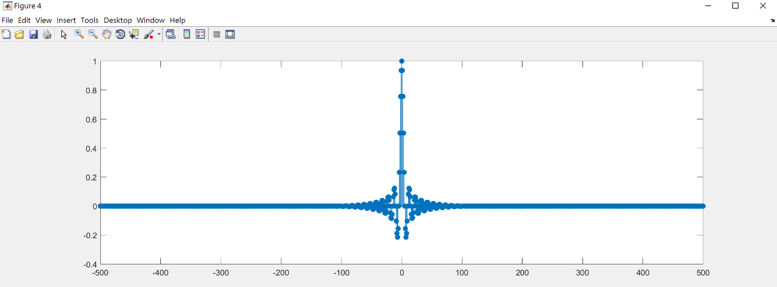

(c) **Plot the magnitude response of the DFT of y[n]. The zero**

**frequency should be centered in your plot. Observe the Gibbs**

**phenomenon here and compare it the that of 1(b).**

(using the command “plot”)

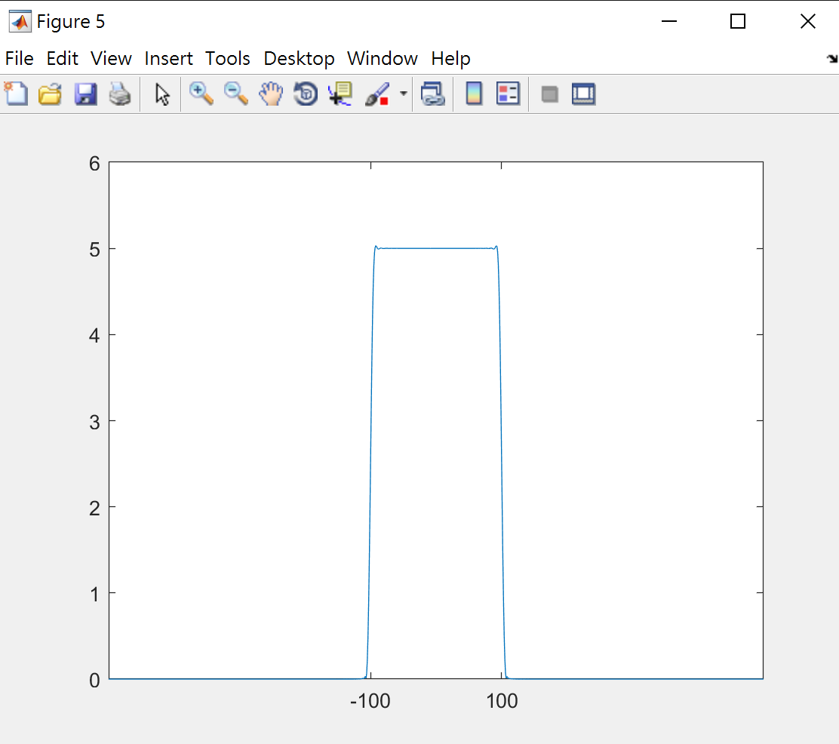

Compared to 1 (b), the overshoot near n=100 and n=-100 is greatly reduced.

Therefore, *Hanning* window play the role as a filter, and multiplying signals by a *Hanning* window will greatly mitigating Gibbs phenomenon.