Narrative of Feedforward Medical Student Evaluation System Concept of operations
The medical school at USF is building a system to speed up the feedback and evaluation process loop for medical students performing skills (competencies) during their “rounds” interacting with patients. The system has a mobile app module and a reporting module. The mobile app module system process begins (input) with a medical student who has completed a skill attempt (task) to request feedback about the task from an evaluator. The evaluator receives a notification that the student has completed a particular task and is requesting feedback. The evaluator then enters feedback for the task. The process ends (output) with the student receiving the feedback. The reporting module has visual dashboards of the tasks performed, by who and when, evaluated by who and when, which tasks map to which EPAs, Domains, Competency, Rotation, Track, and Program. The reporting is planned to be capable of aggregating and drilling down to a variety of demographic and performance metrics selected to be collected.
Data Diagram
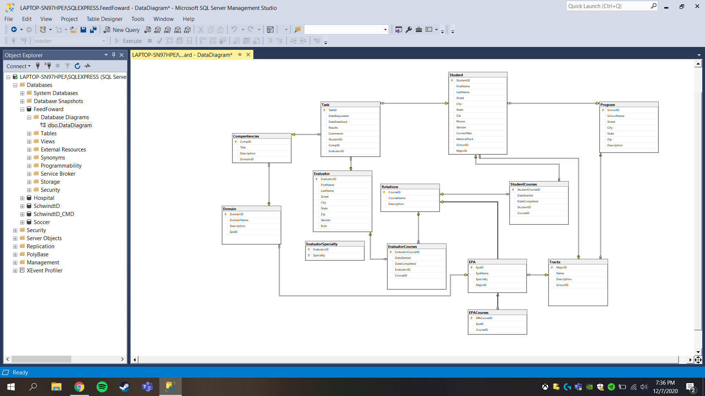

How many tasks are pending for an educator?
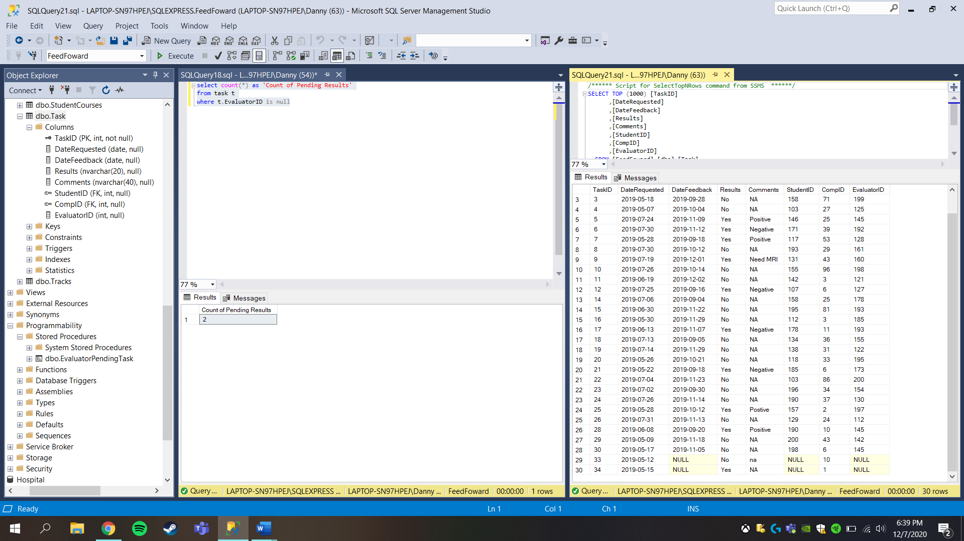
How many competencies were completed by a student between date 1 and date 2?
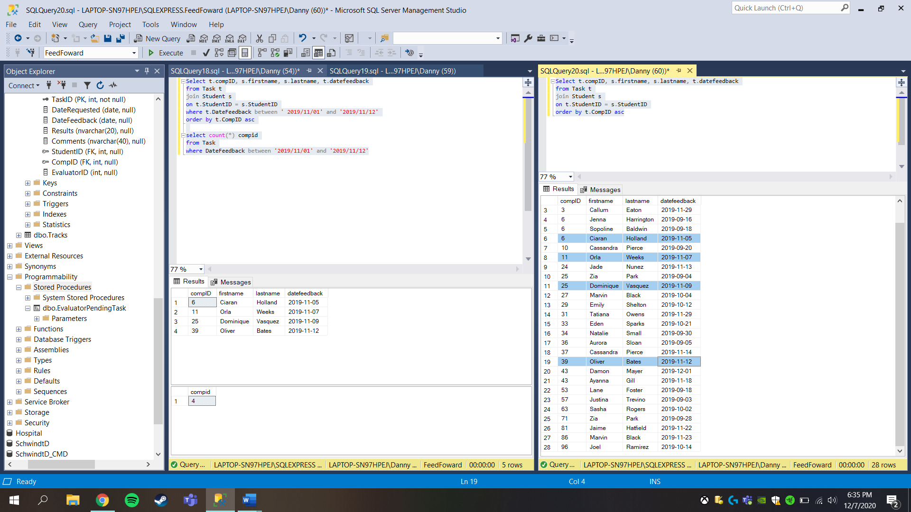

How many comments are positive, negative, neutral?
