There is no special instruction to run SDES.java, TripleSDES.java, and Hacking.java with the exception of that all the files are stored in a package called main. Hacking.java contains the answers for part 3. Run the files how ones usually run java files but on Haking.java it does take around 3 min to finish. Below are screenshots in order of SDES.java, TrippleSDES.java and Hacking.java.

Q1)

Unknown cipher Text

1. 11110000
2. 00001111
3. 01000011
4. 11100001

Unknown plain text

1. 00111000
2. 00001100
3. 11111100
4. 10100101

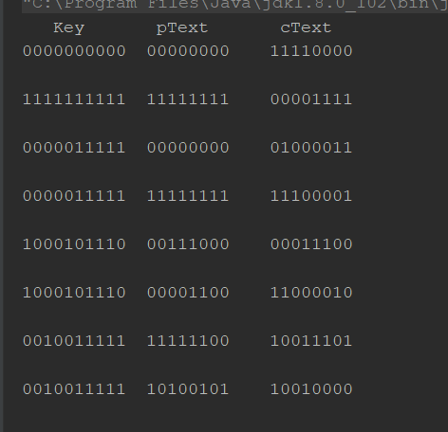

Q2)

Unknown cipher text

1. 11110000
2. 10111001
3. 11100100
4. 00000100

Unknown plain text

1. 11111101
2. 10100001
3. 01010010
4. 00100101

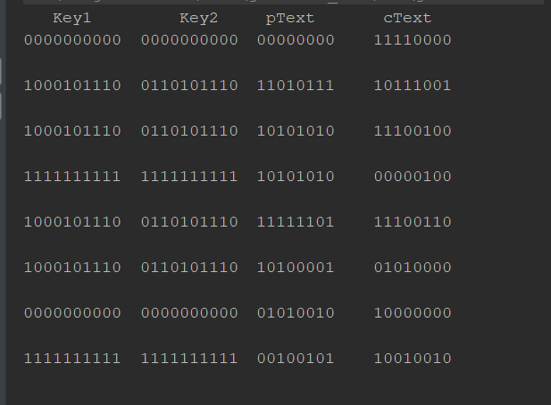

Q3) 1) CRYPTOGRAPHY encrypted becomes 0110000111001010101101101111010011000101011101101111110001110111

2) Key = 1011110100

Text = WHOEVER THINKS HIS PROBLEM CAN BE SOLVED USING CRYPTOGRAPHY, DOESN'T UNDERSTAND HIS PROBLEM AND DOESN'T UNDERSTAND CRYPTOGRAPHY. ATTRIBUTED BY ROGER NEEDHAM AND BUTLER LAMPSON TO EACH OTHER

3) Key 1= 1110000101

Key 2= 0101100011

Text= THERE ARE NO SECRETS BETTER KEPT THAN THE SECRETS THAT EVERYBODY GUESSES.

