@Mr. / Ms. @Last Name,

@Company does a fantastic job of giving back to the community and supporting worthwhile causes. Let me explain why it would be advantageous for @company to support Ultimate Impact 2014 - A fight against Lou Gehrig's disease.

All money raised during this tournament will benefit the thousands of families suffering against Lou Gehrig’s disease. One of those families includes the organizer of this tournament.



@Company would ‘sponsor’ a player who then plays there heart out at the tournament to defeat ALS. For every score or interception the player got, they would raise money. The sponsored player would represent team up with @company and represent with a shirt.

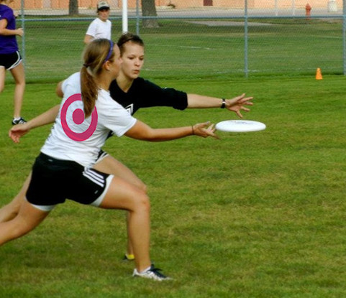

The sponsored player is thrilled by the generosity of target. At the end of the event they will share about the difference and the awesome time they had at the event.

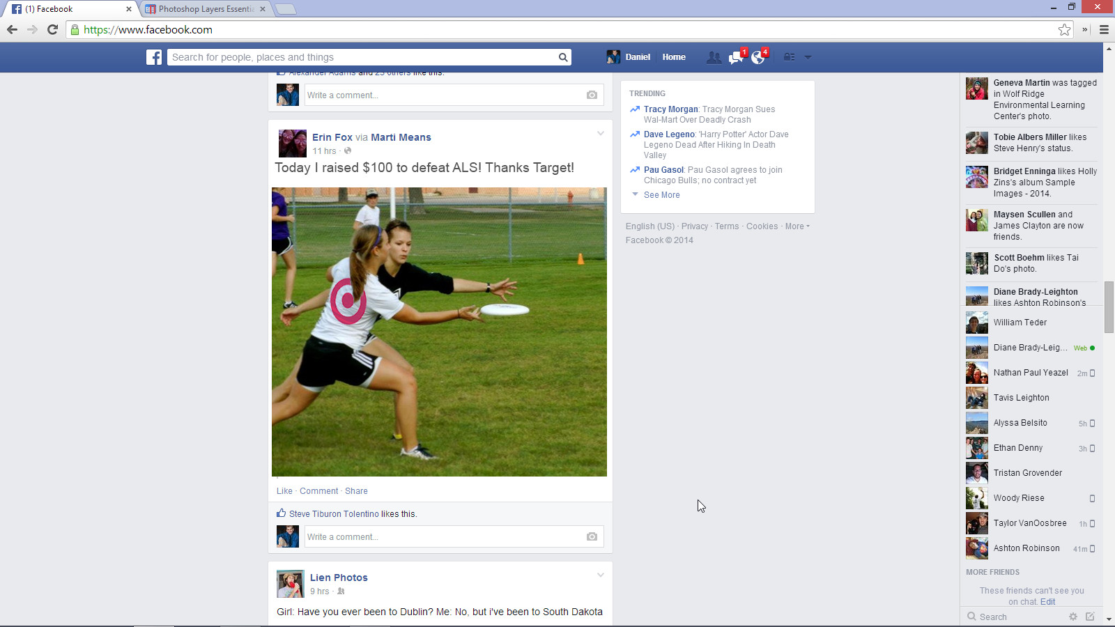

This opportunity gives @company an excellent opportunity to engage social networks and also connect with consumers in a meaningful way. Also, @company would be featured on our website, <ultimpact.com>, and on our social media pages.

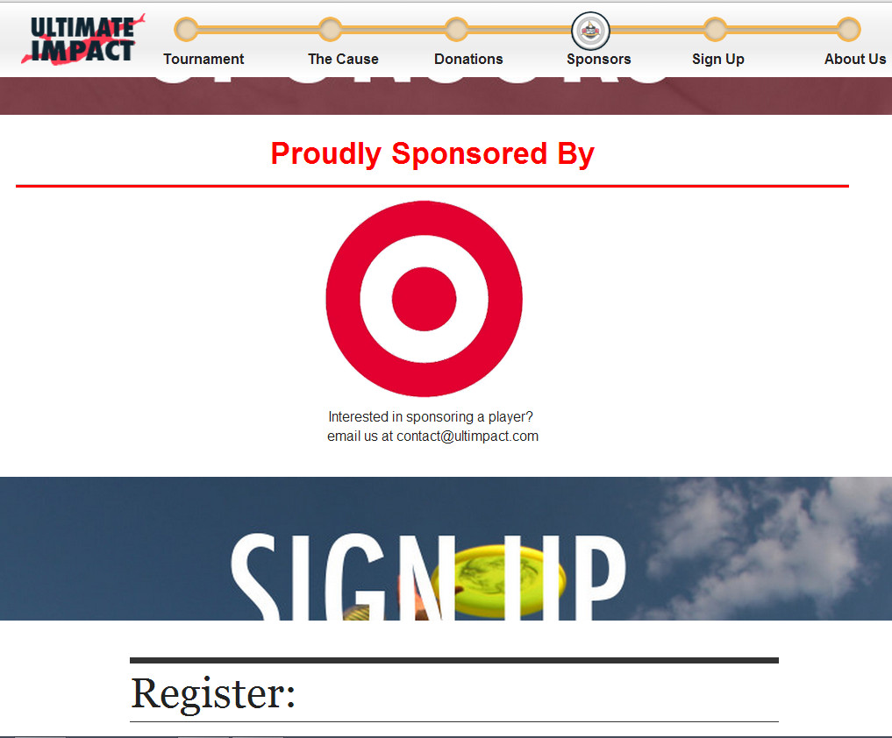

Engage your customers, their networks and make a meaningful difference in the lives of families across the nation.

|  |  |
| --- | --- |
| Tier | Sponsor Amount |
| General Support | $50 |
| Sponsor One Player | $100 |
| Sponsor Two Players | $200 |
| Sponsor Five Players | $500 |
| Other… | Gift cards, food, or swag. |