Regions

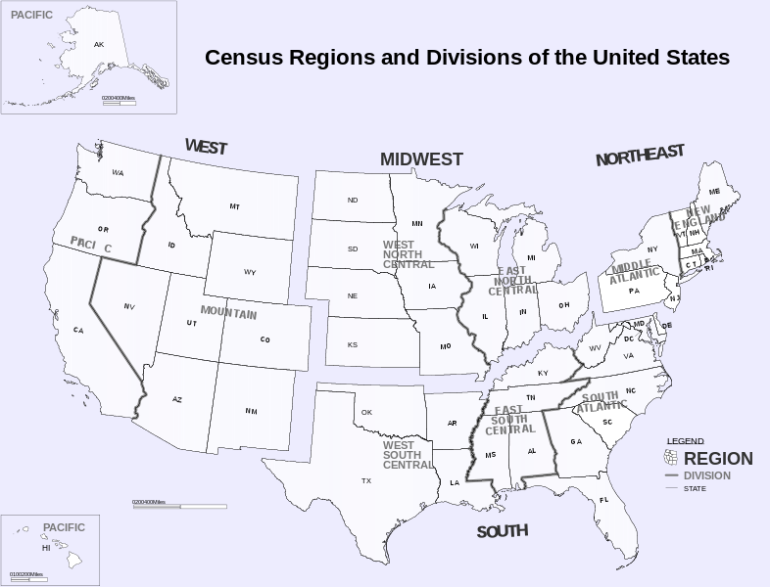

Region 1 (Northeast)

Maine

New Hampshire

Vermont

Massachusetts

Rhode Island

Connecticut

New York

Pennsylvania

New Jersey

Region 2 (Midwest)

Wisconsin

Michigan

Illinois

Indiana

Ohio

Missouri

North Dakota

South Dakota

Nebraska

Kansas

Minnesota

Iowa

Region 3 (South)

Delaware

Maryland

Washington

D.C.

Virginia

West Virginia

North Carolina

South Carolina

Georgia

Florida

Kentucky

Tennessee

Mississippi

Alabama

Oklahoma

Texas

Arkansas

Louisiana

Region 4 (West)

Idaho

Montana

Wyoming

Nevada

Utah

Colorado

Arizona

New Mexico

Alaska

Washington

Oregon

California

Hawaii

Results should be ranked in ascending alphabetica

We might want to include having a team page or something. See below.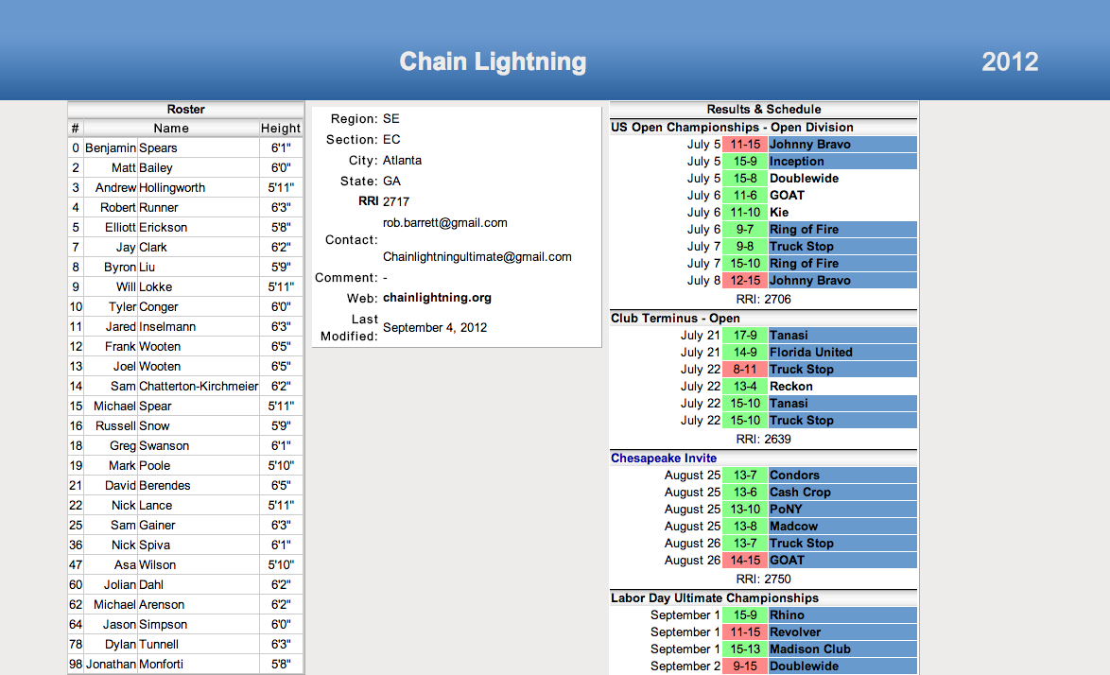l order.

Also we have to be careful to only have 1 function or separate program that translates the site into our data. Else when the update our site we wont have to redo the whole app just that one function.

Other ideas

Reminders on bids due – upcoming tournament entries

Teams

Submit score?

Tournament description – make sure you are hot lking phone numbers, addresses and webpages