SIMATS ENGINEERING

(SAVEETHA SCHOOL OF ENGINEERING)
Department of Computer Science and Engineering

CO1 ASSESSMENT TOOL 1 – CASE STUDY ANALYSIS
Annexure A – Case Study Report

Course Code / Title | CSA10 / CSA1005 – Software Engineering
CO Assessed | CO1 – Apply advanced methodologies and agile project management techniques to manage software projects effectively
Assessment | Assessment Tool 1 – Case Study Analysis (Weightage 20%, Total Marks: 25)
Problem Statement No. | 40
Case Study Title | Smart Emergency Medicine Availability and Hospital Coordination Platform
Student Name | M RENE DANIEL
Reg. No. | 1971260041  11
Date / Duration | / 60 minutes

Code of Conduct
I (Name / Reg No) certify that this submission is my original work and that I have adhered to the guidelines specified for this assessment. I understand that any violation of academic integrity rules will result in disciplinary action.

Signature of the Student:

Report Contents
- Understand the Problem Statement
- Identify Key Stakeholders and Challenges
- Analyze the Current Approach
- Propose a Suitable Solution Using Software Engineering Principles
- Justify the Chosen Methodology / Framework
- Discuss Expected Outcomes and Limitations Assessment Rubrics and Marks Sheet

Understand the Problem Statement

Problem in my own words
When a road accident victim, a stroke patient or a pregnant woman in distress needs urgent care, the first minutes decide the outcome. Paramedics and referring doctors must find a hospital that has a free ICU bed, a ventilator, a trauma theatre or the right specialist on duty, and that is reachable in time. Today this is mostly done by phoning hospital after hospital. Each call costs minutes, the answers may already be outdated, and a patient may be taken to a hospital that cannot actually treat them, forcing a second transfer.
The problem is therefore an information and coordination gap: there is no single, trustworthy, up-to-date view of which participating hospitals can handle which emergency right now, and no quick, auditable channel to request and confirm a place. The task is to design a Smart Emergency Hospital Coordination Platform (SEHCP) that closes this gap while respecting patient privacy and role-based access.

Objectives of the proposed system
    - Maintain participating hospital information (profile, location, tier, contacts).
    - Record emergency facilities (ER, trauma centre, burns unit, stroke unit, blood bank, etc.).
    - Maintain department and specialist information, including on-call duty rosters.
    - Track resource availability (ICU/ward beds, ventilators, operation theatres, ambulances) where supported by the hospital.
    - Receive emergency coordination requests from authorised healthcare personnel.
    - Match each request with the most suitable facilities automatically.
    - Notify authorised hospital personnel instantly and capture their response.
    - Maintain a complete emergency coordination history for audit and learning.
    - Generate operational reports (response times, acceptance rate, resource utilisation).

Scope of the problem
Aspect | Details
In scope | Hospital and department registry; resource availability updates (manual, periodic or via API); emergency request creation; rule-based matching and ranking; notifications; request lifecycle tracking; dashboards; audit trail; reports; role-based access control.
Out of scope | Full electronic medical records (EMR/EHR), billing and insurance, ambulance GPS fleet hardware, clinical diagnosis or treatment decisions, and patient-facing public booking.
Users / coverage | Authorised paramedics, ED coordinators, bed managers, specialists, administrators and health authorities of participating hospitals in a city or district network.
Key constraint | Only the minimum patient data needed for coordination is shared; data quality depends on how regularly hospitals update availability.

Identify Key Stakeholders and Challenges

Stakeholders, roles and responsibilities
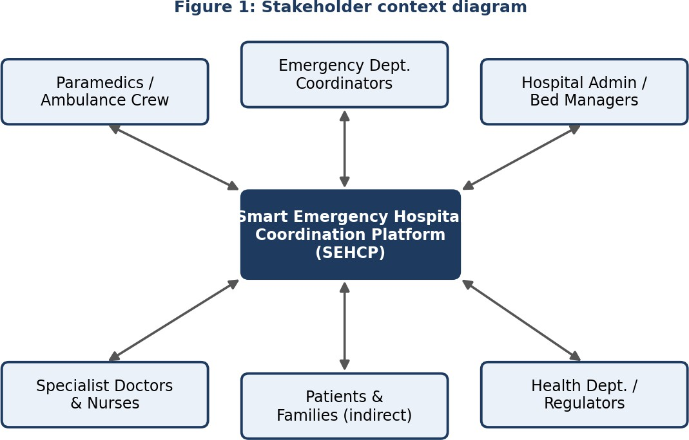
The plaVorm sits at the centre of a two-way information flow between all stakeholders.

Stakeholder | Roles and responsibilities
Paramedics / ambulance crew | Raise emergency requests with patient condition, urgency, location and required resources; receive confirmed destination and ETA.
Referring doctors / ED coordinators | Review matches, choose or override destination, manage inter-hospital transfer requests, close the case.
Hospital admin / bed managers | Register hospital, departments and facilities; keep bed, ICU, ventilator and theatre counts current; manage user accounts.
Specialist doctors & nurses on duty | Receive alerts, accept or decline a case within a time limit, prepare the team and equipment for arrival.
Patients and families (indirect) | Beneficiaries of faster treatment; their data must be protected and used only for coordination.
Health department / regulators | Monitor response performance and resource utilisation, plan capacity, audit privacy and compliance.
System administrator / IT team | Operate and secure the platform, manage integrations, backups and releases.

Major challenges faced by the stakeholders
    - Delay and manual effort: paramedics call many hospitals one by one while the patient deteriorates.
    - Stale or unavailable information: bed and specialist status changes minute by minute but is rarely published.
    - Wrong-destination transfers: patients reach a hospital that lacks the needed unit or specialist.
    - Overloaded hospitals: no network-wide view, so some emergency departments are overcrowded while others are idle.
    - Privacy and trust: sharing patient details across hospitals needs strict, auditable access control.
    - Data discipline and adoption: busy staff may not update resource counts; hospitals use different systems and formats.
    - Connectivity and reliability: ambulances and smaller hospitals may have weak networks; the system must degrade gracefully.
    - No reporting: authorities lack data on delays, refusals and capacity gaps for planning.

Analyze the Current Approach

Existing system / current process
Emergency coordination today is largely telephone and message based. The ambulance crew or referring doctor calls the emergency desk of nearby hospitals (or a central control room), asks about beds and specialists, waits for a verbal confirmation, and then drives to the chosen hospital. Information is noted on paper or in chat groups, hospitals keep their own isolated records, and no shared history is maintained. Some hospitals use standalone HIS/bed-management software, but it is not connected to other hospitals or to ambulance services.

Aspect | Strengths of current approach | Limitations / gaps
Process | Simple, needs no technology; personal relationships can speed up a call. | Sequential calls; time-consuming; depends on who answers the phone.
Information | Direct human confirmation from the hospital duty staff. | Data is outdated within minutes; no real-time or shared view of availability.
Coordination | Flexible; humans handle exceptional cases. | No standard request format; no tracking, no accountability, no notifications to specialists.
Privacy / audit | Limited data is exposed. | Patient details are shared over calls or chat apps; no access control or audit log.
Reporting | — | No history, so no analytics on response time, refusals or utilisation.
Scalability | Works for small volumes. | Breaks down during mass-casualty events, peak hours or in large cities.

Problems and gaps to be addressed
    - A single, current, searchable source of hospital capability and capacity.
    - Structured emergency requests that carry exactly the information a hospital needs to decide.
    - Automatic matching and ranking by capability, availability and distance instead of repeated phone calls.
    - Instant, targeted notifications and a recorded accept / decline / escalate workflow.
    - Secure, role-based access with a full audit trail to protect patient privacy.
    - Operational reports and dashboards for continuous improvement and capacity planning.

Propose a Suitable Solution Using Software Engineering Principles

Proposed software-based solution
SEHCP is a web and mobile platform with a secure cloud back end. Hospitals register their facilities and keep availability current through a dashboard, scheduled uploads or an integration API. An authorised paramedic or doctor creates an emergency request; the matching engine filters hospitals by required capability, free resources, specialist on-call status and travel distance, ranks them, and notifies the duty team of the best candidates. The first acceptance confirms the destination and the full history is logged.
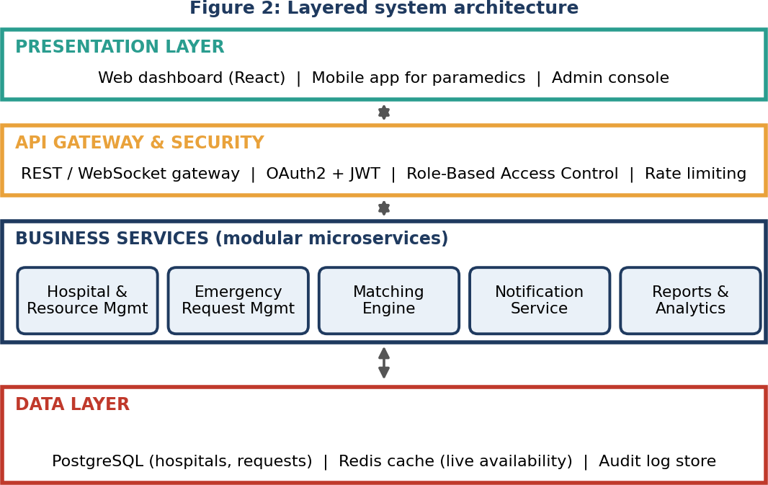

Layered, modular architecture: each service can be developed, tested and scaled independently.

Major functional modules
Module | Description
1. Hospital & Facility Management | Registers hospitals, emergency facilities, departments and contact points; manages approvals for new participants.
2. Specialist & Roster Management | Stores specialties and on-call duty schedules; shows who is available now.
3. Resource Availability Tracker | Tracks ICU/ward beds, ventilators, theatres, blood and ambulances; supports manual, periodic and API updates with a "last updated" timestamp.
4. Emergency Request Management | Creates, edits, escalates and closes requests with priority, condition category and required resources.
5. Matching & Ranking Engine | Rule-based scoring on capability fit, availability, distance/ETA and current load; returns ranked options.
6. Notification & Communication | SMS, push and in-app alerts to duty teams; accept/decline responses; in-case messaging.
7. Dashboard & Reporting | Live hospital dashboards, case history, response-time, acceptance and utilisation reports (PDF/CSV).
8. Security & Administration | Authentication, role-based access, consent/privacy rules, audit logs, user and configuration management.

Functional and non-functional requirements
Functional requirements (FR) | Non-functional requirements (NFR)
FR1: Register and approve hospitals, departments and emergency facilities. | NFR1 Performance: matching results within 3 seconds for 95% of requests.
FR2: Maintain specialist information and on-call rosters. | NFR2 Availability: 99.9% uptime; offline-tolerant mobile app with queued requests.
FR3: Update and display resource availability with timestamps. | NFR3 Security: encryption in transit and at rest, MFA for staff, least-privilege RBAC.
FR4: Create, track and close emergency requests. | NFR4 Privacy: data minimisation, consent, compliance with applicable health-data laws.
FR5: Match and rank suitable facilities for a request. | NFR5 Scalability: horizontal scaling to many hospitals and concurrent requests.
FR6: Notify authorised personnel and record responses. | NFR6 Usability: simple screens usable under stress; works on phone, tablet and PC; multi-language.
FR7: Keep complete coordination history and audit trail. | NFR7 Maintainability: modular code, automated tests, API documentation.
FR8: Generate operational and management reports. | NFR8 Reliability and Interoperability: data backup and recovery; HL7 FHIR / REST APIs for integration.

Software engineering principles incorporated
Principle | How it is applied in SEHCP
Modularity | Eight loosely coupled services with clear APIs; high cohesion inside each module; replaceable matching rules.
Scalability | Stateless services behind a gateway, caching of live availability (Redis), horizontal scaling and queue-based notifications.
Maintainability | Layered design, coding standards, CI/CD pipeline, automated unit and integration tests, versioned APIs and documentation.
Reliability | Redundant deployment, health checks, retry and fallback to SMS, data backup, graceful degradation if a hospital feed is stale.
Usability | Role-specific dashboards, minimal-tap request form, colour-coded priority, user testing with paramedics and ED staff.
Security | Role-based access, MFA, TLS/AES encryption, consent-based data sharing, tamper-evident audit logs, regular security testing.

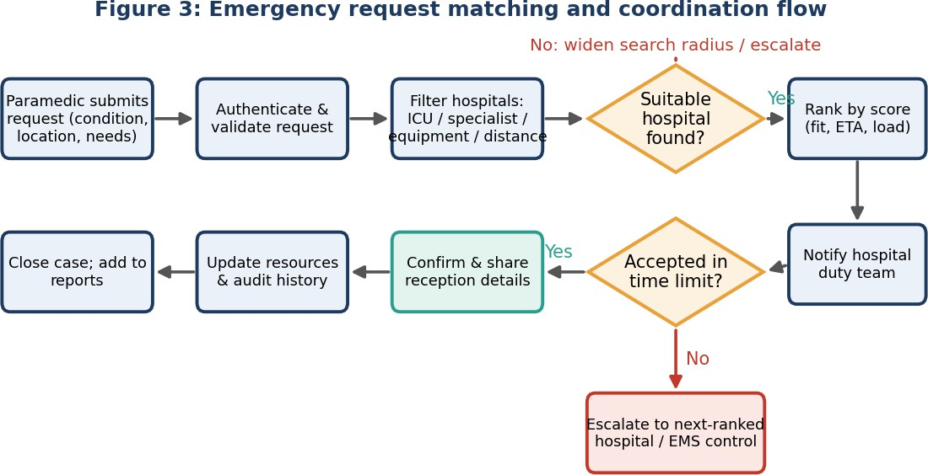

Request matching workflow: from submission to confirmed hospital or escalation.
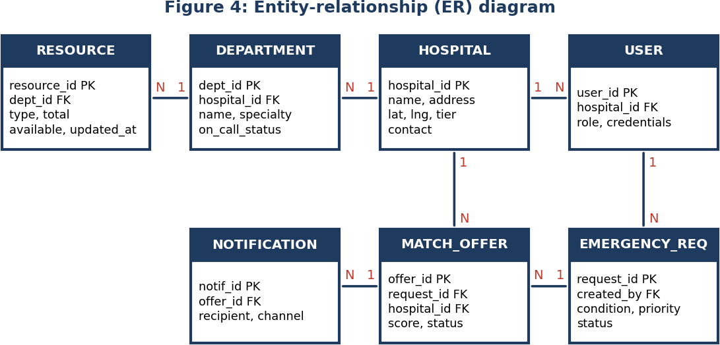

Core data model: hospital, department, resource, user, request, match offer and notification.
Design notes: matching uses a weighted score, for example Score = 0.4 × capability fit + 0.3 × resource availability + 0.2
× (1 / ETA) + 0.1 × (1 / current load), configurable by the health authority. Stale availability (older than a set threshold) is shown with a warning and ranked lower, and all data access is checked against the user's role.

Justify the Chosen Methodology / Framework

Selected framework: Agile – Scrum
Scrum with two-week sprints is selected, supported by a lightweight DevOps pipeline (CI/CD, automated tests, monitoring) and a Kanban board for post-release maintenance. A Product Owner (from the health department / hospital network) maintains the product backlog, a Scrum Master facilitates, and a cross-functional team of developers, a tester and a UX designer delivers a potentially releasable increment each sprint.
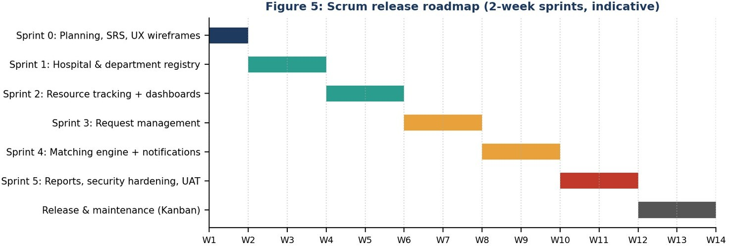

Why Scrum is suitable for this system
Project characteristic | Why Scrum fits
Evolving requirements | Hospitals, paramedics and regulators will refine needs after seeing working software; Scrum welcomes change at every sprint review.
Many stakeholder groups | Regular reviews and a single Product Owner prioritise conflicting needs transparently.
High risk and safety impact | Short feedback loops, early pilots in one or two hospitals, and automated testing detect defects early.
Need for early value | The registry and availability dashboard (Sprints 1–2) can go live early and benefit users while matching is still built.
Integration uncertainty | Incremental integration with hospital systems lets the team learn and adjust per hospital.
Why not Waterfall | Rigid up-front requirements and late testing would be risky for a life-critical, changing domain; Spiral is heavier than needed, though its risk analysis is borrowed in sprint planning.

How it supports development and maintenance
    - Each increment is demonstrated, accepted and deployable, so the platform grows safely with continuous user feedback.
    - Definition of Done covers testing, security checks, documentation and accessibility, which keeps quality high.
    - Retrospectives improve the process; velocity and burndown charts give measurable progress for project management.
    - The CI/CD pipeline, monitoring and the Kanban board allow rapid bug fixes, rule updates and onboarding of new hospitals after release.

Discuss Expected Outcomes and Limitations

Expected benefits and how challenges are addressed
Identified challenge | How SEHCP addresses it / expected benefit
Delays from repeated calls | One request reaches all suitable hospitals: faster identification of suitable facilities and reduced communication delays.
Outdated information | Timestamped availability dashboards give better visibility of available services.
Wrong-destination transfers | Capability-based matching reduces unnecessary secondary transfers.
Uneven hospital load | Network-wide view enables more efficient emergency resource utilisation and improved inter-hospital coordination.
Privacy concerns | RBAC, minimal data sharing and audit logs ensure appropriate privacy and access control.
No history or reporting | Coordination histories and operational reports support audits, planning and continuous improvement.

Potential risks, implementation challenges and limitations
Risk / limitation | Description | Mitigation
Stale availability data | Hospitals may not update counts regularly, giving wrong matches. | Timestamps, reminders, API integration, ranking penalty for stale data.
Adoption and training | Staff resistance or limited training in busy emergency units. | Pilot rollout, simple UI, training and incentives.
Privacy / security breach | Health data is a high-value target. | Encryption, MFA, audits, penetration testing, data minimisation.
Connectivity / downtime | Weak networks or outages can block requests. | Offline queue, SMS fallback, redundant hosting.
Integration complexity | Hospitals use different HIS formats. | Standard APIs (HL7 FHIR), adapters, phased integration.
Limitation of scope | The platform advises on facilities; final clinical decisions stay with doctors. Accuracy depends on hospital data. | Clear disclaimers, manual override, human confirmation.

Possible future enhancements
    - Real-time ambulance GPS tracking and traffic-aware ETA prediction.
    - Machine-learning models to predict bed demand, surge periods and best-fit hospital.
    - IoT bed and equipment sensors for automatic availability updates.
    - Integration with national health ID / EHR systems with patient consent, and tele-consultation for specialists.
    - Mass-casualty and disaster-mode dashboards, multilingual voice requests and blood-bank/organ-donor coordination.

Conclusion
SEHCP replaces slow, fragmented phone coordination with a secure, modular and auditable platform that matches emergencies to capable hospitals in seconds. Developed iteratively with Scrum and sound software engineering principles, it offers a feasible path to faster care, better resource use and stronger inter-hospital coordination.

Assessment Rubrics and Marks Sheet
Rubrics for Calculation (each criterion is scored out of 5 marks).

Criteria | Excellent (5) | Good (3) | Satisfactory (2) | Needs Improvement (1)
Problem Understanding (30%) | Clearly explains problem, objectives and scope with complete understanding. | Explains problem with minor omissions. | Basic understanding, limited explanation. | Poor understanding; objectives and scope unclear or missing.
Stakeholder & Challenge Analysis (25%) | Identifies all stakeholders, roles and challenges with clear analysis. | Identifies most stakeholders and challenges. | Identifies only a few stakeholders or challenges. | Stakeholder and system analysis incomplete or inaccurate.
Current System Analysis (20%) | Thorough analysis of strengths, weaknesses and all gaps. | Good analysis with most strengths and weaknesses. | Limited analysis; partial issues identified. | Analysis unclear; requirements largely missing.
Proposed Solution & SE Principles (15%) | Innovative, feasible solution applying modularity, scalability, maintainability, security etc. | Suitable solution with good application of principles. | Basic solution with limited application of principles. | Methodology inappropriate, poorly justified or not discussed.
Methodology / Framework Justification (10%) | Most suitable SDLC/framework with strong technical justification. | Suitable methodology with adequate justification. | Methodology selected but justification weak. | Outcomes, limitations or enhancements missing; poor organisation.

Marks Awarded (to be filled by the evaluator)

Criteria | Mark
Problem Understanding (30%) | /5
Stakeholder & Challenge Analysis (25%) | /5
Current System Analysis (20%) | /5
Proposed Software Solution & Software Engineering Principles (15%) | /5
Methodology / Framework Justification (10%) | /5
TOTAL | /25

Evaluator signature: Date:

