FACULTY OF ENGINEERING AND BASIC SCIENCES
ACADEMIC PROGRAM: DATA ENGINEERING AND ARTIFICIAL INTELLIGENCE

COURSE: ETL (G01)
Workshop-1: From Business Requirements to a Dimensional Data Warehouse

- . Introduction

This workshop simulates a real-world Data Engineering technical challenge in which you must transform business needs and raw operational data into an analytical data system.

You will work with candidate application data from technical recruitment processes. Your goal is not only to implement an ETL pipeline, but to design and build a Dimensional Data Warehouse that supports specific business requirements and analytical decisions.

Throughout the workshop, you will apply the following engineering workflow:
Business Requirements → Data Understanding → Dimensional Modeling → ETL → Data Warehouse → Analytics → Business Decisions

This workshop evaluates your ability to:
- Understand analytical business requirements.
- Translate business requirements into data requirements.
- Define the appropriate grain for an analytical model.
- Design a Dimensional Data Model using a Star Schema.
- Implement a reproducible ETL pipeline.
- Load dimensions and facts into a Data Warehouse.
- Generate analytical information directly from the Data Warehouse.
- Verify that the implemented system satisfies the original business requirements.
- Document and communicate technical decisions professionally.

The objective is not simply to build a Data Warehouse. The objective is to build an analytical data system that satisfies business requirements.

- . Scenario

A technology recruitment company wants to improve its understanding of its candidate selection processes.

The company receives thousands of applications from candidates with different professional backgrounds, levels of experience, countries, seniority levels, and technology profiles.

Candidate performance is evaluated using two technical assessments:
- Code Challenge Score

- Technical Interview Score

Currently, candidate application data are available as raw files, but the organization needs an analytical system that allows decision-makers to understand hiring patterns and evaluate recruitment performance from different perspectives.

You have been assigned as the Data Engineer responsible for designing and implementing the first version of this analytical system.

Your solution must:
- Understand and refine the analytical requirements.
- Analyze the available source data.
- Design a Dimensional Data Model.
- Implement the required ETL transformations.
- Load the resulting model into a Data Warehouse.
- Generate analytical queries and KPIs.
- Demonstrate that the final system satisfies the defined business requirements.

. Business Requirements

The organization has identified the following initial analytical requirements:

R1 — Hiring Trends
Monitor hiring trends over time to identify changes in recruitment outcomes.
The system should allow analysts to study hiring behavior across different periods.

R2 — Technology Analysis
Compare hiring results across technologies to identify which technical profiles generate the largest number and proportion of hired candidates.

R3 — Candidate Profile Analysis
Analyze hiring outcomes according to candidate seniority and years of professional experience to identify differences in recruitment outcomes across candidate profiles.

Define Two Additional Business Requirements
Your team must propose two additional business requirements (R4 and R5) using the available data. The requirements must:
    - Address a meaningful analytical need.
    - Support a business decision or provide useful information for recruitment management.
    - Be answerable using the available data.
    - Be different from R1–R3.
    - Require analytical processing, not simply retrieving individual records.

ID | Business Requirement | Business Question | Decision Supported

R4 | Country Analysis  Evaluate recruitment activity and hiring effectiveness by candidate country of origin. | Which countries generate the highest volume of applications, and which ones have the highest hire rate? | Prioritize sourcing investment and effort in countries with high volume and high success rates, while identifying high-volume, low-conversion markets that may signal profile or process misalignments.
R5 | Technical Evaluation  Analyze the efficiency and consistency of the technical evaluation process by comparing Code Challenge Scores against Technical Interview Scores. | Is there a systematic gap between both scores, and which test acts as the primary bottleneck preventing hiring? | Decide whether to recalibrate either assessment or the interview process and determine where to allocate candidate preparation resources or interviewer training.

Important
A visualization, SQL query, or dashboard is not a business requirement.

Incorrect: Create a bar chart of candidates by country.
Better: Identify countries with the highest recruitment activity and compare their hiring outcomes to support geographic recruitment strategies.

. Requirements Traceability

Before designing the Data Warehouse, analyze the five business requirements. Complete the following table:

Requirement | Business Question | Data Required | Expected Analytical Output
R1 | How have hiring results (hired vs not hired) changed over time? | Application Date, Code Challenge Score, Technical Interview Score | Time series (monthly) of applications, hires, and hire rate (%)
R2 | Which technologies generate the highest number and proportion of hired candidates? | Technology, Code Challenge Score, Technical Interview Score | Ranking of technologies by number of hires and hire rate (%)
R3 | How do hiring results change according to candidate seniority and years of experience? | Seniority, YOE, Code Challenge Score, Technical Interview Score | Hire rate by seniority level and experience range (YOE)
R4 | Which countries generate the highest volume of applications and what is their hire rate? | Country, Code Challenge Score, Technical Interview Score | Ranking of countries by application volume vs hire rate
R5 | Is there a difference between Code Challenge Score and Technical Interview Score, and which test is the main bottleneck for hiring? | Code Challenge Score, Technical Interview Score | Average difference between tests + breakdown of candidates failing “only by code challenge”, “only by interview”, or “both”.

This table must be completed before designing the dimensional model.
Do not start by designing tables. Start by understanding what the business needs to know.

- . Data Description

The source dataset contains approximately 50,000 candidate applications. Each row represents one candidate application.

The available attributes are:
    - First Name
    - Last Name
    - Email
    - Country
    - Application Date
    - YOE (Years of Experience)
    - Seniority
    - Technology
    - Code Challenge Score
    - Technical Interview Score

5.1 Business Rule — Hiring Outcome

A candidate is considered HIRED when:
Code Challenge Score ≥ 7 AND Technical Interview Score ≥ 7 Otherwise: NOT HIRED

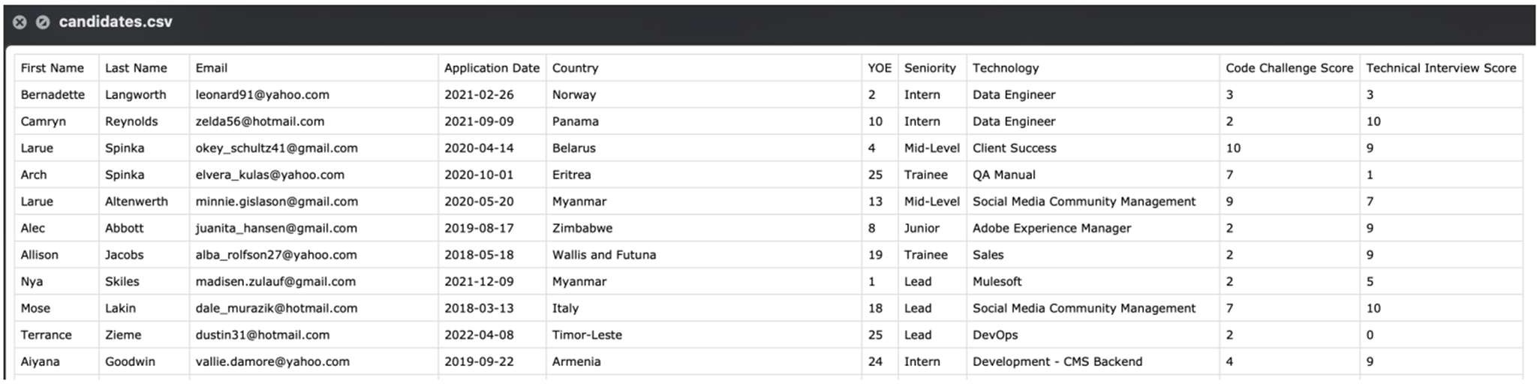
This business rule must be implemented during the transformation process. The following figure shows a small sample of the data.

Figure 1. Small sample of the data.

. Proposed System Architecture

Your solution should follow the general analytical flow shown below. The architecture represents the system at a high level. Your implementation may organize individual components differently, but the complete data flow must be clearly documented.
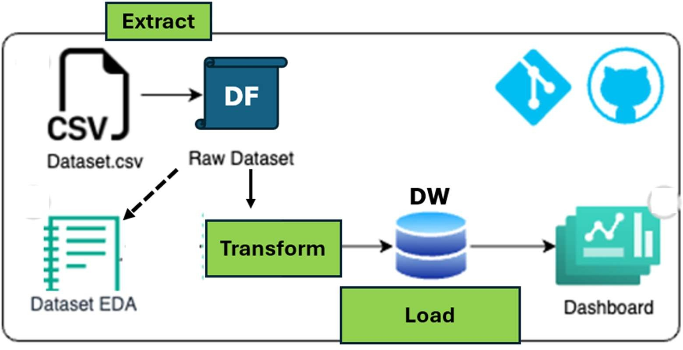

Figure 2. Proposed analytical system architecture.

. Technologies

You must use:
- Python
- Pandas
- Jupyter Notebook for initial data profiling
- SQL
- MySQL or PostgreSQL as the Data Warehouse
- Git and GitHub
- BI Tool (Power BI, Tableau, Looker Studio, or another approved BI tool for analytical visualization)

For this workshop, you must follow an ETL approach:
Required transformations must be performed before loading the analytical data into the Data Warehouse.

- . Task 1: Initial Data Profiling

Before designing or transforming the data, understand the source dataset. Perform basic profiling including at least:
- Number of rows and columns.
- Column names.
- Data types.
- Missing values.
- Duplicate records.
- Unique values in relevant categorical attributes.
- Minimum and maximum application dates.
- Score ranges.
- Basic descriptive statistics for numerical attributes.

The purpose of this activity is not to perform an extensive EDA. The objective is to understand the data sufficiently to support your modeling and transformation decisions.
Document the most important findings.

. Task 2: Dimensional Data Model

Design a Star Schema capable of satisfying the five business requirements. Follow the dimensional modeling process in the correct order.

Step 1 — Select the Business Process
Identify the business process being analyzed and briefly justify your decision.

Business Process: Technical candidate recruitment and selection process, each application is evaluated through two technical test and results in a binary hiring decision.
Justification: It’s the only business process present in the data source and all 5 business questions resolve around the application and its outcome.

Step 2 — Declare the Grain
Before defining dimensions or facts, explicitly state what one row in the Fact Table represents. Complete the following sentence:

One row in FactApplications represents
a single candidate application to the selection process, evaluated with a specific Code Challenge Score and Technical Interview Score, resulting in a single hiring outcome (hired / not hired).

The grain must be precise and consistent with the business requirements.

All dimensions and measures included in the Fact Table must be compatible with the declared grain.

Step 3 — Identify the Dimensions
Identify the dimensions required to provide context to the business process. For each dimension, specify:

Dimension | Purpose | Main Attributes | Requirement(s) Supported
DimDate | Analyze hiring trends over time | Date_key (PK), full_date, day, month, month_name, quarter, year | R1
DimTechnology | Compare hiring outcomes by technical profile | Technology_key (PK), technology_name | R2
DimCandidateProfile | Group candidates by seniority and experience range (YOE) to compare outcomes across profiles | Profile_key (PK), seniority, yoe_band, yoe_min, yoe_max | R3
DimCountry | Compare recruitment volume and effectiveness by country | Country_key (PK), country_name | R4
Note: I combined seniority + YOE into a single dimension (DimCandidateProfile), because R3 always asks for them combined and YOE is continuous numerical data. I grouped it into bands (Entry 0-2, Junior 3-5, Mid 6-9, Senior 10-15, Expert 16+) to make it a useful categorical dimension rather. I did not create a separate dimension for R5 because both scores are fact measures, not descriptive context attributes.

Do not create dimensions simply because categorical columns exist in the source data.

Every dimension should have a clear analytical purpose.

Step 4 — Identify Facts and Measures
Identify the facts or measures required to answer the business questions.

Measure | Meaning | Source / Calculation | Requirement(s) Supported
is_hired | Binary hiring indicator (1 = hired, 0 = not hired) | Derived: (code_challenge_score >= 7) AND (technical_interview_score >= 7) = 1, otherwise = 0 | R1, R2, R3, R4, R5
code_challenge_score | Raw score from the coding test (0-10) | Source column, untransformed | R5
technical_interview_score | Raw score from the technical interview (0-10) | Source column, untransformed | R5
score_gap | Difference between both tests, to measure which one fails more often | Technical_interview_score – code_challenge_score | R5

Note: code_challenge_score and technical_interview_score are not additive measures. They are stored at the grain level to calculate averages (AVG) and aggregated comparisons in queries. Is_hired is fully additive (SUM = total hires count, and AVG = hire rate).

Remember: Not every numeric field is necessarily an additive measure. Step 5 — Design the Star Schema
Create the complete Star Schema. The model must include:
- One Fact Table.
- Required Dimension Tables.
- Primary keys.
- Foreign keys.
- Surrogate keys for dimensions. (date_key, technology_key, profile_key, country_key)
- Measures. (code_challenge_score, technical_interview_score, score_gap e is_hired)
- Relevant dimensional attributes.

Important: Do not use natural source keys as the primary keys of the dimensions. Each dimension must use a surrogate key.

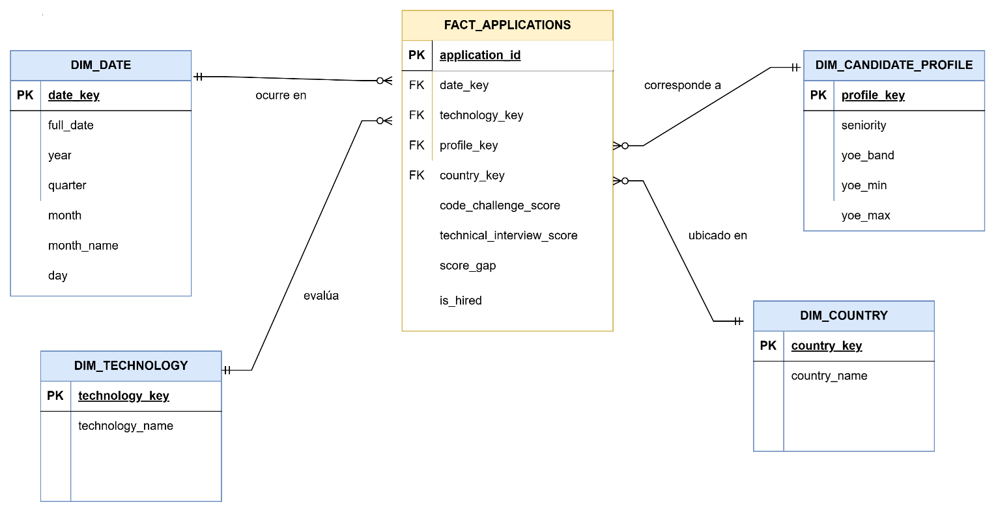

Step 6 — Validate the Model Against the Requirements
Before implementing the model, verify that it supports all five requirements.

Requirement | Dimension(s) Required | Measure(s) Required | Supported?
R1 | DIM_DATE | is_hired | Yes
R2 | DIM_TECHNOLOGY | is_hired | Yes
R3 | DIM_CANDIDATE_PROFILE | is_hired | Yes
R4 | DIM_COUNTRY | is_hired | Yes
R5 | No additional dimensions, direct conversion of measurements | Code_challenge_score, technical_interview_score, score_gap, is_hired | Yes

If one or more requirements cannot be satisfied, revise the dimensional model before continuing.

- . Task 3: ETL Process

Implement a reproducible ETL pipeline in Python. The ETL process should remain relatively simple. The main focus of this workshop is dimensional modeling and its connection with business requirements.

  - Extract
    - Read the source data.
    - Preserve the original source file.
    - Load the source data into an appropriate Pandas DataFrame. Do not perform business transformations during extraction.

Data Preparation
Perform only the preparation required by the data and the analytical model. This may include:
    - Correcting data types.
    - Standardizing relevant formats.
    - Handling missing values when necessary.
    - Handling duplicated records when justified.
    - Preparing dates and categorical attributes.
All relevant preparation decisions must be documented.

Business Transformation
Implement the hiring business rule:
HIRED = (Code Challenge Score ≥ 7) AND (Technical Interview Score ≥ 7)
Create any additional derived attributes required by your five business requirements.

Do not create transformations that have no analytical purpose.

- . Task 4: Dimensional Transformation

Transform the prepared source data into the dimensional structures defined in Task 2. Your process must:
- Create the dimension datasets.
- Remove duplicated dimension members where appropriate.
- Generate surrogate keys.
- Map each application to the corresponding dimension surrogate keys.
- Create the Fact Table according to the declared grain.
- Include only facts and relationships justified by the analytical requirements.

Conceptually:
Prepared Candidate Data → Dimension Records → Surrogate Keys → Key Mapping → Fact Table

- . Task 5: Load the Data Warehouse

Create the Data Warehouse schema in MySQL or PostgreSQL.

Load the tables in the appropriate order:
Dimensions → Fact Table

Validate:
- Primary keys.
- Foreign keys.

- Referential integrity.
- Number of records loaded.
- Absence of invalid dimension references.

The final Fact Table must contain foreign keys referencing valid dimension records.

. Task 6: Analytical Queries and KPIs

Once the Data Warehouse has been loaded, all analytical results must be generated from the Data Warehouse, not from the source file or intermediate DataFrames.

For each of the five business requirements, implement at least one analytical SQL query or KPI. Therefore, your solution must contain at least five analytical outputs — one per business requirement.

For every analytical output, identify:
- Business requirement.
- Business question.
- SQL query.
- Result.
- Brief interpretation.

. Task 7: BI Visualization and Interpretation

Connect a Business Intelligence tool directly to the implemented Data Warehouse and create analytical visualizations that support the defined business requirements.

Create at least three visualizations, including:
  - At least one temporal analysis.
  - At least one comparative analysis.
  - At least one analysis associated with R4 or R5 proposed by your team.

The visualizations must be created using a BI tool such as Power BI, Tableau, Looker Studio, or another tool previously approved by the instructor.

Each visualization must clearly identify:
  - The business requirement it supports.
  - The business question being answered.
  - The KPI or measure represented.
  - A brief interpretation of the result.

Important: The BI tool must obtain the analytical data from the Data Warehouse, not directly from the source CSV.

A visualization is not evaluated only by its appearance. It must provide information that supports a business decision. For each one, briefly explain: What does this result tell the organization and why could it matter?

. Task 8: Final Requirements Validation

Return to the five business requirements defined at the beginning of the workshop and complete the following table:

Requirement | Implemented? | DW Tables Used | Query / KPI | Main Finding
R1 | Yes / No
R2 | Yes / No
R3 | Yes / No
R4 | Yes / No
R5 | Yes / No

Then answer:
- Does the final Data Warehouse provide enough information to satisfy all five business requirements?
- Does the dimensional model contain elements that are not justified by the analytical requirements?
- What business decisions can now be supported by the implemented analytical system?

. GitHub Repository

The complete project must be available in a GitHub repository. A recommended structure is:

workshop-1/
│
├── data/
│ └── raw/
│ └── candidates.csv
│
├── notebooks/
│ └── data_profiling.ipynb
│
├── src/
│ ├── extract.py
│ ├── transform.py
│ ├── dimensional_model.py
│ ├── load.py
│ └── main.py
│
├── sql/
│ ├── create_tables.sql
│ └── analytical_queries.sql
│
├── database/
│ └── recruitment_dw.db
│
├── diagrams/
│ └── star_schema.png
│
├── results/

│
├── README.md
├── requirements.txt
└── .gitignore

. README Requirements

The README must allow another person to understand and reproduce the project. It must include:
- Project objective.
- Business context.
- Five business requirements.
- Requirements traceability.
- Dataset description.
- Main profiling findings.
- Business process.
- Grain definition.
- Star Schema diagram.
- Explanation of dimensions and facts.
- ETL architecture.
- Main transformation decisions.
- Technologies.
- Instructions to run the project.
- Analytical queries and KPIs.
- Main business findings.
- Final requirements validation.

. Deliverable

Submit only the GitHub repository URL through the LMS.
The repository must contain all source code, SQL scripts, documentation, diagram, results, and instructions required to reproduce the project.

. Assessment Rubric Part A — GitHub Repository: 80%
Criterion | Evidence | Weight
Business Requirements & Traceability | R4–R5 are meaningful and all five requirements are  connected to data, model components, and analytical outputs. | 10%
Dimensional Model Design | Correct business process, grain, dimensions, facts, surrogate keys, relationships, Star Schema, and design  justification. | 20%
ETL & Dimensional Transformation | Correct extraction, required preparation, business rule, dimensional transformation, surrogate-key mapping, and  reproducible pipeline. | 15%
Data Warehouse Implementation | Correct schema, dimensions/fact loading, keys, and referential integrity. | 10%
Analytical Queries & KPIs | Five correct analytical outputs generated from the DW and aligned with R1–R5. | 10%
Analysis & Business Interpretation | Visualizations and findings correctly interpret analytical results and connect them with business decisions. | 10%
Repository, Reproducibility &  Documentation | Organized GitHub repository, README, requirements,  .gitignore, clear execution instructions, and professional documentation. | 5%
Total |  | 80%

Part B — Presentation and Defense: 20%  Criterion | Weight
Understanding of the proposed solution | 5%
Explanation and justification of technical decisions | 5%
Business interpretation of results | 4%
Response to questions / individual mastery | 4%
Clarity, organization, and professional communication 2%
Presentation Total 20%

