INVESTIGACIÓN
A. NULL
1. ¿Qué significa?
Marcador especial usado en (SQL) para indicar que no existe un valor dentro de una base de datos. Función de solventar el requisito de que los sistemas de gestión relacionales de base de datos verdaderos que puedan representar información “desconocida” o “no aplicable”.

*Información tomada: *https://es.wikipedia.org/wiki/Null_(SQL)
2. ¿Resultado de operarlo con los diferentes tipos de operadores: aritméticos, lógicos y de comparación?
*10=NULL (Comparaciones con valor desconocido)
El resultado lógico de la siguiente expresión, la cual compara el valor 10 con Null, es Desconocido.

*TRUE OR NULL
Valor a la derecha de OR es desconocido es irrelevante, porque el resultado de la operación debería ser Verdadera a pesar del valor de la derecha. SQL aplica resultados lógicos ternarios, luego las aplicaciones de SQL deben proporcionar unos valores lógicos ternarios especializados.

*CASE
Puede ser evaluado como una serie de condiciones de comparación de igualdad, una expresión de CASE simple no puede comprobar la existencia de Null directamente.

*COALESCE
La función COALESCE acepta una lista de parámetros, devolviendo el primer valor no Null de la lista.

*INTEGER NOT NULL
Comparación valores de una tabla que sean diferentes a Null.

*IF i=NULL
Realiza acciones sólo para aquellas comparaciones que evalúan la Verdad. Para las declaraciones que evalúan la Falsedad o Desconocimiento, la declaración IF pasa el control de la cláusula ELSEIF, y finalmente la cláusula ELSE.
*JOIN
Cuando integramos tablas y no hay valor para algún elemento, su contenido dirá NULL.

* ( * )( + )( - )( / ) operaciones matemáticas con NULL
Usando operadores matemáticos sobre Null resulta un valor desconocido, que es representado por Null, resulta en Null.

*NULL IF

La función de NULLIF acepta dos parámetros. Si el primer parámetro es igual al segundo, NULLIF devuelve Null. De otra manera, el valor del primer parámetro es devuelto.

*Información tomada:* https://es.wikipedia.org/wiki/Null_(SQL)

B. JUNTA
- ¿Cuáles son las diferencias entre junta interna y externa?

Un inner join de A y B entregará el resultado de la intersección de los conjuntos A y B. En otras palabras, la parte interna –intersección– en un diagrama de Venn.
Un full outer join entre A y B entregará el resultado de la unión de A y B. En otras palabras, la parte externa –unión– en un diagrama de Venn.

* Información tomada:
*http://es.stackoverflow.com/questions/36/cu%C3%A1l-es-la-diferencia-entre-un-inner-y-un-outer-join

- ¿Qué opciones se tienen para la junta interna?

Con esta operación calcula el producto cruzado, así cada registro en la tabla A es combinado con cada registro de la tabla B; pero sólo permanecen aquellos registros en la tabla combinada que satisfacen las condiciones que se especifiquen.
Natural (Natural join): especialización de la combinación de equivalencia, Se comparan todas las columnas que tengan el mismo nombre en ambas tablas. La tabla resultante contiene sólo una columna por cada par de columnas con el mismo nombre.
Cruzada (Cross.JOIN): Presenta el producto cartesiano de todos los registros de las dos tablas. El código SQL para realizar este producto cartesiano enuncia las tablas que serán combinadas, pero no incluye algún predicado que filtre el resultado.

- ¿Qué opciones se tienen para la junta externa?

Mediante esta operación no se requiere que cada registro en las tablas a tratar tenga un registro equivalente en la otra tabla. El registro es mantenido en la tabla combinada si no existe otro registro que le corresponda.
Este tipo de operación se subdivide dependiendo de la tabla a la cual se le admitirán los registros que no tienen correspondencia, ya sean de tabla izquierda, de tabla derecha o combinación completa.
(LEFT OUTER JOIN o LEFT JOIN): contiene todos los registros de la tabla de la izquierda (la primera tabla que se menciona en la consulta), aun cuando no exista un registro correspondiente en la tabla de la derecha para uno de la izquierda.
La sentencia LEFT OUTER JOIN retorna la pareja de todos los valores de la tabla izquierda con los valores de la tabla de la derecha correspondientes, o retorna un valor nulo NULL en caso de no correspondencia.
(RIGHT OUTER JOIN o RIGHT JOIN): Esta operación es inversa a la anterior; el resultado de esta operación siempre contiene todos los registros de la tabla de la derecha (la segunda tabla que se menciona en la consulta), aun cuando no exista un registro correspondiente en la tabla de la izquierda para uno de la derecha.
La sentencia RIGHT OUTER JOIN retorna la pareja de todos los valores de la tabla derecha con los valores de la tabla de la izquierda correspondientes, o retorna un valor nulo NULL en caso de no correspondencia.

*Información tomada:
*https://es.wikipedia.org/wiki/Join#Combinaci.C3.B3n_interna_.28INNER_JOIN.29

PRÁCTICA
- A
  - Estudien la información de referencia de las secciones indicadas y escriban expresiones para las consultas.

- B
  - Escriban las consultas propuestas en el autoestudio. (games-city) Utilicen el motor SQL SERVER

1. ¿De qué juegos no se conoce la sede?
SELECT* FROM games JOIN city
ON games.city = city.name
where not (city in ((SELECT city
FROM games JOIN city
ON games.city = city.name)))
2. ¿Qué ciudades no han sido sedes de ningún juego?
SELECT name FROM city JOIN games WHERE name="Sydney"
GROUP BY name
3. ¿Qué países son sedes de cada uno de los juegos?
SELECT country FROM games,city WHERE games.city=city.name
GROUP BY country
4. ¿Cuáles son todos los lugares (ciudades y países) que se conocen? Lístelos en orden alfabético.
SELECT name,country FROM city ORDER BY name
5. ¿Qué área tiene cada una de las regiones?

- C
  - Realicen los ejercicios propuestos en los siguientes tutoriales. Utilice el motor My SQL 5.
- The first example shows the goal scored by a player with the last name
Bender'. The * says to list all the columns in the table - a shorter wayof saying matchid, teamid, player, gtime

SELECT matchid, player FROM goal
WHERE teamid LIKE 'GER'
- Show id, stadium, team1, team2 for just game 1012
SELECT id, stadium, team1, team2 FROM game
WHERE id=1012
- Modify it to show the player, teamid, stadium and mdate and for every German goal.

SELECT player, teamid, stadium, mdate FROM game JOIN goal ON (id=matchid)
WHERE teamid='GER'
- Show the team1, team2 and player for every goal scored by a player called Mario player LIKE 'Mario%'

SELECT team1, team2, player FROM game JOIN goal ON (id=matchid)
WHERE player LIKE 'Mario%'

- Show player, teamid, coach, gtime for all goals scored in the first 10 minutes gtime<=10

SELECT player, teamid, coach, gtime FROM goal JOIN eteam ON (teamid=id) WHERE gtime<=10

- List the dates of the matches and the name of the team in which 'Fernando Santos' was the team1 coach.

SELECT mdate, teamname FROM game JOIN eteam ON (team1=eteam.id) WHERE coach='Fernando Santos'

- List the player for every goal scored in a game where the stadium was 'National Stadium, Warsaw'

SELECT player FROM goal JOIN game ON (id=matchid)
WHERE stadium = 'National Stadium, Warsaw'

- Instead show the name of all players who scored a goal against Germany.

SELECT DISTINCT player FROM game JOIN goal ON matchid = id
WHERE (team1 = 'GER' OR team2 = 'GER') AND teamid!='GER'

- Show team name and the total number of goals scored.

SELECT teamname, COUNT(teamid) FROM eteam JOIN goal ON id=teamid GROUP BY teamname

- Show the stadium and the number of goals scored in each stadium.

SELECT stadium,COUNT(1) FROM goal JOIN game ON id=matchid
GROUP BY stadium

- For every match involving 'POL', show the matchid, date and the number of goals scored.

SELECT matchid, mdate, COUNT (teamid) FROM game JOIN goal ON matchid = id WHERE (team1 = 'POL' OR team2 = 'POL') GROUP BY matchid, mdate

- For every match where 'GER' scored, show matchid, match date and the number of goals scored by 'GER'

SELECT matchid, mdate, COUNT (teamid) FROM game JOIN goal ON matchid = id WHERE (teamid='GER') GROUP BY matchid, mdate

- List every match with the goals scored by each team as shown. This will use "CASE WHEN" which has not been explained in any previous exercises.

SELECT mdate, team1, SUM (CASE WHEN teamid=team1 THEN 1 ELSE 0 END) score1, team2, SUM (CASE WHEN teamid=team2 THEN 1 ELSE 0 END) score2 FROM game LEFT JOIN goal ON matchid = id
GROUP BY mdate, matchid, team1, team2

MORE JOIN OPERATIONS

- List the films where the yr is 1962 [Show id, title]

SELECT id, title FROM movie
WHERE yr=1962

- Give year of 'Citizen Kane'.
SELECT yr FROM movie
WHERE title='Citizen Kane'
- List all of the Star Trek movies, include the id, title and yr (all of these movies include the words Star Trek in the title). Order results by year.
SELECT id,title, yr FROM movie
WHERE title LIKE 'Star Trek%'
ORDER BY yr
- What are the titles of the films with id 11768, 11955, 21191

SELECT title
FROM movie
WHERE id IN (11768, 11955, 21191)

- What id number does the actress 'Glenn Close' have?
SELECT id FROM actor WHERE name= 'Glenn Close'

- What is the id of the film 'Casablanca'

SELECT id FROM movie WHERE title='Casablanca'

- Use movieid=11768, this is the value that you obtained in the previous question.

SELECT name FROM casting, actor
WHERE movieid=(SELECT id FROM movie WHERE title='Casablanca') AND actorid=actor.id

- Obtain the cast list for the film 'Alien'

SELECT name FROM movie, casting, actor
WHERE title='Alien' AND movieid=movie.id AND actorid=actor.id

- List the films in which 'Harrison Ford' has appeared

SELECT title FROM movie, casting, actor
WHERE name='Harrison Ford' AND movieid=movie.id AND actorid=actor.id

- List the films where 'Harrison Ford' has appeared - but not in the starring role. [Note: the ord field of casting gives the position of the actor. If ord=1 then this actor is in the starring role]

SELECT title FROM movie, casting, actor
WHERE name='Harrison Ford' AND actorid=actor.id AND movieid=movie.id AND ord<>1

- List the films together with the leading star for all 1962 films.

SELECT title, name FROM movie, casting, actor
WHERE yr=1962 AND actorid=actor.id AND movieid=movie.id AND ord=1

- Which were the busiest years for 'John Travolta', show the year and the number of movies he made each year for any year in which he made more than 2 movies.

SELECT yr,COUNT(title) FROM movie JOIN casting ON movie.id=movieid
JOIN actor ON actorid=actor.id
WHERE name='John Travolta'
GROUP BY yr
HAVING COUNT(title)=(SELECT MAX(c) FROM
(SELECT yr,COUNT(title) AS c FROM
movie JOIN casting ON movie.id=movieid
JOIN actor ON actorid=actor.id
WHERE name='John Travolta'
GROUP BY yr) AS t
)

- List the film title and the leading actor for all of the films 'Julie Andrews' played in.
SELECT title, name FROM movie
JOIN casting x ON movie.id = movieid
JOIN actor ON actor.id =actorid
WHERE ord=1 AND movieid IN
(SELECT movieid FROM casting y
JOIN actor ON actor.id=actorid
WHERE name='Julie Andrews')

- Obtain a list, in alphabetical order, of actors who've had at least 30 starring roles.

SELECT name FROM casting JOIN actor ON actorid = actor.id
WHERE ord=1 GROUP BY name HAVING COUNT (movieid)>=30

- List the films released in the year 1978 ordered by the number of actors in the cast.

SELECT title, COUNT(actorid) FROM casting, movie
WHERE yr=1978 AND movieid=movie.id GROUP BY title ORDER BY 2 DESC

- List all the people who have worked with 'Art Garfunkel'.
SELECT DISTINCT d.name FROM actor d JOIN casting a ON (a.actorid=d.id) JOIN casting b ON (a.movieid=b.movieid) JOIN actor c ON (b.actorid=c.id AND c.name='Art Garfunkel') WHERE d.id!=c.id

USING NULL

1) List the teachers who have NULL for their department.

SELECT name FROM teacher
WHERE dept IS NULL

2) Note the INNER JOIN misses the teachers with no department and the departments with no teacher.

SELECT teacher.name, dept.name FROM teacher INNER JOIN dept
ON (teacher.dept=dept.id

3) Use a different JOIN so that all teachers are listed.

SELECT teacher.name, dept.name
FROM teacher
LEFT JOIN dept ON (teacher.dept=dept.id)

4) Use a different JOIN so that all departments are listed.

SELECT teacher.name, dept.name FROM teacher
RIGHT JOIN dept ON (teacher.dept=dept.id)

5) Use COALESCE to print the mobile number. Use the number '07986 444 2266' if there is no number given. Show teacher name and mobile number or '07986 444 2266'

SELECT name, COALESCE(mobile,'07986 444 2266') FROM teacher

6) Use the COALESCE function and a LEFT JOIN to print the teacher name and department name. Use the string 'None' where there is no department.

SELECT teacher.name, COALESCE(dept.name,'None') FROM teacher LEFT JOIN dept ON teacher.dept=dept.id

7) Use COUNT to show the number of teachers and the number of mobile phones.

SELECT COUNT(teacher.name), COUNT(mobile) FROM teacher

8) Use COUNT and GROUP BY dept.name to show each department and the number of staff. Use a RIGHT JOIN to ensure that the Engineering department is listed.

SELECT dept.name, COUNT(teacher.name) FROM teacher RIGHT JOIN dept ON teacher.dept=dept.id GROUP BY dept.name

9) Use CASE to show the name of each teacher followed by 'Sci' if the teacher is in dept 1 or 2 and 'Art' otherwise.

SELECT name, CASE WHEN dept IN (1,2) THEN 'Sci' ELSE 'Art' END FROM teacher

10) Use CASE to show the name of each teacher followed by 'Sci' if the teacher is in dept 1 or 2, show 'Art' if the teacher's dept is 3 and 'None' otherwise.

SELECT name, CASE WHEN dept IN (1,2) THEN 'Sci' WHEN dept = 3 THEN 'Art' ELSE 'None' END FROM teacher

- Show the the percentage who STRONGLY AGREE

SELECT A_STRONGLY_AGREE FROM nss WHERE question='Q01' AND institution='Edinburgh Napier University' AND subject='(8) Computer Science'

- Show the institution and subject where the score is at least 100 for question 15.

SELECT institution, subject FROM nss
WHERE question='Q15' AND score>=100

- Show the institution and score where the score for '(8) Computer Science' is less than 50 for question 'Q15'

SELECT institution, score FROM nss WHERE question='Q15' AND score<50 AND subject = '(8) Computer Science'

4) Show the subject and total number of students who responded to question 22 for each of the subjects '(8) Computer Science' and '(H) Creative Arts and Design'.

SELECT subject,SUM(response) FROM nss
WHERE question='Q22' AND subject IN ('(8) Computer Science','(H) Creative Arts and Design') GROUP BY subject

- Show the subject and total number of students who A_STRONGLY_AGREE to question 22 for each of the subjects '(8) Computer Science' and '(H) Creative Arts and Design'.

SELECT subject,SUM(response*A_STRONGLY_AGREE/100) FROM nss
WHERE question='Q22' AND subject IN ('(8) Computer Science','(H) Creative Arts and Design') GROUP BY subject

- Show the percentage of students who A_STRONGLY_AGREE to question 22 for the subject '(8) Computer Science' show the same figure for the subject '(H) Creative Arts and Design'.

SELECT subject,ROUND(SUM(response*A_STRONGLY_AGREE)/SUM(response),0)FROM nss WHERE question='Q22' AND subject IN ('(8) Computer Science','(H) Creative Arts and Design')GROUP BY subject

- Show the average scores for question 'Q22' for each institution that include 'Manchester' in the name.

SELECT institution, ROUND(SUM(response*score)/SUM(response),0) score FROM nss WHERE question='Q22' AND (institution LIKE '%Manchester%') GROUP BY institution

- Show the institution, the total sample size and the number of computing students for institutions in Manchester for 'Q01'.

SELECT institution,
SUM(sample),
SUM(CASE WHEN subject LIKE '(8)%' THEN sample END) comp
FROM nss
WHERE question='Q01'
AND (institution LIKE '%Manchester%')
GROUP BY institution

SELF JOIN

- How many stops are in the database.

SELECT COUNT(*) FROM stops

- Find the id value for the stop 'Craiglockhart'

SELECT id FROM stops WHERE name='Craiglockhart'

- Give the id and the name for the stops on the '4' 'LRT' service.

SELECT id, name FROM stops, route WHERE id=stop AND company='LRT' AND num='4'

- The query shown gives the number of routes that visit either London Road (149) or Craiglockhart (53). Run the query and notice the two services that link these stops have a count of 2. Add a HAVING clause to restrict the output to these two routes.
SELECT company, num, COUNT(*) FROM route WHERE stop=149 OR stop=53 GROUP BY company, num
HAVING COUNT(*)=2

- Change the query so that it shows the services from Craiglockhart to London Road.

SELECT a.company, a.num, a.stop, b.stop
FROM route a JOIN route b ON
(a.company=b.company AND a.num=b.num)
WHERE a.stop = 53 AND b.stop=149

- Change the query so that the services between 'Craiglockhart' and 'London Road' are shown. If you are tired of these places try 'Fairmilehead' against 'Tollcross'

SELECT a.company, a.num, stopa.name, stopb.name
FROM route a JOIN route b ON
(a.company=b.company AND a.num=b.num)
JOIN stops stopa ON (a.stop=stopa.id)
JOIN stops stopb ON (b.stop=stopb.id)
WHERE stopa.name='Craiglockhart'
AND stopb.name='London Road'

- Give a list of all the services which connect stops 115 and 137 ('Haymarket' and 'Leith')

SELECT DISTINCT R1.company, R1.num
FROM route R1, route R2 WHERE R1.num=R2.num AND R1.company=R2.company AND R1.stop=115 AND R2.stop=137

- Give a list of the services which connect the stops 'Craiglockhart' and 'Tollcross'

SELECT R1.company, R1.num
FROM route R1, route R2, stops S1, stops S2 WHERE R1.num=R2.num AND R1.company=R2.company AND R1.stop=S1.id AND R2.stop=S2.id
AND S1.name='Craiglockhart' AND S2.name='Tollcross'

- Include the company and bus no. of the relevant services.

SELECT DISTINCT S2.name, R2.company, R2.num
FROM stops S1, stops S2, route R1, route R2 WHERE
S1.name='Craiglockhart' AND S1.id=R1.stop AND
R1.company=R2.company AND R1.num=R2.num AND R2.stop=S2.id

- Show the bus no. and company for the first bus, the name of the stop for the transfer,and the bus no. and company for the second bus.

SELECT DISTINCT a.num, a.company, stopb.name , c.num, c.company FROM route a JOIN route b ON (a.company = b.company AND a.num = b.num) JOIN ( route c JOIN route d ON (c.company = d.company AND c.num= d.num)) JOIN stops stopa ON (a.stop = stopa.id) JOIN stops stopb ON (b.stop = stopb.id) JOIN stops stopc ON (c.stop = stopc.id) JOIN stops stopd ON (d.stop = stopd.id) WHERE stopa.name = 'Craiglockhart' AND stopd.name = 'Sighthill' AND stopb.name = stopc.name ORDER BY LENGTH(a.num), b.num, stopb.id, LENGTH(c.num), d.num

TUTORIAL QUIZZES

SELECT Quiz

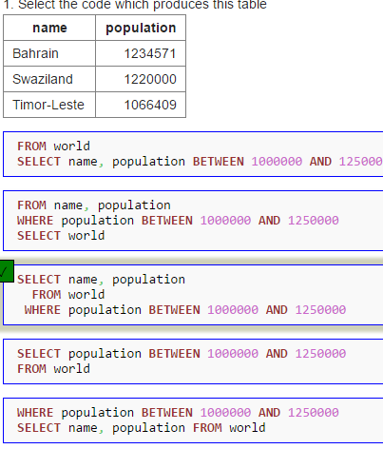
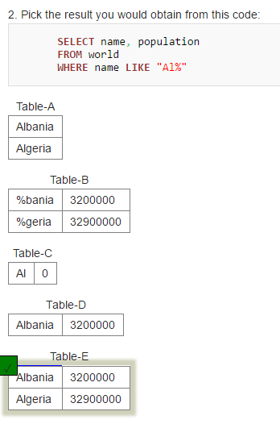
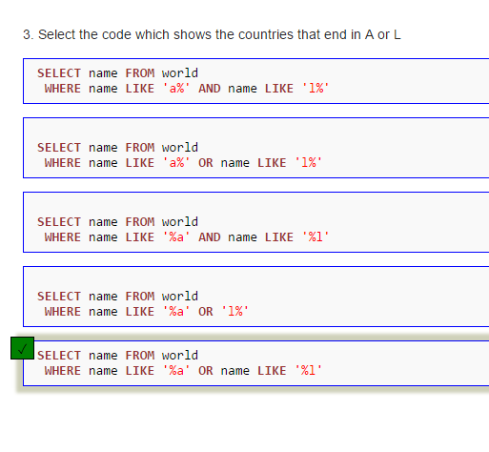
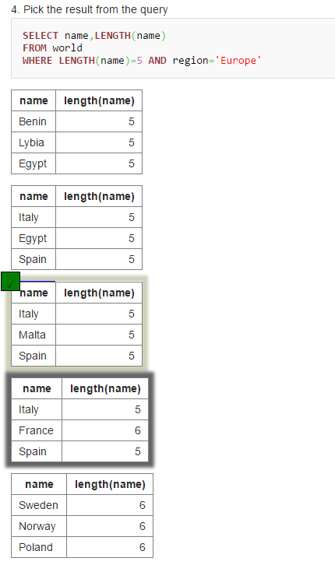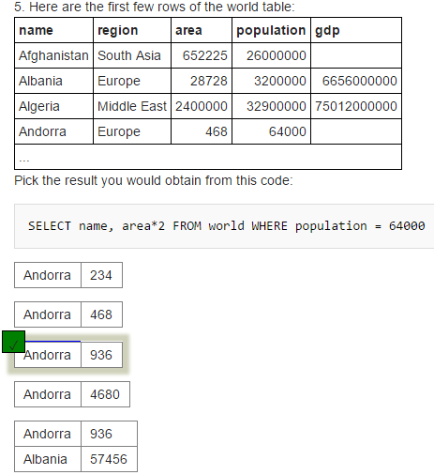
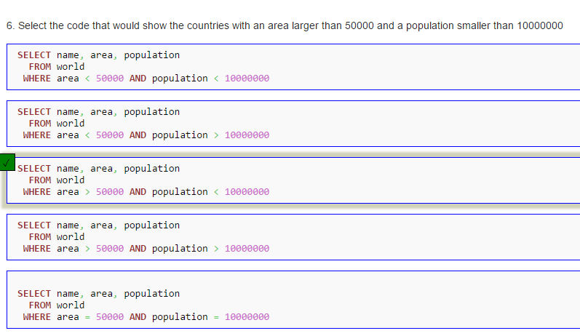
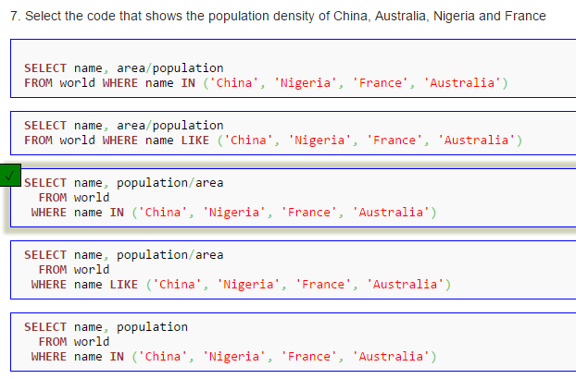

NOBEL QUIZ

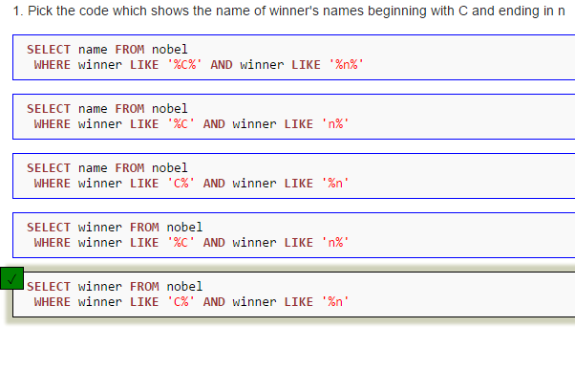
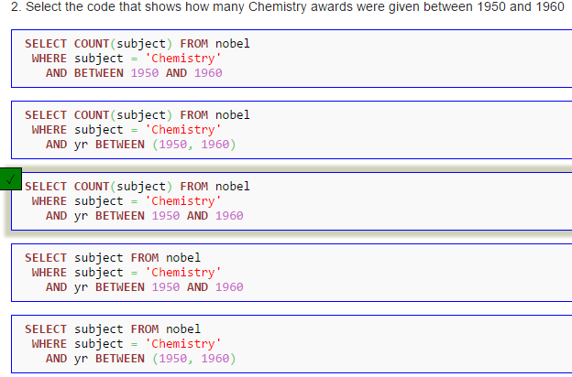

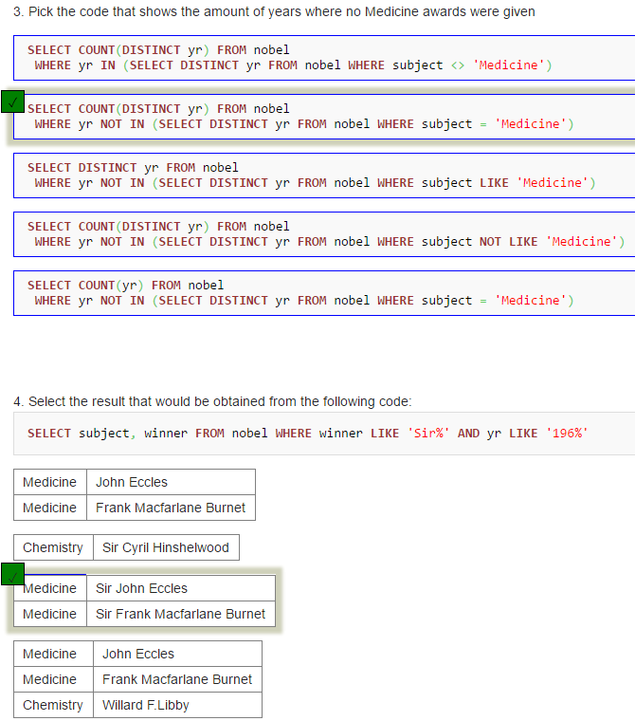

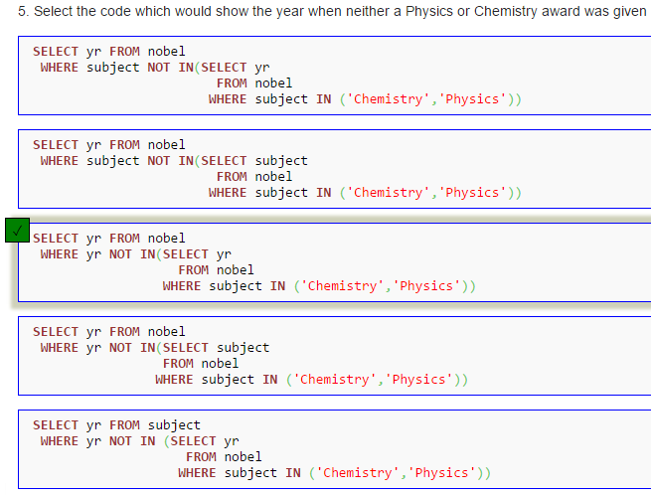
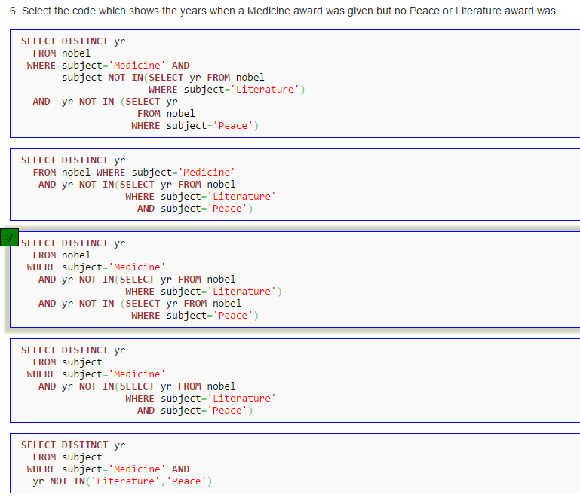
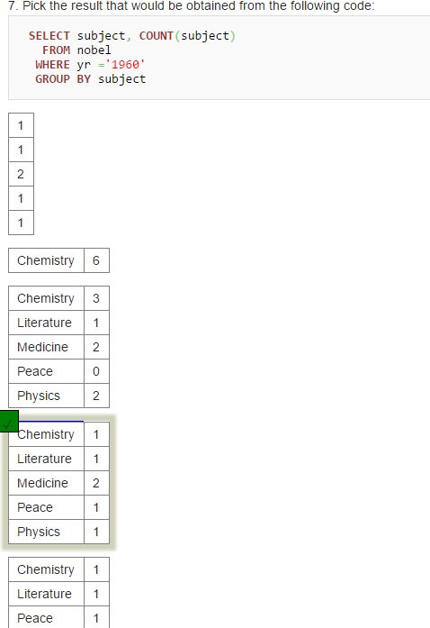

BBC QUIZ
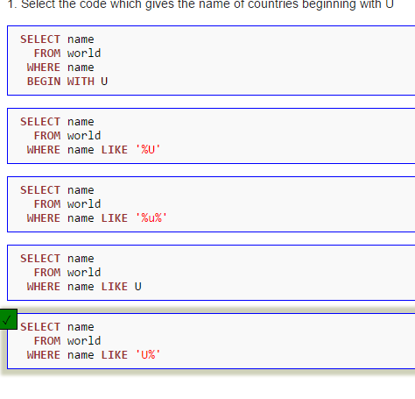
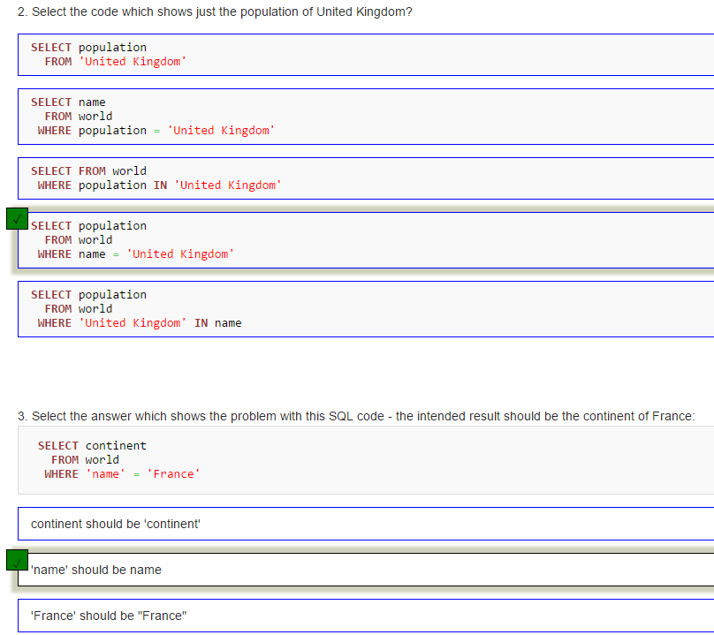

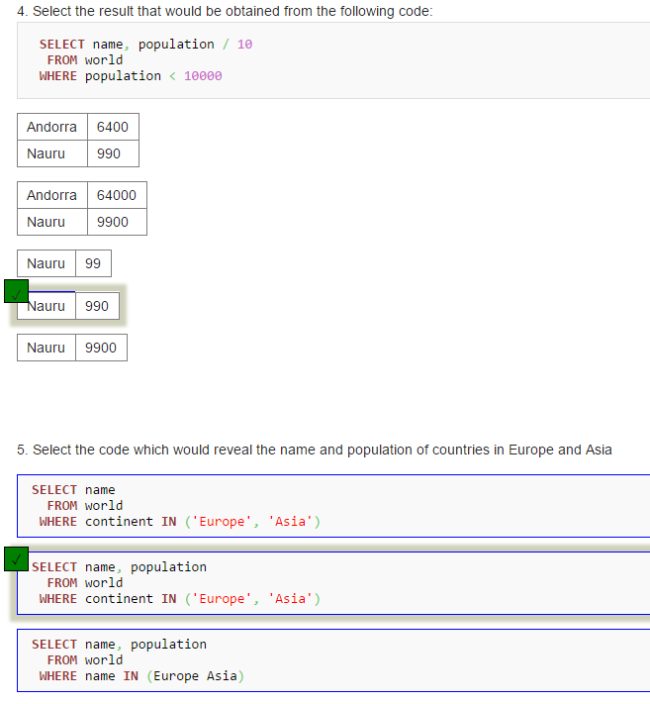
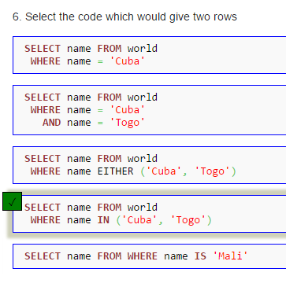
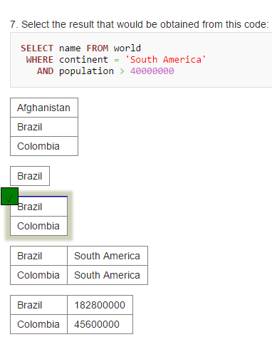
NESTED SELECT QUIZ

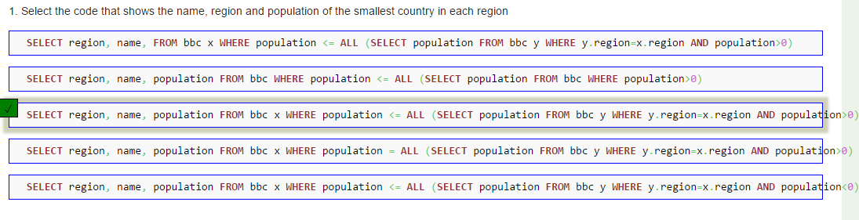
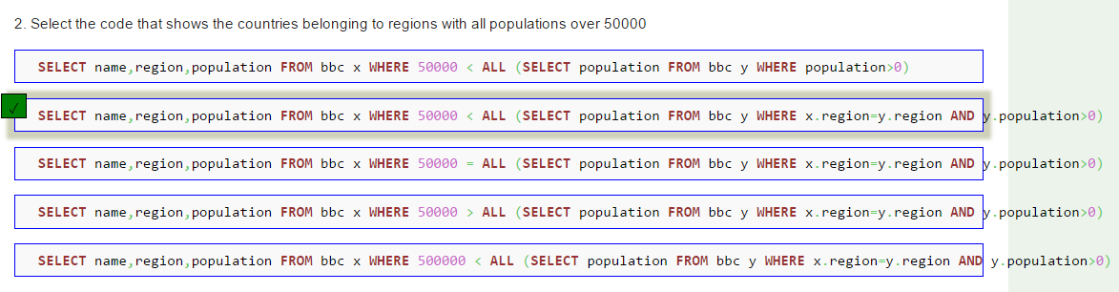

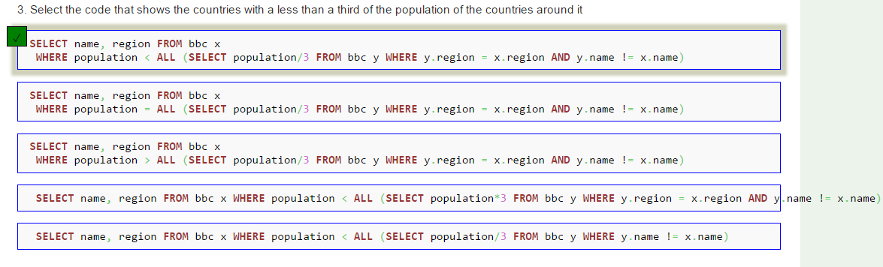

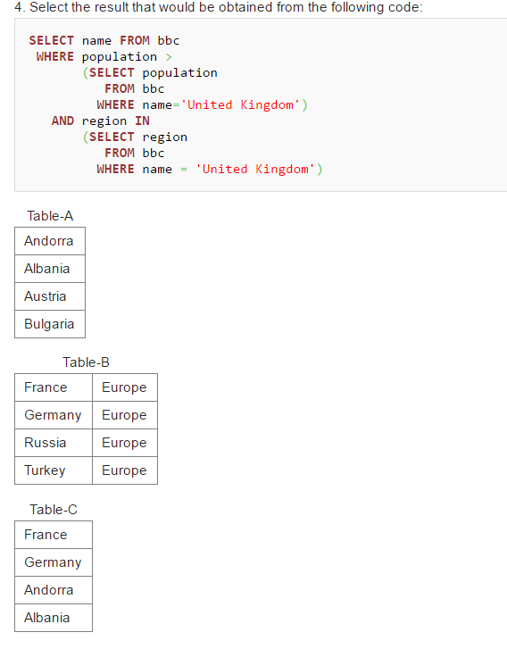
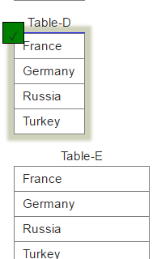

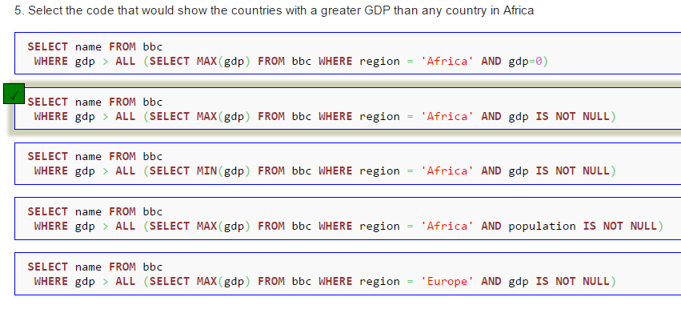
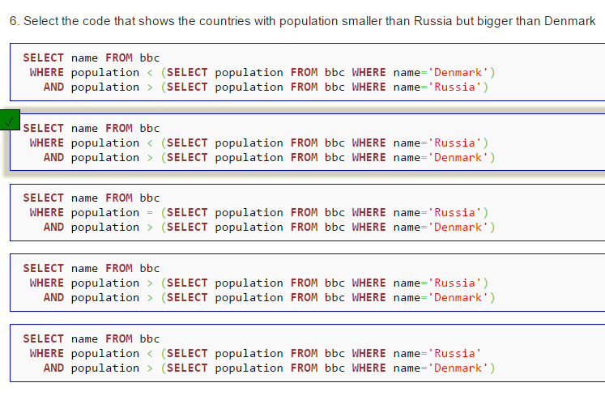
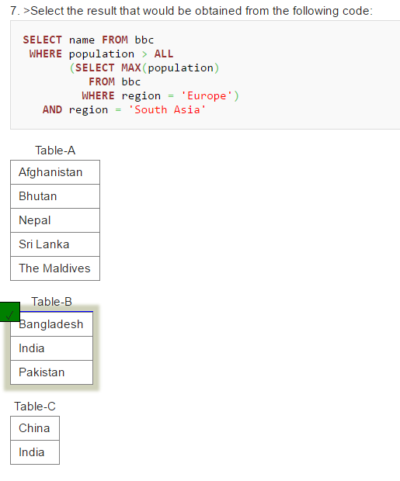

SUM and COUNT Quiz

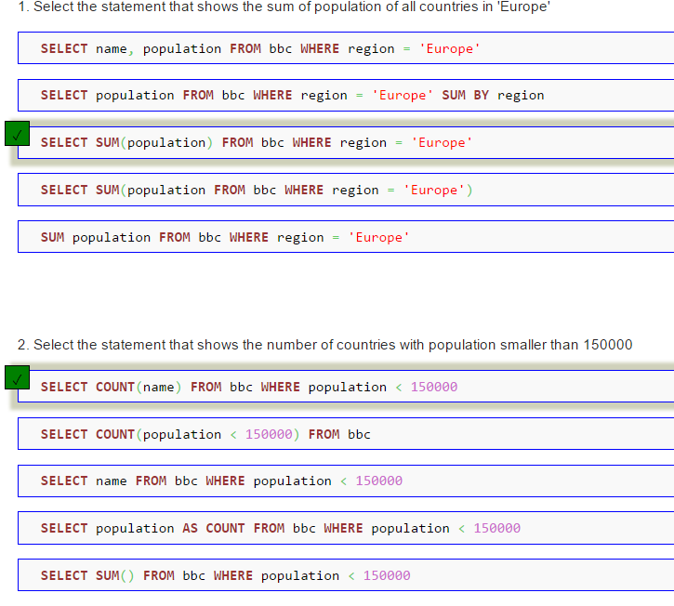
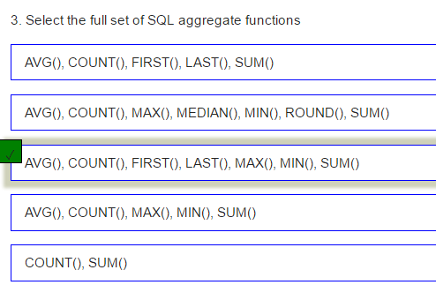
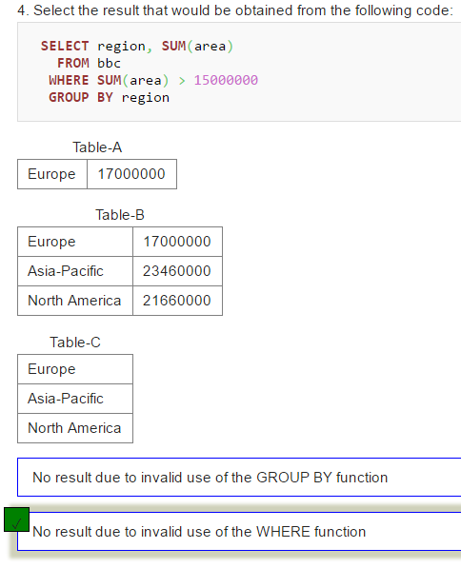
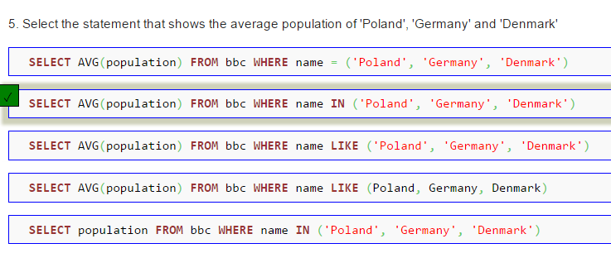
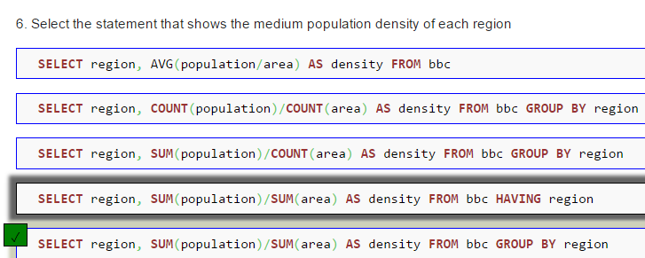

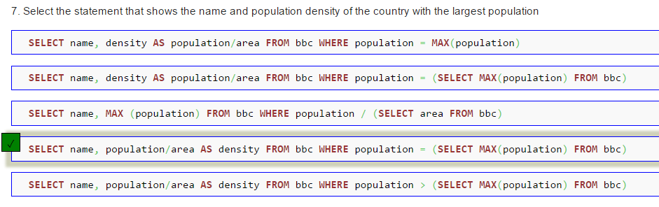
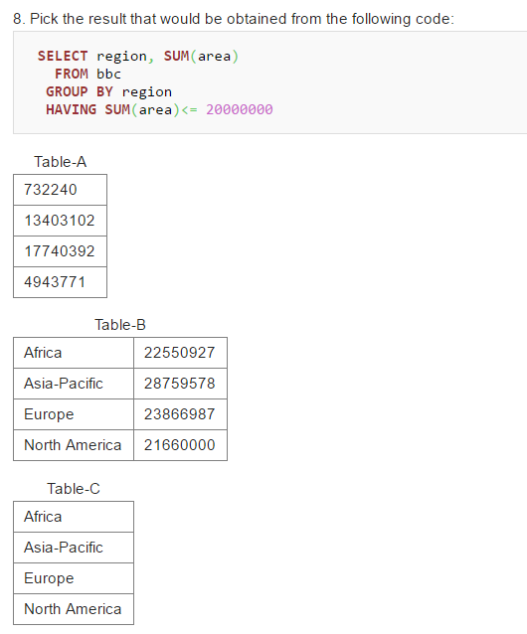
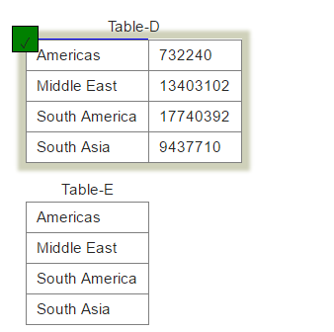

JOIN QUIZ

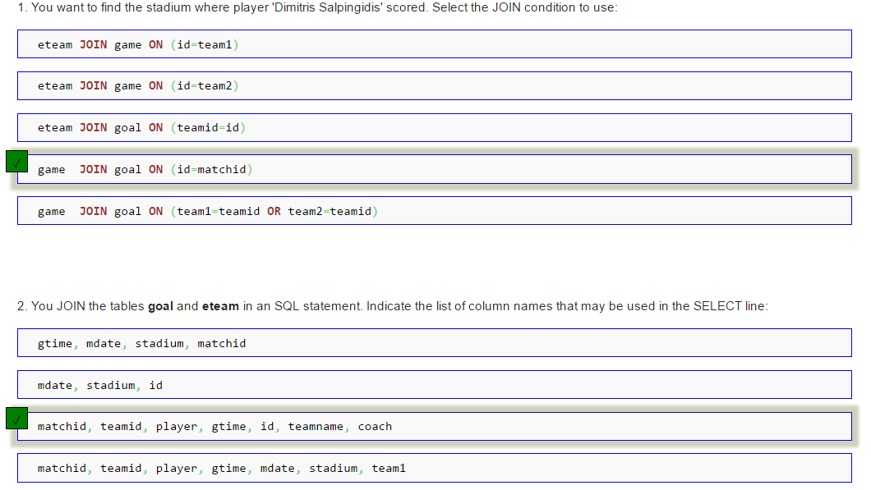

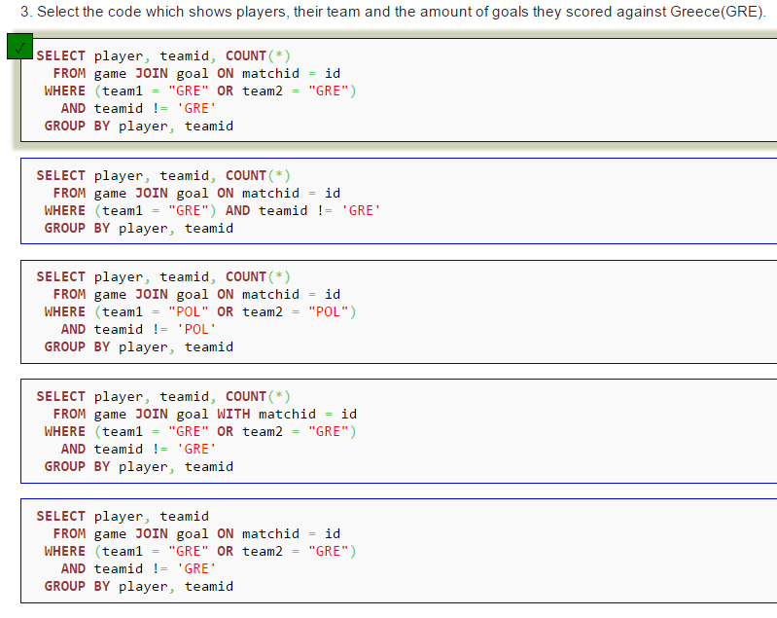
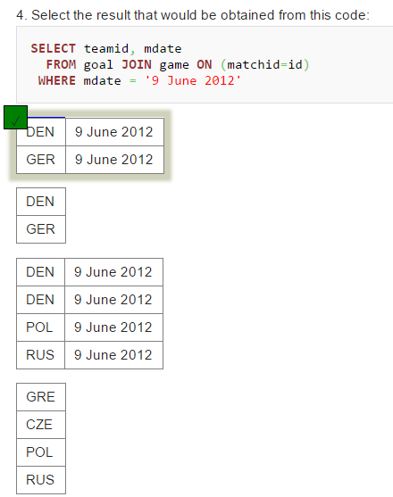
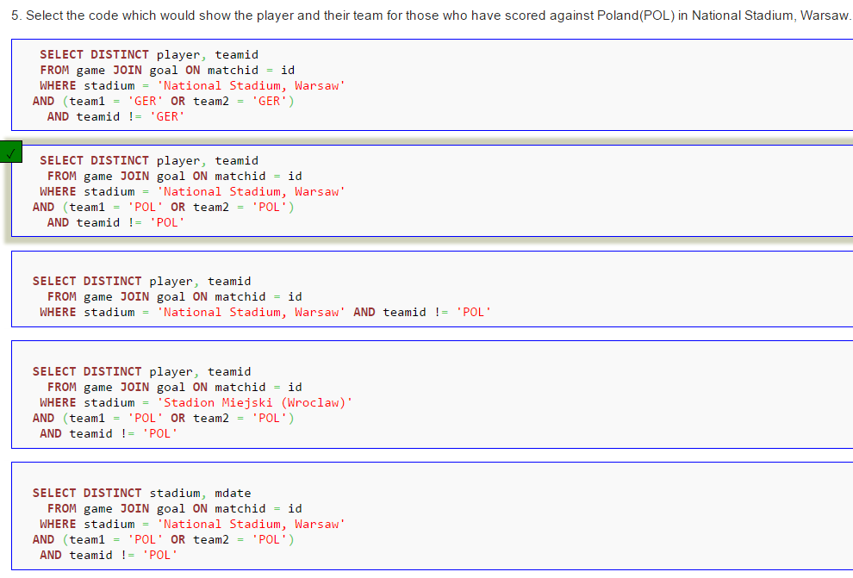
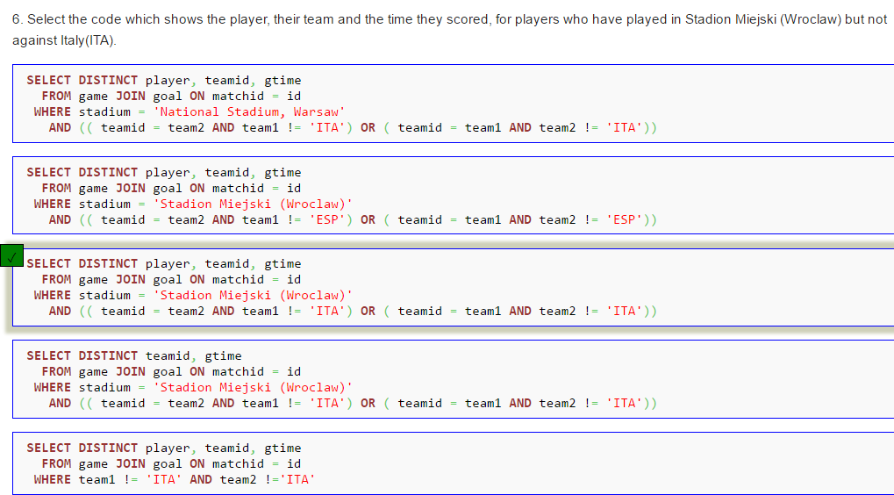

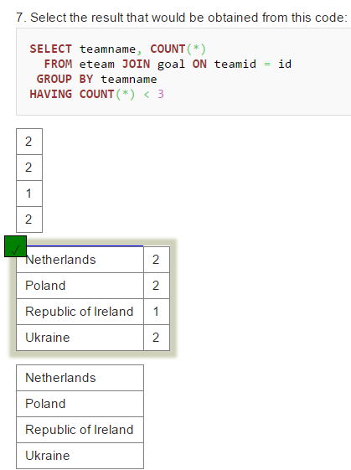

JOIN Quiz 2
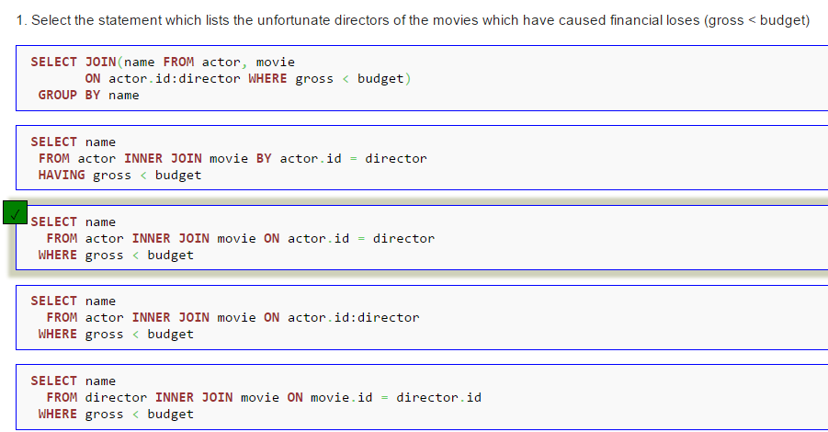
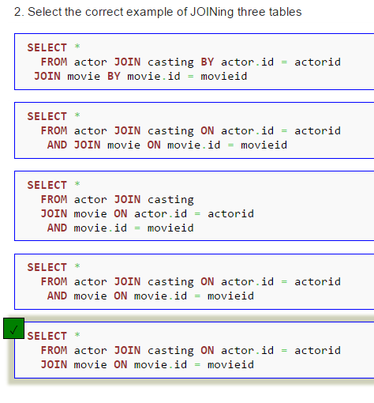
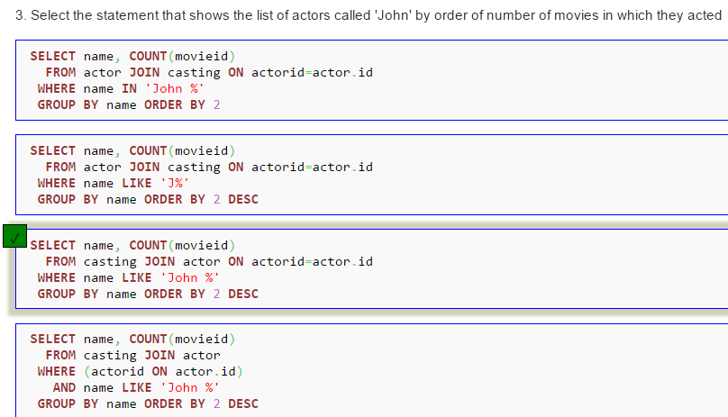
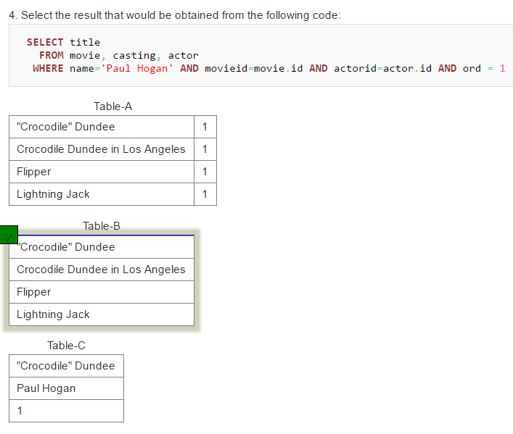
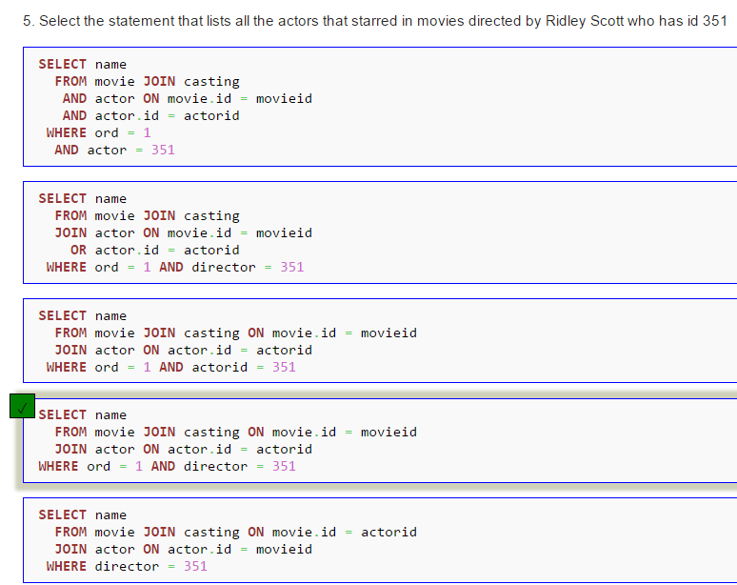
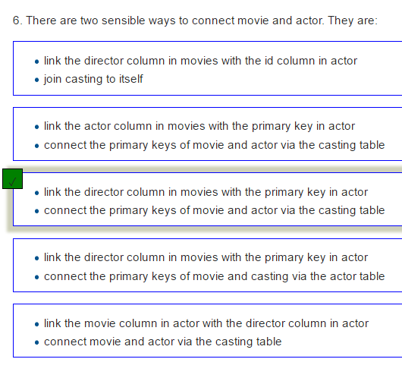
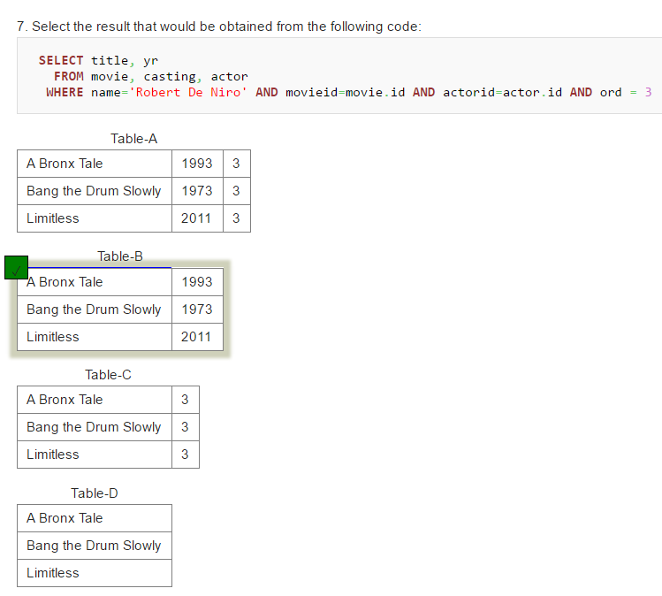

Using Null Quiz
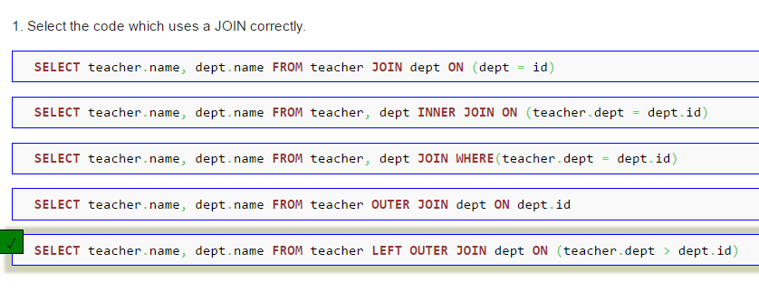

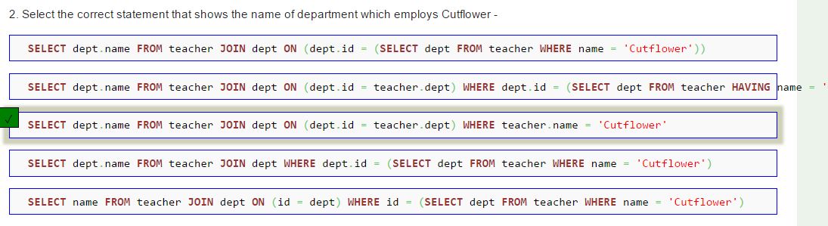
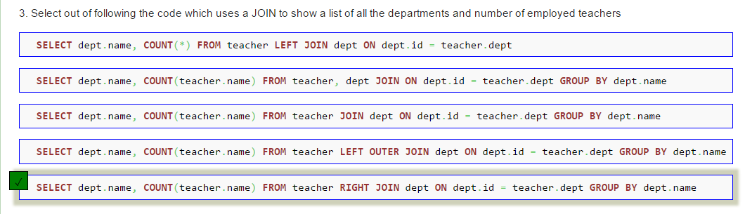

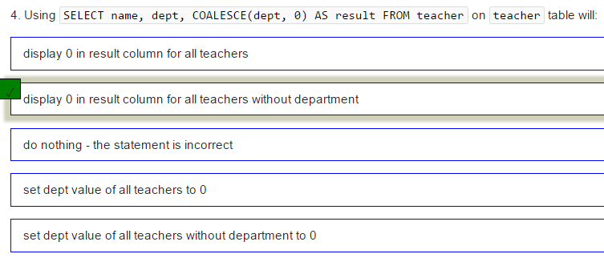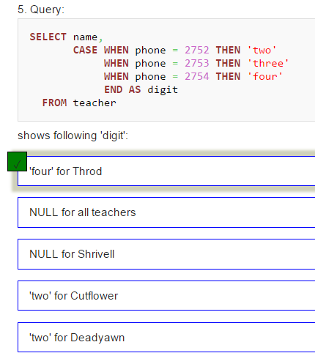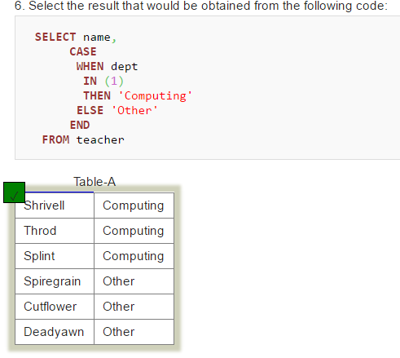

Self join Quiz

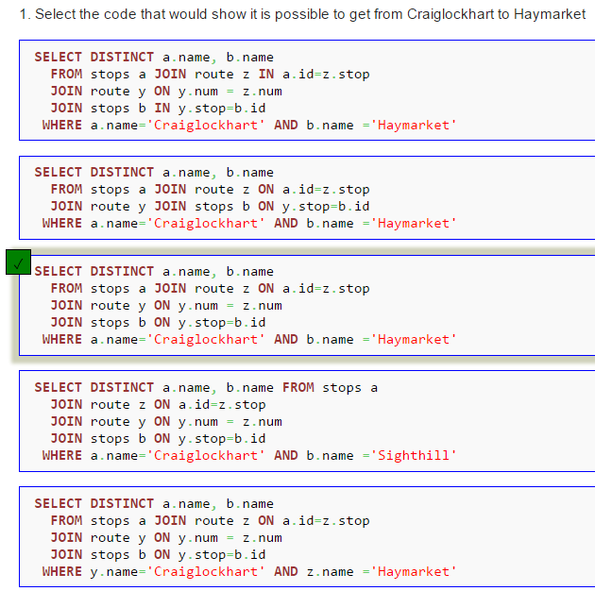

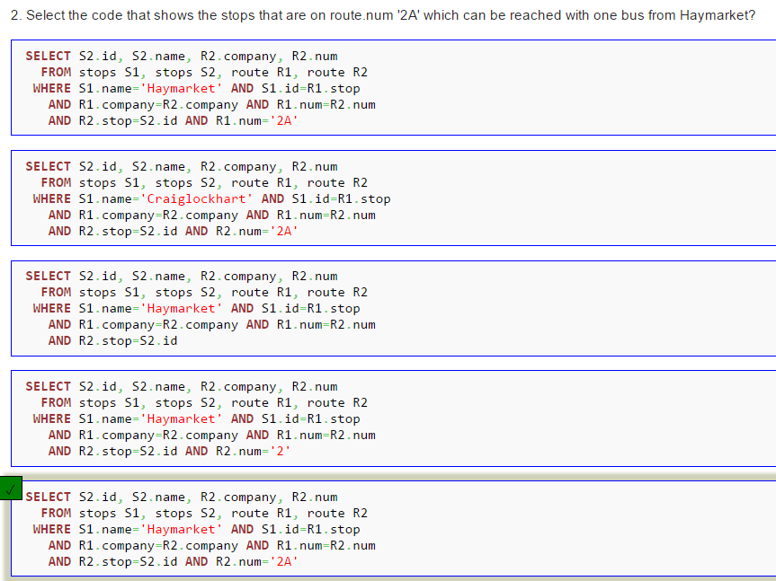
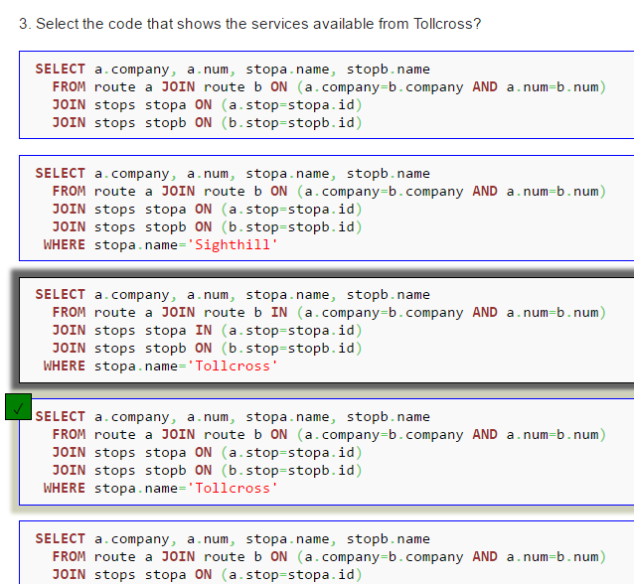

1. UNION:
Muestre en una tabla la unión entre el compositor y el título de la composición.
SELECT m_name FROM musician UNION SELECT c_title FROM composition
2. Muestre la combinación del artista con su composición.
SELECT * FROM performer UNION ALL SELECT * FROM composition
3. D
4. F
5. Muestre el país donde nació es igual a donde vive.
SELECT place_country FROM musician LEFT JOIN place ON place.place_no=musician.living_in
6. Liste el país donde nació es igual a donde vive.
SELECT place_country FROM musician RIGHT JOIN place ON place.place_no=musician.living_in
7. Visualice el país donde nació es igual a donde vive.
SELECT place_country FROM musician CROSS JOIN place ON place.place_no=musician.living_in
8.

