**Phenotype switching explains the emergence of alternative stable states in a gut microbial community**

Daniel Garza1,2†*, Bin Liu1†, Charlotte van de Velde1†, Pallabita Saha1, Didier Gonze3, Kenneth Simoens4, Kristel Bernaerts4, Karoline Faust1*

1 Department of Microbiology, Immunology and Transplantation, Rega Institute for Medical Research, Laboratory of Molecular Bacteriology, KU Leuven, Leuven B-3000, Belgium

2 Université Paris-Saclay, INRAE, PROSE, 92160 Antony, France

3 Unité de Chronobiologie Théorique, Faculté des Sciences, CP 231, Université Libre de Bruxelles, Bvd du Triomphe, B-1050 Bruxelles, Belgium

4 Department of Chemical Engineering, Chemical and Biochemical Reactor Engineering and Safety (CREaS), KU Leuven, B-3001 Leuven, Belgium

† These authors contributed equally to this work

*corresponding authors. Email: karoline.faust@kuleuven.be, [danielriosgarza@gmail.com](mailto:danielriosgarza@gmail.com)

**Abstract:** Several human-associated microbial communities occur in more than one configuration and change their composition in response to perturbations, remaining in an altered state even after the perturbation has ceased. Although different hypotheses were proposed to explain this behavior, they have not yet been clearly demonstrated. To identify mechanisms, we investigated life history strategies of three common human gut bacteria. A kinetic model parameterized on their mono- and co-cultures predicted that alternative states emerge due to phenotype switching in *Blautia hydrogenotrophica*. Perturbation experiments confirmed these predictions and simulations showed that phenotype switching can also explain alternative states in larger communities. Thus, a transient perturbation combined with metabolic flexibility is sufficient for alternative communities to emerge, implying that they are not necessarily explained by differences between hosts.

**One-Sentence Summary:** We show on the example of a synthetic human gut microbial community that phenotype switching explains the emergence of alternative stable states.

**Main Text:** Several human-associated microbial communities assemble into more than one configuration (*1*–*3*) and change their composition in response to perturbations, remaining in an altered state even after the perturbation has ceased (*4*, *5*). While different hypotheses could explain this behavior (*6*–*8*), clear demonstrations of the mechanisms underlying these hypotheses are still lacking. A frequent explanation, supported by empirical evidence, suggests that microbiomes, like many ecological systems, can assemble into alternative stable states (*7*). Thus, even when the same microbes are assembled under similar environmental conditions, they may converge towards distinct community compositions, influenced by their assembly history (*9*). Additionally, minor yet continuous changes in environmental parameters could lead to significant shifts in community states (*10*). Historically, mechanistically identifying alternative stable states and regime shifts in natural communities is challenging (*11*). This is because organisms can change their own environments—microbes, for example, consume resources (*12*), change the environment’s pH (*13*), create physical structures (*14*), etc.—in response to biotic and abiotic changes, thereby making it difficult to disentangle community states from environmental factors.

Microbial cells exist in dynamic equilibrium, coexisting with other cells and their environments (*15*). Their metabolic capabilities are encoded in their genomes, but the metabolic programs they execute depend on the differential expression of enzymes (*16*). This differential expression enables a variety of metabolic strategies, which are evolvable and can be flexible, heterogeneous, and dynamic (*17*–*19*). For instance, when exposed to a mix of substrates, cells might use these substrates either simultaneously or sequentially (*20*)—first consuming one and then another—or they might alternate between both strategies (*21*).

While the dynamic metabolic strategies of microbes, gene regulation, and phenotype switching have been extensively studied in isolates since Jacques Monod’s seminal work (*22*), their impact on microbiome ecology and stability remains vastly underexplored (*23*). In our previous study, we observed that the ecological interactions between two gut bacterial species changed during co-culture (*24*). These changes were in response to alterations in pH and the concentration of degradation products resulting from their metabolic strategies. Given that bacteria express alternative metabolic programs under varying environmental conditions, we hypothesize that the coexistence and switching between bacterial growth strategies could induce sharp transitions in community-level phenotypes, leading to multistability and the emergence of predictable alternative community states.

**Life history strategies of gut bacteria in a heterogenous environment**

To test this hypothesis, we used a simple three species gut community that allowed us to combine in vitro experiments with mechanistic modeling. We first investigated individual phenotypes of three common human gut bacteria in Wilkins-Chalgren (WC) anaerobic medium. This medium includes two simple carbon sources, glucose and pyruvate, along with substrates from tryptone and yeast extract, notably containing measurable amounts of trehalose (average 0.71 mM +/-0.07). The composition of this medium is simple enough to allow us to track the kinetics of key metabolites while its complex components mimic the nutrient heterogeneity expected in the colon.

We used genome-scale metabolic models to derive sets of biochemical reactions that define the core energy metabolism of each species. We then collected RNA-seq data at different growth stages to confirm pathway activities (Figure 1 A-C). These core pathways connect the import of carbon sources with the production of fermentation acids, enabling comparison with the measured data (Figure 1 D-F). By analyzing these pathways alongside live cell growth kinetics, medium pH changes, and metabolite composition, we were able to outline bacterial life history strategies (*25*). These were incorporated into an ordinary differential equation model (Supplementary text S1). This model was calibrated against experimental data, as indicated by the traced lines in Figure 1 D-F.

Briefly, under our growth conditions, *Blautia hydrogenotrophica* initially consumes trehalose via a trehalose-specific PTS transporter. The gene for this transporter is overexpressed in the early stages of growth compared to the later stages (TREpts, Figure 1A). It only switches to glucose utilization after trehalose is depleted, facilitated by a non-PTS glucose transporter that is inhibited during trehalose consumption (GLCabc, Figure 1A). Interestingly, its genome lacks the glucose-specific IIA component gene of the PTS system, commonly found in closely-related *Blautia* and *Ruminococcus* strains (Supplementary Table S1). We confirmed this sequential substrate preference by showing that higher trehalose concentrations extended *Blautia hydrogenotrophica*’s non-glucose consuming phase (Supplementary Figure S1). Flow cytometry showed a clear bimodal population distribution during this transition, leading us to hypothesize that it reflects similar subpopulation sizes of trehalose consumers, which are not dividing, and emerging glucose consumers, which are dividing (Supplementary Movie S1). The growth rate increased during glucose consumption compared to the trehalose phase (inflection point in growth curve, Figure 1D, ~26 hrs). Equations modeling *Blautia hydrogenotrophica*’s life history strategy are detailed in Supplementary Text S1.

*Bacteroides thetaiotaomicron* rapidly metabolizes glucose and pyruvate, producing fermentation acids that significantly reduce the medium's pH (Figure 1E). However, this organism is inhibited under low pH conditions (*26*). When the carbon sources are exhausted, most cells lose viability at low pH values but can still be detected through SYBR green staining in flow cytometry. The loss of membrane integrity was confirmed using propidium iodine staining. To reflect this in our model, we introduced functions that describe transitions from active to inactive subpopulations, triggered by nutrient scarcity in acidic environments (see Supplementary Text S1). We consistently observed a second growth peak before a major population inactivation (as shown in Figure 1E), which we believe is due to trace mannose consumption, consistent with our previous findings (*24*). Mannose depletion was verified through measurements and gene expression analysis, although the precise kinetics remain unresolved.

*Roseburia intestinalis* generates butyrate through the reverse β-oxidation pathway (illustrated in Figure 1C). In our experiments, *R. intestinalis* efficiently consumed glucose and pyruvate, producing butyrate, acetate, and lactate, impacting the pH to a lesser extent than *B. thetaiotaomicron*. As we previously described (*24*), in the absence of glucose, *R. intestinalis* transitions to a slow growth mode, characterized by the prolonged survival of viable cells (evident in “Live Cells” curves in Figure 1F), sporadic consumption of lactate/acetate (as shown in Figure 1F), and continuous butyrate production (also in Figure 1F). In our model, we represented this average behavior by incorporating rapid cell death in the absence of glucose and shifting subpopulations to slow growth in response to lactate and acetate (detailed in Supplementary Text S1). However, our model does not fully account for the observed heterogeneous lactate utilization across different experiments (as depicted in Figure 1F).

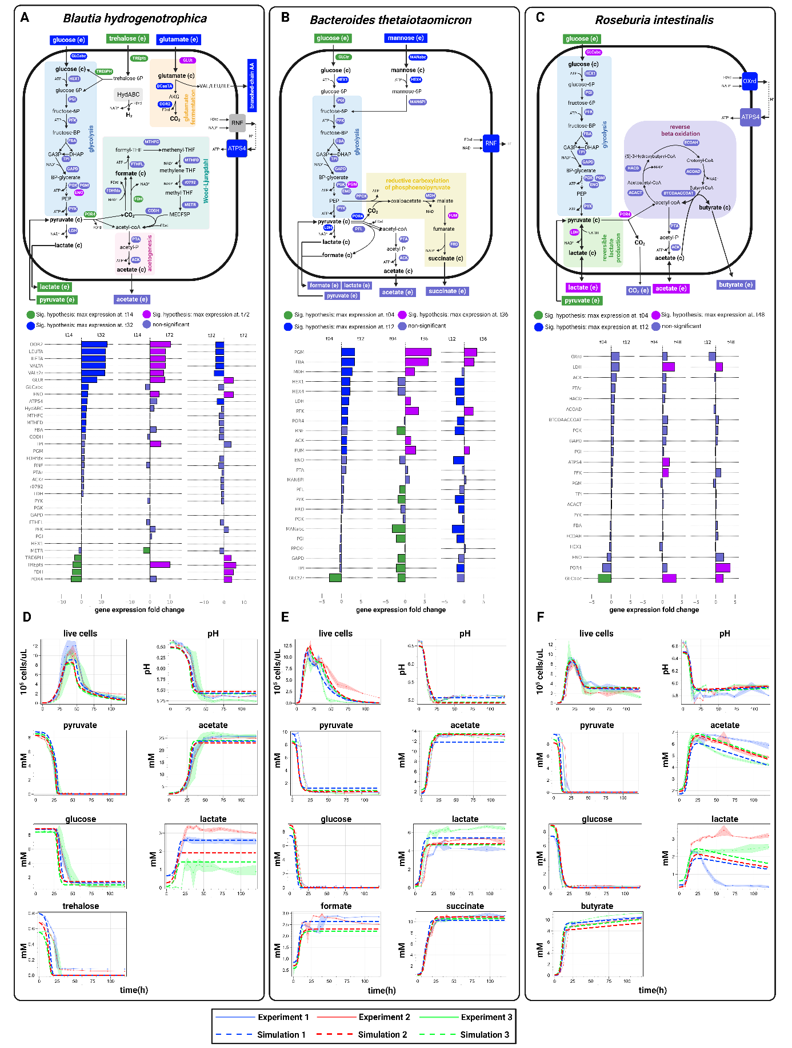

**Fig. 1: Growth kinetics and modeled metabolism of three human gut bacteria.** This figure provides a schematic illustration of the core energy metabolism pathways for *Blautia hydrogenotrophica* (**A**), *Bacteroides thetaiotaomicron* (**B**), and *Roseburia intestinalis* (**C**), as deduced from genomic metabolic model reconstructions coupled with empirical growth data. The middle panel details gene expression changes observed during cultivation, with corresponding gene names linked to their associated reactions in the upper panel, and hypothesis testing performed using DESeq2. It also depicts the consumption of carbon sources (glucose, pyruvate, and trehalose) and the generation of fermentation products (including acetate, lactate, and butyrate). Panels (**D**-**F**) compare experimental growth data over time with model simulations (represented by dashed lines) for the three species cultured in WC medium. The growth data represents averages from three independent monoculture experiments, each with 3-6 biological replicates (solid dots are the averages and the shaded lines the standard deviations of biological replicates). Simulation initial conditions were the same as the experimental setups.

**The model’s stability landscape reveals sharp transition zones**

After calibrating our model with monoculture growth data (Figure 1 D-F and Supplementary Text S1) and validating its performance in batch cocultures (Supplementary Figure S2), we incorporated dilution terms to simulate in silico the stability landscape of the community in a continuous culture environment. We explored how steady-state concentrations of bacteria and metabolites respond to controllable factors—medium pH and dilution rate—which do not directly alter their initial concentrations but can impact the systems’ dynamics. The dilution rate impacts the steady-state concentration of metabolites and nutrient availability, thereby affecting population growth rates and the transition between metabolic phenotypes (Figure 2A), while pH directly impacts growth. Changes in growth also impact the production of fermentation acids and, for instance, their subsequent utilization by *Roseburia intestinalis*’s slow growth mode. In summary, these parameters significantly shape the overall community phenotype (Figure 2B and C).

A surprising observation that resulted from this in silico analysis of the community is that the stability landscape of some of the state variables revealed sharp transitions between steady-state metabolite and bacterial cells concentration profiles. For example, *Blautia hydrogenotrophica* maintains consistent concentrations under wide pH ranges, but undergoes a sharp shift when the dilution rate increases beyond a certain level (Figure 2B). *Roseburia instestinalis* survives in two separate zones, including a narrow range of conditions where it outcompetes the other species (Figure 2C). These zones are separated by areas where no growth occurs. Overall, the presence of sharp transitions between zones in the stability landscapes suggest that alternative stable states can emerge depending on the initial concentrations. It also indicates the presence of tipping points, where minor environmental changes can lead to significant shifts in community structure.

**Phenotype-switching explains multistability both in silico and in vitro**

To understand the mechanistic basis for these alternative stable states in our model, we individually varied the dilution rate while allowing the pH to vary according to the accumulation of organic acids (see “environment pH” section of the Supplementary text S1). Two clearly distinguishable states emerged (Figure 3A): one where *Blautia hydrogenotrophica* and *Bacteroides thetaiotaomicron* co-dominate, with *Roseburia intestinalis* almost completely outcompeted, and another where *Bacteroides thetaiotaomicron* and *Roseburia intestinalis* prevail, with Blautia hydrogenotrophica maintaining a low abundance. The shift to one state or the other is dependent on the concentration of *Blautia hydrogenotrophica*’s glucose-consuming cells. High dilution rates lead to trehalose accumulation, which in turn inhibits the glucose consuming phenotype. When *Blautia hydrogenotrophica* is not consuming glucose, it occupies a niche that has negligible impact on the other species. In contrast, if the trehalose concentration is low and a sufficient population shifts to glucose consumption, *Blautia hydrogenotrophica* becomes a strong competitor, inhibiting the other species. Interestingly, this phenotype displays characteristics of hysteresis (ecological memory): once the glucose-consuming population is established, for example, by stopping the feed (setting the dilution rate to zero), then restoring it to previous levels does not return the system to its former state (Figure 3A). Consequently, two states can coexist under the same parameter values, and the system’s history is required to predict its behavior (for a more in-depth exploration of this behavior refer to Supplementary Figure S3 and its caption).

Similar alternative stable states also exist along the pH gradient. Since these depend on the dilution rate, we fixed the dilution rate at 0.067h-1 and explored community landscape with varying pH values (Figure 3B). At lower pH values (e.g. 5.47 see Figure 3B), *Roseburia intestinalis* is favored. Overall, *Bacteroides thetaiotaomicron* is favored by pH control, since it can produce a large amount of organic acids without lowering the environment pH and inhibiting its own growth. The state of the system, however, ultimately depends on its history, which is illustrated in the lower plot of Figure 3B: changing the pH after the system is established does not necessarily lead to a change in community state (Figure 3B). Of note, this effect is related to the concentration of cells in a specific phenotype reaching a tipping point and not to the extinction of *Roseburia intestinalis* cells, as the shift is performed while there is still a significant abundance of live *Roseburia intestinalis* cells in the system (also see Supplementary Figure S3).

The alternative steady-states and tipping points emerging from our model's stability landscape analysis helped us interpret experimental data. We cultured gut species in minibioreactors that enable parallel cultivation and sampling in controlled conditions, emulating a chemostat via continuous inflow and pipette-controlled outflow, as reported previously (*27*). Despite treating vessels as biological replicates, distinct community states clearly emerged when transient perturbations were applied, splitting along PC1/PC2 axes (as shown by the four ellipses of Figure 3C, which are illustrated in the heatmap). These states show sharp transitions in species composition within a narrow range of experimental conditions, as we predicted with the model’s stability landscape (Figure 2C). These states, like our model, typically exhibited high or low abundance of *Blautia hydrogenotrophica*. In reactors where *Blautia hydrogenotrophica* was highly abundant, trehalose was completely consumed (Supplementary Table 2), suggesting that the glucose-consuming subpopulation could emerge and influence the abundance of other species. Conversely, *Blautia hydrogenotrophica* was absent or present at low levels in reactors where trehalose remained at detectable concentrations. In contrast, only one community state was reached in twelve unperturbed vessels (Movie S2).

Depending on the state that the system assumes, perturbations have a lasting effect, even when the system is returned to its previous conditions. In one experiment, as indicated by the blue dots in Figure 3C, the community initially converged to a steady-state with low abundance of *Blautia hydrogenotrophica* (ellipse I in Figure 3C, detailed in the first set of columns of the heatmap). Following sequential pH and dilution rate perturbations—acidifying the pH to around 4 and later stopping the feed—the replicates diverged into three alternative stable states after the system was returned to its previous conditions: either reverting to its previous state with low *Blautia hydrogenotrophica abundance*, transitioning to a state were the three species coexist (ellipse II in Figure 3C), or moving to a state where *Bacteroides thetaiotaomicron* predominated (ellipse IV in Figure 3C). In a second experiment, represented by the purple dots in Figure 3C, the system initially converged to the steady-state were the three species coexist (ellipse II in Figure 3C). Following a dilution rate perturbation (feed stop), the system transitioned to a state with high abundance of *Blautia hydrogenotrophica* and low abundance of *Roseburia intestinalis*, similar to the behavior predicted by the model (Figure 3A and Figure S3A). Since replicates from different experiments cluster into distinct steady states following perturbations—predominantly influenced by trehalose and glucose-consuming subpopulations of *Blautia hydrogenotrophica*—this corroborates the history-dependent multistability mechanism suggested by our model's landscape analysis (For a detailed illustration of the trajectories of the two experiments, refer to Movie S2).

**Simulating multistability in systems with many species**

To further confirm this multistability mechanism and explore its potential to explain microbiome landscape dynamics, we abstracted components of our model into a new formalism (for details refer to Supplementary text S2). Species are defined by Lotka-Volterra growth/interaction rates, but instead of single growth rates and interaction vectors, species encompass subpopulations with alternative phenotypes (two and potentially more growth rates and interaction terms) with environment-responsive transitions between them (Figure 4A). As in our mechanistic model, this simplified model exhibits alternative community types separated by a tipping point (Figure 4B). States arise from subpopulation shifts to strongly competing phenotypes (e.g. more efficient usage of key nutrients). Simulations show that even in larger communities, environment-driven emergence of such competitive phenotypes can significantly reshape the landscape, producing distinct community types resembling enterotypes (Figure 4C). Similar to an empirical study of species distribution across stool samples (*28*), the species driving such community shifts—referred to as tipping elements—exhibit a bimodal distribution in our model (Figure 4C).

**Discussion**

Here, we first explored in depth the metabolic strategies of three common human gut bacterial species and demonstrated in silico and in vitro that multistability arises as a consequence of bacterial metabolic flexibility. Sharp transitions between alternative states in our system are driven by varying ecological interactions among phenotypically flexible bacteria. For example, the glucose-consuming phenotype of *Blautia hydrogenotrophica* competes strongly and inhibits the fast growth mode of *Roseburia intestinalis*. Communities where this phenotype is expressed are significantly different from communities where it is repressed. The history-dependent behavior observed in our model and chemostat experiments emerges from feedback loops between subpopulations and environmental factors. For example, while increasing the dilution rate may increase the steady-state concentration of trehalose and inhibit *Blautia hydrogenotrophica*’s glucose-consuming phenotype, if a large population of glucose-consuming cells are already present in the system, then many cells are available to switch and quickly consume the excess trehalose that would otherwise accumulate due to the increase of the dilution rate, leading to a different proportion of subpopulations and altering the community phenotype. To the best of our knowledge, this study is the first to observe more than one alternative community type in controlled conditions in response to a perturbation.

Our simulations further confirm that the presence of different phenotypes can give rise to alternative community types in large communities. Thus, we suggest that multistability is a potential driver behind alternative community types observed in the gut microbiome (*1*, *3*), supporting previous propositions (*1*, *7*). The occurrence of alternative community types in other host-associated microbiota, which are not easily explained by environmental differences (*2*, *29*, *30*), implies that multistability may be more common than previously thought. As we and others have previously discussed (*7*, *8*, *28*), it is relevant whether alternative community types are due to environmental differences caused by diet, host genetics etc. or whether they are due to multistability. In the case of the latter, alternative community types can result from past transient perturbations rather than from current differences between hosts.

We also note that popular mathematical models of microbial communities, such as the generalized Lotka-Volterra (gLV) model, do not account for metabolic flexibility. Moreover, several established methods assume the absence of multi-stability in microbial communities. One of these is the dissimilarity-overlap curve analyses (*29*, *30*), which evaluates the universality of microbial interactions by relying on an empirical negative correlation between compositional dissimilarity and species overlap. Another is EPICS (effective pairwise interactions for predicting community structures), which parameterizes the gLV model from leave-one-out communities (*31*). The accuracy of other inference methods like such as BEEM (*32*) or MDSINE (*33*) may also be affected by the occurrence of multistability.

There are different ways to integrate metabolic knowledge into community models (*34*). Here, we opted for a kinetic model instead of a metabolic model. This choice was made to effectively capture pH response and phenotypic switches, as well as to investigate history-dependence and the stability landscape of the community. However, the kinetic model was designed based on insights manually derived from metabolic reconstructions. It may be possible to construct such kinetic models automatically from metabolic models in the future.

In summary, we have shown that flexible microbial strategies impact the composition of gut microbial communities. In the future, we need to systematically elucidate these strategies in other gut microorganisms to better understand and efficiently modulate gut microbial communities.