In a previous study we found that the ecological interactions between two gut bacterial species shift during co-culture. These shifts are in response to changes in pH and concentration of degradation products introduced by their metabolic strategies. These alterations are driven by the expression of alternative metabolic programs under varying environmental conditions. We hypothesize here that the coexistence and switching between bacterial growth strategies can induce sharp transitions in the community-level phenotypes, leading to multistability and predictable alternative community states.

To test this hypothesis, we used a simple three species gut community to combine in vitro experiment with mechanistic modeling. We first investigated phenotypes of three human gut bacteria in WC medium. This medium includes two simple carbon sources, glucose and pyruvate, along with substrates from tryptone and yeast extract, notably containing measurable amounts of trehalose (average xxx +/-). The composition of this medium is simple enough to allow us to track the kinetics of key components yet contains sufficient nutrient heterogeneity to partially resemble complex anaerobic environments such as the gut.

We used genome-scale metabolic models to derive sets of chemical reactions that define the core energy metabolism of each species. We then collected RNAseq data at different growth stages to confirm pathway activities (Figure 1 A-C). These core pathways connect the import of carbon sources with the production of fermentation acids, enabling comparison with the measured data (Figure 1 D-F). By analyzing these pathways alongside live cell growth kinetics, medium pH changes, and metabolite composition, we were able to outline some general life strategies. These were incorporated into an ordinary differential equation model (Supplementary text S1). This model was calibrated against experimental data, as indicated by the traced lines in Figure 1 D-F.

Briefly, under our growth conditions, *Blautia hydrogenotrophica* initially consumes trehalose via an overexpressed, trehalose-specific PTS transporter (TREpts, Fig. 1A). It only switches to glucose utilization after trehalose is depleted, facilitated by a non-PTS glucose transporter that is inhibited during trehalose consumption (GLCabc, Fig. 1A). Interestingly, its genome lacks the glucose-specific IIA component of the PTS system gene, commonly found in closely-related Blautia and Ruminococcus strains (Supplementary Table S1). We confirmed this sequential substrate preference by showing that increased trehalose extended the non-glucose consuming phase (Supplementary Fig. S1). Flow cytometry showed a clear bimodal population distribution during this transition, leading us to hypothesize that it reflects similar subpopulation sizes of trehalose consumers, which are not dividing, and emerging glucose consumers, which are dividing (Supplementary Video 1). The growth rate increased during glucose consumption compared to the trehalose phase (inflection point in growth curve, Fig. 1D, ~26 hrs). Equations modeling *Blautia hydrogenotrophica*’s lifestyle strategy are detailed in Supplementary Text S1.

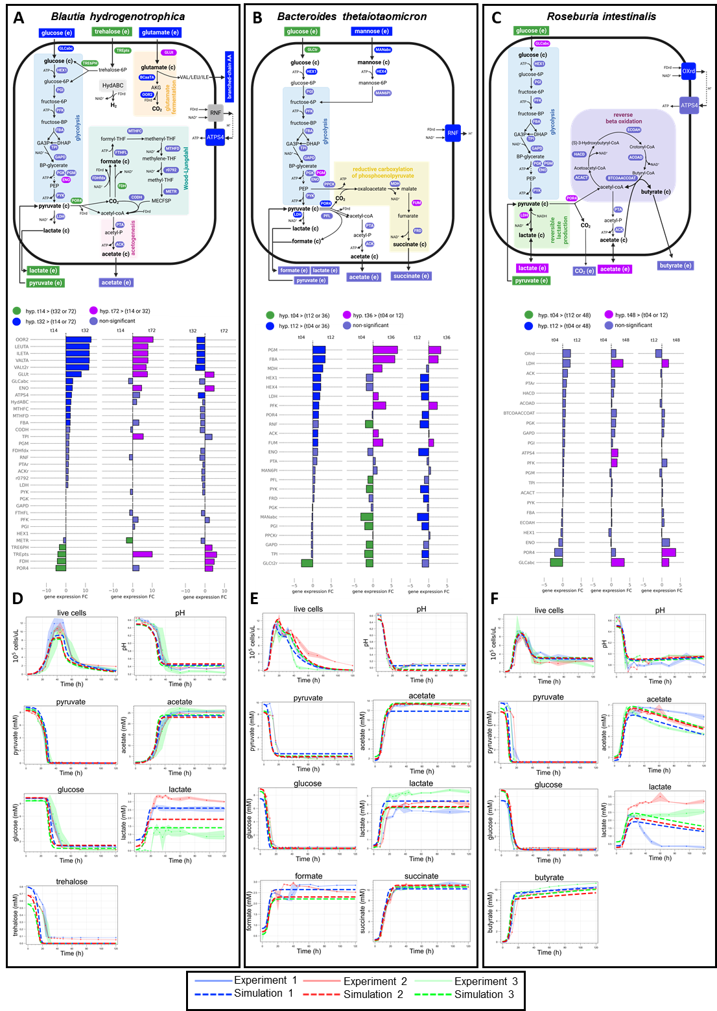

**Figure 1:** Growth kinetics and modeled metabolism of three human gut bacteria. Schematic illustration of the core energy metabolism of *Blautia hydrogenotrophica* (A), *Bacteroides thetaiotaomicron* (B), and *Roseburia intestinalis* (C), as inferred from genomic metabolic model reconstructions and empirical growth data. It includes gene expression changes during cultivation (middle panel), consumption of carbon sources (glucose, pyruvate, trehalose, etc.) and the production of fermentation products (acetate, lactate, butyrate, etc.). Panels D-F compare experimental growth data over time with model simulations (represented by dashed lines) for the three species cultured in WC medium. The growth data represents averages from three independent monoculture experiments, each with 3-6 biological replicates. Simulation initial conditions were the same as the experimental setups.

Bacteroides thetaiotaomicron rapidly metabolizes glucose and pyruvate, producing fermentation acids that significantly reduce the medium's pH. However, this organism is inhibited under low pH conditions []. When the carbon sources are exhausted, most cells lose viability but can still be detected through SYBR green staining in flow cytometry. The loss of membrane integrity was confirmed using PI staining. To reflect this in our model, we introduced functions that describe transitions from active to inactive subpopulations, triggered by nutrient scarcity in acidic environments (see Supplementary Text S1). We consistently observed a second growth peak before a major population inactivation (as shown in Figure 1E), which we believe is due to trace mannose consumption, consistent with our previous findings []. Mannose depletion was verified through measurements and gene expression analysis, although the precise kinetics remain unresolved.

*Roseburia intestinalis* generates butyrate through the reverse β-oxidation pathway (illustrated in Fig. 1C). In our experiments, *R. intestinalis* efficiently consumed glucose and pyruvate, producing butyrate, acetate, and lactate, impacting the pH to a lesser extent than *B. thetaiotaomicron*. As previously described [], in the absence of glucose, *R. intestinalis* transitions to a slow growth mode, characterized by the prolonged survival of viable cells (evident in “Live Cells” curves in Figure 1F), sporadic consumption of lactate/acetate (as shown in Figure 1F), and continuous butyrate production (also in Figure 1F). In our model, we represented this average behavior by incorporating rapid cell death in the absence of glucose and shifting subpopulations to slow growth in response to lactate and acetate (detailed in Supplementary Text S1). However, our model does not fully account for the observed heterogeneous lactate utilization across different experiments (as depicted in Fig. 1F).

After calibrating our model with monoculture growth data (Figure 1 D-F) and validating its performance in batch cocultures (Supplementary text S2), we incorporated dilution terms to simulate stability landscapes in a continuous culture environment. We explored how steady-state bacteria/metabolite levels respond to controllable factors - culture pH and dilution rate - which do not directly alter their initial concentrations but can shift dynamics. The dilution rate impacts the steady-state concentration of metabolites and nutrient availability, thereby affecting population growth rates and the transition between metabolic phenotypes (Figure 2A), while pH directly impacts growth. Changes in growth also impact the production of fermentation products and, for instance, their subsequent utilization by *Roseburia intestinalis*’s slow growth mode. In summary, these parameters significantly shape the overall community phenotype (Figure 2 B and C).

A surprising observation that resulted from this analysis is that the stability landscape of some of the state variables revealed sharp transition between alternative concentration profiles. For example, *Blautia hydrogenotrophica* maintains consistent concentrations under wide pH ranges, but undergoes a sharp shift when the dilution rate increases beyond a certain point (Figure 2B). *Roseburia instestinalis* survives in two separate zones, including a narrow range of conditions where it outcompetes the other species (Figure 2C), these zones are separated by areas where no growth occurs. Overall, the presence of sharp transitions zones in the stability landscapes suggest that alternative stable states can emerge depending on the initial concentrations. It also indicates the presence of tipping points, where minor environmental changes can lead to significant shifts in community structure.

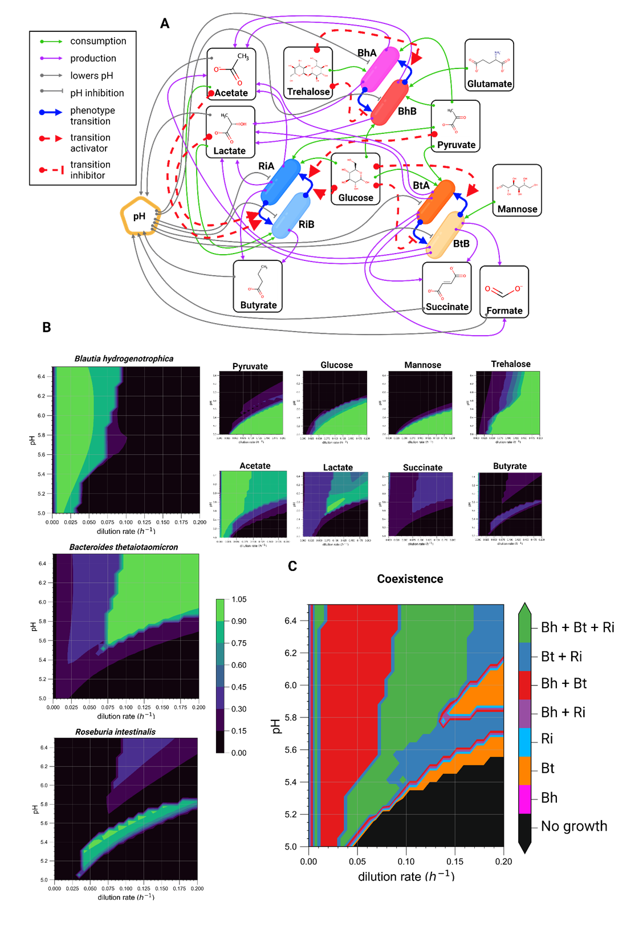

**Figure 2:** Mechanistic modeling reveals pH and dilution rate drive community transitions. (A) Schematic of mechanistic model encoded as ordinary differential equations (Supplementary Text 1). Model incorporates experimental data (Fig. 1B-D, Supplementary Fig. S1) to simulate variables under different conditions. (B) Contour plots showing predicted steady-state concentrations of model variables across pH 5.0-6.5 and dilution rates 0-0.2 h-1. Concentrations normalized to maximum values for comparison. (C) Community composition phase plot indicates presence/absence of species across pH-dilution rate conditions. Species considered present if the steady-state concentration is greater than 0.01 x 105 cells/μL.

To understand the mechanistic basis for these alternative stable states in our model, we individually varied the dilution rate while allowing the pH to vary according to the accumulation of fermentation products (see “environment pH” section of the Supplementary text S1). Two clearly distinguishable states emerged (Figure 3A): one where *Blautia hydrogenotrophica* and *Bacteroides thetaiotaomicron* co-dominate, with *Roseburia intestinalis* almost completely outcompeted, and another where *Bacteroides thetaiotaomicron* and *Roseburia intestinalis* prevail, with *Blautia hydrogenotrophica* maintaining a low abundance. The shift to one state or the other is dependent on the concentration of *Blautia hydrogenotrophica*’s glucose-consuming cells. High dilution rates lead to trehalose accumulation, which in turn inhibits the glucose consuming phenotype. When *Blautia hydrogenotrophica* is not consuming glucose, it occupies a niche that has negligible impact on the other species. In contrast, if the trehalose concentration is low and a sufficient population shifts to glucose consumption, *Blautia hydrogenotrophica* becomes a strong competitor, inhibiting the other species. Interestingly, this phenotype displays characteristics of hysteresis (ecological memory): once the glucose-consuming population is established, for example, by stopping the feed (setting the dilution rate to zero), then restoring it to previous levels does not return the system to its former state (Figure 3A). Consequently, two states can coexist under the same parameter values, and the system’s history is required to predict its behavior.

Similar alternative stable states also exist along the pH gradient. Since these depend on the dilution rate, we fixed these at 0.067h-1 and explored community landscape with varying pH values (Figure 3B). At lower pH values (e.g. 5.47 see Figure 3B), *Roseburia intestinalis* is favored. Overall, *Bacteroides thetaiotaomicron* is favored by pH control, since it can produce a large amount of acids without lowering the environment pH and inhibiting its own growth. The state of the system, however, ultimately depends on its history, which is illustrated in the lower plot of Figure 3B: changing the pH after the system is established does not necessarily lead to a change in community state (Figure 3B). Of note, this effect is related to the concentration of cells in a specific phenotype reaching a tipping point and not to the extinction of *Roseburia intestinalis* cells, as the shift is performed while there is still a significant abundance of live *Roseburia intestinalis* cells in the system.

The alternative steady-states and tipping points emerging from our model's stability landscape analysis help interpret experimental data. Previously, we cultured gut species in minibioreactors with imprecise control conditions - e.g. set continuous inflow but pipette-controlled outflow. Despite conditioning reactors under similar (noisy) states, distinct community states clearly emerged, splitting along PC1/PC2 axes (Fig. 3C). As with our model, these states are generally characterized by either a low or high abundance of *Blautia hydrogenotrophica*. In reactors with a high abundance of *Blautia hydrogenotrophica*, trehalose is completely consumed (Figure 3C and Supplementary Tables 2 and 3), suggesting that the glucose-consuming subpopulation could emerge and influence the abundance of other species. Conversely, *Blautia hydrogenotrophica* is absent or at low levels in reactors where trehalose remains. Since replicates form distinct clusters rather than a continuous environmental gradient, we infer that this supports the multistability mechanism proposed by our model's landscape analysis.

To further confirm this multistability mechanism and explore its potential to explain microbiome landscape dynamics, we abstracted components of our model into a new formalism. Species are defined by Lotka-Volterra growth/interaction rates, but additionally encompass multiple phenotypes with environment-responsive transitions between them (Fig. 4A). As in our mechanistic model, this simplified model exhibits alternative stable states separated by a tipping point (Fig. 4B). States arise from subpopulation shifts to strongly competing phenotypes (e.g. more efficient usage of key nutrients). Simulations show that even in larger communities, environment-driven emergence of such competitive phenotypes can significantly reshape the landscape, producing distinct community types resembling enterotypes (Fig. 4C).

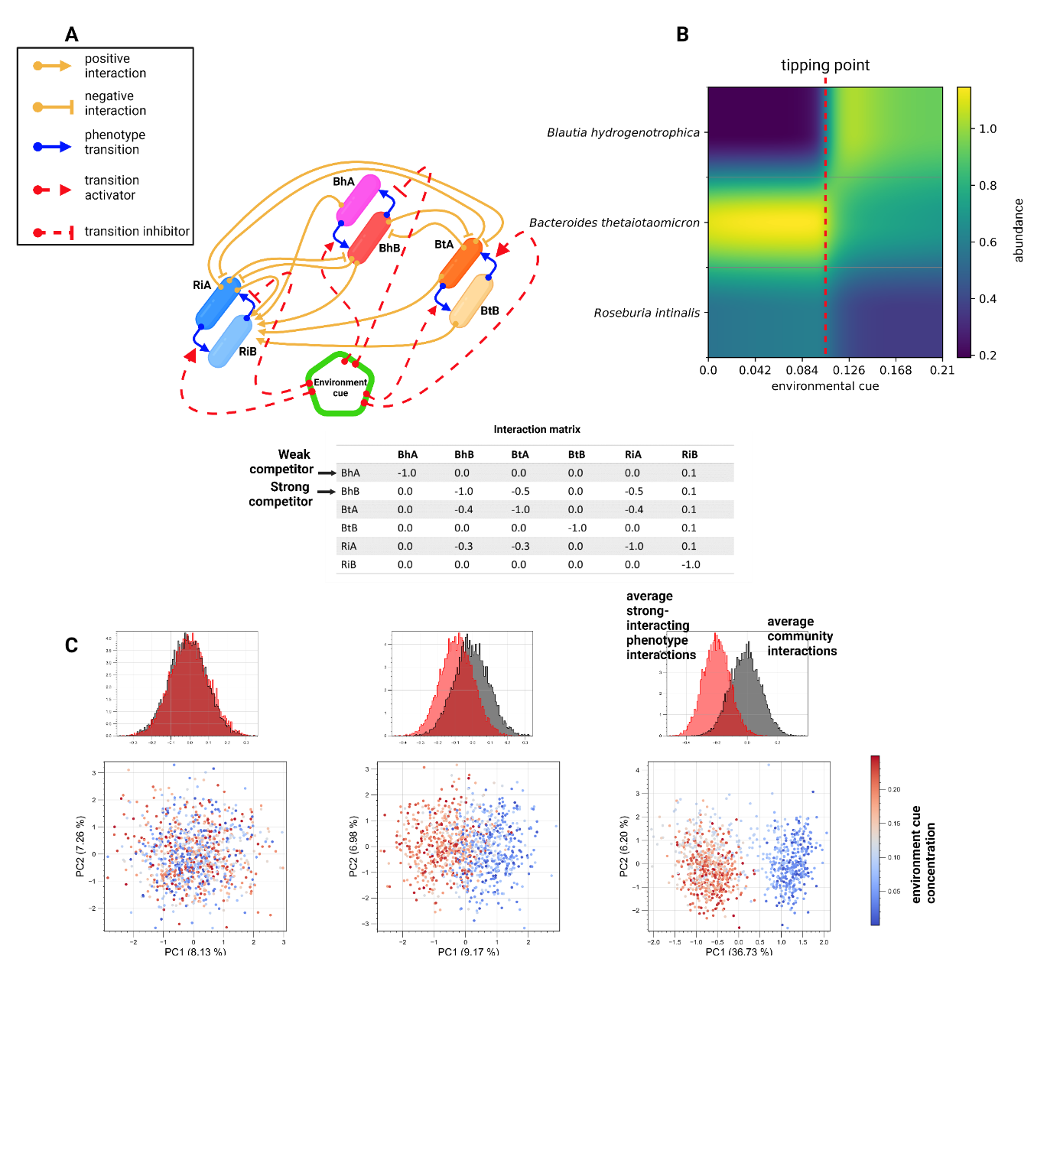

**Figure 4:** Toy model demonstrates our conceptual mechanism for multistability. (A) Species have alternative phenotypes connected by environment-responsive transition functions. (B) If one phenotype strongly interacts with others, phenotype switching can induce a sharp transition between alternative community states (e.g. high steady-state concentrations of trehalose leads Blautia hydrogenotrophica to weakly competing phenotype, but low trehalose triggers metabolic shift, enabling Blautia to strongly compete the others). (C) Simulations with 1000 random communities containing 50 species and a random concentration of the environment factor show this mechanism can explain emergent alternative stable states reminiscent of enterotypes. Gray histograms show distribution of interaction strengths across communities; red a phenotype -specific strong interaction that emerges in response to the concentration of an environment factor.

Methods

Microbial strains

Human gut bacterial strains of *Blautia hydrogenotrophica* S5a33 (DSM 10507T), *Bacteroides thetaiotaomicron* VPI-5482 (DSM 2079T) and *Roseburia intestinalis* L1-82 (DSM 14610T) were obtained from the Deutsche Sammlung von Mikroorganismen und Zellkulturen (DSMZ, Germany). The strains were frozen in Wilkins-Chalgren Anaerobe Broth (WC; Oxoid Ltd., Basingstoke, United Kingdom) plus 20% glycerol and maintained at ­-80°C until use.

Batch cultivation and sample collection

Batch cultivations of monoculture, bi-culture and tri-culture were followed for 120 h in 120-ml serum bottles containing 60 ml WC medium. The serum bottles were prepared in a same way as described by Liu et al. ISME 2023, and were inoculated with 1 ml of the diluted preculture to an OD600 of 0.1 (either a single species or the mixture of them). The bottles were incubated at 37 °C and at a constant stirring rate of 170 rpm (shaker KS 4000 i; IKA, Staufen, Germany). Samples were taken from the liquid broth every four hours for the first 48 h and every 12 h afterwards. Three biological replicates were designed for testing the monocultures in three independent batch experiments. All bi-culture and tri-culture experiments were performed in six biological replicates and always had a negative control bottle without inoculation but with sampling for each time, to verify its sterility.

Sterile syringes were used for each timepoint to collect 1 ml of the fermentation broth into 2-ml tubes (Eppendorf) under anoxic conditions. Subsequently, these tubes were used to measure OD600, pH, metabolites and to count bacterial cells by live/dead staining followed by flow cytometry as previously described (Liu et al, ISME 2023).

Chemostat experiment with ambr 15

Quantification of bacterial cell counts using flow cytometry

**Flow cytometry data processing**

Contamination check and confirmation of abundance profiles with 16S rRNA genes

Metabolite profiling

After centrifuging the liquid broth for 20 min at 21,130 × *g* at 4 °C (Centrifuge 5424R; Eppendorf, Hamburg, Germany), the supernatants were used for measuring the concentrations of trehalose, glucose, pyruvate, succinate, formate, acetate, lactate and *n*-butyrate, which were determined in triplicate by high-performance liquid chromatography (HPLC) as previously reported (Liu et al., ISME 2023).

RNA extraction and sequencing

A total of 27 samples representing the different growth phases of monocultures Bh, Bt and Ri in three biological replicates were selected for RNA sequencing, including these timepoints of three independent experiments: monoculture Bh in WC (14h, 32h and 72h), monoculture Bt in WC (4 h, 12 h and 36 h) and monoculture Ri in WC (4 h, 12 h and 48 h). Details of the extraction and purification of total RNA, evaluation of RNA integrity and yield, as well as library preparation and sequencing can be found in our recent paper (Liu et al., ISME 2023).

RNA-seq data processing

Statistics

Modeling