**Phenotype switching explains the emergence of alternative stable states in a gut microbial community**

Daniel Garza

Bin Liu

Charlotte van de Velde

Pallabita Saha

Didier Gonze

Kenneth Simoens

Kristel Bernaerts

Karoline Faust

Main Text

Several human-associated microbial communities assemble into more than one configuration [21508958, 22553250, 29255284] and change their composition in response to perturbations, remaining in an altered state even after the perturbation has ceased [25146375, 20847294]. While different hypotheses could explain this behavior [26866806, 28475180, 30022156], clear demonstrations are still lacking. A frequent explanation, supported by empirical evidence, suggests that microbiomes, like many ecological systems, can assemble into alternative stable states [28475180]. Thus, even when the same microbes assembled under similar environmental conditions, they may converge towards distinct community compositions, influenced by their assembly history [https://www.nature.com/articles/269471a0]. Additionally, minor yet continuous changes in environmental parameters could lead to significant shifts in community states [0691122032]. Historically, mechanistically identifying alternative stable states and regime shifts in natural communities is challenging [https://www.jstor.org/stable/2460854]. This is because organisms can change their own environments—microbes consume resources [https://doi.org/10.1101/2022.02.13.480281], change the environment’s pH [29662223], create physical structures [36789239], etc.—in response to biotic and abiotic changes, thereby making it difficult to disentangle community states from environmental factors.

Microbial cells exist in dynamic equilibrium, coexisting with other cells and their environments [33022263]. Their metabolic capabilities are encoded in their genomes, but the metabolic programs they execute depend on the differential expression of enzymes [36376406]. This differential expression enables a variety of metabolic strategies, which are evolvable and can be flexible, heterogeneous, and dynamic [34928547, 32781027, 37365188]. For instance, when exposed to a mix of substrates, cells might use these substrates either simultaneously or sequentially [30894528]—first consuming one and then another—or they might alternate between both strategies [32561713].

While the dynamic metabolic strategies of microbes, gene regulation, and phenotype switching have been extensively studied in isolates since Jacques Monod’s seminal work [Recherches sur la croissance des cultures bactériennes], their impact on microbiome ecology and stability remains vastly underexplored [37258505]. In our previous study, we observed that the ecological interactions between two gut bacterial species changed during co-culture [37670028]. These changes were in response to alterations in pH and the concentration of degradation products resulting from their metabolic strategies. Given that bacteria express alternative metabolic programs under varying environmental conditions, we hypothesize that the coexistence and switching between bacterial growth strategies could induce sharp transitions in community-level phenotypes, leading to multistability and the emergence of predictable alternative community states.

To test this hypothesis, we used a simple three species gut community that allowed us to combine in vitro experiments with mechanistic modeling. We first investigated phenotypes of three human gut bacteria in WC medium. This medium includes two simple carbon sources, glucose and pyruvate, along with substrates from tryptone and yeast extract, notably containing measurable amounts of trehalose (average 0.71 mM +/-0.07). The composition of this medium is simple enough to allow us to track the kinetics of key components yet contains sufficient nutrient heterogeneity to partially resemble complex anaerobic environments such as the gut.

We used genome-scale metabolic models to derive sets of chemical reactions that define the core energy metabolism of each species. We then collected RNAseq data at different growth stages to confirm pathway activities (Figure 1 A-C). These core pathways connect the import of carbon sources with the production of fermentation acids, enabling comparison with the measured data (Figure 1 D-F). By analyzing these pathways alongside live cell growth kinetics, medium pH changes, and metabolite composition, we were able to outline some general life strategies. These were incorporated into an ordinary differential equation model (Supplementary text S1). This model was calibrated against experimental data, as indicated by the traced lines in Figure 1 D-F.

Briefly, under our growth conditions, *Blautia hydrogenotrophica* initially consumes trehalose via an overexpressed, trehalose-specific PTS transporter (TREpts, Figure 1A). It only switches to glucose utilization after trehalose is depleted, facilitated by a non-PTS glucose transporter that is inhibited during trehalose consumption (GLCabc, Figure 1A). Interestingly, its genome lacks the glucose-specific IIA component of the PTS system gene, commonly found in closely-related *Blautia* and *Ruminococcus* strains (Supplementary Table S1). We confirmed this sequential substrate preference by showing that increased trehalose extended the non-glucose consuming phase (Supplementary Figure S1). Flow cytometry showed a clear bimodal population distribution during this transition, leading us to hypothesize that it reflects similar subpopulation sizes of trehalose consumers, which are not dividing, and emerging glucose consumers, which are dividing (Supplementary Video S1). The growth rate increased during glucose consumption compared to the trehalose phase (inflection point in growth curve, Fig. 1D, ~26 hrs). Equations modeling *Blautia hydrogenotrophica*’s lifestyle strategy are detailed in Supplementary Text S1.

*Bacteroides thetaiotaomicron* rapidly metabolizes glucose and pyruvate, producing fermentation acids that significantly reduce the medium's pH (Figure 1E). However, this organism is inhibited under low pH conditions [19397676]. When the carbon sources are exhausted, most cells lose viability but can still be detected through SYBR green staining in flow cytometry. The loss of membrane integrity was confirmed using PI staining. To reflect this in our model, we introduced functions that describe transitions from active to inactive subpopulations, triggered by nutrient scarcity in acidic environments (see Supplementary Text S1). We consistently observed a second growth peak before a major population inactivation (as shown in Figure 1E), which we believe is due to trace mannose consumption, consistent with our previous findings [37670028]. Mannose depletion was verified through measurements and gene expression analysis, although the precise kinetics remain unresolved.

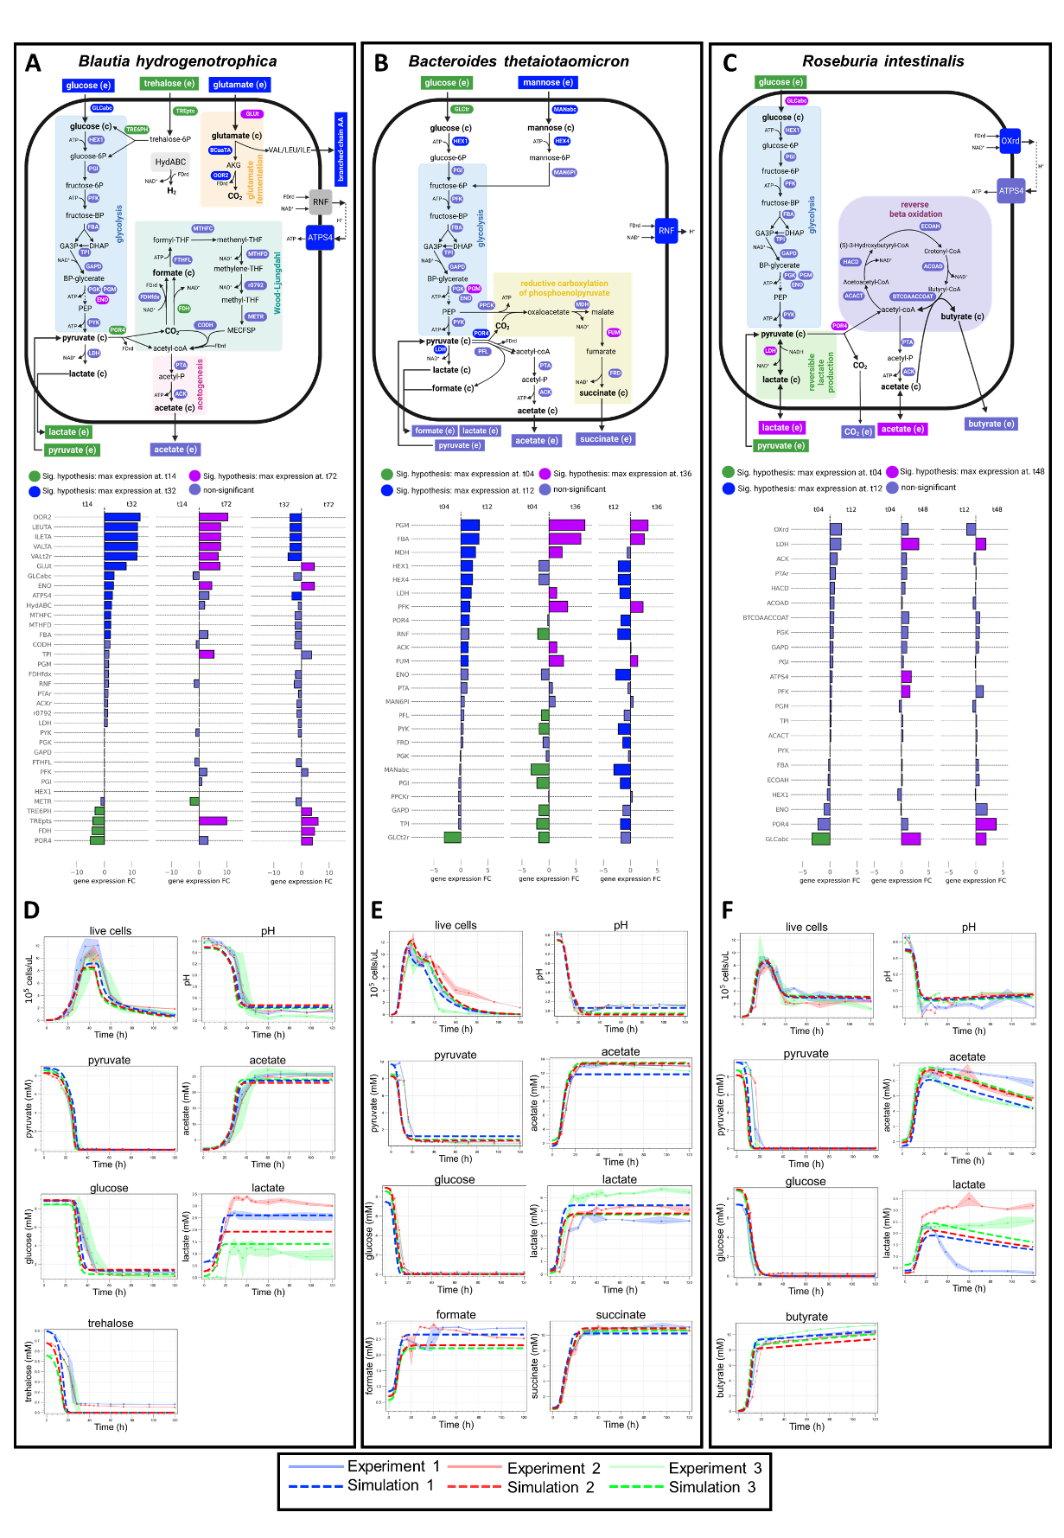

**Figure 1:** Growth kinetics and modeled metabolism of three human gut bacteria. This figure provides a schematic illustration of the core energy metabolism pathways for *Blautia hydrogenotrophica* (A), *Bacteroides thetaiotaomicron* (B), and *Roseburia intestinalis* (C), as deduced from genomic metabolic model reconstructions coupled with empirical growth data. The middle panel details gene expression changes observed during cultivation, with corresponding gene names linked to their associated reactions in the upper panel, and hypothesis testing performed using DESeq2. It also depicts the consumption of carbon sources (glucose, pyruvate, and trehalose) and the generation of fermentation products (including acetate, lactate, and butyrate). Panels D-F compare experimental growth data over time with model simulations (represented by dashed lines) for the three species cultured in WC medium. The growth data represents averages from three independent monoculture experiments, each with 3-6 biological replicates. Simulation initial conditions were the same as the experimental setups.

*Roseburia intestinalis* generates butyrate through the reverse β-oxidation pathway (illustrated in Figure 1C). In our experiments, *R. intestinalis* efficiently consumed glucose and pyruvate, producing butyrate, acetate, and lactate, impacting the pH to a lesser extent than *B. thetaiotaomicron*. As we previously described [37670028], in the absence of glucose, *R. intestinalis* transitions to a slow growth mode, characterized by the prolonged survival of viable cells (evident in “Live Cells” curves in Figure 1F), sporadic consumption of lactate/acetate (as shown in Figure 1F), and continuous butyrate production (also in Figure 1F). In our model, we represented this average behavior by incorporating rapid cell death in the absence of glucose and shifting subpopulations to slow growth in response to lactate and acetate (detailed in Supplementary Text S1). However, our model does not fully account for the observed heterogeneous lactate utilization across different experiments (as depicted in Figure 1F).

After calibrating our model with monoculture growth data (Figure 1 D-F and Supplementary Text S1) and validating its performance in batch cocultures (Supplementary Figure S2), we incorporated dilution terms to simulate in silico the stability landscapes in a continuous culture environment. We explored how steady-state bacteria/metabolite levels respond to controllable factors - culture pH and dilution rate - which do not directly alter their initial concentrations but can impact the systems’ dynamics. The dilution rate impacts the steady-state concentration of metabolites and nutrient availability, thereby affecting population growth rates and the transition between metabolic phenotypes (Figure 2A), while pH directly impacts growth. Changes in growth also impact the production of fermentation products and, for instance, their subsequent utilization by *Roseburia intestinalis*’s slow growth mode. In summary, these parameters significantly shape the overall community phenotype (Figure 2B and C).

A surprising observation that resulted from this in silico analysis is that the stability landscape of some of the state variables revealed sharp transition between alternative concentration profiles. For example, *Blautia hydrogenotrophica* maintains consistent concentrations under wide pH ranges, but undergoes a sharp shift when the dilution rate increases beyond a certain point (Figure 2B). *Roseburia instestinalis* survives in two separate zones, including a narrow range of conditions where it outcompetes the other species (Figure 2C), these zones are separated by areas where no growth occurs. Overall, the presence of sharp transitions zones in the stability landscapes suggest that alternative stable states can emerge depending on the initial concentrations. It also indicates the presence of tipping points, where minor environmental changes can lead to significant shifts in community structure.

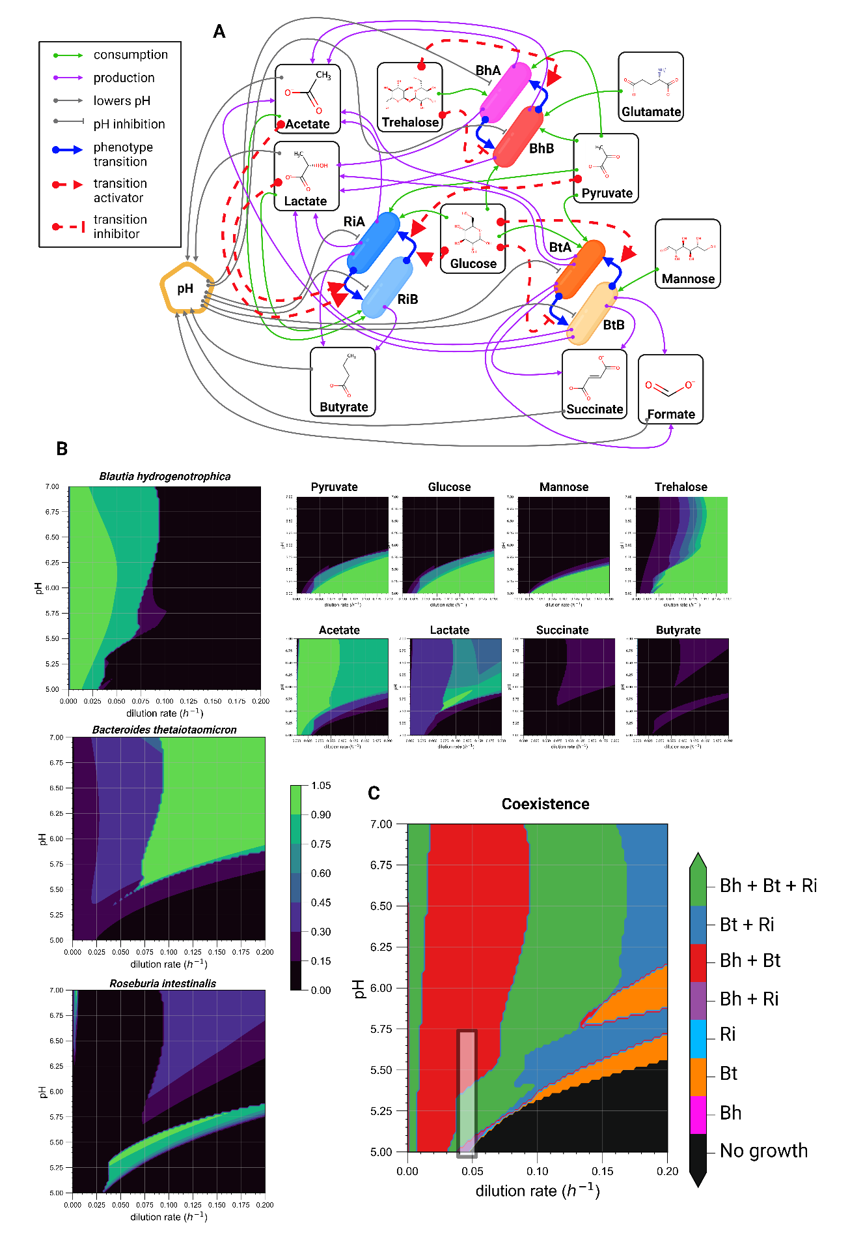

**Figure 2:** Mechanistic modeling reveals that pH and dilution rate drive community transitions. (A) Schematic of the mechanistic model encoded as ordinary differential equations (see Supplementary Text 1). The model incorporates experimental data (refer to Fig. 1B-D and Supplementary Figures S1 & S2) to simulate variables under varying conditions. (B) Contour plots depicting the predicted steady-state concentrations of model variables across a pH range of 5.0-6.5 and dilution rates from 0 to 0.2 h-1. Concentrations are normalized to their maximum values for comparative purposes. (C) A community composition phase plot indicates the presence or absence of species across different pH and dilution rate conditions. A species is considered present if its steady-state concentration exceeds 0.01 x 105 cells/μL. The black shaded rectangle within the plot highlights the conditions that closely approximate those of our mini-bioreactor experiments (refer to Figure 3).

To understand the mechanistic basis for these alternative stable states in our model, we individually varied the dilution rate while allowing the pH to vary according to the accumulation of fermentation products (see “environment pH” section of the Supplementary text S1). Two clearly distinguishable states emerged (Figure 3A): one where *Blautia hydrogenotrophica* and *Bacteroides thetaiotaomicron* co-dominate, with *Roseburia intestinalis* almost completely outcompeted, and another where *Bacteroides thetaiotaomicron* and *Roseburia intestinalis* prevail, with *Blautia hydrogenotrophica* maintaining a low abundance. The shift to one state or the other is dependent on the concentration of *Blautia hydrogenotrophica*’s glucose-consuming cells. High dilution rates lead to trehalose accumulation, which in turn inhibits the glucose consuming phenotype. When *Blautia hydrogenotrophica* is not consuming glucose, it occupies a niche that has negligible impact on the other species. In contrast, if the trehalose concentration is low and a sufficient population shifts to glucose consumption, *Blautia hydrogenotrophica* becomes a strong competitor, inhibiting the other species. Interestingly, this phenotype displays characteristics of hysteresis (ecological memory): once the glucose-consuming population is established, for example, by stopping the feed (setting the dilution rate to zero), then restoring it to previous levels does not return the system to its former state (Figure 3A). Consequently, two states can coexist under the same parameter values, and the system’s history is required to predict its behavior (for a more in-depth exploration of this behavior refer to Supplementary Figure S3 and its caption).

Similar alternative stable states also exist along the pH gradient. Since these depend on the dilution rate, we fixed these at 0.067h-1 and explored community landscape with varying pH values (Figure 3B). At lower pH values (e.g. 5.47 see Figure 3B), *Roseburia intestinalis* is favored. Overall, *Bacteroides thetaiotaomicron* is favored by pH control, since it can produce a large amount of acids without lowering the environment pH and inhibiting its own growth. The state of the system, however, ultimately depends on its history, which is illustrated in the lower plot of Figure 3B: changing the pH after the system is established does not necessarily lead to a change in community state (Figure 3B). Of note, this effect is related to the concentration of cells in a specific phenotype reaching a tipping point and not to the extinction of *Roseburia intestinalis* cells, as the shift is performed while there is still a significant abundance of live *Roseburia intestinalis* cells in the system (also see Supplementary Figure S3).

The alternative steady-states and tipping points emerging from our model's stability landscape analysis helped us interpret experimental data. We cultured gut species in minibioreactors that enable parallel cultivation and sampling, however control conditions are less precise than standard lab-scale reactors-—e.g. featuring continuous inflow but pipette-controlled outflow. Despite conditioning reactors under similar but slightly variable conditions, distinct community states clearly emerged, splitting along PC1/PC2 axes (as shown by the three ellipses of Figure 3C). As with our model, these states typically exhibited high or low abundance of *Blautia hydrogenotrophica*. In reactors where *Blautia hydrogenotrophica* was highly abundant, trehalose was completely consumed (Supplementary Tables 2), suggesting that the glucose-consuming subpopulation could emerge and influence the abundance of other species. Conversely, *Blautia hydrogenotrophica* was absent or present at low levels in reactors where trehalose remained at detectable concentrations.

Depending on the state that the system assumes, perturbations have a lasting effect, even when the system is returned to its previous conditions. In one experiment, as indicated by the blue dots in Figure 3C, the community initially converged to a steady-state with low abundance of *Blautia hydrogenotrophica* (ellipse II in Figure 3C). Following pH and dilution rate perturbations—stooping the feed while acidifying the pH to around 4—the replicates diverged into three alternative stable states after the system was returned to its previous conditions: either reverting to its previous state with low *Blautia hydrogenotrophica* abundance, transitioning to a state with high *Blautia hydrogenotrophica* and low *Roseburia intestinalis* abundance (ellipse I in Figure 3), or moving to a state where *Bacteroides thetaiotaomicron* predominated (ellipse III in Figure 3). In a second experiment, represented by the purple dots in Figure 3C, the system initially converged to a steady-state with high *Blautia hydrogenotrophica*’s abundance. Following a dilution rate perturbation, the system reverted to the same state. Since replicates from different experiments cluster into distinct steady states following either noisy conditions or perturbations—predominantly influenced by trehalose and glucose-consuming subpopulations of *Blautia hydrogenotrophica*—we infer that this corroborates the history-dependent multistability mechanism suggested by our model's landscape analysis.

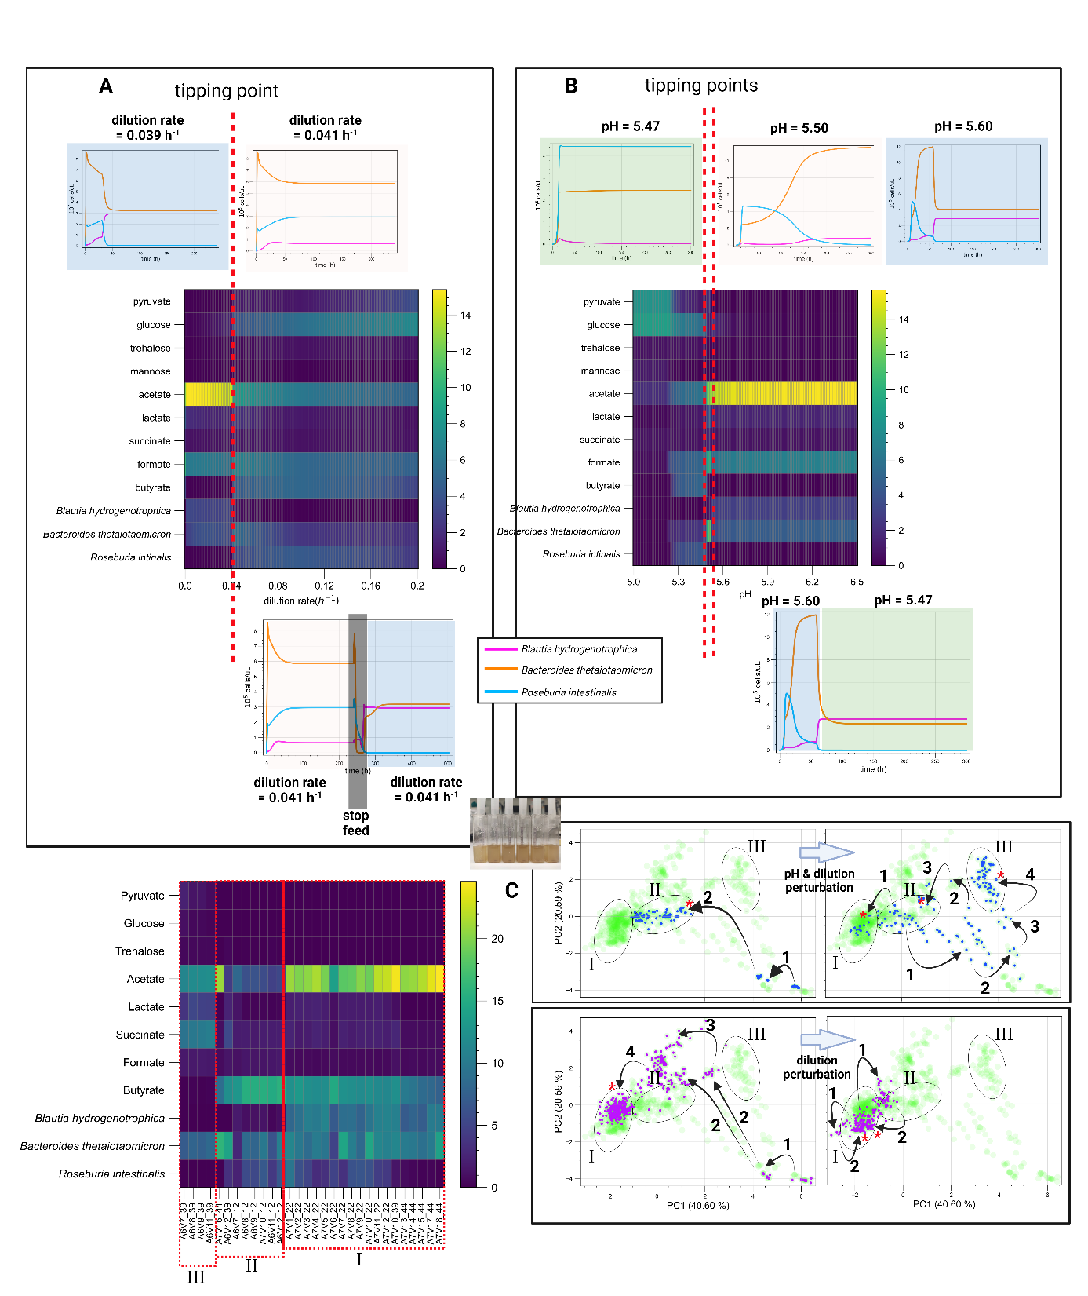

**Figure 3:** Modeling and experimental validation of tipping points and multistability. Model simulations predict alternative steady states connected by sharp transitions that exhibit hysteresis (ecological memory). For example, (A) a perturbation of the dilution rate drives a change to the alternative community state. Even when the original dilution rate is restored, the system does not return to the initial state. (B) Conditioning the system pH affects which steady-state community composition ultimately emerges. (C) Experimental validation conducted in minibioreactors (shown in the small inset photograph) reveals sharply defined, stable community compositions that persist under nearly identical environmental conditions, aligning with the model's predictions of multistability. We systematically collected periodic samples and analyzed the community state using HPLC for metabolites, alongside 16S rDNA sequencing and flow cytometry for bacterial species quantification (detailed in Supplementary Table S2). The heatmap illustrates endpoint replicates before perturbation and after achieving a post-perturbation steady-state, classified by “states” corresponding to ellipses I, II, and III in the PCA plots. The top and bottom plots track the trajectories of two separate experiments within principal component space. The left plots depict the paths taken by samples towards their steady-states, starting at “1” and progressing until they reach a point of minimal change; their arrival at a steady-state is denoted by red asterisks within the ellipses. The right plots trace post-perturbation trajectories: in the first experiment (blue dots), samples transition from steady-state II to alternative stable states, whereas in the second experiment (purple dots), samples revert to their original state (state I). The light green PCA background comprises all samples; steady-states were identified by observing temporal sample trajectories consistently drifting within a delimited area, around which the ellipses were drawn.

To further confirm this multistability mechanism and explore its potential to explain microbiome landscape dynamics, we abstracted components of our model into a new formalism (for details refer to Supplementary text S2). Species are defined by Lotka-Volterra growth/interaction rates, but instead of single growth rates and interaction vectors, species encompass subpopulations with alternative phenotypes (two and potentially more growth rates and interaction terms) with environment-responsive transitions between them (Figure 4A). As in our mechanistic model, this simplified model exhibits alternative community types separated by a tipping point (Figure 4B). States arise from subpopulation shifts to strongly competing phenotypes (e.g. more efficient usage of key nutrients). Simulations show that even in larger communities, environment-driven emergence of such competitive phenotypes can significantly reshape the landscape, producing distinct community types resembling enterotypes (Figure 4C). Similar to an empirical study of species distribution across stool samples [25003530], the species driving such community shifts—referred to as typing elements—exhibit a bimodal distribution in our model (Figure 4C).

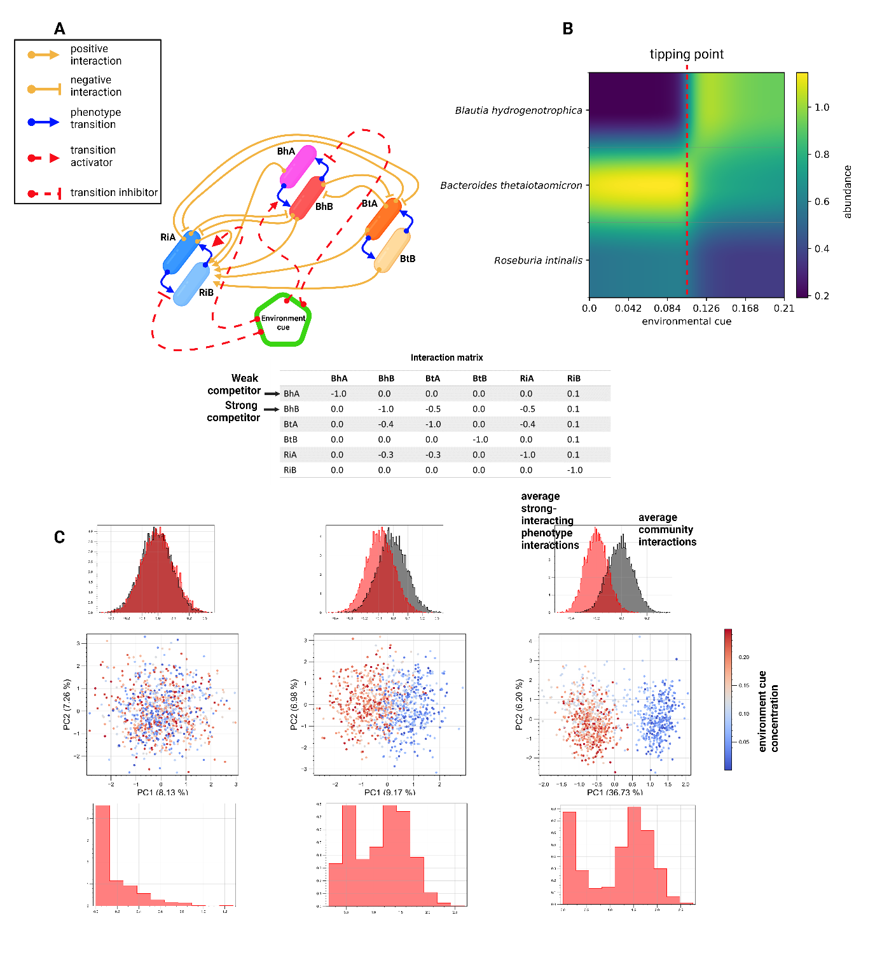

**Figure 4:** Toy model demonstrates conceptual mechanism for multistability. (A) Species have alternative phenotypes connected by environment-responsive transition functions, implemented through hill-equations, allowing dynamic interswitching between phenotypes during simulations (refer to Supplementary Text S2 for details). (B) If one phenotype strongly interacts with others (average interaction strengths are higher than the average community interactions), phenotype switching can induce a sharp transition between alternative community states (e.g. high steady-state trehalose leads *Blautia hydrogenotrophica* to a weakly competing phenotype, but low trehalose triggers a metabolic shift, enabling *Blautia hydrogenotrophica* to strongly outcompete others). (C) Simulations with 1000 random communities containing 50 species and a random concentration of an environmental factor show this mechanism can explain emergent alternative stable states reminiscent of enterotypes (seem as two distinct clusters in principal component space). Gray histograms show distribution of interaction strengths across communities; red denotes a phenotype-specific strong interactor that is expressed in response to the concentration of an environment factor. The lower histograms show the distribution of this species across samples. Notably, when enterotypes emerge, this typing element exhibits a bimodal distribution across samples.

Discussion

Here, we first explored in depth the metabolic strategies of three common human gut bacterial species and demonstrated in silico and in vitro that multi-stability arises as a consequence of bacterial metabolic flexibility. Sharp transitions between alternative states in our system are driven by varying ecological interactions among phenotypically flexible bacteria. For example, the glucose-consuming phenotype of *Blautia hydrogenotrophica* competes strongly and inhibits the fast growth mode of *Roseburia intestinalis*. Communities where this phenotype is expressed are significantly different from communities where it is repressed. The history-dependent behavior observed in our model and chemostat experiments emerges from feedback loops between subpopulations and environmental factors. For example, while increasing the dilution rate may increase the steady-state concentration of trehalose and inhibit *Blautia hydrogenotrophica*’s glucose-consuming phenotype, if a large population of glucose-consuming cells are already present in the system, then many cells are available to quickly consume that excess trehalose that enters through the increase of the dilution rate, leading to a different proportion of subpopulations and altering the community phenotype. To the best of our knowledge, this study is the first to observe more than one alternative community type in controlled conditions in response to a perturbation.

Our simulations further confirm that the presence of different phenotypes can give rise to alternative community types in large communities. Thus, we suggest that multistability is a potential driver behind alternative community types observed in the gut microbiome [21508958, 29255284], supporting previous propositions [28475180, 21508958]. The occurrence of alternative community types in other host-associated microbiota, which are not easily explained by environmental differences [22553250, 24739969, 30679075], implies that multistability may be more common than previously thought. As we and other have previously discussed [25003530, 28475180], it is relevant whether alternative community types are due to environmental differences caused by diet, host genetics etc. or whether they are due to multistability. In the case of the latter, alternative community types can result from past transient perturbations rather than from current differences between hosts.

We also note that popular mathematical models of microbial communities, such as the generalized Lotka-Volterra (gLV) model, do not account for metabolic flexibility. Moreover, several established methods assume the absence of multi-stability in microbial communities. One of these is the dissimilarity-overlap curve analyses [27279224, 32555503], which evaluates the universality of microbial interactions by relying on an empirical negative correlation between compositional dissimilarity and species overlap. Another is EPICS (effective pairwise interactions for predicting community structures), which parameterizes the gLV model from leave-one-out communities [https://www.nature.com/articles/s43588-021-00131-x]. The accuracy of other inference methods like as BEEM [34495960] or MDSINE [27259475] may also be affected by the occurrence of multistability.

There are different ways to integrate metabolic knowledge into community models [36796330]. Here, we opted for a kinetic model instead of a metabolic model. This choice was made to effectively capture pH response and phenotypic switches, as well as to investigate history-dependence and the stability landscape of the community. However, the kinetic model was designed based on insights manually derived from metabolic reconstructions. It may be possible to construct such kinetic models automatically from metabolic models in the future.

In summary, we have shown that flexible microbial strategies impact the composition of gut microbial communities. In the future, we need to systematically elucidate these strategies in other gut microorganisms to better understand and efficiently modulate gut microbial communities.

Methods

Microbial strains

Human gut bacterial strains of *Blautia hydrogenotrophica* S5a33 (DSM 10507T), *Bacteroides thetaiotaomicron* VPI-5482 (DSM 2079T) and *Roseburia intestinalis* L1-82 (DSM 14610T) were obtained from the Deutsche Sammlung von Mikroorganismen und Zellkulturen (DSMZ, Germany). The strains were frozen in Wilkins-Chalgren Anaerobe Broth (WC; Oxoid Ltd., Basingstoke, United Kingdom) plus 20% glycerol and maintained at ­-80°C until use.

Batch cultivation and sample collection

Batch cultivations of monoculture, bi-culture and tri-culture were followed for 120 h in 120-ml serum bottles containing 60 ml WC medium. The serum bottles were prepared in a same way as described by Liu et al. ISME 2023, and were inoculated with 1 ml of the diluted preculture to an OD600 of 0.1 (either a single species or the mixture of them). The bottles were incubated at 37 °C and at a constant stirring rate of 170 rpm (shaker KS 4000 i; IKA, Staufen, Germany). Samples were taken from the liquid broth every four hours for the first 48 h and every 12 h afterwards. Three biological replicates were designed for testing the monocultures in three independent batch experiments. All bi-culture and tri-culture experiments were performed in six biological replicates and always had a negative control bottle without inoculation but with sampling for each time, to verify its sterility.

Sterile syringes were used for each timepoint to collect 1 ml of the fermentation broth into 2-ml tubes (Eppendorf) under anoxic conditions. Subsequently, these tubes were used to measure OD600, pH, metabolites and to count bacterial cells by live/dead staining followed by flow cytometry as previously described (Liu et al, ISME 2023).

Chemostat experiment with ambr 15

Quantification of bacterial cell counts using flow cytometry

**Flow cytometry data processing**

Contamination check and confirmation of abundance profiles with 16S rRNA genes

Metabolite profiling

After centrifuging the liquid broth for 20 min at 21,130 × *g* at 4 °C (Centrifuge 5424R; Eppendorf, Hamburg, Germany), the supernatants were used for measuring the concentrations of trehalose, glucose, pyruvate, succinate, formate, acetate, lactate and *n*-butyrate, which were determined in triplicate by high-performance liquid chromatography (HPLC) as previously reported (Liu et al., ISME 2023).

RNA extraction and sequencing

A total of 27 samples representing the different growth phases of monocultures Bh, Bt and Ri in three biological replicates were selected for RNA sequencing, including these timepoints of three independent experiments: monoculture Bh in WC (14h, 32h and 72h), monoculture Bt in WC (4 h, 12 h and 36 h) and monoculture Ri in WC (4 h, 12 h and 48 h). Details of the extraction and purification of total RNA, evaluation of RNA integrity and yield, as well as library preparation and sequencing can be found in our recent paper (Liu et al., ISME 2023).

RNA-seq data processing

Statistics

Modeling