Note:
Find the right data to answer each question?
What does ‘week’ means? 1-11

RAW DATA TABLE
Position | parkrunner | Gender | Age Group | Club | Time
1 | Hannah BARTRAM51 parkruns |  Female  1  Â  |  Member of the 50 Club  SW20-24 | 74.00% | Female  1 | SW20-24 74.00% age grade |  | 20:00PBÂ 19:20
2 | Tim GREALLY128 parkruns |  Male  1  Â  |  Member of the 100 Club  â€‹  Member of the Volunteer 25 Club  VM50-54 | 66.67% | Male  1 | VM50-5466.67% age grade |  | 22:18PBÂ 21:33
3 | Unknown
4 | Justin FLETCHER49 parkruns |  Male  2  Â  |  Member of the 25 Club  SM30-34 | 58.34% | Male  2 | SM30-3458.34% age grade |  | 22:29PBÂ 21:55

EXPECTED CLEAN DATA TABLE
General position | ID anonymize  (Last 2-3 numbers in the parkrunner collumn, still thinking how to do this) | Number of parkrun completed | Consistent runner club (This show how many parkruns that this runner completed) | Volunteer club  (How many time volunteer in parkrun) | Gender | Position by gender | Age group | Age grade | Club | Time  (in seconds) | Pb time | First timer  (T or F | Week (???) | Parkrun
1 | Hannah BARTRAM51 | 51 | Member of the 50 club |  | Female | 1 | SW20-24 | 74.00 |  | 20:00 | 19:20 | F |  | broadpark
2 | Tim GREALLY128 | 128 | Member of the 50 club | Member of the Volunteer 25 club | Male | 1 | VM50-54 | 66.67 |  | 22:18 | 21:33 | F |  | broadpark
3 | Unknown
4 | Justin FLETCHER49 | 49 | Member of the 25 club |  | Male | 2 | SM30-34 | 58.34 |  | 22:29 | 21:55 | F |  | broadpark
Note data table:
4. Club Membership Status:
E.g:
Member of the 100 Club
Member of the Volunteer 25 Club
- 100 Club: Completed 100+ parkruns total
- Volunteer 25 Club: Volunteered 25+ times at parkrun events
- Other possible clubs: 10 Club, 50 Club, 250 Club, Volunteer 50 Club, Volunteer 100 Club
5. Age Category and Grade: VM50-54 | 66.67%
- VM50-54: Age category
  - First letter: V = Veteran (but parkrun uses specific codes)
  - Second letter: M = Male
  - Number range: 50-54 = Age range
- 66.67%: Age Grade percentage
- Parkrun Age Category Codes:
For Women:
- JW = Junior Woman (under 18)
- SW = Senior Woman (18-39)
- VW = Veteran Woman (40+)
For Men:
- JM = Junior Man (under 18)
- SM = Senior Man (18-39)
- VM = Veteran Man (40+)
Age ranges: The numbers indicate the age bracket (e.g., JW10, JW11-14, SW20-24, VW35-39, VM50-54, etc.)
- What is Age Grade?
- A percentage that compares your time to the world record for your age and gender
- 100% = world record pace
- 66.67% = quite good (above average)
- Typically: <50% = beginner, 50-60% = average, 60-70% = good, 70-80% = very good, 80%+ = excellent

Write an R script to clean data for 1 file (Andy and Daniel)
Create a data dictionary: (Daniel)
Writing report (Daniel) (This one for later)
High-Level Role Discussion (Initial): Based on people's strengths, have an initial chat about who might be best suited for what. Don't finalize everything, but get a sense. Who enjoys data cleaning? Who is good at stats? Who is a good writer?

1. Which Parkrun provides the best marketing opportunity with the largest number of people?
- Visualisation with bart chart: x-axis: name of parkruns, y-axis: count of participants
- Hypothesis: The more people in a parkrun, the better the marketing opportunity and the Parkrun that has the most participants (runner), then the marketing campaign might reach out to the most people

2. Do new people come each week or is it always the same people?
- First thought: the people with New timer records should answer this question
- Bart chart:
Draft of how the chart look like:
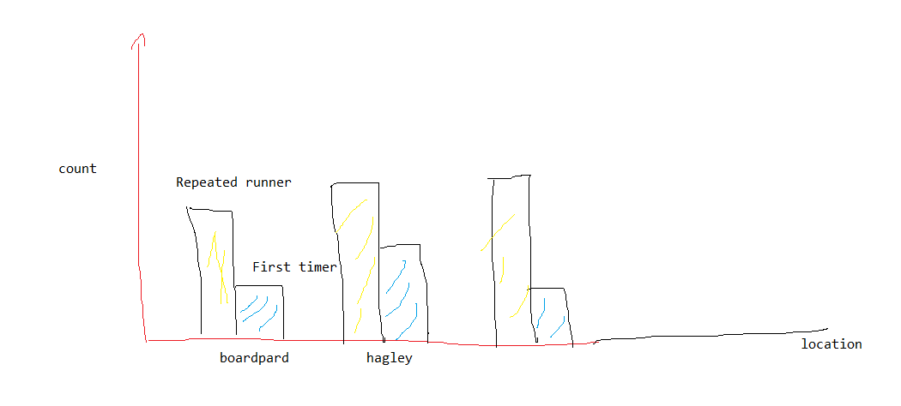
- Hypothesis: New people do come each week
3. Do people move between Parkruns? Does this mean if you advertise at fewer places you eventually see people from other locations?
- First thought: Look at the same name across each Parkruns.
4. If Puma want to target elite runners, where should they focus their efforts?
- First thought: The Parkrun that has the most same runners, or the Parkrun that has the PB best or the most competitive Parkrun (Look the differences in the top 20s first time)
- Age grade performance
- There are 6 age group (JM, SM, VM; JW, SW, VW), Or can do like Men and Women with 70% above between each parkruns.
- Variables use: name, age grade, club
- Limitation of the dataset: lack of race distance, weather condition, time of in the year
5. Puma believe more consistent runners have better potential as customers, how many runners are consistent and is consistency different across locations?
- First thought: The number of participants that repeatedly join a Parkrun.
6. Does the distance between Parkrun locations predict the amount of mixing of people between those
locations?
- First thought: Cross comparision between Parkruns.
- Hypothesis: the closer between 2 parkrun the more mix of people

Note: Riverlution parkrun is newly opened

Report detailing methods
- At the start of the report, contributions section decrible what people do in the project, only a few sentence identifying each members role
- Decrible the entire pipline in detail
- Any corrections, conversions, or clarifications around the data should be included
- Chart to highlight specific details
- Decrible limitation of the data
- Future improvement for future development

Report addressing key question from stakeholders
- Address key question mention in SOW
- Chart for visualization

Technical report Structure
1. Overview
2. Contribution
3. Methodology
4. Data dictionary
5. Cleaning data
6. Key question (need to be rename)
7. Limitation of the dataset
8. Conclusion

