A Parable of Chess
Daniel Rothschild

"It may be noted that a machine has several advantages over humans: -
(1)High-speed operations in individual calculations.
(2)Freedom from errors. The only errors will be due to deficiencies of the program while human players are continually guilty of very simple and obvious blunders.
(3)Freedom from laziness. It is all too easy for a human player to make instinctive moves without proper analysis of the position.
(4)Freedom from "never". Human players are prone to blunder due to overconfidence in "won" positions or defeatism and self-recrimination in "lost" positions.
These must be balanced against the flexibility, imagination and inductive and learning capacities of the human mind. "
Claude Shannon (1950)

Claude Shannon and Alan Turing had a lot in common. Both were soft-spoken, introverted mathematical geniuses. Turing is credited with inventing the modern definition of moocomputation, while Shannon's master’s thesis laid some of the groundwork for the first digital computers. Both men worked on cryptography during the second world war, Turing led British the effort to successfully crack the German Enigma code, while back in America Shannon discovered some of the deepest mathematical results about codes and transmission of information.
Their lifestyles were against the grain of conservative, mainstream mid-century British and American society. Turing was gay, a way of life for which he would eventually be criminally convicted by the British state, stripped of his security clearance and subjected to a chemical castration to avoid prison. This treatment led to his suicide in 1956. In the Forties, Shannon led a bohemian life from a messy studio apartment in Greenwich Village and his office in the research division of Bell Labs. During the days he tinkered with machines and did mathematics, and in the evenings he often went out to dinner and jazz in the city, scribbling more mathematics on napkins.

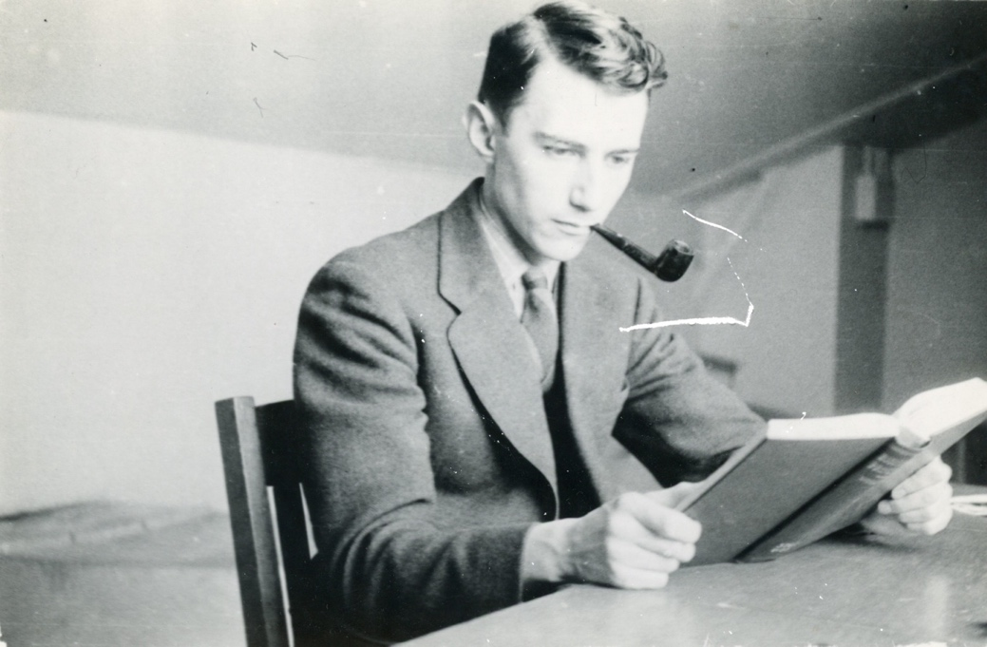

Claude Shannon

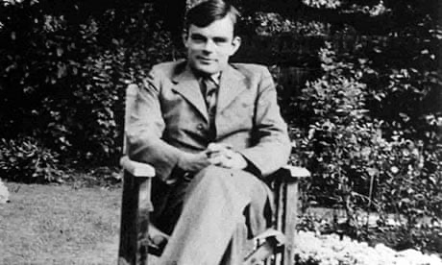

Alan Turing
Turing and Shannon met in 1943 when Turing was posted to the US during the war. They immediately recognized their commonalities and had a series of long deep conversations at Bell Labs in NY. The one thing they didn't talk about was codes and cryptography, as British-American cooperation, even during the war, didn't quite extend that far. Their conversations often focused on the computers they had both helped shepherd into the world. As part of this conversation they discussed each other's ideas for designing a computer that could play chess.
The chess-playing computer long served as a symbol of computers approaching human-level intelligence. A computer that could be play chess well, would match one of the heights of human ingenuity. Both Turing and Shannon designed programs and even physical machines (in Shannon's case) for playing chess. Shannon, in 1950, published an article entitled "Programming a Computer for Playing Chess". Shannon's article, which the quote starting this section is from, is an elegant, high-level look at the basic problem of getting a computer to play a decent game of chess. Shannon is adamant, as the quote shows, that if a computer were to win at chess it is a reflection of different skills than a human has. The computer's basic advantage is flawless, fast calculation. Humans have the advantage of creativity, flexibility and a capacity to learn.
If computers were fast enough chess would be no problem at all: as all you have to do is look up every single possible way the game can go and find the "winning" strategy (or at least the best strategy available). The problem is that there are a lot of possible ways a game can go, in fact, about 10¹²⁰ which is more particles than there are in the known universe. We would wait millennia upon millennia for such a machine to choose its first move.
For this reason you have to find a way to play a good game rather than a perfect game. Shannon's strategy requires estimating how good any board position is using strategic principles. For example, if Black has a queen and White doesn't than, all else equal, Black is in a better position than White. Human players think this way as well. Shannon envisages a simple system for giving a numerical score to any position based on the number of pieces on board and easily checked facts about their locations (e.g. is a King protected). Once you have such a scoring system, instead of aiming directly to play towards a win (that is, a checkmate) the machine can aim to play towards a better board position. Since every position is scored you don't need to look all the way ahead to the end of the game to see how good a move is. Rather you might just look a few moves ahead and see whether you might expect to get a better or worse board for a move. Any chess player will recognize this kind of thinking from their own play. Shannon showed how a computer can be programmed to efficiently look ahead a bit in the game to see what a move is likely to lead to. With just the value system and the look ahead mechanism you can now create a program that plays a reasonable game of chess: just check all the possible moves and see which looks best when you look ahead.
Early machines for playing chess were largely designed along Shannon's lines. These include IBM's Deep Blue which beat World Champion Gary Kasparov in 1997 to great fanfare. Looked at from Shannon's perspective Deep Blue's victory was just the inevitable result of calculations getting speedy enough that the machine's advantages of high-speed error-free calculation outpaced human creativity, flexibility and learning capacity. A technology magazine wrote decades later of the paper, "There have been few new ideas in computer chess since Claude Shannon."
There was one idea that wasn't in the paper, though. Shannon didn't think to have the computer learn through experience what the value of a board position was. Rather he programmed in rules determining the value system based on the common strategic thinking of chess players. Shannon even wrote, in the quote that starts this section, that learning was a distinct advantage humans had over machines, not something the machine itself could aspire to. But if a computer could be taught to learn for itself what board positions were good, perhaps it could do better than just by relying on conventional wisdom?
This finally happened in the twenty-first century. The latest headline-making chess machine, designed by Deep Mind in London has at its core a system for learning to value of a board position. No longer is the machine programmed to value having queen over not having one, rather this, along with everything else, is something it has to figure out. Through extensive training in which it plays games, AlphaZero, DeepMind's chess playing machine, gradually learns what good board positions look like from seeing what happens in thousands and thousands of games. The learning system AlphaZero uses isn't even geared towards chess. In fact, DeepMind's noted triumph in boardgames is not in chess at all but in the very different game of Go, where a predecessor of Alphazero (AlphaGo) became the first machine to beat a world champion (Lee Sedol in 2016). But the machine is equally good at chess, beating the best rival computer chess machines in 2018. (Humans had already dropped out of the competition for best chess player.)
A new way of getting a computer to play games thus emerged: letting the machine learn on its own what a good strategy looks like.
This shift in how computers are programmed to play chess is part of a major shift across AI. The name itself of the most successful form of AI today, deep learning, reflects the centrality of learning. Deep learning doesn’t not work by performing complex calculations at superhuman speeds according to rules wired in by engineers like Shannon. That is traditional AI. In deep learning, rather, the designer creates a large neural network that learns through experience the rules it needs to follow to succeed at a task.

