System Architecture and Requirements Document Template
Student template for documenting the centralized routing system

Field | Description
Course | Informatics for Telecommunications
Program | Telecommunication Engineering
Project | Centralized Routing System
Team name
Team members | Natalia Silva, Daniel Rueda, Paola Ordoñez
Professor | Oscar Mauricio Caicedo Rendon
Date | 26/04/2026
Version | 1.0

1. Introduction

1.1 Purpose of the Document
This document describes the requirements, architecture, components, communication mechanisms, data structures, and testing strategy of the centralized routing system developed as part of the Informatics for Telecommunications course.

1.2 Project Context
The project consists of developing a software-based centralized routing system in Python. The system includes a controller application and several router applications. The controller collects topology information, computes routing paths, generates routing tables, and distributes them to routers.

1.3 Project Scope
Included | Not included
Controller application | Real physical routers
Router applications | Real packet forwarding
TCP or UDP communication | Internet-scale routing
JSON-based messages | Full BGP, OSPF, or RIP implementation
Shortest path calculation | Hardware-level routing
Routing table generation | Production-grade SDN controller

2. Objectives
General objective: Develop a centralized routing system in Python that allows router applications to register with a controller, send topology information, receive routing tables, and simulate routing decisions based on shortest path computation.
- Design the architecture of a centralized routing system composed of a controller and multiple router applications.
- Implement communication between routers and the controller using sockets and JSON messages.
- Implement a routing algorithm to compute shortest paths and generate routing tables.
- Validate the system through functional and non-functional test cases.

3. System Overview
The centralized routing system follows a controller-based architecture. Router applications do not compute complete network routes independently. Each router sends its local information to the controller. The controller builds a global view of the network and computes routing tables for all routers.
Component | Description
Controller application | Central entity that manages topology, computes routes, and sends routing tables
Router application | Software entity that registers with the controller and receives routing information
Communication module | Handles message exchange between controller and routers
Topology manager | Stores and updates the network topology
Routing algorithm module | Computes shortest paths using Dijkstra algorithm
Routing table manager | Generates and stores routing tables
CLI module | Allows users to interact with the system through the command line
Logging module | Records relevant system events

4. Functional Requirements
ID | Requirement | Description | Priority
FR-01 | Router registration | Routers must register with the controller by sending router ID, IP address, and port. | High
FR-02 | Neighbor information exchange | Routers must send neighbor and link cost information to the controller. | High
FR-03 | Topology storage | The controller must store the network topology. | High
FR-04 | Route computation | The controller must compute shortest paths using Dijkstra algorithm. | High
FR-05 | Routing table generation | The controller must generate a routing table for each router. | High
FR-06 | Routing table delivery | The controller must send the corresponding routing table to each router. | High
FR-07 | Routing table visualization | Routers must display their routing tables through the command line. | Medium
FR-08 | Link cost update | The system should allow link cost updates and route recalculation. | Medium
FR-09 | Event logging | The system should log registrations, topology updates, and routing table delivery. | Low
FR-10 | Message validation | The controller must validate incoming messages, ensuring correct JSON format, required fields, and valid data values before processing. | High
FR-11 | Network topology visualization | The system should display the network topology, including routers, connections, and link costs, through the command-line interface. | Medium

5. Non-Functional Requirements
ID | Requirement | Description | Priority
NFR-01 | Python implementation | The system must be implemented in Python. | High
NFR-02 | Modular design | The code must be organized into clear modules or classes. | High
NFR-03 | JSON messages | The system must use JSON for message exchange. | High
NFR-04 | Command-line interface | The system must be operated from the terminal. | High
NFR-05 | Error handling | The system must handle invalid messages without crashing. | Medium
NFR-06 | Scalability | The system should support at least four routers. | Medium
NFR-07 | Maintainability | The code should be readable and documented. | Medium
NFR-08 | Testability | The system should include documented test cases. | Medium

6. System Architecture

6.1 Architectural Style
The system follows a centralized controller-based architecture, similar to the basic idea of Software-Defined Networking at a simplified educational level.

6.2 Architecture Diagram

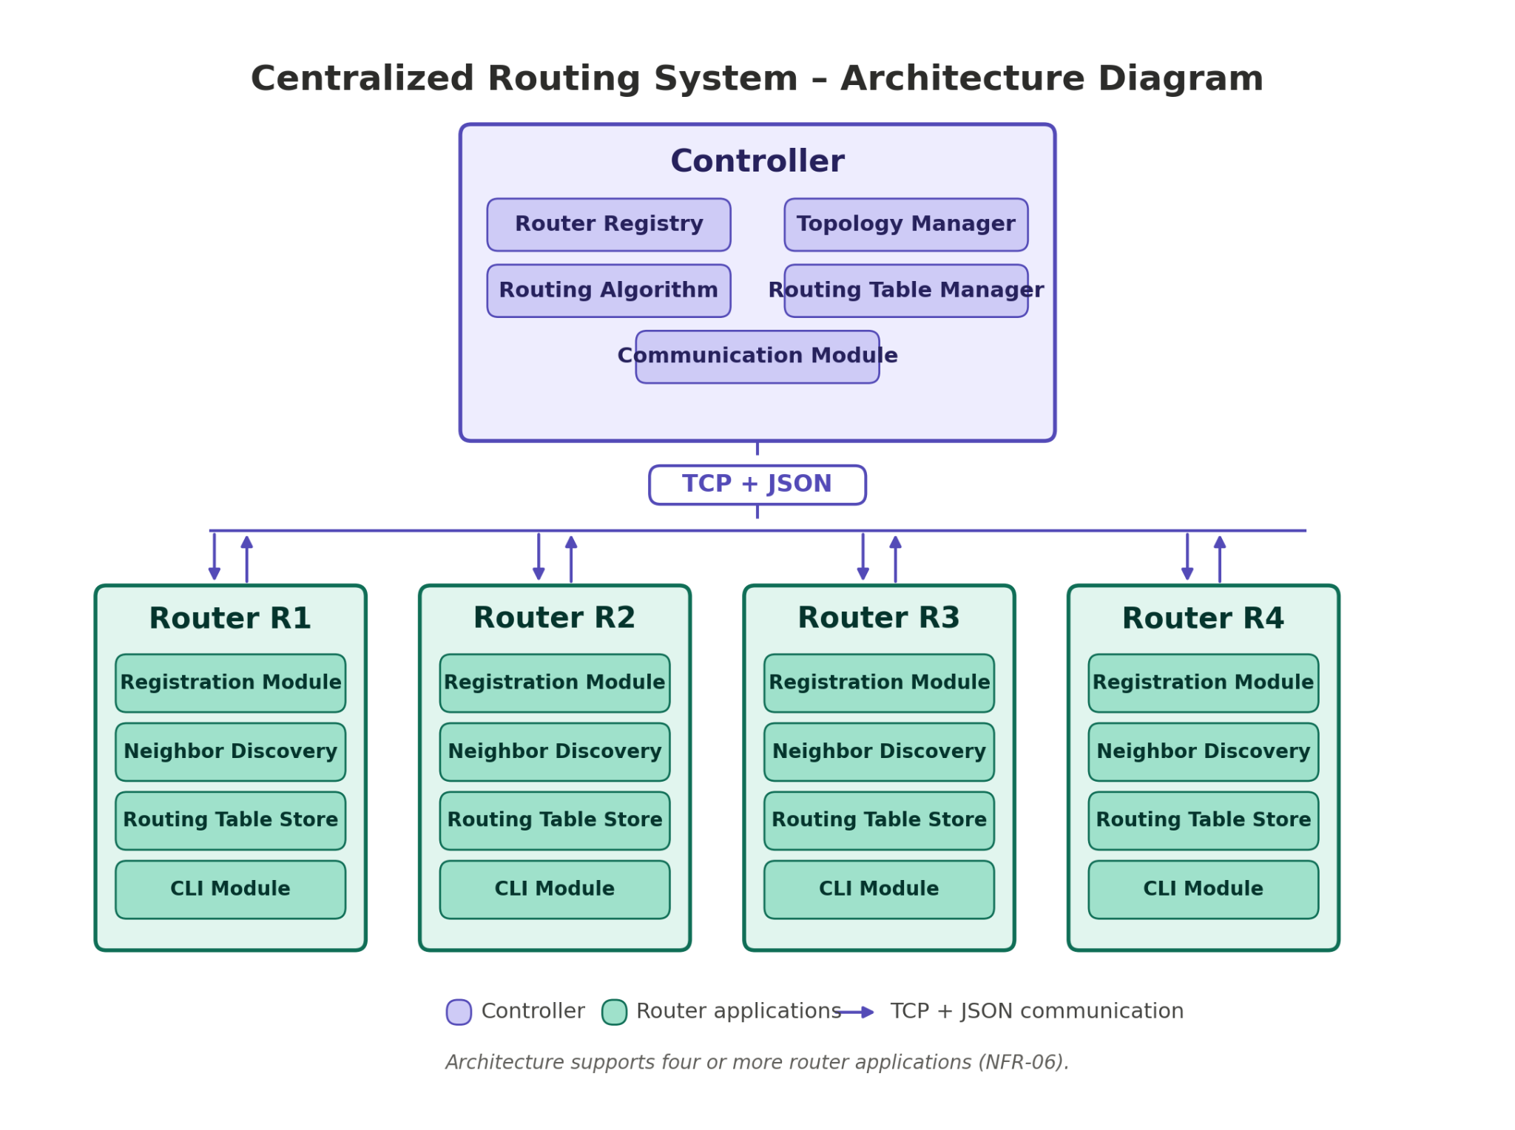

7. Component Description
Component | Main responsibility | Input | Output
Controller application | Manage global network information and compute routes | Router registration, topology updates, link cost updates | Routing tables, ACK messages, error messages
Router application | Represent a network router in software | Routing table from controller | Registration message, neighbor information, link cost updates
Topology manager | Store the network topology | Nodes, links, costs | Graph or adjacency list
Routing algorithm module | Compute shortest paths | Network topology | Paths and costs
Routing table manager | Convert paths into routing table entries | Shortest paths | Destination, next hop, cost entries

8. Communication Design
Field | Description
Protocol | TCP or UDP
Data format | JSON
Encoding | UTF-8
Communication model | Client-server
Server | Controller
Clients | Router applications

Message type | Sender | Receiver | Purpose
REGISTER_ROUTER | Router | Controller | Register a router
TOPOLOGY_UPDATE | Router | Controller | Send neighbor information
ROUTING_TABLE | Controller | Router | Send routing table
LINK_COST_UPDATE | Router/Admin | Controller | Update link cost
ERROR | Controller/Router | Controller/Router | Report an error
ACK | Controller/Router | Controller/Router | Confirm successful operation

9. Example JSON Messages
Router registration message:
{
"type": "REGISTER_ROUTER",
"router_id": "R1",
"ip": "127.0.0.1",
"port": 5001
}
Topology update message:
{
"type": "TOPOLOGY_UPDATE",
"router_id": "R1",
"neighbors": [
{"neighbor_id": "R2", "cost": 10},
{"neighbor_id": "R3", "cost": 5}
]
}
Routing table message:
{
"type": "ROUTING_TABLE",
"router_id": "R1",
"routing_table": [
{"destination": "R2", "next_hop": "R2", "cost": 10},
{"destination": "R4", "next_hop": "R3", "cost": 8}
]
}

10. Data Model
Entity | Field | Type | Description
Router | router_id | String | Unique router identifier
Router | ip | String | Router IP address
Router | port | Integer | Router communication port
Router | status | String | Active or inactive
Link | source_router | String | Source router ID
Link | destination_router | String | Destination router ID
Link | cost | Integer/Float | Link cost
Routing table entry | destination | String | Destination router
Routing table entry | next_hop | String | Next router in the path
Routing table entry | cost | Integer/Float | Total path cost

11. Suggested Projects Structure

CONTROLLER
centralized-routing-controller/
|-- app/
| |-- main.py
| |-- controllers/
| | |-- controller_app_controller.py
| | |-- router_registry_controller.py
| | |-- topology_controller.py
| | |-- routing_controller.py
| | `-- communication_controller.py
| |-- models/
| | |-- router.py
| | |-- link.py
| | |-- topology.py
| | |-- routing_table.py
| | `-- routing_table_entry.py
| |-- views/
| | |-- controller_cli_view.py
| | |-- topology_view.py
| | |-- routing_table_view.py
| | `-- log_view.py
| |-- dao/
| | |-- router_dao.py
| | |-- topology_dao.py
| | |-- routing_table_dao.py
| | `-- log_dao.py
| |-- services/
| | |-- dijkstra_service.py
| | |-- routing_table_service.py
| | |-- topology_service.py
| | `-- message_service.py
| |-- network/
| | |-- tcp_server.py
| | |-- udp_server.py
| | `-- client_handler.py
| |-- config/
| | |-- controller_config.json
| | `-- logging_config.json
| |-- data/
| | |-- routers.json
| | |-- topology.json
| | |-- routing_tables.json
| | `-- logs.json
| `-- utils/
| |-- constants.py
| |-- logger.py
| `-- json_utils.py|
|-- tests/
| |-- test_router_registry.py
| |-- test_topology.py
| |-- test_dijkstra_service.py
| |-- test_routing_table_service.py
| `-- test_controller_communication.py
|-- docs/
| |-- requirements.md
| |-- architecture.md
| |-- api_messages.md
| `-- test_plan.md
|-- README.md
`-- requirements.txt

ROUTER
centralized-routing-router/
|-- app/
| |-- main.py
| |-- controllers/
| | |-- router_app_controller.py
| | |-- registration_controller.py
| | |-- neighbor_controller.py
| | |-- routing_table_controller.py
| | `-- forwarding_controller.py
| |-- models/
| | |-- router.py
| | |-- neighbor.py
| | |-- link.py
| | |-- routing_table.py
| | `-- routing_table_entry.py
| |-- views/
| | |-- router_cli_view.py
| | |-- routing_table_view.py
| | |-- neighbor_view.py
| | `-- forwarding_view.py
| |-- dao/
| | |-- router_config_dao.py
| | |-- neighbor_dao.py
| | |-- routing_table_dao.py
| | `-- log_dao.py
| |-- services/
| | |-- registration_service.py
| | |-- neighbor_service.py
| | |-- routing_table_service.py
| | |-- forwarding_service.py
| | `-- message_service.py
| |-- network/
| | |-- tcp_client.py
| | |-- udp_client.py
| | `-- controller_connection.py
| |-- config/
| | |-- router_config.json
| | `-- controller_config.json
| |-- data/
| | |-- neighbors.json
| | |-- routing_table.json
| | `-- logs.json
| `-- utils/
| |-- constants.py
| |-- logger.py
| `-- json_utils.py
|-- tests/
| |-- test_registration.py
| |-- test_neighbor_service.py
| |-- test_routing_table_storage.py
| |-- test_forwarding_service.py
| `-- test_router_communication.py
|-- docs/
| |-- requirements.md
| |-- architecture.md
| |-- api_messages.md
| `-- test_plan.md
|-- README.md
`-- requirements.txt

12. Routing Algorithm Description
Students must explain the selected algorithm. For example: The system uses Dijkstra algorithm to compute the shortest path from each router to all other routers. The controller applies the algorithm over the global network topology. After computing the shortest paths, the controller extracts the next hop for each destination and builds a routing table for every router.

13. Sequence Diagram
Router R1 Controller
| |
|---- REGISTER_ROUTER ------>|
|<--------- ACK -------------|
| |
|---- TOPOLOGY_UPDATE ------>|
|<--------- ACK -------------|
| |
| | Compute shortest paths
| | Generate routing table
| |
|<----- ROUTING_TABLE -------|
|--------- ACK ------------->|

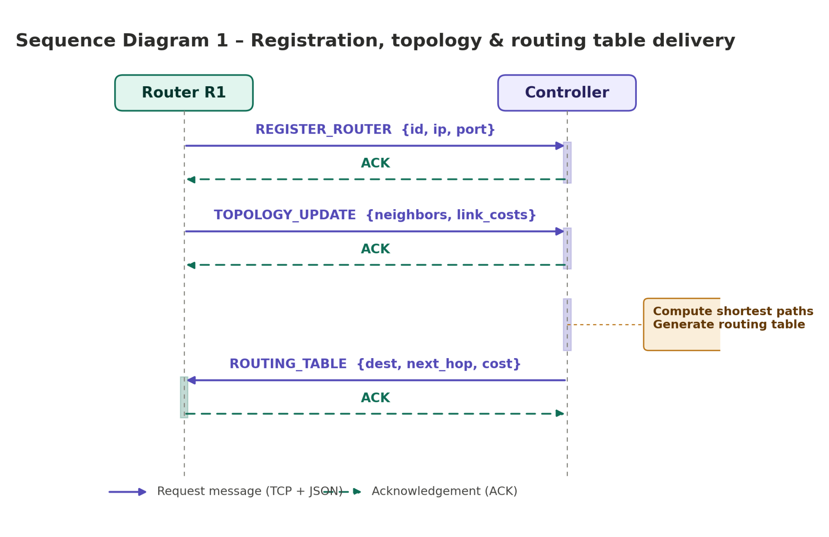

14. Test Strategy
Test area | Description
Router registration | Verify that routers register correctly
Topology update | Verify that topology information is received and stored
Shortest path calculation | Verify that the routing algorithm returns correct paths
Routing table generation | Verify destination, next hop, and cost
Routing table delivery | Verify that each router receives its table
Error handling | Verify invalid messages do not crash the system

15. Conclusions
Students should answer: Was the system implemented successfully? Did the controller correctly compute routing tables? Did the routers receive and display routing information? What were the main technical challenges? What improvements could be added in future versions?

