**BCP Test Report**

Tester : Jhonny Cristian

Date : 21 August 2024

Test Scenario

1. Check data on dashboard

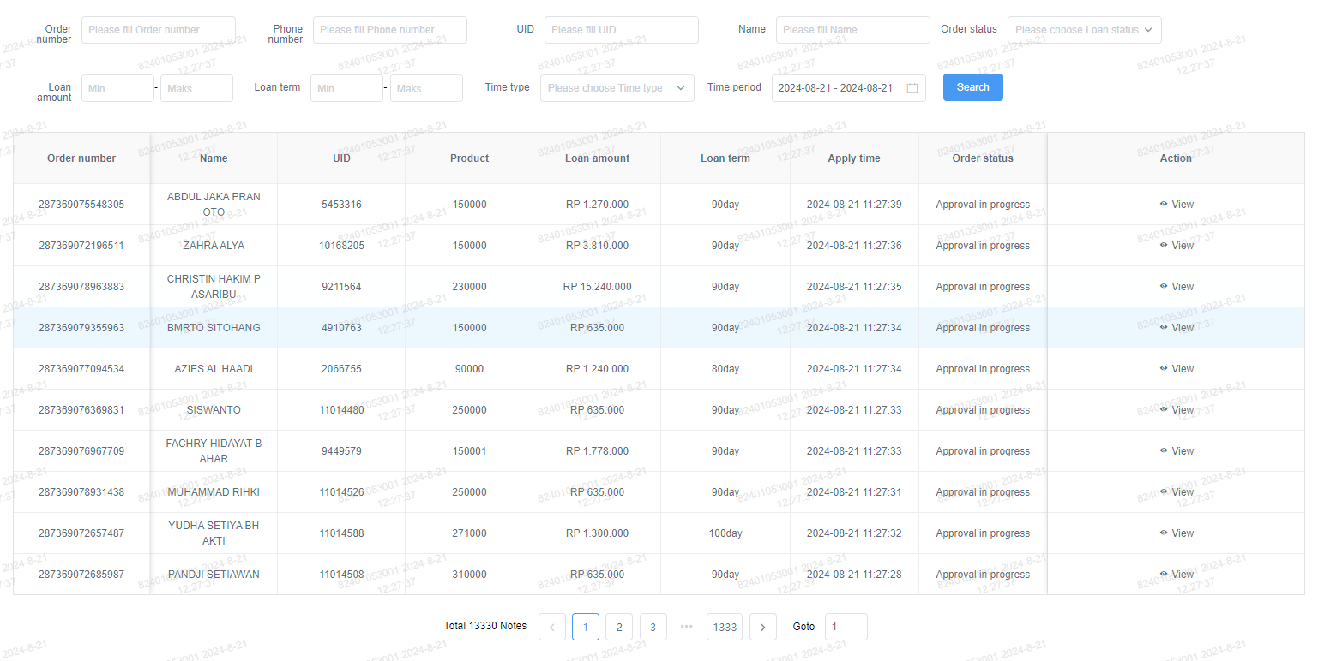

1. Stop the server

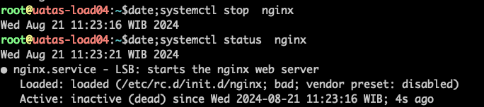

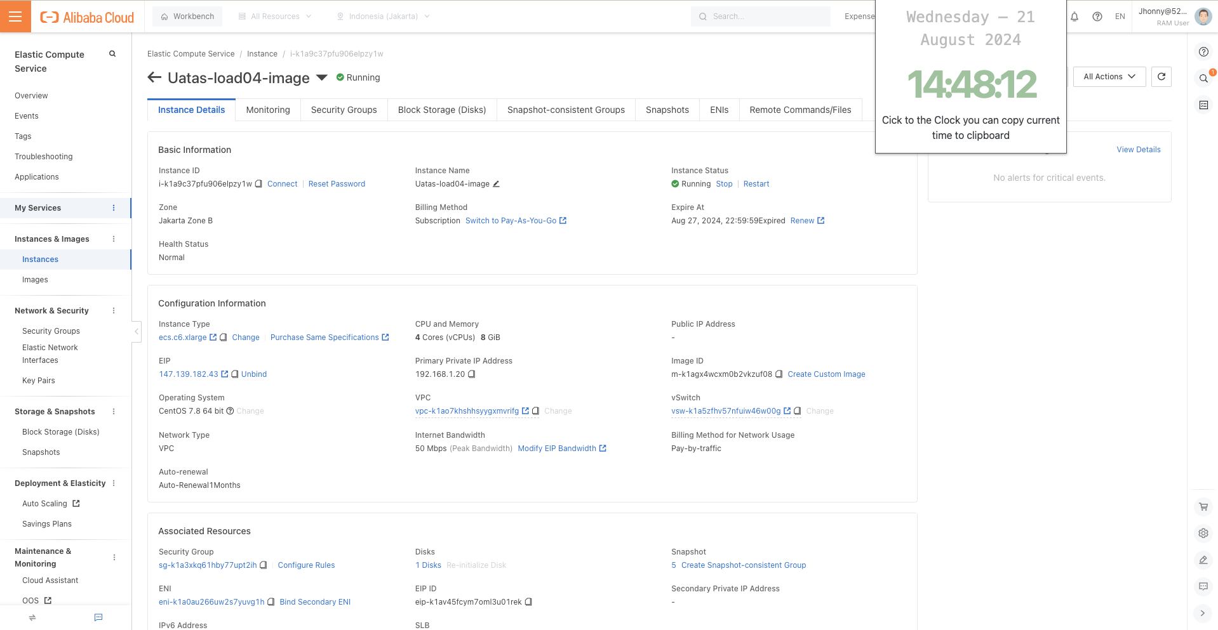

1. Check the dashboard after server has been stopped, the data still can be accessed or not

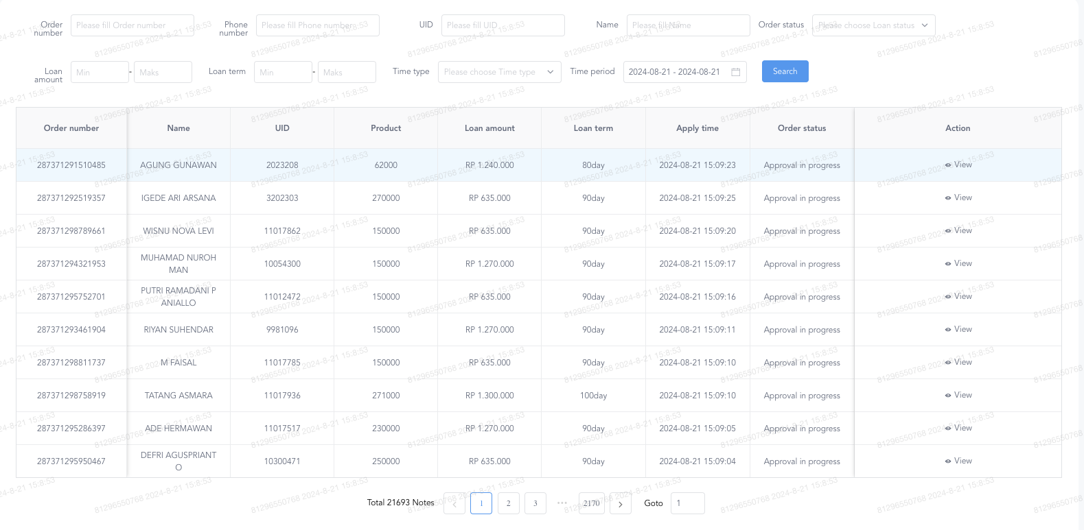

1. Check the mobile apps after server has been stopped

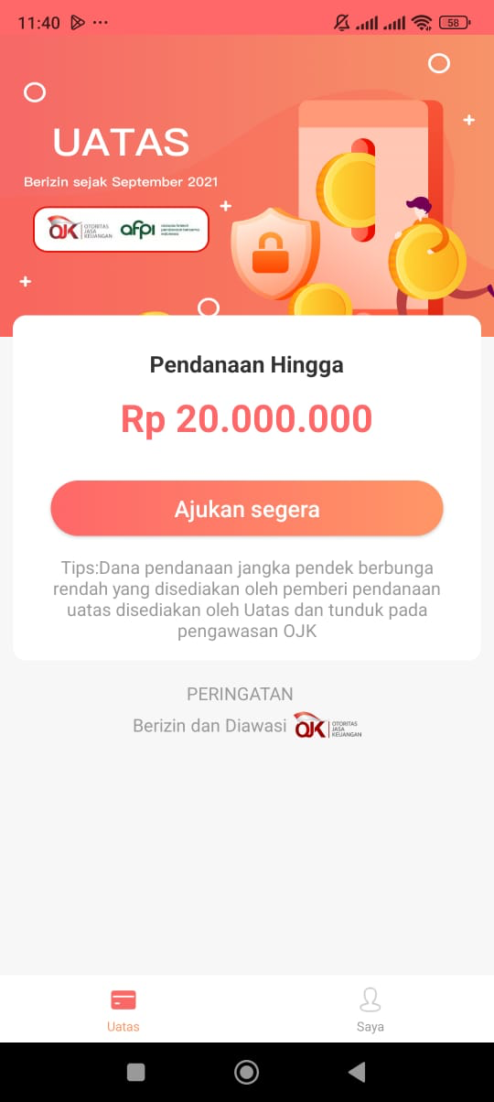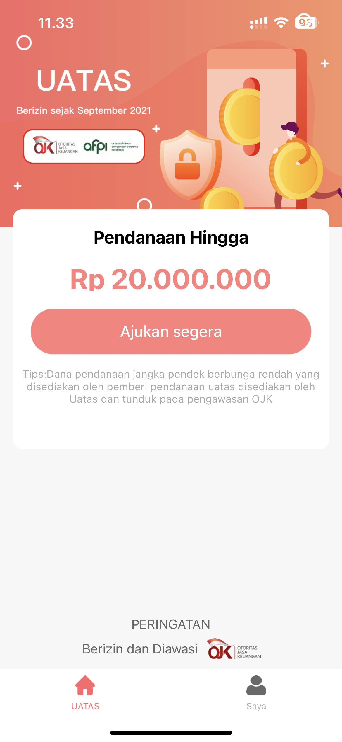

Result : after the server is stopped, data on the dashboard can still be accessed normally

Catatan : sistem yang telah diberhentikan diakses melalui load balancer, jika server mengalami kendala maka sistem dashboard order dan aplikasi mobile akan tetap berjalan dan tidak mempengaruhi proses bisnis.

Notes : the dashboard data handled by load balancer system, whenever the main server is not available the data still can be accessed through load balancer and also the mobile apps works well.

|  |  |
| --- | --- |
| Tester,  Jhonny Cristian  IT Manager | Acknowledged,  Aaron Tang  CTO |