**Backup & Restore Report**

Tester : Jhonny Cristian

Date : 20 August 2024

Test Scenario

Backup :

1. Check data on dashboard

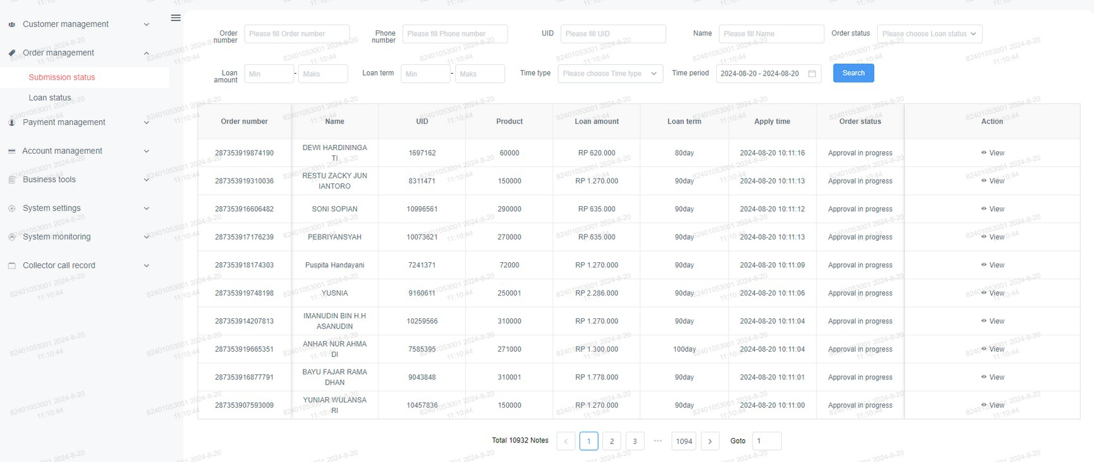

1. Check the data count from production server

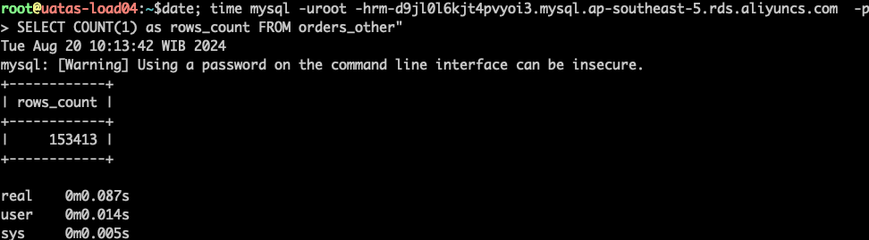

1. Check the data count from backup files

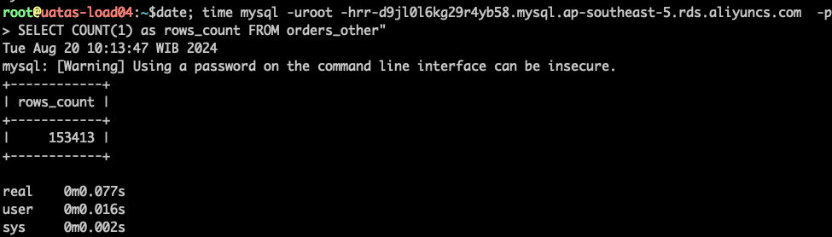

1. Create manual backup

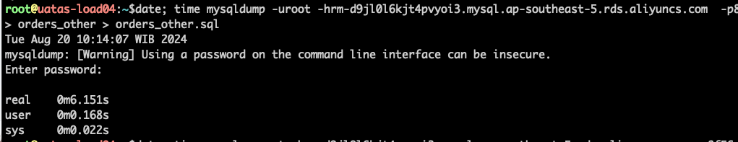

1. Delete production data

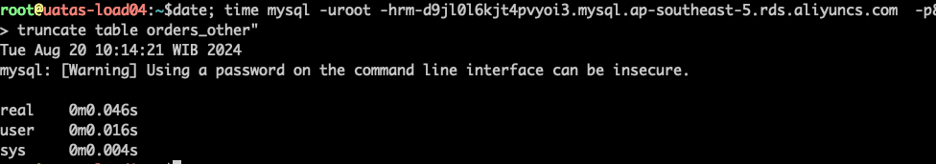

1. Check the data count on production server

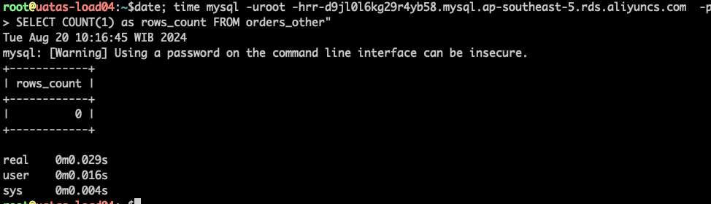

1. Dashboard check

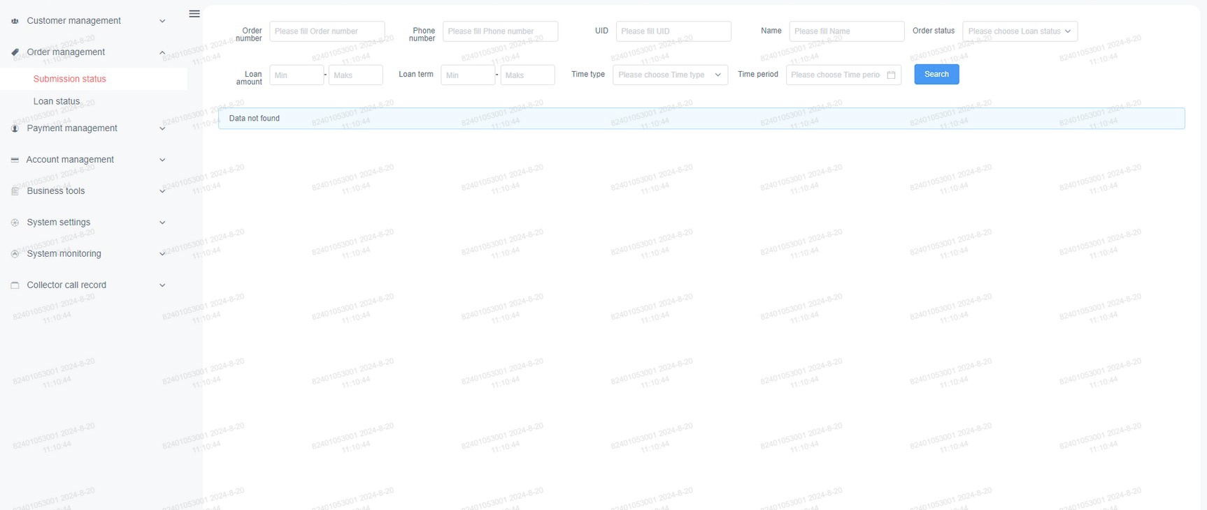

Restore :

1. Restoring the backup files

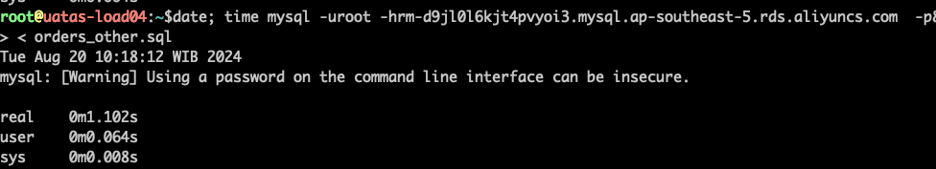

1. Check data count on production server

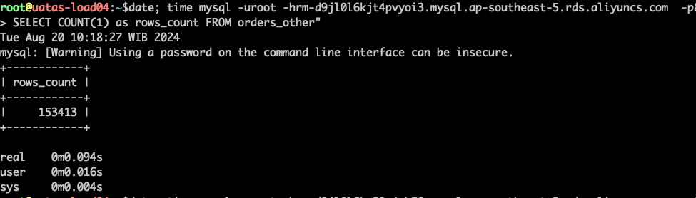

1. Check data count on backup files

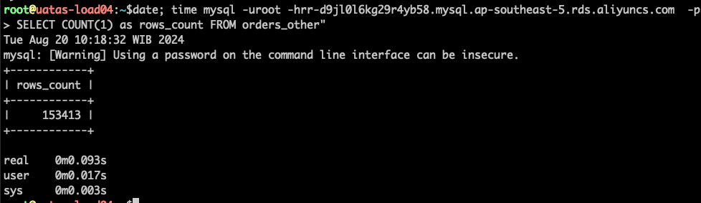

1. Check the data on dashboard

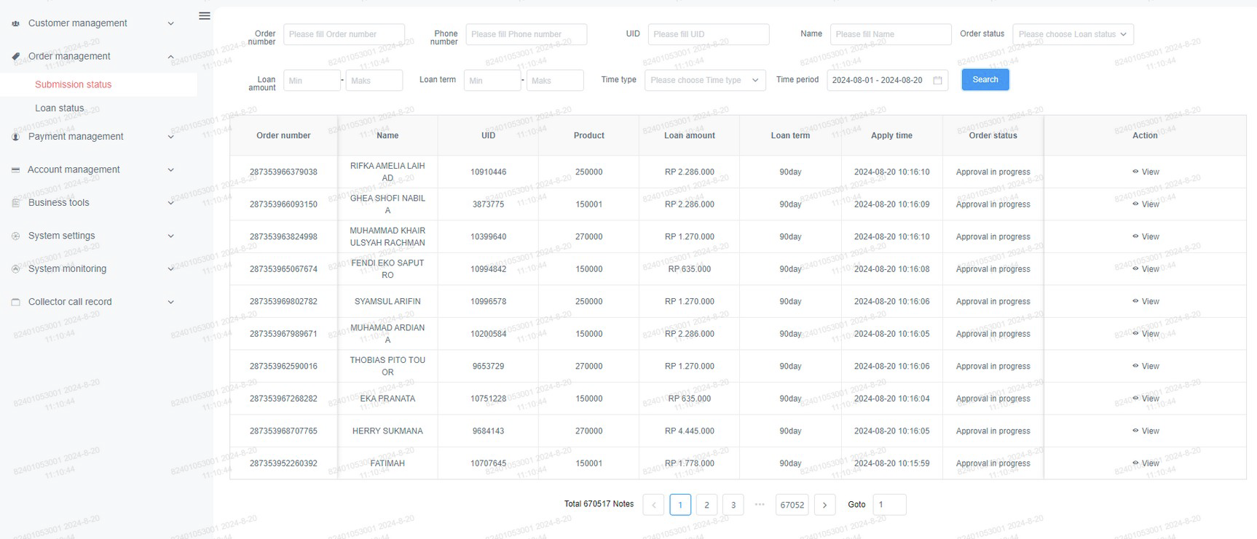

Result : backup–­ and restore data running normal

Notes : this test using manual backup, for production we have enable daily backup.

|  |  |
| --- | --- |
| Tester,  Jhonny Cristian  IT Manager | Acknowledged,  Aaron Tang  CTO |