Insert your name, centre number and candidate number into the header above.
Save this evidence document as evidence_ followed by your centre number_ candidate number. For example: evidence_zz999_9999.docx
Screenshots or program listings must be copied into appropriate cells in the following tables.
Examiners must be able to read the contents including any screenshots without the use of a magnifying glass. Answers that are not readable or missing will not be awarded any marks.
Save this evidence document at regular intervals, for example every 10 minutes.
Question 1
1(a)
Queue = [-1 for i in range(10)] #QUEUE 10 SPACES INTEGER
HeadPointer = -1 #INTEGER
TailPointer = -1 #INTEGER

1(b)
def Enqueue(DataToEnq):
global TailPointer, HeadPointer, Queue
if TailPointer >= 9:
return False

if TailPointer == -1 and HeadPointer == -1:
HeadPointer, TailPointer = 0, 0
Queue[TailPointer] = DataToEnq
return True
else:
TailPointer += 1
Queue[TailPointer] = DataToEnq
return True

1(c)(i)
for i in range(11):
user_input = int(input("Enter a number: "))
result = Enqueue(user_input)
if not result:
print("Queue full")

print(f"Queue: {Queue}\n")

1(c)(ii)
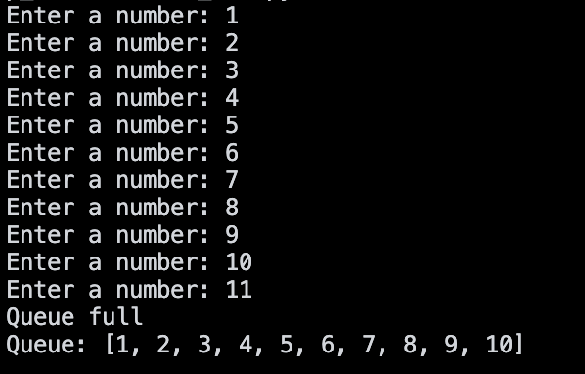

1(d)
def Dequeue():
global TailPointer, HeadPointer, Queue
if TailPointer == -1 and HeadPointer == -1:
return -1

if TailPointer + 1 == HeadPointer:
TailPointer, HeadPointer == -1, -1

removed = Queue[HeadPointer]
HeadPointer += 1
return removed

1(e)(i)
for i in range(6):
user_input = int(input("Enter a number: "))
result = Enqueue(user_input)
if not result:
print("Queue full")
for i in range(4):
print(f"Removed: {Dequeue()}")

1(e)(ii)
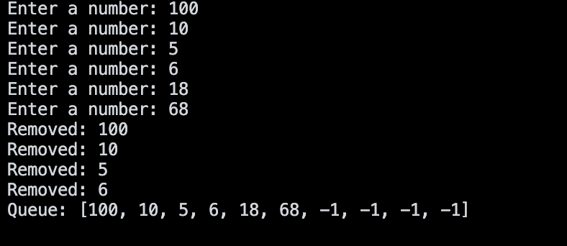

Question 2
2(a)
class ToyRecord:
def __init__(self, ToyName, NumberBricks, Difficulty, Category):
self.__ToyName = ToyName
self.__NumberBricks = NumberBricks
self.__Difficulty = Difficulty
self.__Category = Category

def GetToyName(self):
return self.__ToyName

def GetNumberBricks(self):
return self.__NumberBricks

def GetDifficulty(self):
return self.__Difficulty

def GetCategory(self):
return self.__Category

2(b)(i)
def ReadData(ToyArray):
try:
with open(file_path, 'r') as f:
data = f.read().strip().split('\n')

for i in data:
ind = i.split(',')
ToyArray.append(ToyRecord(ind[0], ind[1], ind[2], ind[3]))
return ToyArray
except Exception as e:
print(f"Error: {e}")

.
2(b)(ii)
def OutputToys(ToyArray):
for i in ToyArray:
print(f'Name: {i.GetToyName()}')
print(f'NumberBricks: {i.GetNumberBricks()}')
print(f'Difficulty: {i.GetDifficulty()}')
print(f'Category: {i.GetCategory()}\n')

2(b)(iii)
ToyArray = [] #Data type Record
ToyArray = ReadData(ToyArray)
OutputToys(ToyArray)

2(b)(iv)
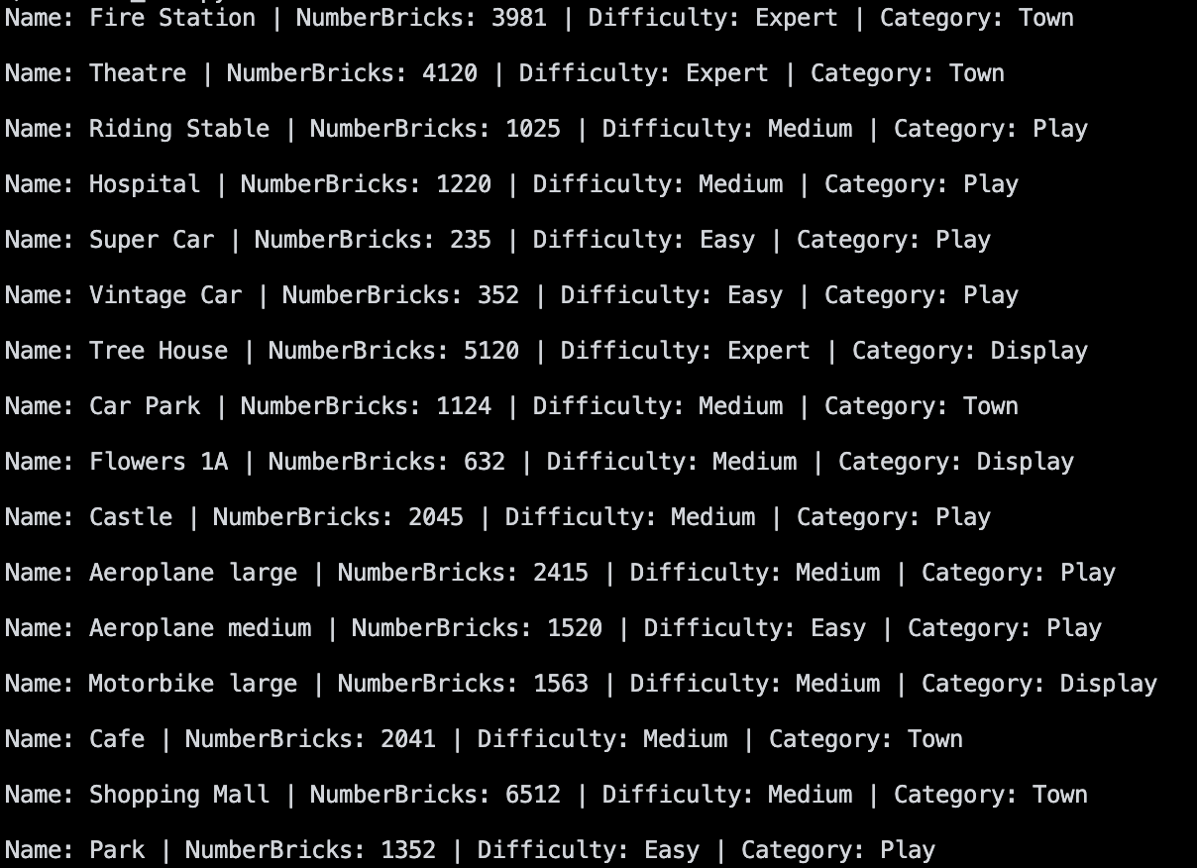
.
2(c)(i)
def SearchToys(ToyArray):
user_input = str(input("Enter a difficulty: "))

while user_input.lower() not in ['easy', 'medium', 'expert']:
user_input = int(input("Invalid input. Retry"))

diffarr = []
for i in ToyArray:
if i.GetDifficulty().lower() == user_input.lower():
diffarr.append(i)

return diffarr

2(c)(ii)
def WriteToys(ToyArray):
with open('SelectedToys.txt', 'w') as f:
for i in ToyArray:
f.write(f'{i.GetToyName()},{i.GetNumberBricks()},{i.GetDifficulty()},{i.GetCategory()}\n')

2(c)(iii)
WriteToys(SearchToys(ToyArray))

2(c)(iv)
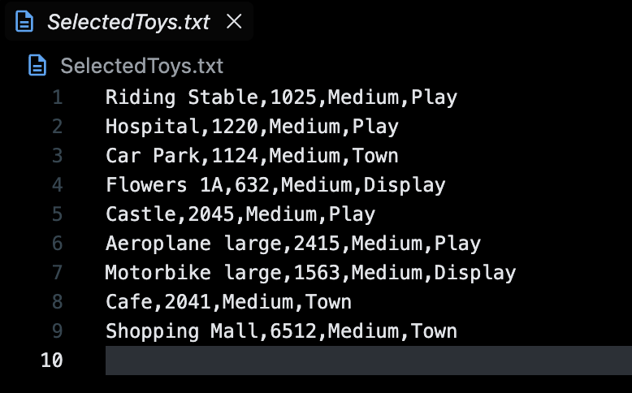

Question 3
3(a)(i)
class TheObject:
def __init__(self, ObjectType, Amount):
self.ObjectType = ObjectType #String
self.Amount = Amount #Integer

3(a)(ii)
class Path:
def __init__(self, NumberSpaces):
self.BoardArray = [TheObject('', -1) for i in range(100)] #TheObject
self.NumberSpaces = NumberSpaces #Integer

def GetNumberSpaces(self):
return self.NumberSpaces

3(a)(iii)
def InitialiseData(self, TheObjArray):
if self.NumberSpaces < len(TheObjArray):
return False

for index, item in enumerate(TheObjArray):
self.BoardArray[index] = item
self.NumberSpaces -= 1

return True

3(a)(iv)
def ReturnPath(self):
string = ""
for item in self.BoardArray:
if item.Amount != -1:
string += f"{item.ObjectType}-{item.Amount} "

return string

3(a)(v)
def GetPathObject(self, index):
return self.BoardArray(index)

3(b)(i)
ArrayOfObjects = [
TheObject("Money", 50),
TheObject("Expereince", 100),
TheObject("Money", 200),
TheObject("Money", 20),
TheObject("Experience", 30)
]

Path1 = Path(5)
Path1.InitialiseData(ArrayOfObjects)
print(Path1.ReturnPath())

3(b)(ii)

