Thirty years after translocation: genetic and morphological changes in the source and reintroduced populations of Phengaris (Maculinea) teleius butterflies.
Daniel Sánchez-García^{1,*}, Luca Pietro Casacci², Irma Wynhoff³, Joanna Kajzer-Bonk⁴, Anna Sztencel-Jabłonka¹, Piotr Nowicki⁵, and Magdalena Witek¹
¹ Museum and Institute of Zoology, Polish Academy of Sciences, ul. Wilcza 64, 00-679 Warsaw, Poland
² Department of Life Sciences and Systems Biology, University of Turin, Via Accademia Albertina 13, 10123 Turin, Italy
³ Dutch Butterfly Conservation, P.O. Box 506, 6700 AM, Wageningen, The Netherlands
⁴ Institute of Zoology and Biomedical Research, Faculty of Biology, Jagiellonian University, Gronostajowa 7, Krakow 30-387, Poland
⁵ Institute of Environmental Sciences, Faculty of Biology, Jagiellonian University, Gronostajowa 9, Krakow 30-387, Poland
* Correspondence: Daniel Sánchez-García <danielsangarci@gmail.com>
Keywords:

Abstract

Introduction
Evolutionary changes are driven by selective pressure on genetically variant individuals. According to Darwin’s theory, populations of organisms are closely adapted to their habitats but any environmental disturbance can change the selective pressure. Nowadays, extensive anthropogenic alterations of the environment like global warming, urbanization, pollution, agricultural intensification and habitat fragmentation lead to biodiversity loss and high population or species extinction risk (Ceballos et al. 2015).
Currently, one of the most rapidly declining group of animals are insects (e.g., Hallmann et al. 2017, Habel et al. 2019, Raven and Wagner 2021). This trend can be even stronger for specialist species Nilsson et al. (2008) and those living in more complex ecological networks (e.g., mutualistic or parasitic ones). Closely interacting species are more vulnerable to environmental changes, because their survival depends on the persistence of other organisms and is maintained by complex adaptations; thus, coextinction processes are more likely to occur in such cases (e.g., Koh et al. 2004, Kehoe et al. 2021). While coevolution can mitigate the negative effects of habitat loss and fragmentation in mutualistic networks by creating new opportunistic interactions (Gawecka et al. 2022), host-parasite systems are more vulnerable to habitat changes (Grass et al. 2018). In this perspective, when reintroducing a parasitic species not only the parasite itself, but also the host species must be taken into account to increase the probability of success (Wynhoff et al. 2011).
Reintroduction is popularly used in conservation biology as a tool to recover a species loss after local extinction in a specific ecosystem (Seddon et al. 2014), also aiming at restoring ecological processes. Reintroduction biology is considered an applied science, with the aim of offering knowledge about the management strategies to implement animal and plant translocations (Taylor et al. 2017), but reintroduction events can also represent great opportunities to study evolutionary changes in populations translocated to new habitats with different characteristics. For instance, it was demonstrated that the anadromous threespine stickleback (Gasterosteus aculeatus) reintroduced in Alaska needed only one generation to show changes in morphology (Wund et al. 2016) and in the American marten (Martes americana) reintroduced in the Upper Peninsula of Michigan morphological variation was detected after 45 years since reintroduction (Howell et al. 2016). The changes occurring in such a relatively short evolutionary time prove the potential of studying phenotypic plasticity and/or adaptations after reintroductions.
During the last decades, in certain European countries butterflies experienced greater losses than vascular plants and terrestrial vertebrates (Thomas et al. 2004) and among insects, they were the most frequently translocated species with about 50 translocations (~40 %) involving this taxon (Bellis et al. 2019). Generally, butterfly reintroduction appears to be a complicated process and many populations became extinct during the first five years after releasing the butterflies (Oates and Warren 1990), mostly because of the poor knowledge of factors contributing to population decrease, the lack of specific ecological requirements in the new habitat or the small number of translocated individuals and the resulting consequences of the Allee effect (Dempster and Hall 1980, Deredec and Courchamp 2007, Thomas et al. 2009). Nevertheless, two of the most spectacular and successful reintroductions in insect conservation history have been implemented for the myrmecophilous butterflies of the genus Phengaris (Maculinea); P. arion was reintroduced in the United Kingdom from a Swedish population between 1983 and 1992 (Thomas et al. 2009, Andrews 2015) and P. teleius was reintroduced in the Netherlands from a Polish population in 1990 (Wynhoff 1991). Phengaris butterflies have very specialized lifecycle as they are social parasites of ants and their larvae require two resources: species-specific foodplants and Myrmica host ants (Elmes and Thomas 1992). In the case of P. teleius, females lay eggs on Sanguisorba officinalis flowerheads where caterpillars remains for about three weeks. After reaching the fourth instar, it abandons the host plant and must be taken by a Myrmica ant to its nest for further development (Thomas 1984). P. teleius has the widest host range among all Phengaris species, but Myrmica scabrinodis seems to be its main host (Thomas et al. 1989, Tartally et al. 2019).
The successful reintroduction of P. teleius in the Netherlands was the consequence of the translocation of eighty-six butterflies taken from a Polish population to the Dutch nature reserve of Moerputten in 1990. Nowadays, the Dutch population consists of about a few thousand butterflies (Wynhoff and Sevilleja 2018). In both Poland and the Netherlands, butterflies live in a metapopulation system. A difference of almost thirty butterfly generations between the original Polish and the reintroduced Dutch population offers a great and unique opportunity to study various changes of P. teleius butterflies which have occurred in both populations. The main objective of our study was to evaluate if the descendants of the translocated individuals have retained the characteristics of the source population or if they have changed and adapted to the new conditions in a relatively short evolutionary time frame. In our study, we performed multilevel comparisons among the source (from 1990) and current Polish and reintroduced current Dutch populations of P. teleius by investigating (i) population genetics, and (ii) morphology of adult butterflies. We also assessed the metapopulation connectivity of our study systems along the time. We hypothesize that the reintroduced population is characterized by lower genetic variation compared to the source population, and that after thirty years of separation a genetic divergence has occurred. We also hypothesize that different biotic and abiotic conditions, e.g. population size, habitat structure, availability of host plants and Myrmica host ant community, have influenced the two populations in a different way affecting the morphology of adult butterflies. As insufficient landscape connectivity may lead to selection pressure on increasing or decreasing dispersal and morphological traits responsible for that (Bonte et al. 2012), we expected changes in body size and wing size of adults from the populations where connectivity was poor or decreased.

Material and methods

Study site of the source and current Polish population - Kostrze meadows in Poland
The studied Phengaris (=Maculinea) teleius butterfly population occurs in the Vistula River Valley in the Kostrze area, part of the outskirts of Kraków city in South Poland (50º01’N, 19º54’E). The landscape of this valley is composed mostly of abandoned or rarely extensively managed grasslands, arable fields, forests, and settlements (Kajzer-Bonk et al. 2016). The habitats of the focal butterfly species are a part of a large meadow complex with an area exceeding 200 ha and consisting of several dozens of nutrient-poor to mesotrophic meadows with varying densities of S. officinalis. These meadows are a part of one of the best studied metapopulation systems of this butterfly species in Europe (Nowicki et al. 2007, Kajzer-Bonk and Nowicki 2022). The three investigated meadows (K10, K1 and K25) are characterized by relatively large areas (2.4, 6.2 and 33.3 ha, respectively), with the two latter partially mown. All three patches are located close to each other (ca. one hundred meters), with the biggest patch (K25) separated from the two smaller ones by a highway. These meadows are exactly the sites where in 1990 the adult butterflies were collected for reintroduction. Recently, they are partly or entirely included in the Natura 2000 “Dębnicko-Tyniecki Meadow Area”, and comprise stable sub-populations with high densities of P. teleius butterflies. The estimated yearly population numbers reach several dozens of thousands of individuals in each of the considered habitats. They face increasing urbanization pressure, due to growing human settlement and infrastructure (Kajzer-Bonk and Nowicki 2022), including the opening of a highway in 1993.

Study site of the reintroduced population - Moerputten nature reserve in the Netherlands
The nature reserve Moerputten (115 ha) is located south of the city of ’s-Hertogenbosch (The Netherlands) and covers the central part of the Natura 2000 area “Vlijmens Ven, Moerputten and Bossche Broek” (931 ha), (51°41’N, 5°15’E, altitude 2 m above sea level). The nature reserve consists of a central lake, surrounded by tall beds of Phragmites, Typha and tall Carex species. Around these, moist forests of Alnus and various Salix species are present nowadays. On the outer borders of the nature reserve, partially within the forest, different types of grasslands are found, of which the hay meadows with a high abundance of S. officinalis are the most important habitat of P. teleius. Meadow vegetation that is classified as belonging to the assemblage Junco-Molinion, locally with characteristics of Arrhenaterion on dry sites, or Filipendulion on moist sites, for a detailed description of the site see Wynhoff (1998). Nowadays, the area of wet meadows in Moerputten nature reserve has been enlarged with 250 ha of restored fen meadows in neighbouring nature reserves with the aim of enlarging both the rare vegetation as well as the habitat of the butterfly (Wynhoff et al. 2017, Sevilleja et al. 2022).
The historical population of P. teleius in the Netherlands went extinct in 1976, but the species was reintroduced in 1990 on the moist meadows of Moerputten nature reserve (Wynhoff 1998), after detailed studies revealed that this was the only suitable site for this butterfly species in the Netherlands. The reintroduced population consisted of 33 males and 53 females. Recently, P. teleius is restricted to one core population on the meadows at the southern border of the core reserve and two to three subpopulations on other meadows within the nature reserve. We conducted the study at three closely located meadows (BW, PHZ, KBW) characterized by areas of …… , and ha, respectively. Since reintroduction, P. teleius butterflies were recorded on locations at a distances of more than 500 m from the core population (Van Langevelde and Wynhoff 2009).

Metapopulation connectivity
In order to evaluate the changes in the spatial structure of both P. teleius metapopulations over the investigated period, we used Hanski’s connectivity index $I_{4}$ (Hanski 1994), which calculates the connectivity of a given habitat patch (i) based on the distances $d_{ij}$ (in km, measured between patch centres) separating it from other patches in the system (j = 1 to k; j ≠ i) and their areas $S_{j}$ (in ha):
$$I_{4}=∑exp\left(-αd_{ij}\right)S_{j}^{a} \left(1\right)$$
where $α$ and a are species specific scaling parameters. The parameter $α$ (distance dependence) reflects the chances of individuals to reach particular distances, while a (immigration scaling) describes how the chances of immigration to other patches depend on their sizes. The values of $α$ = 6.6 and a = 0.54 were adopted after Nowicki et al. (2014), where they were derived through dispersal analysis for P. teleius in the Polish metapopulation, but also proved typical for other metapopulations of this species in predominantly grassland landscapes. Hanski’s connectivity index was first calculated separately for each patch. Subsequently, in order to assess the average connectivity level within each metapopulation in a given year, we calculated its mean value for all the existing patches as well as the weighted mean, with weights proportional to the patch area-based carrying capacity (and thus also to potential population size) for P. teleius and defined as $S_{i}^{b}$, where b = 0.67 after Nowicki et al. (2007). The calculations were conducted for each year between 1990 and 2021 for the Dutch metapopulation, but in the Polish metapopulation they were restricted to the period starting from 2001, where the habitat patches were mapped for the first time. Nevertheless, we should stress that prior to this year the spatial structure remained mostly unchanged for at least 10-20 years. It is worth noting that whenever some patches are completely lost and/or partly reduced in size between years, then the connectivity within the metapopulation should normally decrease, but occasional slight increases are possible in the cases when only very isolated patches (thus of little value for the connectivity of other patches, but at the same time negatively affecting the mean value) are lost. Similarly, the emergence of new habitat patches in a metapopulation system should normally lead to increased connectivity, although exceptions from this general rule are possible.

Experimental design and sampling
Data were collected from two populations (Polish and Dutch) and from different moments in time: in 1990 (the year of the reintroduction of the butterflies), from the source population from Poland (= PL1990), in 2019 from the current population from Poland (= PL2019) and in 2020 from the reintroduced population in the Netherlands (= NL2020). The individuals which did not survive the trip for the reintroduction in 1990 were dried and preserved (n = 65). The wings from these individuals were digitally photographed and used for morphological analysis (see below).
Altogether, 121 butterflies were captured with entomological nets in Kostrze and 120 in Moerputten. After capture, each butterfly was put into a small jar and treated with carbon dioxide for ten seconds to anesthetize it. Then the butterfly was placed on millimetric paper and photographs of the left and right sides were taken using a Nikon D7200 camera and a Laowa 100 mm f/2.8 2x Ultra Macro APO lens. Photos were used later for geometric morphometric analyses. Next, the butterfly thorax width was measured with a calliper and then the butterfly was placed into a small paper bag and weighed with an Ohaus Scout (SKX123) balance the nearest ± 1 mg. Next, we removed 2–3 mm² of the left hind wing to obtain material for further genetic analysis. This is considered a non-destructive sampling method with no negative effect on the flight ability or the behaviour of the butterflies (Hamm et al. 2010). Finally, the butterflies were marked with a fine-tipped waterproof Stabilo pen on the ventral part of the right fore wing to prevent re-sampling of the same individual. All butterflies were released at the place of capture when they were fully awake again.

Wing morphometry assessment
A total of 277 butterflies (PL1990: n = 65, PL2019: n = 119, NL2020: n = 93) were used for studying the wing morphology of the hind wing. Landmarks were digitized with the software tpsDig v.2.32 (Rohlf 2018). A combination of landmarks and sliding semilandmarks (Bookstein 1997) was applied to study the vein intersections (5 landmarks) and the outline of the wings (9 landmarks and 17 semilandmarks) (Figure 6). As landmarks we considered points that could be precisely identified, while the semilandmarks were allowed to slide equidistantly along the outline trajectory.The landmarks and semilandmarks were used to estimate both wing shape and centroid size, as the square root of the sum of squared distances of all the coordinates, being the most appropriate measure for overall size (Bookstein 1997).
Landmark oversampling for centroid size and shape analysis was tested by performing the Landmark Sampling Evaluation Curve (LaSEC) with 99 iterations using the lasec() function (Watanabe 2017). This performs an ordinary Procrustes alignment to superimpose the distribution of specimens in the subsampled data to that of the full dataset and calculate the degree of congruence between subsampled and full data sets by performing a Procrustes Sum of Squares (PSS) as a measure of fit. The minimum number of landmarks to reach a fit $≥$ 0.95 were 16 for the centroid size and 25 for shape, so oversampling was not considered.
To obtain shape variables from landmark data, a Generalized Procrustes Analysis (GPA) was performed using the gpagen() function (Baken et al. 2021, Adams et al. 2022). Then, directional asymmetry was tested for shape and centroid size differences between the left and right wings using the bilat.symmetry() function (Baken et al. 2021, Adams et al. 2022). No differences were found, allowing to use for the statistical analysis either the left wing, or if absent, the right one (Table 5 and 6).
The outliers were selected and removed using the plotOutliers() function in which the individuals are ordered by their Procrustes distances from the mean shape (Baken et al. 2021, Adams et al. 2022). All specimens above the upper quartile were considered outliers and consequently removed from the dataset (n = 2). Additionally, to account for the impact of uneven sample size for wing shape analysis, the number of individuals of each group was randomly constrained by the group with the smallest sample size (females: n = 34, males: n = 30).

Study of genetic structure of populations: DNA extraction and microsatellite amplification
The total number of butterfly samples used for genetic analysis was n = 118 for the current Polish population (PL2019) and n = 134 for Dutch population (NL2020). The material was collected in the above-described meadows in Poland (n_{K1} = 30, n_{K10} = 30 and n_{K25} = 58) and in the Netherlands (n_{KBW} = 54, n_{PHZ} = 32 and n_{BW} = 49). Genomic DNA was extracted by homogenizing the wing fragment in a solution of 100 μl 5% chelex and 1 μl of proteinase K. The samples were firstly incubated at 56°C for 3 hours, and secondly at 95°C for 15 min., then centrifuged at 13000 rpm for 10 min. Then, 40μl of supernatant was stored at -20 °C. Butterflies were assayed at 17 microsatellite markers: Macu: 1, 3, 8, 9, 11, 15, 16, 26, 31, 44 and Macari: 2, 5, 16, 18, 19, 22, 23 (Zeisset et al. 2005, Ugelvig et al. 2011, Ugelvig et al. 2012, Andersen et al. 2014). Four sets of multiplex reactions were used with the forward primers labeled. The PCRs were performed in a total volume of 15 μl composed of 1 μl of DNA template, Multiplex PCR Master Mix (Qiagen), water and primers. For PCR amplification, a thermal cycler (Applied Biosystems) was used with the following PCR profile: 95 °C for 15 min., then 35 cycles of: 94 °C for 30 s, 52 °C or 56 °C or 58 °C (depending on the multiplex) for 90 s, 72 °C for 90 s, with the final elongation of 72 °C for 30 min. PCR products were run on an ABI 3500 xL automated sequencer with the GeneScan™ 600 LIZ® Size Standard and analysed using GENEMAPPER 4.1 (Applied Biosystems).

Morphometric statistical analysis
Butterfly weight, thorax width and hind wing size were analyzed for the two current populations with a generalized linear model applying as predictor variable the population (for instance, weight ~ population) by using the glm() function (R Core Team 2022). Wing size, estimated as centroid size, was also pairwise-compared by performing estimated marginal means (EMMs) test by using the emmeans() function (Lenth 2023).
The ratios of body weight/centroid size and thorax width/centroid size were also analyzed for the two current populations with a generalized linear model, applying the population as predictor variable (e.g., weight/centroid size ~ population) by using the glm() function (R Core Team 2022).
The differences in the wing shape among populations and allometry were tested by using the ProcD.lm() function (Baken et al. 2021, Adams et al. 2022), which performs a Procrustes ANOVA with permutation for describing patterns of shape variation and covariation for a set of Procrustes shape variables. The model was built using as predictor variables the logarithm of the centroid size and the population. A pairwise comparison was also performed between populations by applying a estimated marginal means (EMMs) test by using the function pairwise() (Collyer and Adams 2018, Collyer and Adams 2022). The effect of allometry was removed from the pairwise comparison by using shape ~ log(centroid size) as the null model. The morphological disparity between groups was also studied by using the morphol.disparity() function (Baken et al. 2021, Adams et al. 2022) which performs a pairwise comparison among groups using residuals of a linear model fit to estimate the Procrustes variance.

Genetic structure of populations - statistical analysis
Analyses were carried out on two levels: 1) large regional scale (comparing Polish and Dutch populations: n_{PL} = 118 and n_{NL} = 134) and 2) local scale (comparing the subpopulations in three meadows in each region separately). To check if loci and groups were in Hardy-Weinberg Equilibrium (HWE), we used an exact probability test (Markov chain parameters: 10,000 dememorizations, 100 batches, 1,000 iterations per batch), with Bonferroni correction (Rice 1989), implemented in GENEPOP on the Web version 4.7 (Raymond and Rousset 1995, Rousset 2008). Genotyping data were checked for amplification errors (large allele dropout, stuttering, and null alleles) using MICRO-CHECKER version 2.2.3 (Van Oosterhout et al. 2004). Linkage disequilibrium for all loci pairs was checked in FSTAT (Goudet 1995, Goudet 2001). FSTAT was also used to assess basic population parameters as: number of alleles, allelic richness (AR), observed heterozygosity (H_{O}), expected heterozygosity (H_{S}) and F-statistics (F_{IS} and F_{ST}). Allelic richness was calculated using the refraction method for n = 28. Differences between the current Polish and Dutch populations were assessed by a two-sided permutation test with 1,000 permutations in FSTAT. Allelic patterns, mean values with standard error of allele number, number of alleles with frequency over 5%, number of private alleles, and genetic distance matrix for individuals (used later for Mantel test with morphometric data) were calculated in GenAlEx6.5 (Peakall and Smouse 2012). To infer about a possible number of genetic clusters a Bayesian clustering approach implemented in Structure 2.3.4 (Pritchard et al. 2000, Falush et al. 2003, Hubisz et al. 2009) was used with ancestry admixture model with correlated frequencies, with and without sampling location as prior information, with 100,000 Markov chain Monte Carlo (MCMC) replicates in each run, 50,000 MCMC after burn-in, and 10 replicate runs for each K (from 1 to 8). To determine the final number of clusters the Evanno method was used (Evanno et al. 2005) as implemented in Structure Harvester (Earl and VonHoldt 2012). The final plot presented shows an average from 10 iterations for results with location as prior information. Effective population size was assessed for each population in LDNE (Waples and Do 2008). This software facilitates calculations with different thresholds for the lowest allele frequencies considered, we present results for threshold 0.02 as an intermediate solution. To test the hypothesis of a bottleneck we used Bottleneck 1.2.02 (Piry et al. 1999). We present results for the two-phase model (TPM) with 30% of infinite alleles model (IAM) and 70% of stepwise mutation model (SM), again on the basis of the rationale of intermediate solution fitting to the reality best (see also discussion: Piry et al. (1999)).

Results

Body weight and thorax width analysis
Adult females of P. teleius had a higher body weight in the current Polish population (PL2019) than in the Dutch one (NL2020), but males did not present any difference between populations (GLM, females: $χ^{2}$ = 11.13, p < 0.001; males: $χ^{2}$ = 0.2, p = 0.655; Figure 1). The thorax width was statistically bigger in the current Polish butterflies than in the current Dutch population in both sexes (GLM, females: $χ^{2}$ = 17.65, p < 0.001; males: $χ^{2}$ = 8.74, p = 0.003; Figure 1).
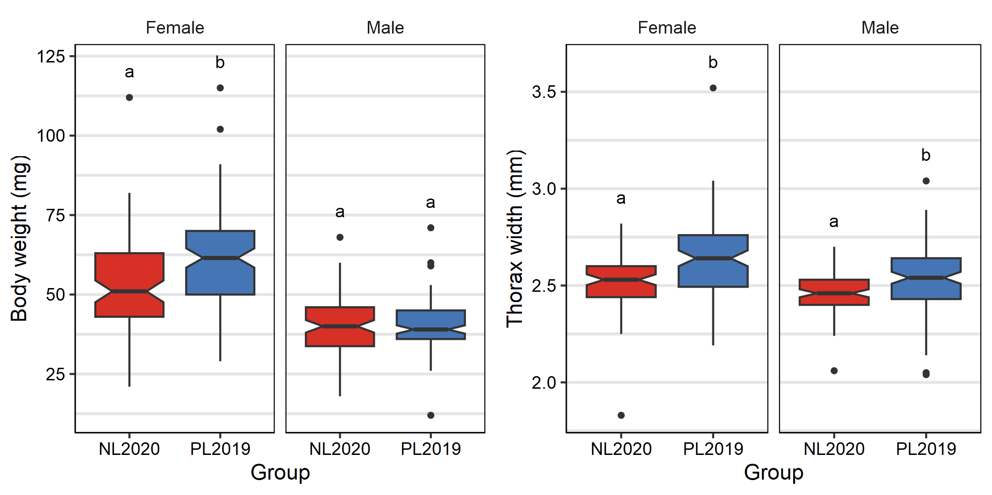
Figure 1: P. teleius butterfly weight and thorax width in the current population from Poland (PL2019; blue) and the Netherlands (NL2020; red) for females and males. The boxes depict the interquartile range, and horizontal black lines indicate median values. Vertical black lines extend from the minimum to the maximum non-outlier values and black dots indicate the outliers. Different letters in the top of the boxplots indicate statistically significant differences between groups.

Hind wing size analysis
The analysis of the hind wing size demonstrated differences between groups coming from different populations and years (PL1990, PL2019, NL2020) for both females and males (GLM, females: $χ^{2}$ = 68.87, p < 0.001; males: $χ^{2}$ = 30.73, p < 0.001). The wing size of the females is significantly different between all three studied populations. Females from the current Polish population (PL2019) have the largest wings, while females from the Polish source population (PL1990) have the smallest ones. The size of the hind wings of the recent Dutch population lies in between. Similarly, males from the current Polish population have the largest wings like females, while no statistical significance in hind wing size between the Polish source population and the current Dutch one (NL2020) could be found (Figure 2; Table 3).
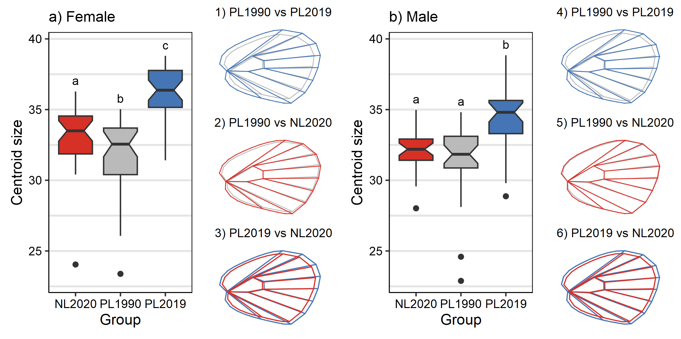
Figure 2: Hind wing size comparison of P. teleius a) females and b) males coming from the source (PL1990; grey) and current Polish (PL2019; blue) and reintroduced Dutch (NL2020; red) populations. The boxes depict the interquartile range, and horizontal black lines indicate median values. Vertical black lines extend from the minimum to the maximum non-outlier values and black dots indicate the outliers. Hind wing graphical representation shows differences in size between each pairwise comparison. Different letters at the top of the boxplots indicate statistically significant differences between groups based on EMMs (estimated marginal means) test results (see Table 3).
The ratio between centroid size and body weight did not show any diffenrece between the two current P. teleius populations for either females nor males (GLM, females: χ2 = 2.85, p = 0.091; males: χ2 = 2.36, p = 0.125; Figure 7). Likewise, the ratio between centroid size and thorax width also did not show any difference between the two current populations for neither females nor males (GLM, females: χ2 = 0.06, p = 0.8; males: χ2 = 0.05, p = 0.83; Figure 7).

Hind wing shape analysis
Both females and males showed differences in hind wing shape among groups coming from the source (PL1990), current Polish (PL2019) and reintroduced Dutch (NL2020) populations (Procrustes ANOVA, females: Z = 5.651, p = 0.001; males: Z = 5.624, p = 0.001; Figure 3). Differences in shape are partially explained by the change in centroid size, showing an allometric effect (Procrustes ANOVA, females: Z = 3.157, p = 0.001; males: Z = 1.632, p = 0.05; Figure 8). All shape pairwise comparisons showed statistically significant differences for both females and males (Table 4), with both sexes from the current Polish population (PL2019) showing a higher level of shape variability when compared with the Polish source (PL1990) and current Dutch (NL2020) populations (Table 1).
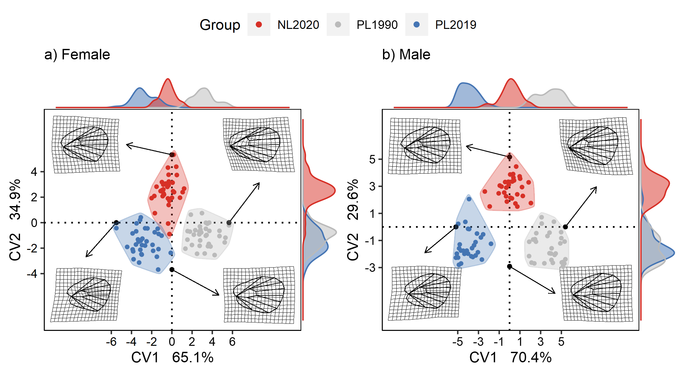
Figure 3: Procrustes CVA shape representation of P. teleius butterfly hind wings (females on the left and males on the right) coming from the Polish source (PL1990, grey), current Polish (PL2019, blue) and Dutch (NL2020, red) populations. The axis densigrams represent the distribution of each canonical variate. The black dots and hind wing graphical representation indicate the most extreme values of each canonical variate and its correspondent estimated wing shape.
Table 1: Morphological disparity test results for female and male hind wing shape pairwise comparison between the different studied populations (PL1990, PL2019, NL2020).
 | Femalesª |  |  | Malesª
 | PL1990 | PL2019 |  | PL1990 | PL2019
NL2020 | 0.640 | 0.049* | NL2020 | 0.849 | 0.005**
PL1990 |  | 0.022* | PL1990 |  | 0.013*
ªFemale Procrustes variances:
NL2020 = 0.0013; PL1990 = 0.0012; PL2019 = 0.0017
ªMale Procrustes variances:
NL2020 = 0.0011; PL1990 = 0.0011; PL2019 = 0.0016
*p ≤ 0.05, **p ≤ 0.01, ***p ≤ 0.001

Metapopulation connectivity
The results of connectivity changes over the years in both investigated metapopulations are given in Figure 9. They clearly indicated a gradual, although relatively slow, decrease in the connectivity in the Polish metapopulation, apparently due to the loss of habitat patches through direct destruction (conversion to build-up areas, or less frequently afforestation) or through natural succession leading to meadow vegetation overgrowth and disappearance of S. officinalis foodplants (cf. Kajzer-Bonk and Nowicki 2022). In turn, the connectivity in the Dutch metapopulation remained relatively stable for a long period till mid 2010s, but then sharply increased thanks to the successful habitat restoration programme (Wynhoff et al. 2017, Sevilleja et al. 2022). Most importantly, the results revealed that in mid 1990s when the reintroduction of P. teleius in the Netherlands occurred, the connectivity of its habitat patch system was already substantially greater than that of the Polish metapopulation from which the reintroduced individuals originated.

Genetic structure of the current Polish and Dutch populations
Five out of 17 studied microsatellites proved to be monophyletic in both populations: Macari 5 (value 148), Macari 16 (value 168), Macari 18 (value 107), Macu 26 (value 90), Macu31 (value 104). Loci Macu1 and Macari44 were not in HWE (p = 0.000). Loci Macari44 had null alleles (with frequencies 0.11 for the Polish and 0.05 for the Dutch population). Linkage disequilibrium was found only for one loci pair, i.e. Macari19 and Macari44. Some signs of null alleles were also detected in Macu15, but with low frequency (0.08) and only for one Polish meadow (25) when groups were analyzed separately. Some discrepancy from HWE (heterozygosity excess) was noted for Macari 3, but on the verge of statistical significance and only in two meadows. Therefore, these two loci were not excluded from the analyses. Finally, nine loci (Macu3, Macu8, Macu9, Macu11, Macu15, Macu16, Macari02, Macari22, Macari23) were chosen for further analyses. There were no significant differences between Polish and Dutch populations regarding allelic richness, observed heterozygosity H_{o}, expected heterozygosity H_{e}, inbreeding coefficient F_{IS} and genetic diversity F_{ST} (Table 2).
Table 2: Comparison of genetic parameters between Polish and Dutch populations.
 | PL | NL | pª
AR | 4.58 | 2.92 | 0.062
H_{O} | 0.33 | 0.44 | 0.112
H_{S} | 0.34 | 0.43 | 0.083
F_{IS} | 0.03 | -0.02 | 0.138
F_{ST} | 0.01 | 0.02 | 0.378
ª *p ≤ 0.05, **p ≤ 0.01, ***p ≤ 0.001
However, the difference in allelic richness (AR) was near significance level (p = 0.06), and the Polish and Dutch population differed more than two-folds in number of alleles (62 vs. 30, respectively). Mean value of allele number was 6.89 ± 2.02 (SE) in Poland and 3.33 ± 0.67 in the Netherlands, number of private alleles 3.56 ± 1.43 vs. 0 ± 0.0, whereas number of alleles with frequencies over 5% was 2.78 ± 0.70 vs. 2.67 ± 0.47. Many of the alleles occurring with low frequencies in the Polish population were not found in the Dutch population. Also a founder effect can be seen, as some alleles of low frequencies in Poland increased their frequency in the Netherlands. More detailed changes in allelic pattern can be seen on Figure 4 (for instance loci Macari 16 with 21 alleles in Poland and 7 in Netherlands).
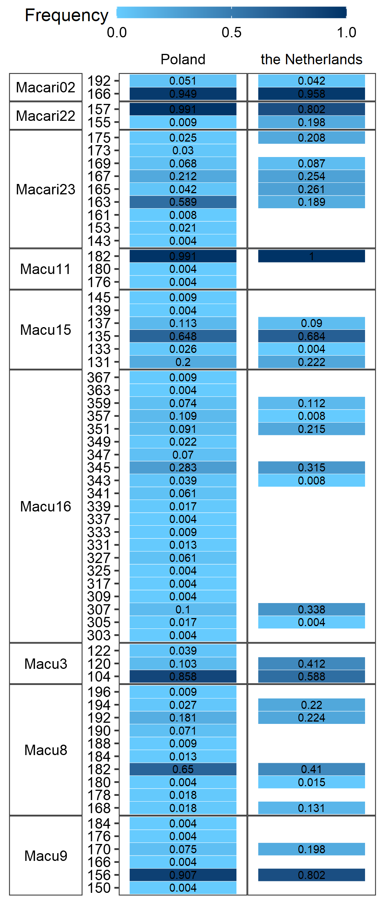
Figure 4: Allele frequencies of the 9 studied microsatellites for the Polish and Dutch P. teleius populations. Microsatellite names are expressed in the first column, while the second column indicate the length of each allele. The color intensity and the number on it indicate the frequency of each allele per loci.
Genetic distances F_{ST} between all meadow subpopulations were low to moderate (from 0.003 to 0.126; Table 7) but significantly different except for the F_{ST} between meadow 1 and 10. All genetic distances were low within Polish and Dutch populations and moderate in cross population comparisons.
No structuring was found in either of the populations; the only well-grounded divide found (based on the rate of change in the log probability) was between the Polish and Dutch population with all individuals showing levels of admixture lesser than 10% (Figure 5).
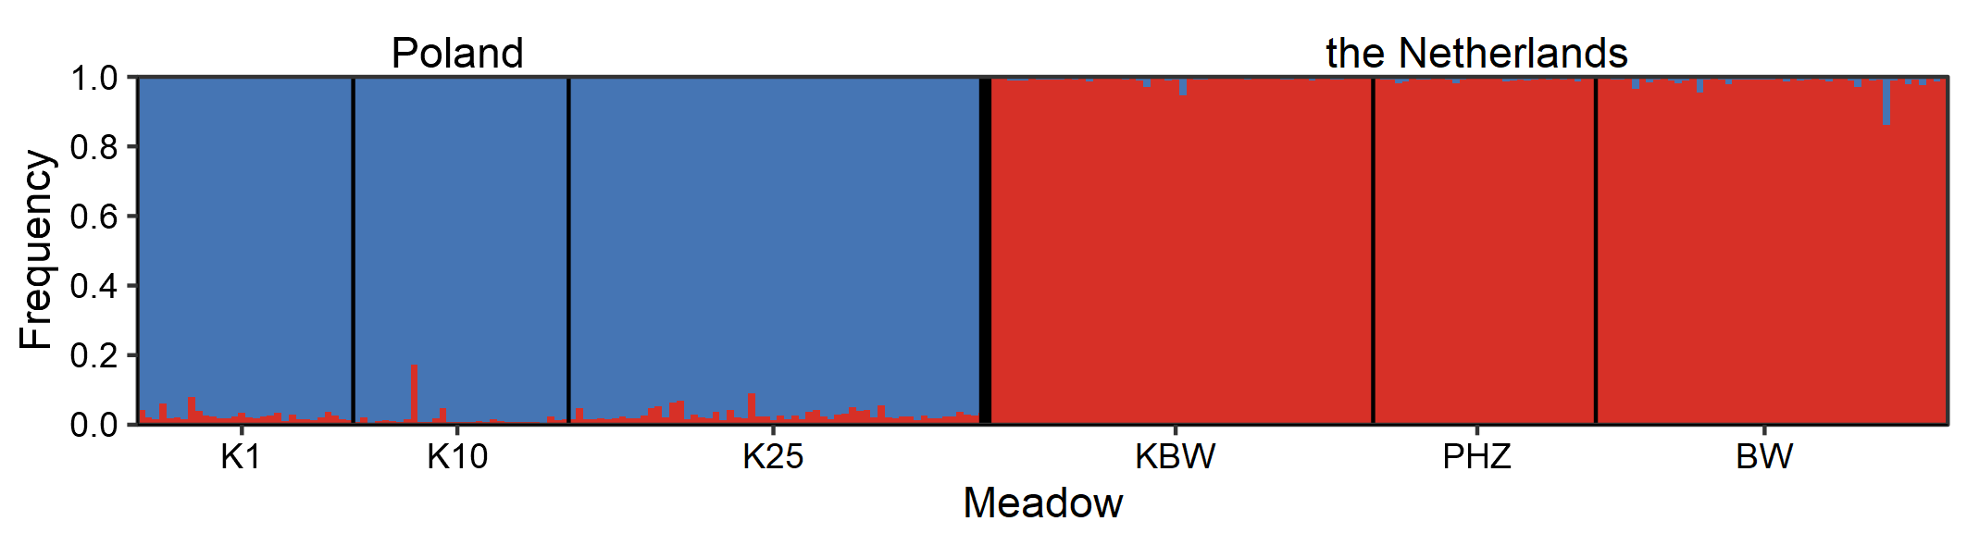
Figure 5: Cluster membership for P. teleius individuals from each sampling site identified using Structure analysis with location as prior information. Individuals are represented by vertical bars, with the colors showing the probability of assignment to different genetic clusters. Cluster membership is based on K = 2 clusters and the average of 10 iterations, which had the highest likelihood. Names of sampling sites are given above the membership diagram.
No signs of population size reduction (bottleneck) was found in the Polish population, but it was found in the Dutch population (p-value of Wilcoxon test for heterozygosity excess over number of alleles hypothesis was 1 for the Polish and 0.005 for the Dutch population). Estimated effective population size amounted to 1165 (Interval of confidence: 177-∞) for the Polish population and 167 (Interval of confidence: 69-4301) when loci over frequency 0.02 were taken into account.

Discussion
Our results demonstrated that after almost three decades of separation between the source and reintroduced populations of P. teleius morphological and genetic changes are observed in both populations. After thirty years of independent development in different types of habitat and under different climatological conditions, differences between the studied populations are expected. Since the translocated butterflies have undergone mostly environmental changes, the reintroduced population was expected to show greater changes since the moment of separation with respect to the source population. Contrary to our expectations, a greater morphological change has been detected in the current Polish population. Polish butterflies have become generally bigger; females are heavier than the ones of the current Dutch population, both sexes have bigger thorax width and much larger hind-wing size. Females of both populations show an increase in wing size compared to the source population, while in the Dutch population the wing size of the males did not change. For both females and males the wing shape changed between all our studied populations. As we expected, genetic changes are in line with our assumptions, with the reintroduced and current populations being genetically different after thirty years of separation. The reintroduced population has a slightly lower genetic variation, probably as a result of a past bottleneck.
Such observed changes suggest that both P. teleius populations were affected by various selective pressures whose strength and synergistic effects can differ between populations. In both places, P. teleius occurs in a metapopulation system but the size of these metapopulations is very different; in the Netherlands it is estimated at about a thousand butterflies (Wynhoff and Sevilleja 2018), whereas the size of the Polish metapopulation is estimated at 70 thousand individuals (Kajzer-Bonk et al. 2013). The area of the Dutch nature reserve is twice smaller (115 ha) than the area of suitable habitats in Poland (185 ha), and P. teleius in the Netherlands is restricted to one core population and two to three small subpopulations on other meadows (Wynhoff et al. 2017), whereas currently in Poland P. teleius occupies 33 patches (Kajzer-Bonk and Nowicki 2022). Previously collected data showed that at both sites the host plant S. officinalis is relatively abundant although recently negative changes have been detected in Poland (Nowicki et al. 2007, Wynhoff et al. 2008, Kajzer-Bonk et al. 2016). Next to the host plants, Myrmica host abundance can be a more differentiating factor; in the Dutch population, host ants are relatively rare and the majority of the foodplants do not well overlap with Myrmica nests (Wynhoff et al. 2008). In the Polish population host ants are widespread in the whole area and well overlapping with the foodplant distribution, while their local densities vary among patches (Witek et al. 2006, Kajzer-Bonk et al. 2013). In the Dutch population P. teleius is using as a primary host M. scabrinodis (Van Langevelde and Wynhoff 2009). In the Polish population various Myrmica species can be used, mostly M. scabrinodis, but also M. rubra and M. ruginodis can be locally used as frequent hosts (Witek et al. 2010). Another important factor are habitat changes and the management regime applied in both regions. In the Netherlands the Life+ project “Blues in the marshes” started in 2012 and lead to the restoration of fen meadows in the area of the Natura 2000 reserve with the P. teleius metapopulation (Wynhoff et al. 2017, Sevilleja et al. 2022), which increased the potential habitat of the butterflies. In the Polish site, a part of the area of the suitable P. teleius habitats was included to Natura 2000 network in 2011 but nevertheless half of the patches occupied by P. teleius have been disappeared in the last two decades (Kajzer-Bonk and Nowicki 2022).
As revealed by our results, such observed environmental changes have strongly influenced the connectivity among P. teleius habitat patches that decreased in the Polish metapopulation and increased in the Dutch metapopulation, mostly in the last decade. Some empirical studies as well as theoretical models demonstrated that habitat fragmentation can lead to lower butterfly dispersal propensity (e.g., Heino and Hanski 2001, Schtickzelle et al. 2006) and also influence morphological traits connected with dispersal ability. It is assumed that wingspan is the most important predictor of butterfly dispersal ability within a species (Sekar 2012) but also other traits like thorax width can be used as good predictors (e.g., Berwaerts et al. 2002). Dempster (1991) showed a reduction in muscle mass in two butterfly species, Papilio machaon and Phengaris arion, influenced by habitat loss and increasing isolation in populations. As in the Dutch population habitat connectivity have increased this could positively affect dispersal abilities of butterflies and lead to the increase of wingspan. Such interpretation cannot be used in the case of the current Polish butterflies, which are significantly bigger, including wing size, than both source Polish and reintroduced Dutch population, but they are living in a more fragmented habitat with a lower connectivity. However, it is also possible to expect that fragmented landscape in some environmental conditions can favour higher mobility. As an example, individuals of forest damselflies that lived in more fragmented pasture landscapes were larger, had heavier thoraxes and longer and wider wings (Taylor and Merriam 1995). Another study, performed on Pararge aegeria, a woodland butterfly which can also occur in fragmented, agricultural landscape, demonstrated that butterflies that developed in agricultural landscapes were heavier and had higher wing load than individuals developed in woodland landscapes (Merckx and Van Dyck 2006). Also, theoretical model presented by Heino and Hanski (2001) predicts that under certain conditions, dispersal can increase with habitat fragmentation and the main factor can be decrease of patch quality manifested by changes in carrying capacity. Such a wide range of insect responses to changes in habitat connectivity can indicate that these differences can be dependent on a combination of several environmental factors and species characteristics.
Many environmental changes have been detected in the Polish metapopulation in the last two decades, which led to a negative effect on the availability of the suitable habitat of P. teleius. The number of habitat patches decreased twofold, from 70 to 33 patches in the last 20 years (Kajzer-Bonk and Nowicki 2022). Additionally, habitat quality has also changed due to prolonged meadow abandonment and goldenrod invasion (Kajzer-Bonk et al. 2016). The latter phenomenon strongly affects two main resources of P. teleius, the abundance of host plants, which is not any more the most dominant plant species in many patches (Kajzer-Bonk et al. 2016) as it is displaced by goldenrods; and ant community structure (Kajzer-Bonk et al. 2016, Trigos-Peral et al. 2018). Myrmica nest number strongly decreased on meadows invaded by goldenrods and Lasius niger became the most dominant ant species. Despite of these changes, the meadow complex in Poland is still supporting the largest metapopulation of P. teleius studied in Europe (Nowicki et al. 2014), and local populations (patches) typically consist of several hundreds to one thousand individuals, with a few of them exceeding a few thousand individuals (Nowicki et al. 2007). Recently, a positive density-dependent emigration was proven for P. teleius, including the Polish metapopulation (Nowicki et al. 2014, Plazio et al. 2020). The former studies indicated that once the carrying capacity is exceeded, the emigration propensity is doubling in males and rising threefold in females. Plazio et al. (2020) demonstrated that density-dependent emigration differs between P. teleius sexes and it is affected by the moment of the flight period. The emigration rate of males is higher in the early season, whereas the rate of the emigration in females is higher in the latter part of the season. It is argued that increased female emigration in the late season can be mostly explained by the attempt of females to avoid intraspecific competition for the diminishing resources, which is the availability of host plant flowerheads in a proper phenological condition and free from conspecific eggs. In fact, it was demonstrated that P. teleius females selectively chose the flowerheads and avoid those containing conspecific egg (Sielezniew and Stankiewicz-Fiedurek 2013). It is important to notice that in the Polish metapopulation, P. teleius occurs sympatrically with P. nausithous, which is using the same foodplant for oviposition. Therefore, the local competition for S. officinalis can be very strong and as the abundance of this resource has been decreasing in last years in the Polish population, it can be a strong selective pressure for dispersal.
As stated by Schtickzelle et al. (2006), dispersal can be a subject to strong, opposite selection pressures. Some factors select against dispersal like the costs of crossing unsuitable habitats and high mortality rate during dispersal - both connected with high habitat fragmentation, whereas other factors can promote dispersal e.g., avoidance of kin competition or temporal variation of reproductive success in local populations. Thus, it is possible to assume that in the current Polish population, despite of the increase of the habitat fragmentation, there is another strong selection favouring higher dispersal abilities. Following Schtickzelle et al. (2006) we argue that in a fragmented landscape the kind of individuals with highest fitness are those that can afford disperse and have higher survival probabilities during dispersal, which means butterflies with bigger body size and bigger wings.
Apart from differences in wing size, we also demonstrated that wings differed in their shape and level of variability. Compared to the source population from 1990, in both current populations, shape of wings changed in females and males and there is also a difference between the two current populations. Other studies also reported differences in wing shape between different populations of the same butterfly species (Mikitová et al. 2022). Giving an explanation of shape variation remain more complicated, as such changes can be associated to different factors, like predation risk (Outomuro and Johansson 2015), mimicry (Jones et al. 2013), mating strategy (Johansson et al. 2009) and larval diet quality (Soule et al. 2020). Additionally, we found slightly different results between females and males in the strength of the allometric effect in shape, which could be explained by the differential effect of natural selection between sexes (DeVries et al. 2010). Moreover, the lower morphological variability found in the reintroduced population compared with the current Polish population might be explained by the effect of a lower genetic diversity, population size and isolation. A similar pattern was found in Parnassius apollo, for which the highest morphological variability was found in a big metapopulation from the Alps with the highest level of genetic diversity compared to other smaller and isolated populations (Habel et al. 2012).
Another possible factor which could explain the changes in body size observed in both current populations is the increase of global temperature. Acording to the ‘temperature-size rule’ (Atkinson 1994) ectotherms should reach smaller adult body size when they are reared at higher temperatures. Hence, Sheridan and Bickford (2011) suggested a widely spread reduction of body size due to global warming effect. However, Angilletta and Dunham (2003) showed little evidence of this rule in ectotherms and in most of the cases an opposite pattern with a positive correlation between temperature and body size was found. Also, several studies have proven that adult butterfly size is often positively influenced by temperature during the late caterpillar stages (Fenberg et al. 2016, Wilson et al. 2019, 2022). Global warming could reduce the constrains in butterfly flight performance in terms of temperature limitations and by getting bigger, butterflies can increase their fitness, explaining the increased in size found in the last 30 years in both studied populations. Furthermore, the lack of differences in wing loading between our two current populations could indicate a similar pressure for the allometric relation between wing and body size. Thermoregulation and as a consequence fly performance, can be constrained by differences in body size and wing loading (Gilchrist 1990). A large body has a relatively lower rate of convective heat loss, and hence a higher equilibrium body temperature than a small body, so large insects have large time constants and relatively slow rates of temperature change (Campbell 1977). Following this reasoning a smaller body size will take advantage of fast temperature fluctuations (e.g. cloudy and sunny moments during the day) in a more efficient way; while a larger body size will benefit from a more constant environment (e.g. sunny days with a constantly high temperature), retaining more efficiently a higher equilibrium body temperature (Gilchrist 1990). Frankino et al. (2005) proved that the allometric relations in wing loading are not developmentally constrained, but rather affected by natural selection. Increasing wing loading also increase wing-beats frequency to compensate weight increase (Casey and Joos 1983, Unwin and Corbet 1984). A higher wing-beat frequency also requires a higher minimum thoracic temperature to be able to fly (Heinrich, 1974), which is generally relatively high in many species of butterflies (e.g. Colias spp. 28-30ºC (Watt 1969); Papilio polyxenes 24ºC (Rawlins 1980)). So, temperature can be considered a strong factor limiting butterfly growing. The global increase of temperature (Hansen et al. 2006), by pushing up the daily temperature fluctuation range, might reduce the pressure for a smaller body size of butterflies. Cope’s rule manifest how a small increase in size might confer an advantage in intraspecific competition (Hone and Benton 2005). It is known that large body size in females may be favoured by natural selection for increased fecundity, being also oviposition rate correlated with temperature (Gossard and Jones 1977, Wiklund and Karlsson 1988).
The morphological changes observed can also be the effect of abiotic factors due to the complex life cycle of P. teleius. One of the possible explanations can be connected with the caterpillar developmental conditions. As Phengaris caterpillars develop inside Myrmica nests, the size of the caterpillar, and later the size of adult butterflies, can depend on the food resources inside the host colony. P. teleius feeds actively on the ant brood (Thomas and Wardlaw 1992) and negatively affects the ant larvae number (Witek et al. 2016), thus only big enough nests can support the butterfly caterpillar (Thomas and Wardlaw 1992). As in the current Polish population many meadows have been abandoned and changed their characteristics, such as, plant cover and height, it could also lead to changes in Myrmica community structure. Such alterations are not positive for M. scabrinodis, but they can support other Myrmica species like M. rubra and M. ruginodis that prefer cooler and more shaded places (Elmes et al. 1998). The latter two Myrmica species have bigger colonies (Elmes et al. 1998) thus they can offer higher amount of food for P. teleius caterpillar. In fact, in our previous studies we showed that P. teleius individuals reared by M. ruginodis had wider hind wings (Witek et al. 2010).
On the basis of our results, we are not able to say whether observed changes in morphology in both populations are the effect of either adaptation or phenotypic plasticity. The greater changes of butterfly morphology in the current, Polish population can be also the effect of higher genetic variation, which allows selection to work more efficiently. Our results demonstrated the loss of allelic richness in the reintroduced Dutch population where half of alleles were lost (62 in current Polish population versus 30 in the Dutch one). Although there were no statically significant differences in various genetic parameters it is important to notice that in the Netherlands the data were mainly collected in the core population and two smaller ones, which cover most of the metapopulation system, whereas in Poland the study was restricted to only three patches (among 33) from where the butterflies were translocated to Netherlands in 1990. Therefore, we can assume the whole genetic variation in the Polish metapopulation is higher than those detected in our study. No changes in heterozygosity were observed, the values of heterozygosity themselves being not very high in both populations, comparable to those of endangered Phengaris arion in the Danish and Swedish populations (Ugelvig et al. 2011). This result is not surprising as allelic richness is known to be more sensitive to number reduction than heterozygosity (Frankham 1995). The same phenomenon has been seen in a bottlenecked population of P. arion (Ugelvig et al. 2011). The 30-year period of separate history of the source and reintroduced population are apparent in results of admixture analysis, where the division between both populations is clearly visible. There was no pronounced structure in either of the populations on the meadow level as can be seen in Bayesian clustering and low pairwise genetic distances, which is in accordance with ecological data of P. teleius dispersal among meadow patches (e.g., Plazio et al. 2020), again only the difference between populations can be seen as expressed in moderate values of genetic pairwise distances FST.
The estimated effective population size is substantially (1165 vs. 177) bigger for Polish population, which is not surprising considering the Polish population is a source one, but due to broad confidence intervals the difference between populations cannot be considered as statistically significant. The Dutch population bears evident and strongly supported signs of bottleneck (highly significant results regardless of mutation model assumed), which are not seen in the Polish population. The evident bottleneck can be assigned to the reintroduction event being in its nature bound with the number reduction event.
To sum up, our results revealed that the reintroduction of less than 100 individuals of P. teleius butterflies was enough to preserve genetic diversity in the Dutch population, which suggests the effectiveness of the sample size of translocated butterflies. It highlights the importance of the correct choice of the source population as this used for reintroduction of P. teleius is the biggest one described in Europe with high genetic diversity. Another essential factor that led to the success of P. teleius reintroduction is a proper and intensive habitat management carried out in Dutch nature reserve for the last thirty years starting from the reintroduction moment. These can be the important cues for the potential, future reintroductions of Phengaris butterflies. Morphological changes of adult butterflies that have taken place in both current populations compared to the original source one suggests that Phengaris butterflies despite of their peculiar life cycle are able to adapt to habitat changes in a relatively short period of time. This can give us an optimistic expectation that such butterfly species like Phengaris may persist both global and local changes, including climate change and habitat fragmentation effects.

Aknowledgement
The study was funded by the Polish National Science Centre (NCN) grant 2018/31/B/NZ8/03476). PN was supported by the Polish National Science Centre (NCN) grant UMO-2019/33/B/NZ9/00590. We would like to thank Istvan Maak and Ewa Śliwińska for their help during the fieldwork in Kraków and testing of microsatellites, respectively. We would also like to thank Cristina Sevilleja for her help during the fieldwork in Moerputten.

References
Adams, D. C., M. L. Collyer, A. Kaliontzopoulou, and E. K. Baken. 2022. Geomorph: Software for geometric morphometric analyses. R package version 4.0.4.
Andersen, A., D. J. Simcox, J. A. Thomas, and D. R. Nash. 2014. Assessing reintroduction schemes by comparing genetic diversity of reintroduced and source populations: A case study of the globally threatened large blue butterfly (Maculinea arion). Biological Conservation 175:34–41.
Andrews, P. 2015. A History of the Large Blue Maculinea arion subspecies eutyphron ( Fruhstorfer , 1915 ) in Somerset. Dispar:1–6.
Angilletta, M. J., and A. E. Dunham. 2003. The Temperature-Size Rule in Ectotherms: Simple Evolutionary Explanations May Not Be General. American Naturalist 162:332–342.
Atkinson, D. 1994. Temperature and Organism Size—A Biological Law for Ectotherms? Advances in Ecological Research 25:1–58.
Baken, E. K., M. L. Collyer, A. Kaliontzopoulou, and D. C. Adams. 2021. geomorph v4.0 and gmShiny: Enhanced analytics and a new graphical interface for a comprehensive morphometric experience. Methods in Ecology and Evolution 12:2355–2363.
Bellis, J., D. Bourke, C. Williams, and S. Dalrymple. 2019. Identifying factors associated with the success and failure of terrestrial insect translocations. Biological Conservation 236:29–36.
Berwaerts, K., H. V. A. N. Dyck, and P. Aerts. 2002. Does flight morphology relate to flight performance ? An experimental test with the butterfly Pararge aegeria. Functional Ecology 16:484–491.
Bonte, D., H. Van Dyck, J. M. Bullock, A. Coulon, M. Delgado, M. Gibbs, V. Lehouck, E. Matthysen, K. Mustin, M. Saastamoinen, N. Schtickzelle, V. M. Stevens, S. Vandewoestijne, M. Baguette, K. Barton, T. G. Benton, A. Chaput-Bardy, J. Clobert, C. Dytham, T. Hovestadt, C. M. Meier, S. C. F. Palmer, C. Turlure, and J. M. J. Travis. 2012. Costs of dispersal. Biological Reviews 87:290–312.
Bookstein, F. L. 1997. Landmark methods for forms without landmarks: localizing group differences in outline shape. Proceedings of the Workship on Mathematical Methods in Biomedical Image Analysis 1:225–243.
Campbell, G. S. 1977. An Introduction to Environmental Biophysics. Springer-Verlag, New York.
Casey, T. M., and B. A. Joos. 1983. Morphometrics, Conductance, Thoracic Temperature, and Flight Energetics of Noctuid and Geometrid Moths. Physiological Zoology 56:160–173.
Ceballos, G., P. R. Ehrlich, A. D. Barnosky, A. García, R. M. Pringle, and T. M. Palmer. 2015. Accelerated modern human-induced species losses: Entering the sixth mass extinction. Science Advances 1:9–13.
Collyer, M. L., and D. C. Adams. 2018. RRPP: An r package for fitting linear models to high‐dimensional data using residual randomization.
Collyer, M., and D. Adams. 2022. RRPP: Linear model evaluation with randomized residuals in a permutation procedure.
Dempster, J. 1991. Fragmentation, isolation and mobility of insect populations. Pages 143–153 in N. M. Collins and J. A. Thomas, editors. The conservation of insects and their habitats. Academic Press, London, UK.
Dempster, J. P., and Hall. 1980. An attempt at re‐establishing the swallowtail butterfly at Wicken Fen. Ecological Entomology 5:327–334.
Deredec, A., and F. Courchamp. 2007. Importance of the Allee effect for reintroductions. Ecoscience 14:440–451.
DeVries, P. J., C. M. Penz, and R. I. Hill. 2010. Vertical distribution, flight behaviour and evolution of wing morphology in Morpho butterflies. Journal of Animal Ecology 79:1077–1085.
Earl, D. A., and B. M. VonHoldt. 2012. STRUCTURE HARVESTER: A website and program for visualizing STRUCTURE output and implementing the Evanno method. Conservation Genetics Resources 4:359–361.
Elmes, G. W., and J. A. Thomas. 1992. Complexity of species conservation in managed habitats: interaction between Maculinea butterflies and their ant hosts. Biodiversity and Conservation 1:155–169.
Elmes, G. W., J. A. Thomas, J. C. Wardlaw, M. E. Hochberg, R. T. Clarke, and D. J. Simcox. 1998. The ecology of Myrmica ants in relation to the conservation of Maculinea butterflies. Journal of Insect Conservation 2:67–78.
Evanno, G., S. Regnaut, and J. Goudet. 2005. Detecting the number of clusters of individuals using the software STRUCTURE: A simulation study. Molecular Ecology 14:2611–2620.
Falush, D., M. Stephens, and J. K. Pritchard. 2003. Inference of population structure using multilocus genotype data: Linked loci and correlated allele frequencies. Genetics 164:1567–1587.
Fenberg, P. B., A. Self, J. R. Stewart, R. J. Wilson, and S. J. Brooks. 2016. Exploring the universal ecological responses to climate change in a univoltine butterfly. Journal of Animal Ecology 85:739–748.
Frankham, R. 1995. Effective population size/adult population size ratios in wildlife: A review. Genetics Research 66:95–107.
Frankino, W. A., B. J. Zwaan, D. L. Stern, and P. M. Brakefield. 2005. Natural selection and developmental constraints in the evolution of allometries. Science 307:718–720.
Gawecka, K. A., F. Pedraza, and J. Bascompte. 2022. Effects of habitat destruction on coevolving metacommunities. Ecology Letters 25:2597–2610.
Gilchrist, G. W. 1990. The Consequences of Sexual Dimorphism in Body Size for Butterfly Flight and Thermoregulation. Functional Ecology 4:475.
Gossard, T. W., and R. E. Jones. 1977. The Effects of Age and Weather on Egg-Laying in Pieris rapae L. The Journal of Applied Ecology 14:65.
Goudet, J. 1995. FSTAT (Version 1.2): A Computer Program to Calculate F-Statistics. Journal of Heredity 86:485–486.
Goudet, J. 2001. FSTAT, a program to estimate and test gene diversities and fixation indices, version 2.9.3.
Grass, I., B. Jauker, I. Steffan-Dewenter, T. Tscharntke, and F. Jauker. 2018. Past and potential future effects of habitat fragmentation on structure and stability of plant–pollinator and host–parasitoid networks. Nature Ecology and Evolution 2:1408–1417.
Habel, J. C., M. Reuter, C. Drees, and J. Pfaender. 2012. Does isolation affect phenotypic variability and fluctuating asymmetry in the endangered Red Apollo? Journal of Insect Conservation 16:571–579.
Habel, J. C., W. Ulrich, N. Biburger, S. Seibold, and T. Schmitt. 2019. Agricultural intensification drives butterfly decline. Insect Conservation and Diversity 12:289–295.
Hallmann, C. A., M. Sorg, E. Jongejans, H. Siepel, N. Hofland, H. Schwan, W. Stenmans, A. Müller, H. Sumser, T. Hörren, D. Goulson, and H. De Kroon. 2017. More than 75 percent decline over 27 years in total flying insect biomass in protected areas. PLoS ONE 12.
Hamm, C. A., D. Aggarwal, and D. A. Landis. 2010. Evaluating the impact of non-lethal DNA sampling on two butterflies, Vanessa cardui and Satyrodes eurydice. Journal of Insect Conservation 14:11–18.
Hansen, J., M. Sato, R. Ruedy, K. Lo, D. W. Lea, and M. Medina-Elizade. 2006. Global temperature change. Proceedings of the National Academy of Sciences of the United States of America 103:14288–14293.
Hanski, I. 1994. A practical model of metapopulation dynamics. The Journal of Animal Ecology 63:151–162.
Heino, M., and I. Hanski. 2001. Evolution of migration rate in a spatially realistic metapopulation model. American Naturalist 157:495–511.
Hone, D. W. E., and M. J. Benton. 2005. The evolution of large size: How does Cope’s Rule work? Trends in Ecology and Evolution 20:4–6.
Howell, P. E., B. Lundrigan, and K. T. Scribner. 2016. Environmental and genealogical effects on emergence of cranial morphometric variability in reintroduced American martens. Journal of Mammalogy 97:761–773.
Hubisz, M. J., D. Falush, M. Stephens, and J. K. Pritchard. 2009. Inferring weak population structure with the assistance of sample group information. Molecular Ecology Resources 9:1322–1332.
Johansson, F., M. Söderquist, and F. Bokma. 2009. Insect wing shape evolution: Independent effects of migratory and mate guarding flight on dragonfly wings. Biological Journal of the Linnean Society 97:362–372.
Jones, R. T., Y. L. Poul, A. C. Whibley, C. Mérot, R. H. Ffrench-Constant, and M. Joron. 2013. Wing Shape Variation Associated With Mimicry In Butterflies. Evolution 67:2323–2334.
Kajzer-Bonk, J., and P. Nowicki. 2022. Butterflies in trouble: The effectiveness of Natura 2000 network in preventing habitat loss and population declines of endangered species in urban area. Ecological Indicators 135:108518.
Kajzer-Bonk, J., P. Nowicki, M. Bonk, P. Skórka, M. Witek, and M. Woyciechowski. 2013. Local populations of endangered Maculinea (Phengaris) butterflies are flood resistant. Journal of Insect Conservation 17:1105–1112.
Kajzer-Bonk, J., P. Skorka, P. Nowicki, M. Bonk, W. Krol, D. Szpilyk, and M. Woyciechowski. 2016. Relative contribution of matrix structure, patch resources and management to the local densities of two large blue butterfly species. PLoS ONE 11:1–19.
Kehoe, R., E. Frago, and D. Sanders. 2021. Cascading extinctions as a hidden driver of insect decline. Ecological Entomology 46:743–756.
Koh, L. P., R. R. Dunn, N. S. Sodhi, R. K. Colwell, H. C. Proctor, and V. S. Smith. 2004. Species coextinctions and the biodiversity crisis. Science 305:1632–1634.
Lenth, R. V. 2023. emmeans: Estimated Marginal Means, aka Least-Squares Means. R package version 1.8.4-1.
Merckx, T., and H. Van Dyck. 2006. Landscape structure and phenotypic plasticity in flight morphology in the butterfly Pararge aegeria. Oikos 113:226–232.
Mikitová, B., M. Šemeláková, and Ľ. Panigaj. 2022. Wing morphology and eyespot pattern of Erebia medusa (Lepidoptera, Nymphalidae) vary along an elevation gradient in the Carpathian Mountains. Nota Lepidopterologica 45:233–250.
Nilsson, S. G., M. Franzén, and E. Jönsson. 2008. Long-term land-use changes and extinction of specialised butterflies. Insect Conservation and Diversity 1:197–207.
Nowicki, P., A. Pepkowska, J. Kudlek, P. Skórka, M. Witek, J. Settele, and M. Woyciechowski. 2007. From metapopulation theory to conservation recommendations: Lessons from spatial occurrence and abundance patterns of Maculinea butterflies. Biological Conservation 140:119–129.
Nowicki, P., V. Vrabec, B. Binzenhöfer, J. Feil, B. Zakšek, T. Hovestadt, and J. Settele. 2014. Butterfly dispersal in inhospitable matrix: Rare, risky, but long-distance. Landscape Ecology 29:401–412.
Oates, M. R., and M. S. Warren. 1990. A review of butterfly introductions in Britain and Ireland. World Wide Fund for Nature, Godalming.
Outomuro, D., and F. Johansson. 2015. Bird predation selects for wing shape and coloration in a damselfly. Journal of Evolutionary Biology 28:791–799.
Peakall, R., and P. E. Smouse. 2012. GenALEx 6.5: Genetic analysis in Excel. Population genetic software for teaching and research-an update. Bioinformatics 28:2537–2539.
Piry, S., G. Luikart, and J. M. Cornuet. 1999. BOTTLENECK: A computer program for detecting recent reductions in the effective population size using allele frequency data. Journal of Heredity 90:502–503.
Plazio, E., T. Margol, and P. Nowicki. 2020. Intersexual differences in density-dependent dispersal and their evolutionary drivers. Journal of Evolutionary Biology 33:1495–1506.
Pritchard, J. K., M. Stephens, and P. Donnelly. 2000. Inference of population structure using multilocus genotype data. Genetics 155:945–959.
R Core Team. 2022. R: A language and environment for statistical computing. R Foundation for Statistical Computing, Vienna, Austria. R version 4.2.1.
Raven, P. H., and D. L. Wagner. 2021. Agricultural intensification and climate change are rapidly decreasing insect biodiversity. Proceedings of the National Academy of Sciences of the United States of America 118:1–6.
Rawlins, J. E. 1980. Thermoregulation by the Black Swallowtail Butterfly, Papilio Polyxenes (Lepidoptera: Papilionidae). Ecology 61:345–357.
Raymond, M., and F. Rousset. 1995. GENEPOP (Version 1.2): Population Genetics Software for Exact Tests and Ecumenicism. Journal of Heredity 86:248–249.
Rice, W. R. 1989. Analyzing tables of statistical test. Evolution 43:223–225.
Rohlf, J. F. 2018. tpsDig version 2.32.
Rousset, F. 2008. GENEPOP’007: A complete re-implementation of the GENEPOP software for Windows and Linux. Molecular Ecology Resources 8:103–106.
Schtickzelle, N., G. G. Mennechez, and M. Baguette. 2006. Dispersal Depression With Habitat Fragmentation. Ecology 87:1057–1065.
Seddon, P. J., C. J. Griffiths, P. S. Soorae, and D. P. Armstrong. 2014. Reversing defaunation: restoring species in a changing world. Science 345:406–412.
Sekar, S. 2012. A meta-analysis of the traits affecting dispersal ability in butterflies: Can wingspan be used as a proxy? Journal of Animal Ecology 81:174–184.
Sevilleja, C. G., F. Van Langevelde, J. Gallego-Zamorano, C. F. Bassignana, and I. Wynhoff. 2022. Sod translocation to restore habitats of the myrmecophilous butterfly Phengaris (Maculinea) teleius on former agricultural fields. Ecology and Evolution 12:1–14.
Sheridan, J. A., and D. Bickford. 2011. Shrinking body size as an ecological response to climate change. Nature Climate Change 1:401–406.
Sielezniew, M., and A. M. Stankiewicz-Fiedurek. 2013. Behavioural evidence for a putative oviposition-deterring pheromone in the butterfly, Phengaris (Maculinea) teleius (Lepidoptera: Lycaenidae). European Journal of Entomology 110:71–80.
Soule, A. J., L. E. Decker, and M. D. Hunter. 2020. Effects of diet and temperature on monarch butterfly wing morphology and flight ability. Journal of Insect Conservation 24:961–975.
Tartally, A., J. A. Thomas, C. Anton, E. Balletto, F. Barbero, S. Bonelli, M. Bräu, L. P. Casacci, S. Csósz, Z. Czekes, M. Dolek, I. Dziekanska, G. Elmes, M. A. Fürst, U. Glinka, M. E. Hochberg, H. Höttinger, V. Hula, D. Maes, M. L. Munguira, M. Musche, P. S. Nielsen, P. Nowicki, P. S. Oliveira, L. Peregovits, S. Ritter, B. C. Schlick-Steiner, J. Settele, M. Sielezniew, D. J. Simcox, A. M. Stankiewicz, F. M. Steiner, G. Švitra, L. V. Ugelvig, H. Van Dyck, Z. Varga, M. Witek, M. Woyciechowski, I. Wynhoff, and D. R. Nash. 2019. Patterns of host use by brood parasitic Maculinea butterflies across Europe. Philosophical Transactions of the Royal Society B: Biological Sciences 374.
Taylor, G., S. Canessa, R. H. Clarke, D. Ingwersen, D. P. Armstrong, P. J. Seddon, and J. G. Ewen. 2017. Is Reintroduction Biology an Effective Applied Science? Trends in Ecology and Evolution 32:873–880.
Taylor, P. D., and G. Merriam. 1995. Wing morphology of a forest damselfly is related to landscape structure. Oikos 73:43–48.
Thomas, J. A. 1984. The behaviour and habitat requirements of Maculinea nausithous (the dusky large blue butterfly) and M. teleius (the scarce large blue) in France. Biological Conservation 28:325–347.
Thomas, J. A., G. W. Elmes, J. C. Wardlaw, and M. Woyciechowski. 1989. Host specificity among Maculinea butterflies in Myrmica ant nests. Oecologia 79:452–457.
Thomas, J. A., D. J. Simcox, and R. T. Clarke. 2009. Successful conservation of a threatened Maculinea butterfly. Science 325:80–83.
Thomas, J. A., M. G. Telfer, D. B. Roy, C. D. Preston, J. J. D. Greenwood, J. Asher, R. Fox, R. T. Clarke, and J. H. Lawton. 2004. Comparative Losses of British Butterflies, Birds, and Plants and the Global Extinction Crisis. Science 303:1879–1881.
Thomas, J. A., and J. C. Wardlaw. 1992. The capacity of a Myrmica ant nest to support a predacious species of Maculinea butterfly. Oecologia 91:101–109.
Trigos-Peral, G., L. P. Casacci, P. ŚlipiŃski, I. M. GrzeŚ, D. MoroŃ, H. Babik, and M. Witek. 2018. Ant communities and Solidago plant invasion: Environmental properties and food sources. Entomological Science 21:270–278.
Ugelvig, L. V., A. Andersen, J. J. Boomsma, and D. R. Nash. 2012. Dispersal and gene flow in the rare, parasitic Large Blue butterfly Maculinea arion. Molecular Ecology 21:3224–3236.
Ugelvig, L. V., P. S. Nielsen, J. J. Boomsma, and D. R. Nash. 2011. Reconstructing eight decades of genetic variation in an isolated Danish population of the large blue butterfly Maculinea arion. BMC Evolutionary Biology 11:201.
Unwin, D. M., and S. A. Corbet. 1984. Wingbeat frequency, temperature and body size in bees and flies. Physiological Entomology 9:115–121.
Van Langevelde, F., and I. Wynhoff. 2009. What limits the spread of two congeneric butterfly species after their reintroduction: Quality or spatial arrangement of habitat? Animal Conservation 12:540–548.
Van Oosterhout, C., W. F. Hutchinson, D. P. M. Wills, and P. Shipley. 2004. MICRO-CHECKER: Software for identifying and correcting genotyping errors in microsatellite data. Molecular Ecology Notes 4:535–538.
Waples, R. S., and C. Do. 2008. LDNE: A program for estimating effective population size from data on linkage disequilibrium. Molecular Ecology Resources 8:753–756.
Watanabe, A. 2017. LaMBDA: LandMark-based data assessment. R package version 0.1.1.0000.
Watt, W. B. 1969. Adaptative significance of pigment polymorphisms in Colias butterflies, II. Thermoregulation and photoperiodically controlled melanin variation in Colias eurytheme. Proceedings of the National Academy of Sciences 63:767–774.
Wiklund, C., and B. Karlsson. 1988. Sexual size dimorphism in relation to fecundity in some Swedish satyrid butterflies. American Naturalist 131:132–133.
Wilson, R. J., S. J. Brooks, and P. B. Fenberg. 2019. The influence of ecological and life history factors on ectothermic temperature–size responses: Analysis of three Lycaenidae butterflies (Lepidoptera). Ecology and Evolution 9:10305–10316.
Wilson, R. J., A. F. de Siqueira, S. J. Brooks, B. W. Price, L. M. Simon, S. J. van der Walt, and P. B. Fenberg. 2022. Applying computer vision to digitised natural history collections for climate change research: Temperature-size responses in British butterflies. Methods in Ecology and Evolution 00:1–13.
Witek, M., P. Nowicki, E. B. Śliwińska, P. Skórka, J. Settele, K. Schönrogge, and M. Woyciechowski. 2010. Local host ant specificity of Phengaris (Maculinea) teleius butterfly, an obligatory social parasite of Myrmica ants. Ecological Entomology 35:557–564.
Witek, M., P. Ślipiński, K. Naumiec, A. Krupski, H. Babik, B. Walter, B. Symonowicz, and A. Dubiec. 2016. Performance of Myrmica ant colonies is correlated with the presence of social parasites. Ecological Entomology 41:284–291.
Witek, M., E. B. Sliwinska, P. Skórka, P. Nowicki, J. Settele, and M. Woyciechowski. 2006. Polymorphic growth in larvae of Maculinea butterflies, as an example of biennialism in myrmecophilous insects. Oecologia 148:729–733.
Wund, M. A., O. D. Singh, A. Geiselman, and M. A. Bell. 2016. Morphological evolution of an anadromous threespine stickleback population within one generation after reintroduction to Cheney Lake, Alaska. Evolutionary Ecology Research 17:203–224.
Wynhoff, I. 1991. Pimpernelblauwtjes weer terug in Nederland? Vlinders 4:18–22.
Wynhoff, I. 1998. Lessons from the reintroduction of Maculinea teleius and M. nausithous in the Netherlands. Journal of Insect Conservation 2:47–57.
Wynhoff, I., R. van Gestel, C. van Swaay, and F. van Langevelde. 2011. Not only the butterflies: Managing ants on road verges to benefit Phengaris (Maculinea) butterflies. Journal of Insect Conservation 15:189–206.
Wynhoff, I., M. Grutters, and F. Van Langevelde. 2008. Looking for the ants: Selection of oviposition sites by two myrmecophilous butterfly species. Animal Biology 58:371–388.
Wynhoff, I., A. M. Kolvoort, C. F. Bassignana, M. P. Berg, and F. Van Langevelde. 2017. Fen meadows on the move for the conservation of Maculinea (Phengaris) teleius butterflies. Journal of Insect Conservation 21:379–392.
Zayed, A., L. Packer, J. C. Grixti, L. Ruz, R. E. Owen, and H. Toro. 2005. Increased genetic differentiation in a specialist versus a generalist bee: implications for conservation. Conservation Genetics 6:1017–1026.
Zeisset, I., T. D. Als, J. Settele, and J. J. Boomsma. 2005. Microsatellite markers for the large blue butterflies Maculinea nausithous and Maculinea alcon (Lepidoptera: Lycaenidae) and their amplification in other Maculinea species. Molecular Ecology Notes 5:165–168.

Supplementary material
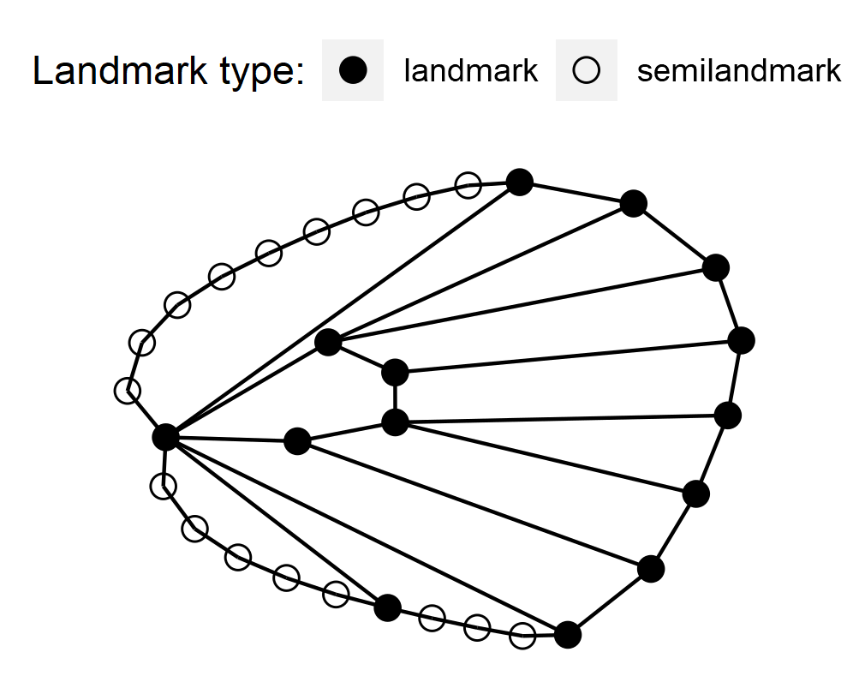
Figure 6: Landmark and semilandmark location in the general consensus hind wing of P. teleius.
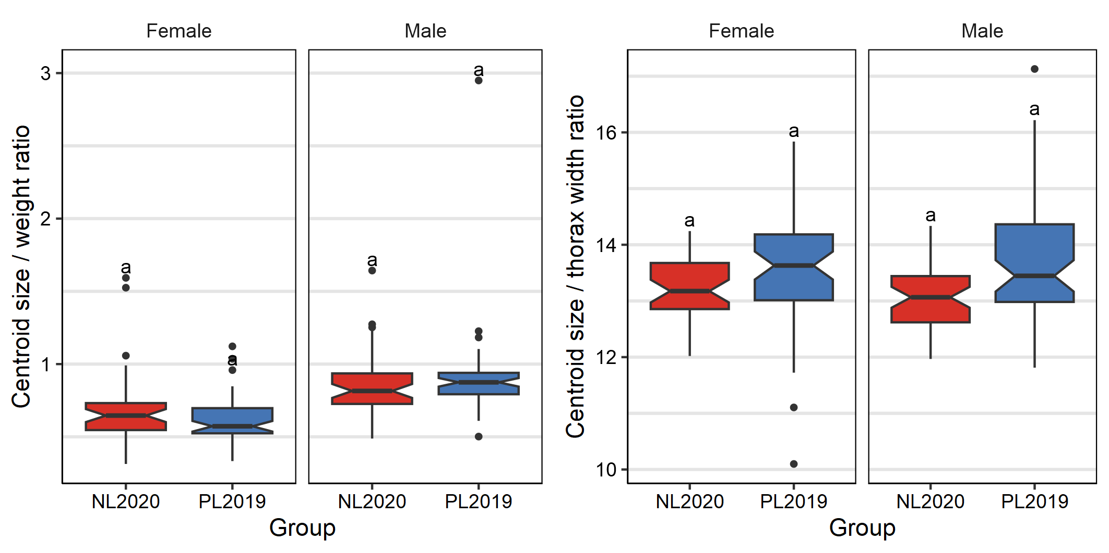
Figure 7: P. teleius butterfly ratio of hind wing centroid size / weight (left) and centroid size / thorax width (right) comparison between the current population from Poland (PL2019) and the reintroduced population from the Netherlands (NL2020) for females and males.
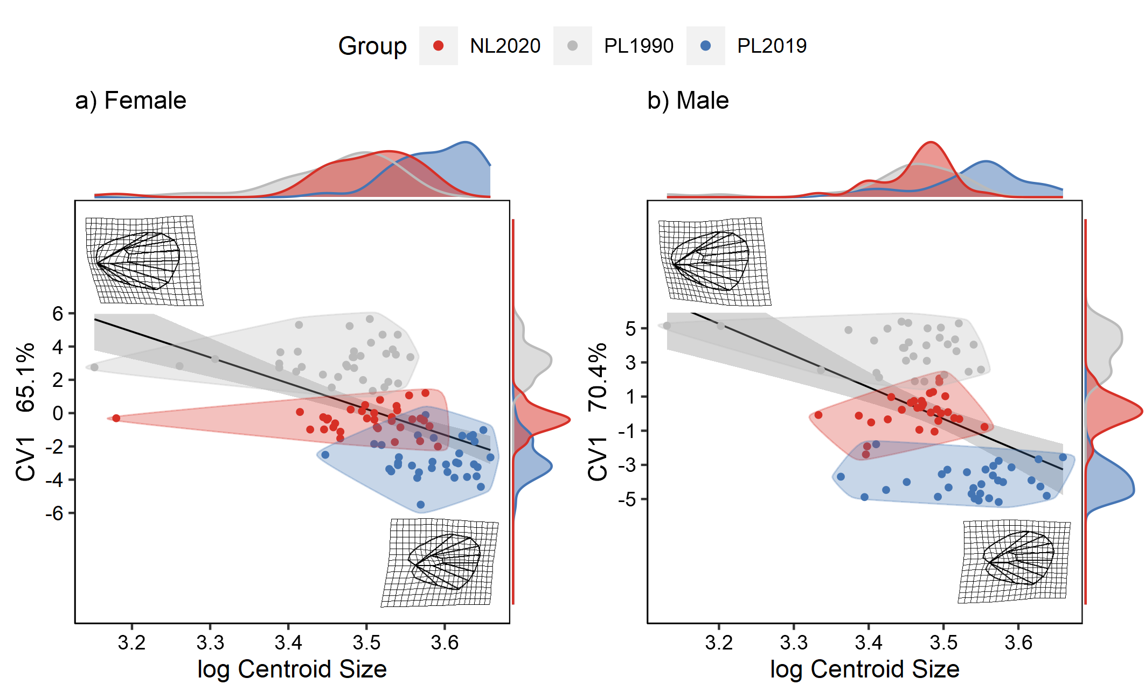
Figure 8: Representation of P. teleius (female on the left and male on the right) butterflies hind wings shape allometry coming from the Polish and Dutch populations in different years: PL1990 (grey; year of the reintroduction), PL2019 (light and dark blue; Polish source population) and NL2020 (orange and red; reintroduced Dutch population).
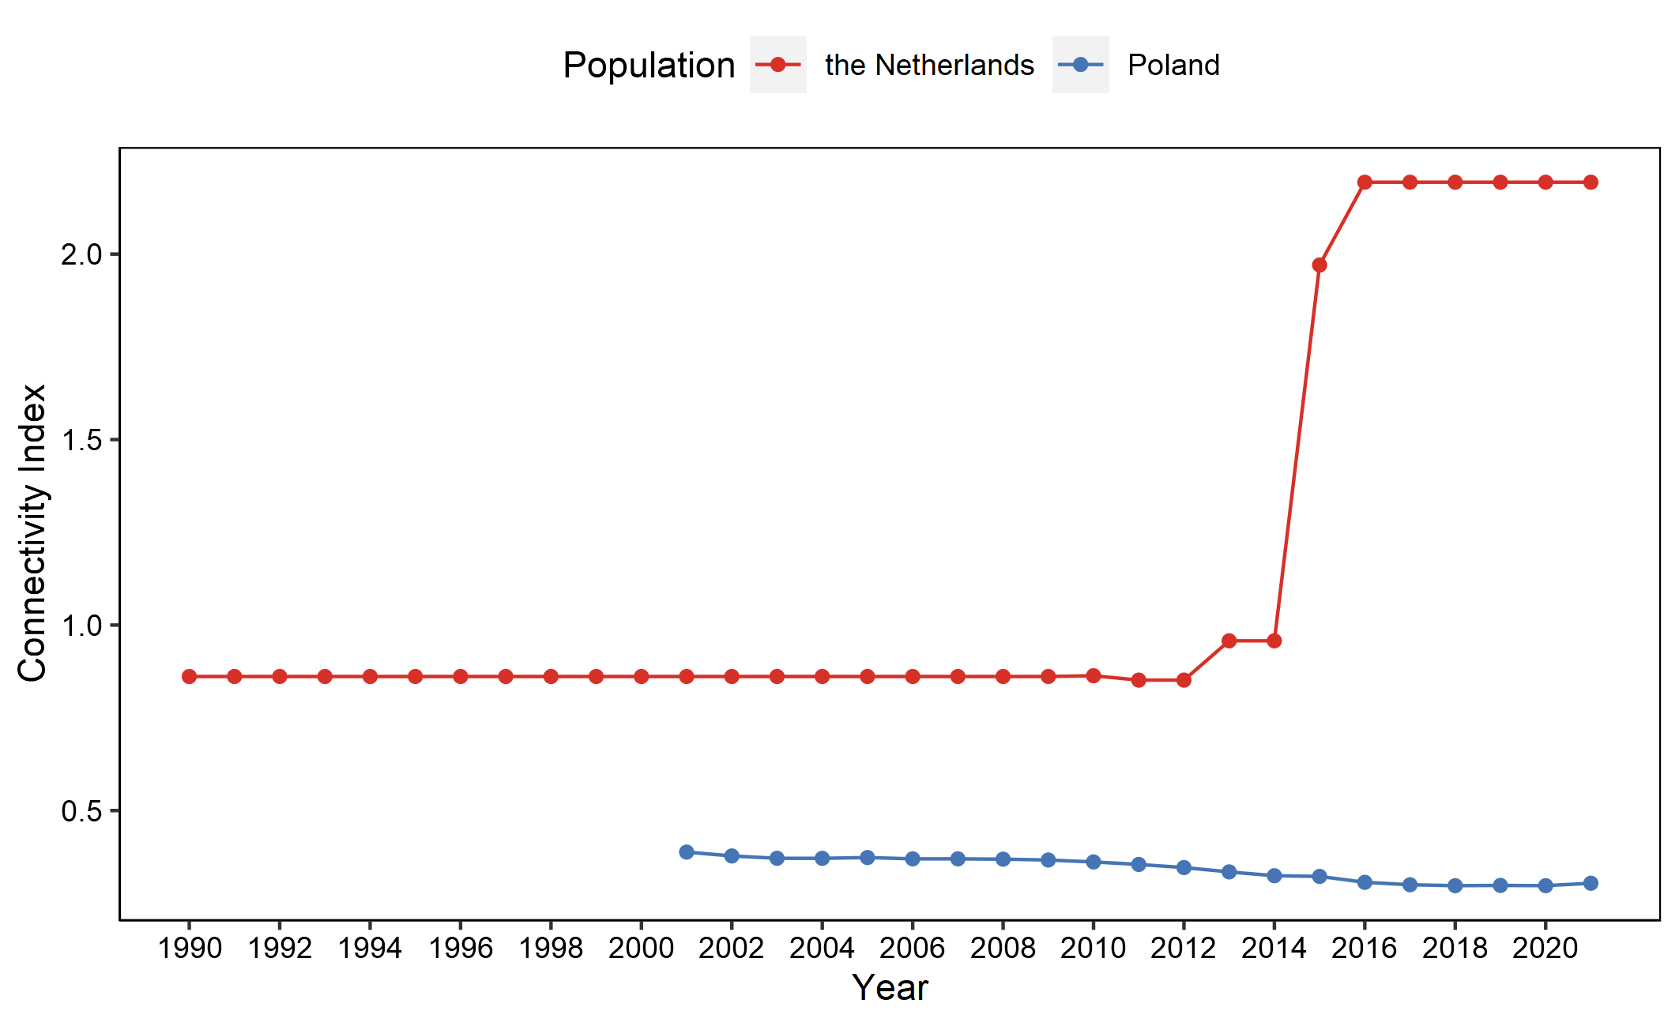
Figure 9: P. teleius metapopulation connectivity for Polish (blue line) and Dutch (red line) populations calculated from 2001 for the Polish and from 1990 for the Dutch population.
Table 3: EMMs (estimated marginal means) test results for the female and male hind wing centroid size pairwise comparison between the source (PL1990), current Polish (PL2019) and reintroduced Dutch (NL2020) *P. teleius* populations.
 |  | PL1990 | PL2019
Female | NL2020 | t = 2.47  p = 0.04* | t = -5.63  p < 0.001***
 | PL1990 | - | t = -8.1  p < 0.001***
Male | NL2020 | t = 0.88  p = 0.655 | t = -4.3  p < 0.001***
 | PL1990 | - | t = -5.18  p < 0.001***
*p ≤ 0.05, **p ≤ 0.01, ***p ≤ 0.001
Table 4: LSMs (Least Square Means) test results for the female and male hind wing shape pairwise comparison between the different studied populations (PL1990, PL2019 and NL2020).
 |  | PL1990 | PL2019
Females | NL2020 | Z = 3.74  p < 0.001*** | Z = 3.87  p < 0.001***
 | PL1990 | - | Z = 3.91  p < 0.001***
Males | NL2020 | Z = 3.99  p < 0.001*** | Z = 2.44  p = 0.006**
 | PL1990 | - | Z = 4.74  p < 0.001***
*p ≤ 0.05, **p ≤ 0.01, ***p ≤ 0.001
Table 5: Bilateral asymmetry ANOVA test statistical results for *P. teleius* female and male hind wing centroid size analysis.
 |  | Df | SS | MS | Rsq | F | Z | pª
Female | Individual | 126 | 1,882.98 | 14.94 | 0.98 | 52.83 | 12.80 | 0.001***
 | Side | 1 | 0.01 | 0.01 | 0.00 | 0.02 | -1.19 | 0.862
Male | Individual | 136 | 1,585.32 | 11.66 | 0.98 | 64.38 | 15.65 | 0.001***
 | Side | 1 | 0.18 | 0.18 | 0.00 | 0.98 | 0.53 | 0.326
ª *p ≤ 0.05, **p ≤ 0.01, ***p ≤ 0.001
Table 6: Bilateral asymmetry ANOVA test statistical results for *P. teleius* female and male hind wing shape analysis.
 |  | Df | SS | MS | Rsq | F | Z | pª
Female | Individual | 126 | 0.27 | 0.00 | 0.72 | 2.67 | 17.10 | 0.001***
 | Side | 1 | 0.00 | 0.00 | 0.00 | 1.72 | 1.52 | 0.073
Male | Individual | 136 | 0.26 | 0.00 | 0.68 | 2.16 | 9.44 | 0.001***
 | Side | 1 | 0.00 | 0.00 | 0.00 | 0.95 | 0.11 | 0.457
ª *p ≤ 0.05, **p ≤ 0.01, ***p ≤ 0.001
Table 7: Pairwise genetic distances FST between all meadows from the current Polish population (1, 10, 25) and the reintroduced Dutch population (KBW, PHZ, BW) groups. Distances significantly different from 0 are marked with an asterisk (*).
 | 1 | 10 | 25 | KBW | PHZ | BW
1 | - | 0.003 | 0.005* | 0.083* | 0.096* | 0.076*
10 |  | - | 0.014* | 0.122* | 0.126* | 0.105*
25 |  |  | - | 0.101* | 0.115* | 0.091*
KBW |  |  |  | - | 0.029* | 0.019*
PHZ |  |  |  |  | - | 0.024*

