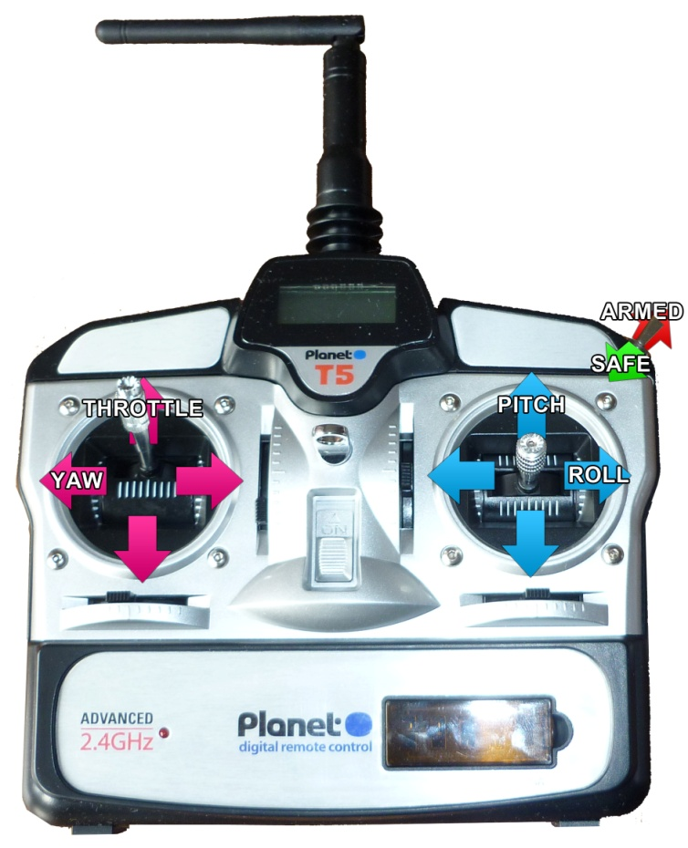

**Instructions for Use**

1. Turn on the transmitter, ensuring the throttle is in the lowest position and the motor switch is set to 'safe'.
2. Plug the battery into the QuadCopter, place it on flat and level ground before standing back.
3. Calibrate the sensors by pulling both sticks to the bottom, outside corners.
4. When ready to fly, set the motor switch to the 'armed' position and slowly increase the 'throttle' to rise.

Once hovering, to move forwards and backwards, alter the 'pitch'. To move left and right, alter the 'roll'. To turn on the spot, alter the 'yaw'. Finally, to ascend or descend further, alter the 'throttle'.

**SAFETY INFORMATION**

The QuadCopter should

only be flown outside, in an open space in good weather, with little wind and must not be flown close to, or above, other people.