1. Data availability and quality checks

1.1. What is the length of available data (climate and discharge) both for CAMELS and climate stations.
After data alignment, the length of the available data, of the CAMELS and the two climate
stations are exactly 2327 days which is about 6.5 years.

Is the period of record sufficiently long to characterise the catchment climate and hydrology? Justify your answer.
Regarding the term climate being defined by an observation period of 30 years, the length of available data can not be seen as long enough to characterise the catchment climate (DWD, 2026a). Since discharge relies heavily on the climates characteristics, such as e.g precipitation and evapotranspiration, the insufficiency in data length also applies for the catchments hydrology.

1.2. When was the discharge gauging station established?
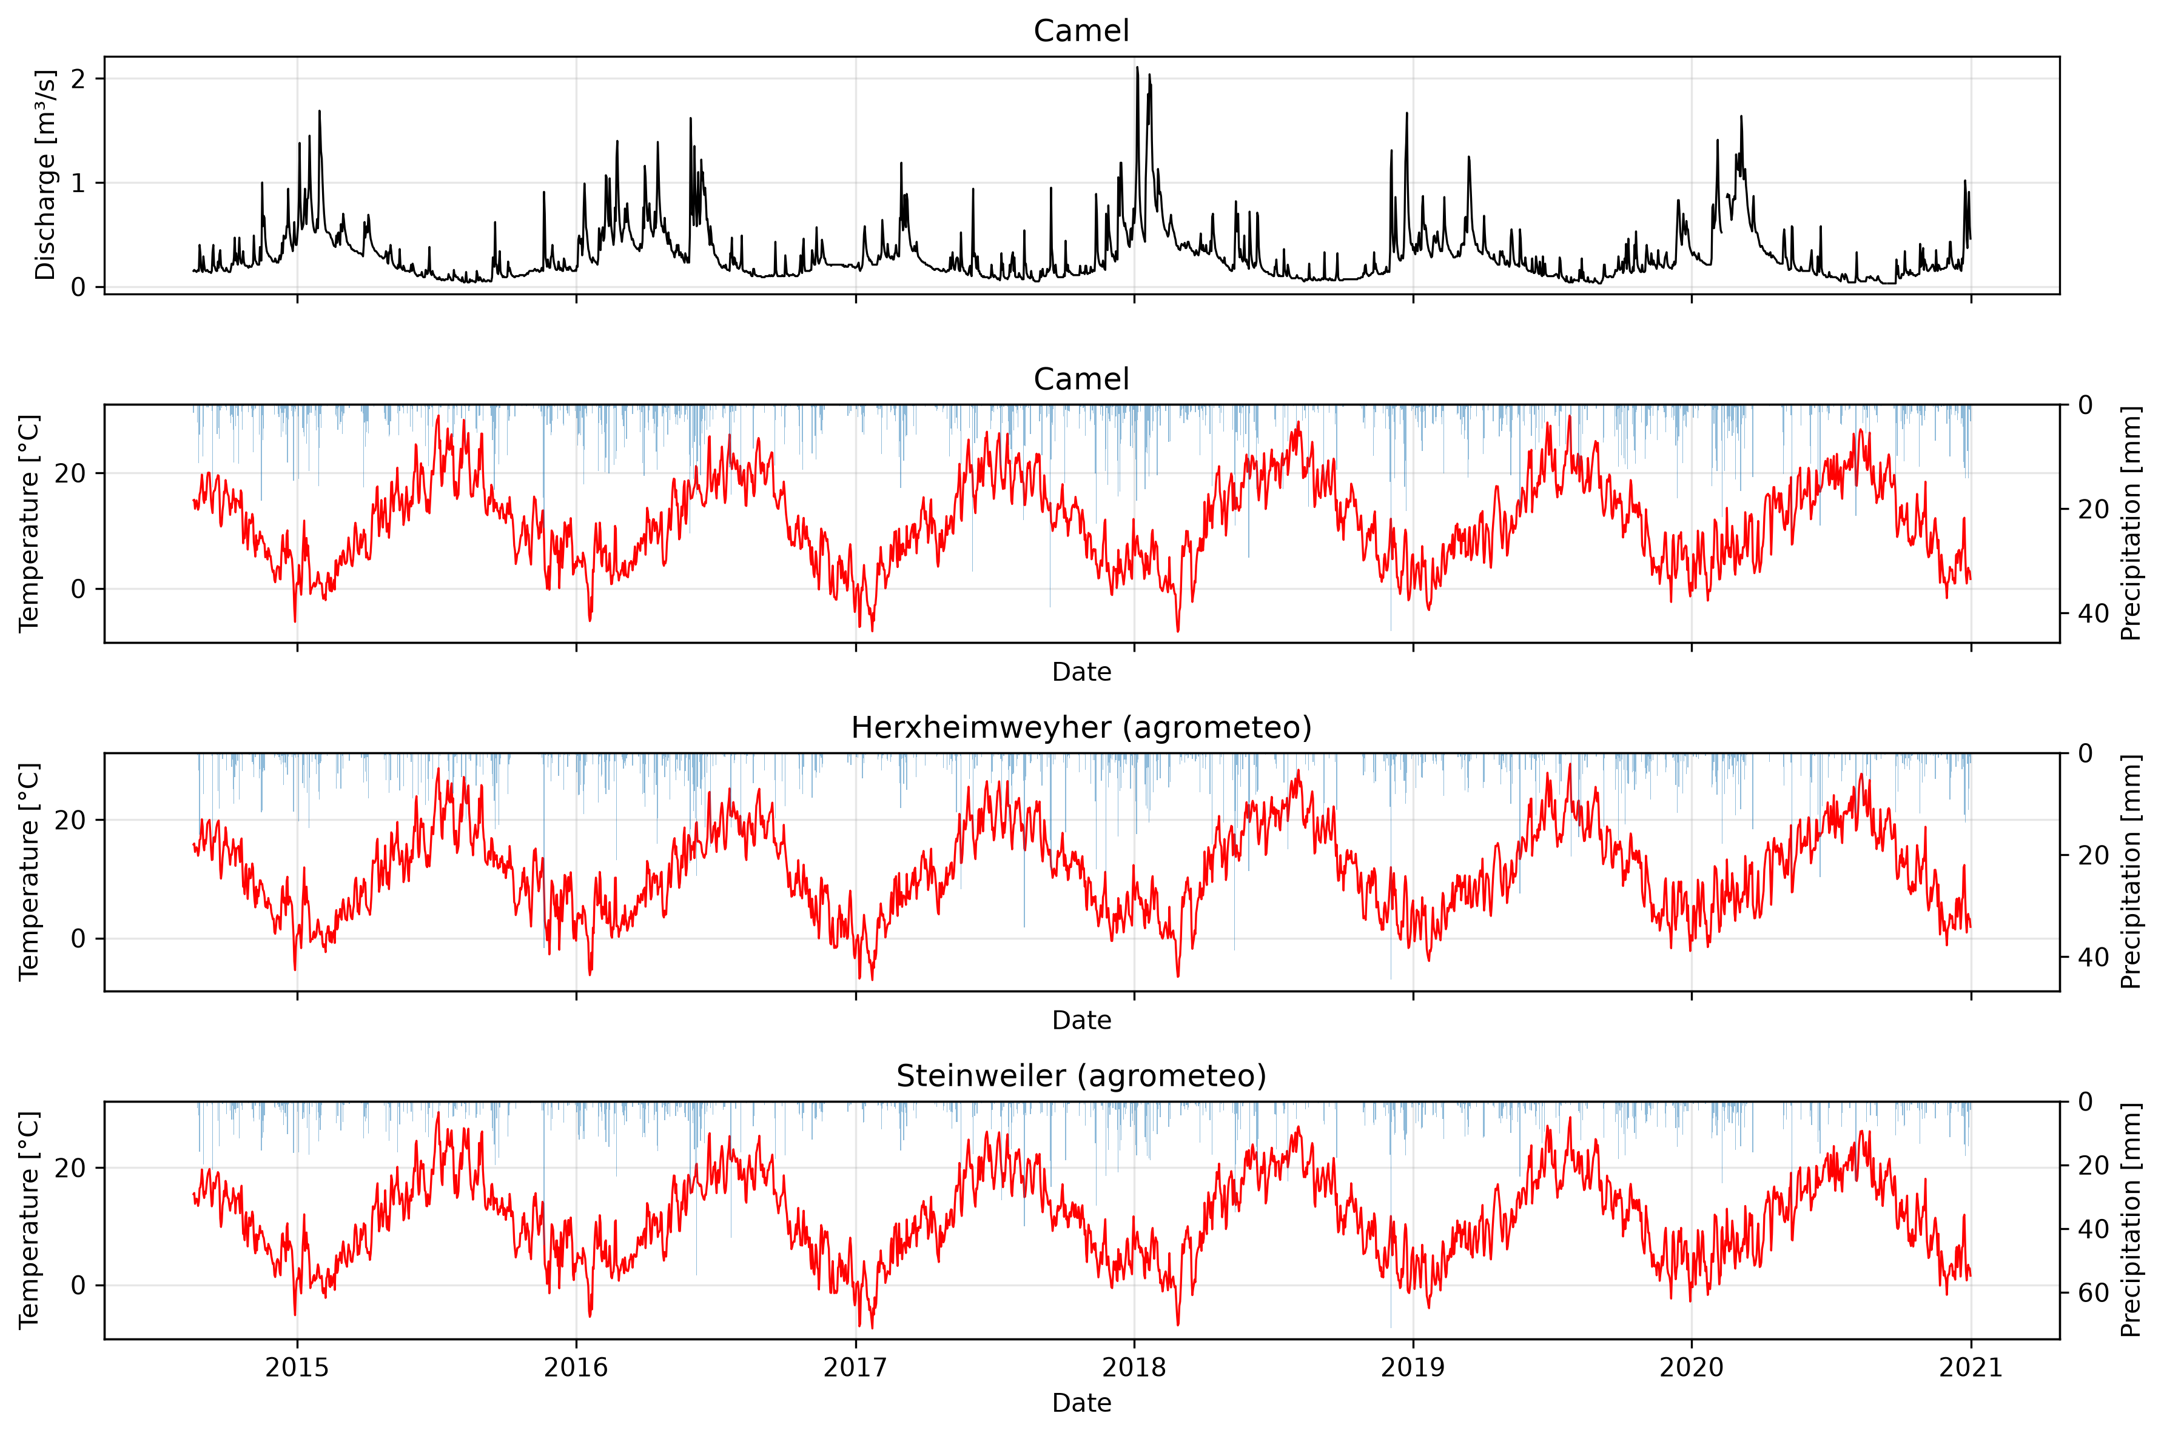Figure 1: Annual discharge, temperature and precipitation for the camels dataset and the two agrometeo weather stations.
The discharge gauging station was established on the 24. December in 1957 (Wasserportal RLP, 2026).

1.3. Are there any missing data? Plot the timeseries of daily flow.
Only the variables discharge_vol_obs, discharge_spec_obs, and water_level_obs from the CAMELS dataset showed missing data:

Table 1: Number and percentage of missing observations in the CAMELS dataset.
Variable | Number of NA’s | Missing [%]
discharge_vol_obs | 8 | 0.34
discharge_spec_obs | 8 | 0.34
water_level_obs | 3 | 0.13

1.4. Are there any outliers or faulty data? Based on what criteria did you label them as outlier or faulty?
BLABLA

1.5. How could missing data and outliers influence subsequent analyses such as catchment statistics and trend detection? How do you deal with these in the following analysis?
BLABLA

2. Catchment description

2.1. What is the geographic location of the catchment? Where are the discharge gauging station and the precipitation stations located?
The geographic location of the catchment is shown in Figure 2.

2.2. What are the coordinates and elevation range?
The coordinates of the gauging station and the precipitation stations are shown in Table 2.
The elevation of the catchments area ranges from 38.0 to 656.0 meter.

Table 2: UTM32 N coordinates of the gauging station and the two weather stations.
Object | Easting (x) | Northing (y)
Gauging station | 441287.555 | 5443734.056
Weatherstation Herxheimweyher | 445319.261 | 5445513.23
Weatherstation Steinweiler | 434303.997 | 5438962.42

2.3. What is the total catchment area?
The catchments area is 100.56 km² and its elevation ranges from 38.0 to 656.0 meter.
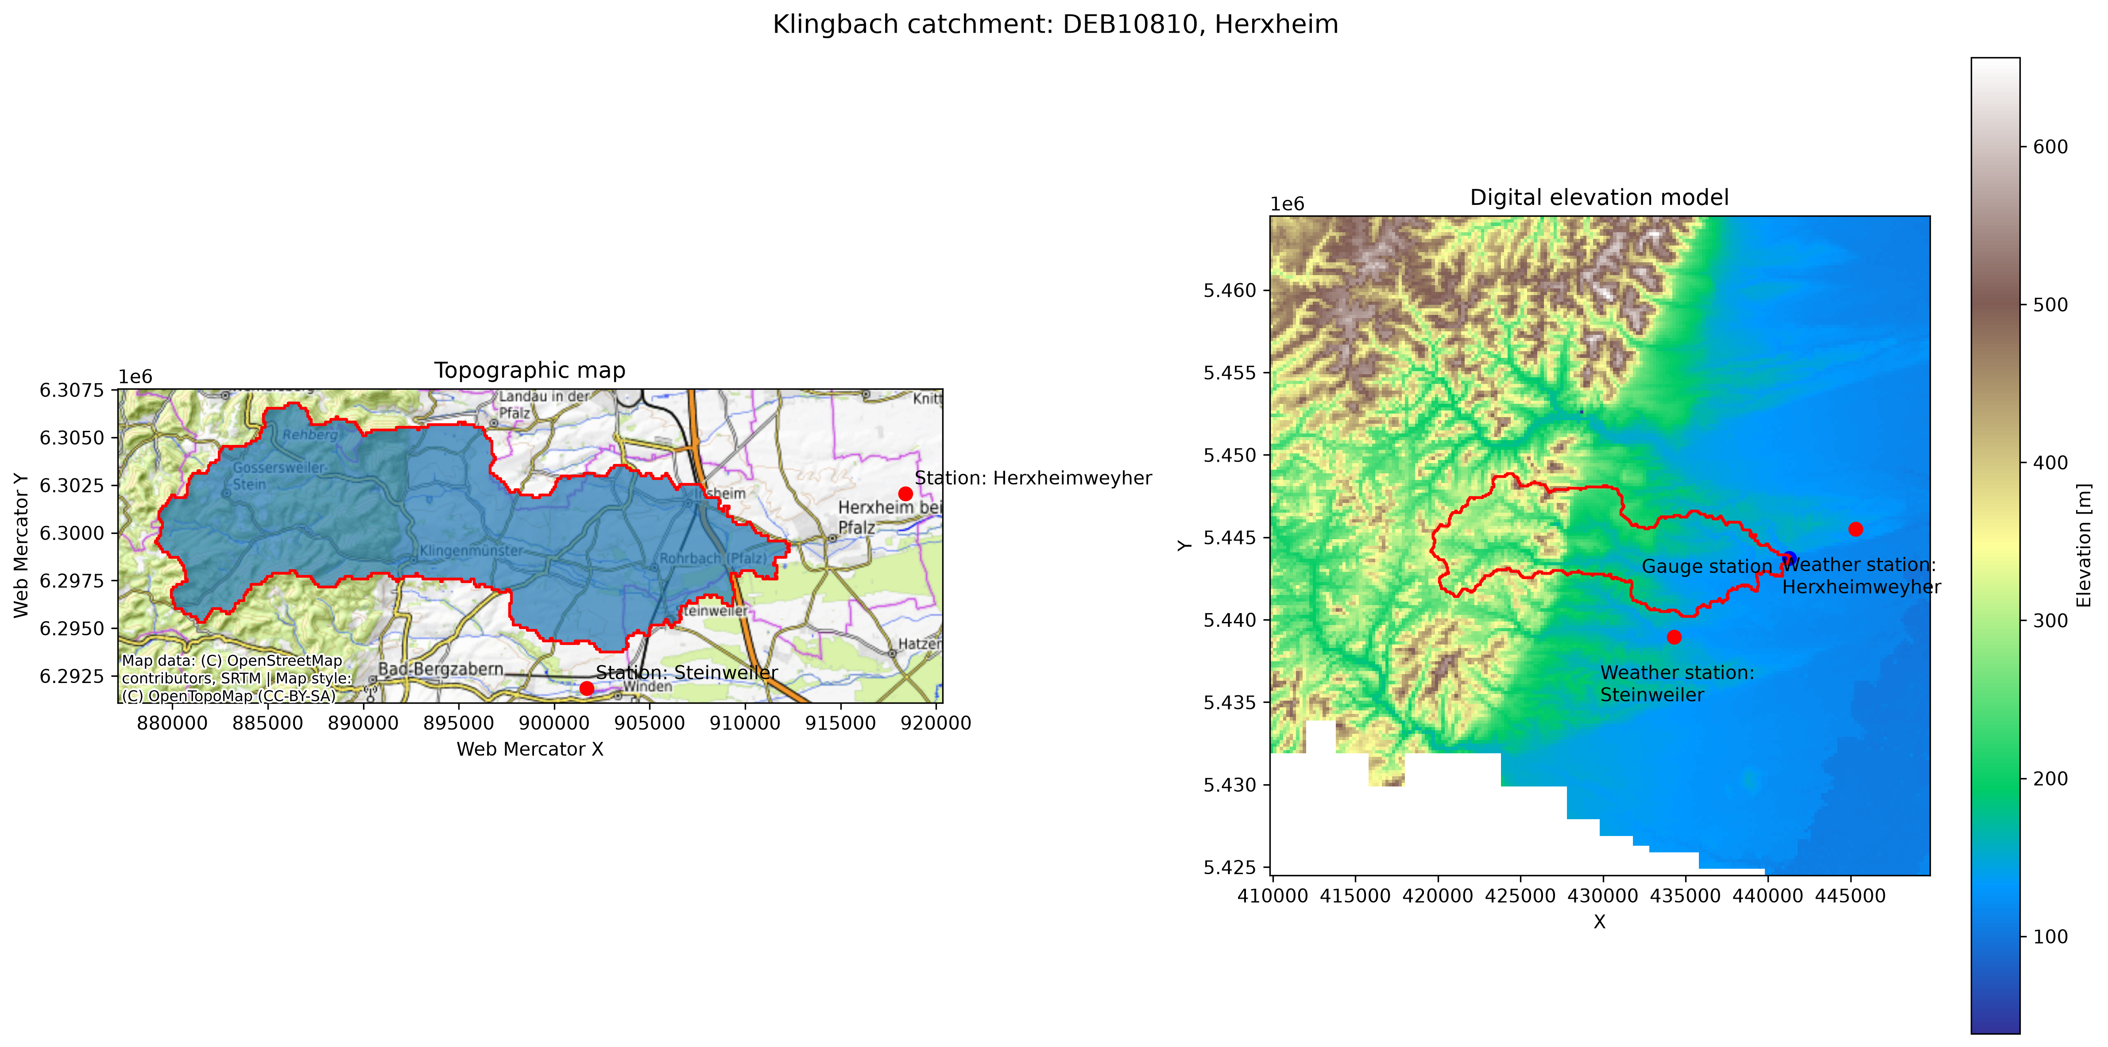Figure 2: Location of the catchment, the gauging station and the two agrometeo weather stations on topographic bachground and with digital elevation model background.

2.4. How is the land use split between agriculture, forests, and artificial areas?
The land use split between agriculture, forests and artificial areas is shown in Figure 3.
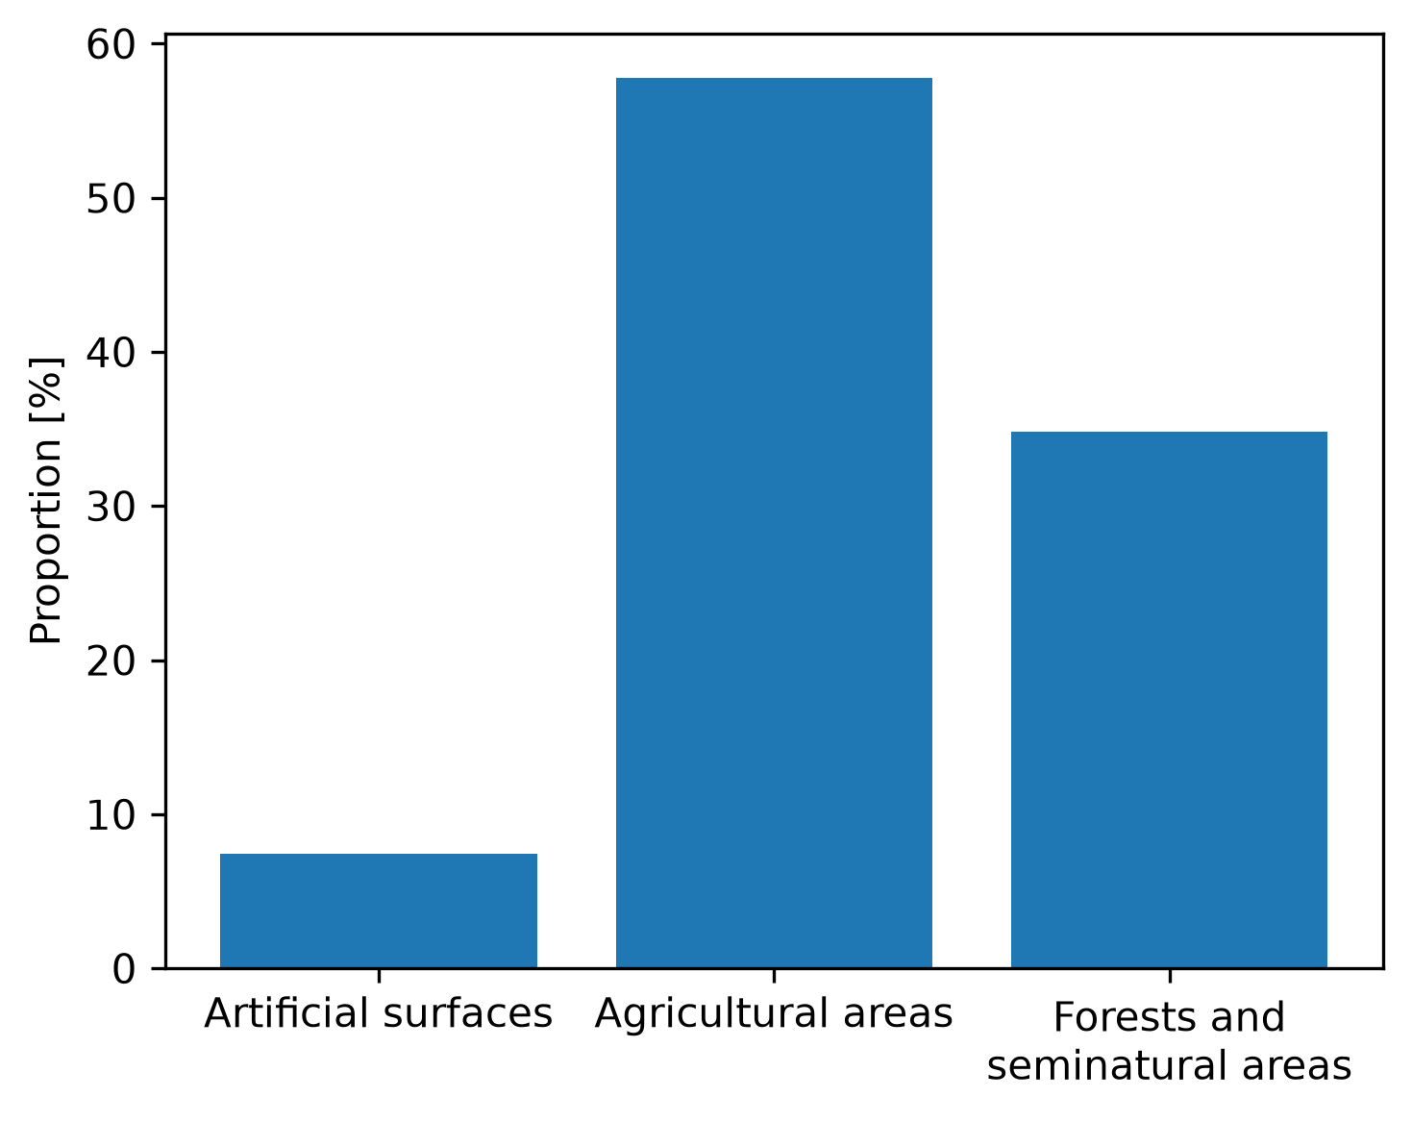Figure 3: Land use split of the catchment area.

2.5. Are there any dams in your catchment?
Unfortunately, the official authorities do not provide any information about dams in the catchment.

3. Climate analysis

3.1. Calculate mean monthly temperature. Which months are the warmest and coldest?
The warmest and coldest months for all three datasets regarding mean temperature are shown in Table 3.

Table 3: Coldest and warmest month for all three datasets.
Dataset | Coldest month | Warmest month
CAMEL | January | Jul
Weatherstation Herxheimweyher | January | Jul
Weatherstation Steinweiler | January | Jul

3.2. Describe the temperature regime of the catchment. What implications might it have for evaporation, vegetation growth, and seasonal runoff?
The mean monthly temperature in the camel dataset ranges between 2.7 ± 4.0°C an 21.4 ± 3.4 °C with January being the coldest and July being the warmest month. Using the FAO 56 Penman-Monteith equation, evaporation is dependend from air temperature and irradiance (Wikipedia, 2026) .
Considering July also being the month with highest global radiation, here evaporation is expected to be highest. However, month with lowest global radiation is December, therefore it remains unclear if evaporation is lowest in December or January, considering only these two input variables.
The catchment lies within the temperate climate zone, where the vegetation period is limited mostly to the spring and summer season.
Evaporation and transpiration by vegetation, important factors in the water balance of a watershed, are expected to have a great influence on the seasonal runoff, with lower discharges in summer and the vegetation period and higher discharge in the cold months outside the growing season.

3.3. How does humidity change seasonally?
Relative humidity shows a contrasting trend with highest humidity in December and lowest humidity in July.
The small increase of humidity in May and June results from increasing precipitation in both months, which is further discussed in chapter 4 „Rainfall analysis“, Figure X.

3.4. How closely does the seasonal temperature cycle correspond to the seasonal pattern in solar radiation?
The seasonal temperature cycle aligns almost perfectly with the seasonal solar radiation pattern. Regarding the monthly mean aggregated data it shows only slightly lag of January being the coldest monts, despite December being the month with lowest global radiation. This might be due to.. .

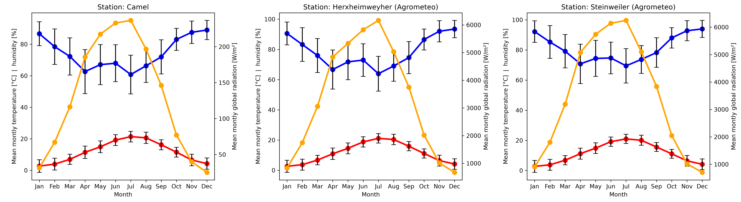Figure 4: Trend of temperature, precipitation and radiation for all three datasets. Data is mean monthly aggregated. Error bars show the standard deviation of the monthly mean values.

3.5. Calculate PET using Hargreaves equation for one of your stations and compare to the CAMELS PET value. Discuss the main differences and their possible causes.
In Figure 5 Hargreaves PET was calculated for both agrometeo weather stations and compared to the simulated PET data from the CAMELS dataset.
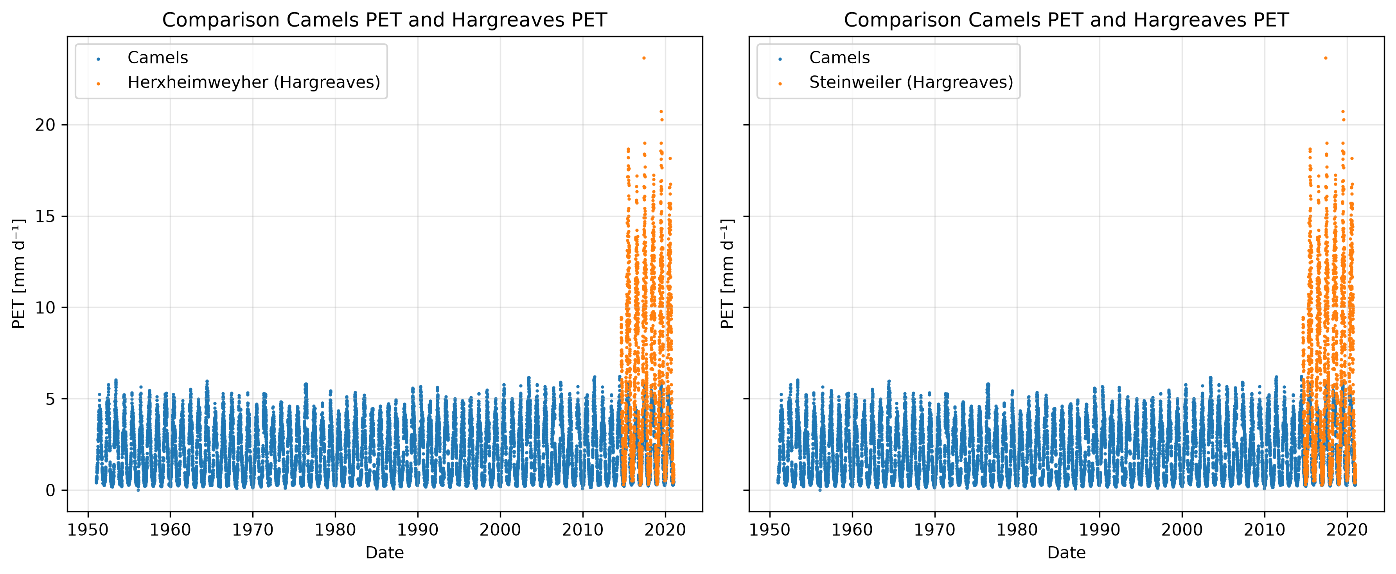Figure 5: Comparison of Hargreaves potential evapotranspiration (PET) calculated for both agrometeo weather stations and simulated PET from CAMELS dataset.
It is noticeable that the calculated Hargreaves PET reaches relatively high maximum values, with 0.95 quantiles of 14.6 and 14.5 mm/d for Herxheimweyher and Steinweiler, respectively. This is in contrast to the simultaed values of the CAMELS dataset a 0.95 quantile value of 4.6 mm/d.
Possible causes for this discrepancy are...

4. Rainfall analysis

4.1. Describe the annual rainfall regime (annual mean sum, seasonal distribution). Does the catchment appear wetter or drier than the German average? What geographic factors might explain this?

Table 4: Comparison of the annual precipitation mean and standard deviation for germany and all three datasets. The period of aggregated data ranges from 2016-2020.
Dataset | Average annual precipitation [mm]
Germany (DWD, 2026b) | 778.9
CAMEL | 687.0 ± 30.8
Herxheimweyher | 562.7 ± 63.52
Steinweiler | 717.66 ± 91.45
The catchment appears drier than the german average. This can be partly explained by the leeward position of the catchment area, relative to the palatinate forest, where moist air masses approaching from the west descend on the eastern side in a foehn-like manner (Diercke, n.d.).
The seasonal distribution of precipitation of the catchment for all three datasets is shown in Figure 7.
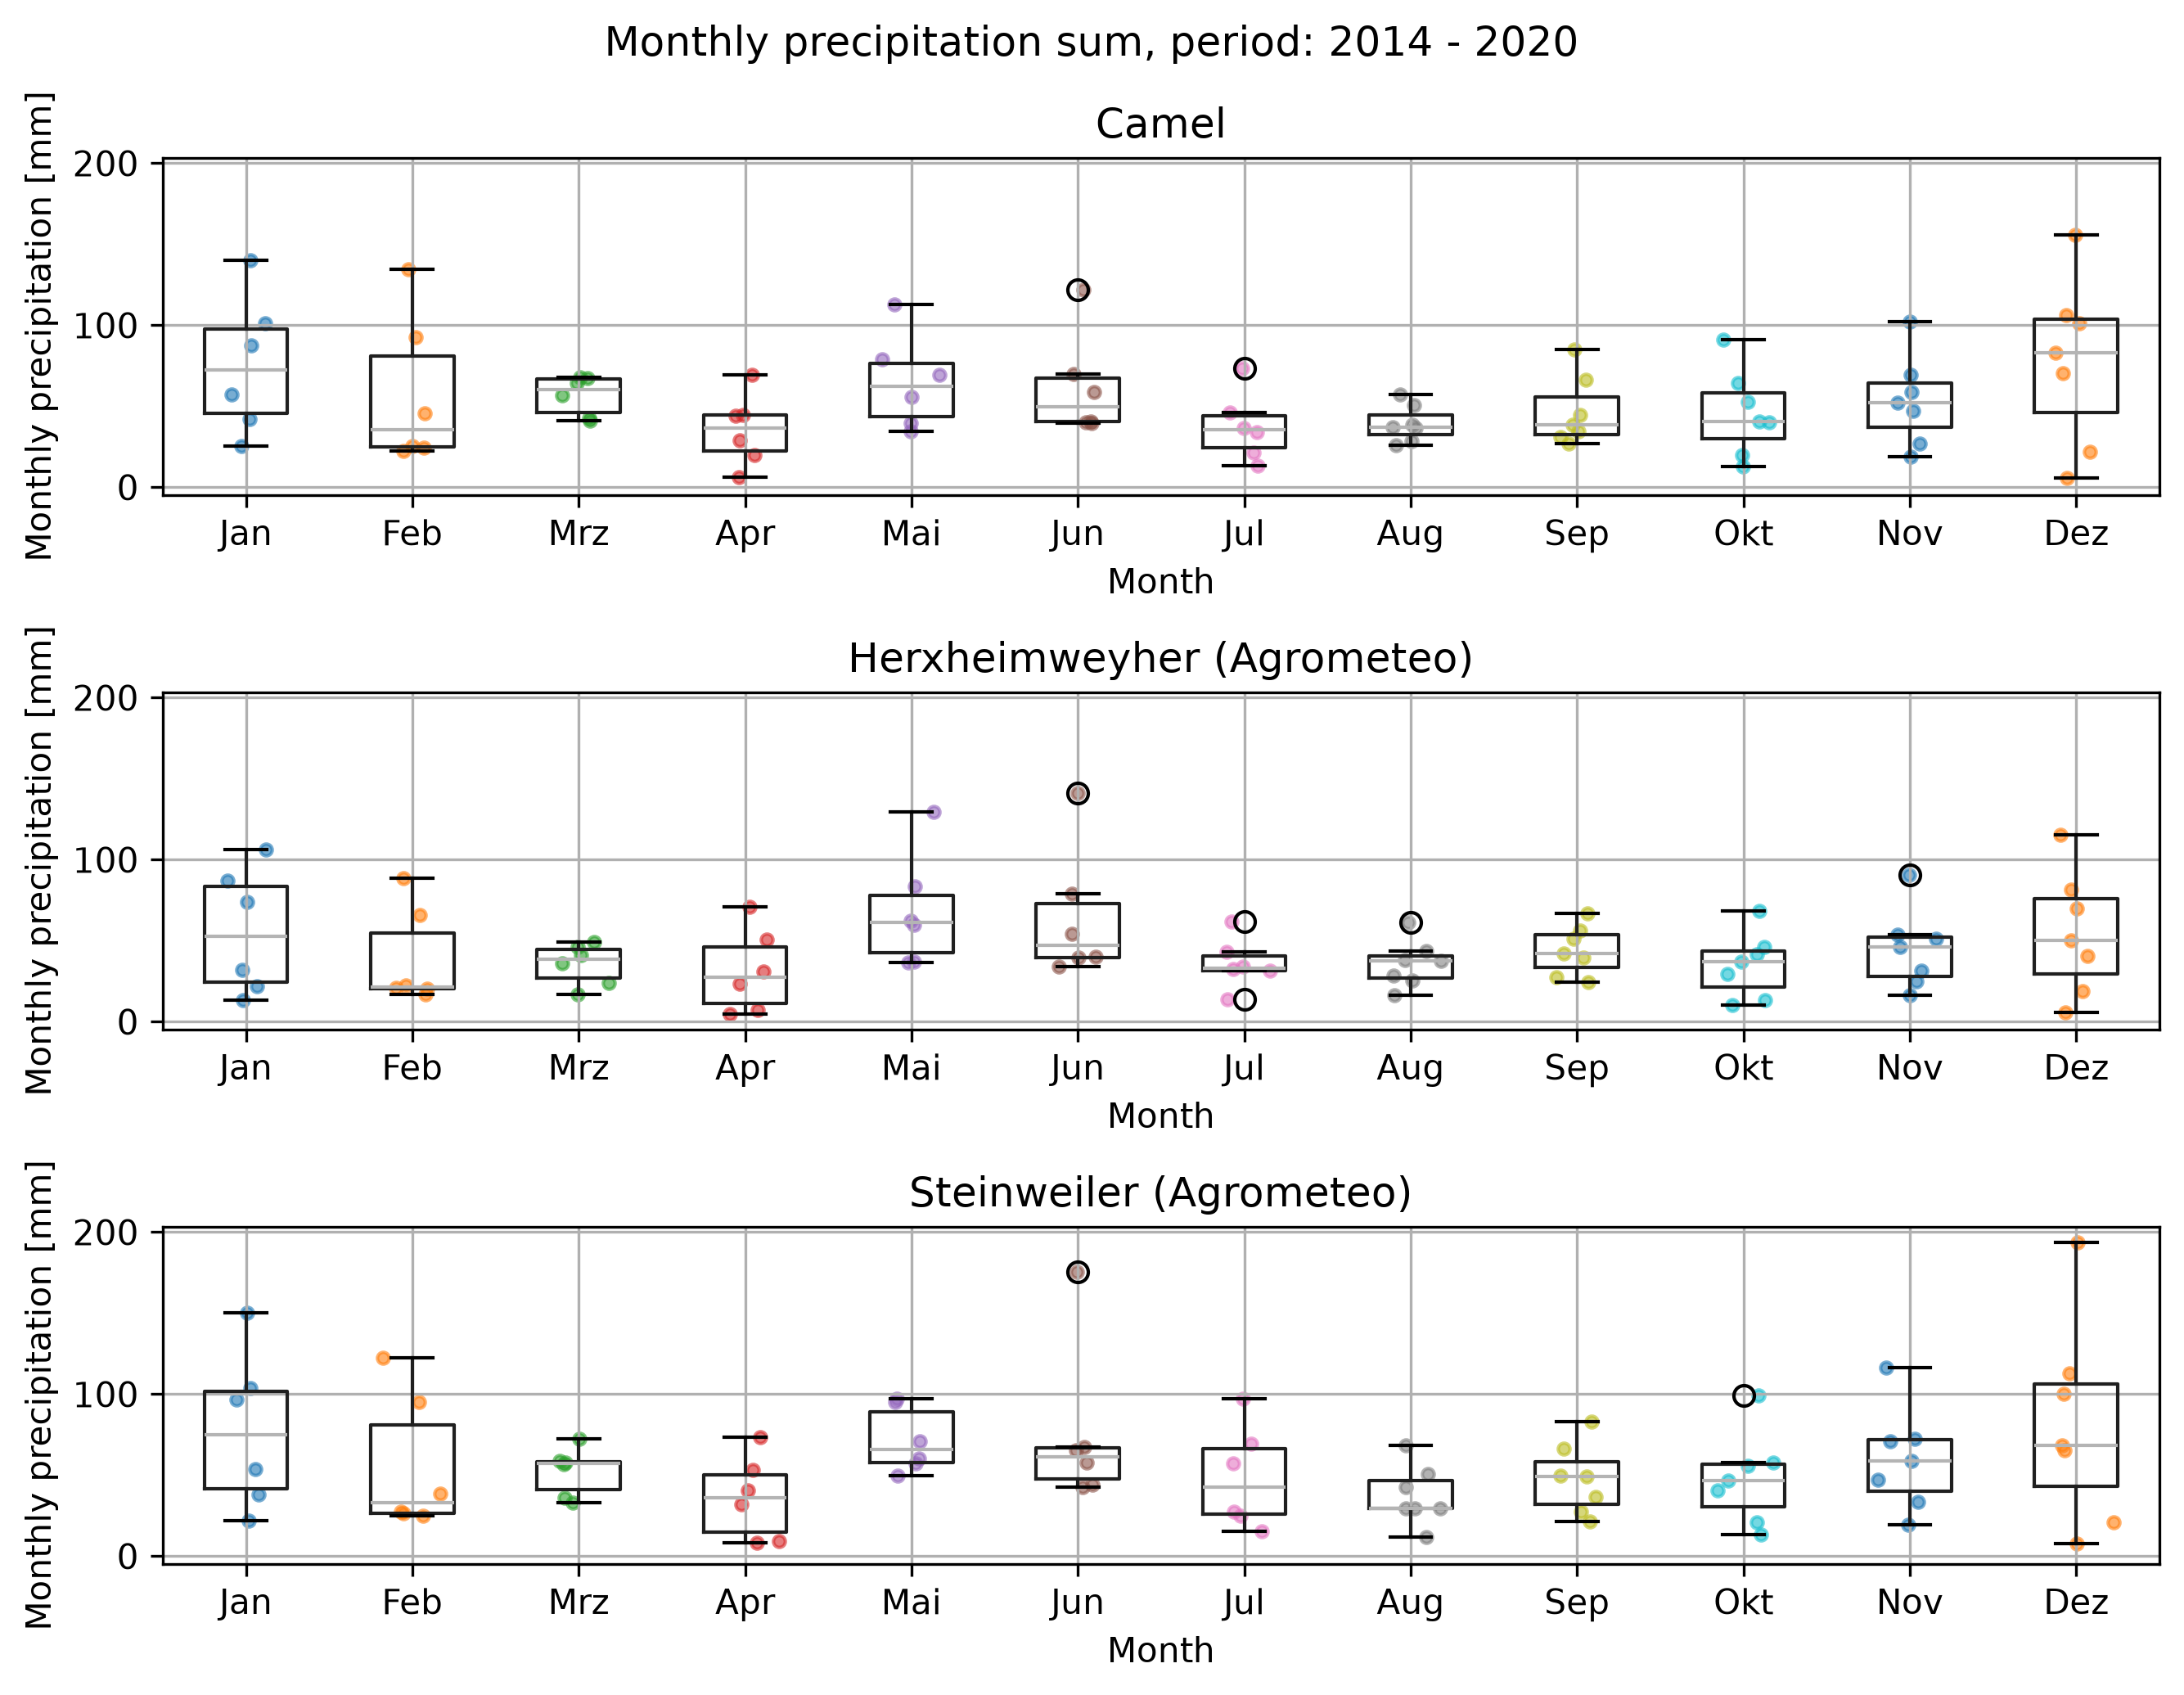Figure 6: Seasonal distribution of monthly precipitation sums for all three datasets. The period of aggregated data ranges from 2014 – 2020.

4.2. Plot the annual average sum of rainfall over time.
The annual mean sum of precipitation of the catchment for all three datasets is shown in Figure 6.

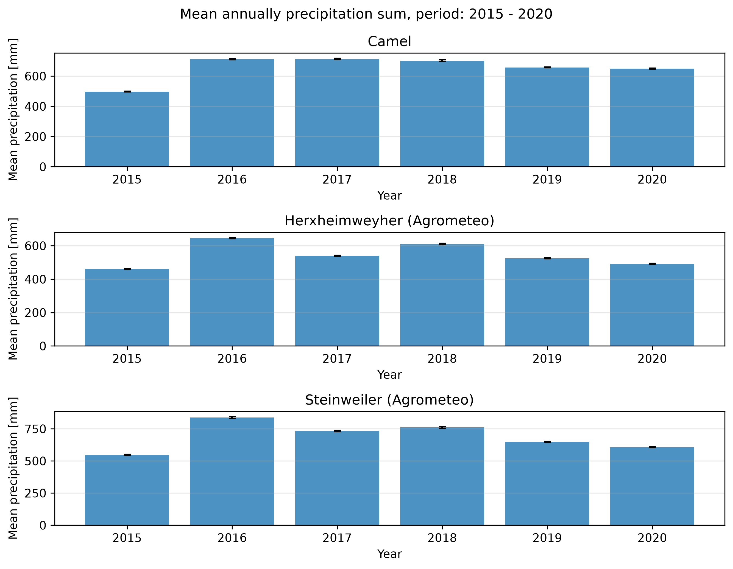Figure 7: Mean annual precipitation sum for all three datasets. The period of aggregated data ranges from 2015 – 2020.

4.3. Is there a significant increase or decrease in the annual average sum of rainfall over time? If a trend exists, discuss possible explanations. Could it represent climate variability, climate change, or limitations of the observation period?
blablablabla

ff
f
f
f
f

4.4 Identify extreme rainfall events (>99th percentile). Do extreme rainfall events occur during a particular season? Discuss possible meteorological causes and implications for flood risk.
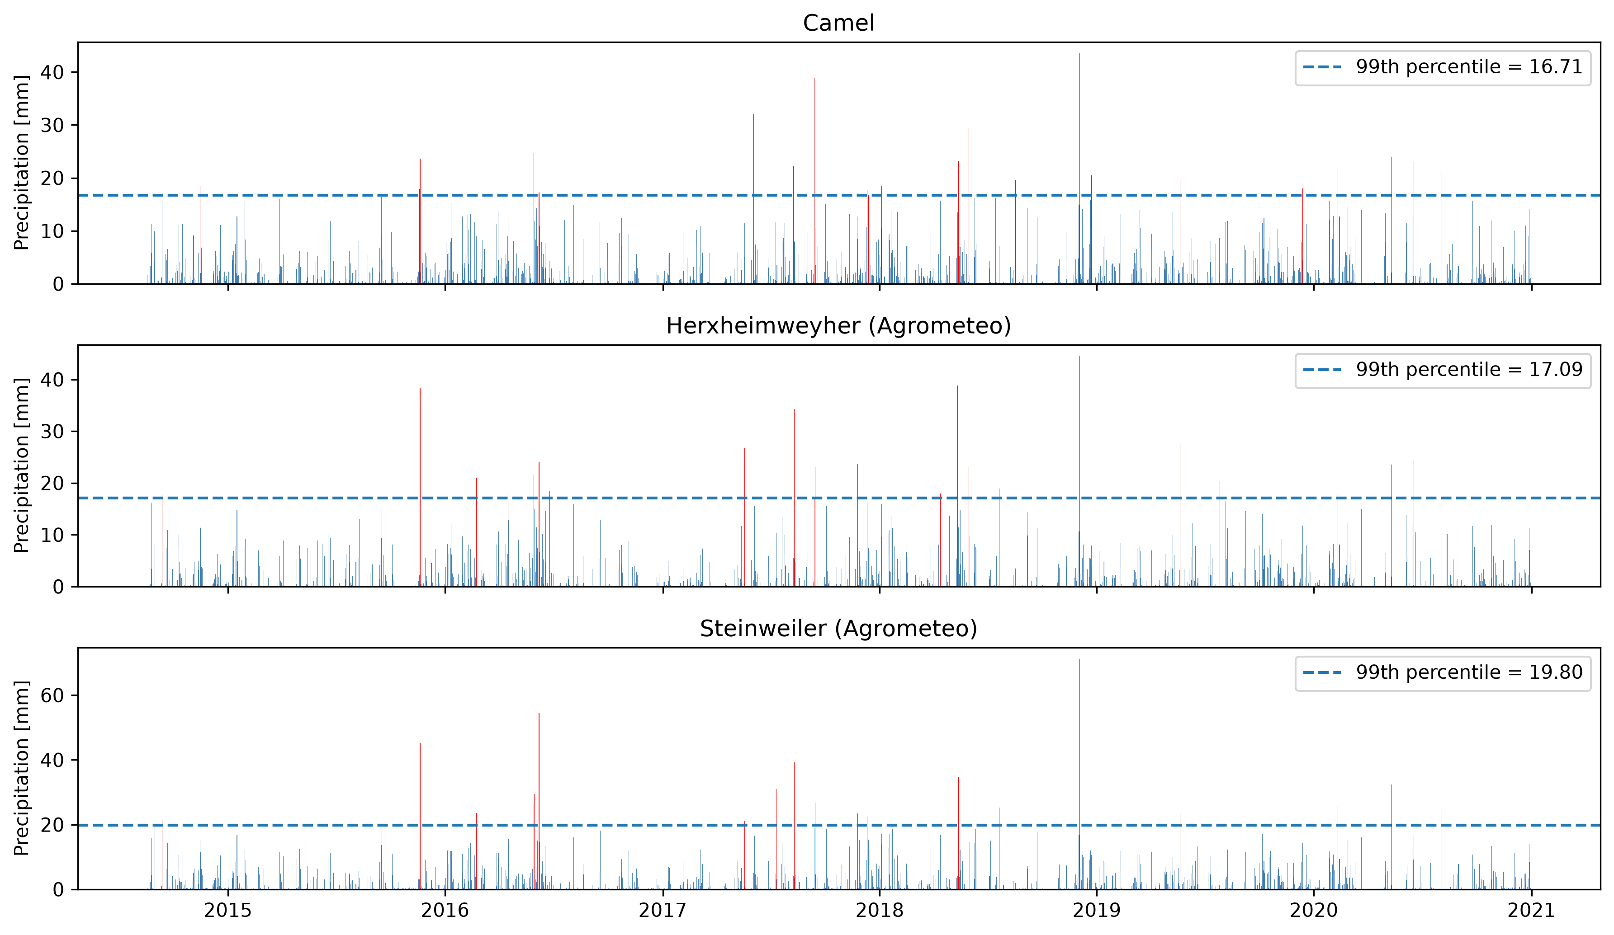Figure 8: Precipitation for all three datasets. The 99th percentile precipitation events are marked in red.
The reinfall events are occurring particularly in blabla season. Possible meteo factors are.. .

5. Streamflow analysis

5.1 What are the average annual flows? Use specific discharge in mm/d to calculate average annual sums that are comparable to the annual precipitation sums.
The average annual flows are shown in Figure 9.
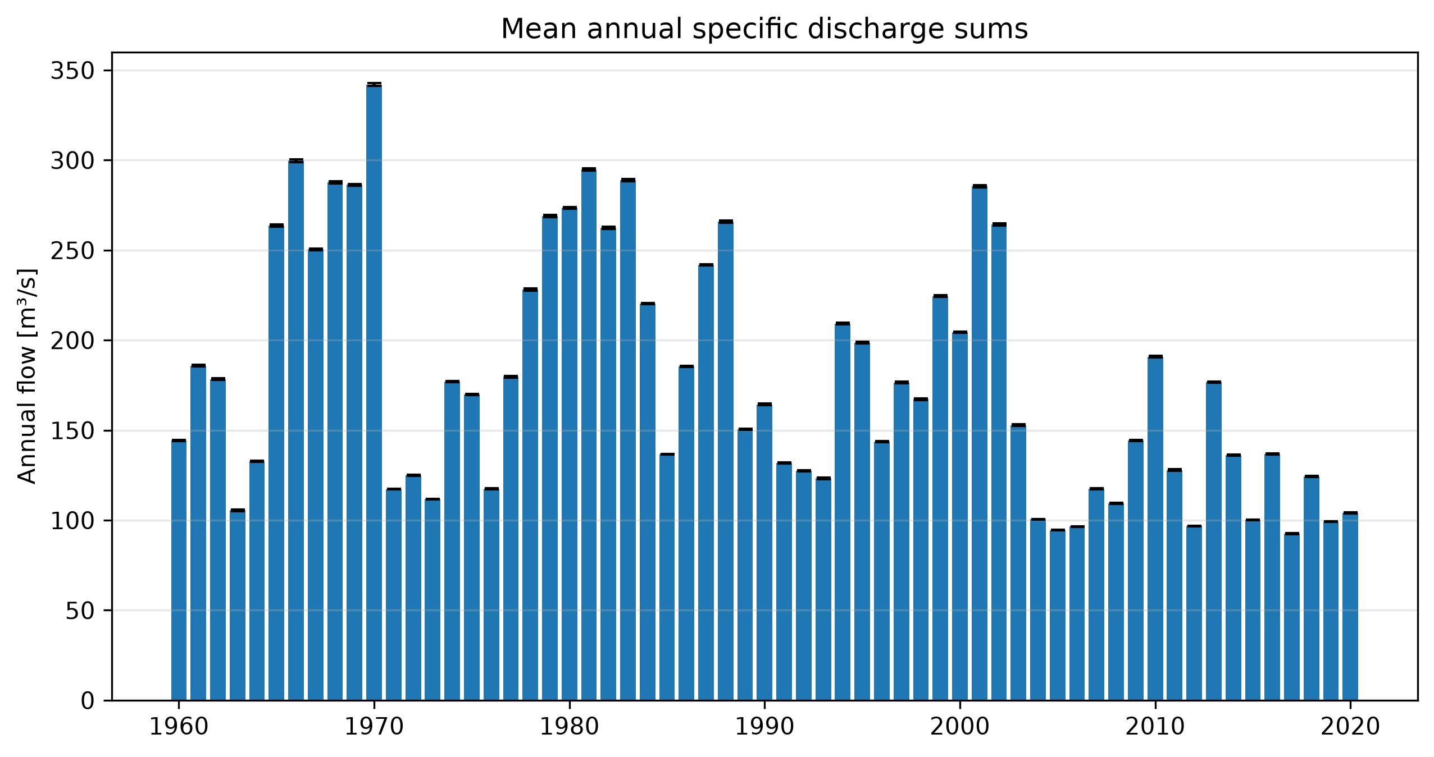Figure 9: Mean annual specific discharge sums for the CAMELS dataset.

5.2. What is the mean daily flow, as well as the highest and lowest recorded flows? [both for m3/s and observed water level].
The mean daily flow and mean observed water level, aggregated across the whole dataset period, are 0.57 m3/s and 29.36 cm, respectively. Minimum and maximum daily flow are 0.02 and 6.58 m3/s, respectively. Minimum and maximum observed water level are 1 and 134 cm, respectively.

5.3. Calculate mean monthly flow. How does streamflow vary throughout the year? Does rainfall seasonality correspond to streamflow seasonality? If not, what processes could explain the differences?
The mean monthly flow is shown in Figure 10.

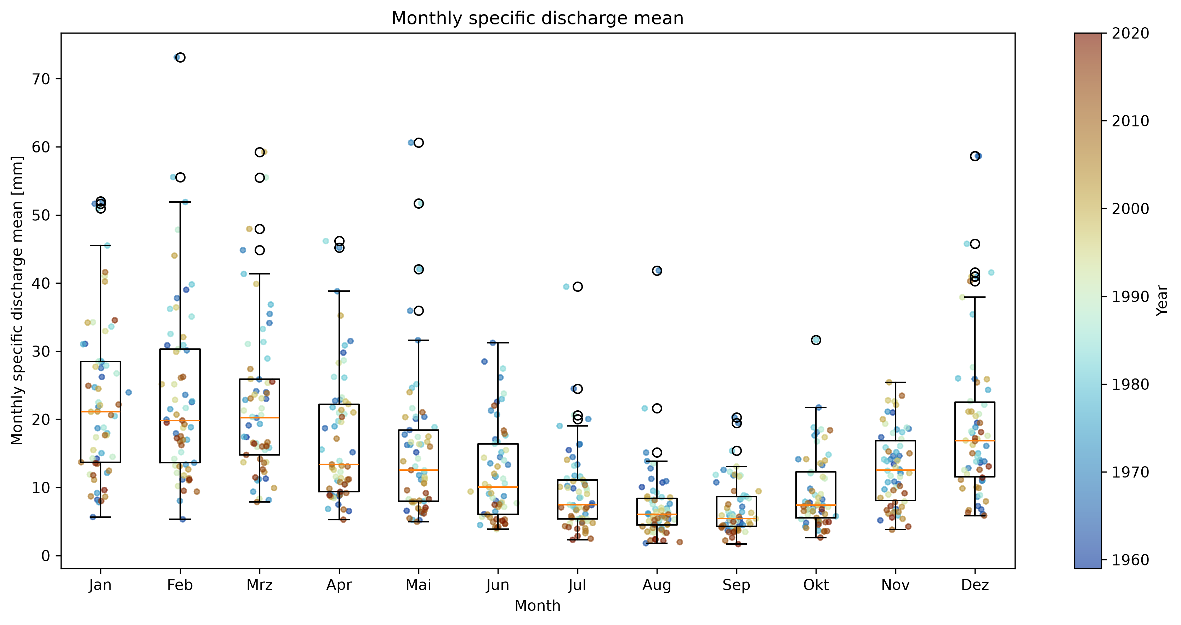Figure 10: Monthly aggregated mean of specifig discharge for the CAMELS dataset.

Regarding the median, mean monthly discharge peaks in winter in january and bottoms out in august. Further, regarding the data inside the whiskers range of the boxplot, variability in mean monthly discharge increases in winter, peaking in february, whereas it decreases in summer with lowest spread in september.
Precipitation sum seasonality does not fully allign with the discharge seasonality pattern. The local peak in Mai and June in monthly precipitation sum is not reflected in the monthly mean specific discharge. The extent to which precipitation contributes to discharge depends on how much of the precipitation reaching the surface actually enters the stream which is mainly influenced by evapotranspiration. Especially the leaf emergence of the main decidious tree species in the palatinate forest (34.4 % beech, 8.9 % oak (Landesforsten RLP, n.d.)), which take place between april and may (LfL Bayern, n.d.), might play a major role in a decreasing specific discharge despite an increase in precipitation sum in these months due to transpiration.

5.4. Identify annual maximum flow days. These are commonly used to calculate flood statistics. Do flood peaks occur predominantly during one season? What climatic or catchment characteristics might explain this pattern?
The monhtly and seasonal distribution of annual maximum discharge events are shown in figure11. Flood peaks occur predominantly from november till march.
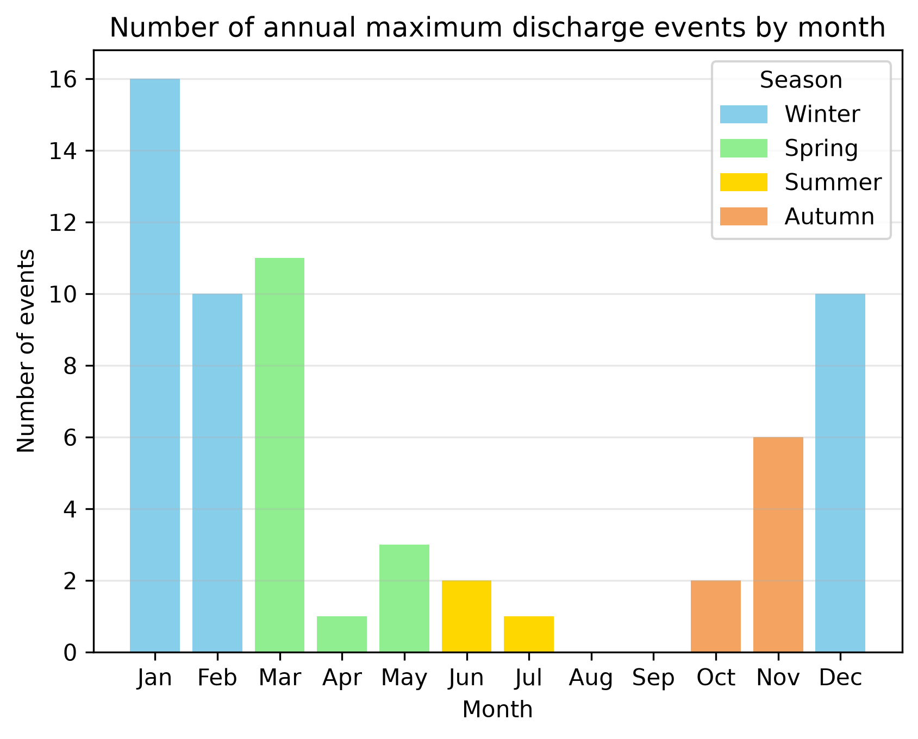Figure 11: Number of annual maximum discharge events by month and season.

There are two decisive factors for this pattern: the amount of precipitation and evapotranspiration. For the winter months, median precipitation is relatively high and shows also the highest outliers which is more relevant regarding extreme discharge events. Further, low temperature and the dormant growing season lead to low evapotranspiration and highly saturated soils. This results in a high percentage of the precipitation reaching the stream, enhanced by high surface runoff.
Increasing temperature and the leaf emergence in May and June, resulting in higher evapotranspiration, mitigate the high precipitation in may and june, leading to significantly lower occurences of extreme discharge events than in the winter months.

5.5. Plot the stage discharge relationship. Are there any noticeable jumps, levelling of or other noticeable patterns? What might cause them?
The stage discharge curve for the gauge station is shown in Figure 12. It is noticeable, that the stage curve changed strongly until about 1990. Since then, the stage discharge curve shows only minor changes and remains relatively stable. Unfortunately there are no further information about the history of the gauging station. But is seems likely, that the river cross-section was not reinforced and changed constantly e.g. due to extreme rain events. The cross-section maybe got reinforced then around 1990 with concrete as it can be seen on the webpage of the water managment agency (Wasserportal RLP, 2026).
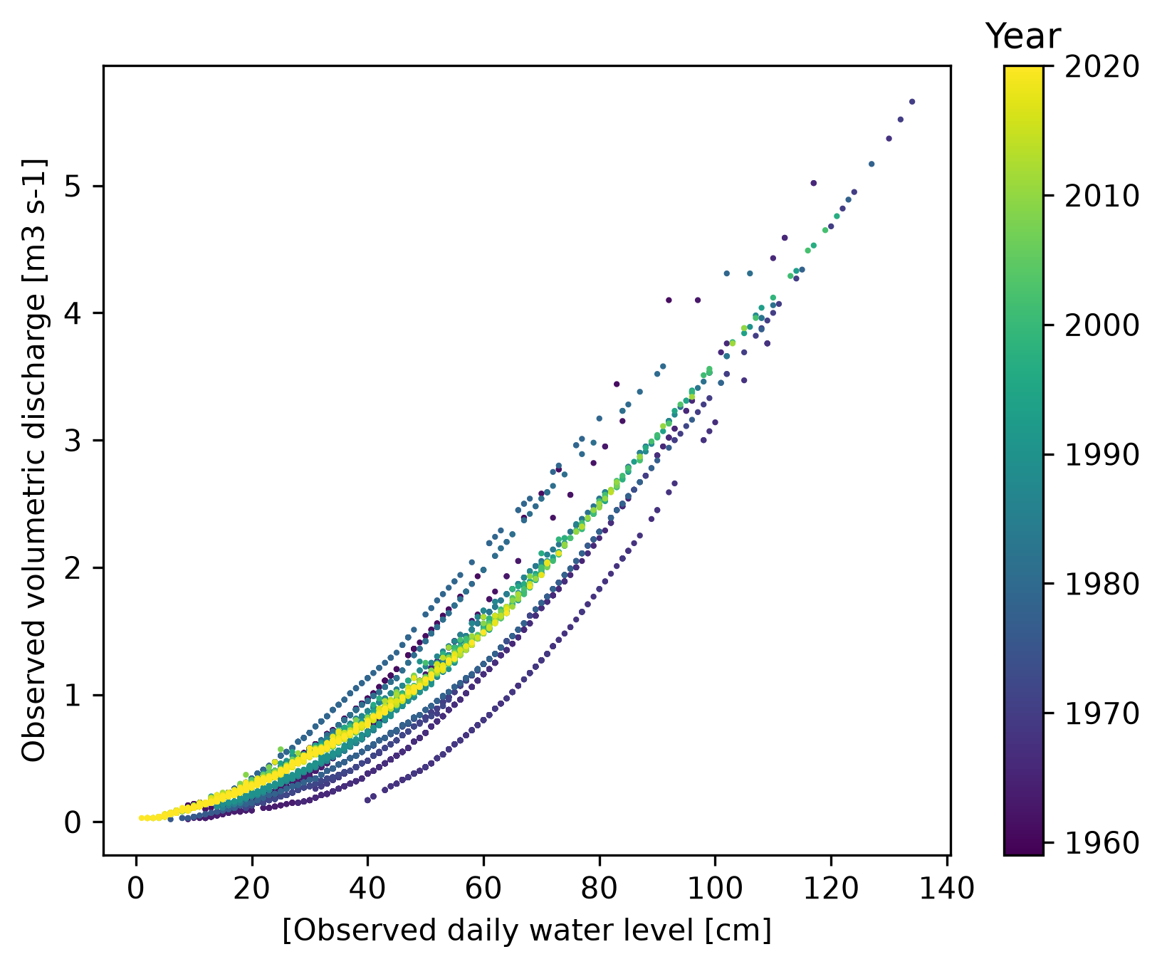Figure 12: stage discharge relationship curve for the Klingbach gauging station by year.

5.6 Is there a significant trend in the daily flow or in the flows above the 95th (Q95, high flow) or below the 5th percentile (Q5, low flow)? If trends are detected in high or low flows, discuss whether they are consistent with observed changes in rainfall or catchment characteristics.
A significant negative trend in the maximum, sum and count aggregated, 95th percentile subset of specific discharge of the CAMELS dataset was detected (Figure 13). This aligns with the observed increasing trend in annual mean temperature (Figure 14) which leads to higher evapotranspiration and therefore to a potential decrease in annual mean specific discharge.
Although no statistically significant trend was detected, the frequency of events below the 5th percentile shows an increasing trend from a descriptive perspective (Figure 15).

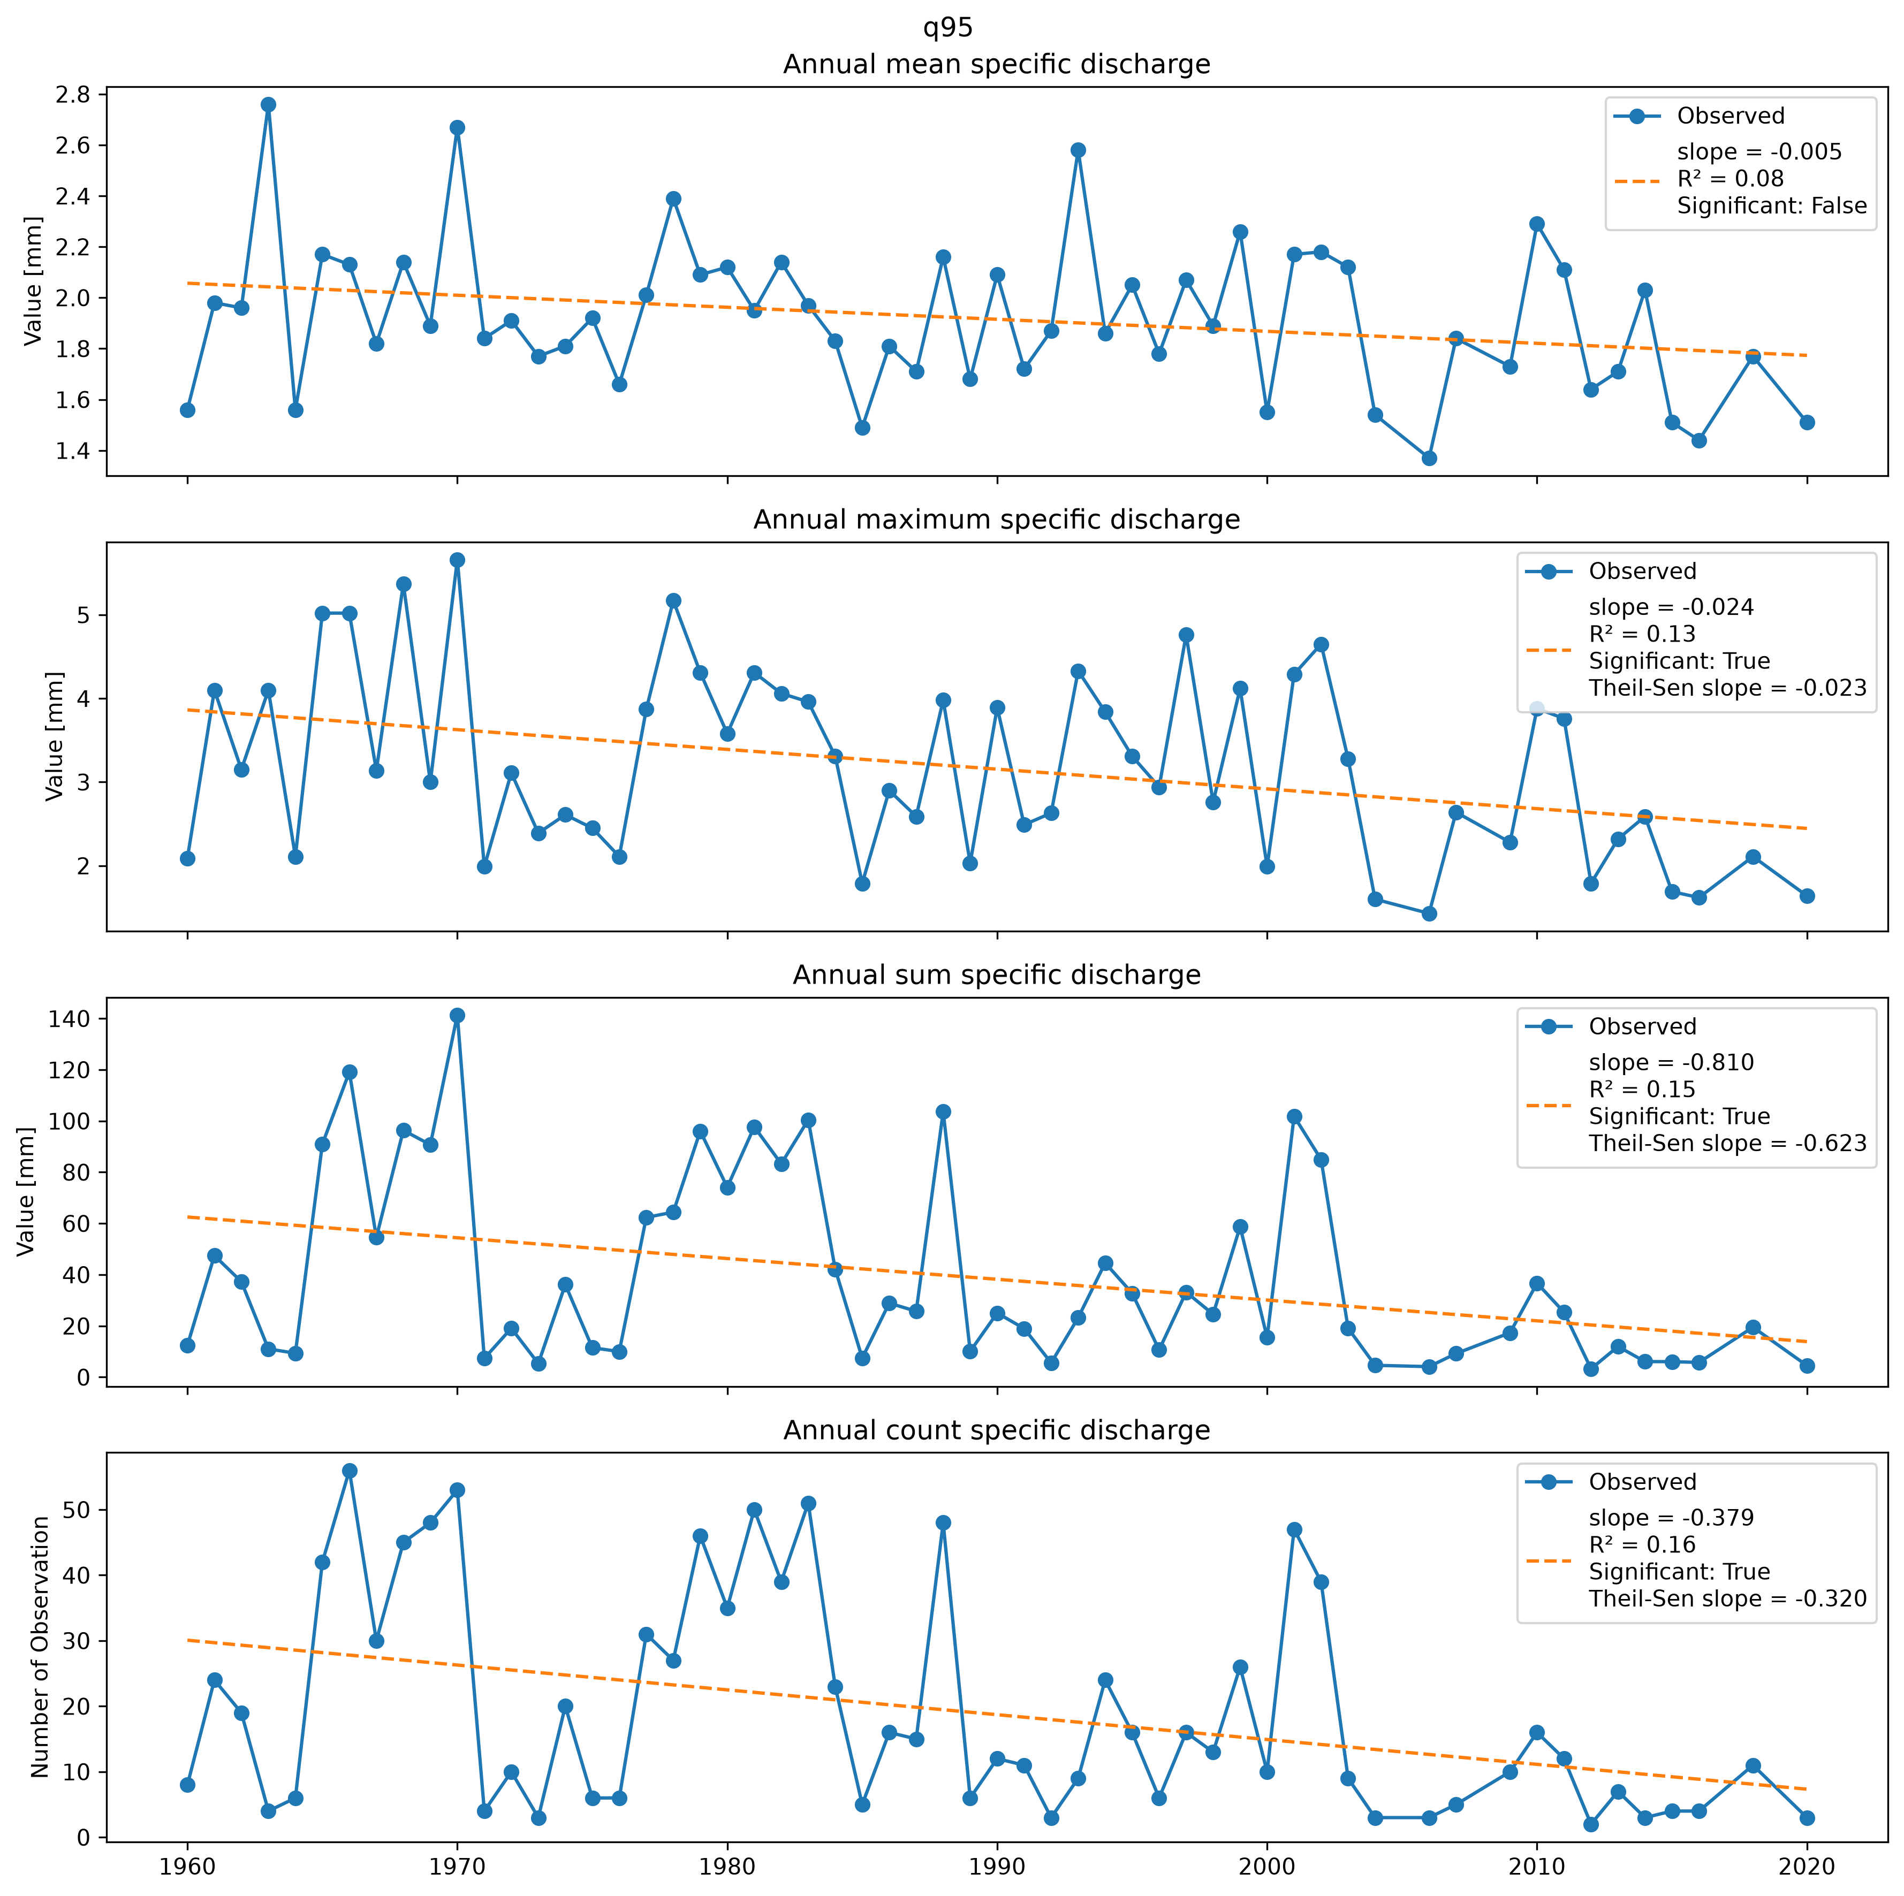Figure 13: Aggregated data for 95-percentile of CAMELS specific discharge dataset. Data is aggregated by mean, maximum, sum and count. For each subset, a linear model was performed and plotted as dashed line, model slope and R² are provided in the legend.Further, for each subset a Mann-Kendall test was performed and if significant the Theil-Sen slope was calculated and provided in the legend.
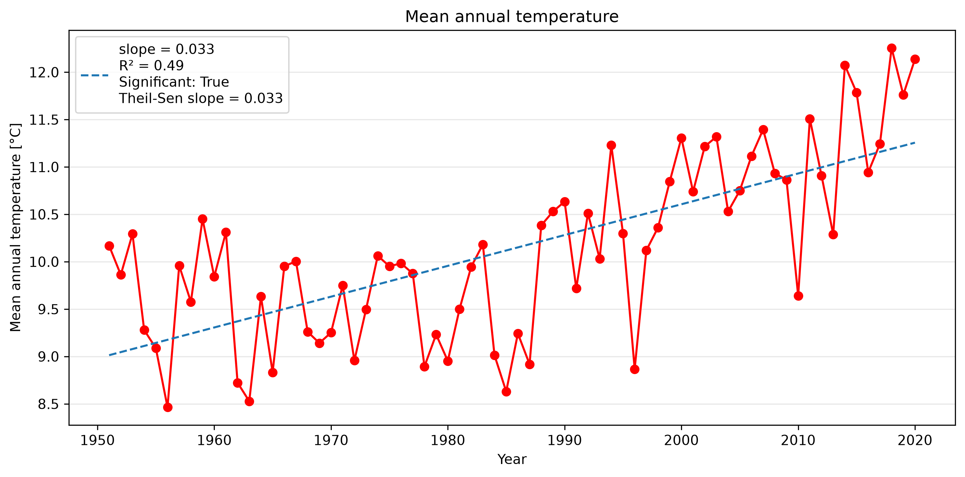Figure 14: Mean annual temperature for the CAMELS dataset. A linear model was performed and plotted as dashed line. Model slope and R² are provided in the legend. Te Mann-Kendall test was significant, therefore the Theil-Sen slope was calculated and also provided in the legend.
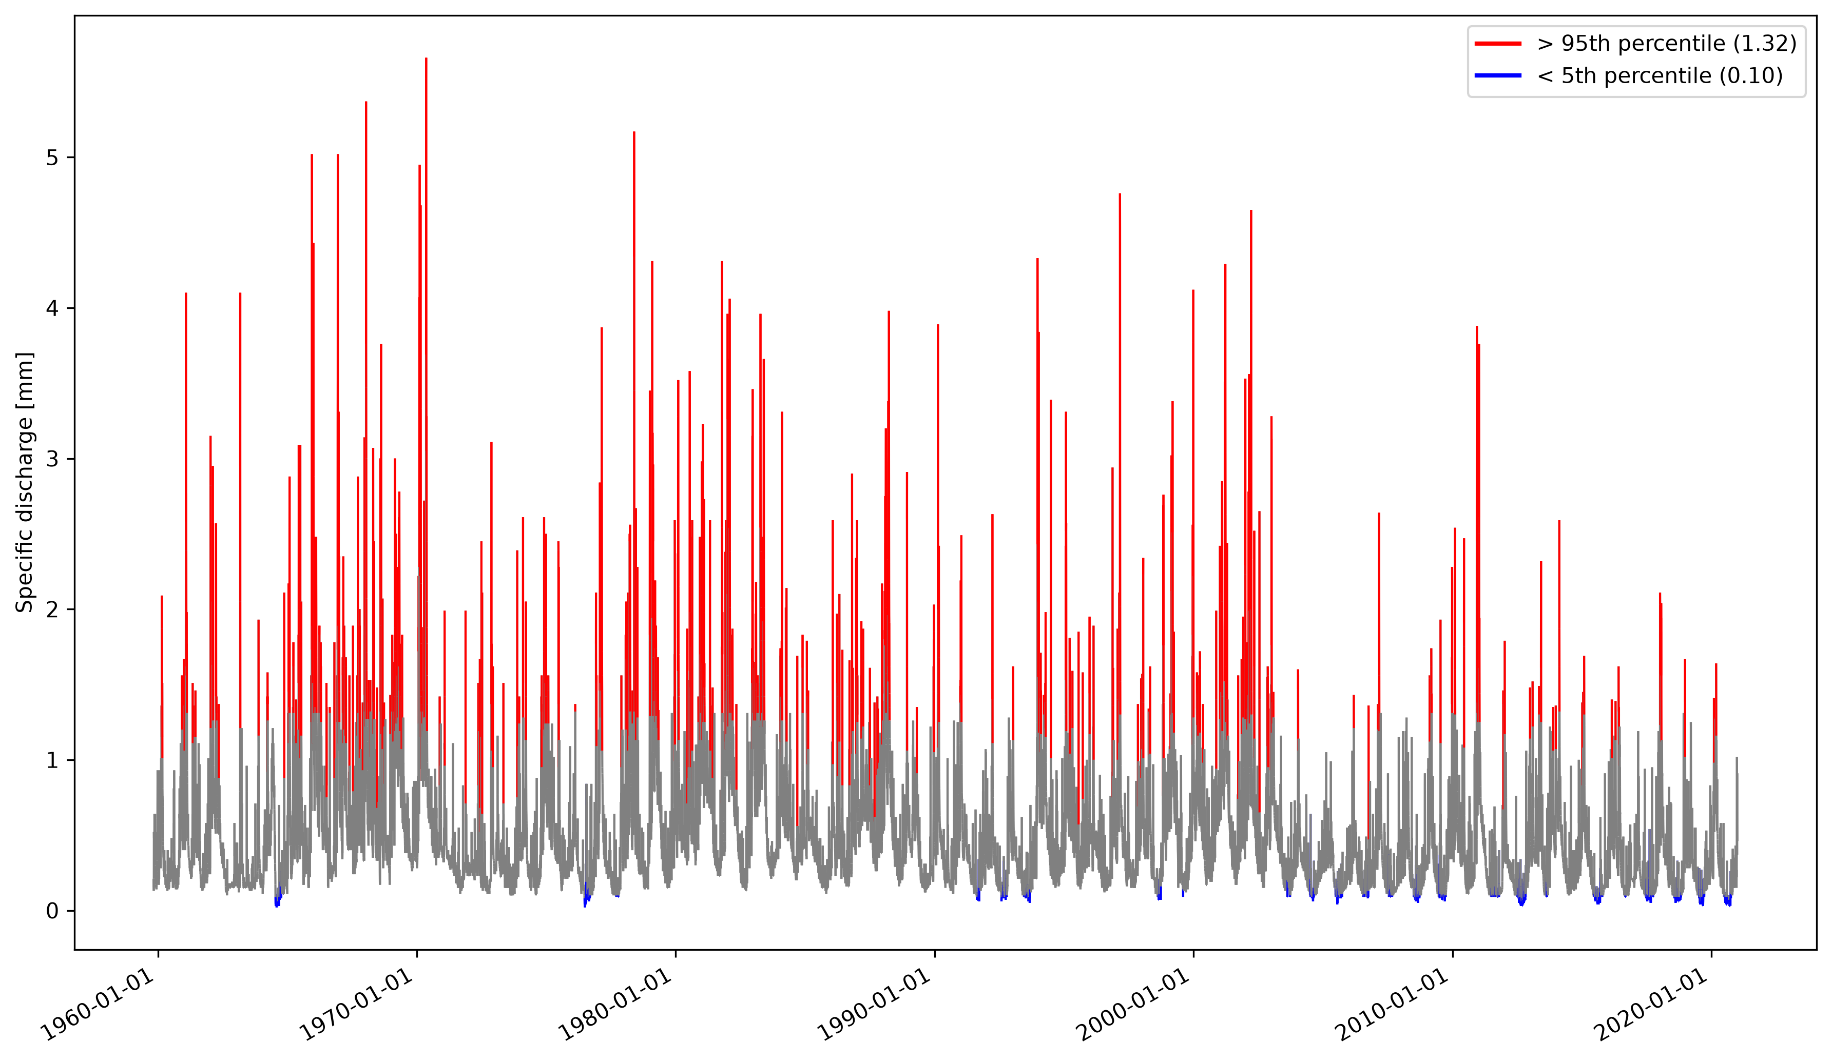Figure 15: Specific discharge timeseries for the CAMELS dataset. The 5th and 95th percentiles are highlighted in blue and red, respectively.

5.7 Calculate the long-term runoff coefficient for your catchment and compare it with your classmates’ catchments. What does it suggest about infiltration, and land cover within the catchment?
The long-term runoff coefficient for the klingbach catchment is 0.167. This means about 16.7 % of the precipitation is converted into the catchments runoff.

6. Water Balance

6.1 Using the given precipitation and discharge data, calculate the long term annual and the annual water balance for your catchment. What is the estimated actual evapotranspiration (AET) using the water balance method? How does this compare to potential evapotranspiration (PET) given in the CAMELS data?

The estimated long-term actual evapotranspiration (AET) using the water balance method is 564.32 mm. Compared to the simulated potential evapotranspiration (PET) of 735.39 mm from the CAMELS dataset the AET is lower. This is due to summer months with low precipitation and high temperatures which lead to a high simulated potential evapotranspiration.

Discuss the limitations of the approach and whether the estimated actual evapotranspiration is realistic for the climate and land use of the catchment.
Regarding estimated actual evapotranspiration of other catchments, ranging from 460 – 490 mm (Frietsch & Schuetz, 2026) or from 219 – 572 mm with a mean of 461 mm (Renner & Hauffe, 2024), the klingbach catchment long-term AET seems to align in the normal range of other temperate climate catchments in germany using the same method of water balance.
Nevertheless, there are factors which could lead to potential errors in the estimation of the AET. The precipitation data of the CAMELS dataset is obtained from the HYRAS raster dataset of the german weather service (DWD). In simplified terms, the HYRAS dataset is created by spatial interpolation of the weather station measurements with a topographical correction (DWD). Despite the corrected spatial interpolation, it is possible that the method estimates wrong precipitation values in the catchment area.
Further, groundwater fluxes are not considered in the simplified water balance equation, leading to a potential higher actual evapotranspiration.

7. Research Question

