Extended Abstract
Course: GEO6 Soil chemistry
Student Number: 216200037
Date of Submission: XX.XX.XXXX

Influence of invasive species and soil properties on the microbial response of root soil samples.

1. Introduction
Soil microorganisms play a central role in soil functioning by decomposing and transforming organic matter and contributing to nutrient cycling. Microbial activity is therefore an important indicator of soil biological functioning (Blume et al., 2010). Microbial respiration reflects the metabolisation of organic carbon and the associated release of CO₂, making it a useful indicator of microbial activity (Wakelin et al., 2013). The MicroResp method enables the assessment of microbial activity by measuring substrate-induced respiration in whole-soil samples, providing insights into microbial substrate utilisation and community-level physiological responses (Campbell et al., 2003).
Plant-associated microorganisms are influenced by root exudates, which contain diverse metabolites that can alter the composition and function of microbial communities. As root exudate profiles vary with plant genotype and environmental conditions, plant identity may contribute to differences in microbial community composition and activity (Koprivova & Kopriva, 2022).These interactions are particularly relevant when investigating invasive plant species, as differences in root-derived metabolites may influence the microbial communities associated with their roots. Comparing invasive and non-invasive plant groups can therefore help investigate whether plant identity is associated with differences in microbial respiration and substrate utilisation.
In addition to plant identity, soil properties can also influence microbial activity and the availability of resources. Sereni et al., 2021 has shown that soil pH can modify the response of microbial respiration to copper contamination, with respiration being more sensitive to copper in acidic soils than in neutral or alkaline soils. This highlights the importance of considering soil properties when investigating microbial functioning. Therefore, this study investigates how plant-group identity and soil properties are associated with microbial respiration and substrate utilisation in root-associated soil samples.

2. Material and methods

Soil sampling
Soil samples were collected from a riparian area along the River Queich near Landau, Germany. Rhizosphere soil was sampled from three plant species: the invasive species Fallopia japonica and Impatiens glandulifera, and the native species Urtica dioica, hereinafter abbreviated as ‚F‘, ‚I‘ and ‚U‘. Additionally, a bulk soil sample was collected from a nearby bare fallow at the same soil depth to serve as a control, hereinafter abbreviated as ‚B’.

Microbial respiration measurements
Microbial respiration was assessed using the MicroResp™ method (Campbell et al., 2003) in three rhizosphere soil samples and one blank sample. Soil samples were transferred into pre-weighed deep-well microplates, weighed to determine soil mass, and pre-incubated at 25 °C for 3–5 days under moist conditions to minimise evaporation.
Respiration was measured following the addition of 24 substrate solutions, consisting of 12 carbon substrates (S0–S11, with S0 including water as control) and 12 treatments combining root extracts from the three plant groups (F, I and U), each at two concentrations, with or without glucose. The specific substrate concentrations were adjusted according to the soil water content and water-holding capacity. For each treatment, 25 µL of substrate solution was added to the soil samples.
Carbon dioxide evolution was determined using detection microplates containing an agar-based bicarbonate buffer with cresol red indicator. Absorbance was measured at 572 nm before substrate addition and after six hours of incubation at 25 °C. Detection plates were accepted only when the coefficient of variation of initial absorbance was ≤ 5 %. A nonlinear calibration curve was calculated from CO₂ standards to convert absorbance measurements into CO₂-C quantities.
Absorbance values were normalised using the initial absorbance measurements to account for differences between wells. The resulting values were converted into CO₂-C quantities using the calibration curve. Basal respiration and substrate-induced respiration rates were calculated per unit of dry soil mass and incubation time. Catabolic diversity was quantified using the Shannon diversity index based on the relative respiration rates of the carbon substrates without root extracts.

3. Results
Figure 1 shows the basal respiration across the four soil samples. Bulk soil showed the lowest median respiration rate, whereas Urtica showed the highest. Fallopia- and Impatiens soils had similar median respiration rates and comparable variability. However, both exhibited a wide range of values, with their distributions overlapping those of Urtica soil.
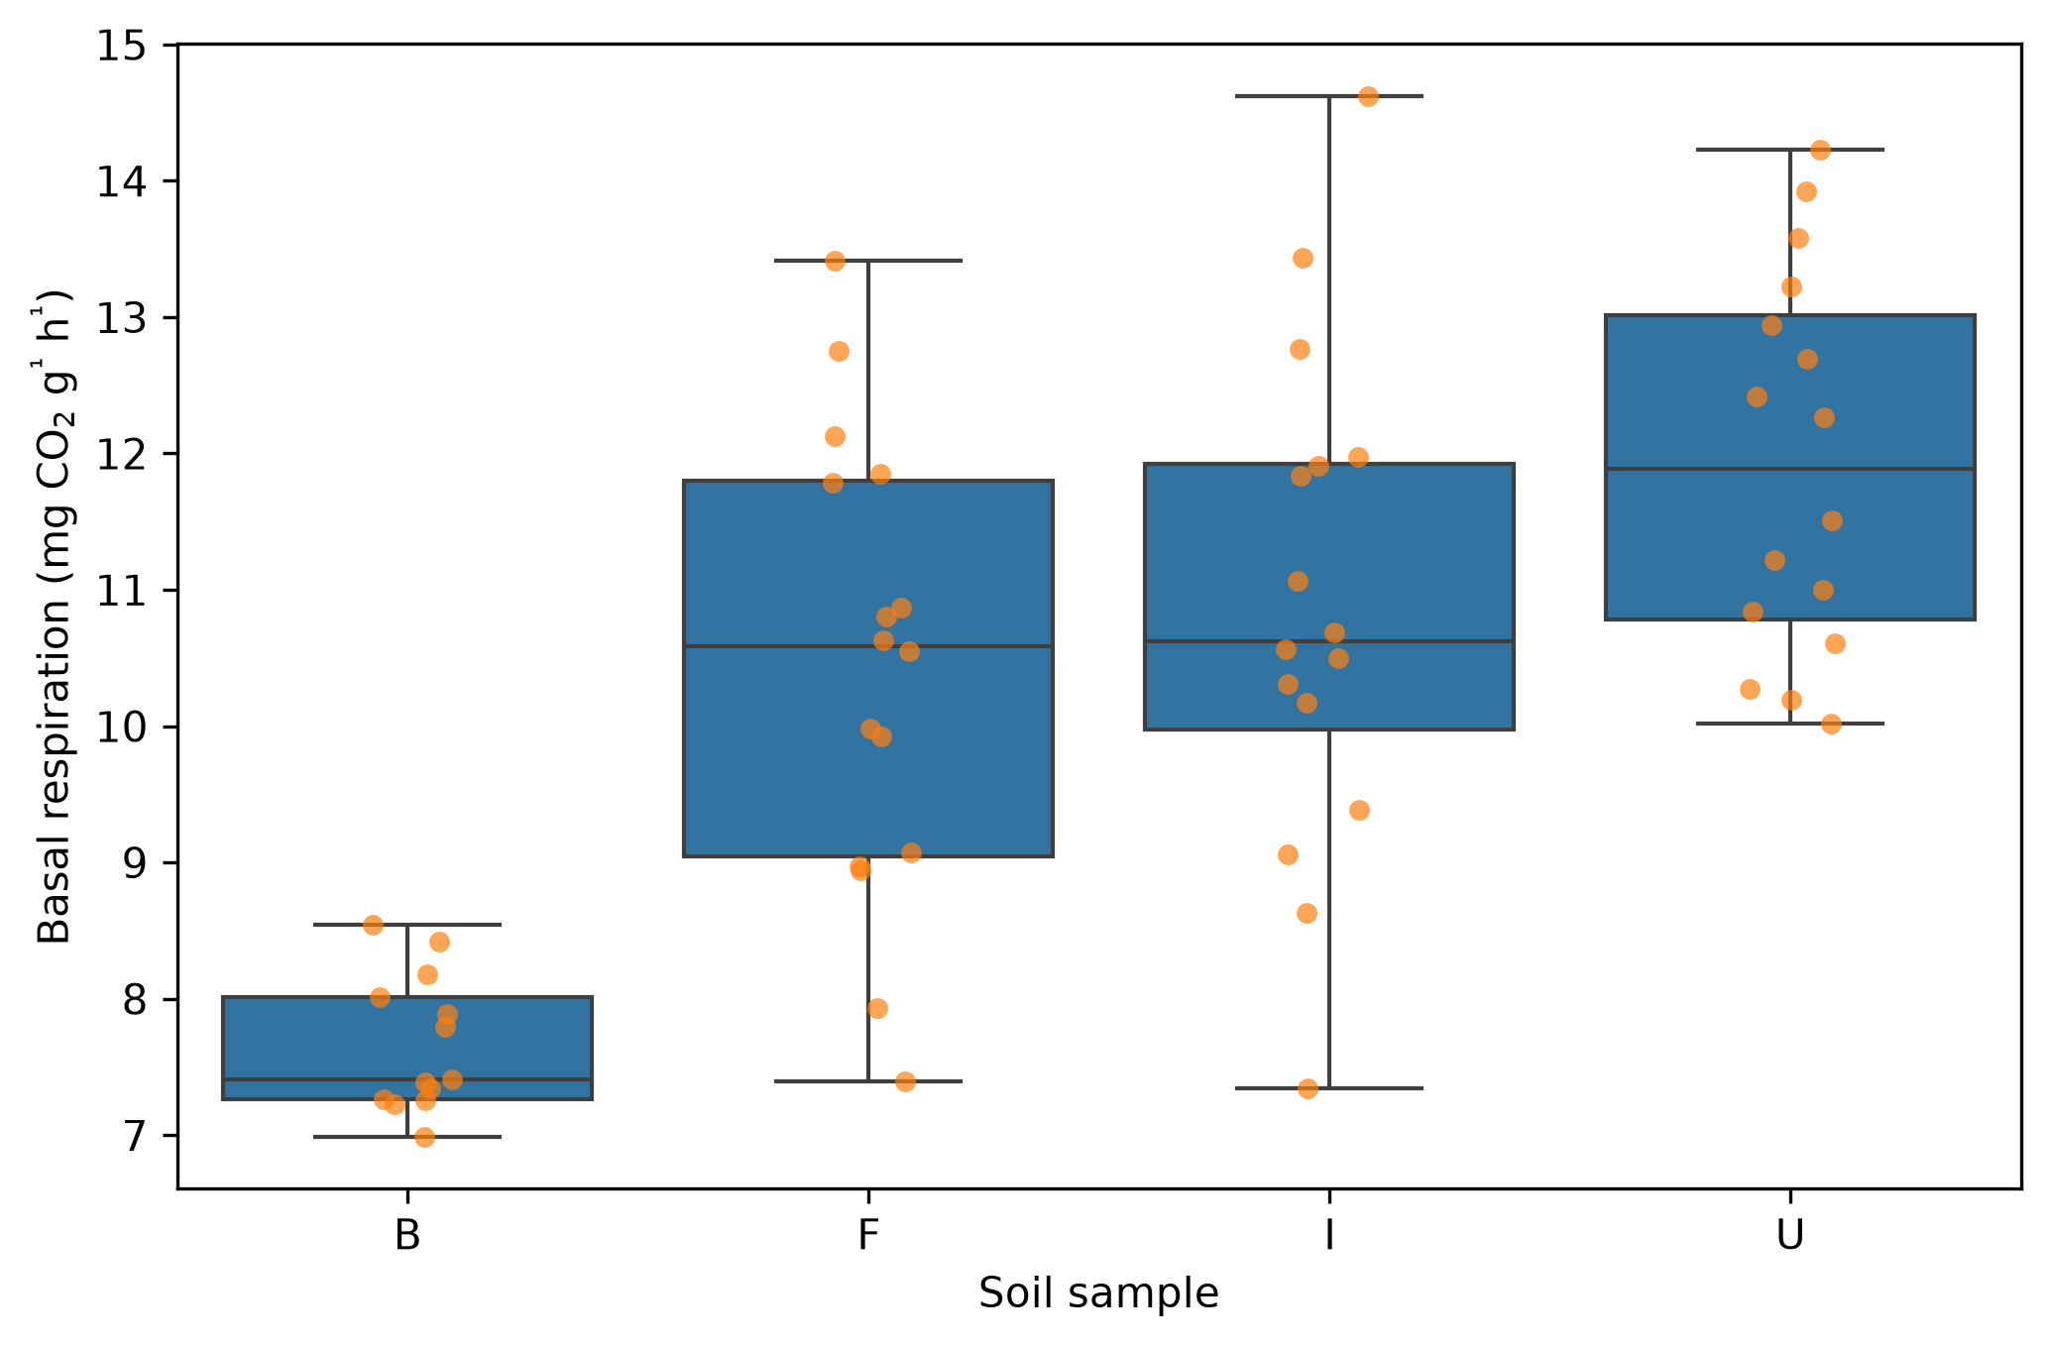Figure 1: Basal respiration across the four soil samples. In addition to the boxplots, the data points were overlayed as scatterplots to visualize the distribution of the individual data points.

The substance induced respiration across all four soil types ( B, F, I, U) and all 11 substances are shown in Figure 2. Descriptively, respiration rates increased from bulk, in the order of Fallopia, Imaptiens and Urtica is visible, for Glucose, Galactose, Trehalose, and γ-Amino buturic acid.
For Cyclodextrin, L-Alanine, the respiration rates for Fallopia and Impatiens are similar, whereas Bulk soil showing a lower and Urtica showing a higher respiration rate.
For L-Phenylalanine, Tri sodium citrat dihydrate the respiration rates of Impatiens and Urtica are similar, lower in Fallopia and lowest in Bulk soil. For L-Arginine, no significant differences in respiration rate among the four soil types can be found, considering the dispersion of data points.
For Lignin alkali, Fallopia shows a high spread of data values, overlapping withe the ranges of Bulk soil and Impatiens. Bulk soil shows a lower respiration rates than Impatiens and Urtica, which appear almost similar in respiration.
Interestingly, for Oxalic acid, Fallopia and Impatiens show a wide range of respiration rates, with Fallopia tending towars higher values. The range in respiration rate observed in Impatiens overlap those of Urtica and the bulk, expect the lower whisker of the bulk soil distribution.
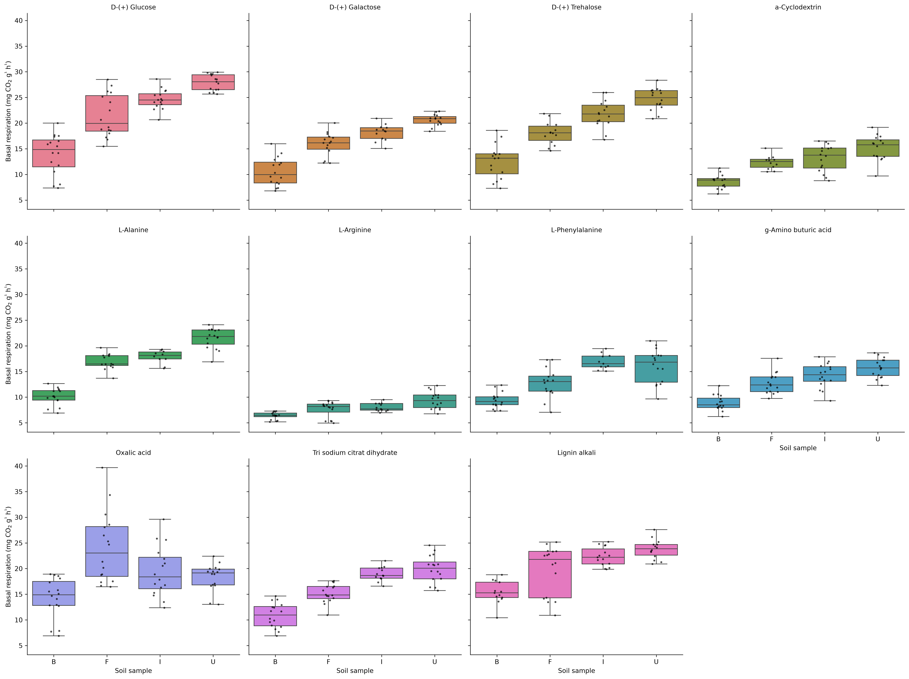Figure 2: Substance induced respiration across all four soil types ( B, F, I, U) and all 11 substances. In addition to the boxplots, the data points were overlayed as scatterplots to visualize the distribution of the individual data points.

4. Discussion

5. Conclusion

shows the basal respiration across the bulk soil and the three plant species with added root extract in two concentrations.
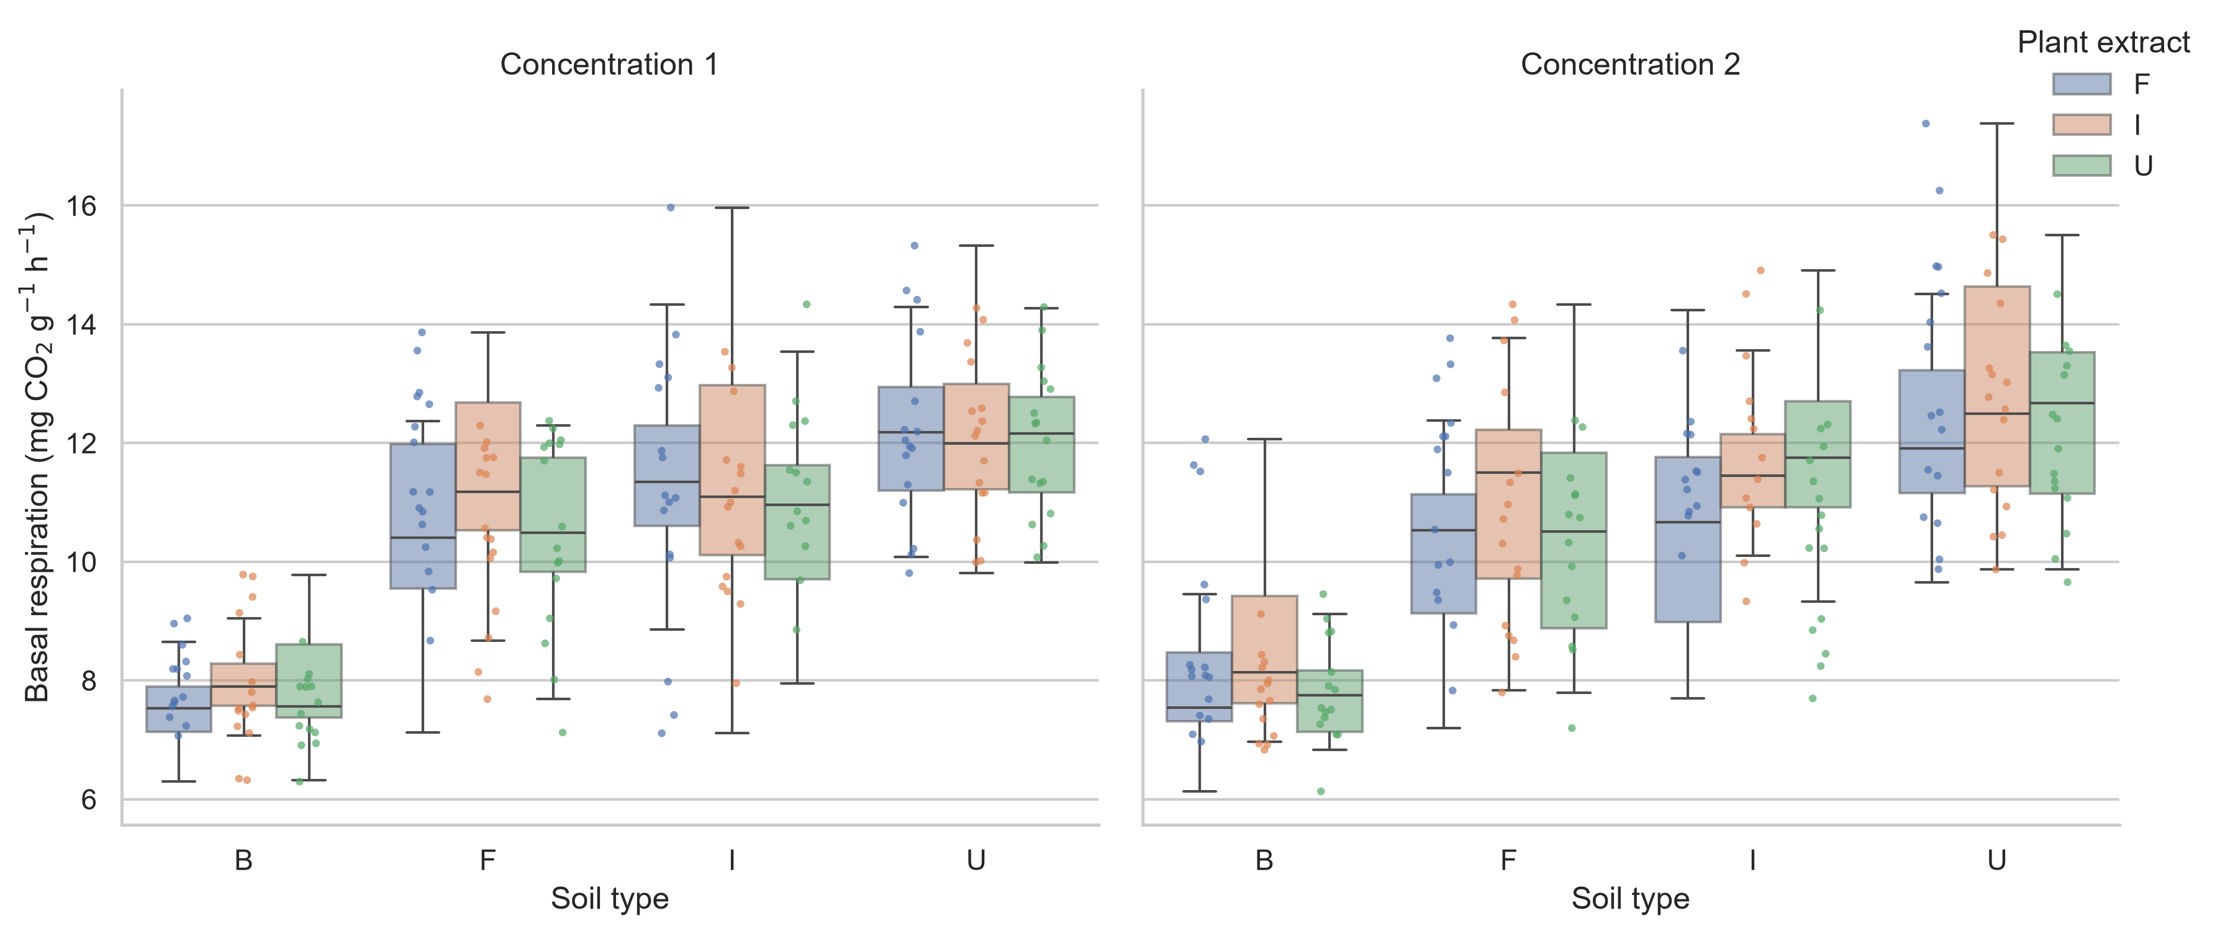Figure 3: Basal respiration across plant species and root extract, added at two concentratons. In addition to the boxplots, the data points were overlayed as scatterplots to visualize the distribution of the individual data points.
The median of the bulk soil samples (B) are noticably lower than of the three rhizosphere soil samples (F, I, U). The rhizosphere soil sample medians, for each root extract treatment, increase from Fallopia over Impatiens to Urtica. However, all three rhizosphere samples vary extremly and between the root extract treatment, regarding the dispersion of the data, no consistent pattern is observable. Comparing the two concentration of root extract treatment, from a descriptive perspective no effect or pattern is visible.

