Catchment Characterisation and Hydrological Assessment

A consultancy-style investigation of climate, hydrology and catchment processes

ACP4 – Methods of Environmental Physics

Student: Daniel Serr
Student number: 216200037
Date of Submission: 15.10.2026
This report investigates the climatic and hydrological characteristics of the Klingbach catchment in Rhineland-Palatinate, Germany, using discharge and meteorological observations from the CAMELS-DE dataset (Dolich et al., 2024) as well as additional meteorological data from two agrometeorological stations provided by the Dienstleistungszentren Ländlicher Raum (DLR) of Rhineland-Palatinate (DLR, n.d.).

1. Data availability and quality checks

1.1. What is the length of available data (climate and discharge) both for CAMELS-DE and climate stations.
Table 1: Length in days and years for all three datasets before and after data alignment through intersecting by available columns and timestamps.
 | Dataset | Length [days] | Length [years]
Before alignment | CAMELS-DE (climate & discharge) | 25567 | 70.1
Before alignment | Agrometeo Herxheimweyher | 6573 | 18.0
Before alignment | Agrometeo Steinweiler | 6573 | 18.0
After alignment | CAMELS-DE & Agrometeo | 4518 | 12.3

Is the period of record sufficiently long to characterise the catchment climate and hydrology? Justify your answer.
Climate is typically being defined by an observation period of 30 years (DWD, 2026a). Therefore, the length of available data is too short to adequately characterise the catchment climate. Since discharge is strongly influenced by climatic conditions, such as e.g precipitation and evapotranspiration, the insufficiency in data length of the aligned dataset also restricts the characterisation of the catchments hydrology.

1.2. When was the discharge gauging station established?
The discharge gauging station was established on the 24. December in 1957 (Wasserportal RLP, 2026).

1.3. Are there any missing data? Plot the timeseries of daily flow.
The timeseries of daily flow is shown in Figure 1. Only the variables discharge_vol_obs, discharge_spec_obs, and water_level_obs from the CAMELS-DE dataset showed missing data:

Table 2: Number and percentage of missing observations in the CAMELS-DE dataset.
Variable | Number of NA’s | Missing [%]
discharge_vol_obs | 8 | 0.14
discharge_spec_obs | 8 | 0.14
water_level_obs | 3 | 0.05

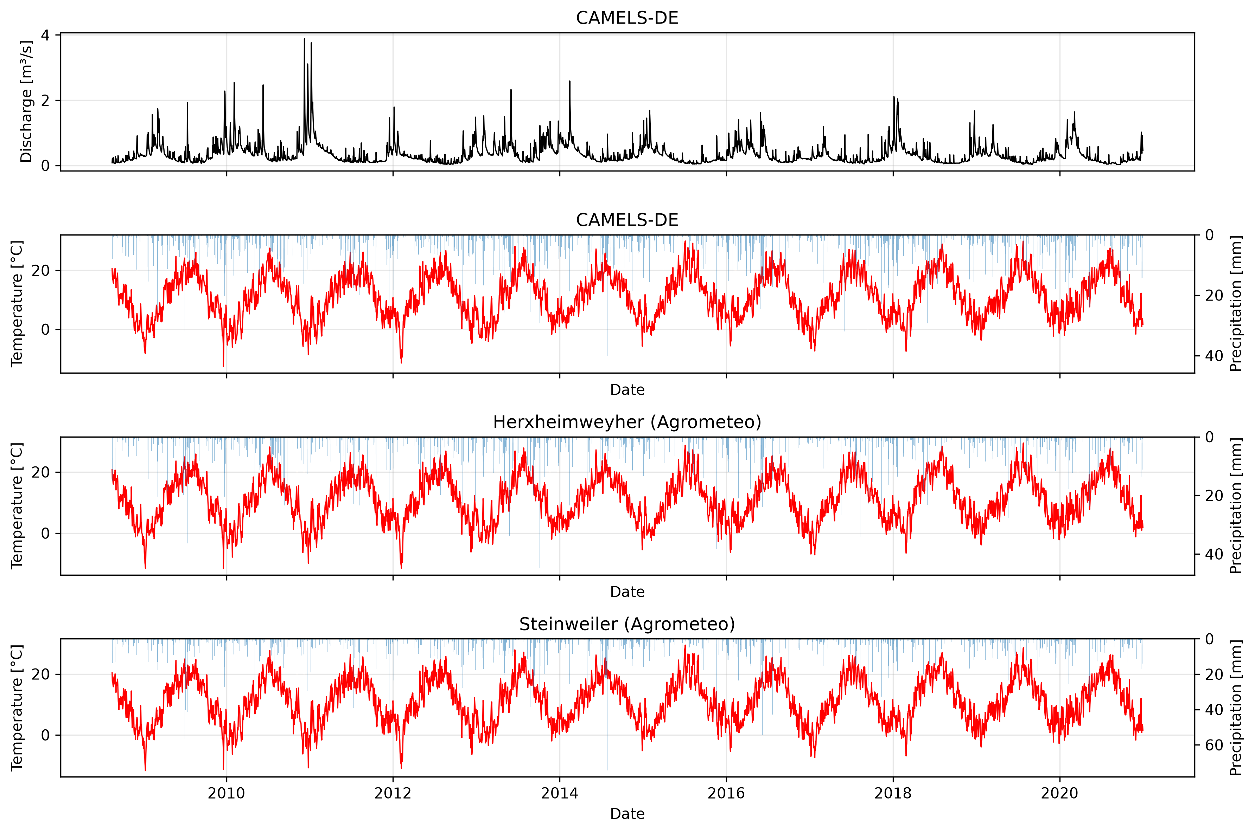Figure 1: Annual discharge, mean temperature and mean precipitation for the CAMELS-DE and the two agrometeo weather stations dataset .

1.4. Are there any outliers or faulty data? Based on what criteria did you label them as outlier or faulty?
No faulty data could be detected with regard to duplicated timestamps and negative values for zero-inflated parameters where negative values are physically impossible, e.g. precipitation.
Asserting the datatype of numerical columns to be float64, excludes possible non-numeric entries with the background of previously handling missing values.
No outliers could be detected using visually inspection. Although the modified z-score for outlier detection could have been used, it was not considered necessary given the visual assessment of the data and the limited scope of the report. However, applying the modified z-score within a sliding window could be useful to account for significant fluctuations due to seasonality.

1.5. How could missing data and outliers influence subsequent analyses such as catchment statistics and trend detection? How do you deal with these in the following analysis?
Missing data and extreme outliers bias and distort the estimates of means, annual sums and trend detection. However, in hydrology extreme observations are common and do not necessarily indicate incorrect data, emphasizing the importance of manually checking statistically detected outliers.
Only the CAMELS-DE dataset showed a low proportion of missing values (Table 2) and therefore simply excluded when calculating summary statistics. No data points needed to be removed due to the absence of extreme outliers or being faulty data.

2. Catchment description

2.1. What is the geographic location of the catchment? Where are the discharge gauging station and the precipitation stations located?
The geographic location of the catchment, the discharge gauging station and precipitation stations are shown in Figure 2.

2.2. What are the coordinates and elevation range?
The coordinates of the gauging station and the precipitation stations are shown in Table 3. The elevation of the catchments area ranges from 38.0 to 656.0 meter.

Table 3: UTM32 N coordinates (EPSG: 25832) of the gauging station and the two weather stations.
Object | Easting (x) | Northing (y)
Gauging station | 441287.555 | 5443734.056
Weatherstation Herxheimweyher | 445319.261 | 5445513.23
Weatherstation Steinweiler | 434303.997 | 5438962.42

2.3. What is the total catchment area?
The catchments area is 100.56 km² and its elevation ranges from 38.0 to 656.0 meter.
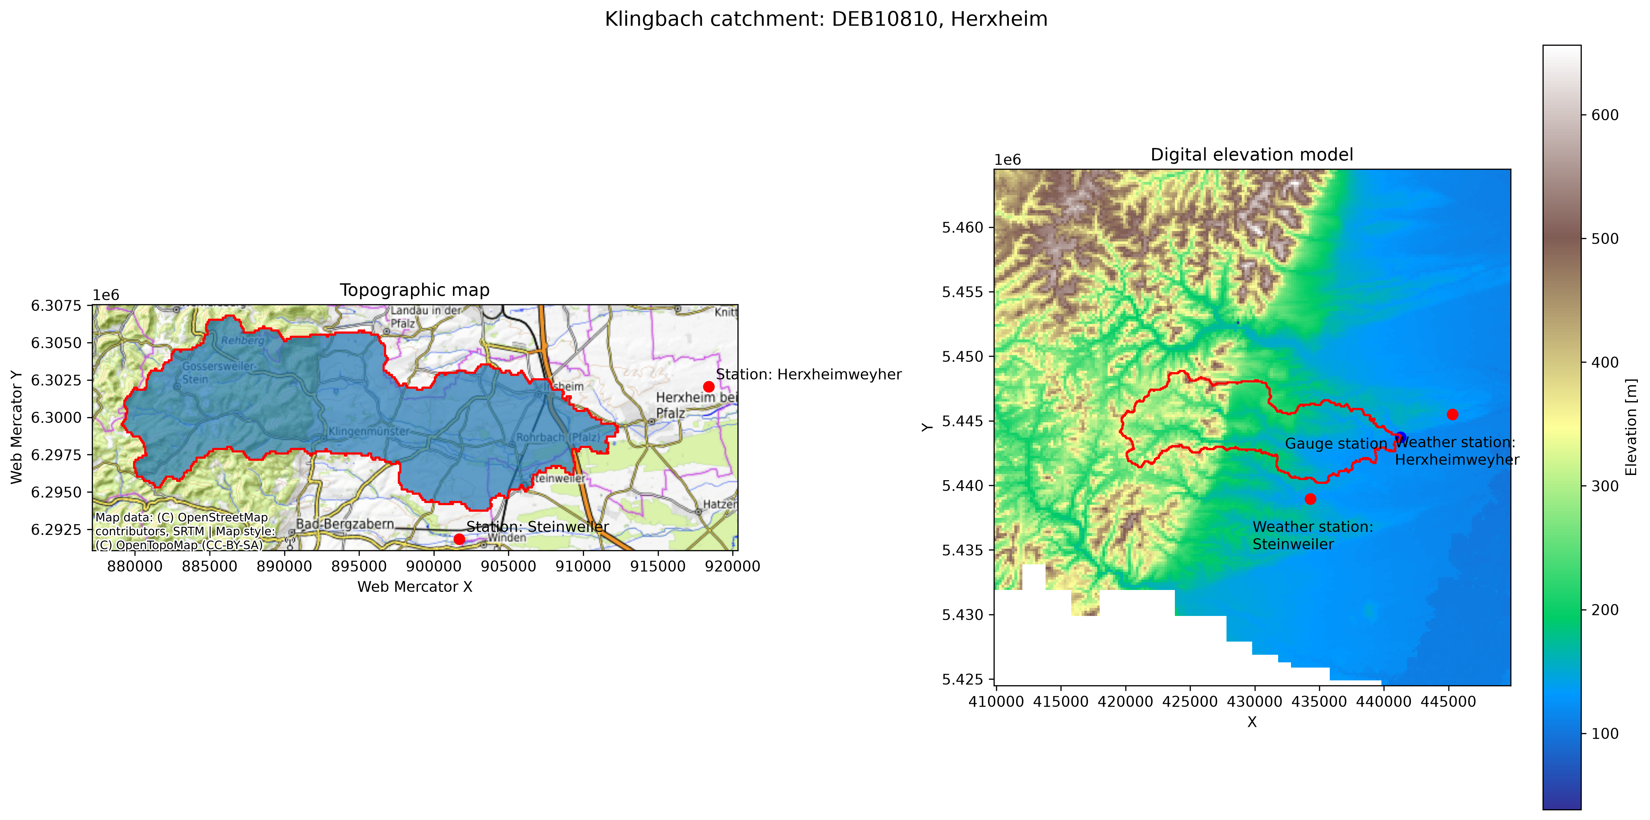Figure 2: Location of the catchment, the gauging station and the two agrometeo weather stations on topographic background and with digital elevation model (DEM) background. The topographip map is projected in Web Mercator (EPSG: 3857) and the DEM map in UTM32 N (EPSG: 25832).

2.4. How is the land use split between agriculture, forests, and artificial areas?
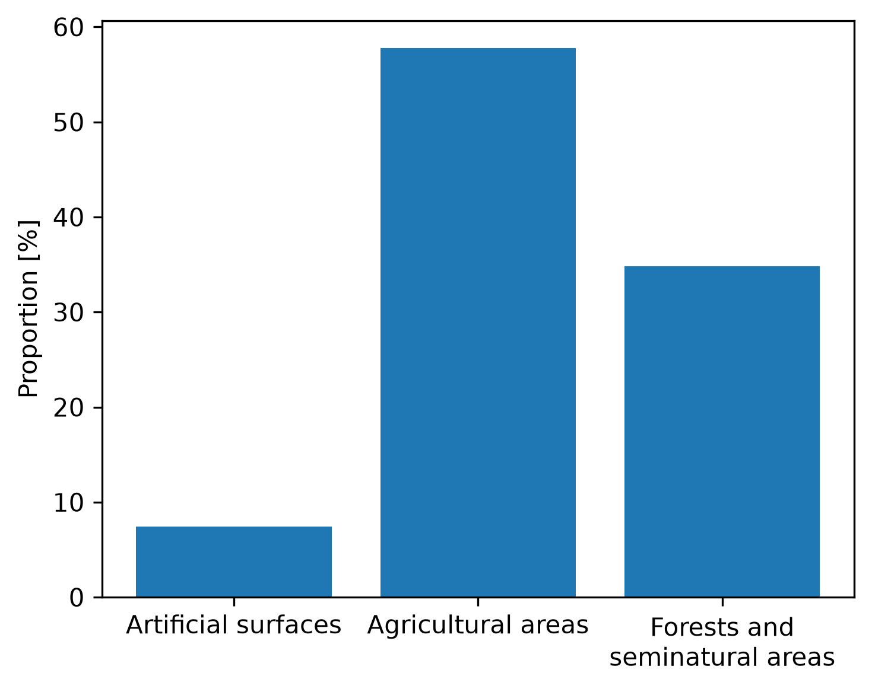Figure 3: Land use split of the catchment area.
The land use split between agriculture, forests and artificial areas is shown in Figure 3.

2.5. Are there any dams in your catchment?
Unfortunately, the official authorities do not provide any information about dams in the catchment.

3. Climate analysis

3.1. Calculate mean monthly temperature. Which months are the warmest and coldest?
The warmest and coldest months for all three datasets regarding mean temperature are shown in Table 4.

Table 4: Coldest and warmest month for all three datasets.
Dataset | Coldest month | Warmest month
CAMELS-DE | January | Jul
Weatherstation Herxheimweyher | January | Jul
Weatherstation Steinweiler | January | Jul

3.2. Describe the temperature regime of the catchment. What implications might it have for evaporation, vegetation growth, and seasonal runoff?
The mean monthly temperature in the camel dataset ranges between 2.7 ± 4.0°C an 21.4 ± 3.4 °C making January the coldest and July the warmest month.
According to the FAO 56 Penman-Monteith equation, potential evaporation depends on several meteorological variables, including air temperature and irradiance (Wikipedia, 2026).
Since July also has the highest global radiation, here evaporation is expected to be highest. However, December hat the lowest global radiation, therefore it remains unclear if potential evaporation is lowest in December or January, considering only temperature and global radiation (Figure 4).
The catchment lies within the temperate climate zone, where the vegetation period is limited mostly to the spring and summer season. Evaporation and transpiration by vegetation, important factors in the water balance of a watershed, are expected to have a great influence on the seasonal runoff, with lower mean discharges in summer and the vegetation period and higher discharge in the cold months outside the growing season.

3.3. How does humidity change seasonally?
Relative humidity shows a contrasting trend with highest humidity in December and lowest humidity in July (Figure 4).
The small increase of humidity in May and June coincides with increased precipitation in both months, whichas is further discussed in chapter 4 „Rainfall analysis“, Figure 6.

3.4. How closely does the seasonal temperature cycle correspond to the seasonal pattern in solar radiation?
The seasonal temperature cycle closely follows the seasonal solar radiation pattern. However, the monthly mean aggregated data show a slight lag, with January being the coldest month despite December having the lowest global radiation (Figure 4). This is presumably caused by the thermal inertia of the land surface and atmosphere.
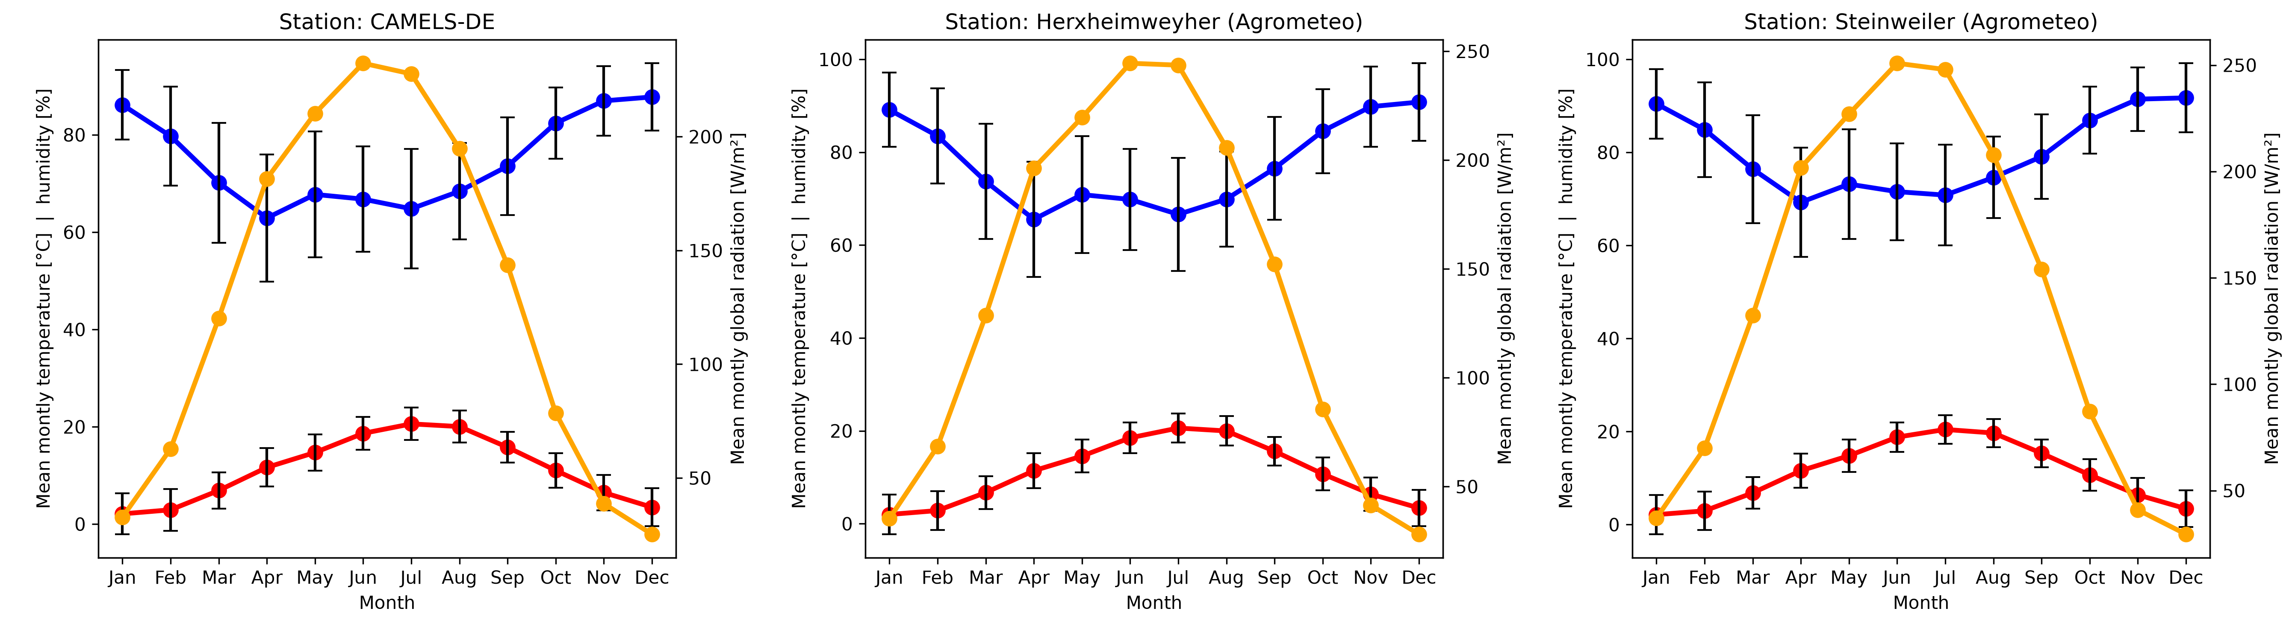Figure 4: Trend of temperature, precipitation and radiation for all three datasets. Data is mean monthly aggregated. Error bars show the standard deviation of the monthly mean values. The error bars for radiation were intentionally omitted to make the graph clearer.

3.5. Calculate PET using Hargreaves equation for one of your stations and compare to the CAMELS PET value. Discuss the main differences and their possible causes.
In Figure 5, Hargreaves potential evapotranspiration (PET) was calculated for both agrometeo weather stations and compared to the PET data from the simulated subset of the CAMELS-DE dataset.
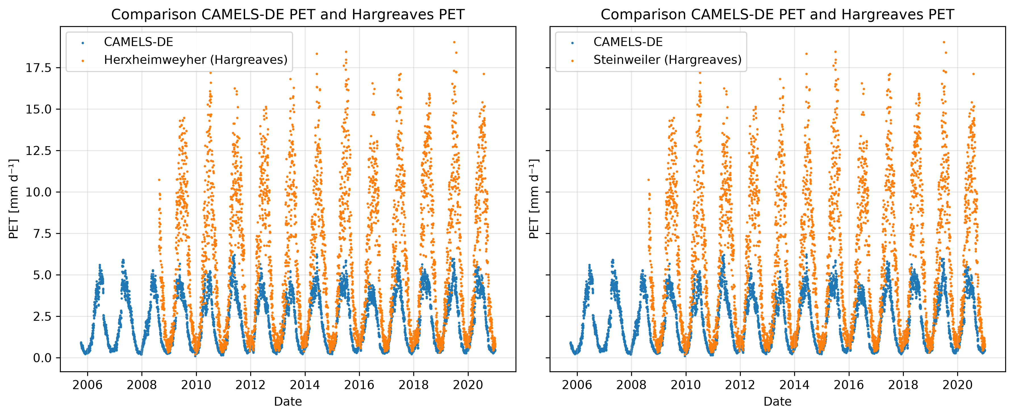Figure 5: Comparison of Hargreaves potential evapotranspiration (PET) calculated for both agrometeo weather stations and simulated PET from CAMELS-DE dataset.

The calculated Hargreaves PET reaches relatively high maximum values, with 0.95 quantiles of 14.6 and 14.5 mm/d for Herxheimweyher and Steinweiler, respectively. This is in contrast with the simulated PET values of the CAMELS-DE dataset, which has a 0.95 quantile value of 4.6 mm/d.
A comparison of the difference in daily minimium and maximum temperature between the CAMELS-DE and the agrometeo datasets, the agrometeo datasets show higher differences, especially for the summer season, potentially leading to higher PET values. However, this can not explain the magnitude of difference between the two datasets.
Another possible explanation is the equation used to calculate the PET in the CAMELS-DE dataset. The CAMELS-DE dataset paper refers to a github repository as the source for the Hargreaves equation used (Table 3, p. 2, Dolich et al., 2024). In the repository, the equation is provided in an example notebook using a modified version of the Hargreaves equation that includes monthly precipitation (Hy2DL, n.d.) The modified Hargreaves equation was developed by (Droogers & Allen, 2002), who reported improved PET estimates for arid regions. This could help explain the higher PET values observed during summer for the agrometeorological datasets using the unmodified Hargreaves equation, although this hypothesis requires further investigation to be confirmed.

4. Rainfall analysis
Table 5: Comparison of the annual precipitation mean and standard deviation for germany and all three datasets. The period of aggregated data ranges from 2009 - 2020.
Dataset | Average annual precipitation [mm]
Germany (DWD, 2026b) | 778.9
CAMEL | 687.0 ± 30.8
Herxheimweyher | 562.7 ± 63.52
Steinweiler | 717.66 ± 91.45
The catchment appears to be drier than the german average. This may partly be explained by its leeward position east of the Palatinate Forest, where moist air masses approaching from the west descend on the eastern side in a foehn-like manner, losing their moisture (Diercke, n.d.).
The seasonal distribution of precipitation of the catchment for all three datasets is shown in Figure 6. The medians of monthly precipitation sums show two minima in April and September, and an increase in the early summer months (May, June, July) and around the winter months (November, December, January, February). The months with higher median monthly precipitation sums show greater variability across the observation period, whereas the drier months appear to be less fluctuative.
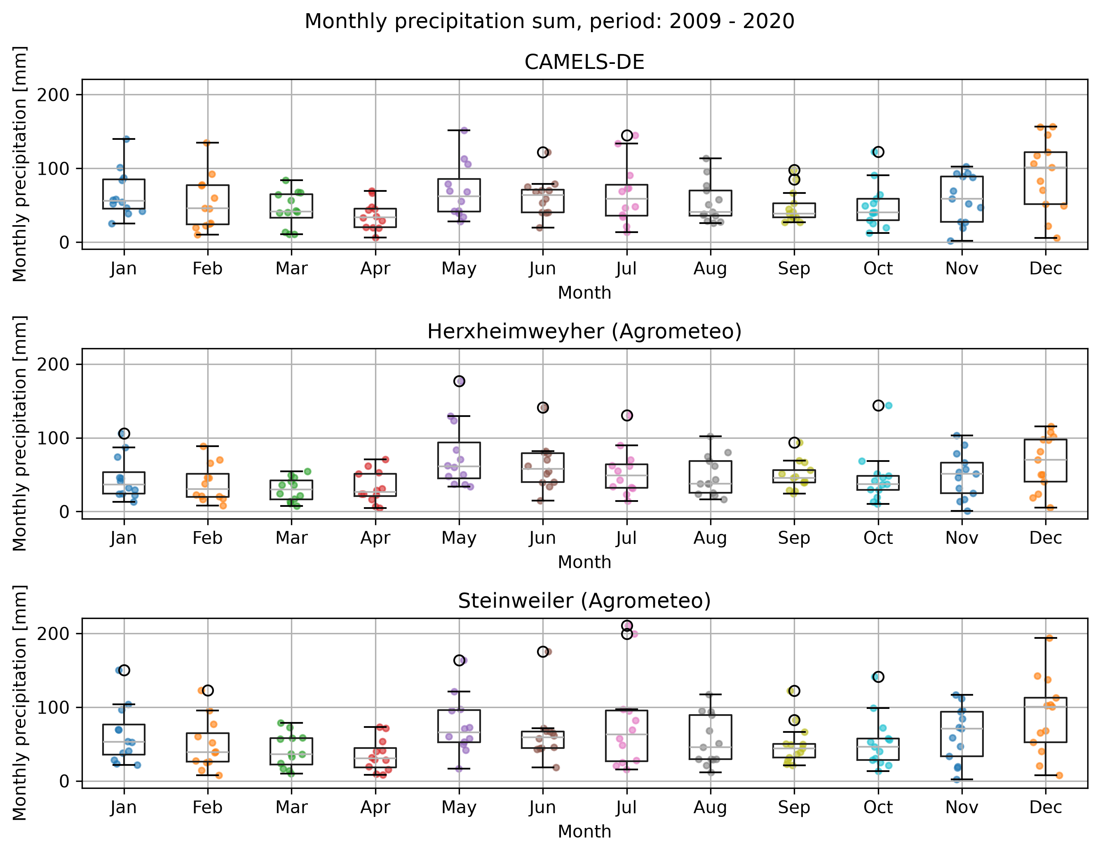Figure 6: Seasonal distribution of monthly precipitation sums for all three datasets. The individual points represent the monthly precipitation sums underlying the boxplot. The period of aggregated data ranges from 2009 – 2020.

4.2. Plot the annual average sum of rainfall over time.
The annual mean sum of precipitation of the catchment for all three datasets is shown in Figure 7.
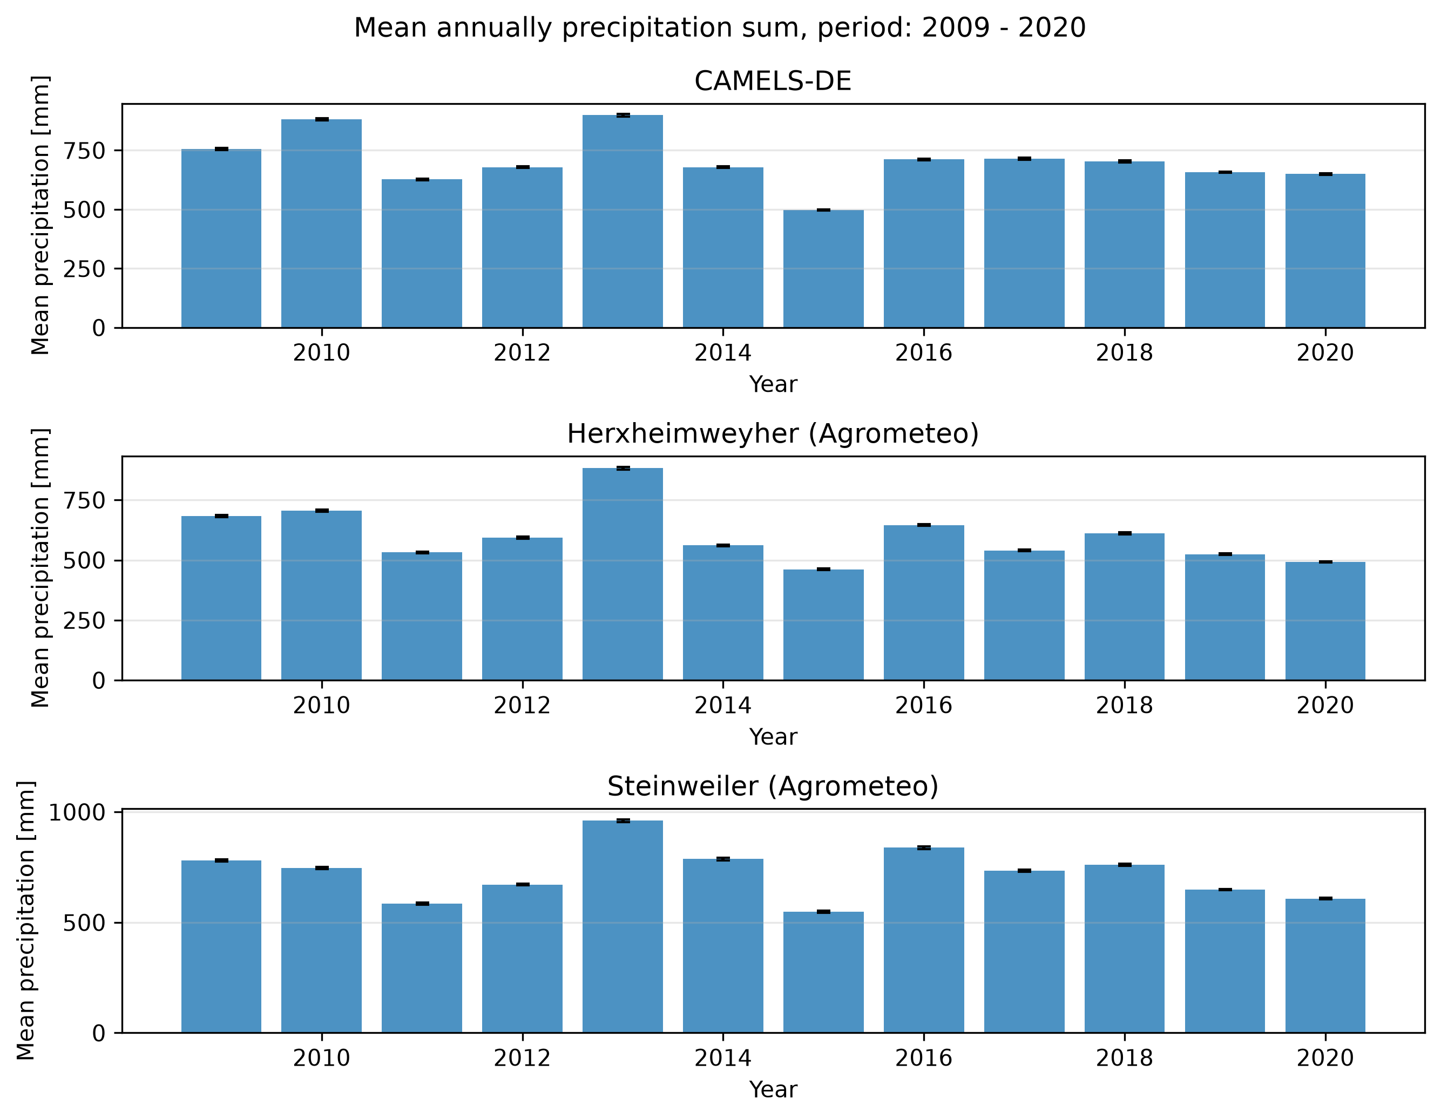Figure 7: Mean annual precipitation sum for all three datasets. The period of aggregated data ranges from 2009 – 2020.

4.3. Is there a significant increase or decrease in the annual average sum of rainfall over time? If a trend exists, discuss possible explanations. Could it represent climate variability, climate change, or limitations of the observation period?
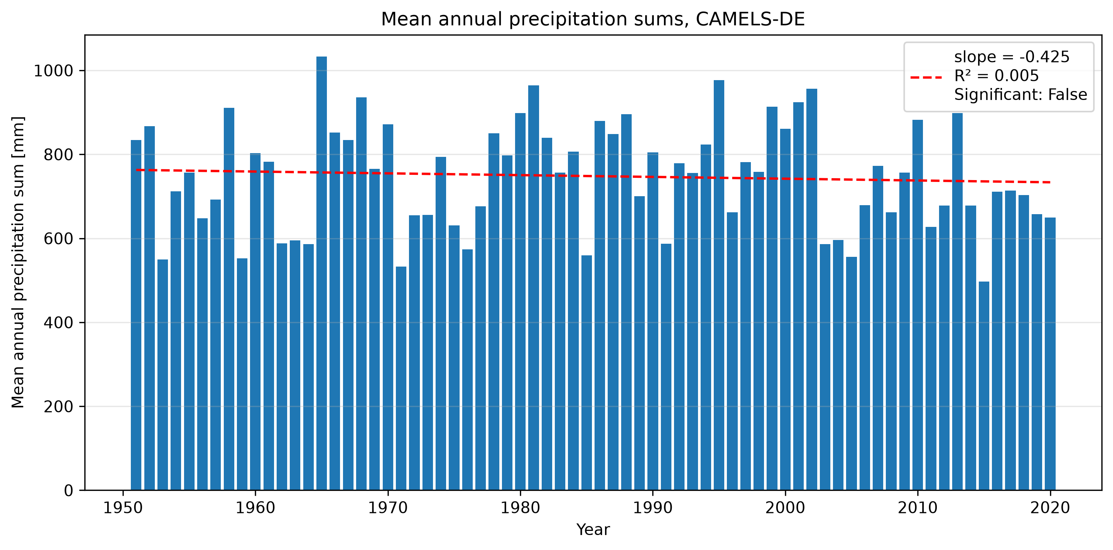Figure 8: Mean annual precipitation sums for the non-aligned CAMELS-DE dataset. Linear regression and Mann-Kendall-Test showed no significant linear trend in the timeseries.
Since the aligned dataset cover too few years to allow for reliable estimates of a possible trend in annual average sum, the non-aligned CAMELS-DE dataset was used for trend estimation (Figure 8). Neither visual inspection nor linear regression with Mann-Kendall-Test showed a significant trend in the data.

4.4 Identify extreme rainfall events (>99th percentile). Do extreme rainfall events occur during a particular season? Discuss possible meteorological causes and implications for flood risk.
Extreme rainfall events mostly occur between May and December (Figure 9). During the summer months, thunderstorms caused by convective uplift of warm, moist air might explain the high amount of extreme events. In autumn and winter, prolonged precipitation from advection might explain the high amount of extreme events. The comparativley low amount of extreme events between January and April may reflect seasonal differences from large-scale weather patterns.
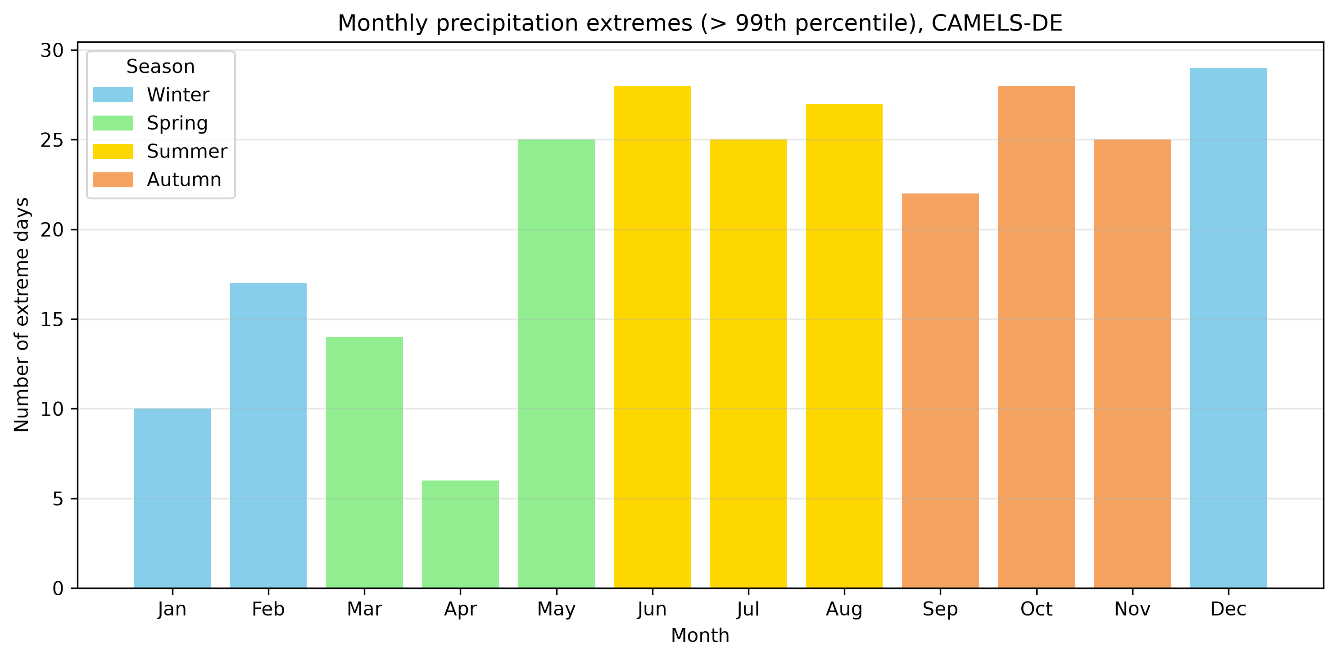Figure 9: Count of extreme precipitation events (> 99th percentile) in the non-aligned CAMELS-DE dataset by month and season.

5. Streamflow analysis

5.1 What are the average annual flows? Use specific discharge in mm/d to calculate average annual sums that are comparable to the annual precipitation sums.
The average annual flows are shown in Figure 10.
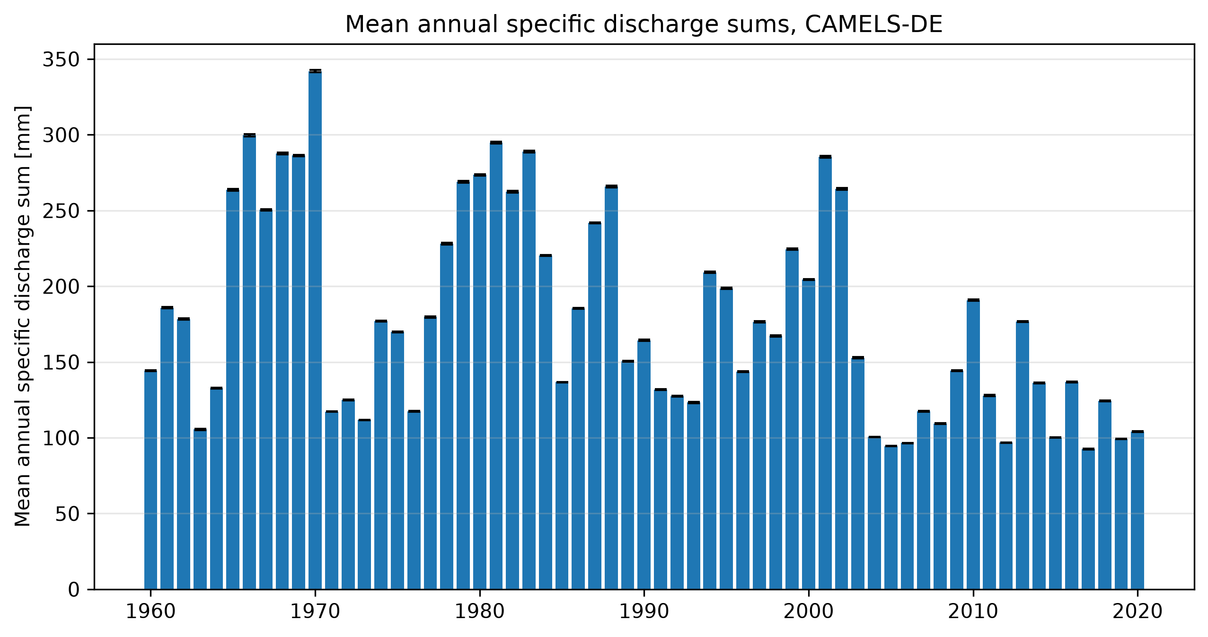Figure 10: Mean annual specific discharge sums for the CAMELS-DE dataset.

5.2. What is the mean daily flow, as well as the highest and lowest recorded flows? [both for m3/s and observed water level].
Table 6: Daily mean, minimum and maximum for observed volumetric discharge, observed specific discharge and water level.
Data aggregation | Volumetric discharge [m³/s] | Specific discharge [mm/d] | Water level [cm]
Daily mean | 0.57 | 0.49 | 29.36
Daily minimum | 0.02 | 0.02 | 1.0
Daily maximum | 6.58 | 5.66 | 134.0

5.3. Calculate mean monthly flow. How does streamflow vary throughout the year? Does rainfall seasonality correspond to streamflow seasonality? If not, what processes could explain the differences?
The mean monthly flow is shown in Figure 11.
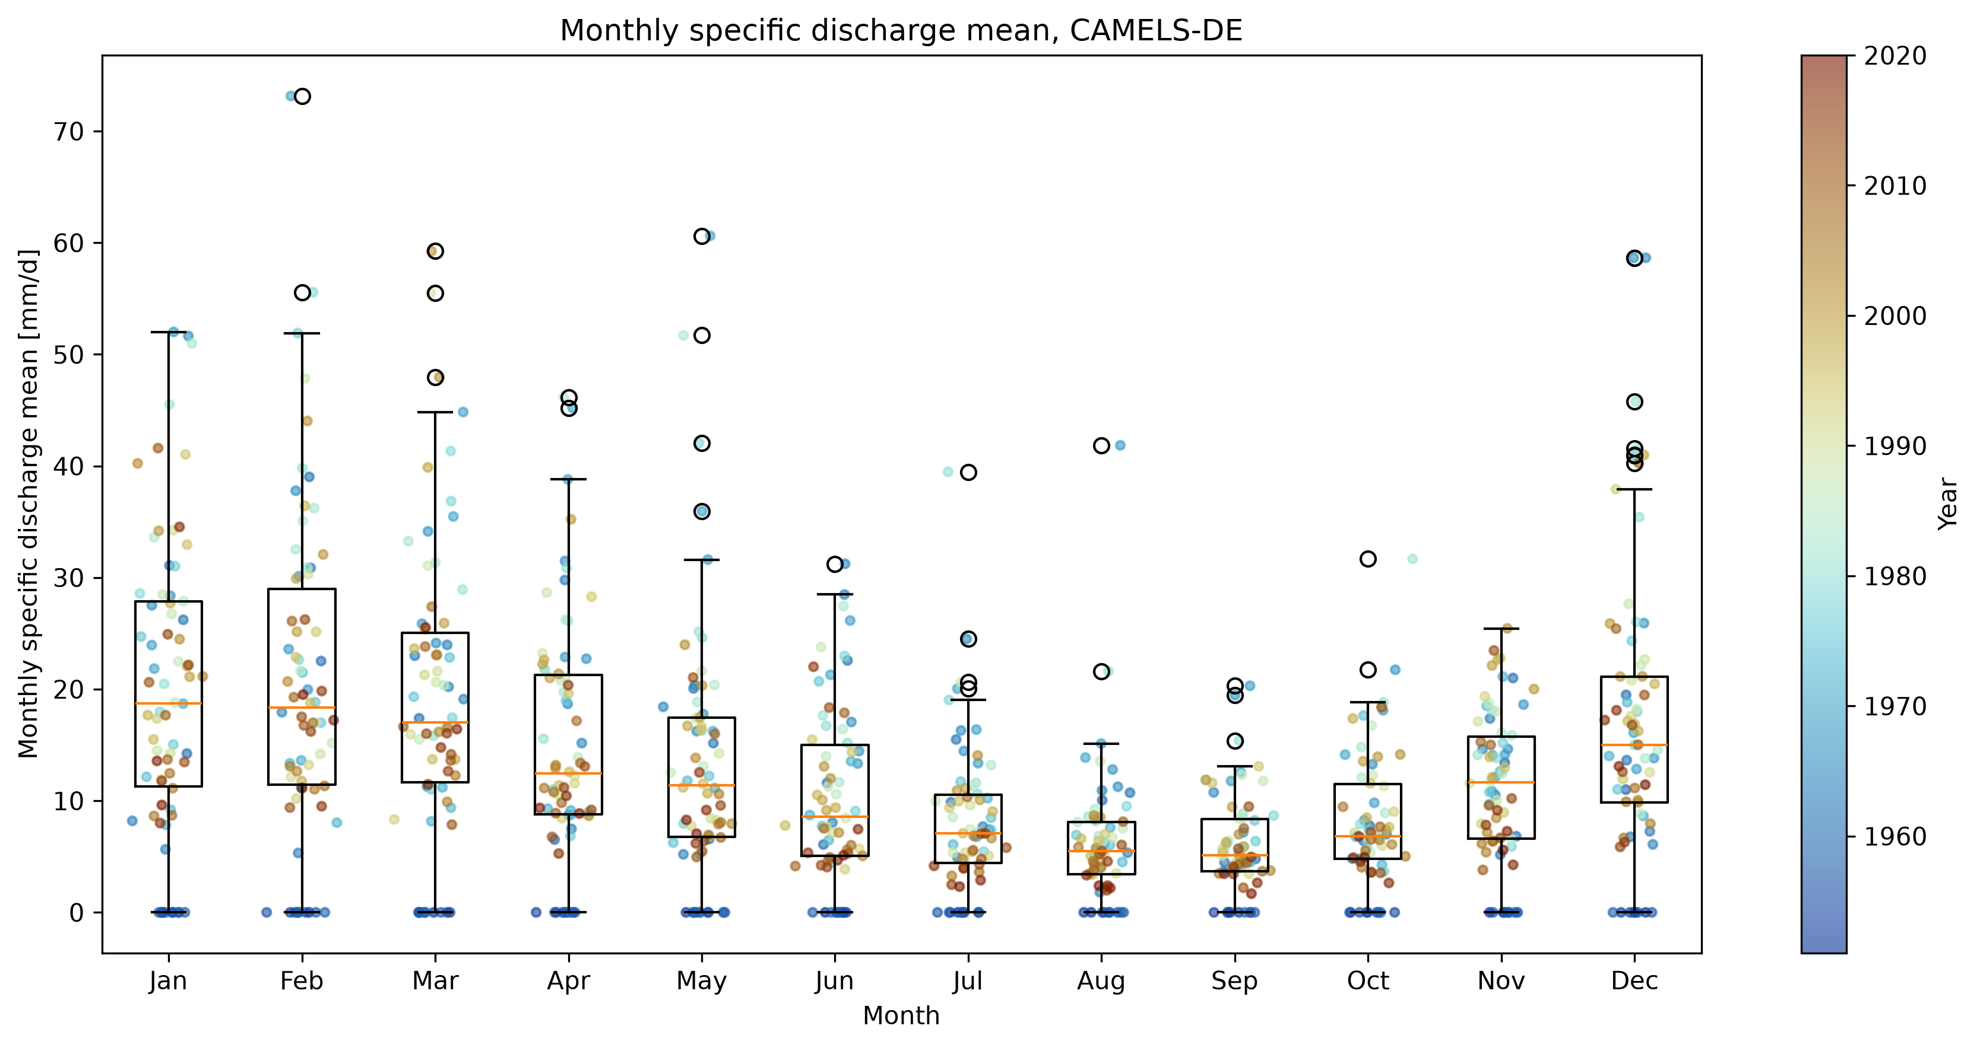Figure 11: Monthly aggregated mean of specifig discharge for the CAMELS-DE dataset. The colorbar shows the year in which the datapoint was recorded.

The median of mean monthly discharge peaks in winter in January and reaches its minimum in August. The spread of the values within the boxplot whiskers increases during winter and peaking in february, while decreasing during summer with lowest spread in September. Furthermore, a pattern of low specific discharge in recent years is visible, particularyl for the summer months from June to September (Figure 11).
The seasonality of precipitation sums does not fully allign with the seasonal discharge pattern. The local peaks in monthly precipitation sum in Mai and June (Figure 6) are not reflected in the monthly mean specific discharge (Figure 11).
The extent to which precipitation contributes to discharge depends on how much of water reaches the stream which is influenced by evapotranspiration, infiltration and groundwater processes.
The leaf emergence of the main decidious tree species in the Palatinate Forest including beech (34.4 %) and oak (8.9 %) (Landesforsten RLP, n.d.), occurs between April and May (LfL Bayern, n.d.) and might play a major role in a decreasing specific discharge despite increasing precipitation during these months, due to transpiration.

5.4. Identify annual maximum flow days. These are commonly used to calculate flood statistics. Do flood peaks occur predominantly during one season? What climatic or catchment characteristics might explain this pattern?
The monthly and seasonal distribution of annual maximum discharge events are shown in Figure 12. Flood peaks occur predominantly between November and March.
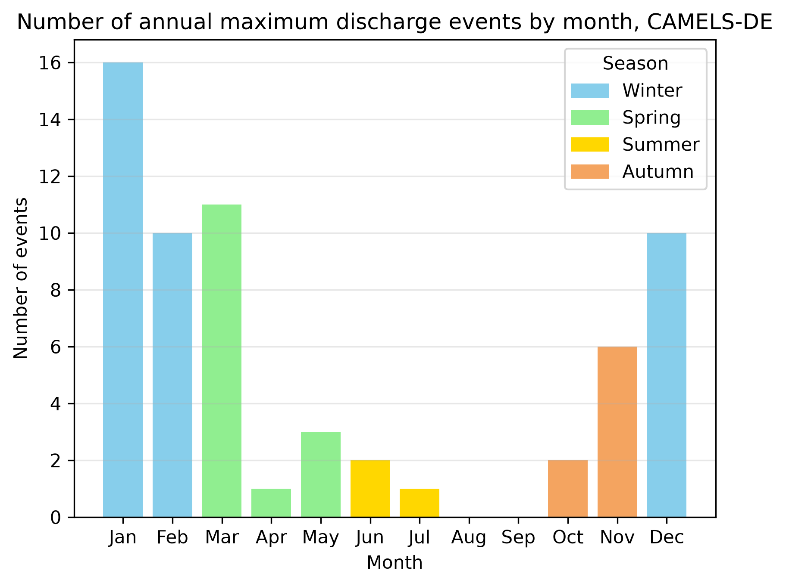Figure 12: Number of annual maximum discharge events by month and season.
Two key factors may explain this pattern: precipitation and evapotranspiration.
During the winter months, median precipitation is relatively high and the highest outliers are also observed during this period, which are particularly relevant for extreme discharge events (Figure 6). Further, low temperature and the dormant growing season lead to low evapotranspiration and highly saturated soils. This results in a larger proportion of the precipitation contributing to streamflow, enhanced by high surface runoff.
Increasing temperature and the leaf emergence in May and June increases evapotranspiration, which potentially mitigate the high precipitation in may and june (Figure 6), leading to significantly lower occurences of extreme discharge events than in the winter months.

5.5. Plot the stage discharge relationship. Are there any noticeable jumps, levelling of or other noticeable patterns? What might cause them?
The stage discharge curve for the gauge station is shown in Figure 13. The stage curve changed considerably up to around 1990. Since then, the stage discharge curve shows only minor changes and remains relatively stable.
Unfortunately, no further information about the history of the gauging station is available. A possible explanation is that the river cross-section was not reinforced and changed constantly e.g. due to extreme rain events. The cross-section possibly got reinforced then around 1990 with concrete, as it can be seen on the website of the water managment authority (Wasserportal RLP, 2026).
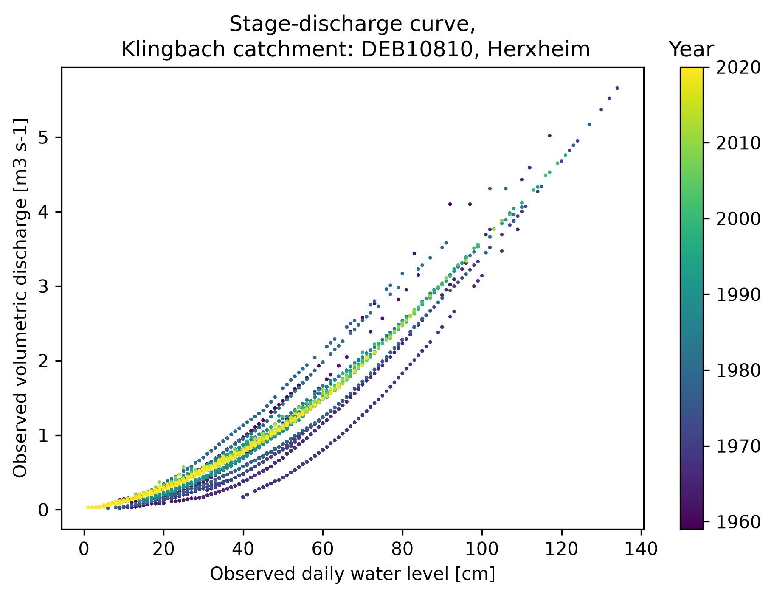Figure 13: stage discharge relationship curve for the Klingbach gauging station by year.

5.6 Is there a significant trend in the daily flow or in the flows above the 95th (Q95, high flow) or below the 5th percentile (Q5, low flow)? If trends are detected in high or low flows, discuss whether they are consistent with observed changes in rainfall or catchment characteristics.
A significant negative trend in the maximum, sum and count aggregated, 95th percentile subset of specific discharge of the CAMELS-DE dataset was detected (Figure 14). This aligns with the observed increasing trend in annual mean temperature (Figure 15) which may lead to higher evapotranspiration and ,consequently, a potential decrease in specific discharge.
Although no statistically significant trend was detected, the frequency of events below the 5th percentile shows an increasing trend in recent years from a descriptive perspective (Figure 15).
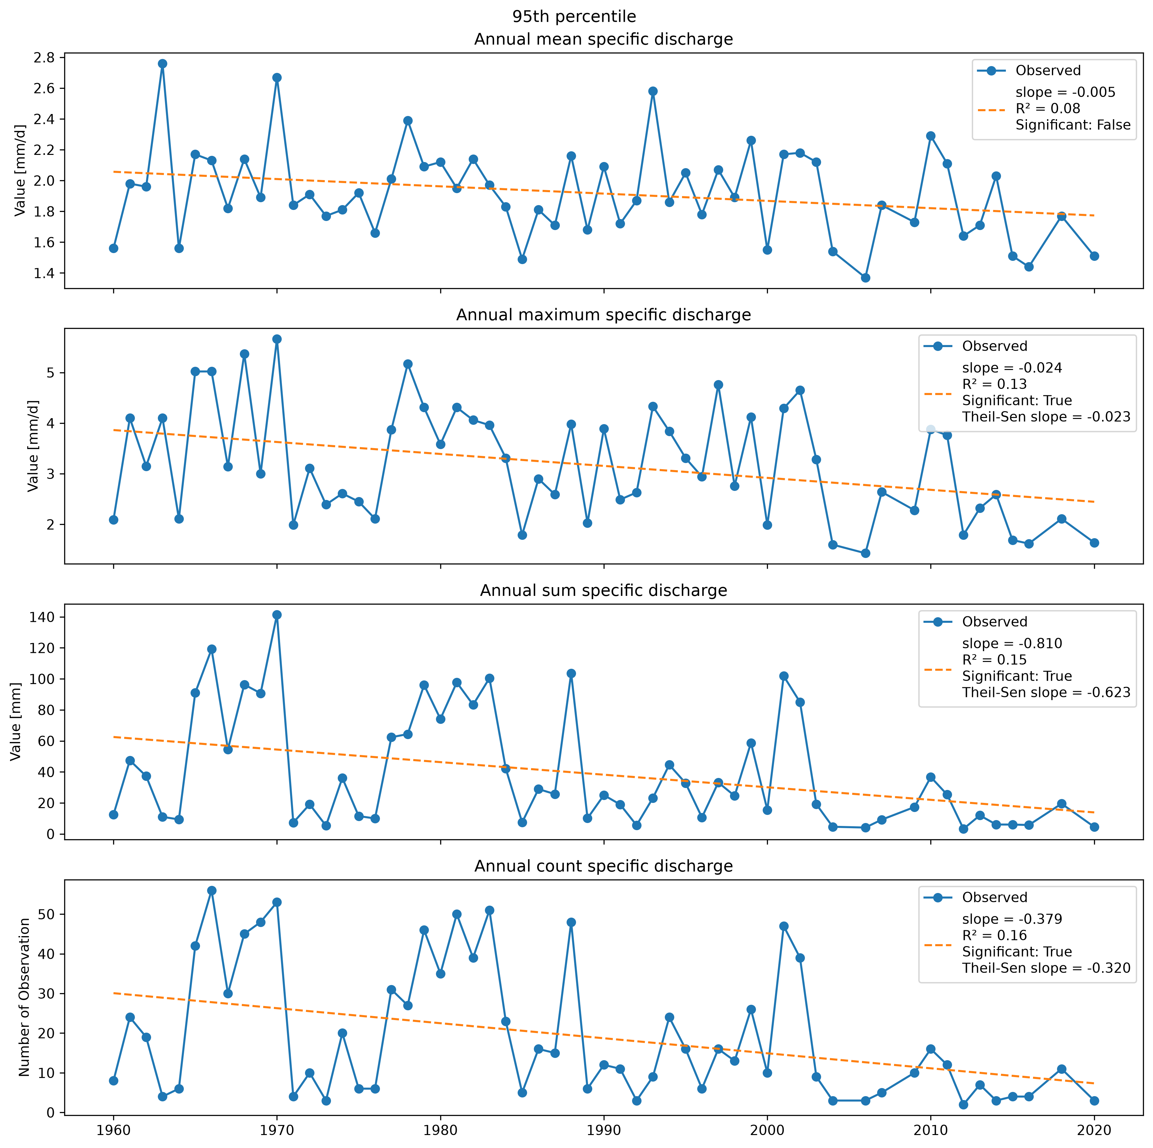Figure 14: Aggregated data for 95th percentile of CAMELS-DE specific discharge dataset. Data is aggregated by mean, maximum, sum and count. For each subset, a linear model was performed and plotted as dashed line, model slope and R² are provided in the legend.Further, for each subset a Mann-Kendall test was performed and if significant the Theil-Sen slope was calculated and provided in the legend.
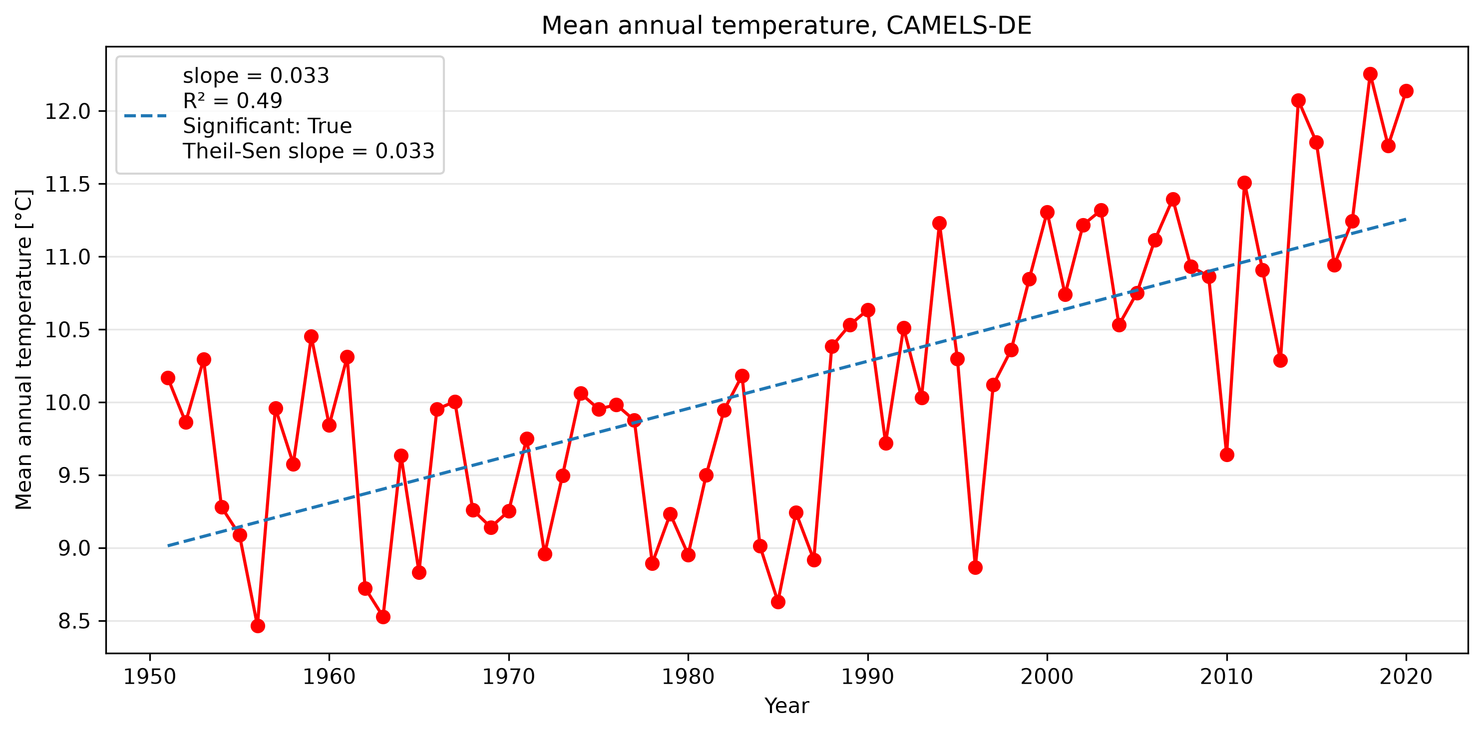Figure 15: Mean annual temperature for the CAMELS-DE dataset. A linear model was performed and plotted as dashed line. Model slope and R² are provided in the legend. The Mann-Kendall test was significant, therefore the Theil-Sen slope was calculated and also provided in the legend.
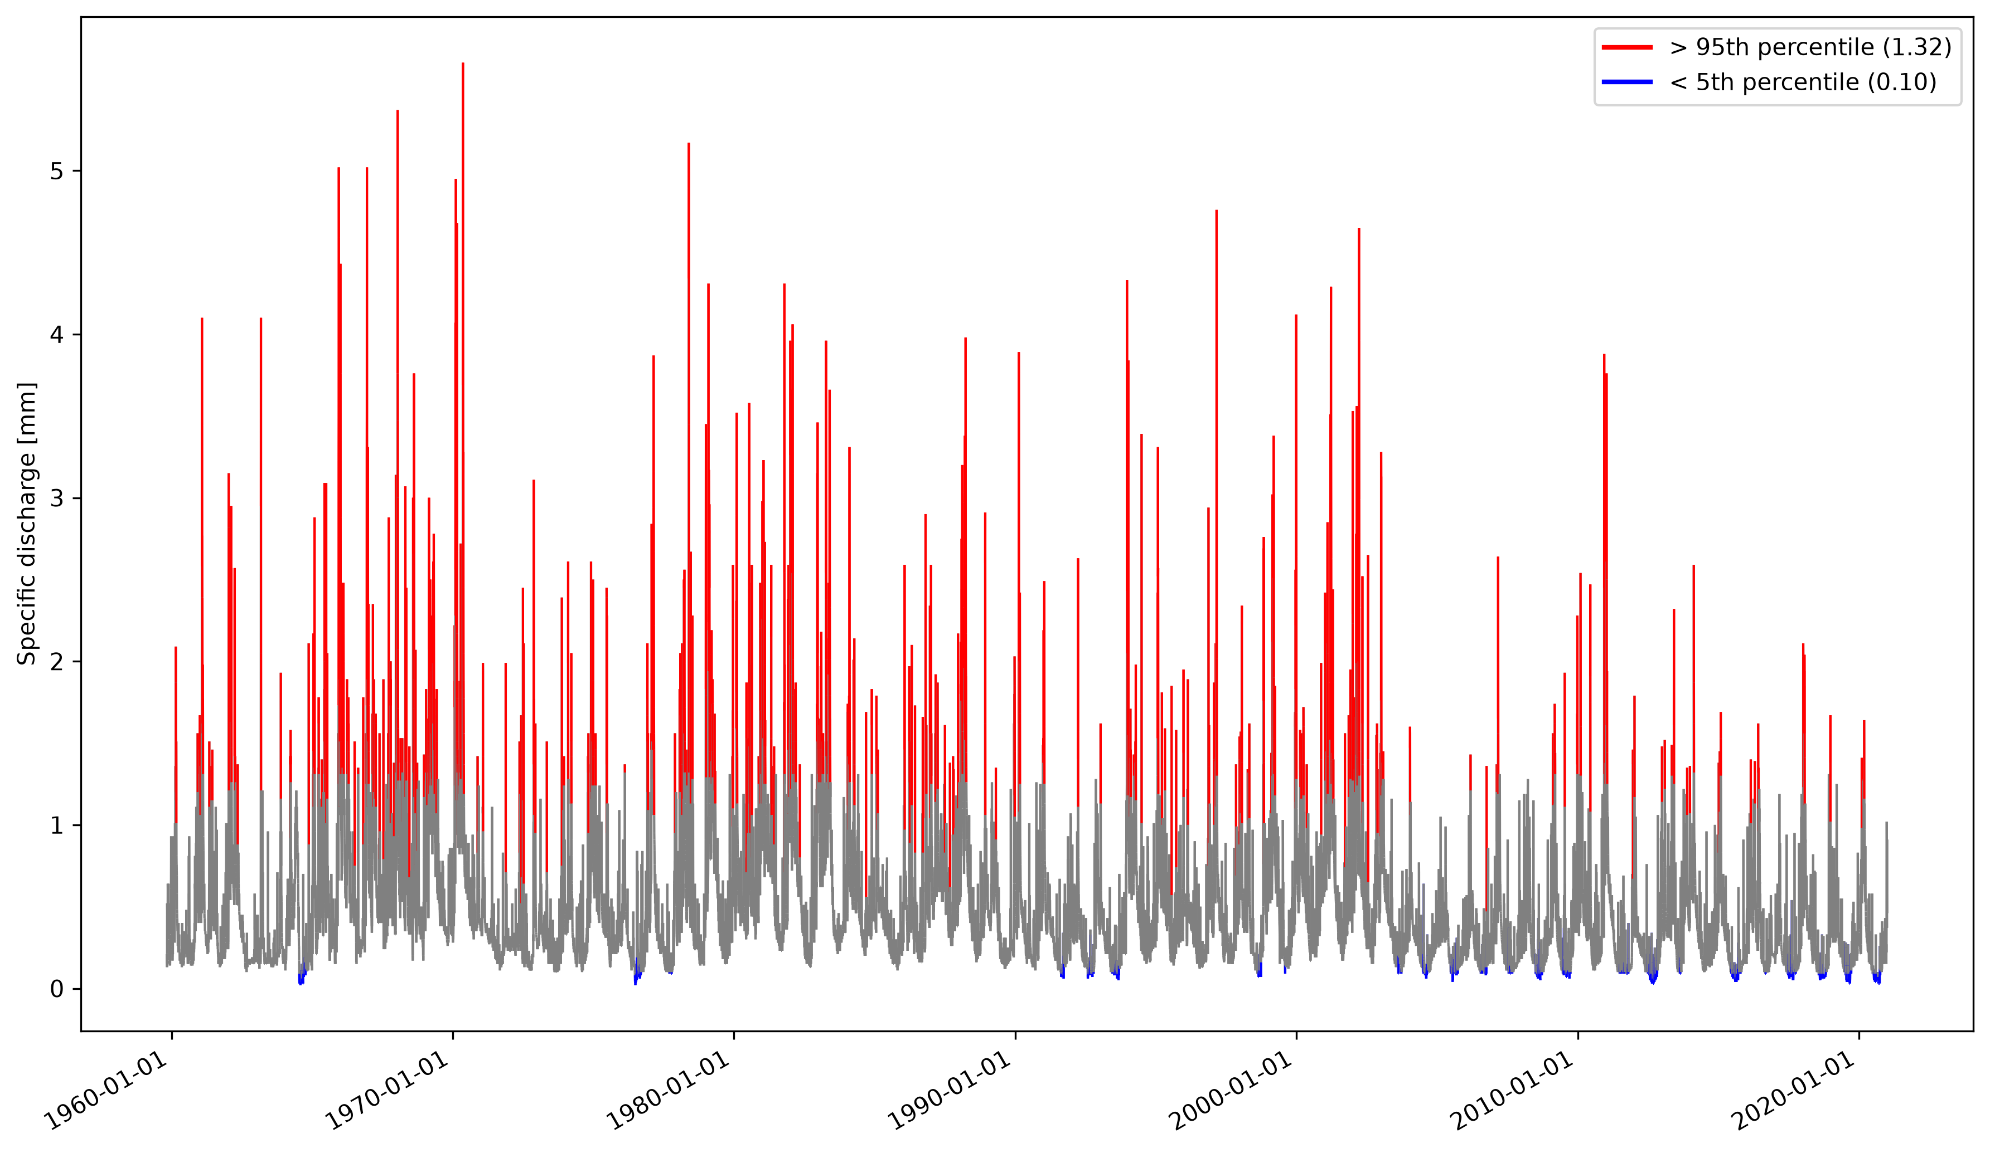Figure 16: Specific discharge timeseries for the CAMELS-DE dataset. The 5th and 95th percentiles are highlighted in blue and red, respectively.

5.7 Calculate the long-term runoff coefficient for your catchment and compare it with your classmates’ catchments. What does it suggest about infiltration, and land cover within the catchment?
The long-term runoff coefficient for the klingbach catchment is 0.167 (Table 7). This means about 16.7% of the precipitation contributes to the catchments runoff.
In general, the runoff-coefficient provides insights into a catchments hydrological response, which is influenced by infiltration rates and the proportion of impervious surfaces. Higher infiltration can increase the amount of precipitation entering soil- or groundwater reservoirs and therefore potentially reducing the runoff coefficient.
Land cover also affects the runoff coefficient through evapotranspiration. Catchments with a high proportion of vegetation may show higher evapotranspiration than catchments dominated by impervious surfaces, resulting in an reduced runoff coefficient. The differences in the runoff-coefficient shown in Table 7 suggests highly different infiltration and land cover among the catchments.

Table 7: Comparison of the runoff-coefficient between the classmates’ catchments
Catchment | Runoff coefficient
Klingbach | 0.167
Siebeldingen | 0.188
Primm | 0.253
Speyerbach | 0.264
Selz | 0.107

6. Water Balance

6.1 Using the given precipitation and discharge data, calculate the long term annual and the annual water balance for your catchment. What is the estimated actual evapotranspiration (AET) using the water balance method? How does this compare to potential evapotranspiration (PET) given in the CAMELS data?
The estimated long-term actual evapotranspiration (AET) using the water balance method is 564.32 mm. The estimated AET is lower, compared to the simulated (PET) of 735.39 mm from the CAMELS-DE dataset. This difference may be partly explained by the low precipitation and high temperatures during the summer months which can increase atmospheric evaporative demand while limiting actual evapotranspiration due to restricted water availability.

Discuss the limitations of the approach and whether the estimated actual evapotranspiration is realistic for the climate and land use of the catchment.
Compared to estimates of actual evapotranspiration for other catchments, ranging from 460 to 490 mm (Frietsch & Schuetz, 2026) and from 219 to 572 mm, with a mean of 461 mm (Renner & Hauffe, 2024), the klingbach catchment long-term AET appears to fall in the normal range of other temperate climate catchments in Germany.
Nevertheless, there are factors which could lead to potential errors in the estimation of the AET. The precipitation data of the CAMELS-DE dataset is obtained from the HYRAS raster dataset of the german weather service (DWD). In simplified terms, the HYRAS dataset is based on spatial interpolation of the weather station measurements with a topographical correction (DWD, n.d.). Despite the corrected spatial interpolation, it is possible that the method estimates wrong precipitation values in the catchment area.
Further, groundwater fluxes are not considered in the simplified water balance equation, potentially leading to over- or underestimation of the estimated AET.

6.2 Compare your catchment water balance with your classmate’ catchments. What are noticeable differences? What could be the reason for those?
While water balance values of the catchments of Klingbach, Primm and Selz are broadly in the same range, Speyerbach and Siebeldingen show noticeably higher values (Table 8).
These differences might be explained by variations in the catchments charateristics like precipitation patterns, topography, infiltration, vegetation and land use. Precipitation and topography influences more the precipitation input of the catchment, wheras vegetation and land use affects more the evapotranspiration and infiltration.
Table 8: Comparison of the water balance between the classmates’ catchments.
Catchment | Water balance [mm/y]
Klingbach | 564.32
Siebeldingen | 732.12
Primm | 481.57
Speyerbach | 595.60
Selz | 486.00

7. Research Question

7.1 Mini-research component: Come up with and answer your own question about the catchment. What data or analysis do you need to answer your question? Present and interpret the results.

7.2 What are the main uncertainties in your analysis?
How rapidly does the Klingbach catchment respond to precipitation and does the respond time vary seasonally?
A simple lagged cross-correlation analysis between mean daily discharge and specific precipitation of the catchment was used to answer the question.
The cross-correlation across the entireCAMELS-DE timeseries is shown in Figure 17 and shows the highest correlation of precipitation and discharge at a lag of one day. Further, the cross-correlation shows a long tailing, gradually decreasing towards a lag time of ten days.
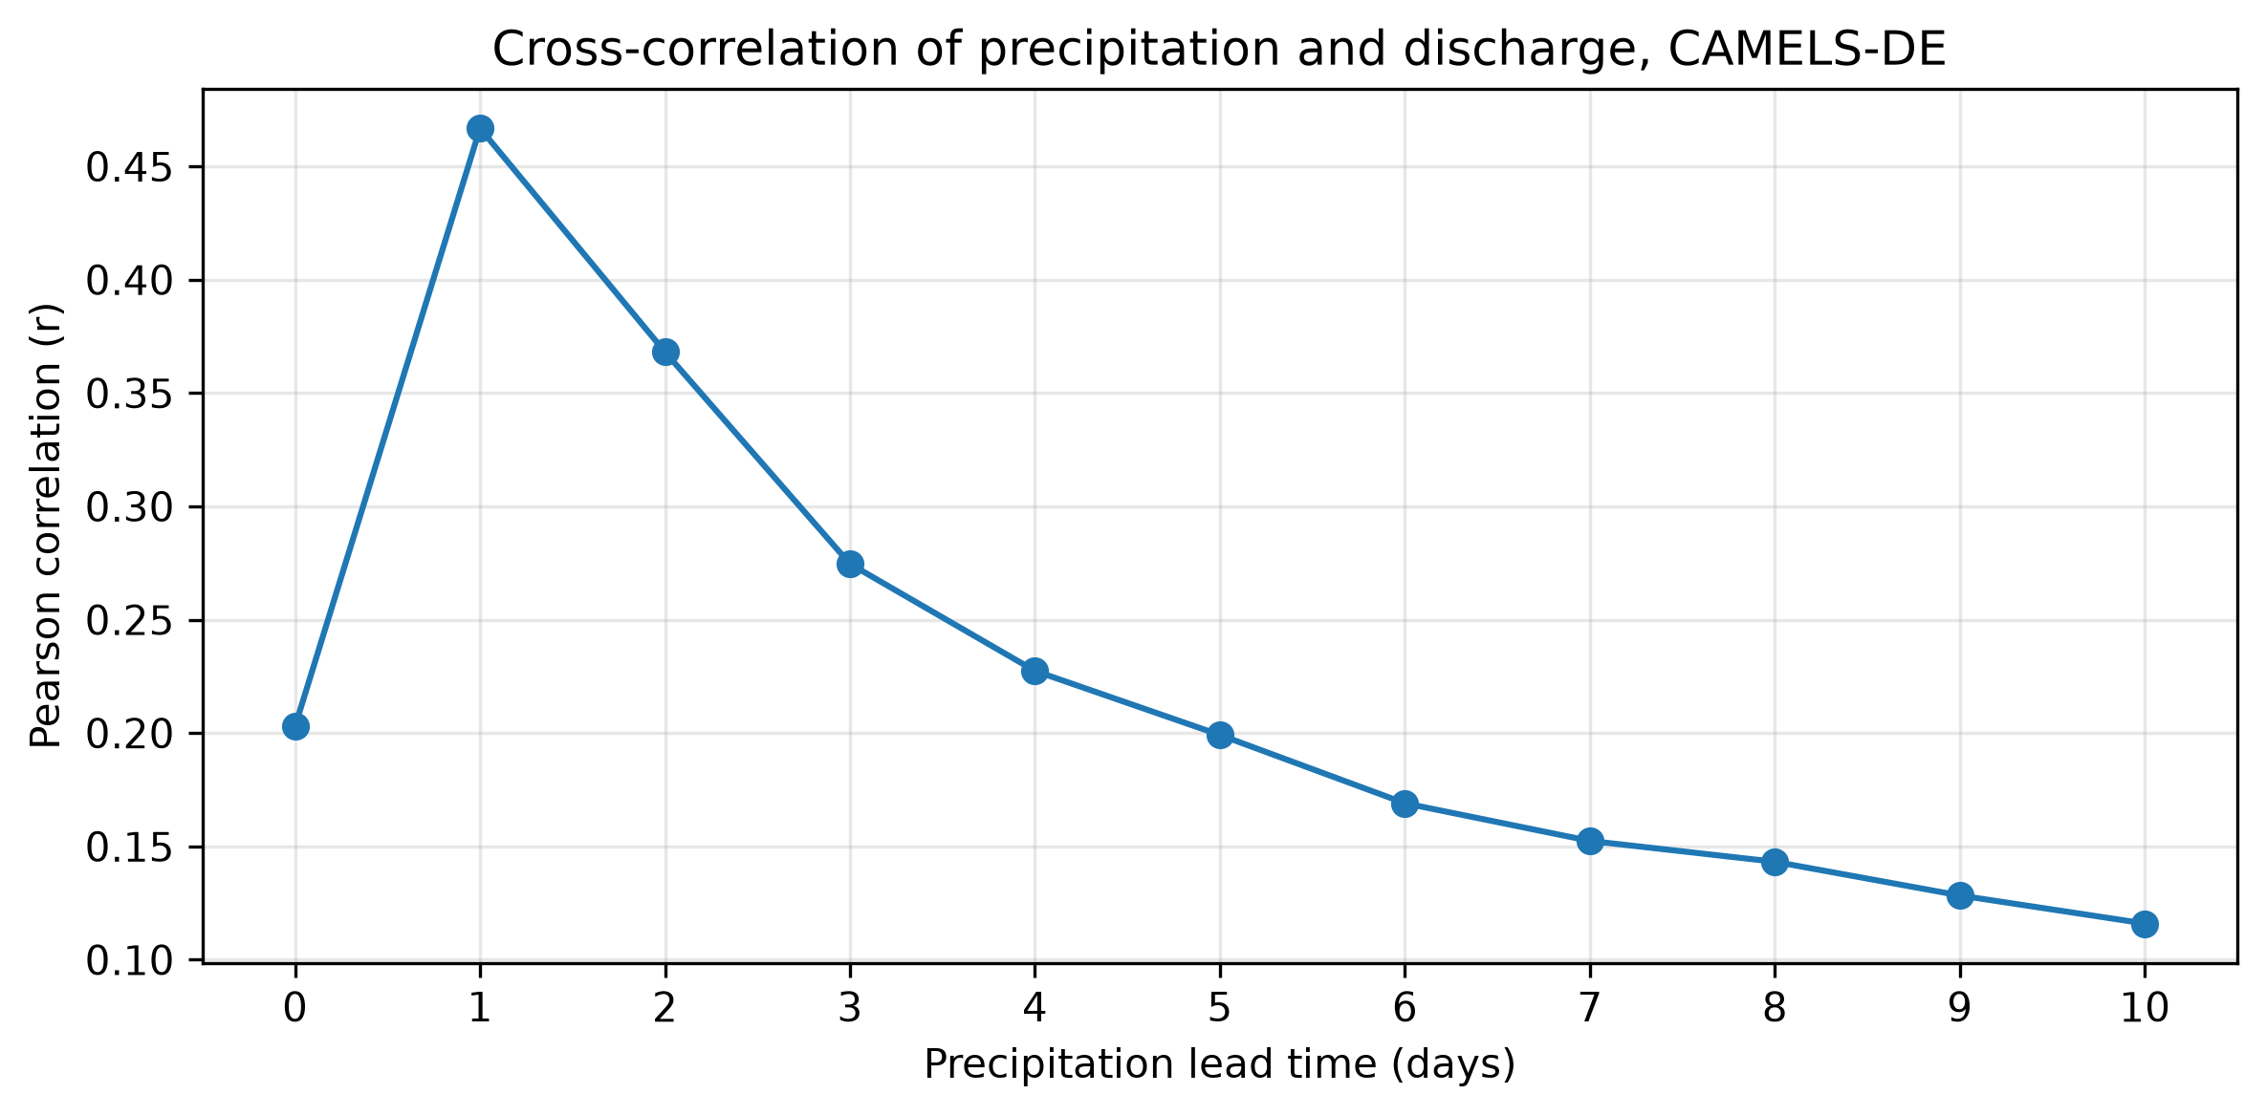Figure 17: Cross-correlation between mean precipitation and specific discharge of the whole CAMELS-DE dataset for a lag range of ten days.
To find out if the respond time varies seasonally, the CAMELS-DE dataset was grouped by month and cross-correlations between mean daily precipitation and specific discharge were calculated for each group. The results are summarised in the heatmap in Figure 18.
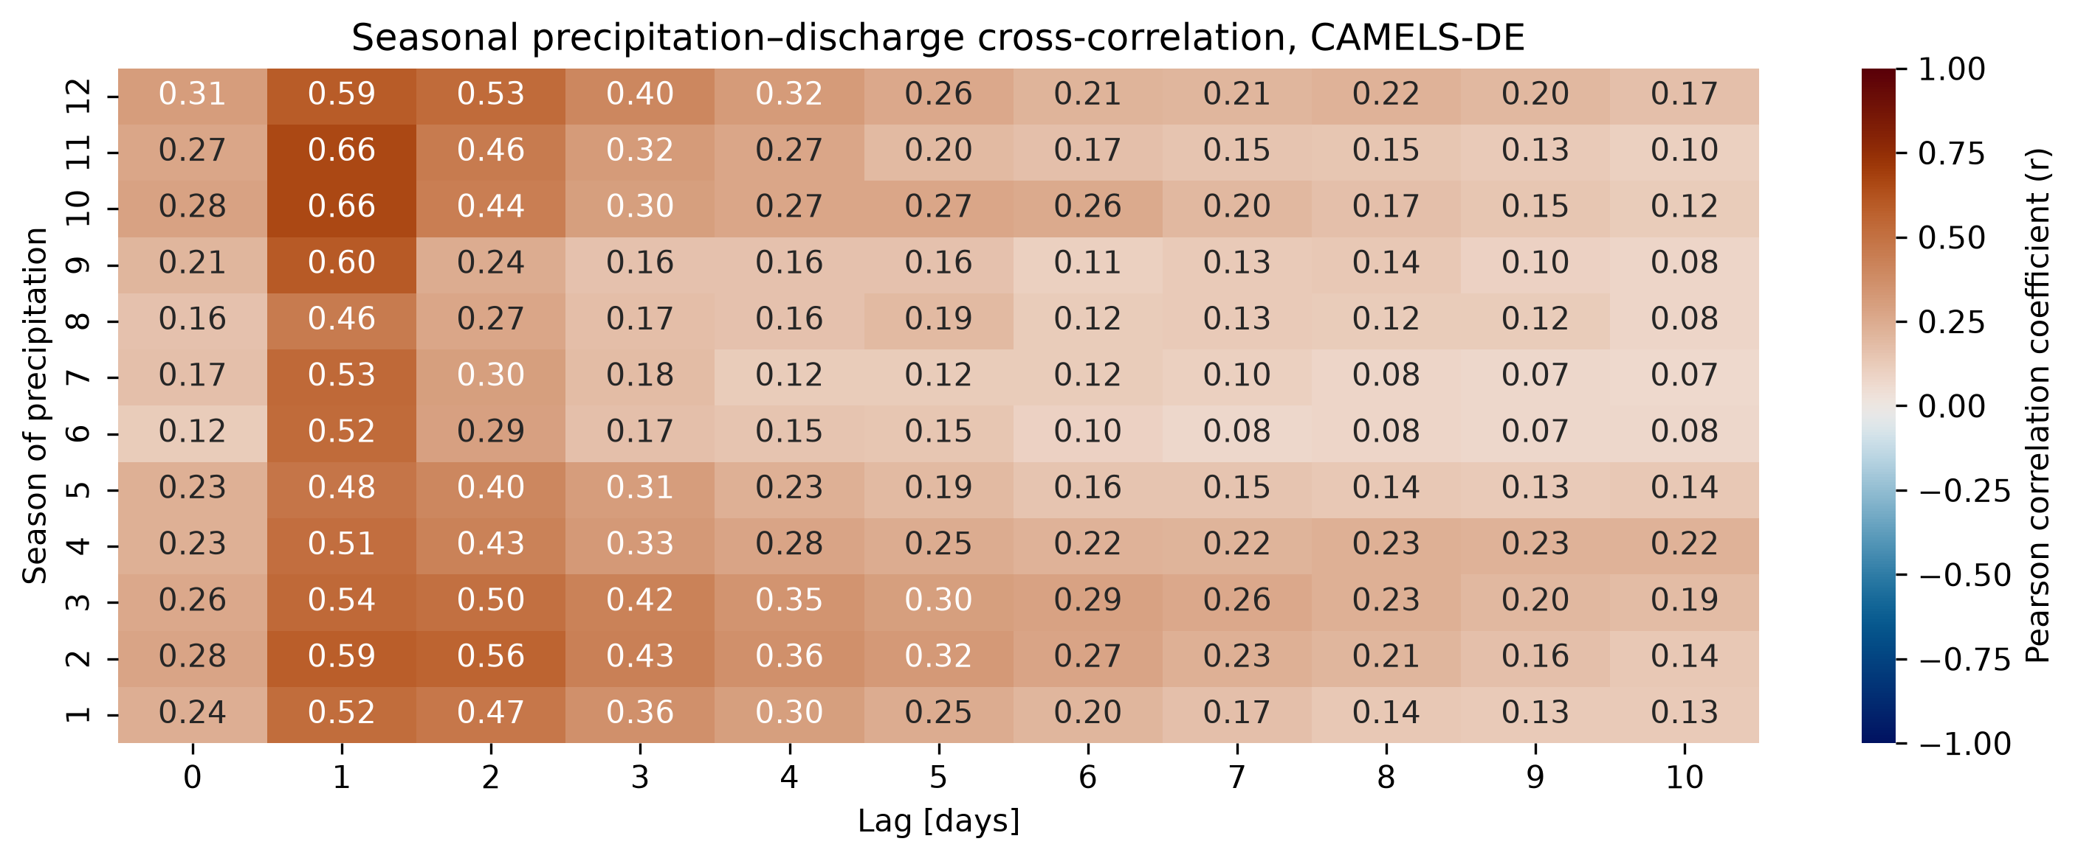Figure 18: Heatmap of the precipitation-discharge cross-correlation of the CAMELS-DE dataset, grouped by months. The number from 1-12 on the y axis correspond to the month number.
For all months, the heatmap shows the highest cross-correlation coeffcient at a lag of one day. Further, it reveals a stronger tailing of the pearson correlation coeffcient peak during the winter and spring months, from December to May, whereas the peak is more pronounced during the summer and autumn months.
For both figures, it should be considered that discharge exhibits strong temporal autocorrelation with elevated discharge often persisting for several days after precipitation events due to catchment storage and recession processes. Consequently, a prolonged precipitation event can highly cross-correlate with an extended discharge peak leading to a high correlation coeffcient across several time lags. This makes it difficult to associate a single precipitation event to a discharge event, using this method alone.
The lag of maximum cross-correlation provides an estimate of the lag at which the strongest association occurs. However, the shape and position of the cross-correlation peak may also reflect temporal autocorrelation, seasonal patterns, and catchment processes such as infiltration and storage. Consequently, the results do not necessarily represent the physical response time of the catchment.
Further, the cross-correlation was applied on the whole dataset and the monthly grouped subsets. Therefore, it does not distinguish between different types of discharge peaks and includes sharp discharge peaks as well as broad segmented peaks from a sequence of precipitation events.
In addition, cross-correlation was not applied on an subset of extreme precipitation and discharge events which are of particular interest in hydrological flood forecasting. An event-based analysis would therefore be required to investigate the rainfall–runoff response during individual flood events more directly.

7.3. If you were advising a water authority, what additional data would you recommend collecting to improve understanding of the catchment?
To improve the understanding of the Klingbach catchment, additional data collection should focus on higher temporal resolution, especially for precipitation and discharge measurements, as well as soil moisture, groundwater level data.
The daily temporal resolution of the dataset limits the ability to capture short-lived precipitation events and rapid discharge responses, for which higher-resolution data may be required to better assess flood-event dynamics and catchment response times.
Soil moisture and groundwater measurements would provide further insights into catchment conditions, infiltration, and storage processes influencing runoff generation.
Finally, the collection of precipitation data from multiple location across the catchment could help in capturing the spatial variability and in verifying precipitation data of the HYRAS data.

Literature
Diercke. (n.d.). Deutschland—Klimaregionen-978-3-14-100371-0-38-1-1 | Diercke.de. Retrieved 7 October 2026, from https://diercke.de/content/deutschland-klimaregionen-978-3-14-100371-0-38-1-1?
DLR. (n.d.). Retrieved 14 October 2026, from https://www.wetter.rlp.de/Agrarmeteorologie/Aktuell/Alle-Stationen
Dolich, A., Espinoza, E. A., Ebeling, P., Guse, B., Götte, J., Hassler, S. K., Hauffe, C., Heidbüchel, I., Jens Kiesel, Mälicke, M., Stölzle, M., Tarasova, L., & Loritz, R. (2024). CAMELS-DE: hydro-meteorological time series and attributes for 1582 catchments in Germany.
Droogers, P., & Allen, R. G. (2002). Estimating Reference Evapotranspiration Under Inaccurate Data Conditions. Irrigation and Drainage Systems, 16(1), 33–45. https://doi.org/10.1023/A:1015508322413
DWD. (n.d.). DWD. Index of /Climate_environment/CDC/Grids_germany/Daily/Hyras_de/Precipitation/. Retrieved 14 October 2026, from https://opendata.dwd.de/climate_environment/CDC/grids_germany/daily/hyras_de/precipitation/
DWD. (2026a). Wetter und Klima—Deutscher Wetterdienst—Glossar—Klima. https://www.dwd.de/DE/service/lexikon/begriffe/K/Klima.html
DWD. (2026b). Wetter und Klima—Deutscher Wetterdienst—Klimaüberwachung—Deutschland—Zeitreihen und Trends. https://www.dwd.de/DE/leistungen/zeitreihen/zeitreihen.html?nn=480164
Frietsch, S., & Schuetz, T. (2026). Exploring controls on solute export mechanisms in anthropogenically impacted catchments in Southern Germany in climatically different periods. Hydrology and Earth System Sciences, 30(7), 2059–2077. https://doi.org/10.5194/hess-30-2059-2026
Hy2DL. (n.d.). GitHub. Retrieved 14 October 2026, from https://github.com/KIT-HYD/Hy2DL/blob/v1.1/Hy2DL/experiments/Estimate_PET.ipynb
Landesforsten RLP. (n.d.). Biosphärenreservat Pfälzerwald. Landesforsten Rheinland-Pfalz. Retrieved 7 October 2026, from https://www.wald.rlp.de/bewahren/naturschutz-im-wald/biosphaerenreservate
LfL Bayern. (n.d.). Stiel-Eiche – Kurzbeschreibung heimischer Gehölze. Retrieved 7 October 2026, from https://www.lfl.bayern.de/iab/kulturlandschaft/151477/index.php
Renner, M., & Hauffe, C. (2024). Impacts of climate and land surface change on catchment evapotranspiration and runoff from 1951 to 2020 in Saxony, Germany. Hydrology and Earth System Sciences, 28(13), 2849–2869. https://doi.org/10.5194/hess-28-2849-2024
Wasserportal RLP. (2026). Wasserstand. https://geodaten-wasser.rlp-umwelt.de/wasserstand/2375030600/stammdaten
Wikipedia. (2026). Penman–Monteith equation. In Wikipedia. https://en.wikipedia.org/w/index.php?title=Penman%E2%80%93Monteith_equation&oldid=1356936016

