

UNITED BUSINESS MEDIA LLC

CONTRIBUTOR AGREEMENT

Contributor Name: Daniel Somerfield
Address: 1417 SE 46th Ave Portland, OR 97215

Type of Work: Editorial_x_ Photography___ Art & Design___ Other__

- a) In consideration of United Business Media LLC or any affiliate (the "Publisher") publishing the freelance work and materials requested by the Publisher and furnished by the Contributor from time to time in the future (the "Work"), the Contributor grants and assigns to the Publisher the following rights throughout the world:

- first-time worldwide publication rights in any medium (including electronic, CD-ROM and media not yet invented or discovered);

- the non-exclusive worldwide right to publicly display and to disseminate reproductions of all or part of the Work or a summary thereof in the Publisher’s publications, products and services and in any medium (including electronic, CD-ROM and media not yet invented or discovered), and the non-exclusive worldwide right to publicly display and to disseminate or authorize licensees to publicly display and to disseminate or authorize licensees to publicly display and to disseminate reprints of the Work in substantially the same form as it appeared in the Publisher’s first use; provided that if the Work is photography, art or design, it may be publicly displayed and disseminated only in the context or in association with the editorial text with which it appeared in the Publisher’s first use;

- the non-exclusive worldwide right to license the public display and republication of the Work and the uses granted to Publisher under subparagraph (a) (ii) above to third party licensees of the editorial content of the Publisher’s publication, product or service in which the Work appeared and to permit such licensees to so use the Work in English or in translation;

- the right to reproduce the Work (appropriately credited to the Contributor) in any Publisher anthology, compilation or educational publication;

- the right to grant permission to users registered with the Copyright Clearance Center to photocopy or otherwise reproduce the Work in accordance with the practices and procedures thereof; and

- the right to use and to authorize others to use the Work and/or the name, biography, likeness and voice of the Contributor (or any employee or contractor of the Contributor who authored or created the Work) in connection with the advertising and/or promotion of the publication, product or service of the Publisher or its licensees in which the Work appeared.

b) Contributor shall not republish or authorize republication of the Work, in full or in part, in final, preliminary or modified form in any media for at least three months after it first appears in the Publisher’s publication, product or service.
c) If the Work is a previously published work, the Contributor grants UBM republication rights upon the above terms and conditions.

- The Contributor represents and warrants to the Publisher that all of the Work furnished by the Contributor (i) will be original and accurate; (ii) to the best of Contributor’s knowledge, will not infringe or violate the rights of any person or entity; and (iii) has not been previously published (or, if it has been previously published, such fact has been fully disclosed to the Publisher).

- The Contributor further represents and warrants that the Contributor (i) will be the creator of all the Work; (ii) will obtain all third-party permissions necessary for the use of all Work and will duly credit any source material incorporated into any Work; (iii) is the sole and exclusive owner of all rights herein conveyed to the Publisher hereunder; and (iv) has the full and unrestricted power to convey such rights to the Publisher free and clear of the claims of any other person or entity.

- The Contributor shall indemnify and hold harmless the Publisher from any claims, damages, losses and costs (including reasonable attorneys' fees) arising out of any violation of any representation or warranty contained in this Agreement, provided, however, that Contributor shall not be liable for any frivolous claims.

- The Publisher shall have the right to accept or reject and/or edit any Work, the decision on which shall be made solely by the editor of the publication, product or service of the Publisher in which such Work appears. No Work shall be considered accepted by the Publisher until any and all revisions requested by the Publisher have been completed to its satisfaction and notice of acceptance has been received by the Contributor.

- If any photographs, transparencies, illustrations, art work or other material furnished or made available to the Publisher in connection with any Work are lost or damaged, the Publisher’s maximum liability for such loss or damage shall not exceed the pre-agreed fee for such Work.

- This Contributor Agreement constitutes the entire agreement between the parties with respect to any Work hereafter requested from the Contributor by the Publisher. No provision of this Agreement may be modified, waived, suspended or terminated except by an agreement in writing signed by the Contributor and by an authorized representative of the Publisher. Any agreement or document purporting to supersede this Agreement or any provision of it will not be effective or binding upon the Publisher or the Contributor unless signed by both parties.

- The relationship of the Contributor to the Publisher shall be that of an independent contractor, and nothing in this agreement is intended to create an employee or agent relationship.

- This agreement shall remain in effect unless terminated by either party upon sixty (60) days' prior written notice. In the event of termination, any Work which has been submitted by Contributor during the term of this agreement shall continue to be governed by it.

Contributor: Publisher:

Daniel R Somerfield United Business Media LLC
Name of Contributor (Print)
By: 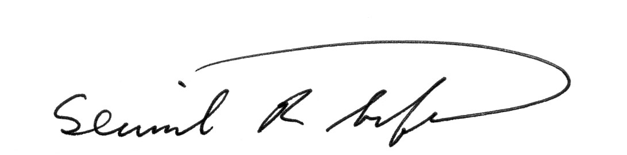 By:
Signature Signature

Date: 09/25/2014 Date:

