Benchmark: glass-iron-claystone interactions in deep geological disposal conditions

- Problem Description Overview
  - Context and setting: deep geological disposal of high-level and long-lived radioactive waste (HLLW) (Figure 1)
  - Processes, properties, and conditions that are being tested/targeted
    - Low Eh, H₂ production during corrosion in clayey environment
    - Complex initial mineralogy and mineral paragenesis, metal corrosion, glass material dissolution, alteration secondary products formation (from iron corrosion and glass dissolution), secondary minerals formation in claystone during glass-iron-clay interactions
    - Strong coupling between chemical reactivity and diffusive transport
(Possible future extension Evolution of transport properties in altered zones, clogging/opening of porosity)
  - Composition of the benchmark problem set
    - Case 1 : corrosion of iron in contact with the claystone (without glass component)
    - Case 2 : complete glass-iron-claystone system

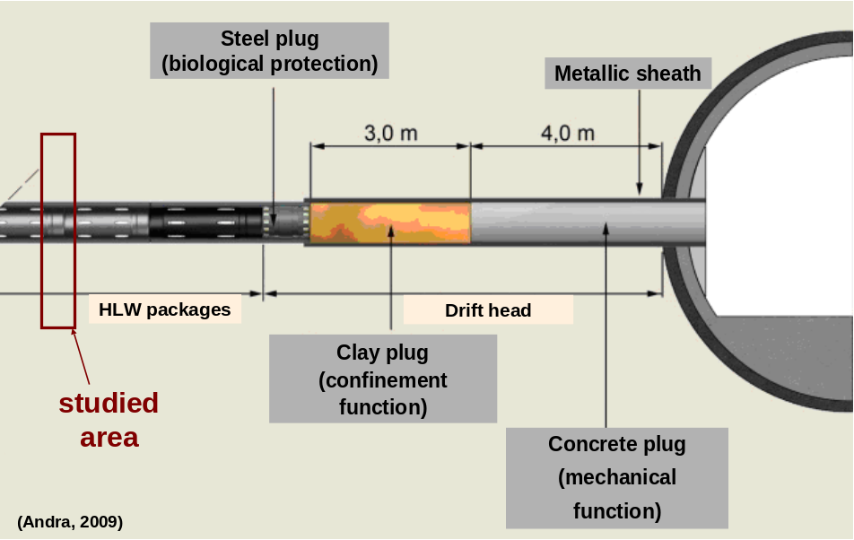
Figure 1 : Partial view of a sealed high level waste cell in the repository (Andra, 2009)

The considered system is a cross section of an ILLW cell where the canisters are emplaced directly in contact with the claystone (except for the thin metallic lining which prevents the claystone from “converging” due to the mechanical stress).

- Simulation Description Overview
  - Transport Model Description
    - Processes
In this problem, the transport is considered to be only diffusive, isothermal (90°C), and in a homogenous porous media saturated with water. The glass and (lining + steel canister) have to be represented as porous media, i.e. with a non-zero porosity (see section 3). The reference case will only deal with a constant porosity (i.e. not updated with regard to the volume variation due to mineral dissolution and/or precipitation). This choice is motivated by the fact that porosity clogging would occur as early as a thousand of years of simulation.

    - Numerical techniques
      - Discretization: 1D radial domain with progressive size of grid cells
      - Numerical scheme: finite volume
      - Solution procedure: global implicit for reactions and transport

  - Reaction Network Description
    - Processes
      - Equilibrium for aqueous complexation
      - No ion exchange
      - Kinetic for mineral dissolution/precipitation reactions
For precipitation and dissolution; in this scenario no zeolites are considered as secondary minerals (see list of secondary minerals below).
    - Numerical techniques
Time-stepping: automatic in Crunchflow (calculated based on the changes of a master variable) and limited by a user-defined maximal value

  - Other specialized capabilities that may be investigated: by corrosion, non-porous materials, porosity clogging, variable temperature (see if propositions for future work are appropriate)

- Detailed Problem Specification

The specification of the problem is given using the syntax and keywords from the Crunchflow input file (comments are occasionally specified after an exclamation point).
Note that the following sections describe the complete system with glass, iron, and claystone (case 2). Case 1 can simply be computed setting the glass dissolution rate to zero or alternatively by filling the glass zone with an inert mineral (in order to avoid changes in geometry).

  - Transport Model Specification
The transport of aqueous species in the whole domain is considered to be only diffusive (same diffusion coefficient for all the species), no flow and advective transport occur in this problem. Temperature and porosity are constant:

    - Domain, Duration
The problem is represented by 50 meters long domain with a 1D radial and a non uniform discretization (Figure 2). Grid cells close to the center of the cell (symmetry axis) corresponding to the glass (21 cells), the canister (14 cells) and the beginning of the claystone (18 cells) are 1 cm wide. The cell size progressively increases in the claystone: 5 cm (40 cells), 10 cm (75 cells), 50 cm (20 cells) and 1 m (30 cells).

xzones 21 1.e-2 1 0.8e-2 13 1.e-2 18 1.e-2 40 5.e-2 75 1.e-1 20 5.e-1 30 1.0

The duration of the simulation is actually determined by the time for which the last output is requested by the user (see section 4), and corresponds here to 100,000 years.

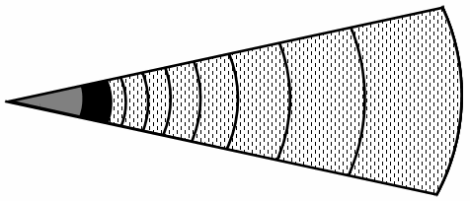

Cells with increasing size

argillite (50 m
–
183
cells)

glass

(21cm
–
21 cells)

iron

(13,8cm
–
14 mailles)

Figure 2 : 1D radial domain and discretization with progressive grid size

    - Numerical parameters and other parameters
A set of parameters is also given to control the convergence and adequate time-stepping during the simulation, including: the initial and maximum time steps, the maximum time step increment after each successful time step, the time tolerance and maximum correction (variation) of the master variable (in this case H⁺) in a time step.
The use of cylindrical coordinates and the Debye-Hückel correction for the aqueous species activity (with calculation of the activity coefficient lagged at the end of the time step) are also specified in this data block.

RUNTIME
timestep_max 0.1
timestep_init 1.e-25
timestep_incr 1.001
time_tolerance 2.
correction_max 2.
!default master variable is H+
debye-huckel true
lag_activity true
coordinates cylindrical
END

    - Material Properties
The material properties are given for the whole domain (no spatial heterogeneity is considered in the reference case). The effective diffusion is specified in terms of the molecular diffusion coefficient at 25°C (D₀), the activation energy (E_{ad}) for the Arrhenius law, the porosity (φ) and the cementation factor for Archie’s law (m):

D_{eff} = D₀ exp 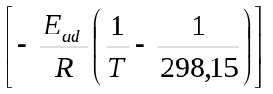Φ ^{m}

TRANSPORT
distance_units meters
time_units seconds
calculate_diffusion 2.0e-9 ! Do in m²/s
diffusion_activation 3.585 ! Ea in kcal/mol = 15 kJ/mol
cementation_exponent 2.5 ! m [-] from Nakashima 1995
END

Note: R = 0.001987 kcal/mol/K

  - Reaction Network Specification
    - Reaction Parameters
All the chemical species are defined in the “Thermoddem” thermodynamic database (Blanc et al.) (the file “base_crunch.dbs” is provided in the benchmark problem) where solid, aqueous and gaseous equilibrium reactions are given.
The only exceptions are iron and glass which are user–defined as minerals:

For glass:
Simplified glass dissolution equation using 1 silicon atom:
(Si-B-Na-Al-Ca-Fe)-Glass + 1.1076 H⁺ + 2.24495 H₂O →
0.5325 B(OH)₃ + H₄SiO₄(aq) + 0.4323 Na⁺ + 0.1285 Al³⁺ + 0.0952 Ca²⁺ + 0.0497 Fe²⁺ + 0.01225 O₂(aq)

The glass rate of dissolution is calculated from experimental data:

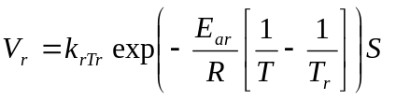

Where T_{r} = 323.15 K; E_{ar} = 53 kJ.mol⁻¹; k_{rTr} = 5.65 ×10⁻¹¹ mol.m⁻².a⁻¹; S = 1000 m²/m³. The rate calculated is not strictly constant because of the evolution of the surface area with glass dissolution (see below). The parameters used for the simulation lead to a complete glass dissolution after 35,000 years (cf. Figure 3).

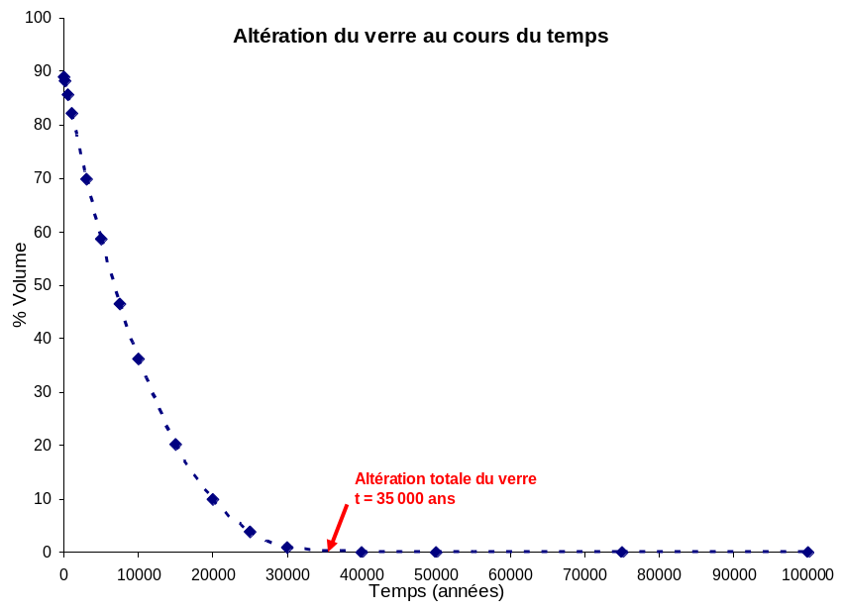
Figure 3 : Percentage of dissolved glass with time

The glass zone takes into account the fraction of void which is 11%: it corresponds to the fact that the primary canister is not initially entirely filled up with glass (see Initial Conditions below).

For iron:
Simplified iron dissolution equation with no water consumption:
Fe⁰ + 2 H⁺ → Fe²⁺ + H₂(aq)

The rate of corrosion is defined as an irreversible law:
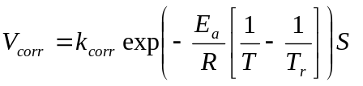
Where T_{r} = 298.15 K; E_{a} = 10.8 kJ.mol⁻¹; k_{corr} = 3 ×10⁻⁷ mol.m⁻².a⁻¹; S = 1 m²/m³. Again, the rate calculated is not strictly constant because of the evolution of the surface area (see below). The parameters used for the simulation lead to a complete corrosion of iron in 25,000 years (Figure 4).
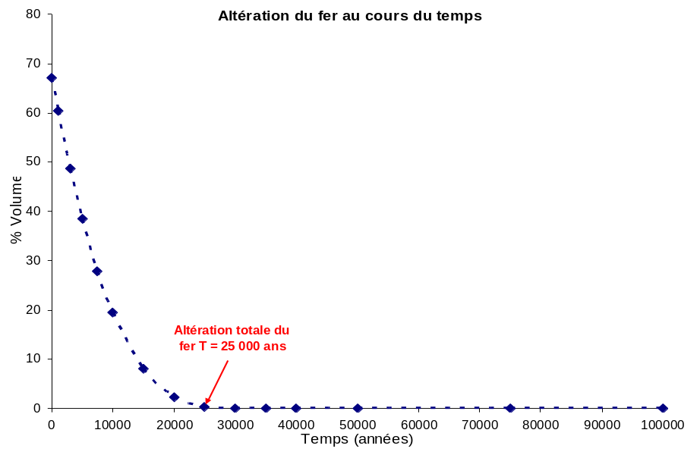
Figure 4 : Percentage of corroded iron with time

The “iron zone” or “lining + canister” zone has a porosity of 33% which corresponds to the volume of the technological gaps between the different parts of the metallic structure (primary canister, overpack, metallic lining and the claystone) (see Initial conditions below).
In the simulations performed with Crunchflow, the parameters for mineral dissolution/precipitation kinetic reactions are defined directly in the database (see file provided with this problem). Note that, in Crunchflow, the reactive surface area, S_{m} [m²/m³], for a mineral m, is updated as a function of the porosity, Φ [−], and its volume fraction Φ_{m} [−]:
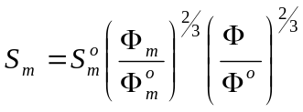

The reactions at thermodynamic equilibrium included in the problem are determined by the list of primary and secondary aqueous species, and gases:

PRIMARY_SPECIES  H+  Na+  Ca++  Cl-  SO4--  H4SiO4(aq)  HCO3-  Mg++  Fe++  Al+++  K+  Sr++  B(OH)3(aq)  O2(aq)  TracerI  TracerV  END  SECONDARY_SPECIES  Fe+++  H2(aq)  HS-  H2S(aq)  OH-  CO3--  CO2(aq)  B(OH)4-  NaB(OH)4(aq)  Al(OH)2+  AlH3SiO4++  AlO2-  AlOH++  AlSO4+  Ca(HCO3)+  CaCl+  CaCl2(aq)  CaCO3(aq)  CaOH+  CaSO4(aq)  Fe(CO3)2--  FeCl+  FeCl2(aq)  FeCO3(aq)  FeCO3OH-  FeHCO3+  FeO  FeO2--  FeOH+  FeSO4(aq)  H2SiO4-- | HAlO2(aq)  HCl(aq)  HFeO2-  HSiO3-  HSO4-  KAlO2(aq)  KCl(aq)  KOH(aq)  KSO4-  Mg(HCO3)+  Mg4(OH)4++++  MgCl+  MgCO3(aq)  MgOH+  MgSO4(aq)  NaAlO2(aq)  NaCl(aq)  NaCO3-  NaHCO3(aq)  NaOH(aq)  NaSO4-  Si2O2(OH)5-  Si2O3(OH)4--  Si3O5(OH)5---  Si3O6(OH)3---  Si4O12H4----  Si4O6(OH)6--  Si4O7(OH)6----  Si4O8(OH)4----  Si6O15------  Sr(CO3)(aq)  Sr(HCO3)+  SrCl+  SrOH+  SrSO4(aq)  Fe(CO3)2-  FeCl++  FeCl2+  FeCO3+  FeO+  FeO2-  FeOH++  FeSO4+  HFeO2(aq)  END  GASES  CO2(g)  H2(g)  O2(g)  H2S(g)  END
Note: gases are specified in this input file for the purpose of calculating the partial pressure of the “virtual” gas in equilibrium with the concentration of the corresponding dissolved species (using Henry’s law). There is no actual gas phase with the exception of H₂ which is treated below.

Kinetic reactions are specified for the different primary and secondary minerals (as the log of k in mol/m²/s):

MINERALS  Amorphous_silica -label prec  Anhydrite  Calcite -label neutre  Calcite -label H+  Celestite  Chalcedony -label prec  Clinochlore_14A  Cronstedtite_7A,alpha  CJ4-Glass -label residual  Daphnite_14A  Dolomite -label neutre  Dolomite -label H+  Ettringite  Ettringite_Fe  Fe-SaponiteCa  Fe-SaponiteNa  Fe-SaponiteK  Fe-SaponiteMg  Fe-MontmorilloniteCa  Fe-MontmorilloniteNa  Fe-MontmorilloniteMg  Fe-MontmorilloniteK  Greenalite  Goethite_B  Gypsum  Illite-FeII  Illite-FeIII  Illite-Mg  Iron -label monod  Kaolinite_B -label neutre  Kaolinite_B -label OH-  Kaolinite_B -label H+ | Magnetite,beta  Microcline -label neutre  Mg-Montmorillonite-Na -label neutre  Mg-Montmorillonite-Na -label H+  Mg-Montmorillonite-Na -label OH-  Mg-Montmorillonite-K  Mg-Montmorillonite-Mg  Mg-Montmo-Ca_B -label neutre  Mg-Montmo-Ca_B -label H+  Mg-Montmo-Ca_B -label OH-  Nontronite-Ca  Nontronite-K  Nontronite-Mg  Nontronite-Na  Pyrite -label oxygen  Pyrite -label ferric  Pyrrhotite,alpha  Quartz_alpha  Saponite-Mg  Saponite-Na  Saponite-K  Saponite-Ca  Sideritelt  Siderite  Huntite  Sepiolite  Minnesotaite  Brucite  CSH_0.8  Maghemite_disordered  Gyrolite  MineralH2_45b -rate -5.  END

The keyword “label” allows for the definition of different kinetic laws which can be used in modeling. It is applied exclusively for the dissolution rate of some primary minerals. This feature is used to take into account the dissolution rate dependency on H⁺ or OH⁻ for aluminosilicate minerals (the rate is the sum of the different rates calculated, see e.g. for kaolinite in the list above). The specific kinetic laws are defined in the database file (at the end of the file). A rate constant can also be defined directly with the label “rate”. Note that for iron a “Monod” type law is used to specify the irreversible corrosion rate (any irreversible formulation will also work).
A specific mineral was created in order to simulate the formation of H₂ gas. This “mineral” (MineralH2_45b) has a very small molar volume and precipitates whenever the concentration of H₂(aq) exceeds the equivalent of a partial pressure of pH₂ = 45 bar. Note that once the gas is formed, it may also dissolve when pH₂ decrease to values below 45 bar. A rather high rate is chosen for this phase in order to simulate a pseudo-equilibrium between H₂(aq) and H₂(g).

    - Initial and Boundary Conditions
The initial and boundary conditions are specified for each geochemical “unit” which corresponds to either a zone in the domain and/or a boundary: the glass unit, the (lining + canister) unit and the claystone unit (this latter is also used for the external boundary). In this problem, the initial water composition, before any reactivity, is the same in the whole domain and corresponds to the interstitial water composition of the claystone. Cl concentration is set using the charge balance of water and the redox is specified in equilibrium with pyrite.

The initial conditions are assigned to the three zones defined by their first and last nodes:
Glass_Solution 1-21
Canister_Solution 22-35
Clay_Solution 36-218

For the boundary conditions, a no flux condition in the center (or at the right, or equivalently at the beginning of the domain) representing the symmetry axis of the cylindrical cell:
X_begin Glass_Solution flux
! whatever the composition, provided that velocity is zero

At the outer limit (at the left or the end of the domain), a Dirichlet condition (claystone water composition) is imposed:
X_end Clay_Solution dirichlet

Clay_Solution

X_begin

Canister_Solution

Glass_Solution
X_end
Figure 5 : Location of the initial and boundary conditions

The three conditions defined in terms of water and mineral composition as follows (note that microcline precipitation is inhibited in the glass zone with a bulk surface area equal to 0 m2/m3):

Condition Glass_Solution
temperature 90.0
pH 6.502
Na+ 0.07253
Cl- charge
SO4-- 1.820e-2
HCO3- 0.008544
Al+++ 7.478e-08
H4SiO4(aq) 0.0008478
K+ 5.085e-3
Mg++ 0.0007417
Sr++ 9.946e-05
Ca++ 0.002884
Fe++ 4.553e-06
B(OH)3(aq) 1.000e-15
O2(aq) Pyrite
TracerI 1.e-25
TracerV 1.e-5
! glass volume fraction
CJ4-Glass 0.89 bulk_surface_area 1000.
Microcline 0.000 bulk_surface_area 0.
END

Condition Canister_Solution
temperature 90.0
pH 6.502
Na+ 0.07253
Cl- charge
SO4-- 1.820e-2
HCO3- 0.008544
Al+++ 7.478e-08
H4SiO4(aq) 0.0008478
K+ 5.085e-3
Mg++ 0.0007417
Sr++ 9.946e-05
Ca++ 0.002884
Fe++ 4.553e-06
B(OH)3(aq) 1.000e-15
O2(aq) Pyrite
TracerI 1.e-25
TracerV 1.e-5
! iron volume fraction
Iron 0.67 bulk_surface_area 1.
END

Condition Clay_solution
temperature 90.0
pH 6.502
Na+ 0.07253
Cl- charge
SO4-- 1.820e-2
HCO3- 0.008544
Al+++ 7.478e-08
H4SiO4(aq) 0.0008478
K+ 5.085e-3
Mg++ 0.0007417
Sr++ 9.946e-05
Ca++ 0.002884
Fe++ 4.553e-06
B(OH)3(aq) 1.000e-15
O2(aq) Pyrite
TracerI 1.e-25
TracerV 1.e-5

The claystone mineral assemblage is defined as follows:

! mineral volume fraction in the Claystone
Illite-Mg 0.22127 bulk_surface_area 1.e2
Mg-Montmo-Ca_B 0.04479 bulk_surface_area 1.e2
Mg-Montmorillonite-Na 0.01535 bulk_surface_area 1.e2
Kaolinite_B 0.00858 bulk_surface_area 1.e1
Microcline 0.05563 bulk_surface_area 1.e-2
Quartz_alpha 0.18612 bulk_surface_area 1.e1
Calcite 0.26252 bulk_surface_area 1.e1
Pyrite 0.00666 bulk_surface_area 1.e-2
Sideritelt 0.00590 bulk_surface_area 1.e-2
Goethite_B 0.00001 bulk_surface_area 1.e-2
Dolomite 0.01189 bulk_surface_area 1.e-4
Celestite 0.00056 bulk_surface_area 1.e-4

- Output Specification

2 types of output file are written in ASCII format:

  - Spatial profiles at specific simulation times

See list of output time in year:

spatial_profile_at_time 1.e-5 1000. 3000. 5000. 7500. 10000. 15000. 20000.
25000. 30000. 35000. 40000. 50000. 75000. 100000.

Crunchflow generates a number of different types of file which will be numbered from 1 to 15 in order to record the profiles at the different time specified. The files of interest for the benchmarking exercise are: “pH*.out”, “gas*.out” and “volume*.out” (where * goes from 1 to 15).

  - Time series at a specific locations in the domain

The location is designated by the node number and a file name is also specified by the user:

time_series_at_node node-glass.out 21
time_series_at_node node-canister.out 35
time_series_at_node node-clay.out 36
time_series_print all
time_series_interval 1000

With these parameters, Crunchflow generates 3 files where the pH and concentration of all the aqueous species are written every 1000 time steps (so that the files keep a reasonable size). The data of interest is the pH evolution at the interface between the canister and the claystone.

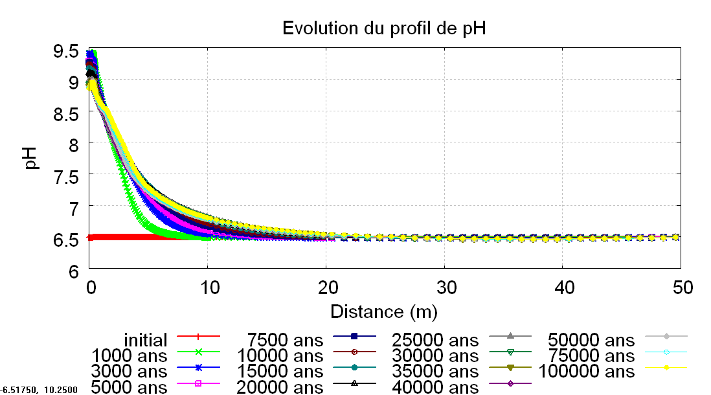

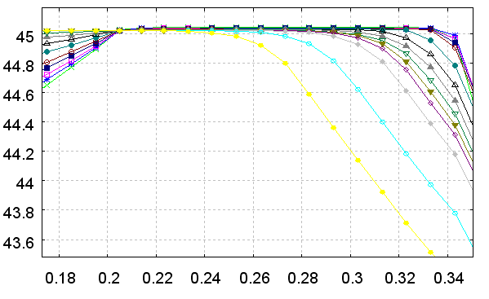
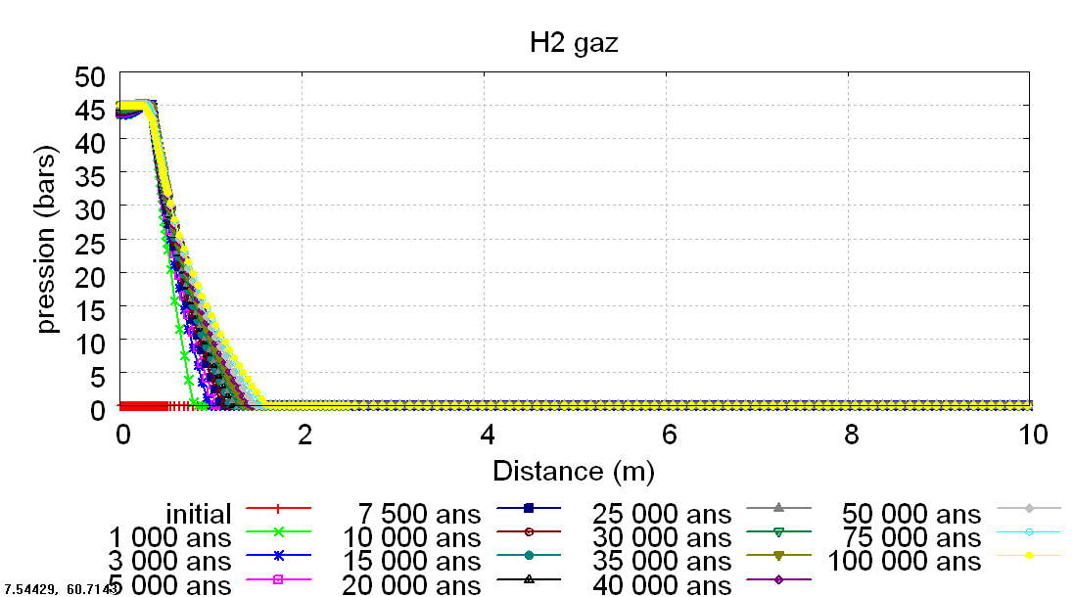

- Minerals in glass zone

a) t = 5 000 years  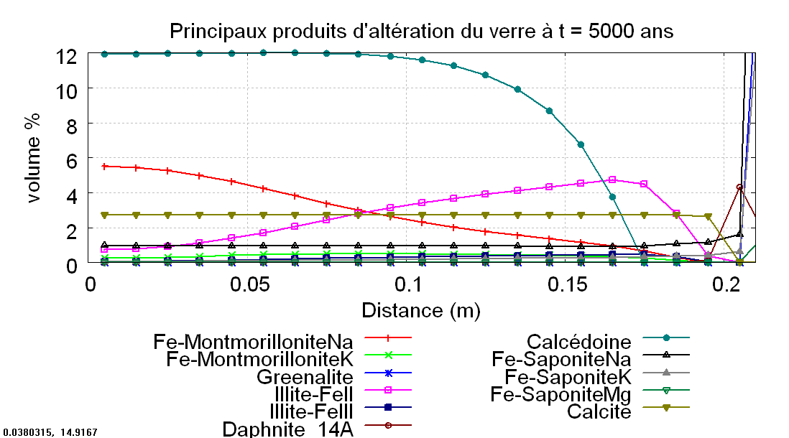 | b) t = 10 000 years  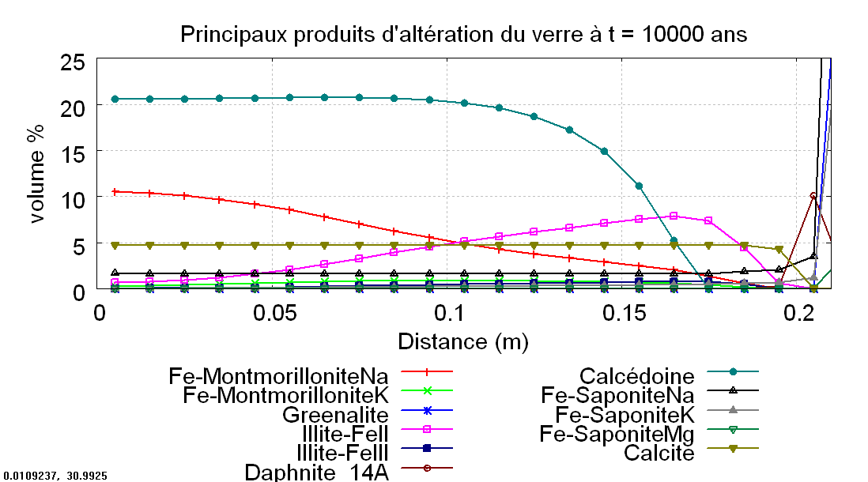
c) t =25 000 years  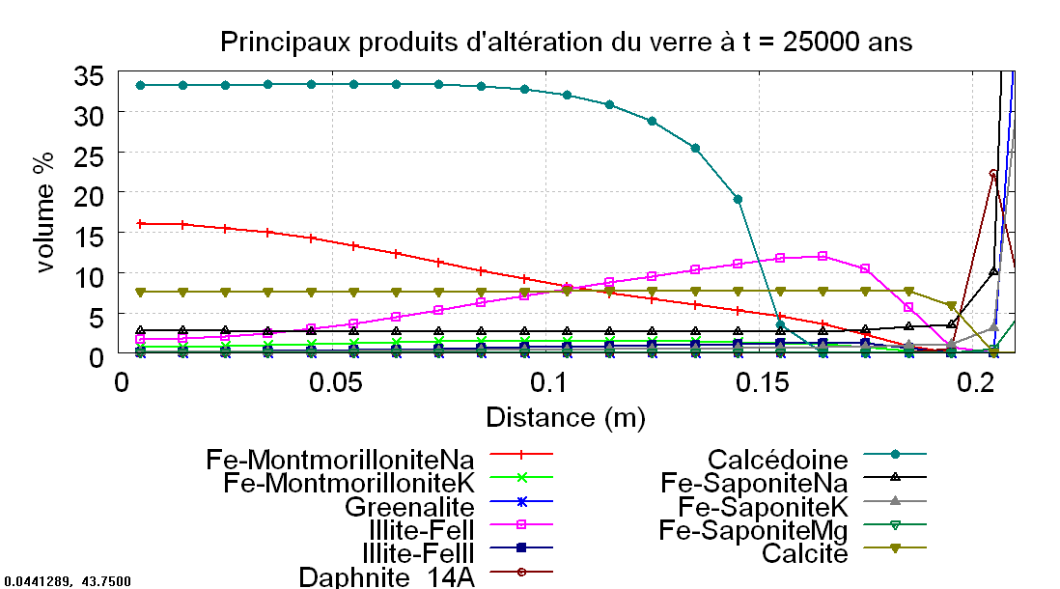 | d) t =35 000 years  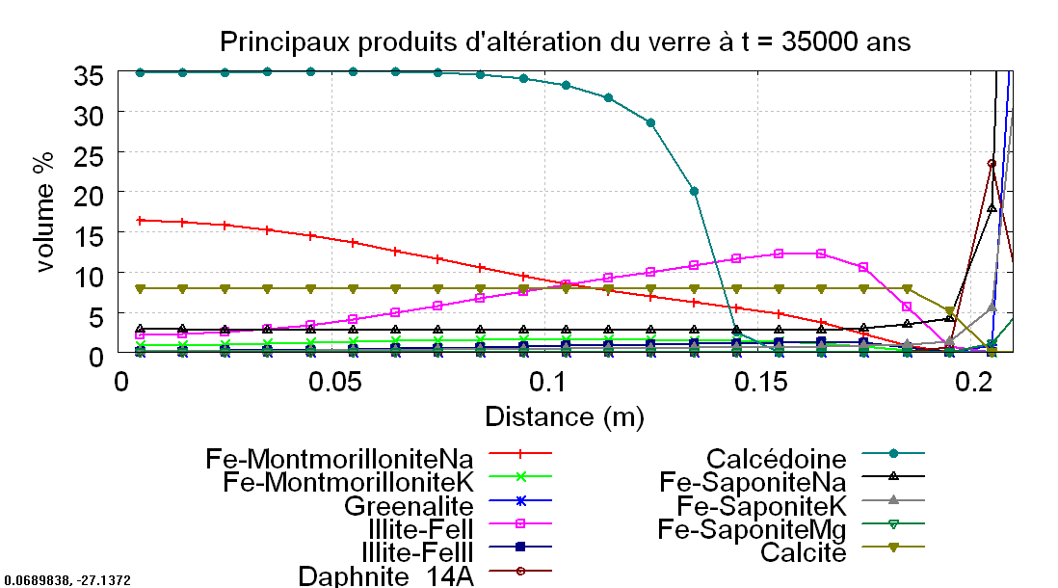
e) t= 50 000 years  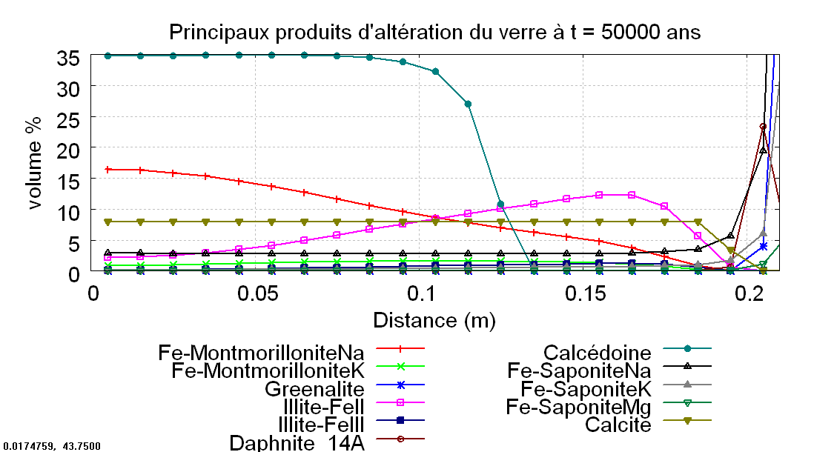 | f) t= 100 000 years  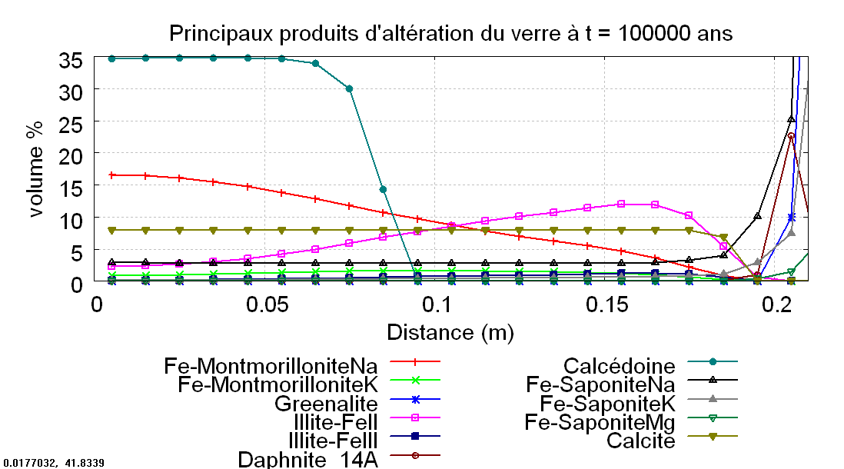

- Minerals in iron zone

a) 5 000 years  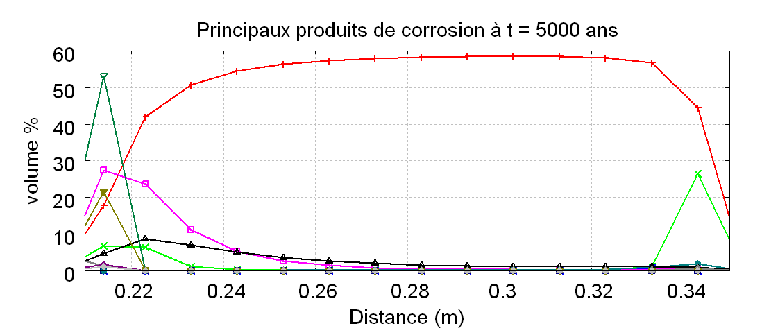 | b) t = 10 000 years  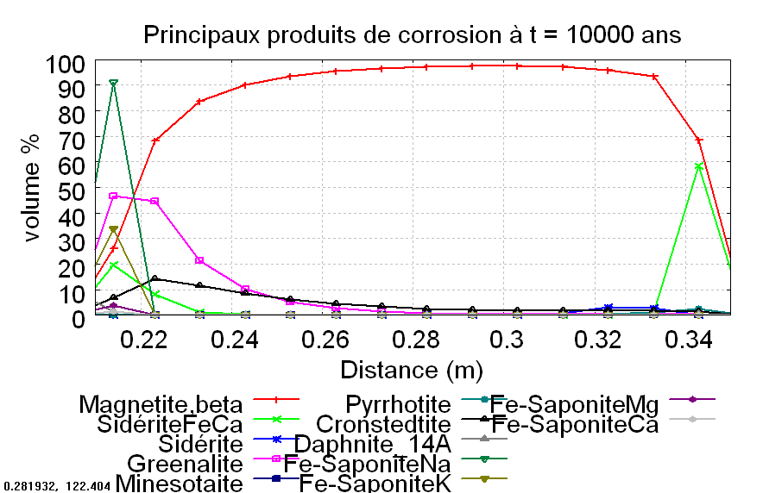
c) t =25 000 years  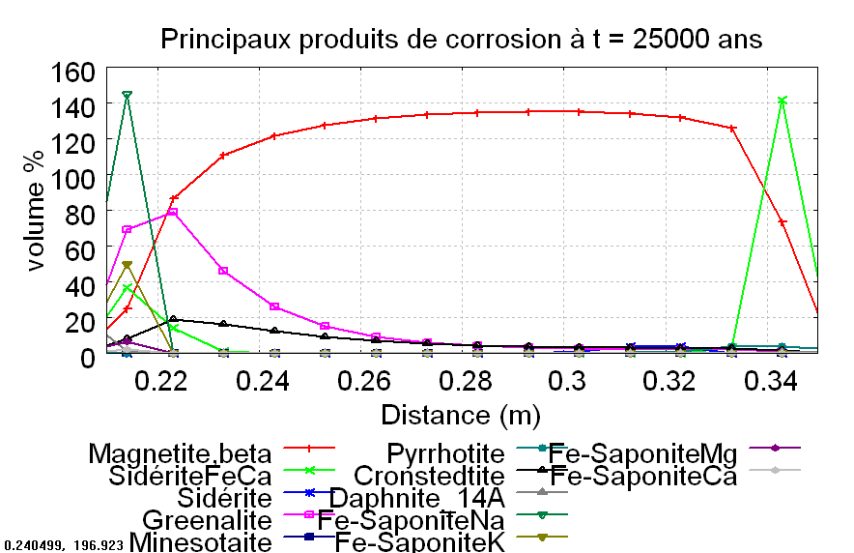 | d) t =35 000 years  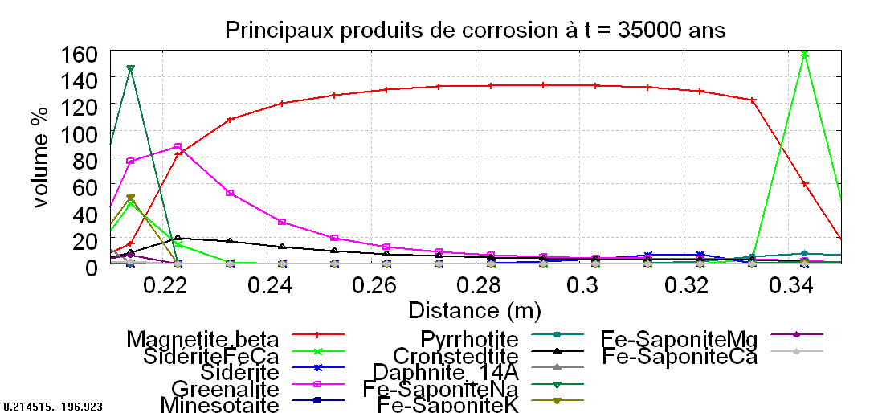
e) t= 50 000 years  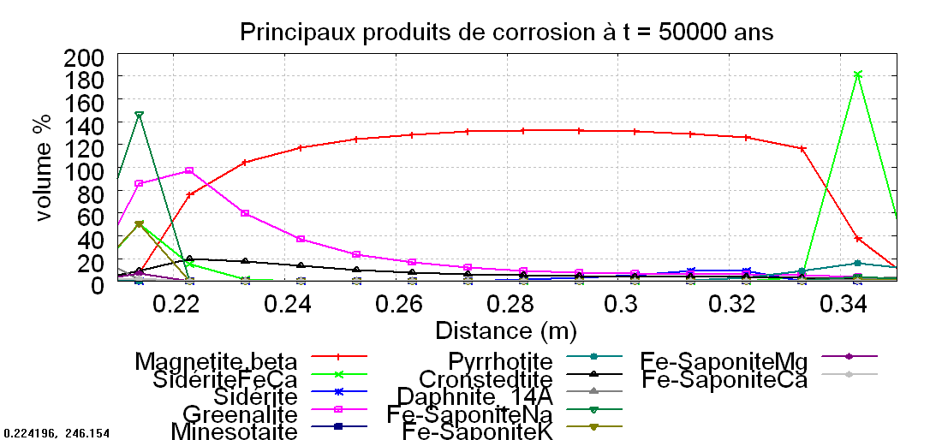 | f) t= 100 000 years  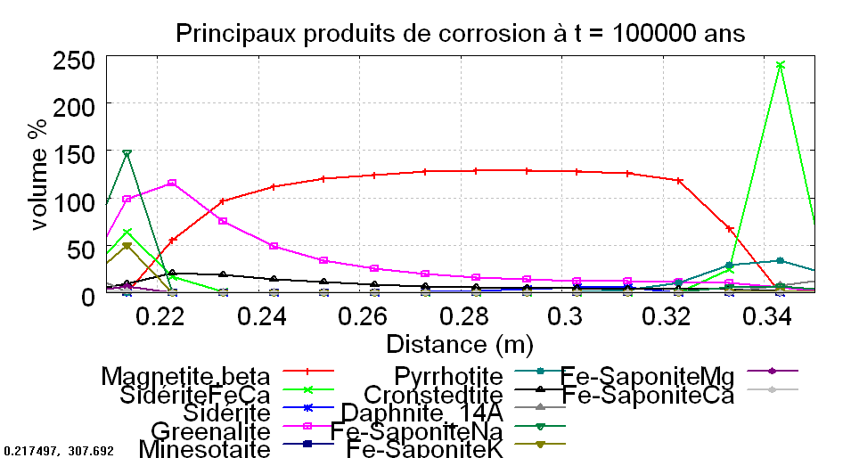

- Secondary minerals in argilites

a) t = 0  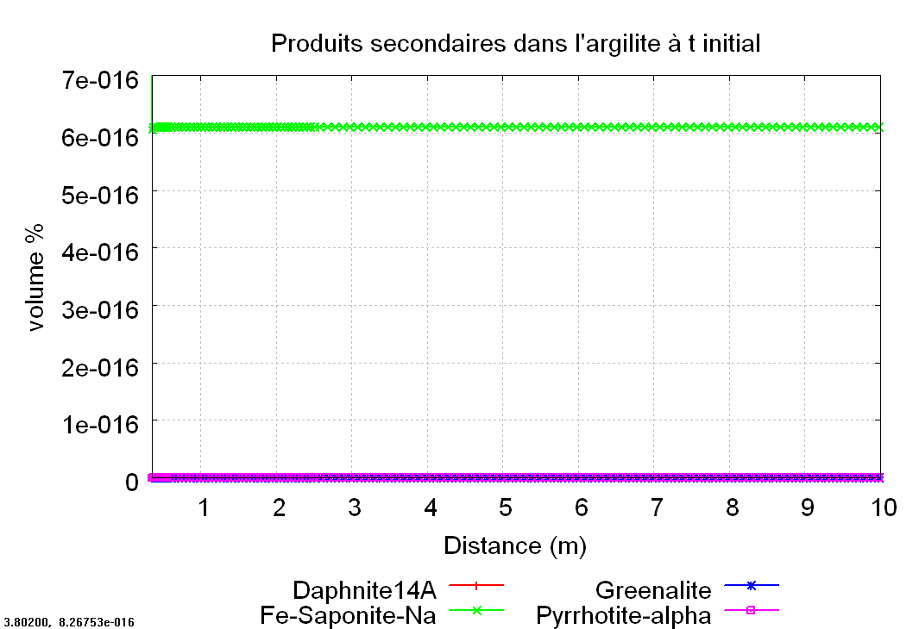 | b) t = 5 000 years  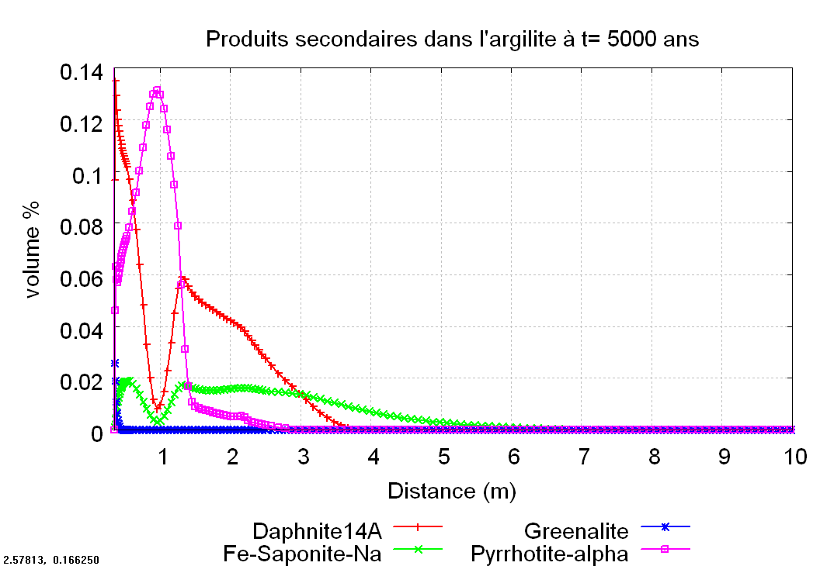
c) t =25 000 years  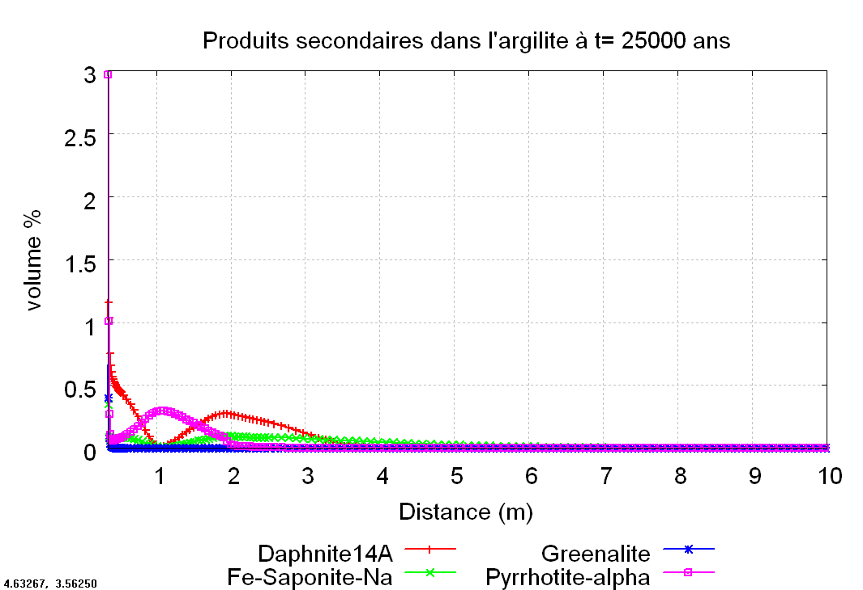 | d) t =35 000 years  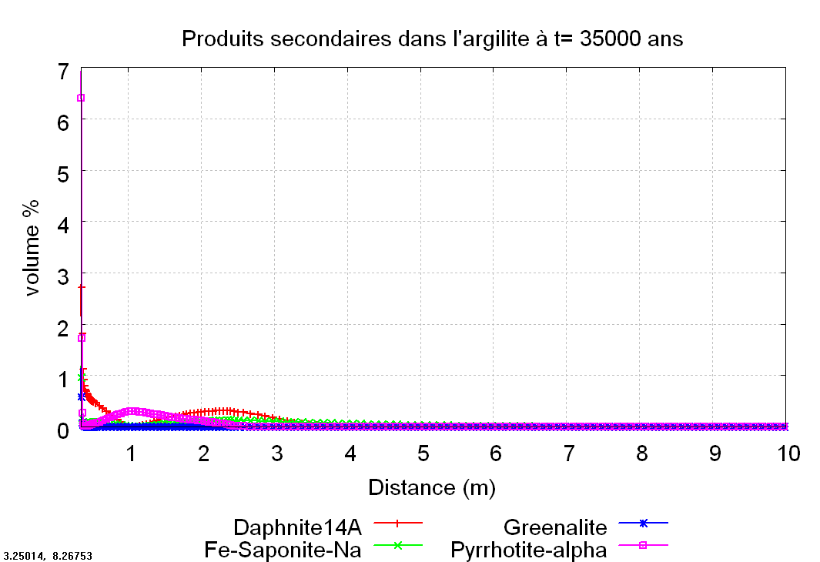
e) t= 50 000 years  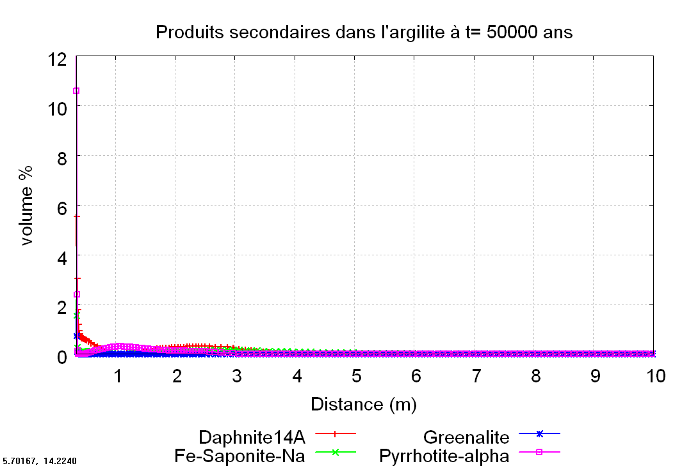 | f) t= 100 000 years  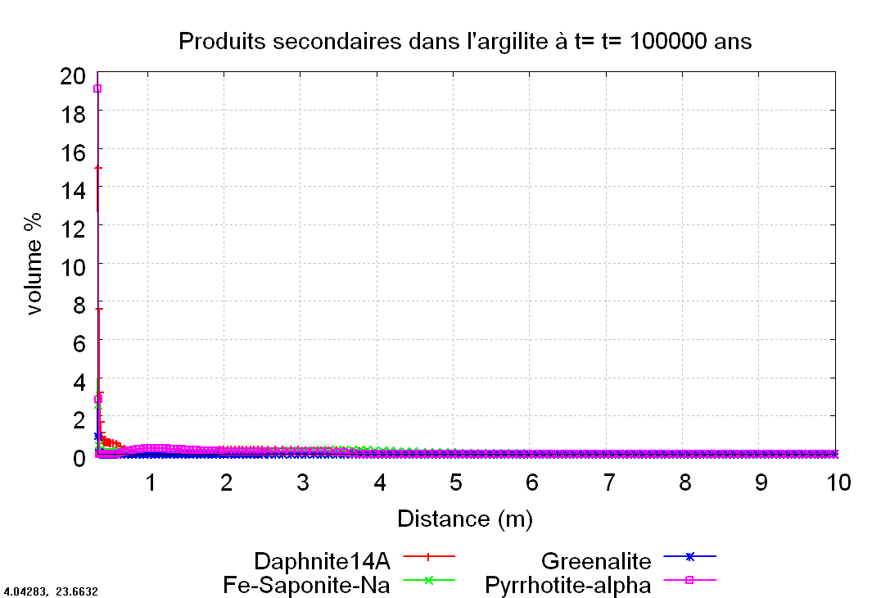

ANNEX

Surface area considered for the primary minerals (see database for chemical formulae)
Primary minerals | Log k (25°C) (mol/m²/s) | Ea (kcal/mol) | Surface area (m²/m³ of rock)
Quartz_alpha | -13.99 | 20.9 | 1.00E+01
Calcite | -5.8 | 5.6 | 1.00E+01
Dolomite | -7.53 | 12.53 | 1.00E-04
Siderite_085 | -7.53 | 12.7 | 1.00E-02
Pyrite | -4.57 | 13.6 | 1.00E-02
Goethite_B | -7.94 | 20.7 | 1.00E-02
Kaolinite_B | -13.8 | 14 | 1.00E+01
Microcline | -12.4 | 9.1 | 1.00E-02
Celestite | -3.2 | 3.4 | 1.00E-04
Mg-Montmo-Ca_B | -14 | 12 | 1.00E+02
Mg-Montmorillonite-Na | -14 | 12 | 1.00E+02
Illite-Mg | -14 | 12 | 1.00E+02

Kinetic constants and activation energy for secondary minerals (see database for chemical formulae). Surface area is considered to be 100 m²/m³ for all these secondary minerals.

Secondary minerals | Log k (25°C) (mol/m²/s) | Ea (kcal/mol)
Amorphous_silica | -9.42 | 11.9
Anhydrite | -3.2 | 3.4
Chalcedony | -9.4 | 11.9
Clinochlore_14A | -14 | 12
Cronstedtite_7A,alpha | -14 | 12
Daphnite_14A | -14 | 12
Ettringite | -14 | 12
Ettringite_Fe | -14 | 12
Fe-SaponiteCa | -14 | 12
Fe-SaponiteNa | -14 | 12
Fe-SaponiteK | -14 | 12
Fe-SaponiteMg | -14 | 12
Fe-MontmorilloniteCa | -14 | 12
Fe-MontmorilloniteNa | -14 | 12
Fe-MontmorilloniteMg | -14 | 12
Fe-MontmorilloniteK | -14 | 12
Greenalite | -14 | 12
Gypsum | -2.79 | 0
Illite-FeII | -14 | 12
Illite-FeIII | -14 | 12
Magnetite,beta | -10.78 | 4.4
Mg-Montmorillonite-K | -14 | 12
Mg-Montmorillonite-Mg | -14 | 12
Nontronite-Ca | -14 | 12
Nontronite-K | -14 | 12
Nontronite-Mg | -14 | 12
Nontronite-Na | -14 | 12
Pyrrhotite,alpha | -10 | 13.6
Saponite-Mg | -14 | 12
Saponite-Na | -14 | 12
Saponite-K | -14 | 12
Saponite-Ca | -14 | 12
Siderite | -7.53 | 12.5
Huntite | -7.53 | 12.5
Sepiolite | -14.41 | 12
Minnesotaite | -14.41 | 12
Brucite | -7 | 15
CSH_0.8 | -7 | -15
Maghemite_disordered | -10.78 | 4.4
Gyrolite | -7 | 15

