Course Assignment: Project planning, process documenting and collaboration

Report by Daniel Talhaug

Submitted to MJ Phillip

I

Summary

This report covers the course assignment for this week, what I have done and why. I write about my Gantt chart and how I made it. I also cover communication with my team and client and how to track progress during creating a website.

List of content

Title I

Summary II

List of contents II

1 Introduction 1

2 Gantt chart 1

3 Communication 1

4 Tracking work 1

5 Conclusion 2

6 References 2

7 Acknowledgments 2

II

Introduction

In this weeks course assignment I had to create a Gantt chart and a report for a website for an imaginary company called Lofthus frukt og saft. The task was to consider all the different elements that should be produced for a functional website. We had to think about

Gantt chart

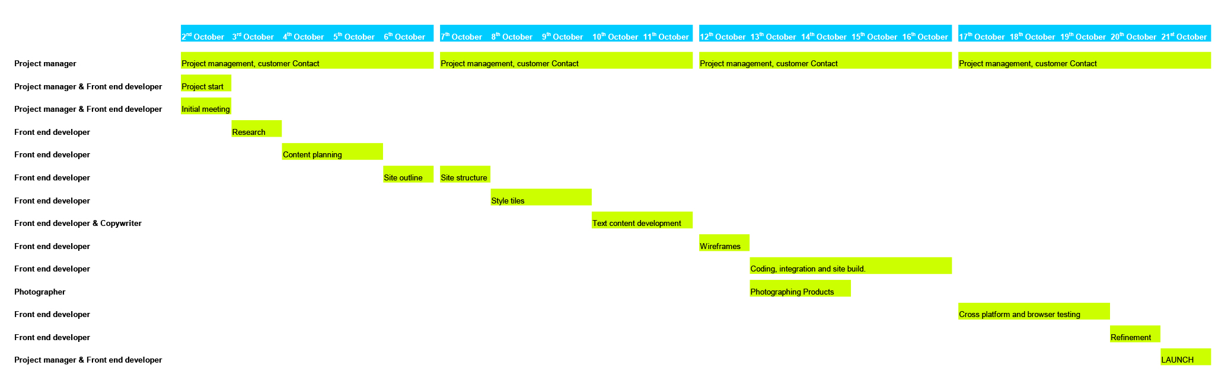
I used Open Office Calc to create my Gantt chart. I had to think about what elements to include in the chart and I wrote down some notes in notepad. I found the Gantt_chart_workflow_case.xlsx file that was added to the Project Methodology files on Canvas. I tried my best not to follow it too closely but It had a lot of really good elements that I didn't think of.
Figure 1 – Gantt Chart

I initially used the green just as a placeholder but I grew to like it. I decided to use the blue for the dates because it went well with the green. I also finally figured out how I could save it as a PSD file without it being chopped up into a bunch of pages by selecting page preview, Format page and selecting Fit print range(s) on number of pages under scaling mode. Maybe that can be helpful to someone else.

Communication
For communicating with my team I would use Slack.com. It's a nice and simple communication tool where we can easily talk and share files in a private environment.

For communicating with the client I would use Google+ Hangouts. It's easy and simple to use both on a computer and phone plus it's free. For file sharing I'd use something like Google drive or Dropbox.

Tracking work
We would use GitHub to track the progress of any files created for the website. Though I think it's a bit tricky to use GitHub, it makes it easy to see the changes over time and should anything go wrong make it easy to perform rollbacks.

1
Conclusion

I created a Gantt chart that shows the tasks that needs to be done over four weeks for the website to be finished. By using slack.com and Google+ hangouts I can easily communicate with my team and client. File sharing can be done through a cloud service and we will use GitHub to save and track the progress of the files for the website.

References

Philip, MJ “Gantt_Chart_Workflow_Case.xlsx” 2017 09 26

Macs, Martins “Report_Template_Lesson_1.1 .docx” 2017 09 13

Acknowledgments

I would like to thank MJ Phillip for all the good work so far. Good teachers are hard to come by but you are without a doubt one of them. The Gantt Chart workflow file was very helpful and it looks great. Great inspiration. I would also like to thank Martins Macs for the Report Template. Very helpful. Writing reports and big chunks of texts is definitely one of my weakest points. I used to be one of the kids with 20pt fonts and wide kerning just to fill one page. I hope I got all that right. It doesn't actually say who did what, I just assumed it because of who uploaded the files.

2

