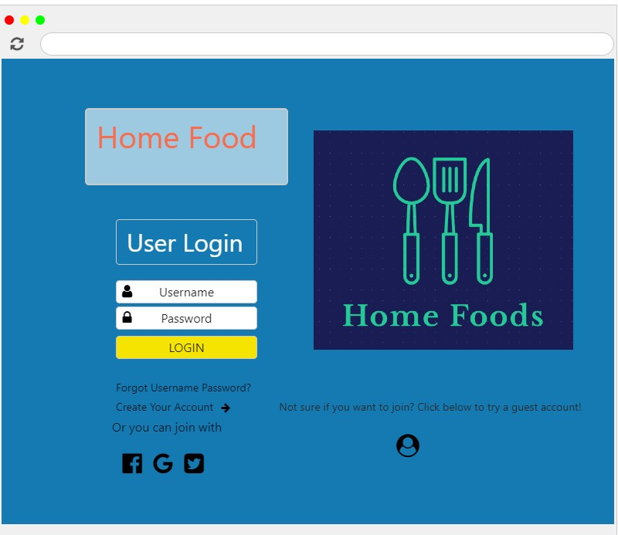

This is the login screen. From here a user can enter in existing credentials, select an alternative login (through Google, Facebook, or Twitter). Users also have the choice to create a new account, or try a guest account.

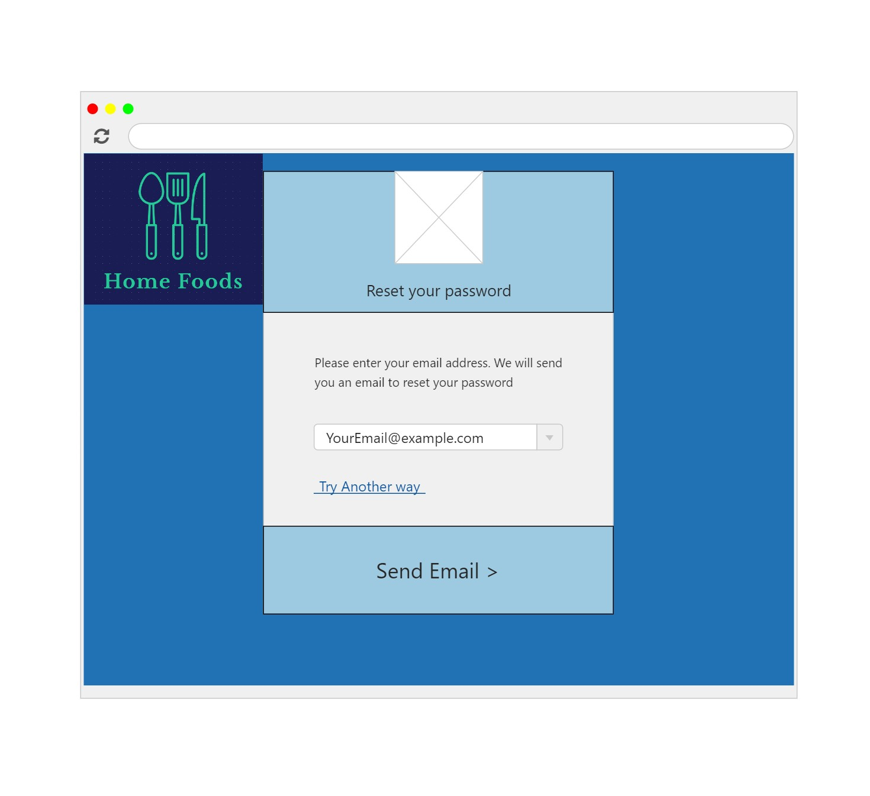

Page customers are brough to when requesting a new password

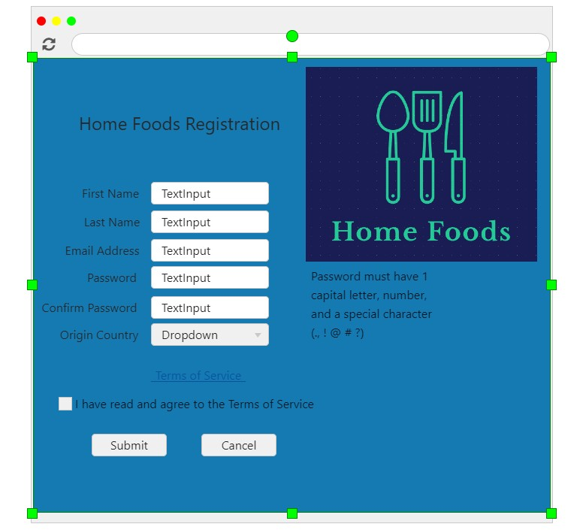

Registration

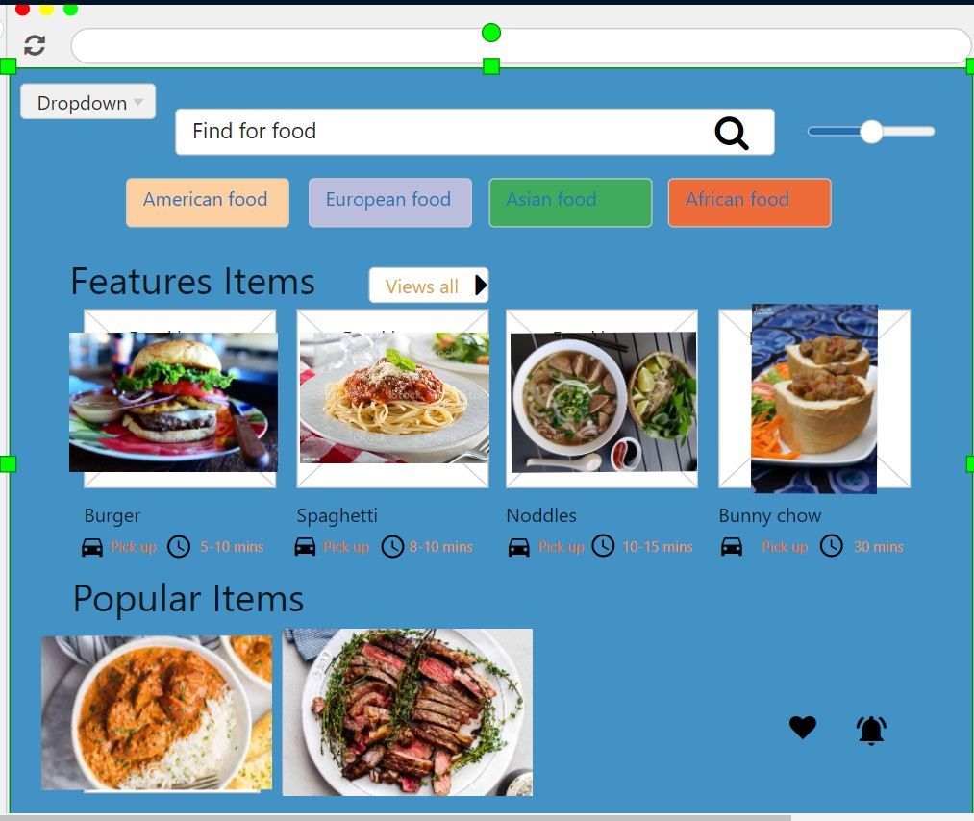

This is how the search page would look, without a search entered

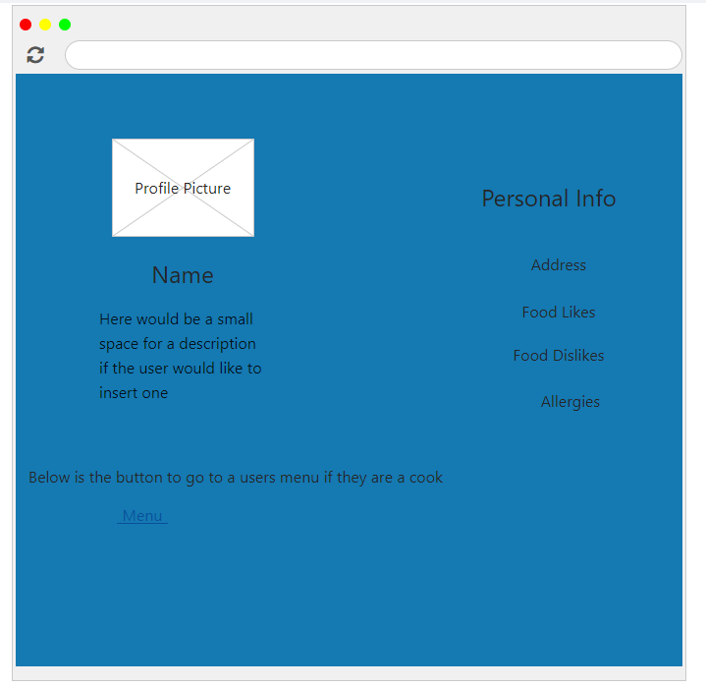

This is a basic layout of how the profile page would be

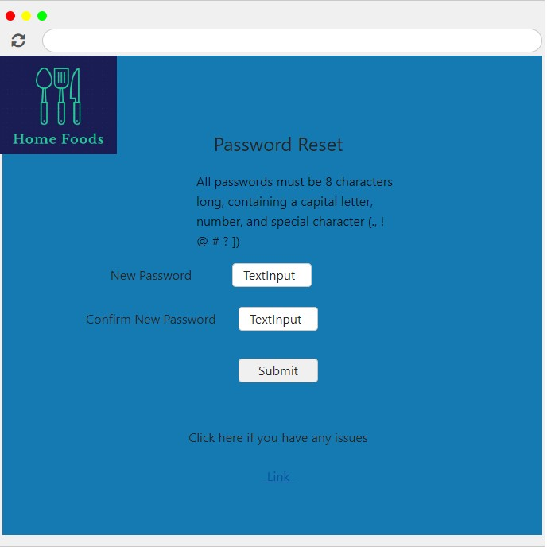

This is the page that you are taken to when resetting your password