**How to turn on FPF2**

It is recommended to turn on FPF2 ONLY after weightgeneration

FPF2 can be turned on by the following 2 step change within workbench.

**ALGORITHM changes**

1. Go to the algorithm editor in workbench
2. Choose the ‘ False Postive Filter’ from the Comparison Functions panel on the right.
3. Add it to the algorithm such that it is connected to the Date of Birth comprole.

Appendix 1 shows how the algorithm will look BEFORE and AFTER FPF2 addition

**WEIGHT changes**

1. Open the mpi_wgthead file and add the following row :

1|1|A|CMPPER-FPF2-DIST|4DIM|CMPPER-FPF2-DIST|12|3|6|3|

1. Copy the mpi_wgt4dim file from the FPF2_weight directory to the weights/MDMSPerson directory
2. Deploy the weights
3. At this stage FPF2 is turned on. In other words, all matching scores will include the mpi_wgt4dim scores

**Appendix I**

**Algorithm screen shot BEFORE FPF2 is added**

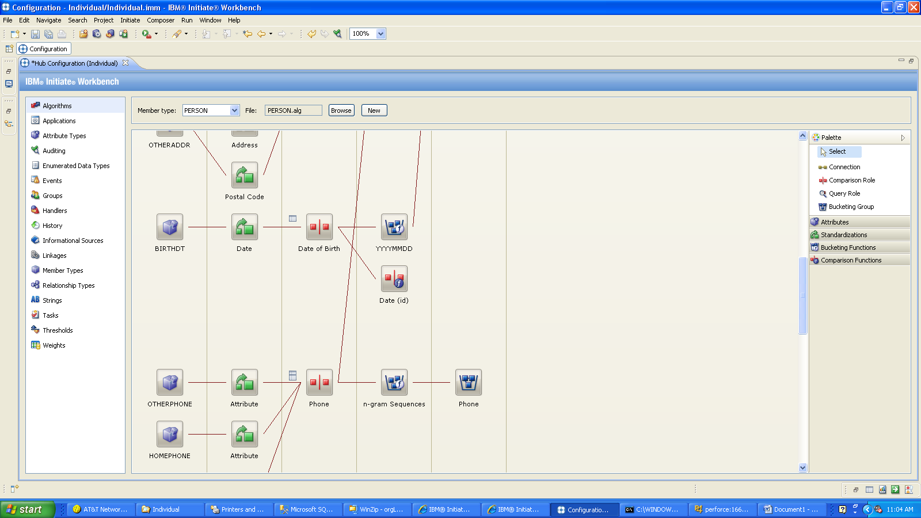

**Algorithm Screen shot AFTER FPF2 is added**

