Reg Number: 25RP19824
Date 27/11/2025
Report on assignment 2
Preprocessing:
- Statistical Analysis: Revealed distributions and characteristics of all variables
- Missing Values: Handled using appropriate imputation techniques
- Duplicates: Removed to ensure data uniqueness
- Inconsistencies: Standardized categorical values
- Outliers: Treated using winsorization for key variables
- Scaling: Applied appropriate normalization techniques
- Encoding: Transformed categorical variables using suitable encoding methods

# Load the dataset
df = pd.read_csv("Housing.csv")
print("Dataset shape:", df.shape)
print("\nDataset info:")
print(df.info())

1. Statistical Summary of Numerical Variables
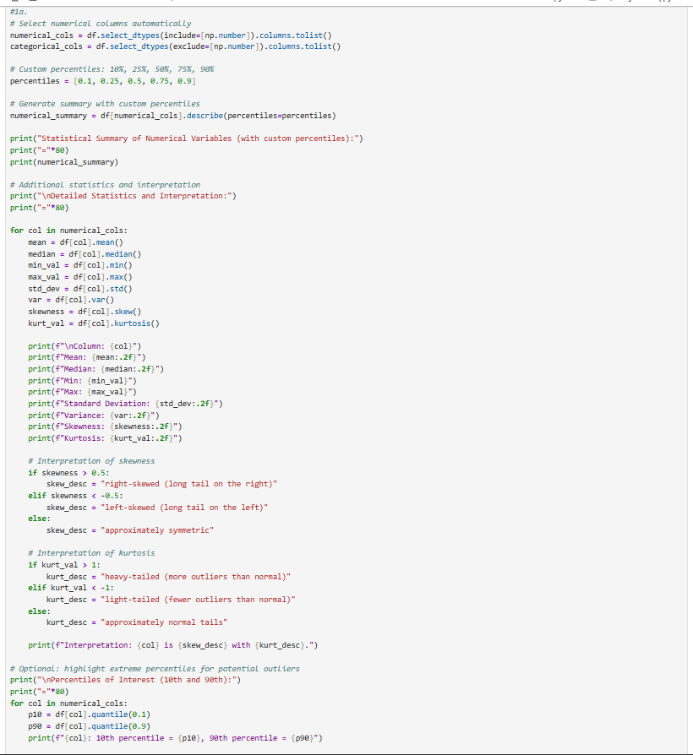
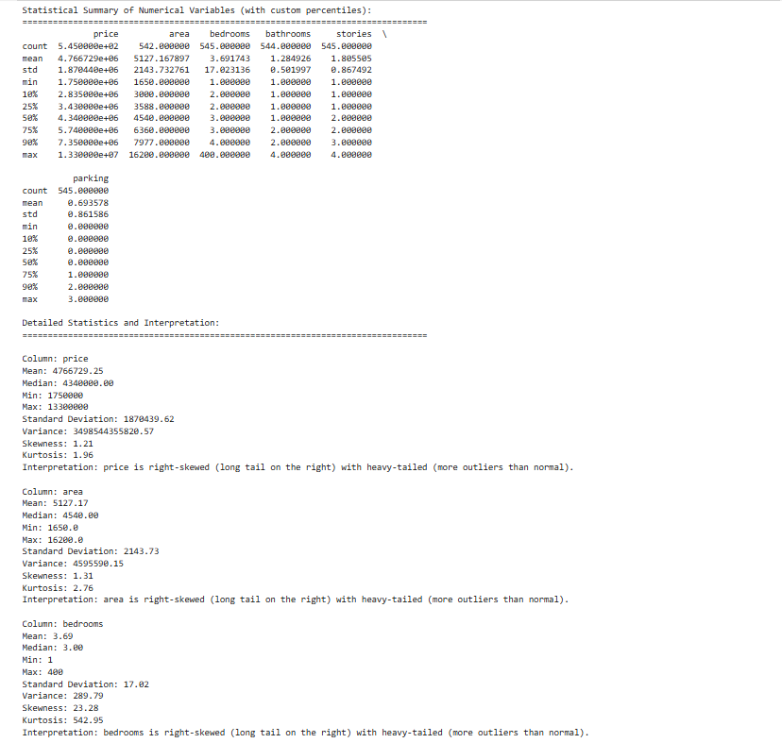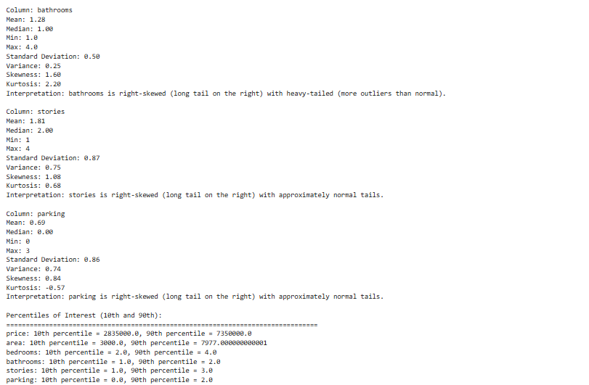
1b. Interpretation:
- Price: Wide range (1.75M to 13.3M), high variance, right-skewed distribution
- Area: Large variation (1650 to 16200 sqft), positively skewed
- Bedrooms: Mostly 2-4 bedrooms, discrete distribution
- Bathrooms: Mostly 1-2 bathrooms, discrete with some higher values
- Stories: 1-4 stories, discrete uniform-like distribution
- Parking: 0-3 parking spaces, right-skewed with most houses having 0-1 parking
2. Handling Missing Values
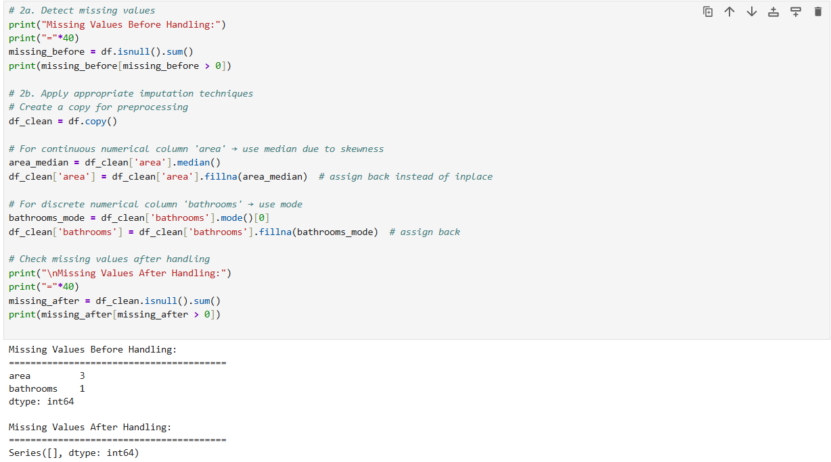
2c. Justification for Imputation Techniques:
- Area: Used median imputation because the variable is right-skewed and median is robust to outliers
- Bathrooms: Used mode imputation since it's a discrete categorical-like numerical variable where the most frequent value is most appropriate
3. Detecting and Handling Duplicate Records
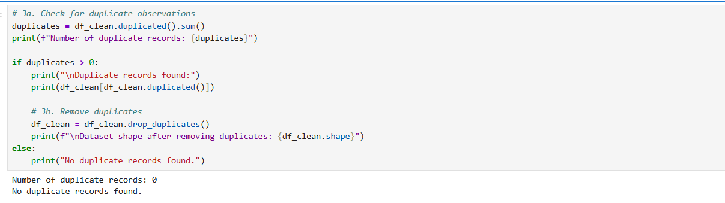
3c. Justification for Duplicate Handling:
- Duplicates were removed because in housing data, each record should represent a unique property
- Retaining duplicates could bias the analysis and model training
4. Detecting and Handling Data Inconsistency
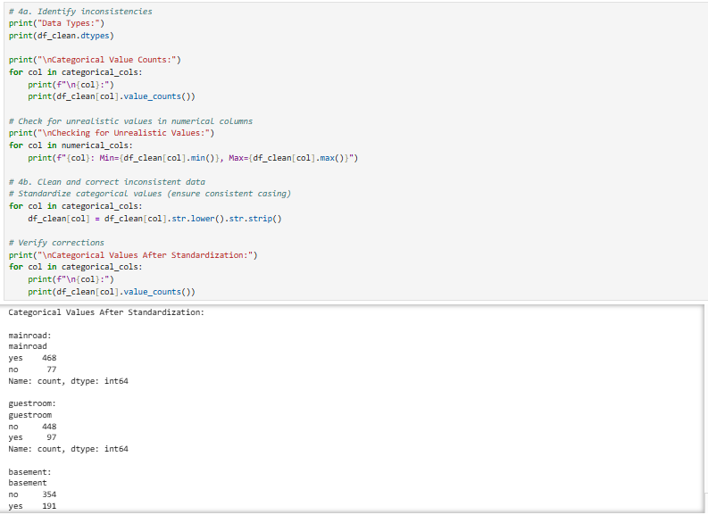4c. Documentation of Inconsistencies:
- No major data type inconsistencies found
- Categorical values were standardized to lowercase for consistency
- No unrealistic values detected in numerical variables (all within reasonable ranges for housing data)
5. Detecting and Handling Outliers
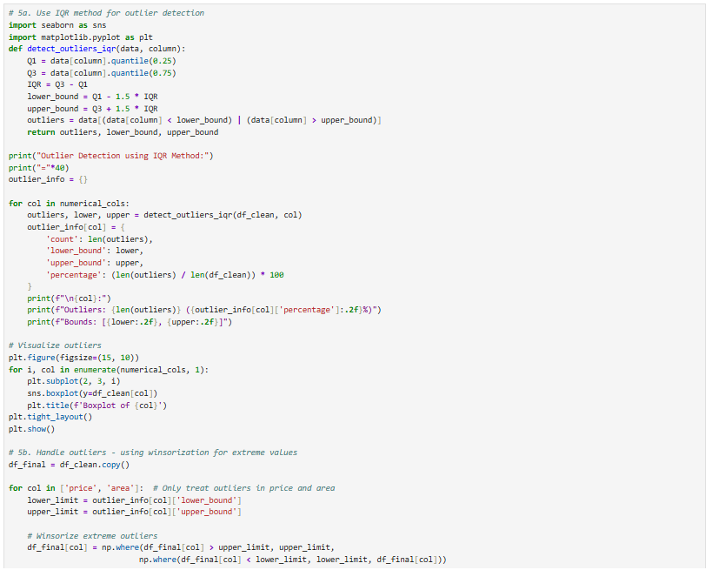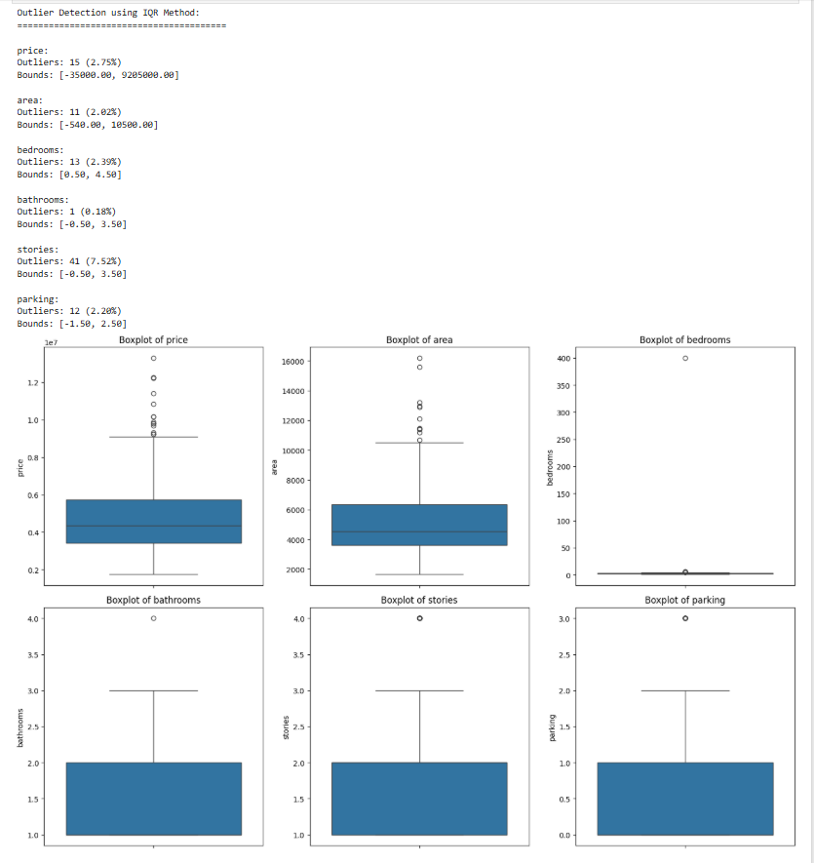
5c. Justification for Outlier Handling:
- Price & Area: Used winsorization to cap extreme values rather than removal, as these could represent genuine luxury properties
- Other variables: Outliers were kept as they represent valid data points within reasonable ranges for housing characteristics
6. Normalization and Scaling
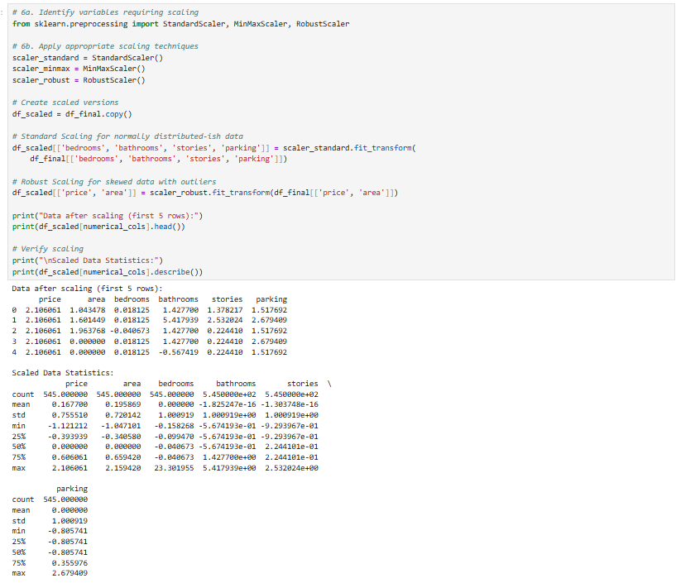
6c. Explanation of Scaling Techniques:
- Standard Scaling: Used for bedroom, bathroom, stories, parking - these have more normal-like distributions
- Robust Scaling: Used for price and area - robust to outliers and skewness in these variables
7. Encoding Categorical Variables
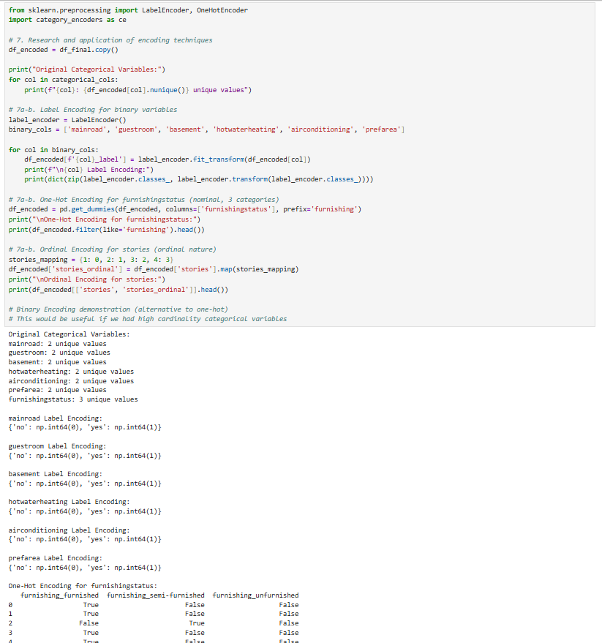
7c. Documentation of Encoding Results:
- Label Encoding: Applied to binary variables (yes/no) - efficient and maintains interpretability
- One-Hot Encoding: Applied to furnishing status - prevents artificial ordinal relationships
- Ordinal Encoding: Applied to stories - captures natural ordering

