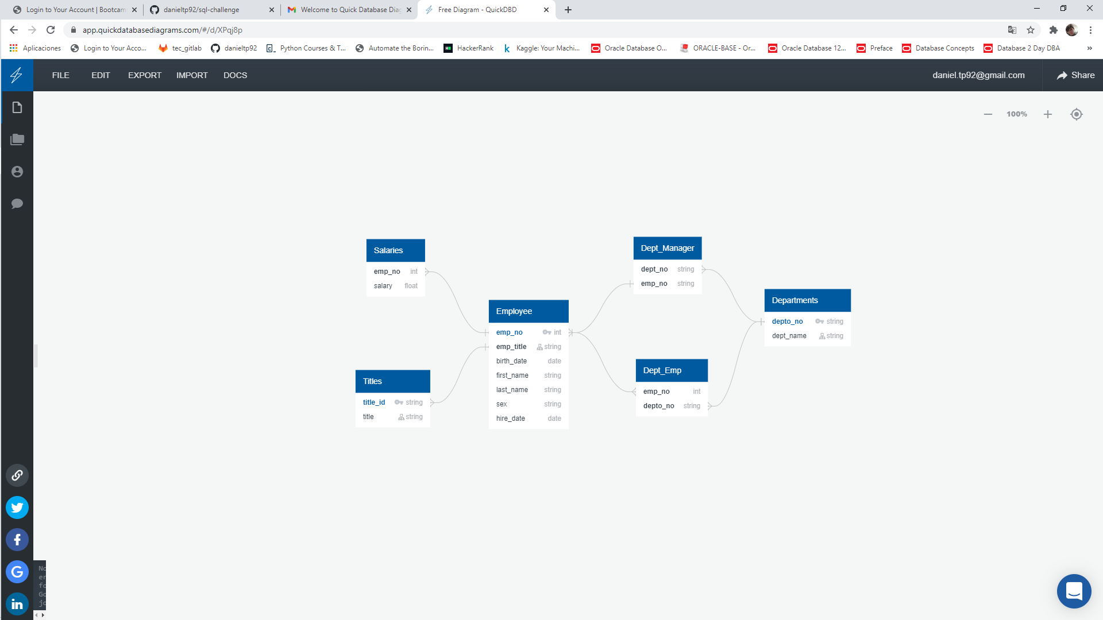**ENTITY RELATIONSHIP DIAGRAM**