Three dimensional line profile analysis

PhD thesis

Gyula Zilahi
2017

Supervisors: Dr. Tamás Ungár, professor emeritus
Dr. Gábor Ribárik, assistant professor

Eötvös Loránd University
Faculty of Science
Doctoral School of Physics
Materials Science and Solid State Physics program

Head of Doctoral School: Dr. Tamás Tél, professor
Program Leader: Dr. István Groma, professor

Table of Contents
List of abbreviations 4
1 Introduction 6
2 Line broadening in thee dimensions 8
2.1 A uniform theory for the description of line-broadening and rocking-curves [Zilahi et al. 2015] 10
2.1.1 Separating the shape function from the density function of a crystal 10
2.1.2 Lattice distortion 12
2.1.3 Series expansion of the Fourier coefficients of lattice distortion 15
2.2 Line profile and rocking curves 17
2.2.1 Line profile or line broadening 18
2.2.2 Rocking-curve broadening 19
2.2.3 Correlation between rocking-curve broadening and the geometrically necessary dislocation density 20
2.3 Relation between line broadening and RC broadening 23
2.3.1 Tensile-deformed copper single crystals 24
2.3.2 Compression-deformed Ge single crystals 25
2.3.3 Tensile-deformed CoTi alloy 27
2.4 Laue asterism 30
2.4.1 GNDs from lattice rotations in microbeam Laue asterism 30
2.5 Direct observation of stretching and rotations of subgrains in diffraction experiments 31
3 Tracing reciprocal space in 3D 32
3.1 Experimental setup 32
3.2 Evaluation procedure 36
3.2.1 Peaksearch 36
3.2.2 Techniques to improve peaksearch results 39
3.2.2.1 Dark image correction 39
3.2.2.2 Filtering peaks 41
3.2.2.3 Merge spots from several different threshold levels 43
3.2.3 Refining experimental parameters and calculating diffraction vectors 44
3.2.4 Identifying grains 46
3.2.5 Refining grain orientations, positions, internal stresses, volume fractions 48
3.2.6 Simulate peak positions on far detectors 49
3.2.7 Integrating diffraction peaks 50
3.2.8 Creating single grain pseudo-patterns for CMWP line profile analysis 50
3.2.9 Fitting line profiles by CMWP 51
3.2.10 Fitting dislocation structure to the measured contrast factors 53
3.2.10.1 Matching the measured strain broadening contrasts with the theoretical contrast factors of different possible dislocation types 54
3.2.10.2 Refining the effect of size broadening 55
3.2.10.3 Direction dependence of dislocation broadening contrast [Zilahi et al. 2017a] 56
3.2.10.4 Fitting fractional dislocation densities by Monte-Carlo type method 58
3.2.10.5 Checking efficiency of Cfit software to reproduce dislocation composition 60
4 Measurement of uniaxially tensiled polycrytalline CoTi and CoZr alloys 62
4.1 Deformation mechanisms in CoTi and CoZr B2 structured intermetallic alloys 62
4.2 Experimental 63
4.2.1 Materials 63
4.2.2 X-ray diffraction experiments 64
4.3 Evaluation of the X-ray diffraction experiments 65
4.4 Results and discussion 69
4.4.1 Cross-checking of the CMWP method and the procedure of matching measured and theoretical contrast factors 69
4.4.2 Prevalent SSs and dislocation densities in the individual grains of CoTi 73
4.4.3 Prevalent SSs and dislocation densities in the individual grains of CoZr 73
4.4.4 Secondary vs. primary slip 73
4.4.5 Correlation between the Schmid factors and the prevalence of slip systems 79
5 Measurements on uniaxially deformed polycraystalline Mg AZ31 alloy specimens 82
5.1 Experimental 82
5.1.1 Specimens 82
5.1.2 X-ray diffraction experiments 83
5.2 Evaluation of the X-ray diffraction experiments 83
5.3 Results 84
5.3.1 Textures of the deformed specimens 84
5.3.2 Identifying twinning 87
5.3.3 Twin pairs in the ND-C specimen 90
5.3.4 Twin pairs in the RD-C specimen 93
5.3.5 Twin pairs in the RD-T specimen 93
5.3.6 Dislocation analysis of the ND-C specimen 94
5.3.7 Dislocation densities in the twin pairs of the ND-C specimen 95
5.3.8 Dislocation analysis of the RD-C specimen 99
5.3.9 Dislocation densities in the twin pairs of the RD-C specimen 102
5.4 Conclusion 104
6 Summary and conclusions 106
Appendix A Integration software 109
A.1. Mains steps of the integration 109
a) Finding local maximum 109
b) Checking peak 109
c) Integration 111
d) Determine integration limits 113
e) Baseline correction 116
A.2. Input files 117
a) Initialization file 117
b) Peaks file 119
c) Geometrical parameters file 120
d) Omega list file 120
e) Detector image files 121
A.3. Output files 121
a) Peak profiles 121
b) Meta data file 122
c) Gif animation 122
Appendix B Manual checking of the peak profiles using the seqKPatternCreator.sh software 124
Appendix C Batch running CMWP for all grains of the specimen 128
Appendix D Cfit software 130
D.1. Command line arguments 130
D.2. Structure of the theoretical contrast factor data required for Cfit 130
D.3. Monitoring convergence 131
D.4. Output files 132
Own publications related to the thesis 133
References 134
Acknowledgement 145
Köszönetnyilvánítás 146

List of abbreviations
3D-XRD 3 Dimensional X-ray Diffraction
APS Advanced Photon Source (synchrotron)
ASCII American Standard Code for Information Interchange
bcc Body Centered Cubic
CMWP Convolutional Multiple Whole Profile (fitting)
CCD Charge-Coupled Device
EBSD Electron BackScatter Diffraction
EDF European Data Format
EDM Electro-Discharge Machining
EPSC ElastoPlastic Self-Consistent (model)
Eq. Equation
ESRF European Synchrotron Radiation Facility
EW East-West (direction)
fcc Face Centered Cubic
FFT Fast Fourier Transform
Fig. Figure
FWHM Full Width at Half Maximum
GE General Electric
GND Geometrically Necessary Dislocation
GUI Graphical User Interface
Hard-M Hard Mode
hcp Hexagonal Close Packed
iPF inverse Pole Figure
LB Line Broadening
LP Line Profile
mrd Multiples of Random Distribution
mWH modified Williamson-Hall (plot)
ND Normal Direction
ND-C Normal Direction Compressed (specimen)
NS North-South (direction)
PF Pole Figure
RC Rocking-Curve
RCB Rocking-Curve Broadening
RD Rolling Direction
RD-C Rolling Direction Compressed (specimen)
RD-T Rolling Direction Tensiled (specimen)
SM Slip Mode
Soft-M Soft Mode
SS Slip System
SST Standard Stereographic Triangle
TEM Transmission Electron Microscopy
TIFF Tagged Image File Format
WH Williamson-Hall (plot)
WSSR Weighted Sum of Squared Residuals

Introduction
Within the frame of the kinematical scattering theory the intensity distribution of a defect free large crystal is similar to a function, i.e. its breadth is zero but its integrated intensity is finite as shown in the powder-power-theorem of Warren in the Eqs. 13.19 to 13.22 in Warren [1969]. When (i) the scattering crystal becomes smaller than about a μm or when it contains (ii) dislocations, (iii) planar defects, (iv) chemical inhomogeneities, (v) lattice strains or other types of lattice defects the diffraction peaks broaden. The intensity scattered around a fundamental Bragg reflection in reciprocal space given by the diffraction vector, is three-dimensional. Analysis of the broadened reflections can provide valuable information on the microstructure of the crystalline materials. Traditional diffraction methods are focusing either on the radial or the tangential components of the peak intensity distribution, that are commonly called line profile and rocking curve, respectively. Examples for the former are powder diffraction and single crystal line profile analysis, for the latter are Laue diffraction, single crystal rocking-curve analysis and texture measurement. In the recent decades, however, high brilliance synchrotron X-ray sources made possible to develop techniques for three dimensional mapping of the reciprocal space [Chung & Ice 1999; Lauridsen et al. 2001; Jakobsen et al. 2006; Levine et al. 2006]. Although the technical conditions are now given to measure diffraction peak broadening and shape in three dimensions, the commonly applied models are still relying either only the radial [Warren & Averbach 1952; Williamson & Hall 1953; Wilkens 1970; Groma 1998] or only the tangential [Wilkens et al. 1987; Barabash & Klimanek 1999; Barabash et al. 2003] intensity distributions.
In chapter 2 [Zilahi et al. 2015], mathematical description of the three dimensional diffraction peak broadening of imperfect crystals is presented. A unified description of line profiles and rocking curves is proposed based on the polar decomposition of the nonlocal strain tensor into a stretching and a rigid-body rotation part. It is shown through experimental examples, that this factorization well complies with the microstructure of the plastically deformed crystals. Possible models for the stretching and the rigid-body rotation parts are briefly outlined and discussed in terms of experimental techniques. X-ray diffraction experiments where line profiles and rocking curves were measured on the same crystals or individuals grains in bulk polycrystals are reviewed and it is shown that the simultaneous evaluation of line and rocking-curve broadening provides qualitative information about the redundant and geometrically necessary character of dislocations, not available if only one or the other is accessible.
In chapter 3 an X-ray diffraction method for line profile analysis of individual grains in bulk polycrystals is presented. The evaluation methods and computer software developed as a part of the present thesis are described in detail. Direction dependence of the line broadening contrast of an arbitrary dislocation composition is discussed [Zilahi et al. 2017a]. A new Monte-Carlo type fitting method is proposed for analyzing dislocation densities of different slip systems and dislocation types in individual grains of a bulk polycrystal based on the dislocation line broadening contrast. The method is applied to plastically deformed bulk polycrystalline CoTi, CoZr [Ungár et al. 2014] and Mg AZ31 [Zilahi et al. 2017b] alloy specimens and the results are presented in chapters 4 and 5.
In chapter 4 [Ungár et al. 2014], the results obtained for uniaxially tensiled CoTi and CoZr alloys are discussed in comparison with earlier electron microscope measurements and elastoplastic self-consistent (EPSC) modeling studies. It is shown that hard dislocation modes, with and type Burgers vectors, rarely observed in single crystal experiments, are present in nearly every grain. This is in good correlation with the previously suggested explanation for the anomalous ductility of two CsCl structured intermetallic compounds. The results call into question the value of employing single crystal deformation experiments alone to understand the deformation behavior of polycrystalline materials.
In chapter 5 [Zilahi et al. 2017b], Mg AZ31 alloy specimens are studied. Grain orientations and volume fractions are determined using the tools presented in chapter 3, and the distribution of the grain orientations, i.e. the texture is analyzed in pole figures and inverse pole figures. 1D and 3D misorientation distributions are calculated and the effect of domain structure forming and twinning is shown. Potential twin pairs are identified based on their specific misorientation relation and dislocation structure is studied in the parent-twin grain pairs. The analysis revealed major differences between the dislocation structure of the parent and the twin crystals. It is shown that there are systematic differences between the total dislocation densities of the parent and the twin, and some of the dislocation types are typical to the parent, while others are typical to the twin crystals.

Line broadening in thee dimensions
The intensity distribution around the , diffraction vector corresponding either to one crystallite in a polycrystalline or powder specimen, or to a single-crystal specimen is shown schematically in Fig. 1. The changes in lattice spacing broaden diffraction in the direction, whereas lattice plane rotations or tilts cause broadening along a sphere with radius . In the following this sphere will be called the rocking-curve (RC) sphere. In the language of line profile analysis broadening parallel to is called line broadening (LB), cf. [Wilkens 1970], whereas broadening in the perpendicular direction is called rocking-curve broadening (RCB), cf. [James 1962]. The two different broadening types will be denoted as and , where , and , are the components of the vector s parallel or perpendicular to g, respectively, as shown schematically in Figs. 1 and 2. There is ample evidence in the literature that peak broadening of defect crystals is anisotropic around the fundamental Bragg positions in reciprocal space, cf. [Wilkens et al. 1987; Nyilas et al. 2004; Jakobsen et al. 2006; Levine et al. 2006; Tamura 2014]. It is a general experience that RCs are substantially broader than line profiles (LPs). Diffraction methods that also have spatial resolution, especially transmission electron microscopy (TEM) combined with diffraction [Wilkens et al. 1987; Hughes & Nix 1989; Liu 1995; Lloyd et al. 1997; Hughes 2001], electron backscatter diffraction (EBSD) [Gan et al. 2002; Field et al. 2005; Pantleon 2008; Zaefferer et al. 2008; Abbey et al. 2011] and Laue microbeam imaging [Barabash et al. 2001, 2003; Magid et al. 2004; Abbey et al. 2011; Tamura 2014] indicate that plastically deformed crystals consist of small misoriented regions. Monochromatic synchrotron diffraction on single grains in bulk polycrystalline specimens have shown that RCB occurs along the Debye-Scherrer lines, where, at the same time, radial broadening is by orders of magnitude smaller indicating that RCB is mainly caused by rotation or tilting of subgrains. It indicates also that the subgrains created by plastic deformation are rotated or tilted with rather small changes of their average lattice distances [Nyilas et al. 2004; Jakobsen et al. 2006; Levine et al. 2006; Jakobsen et al. 2007; Ungár et al. 2014].
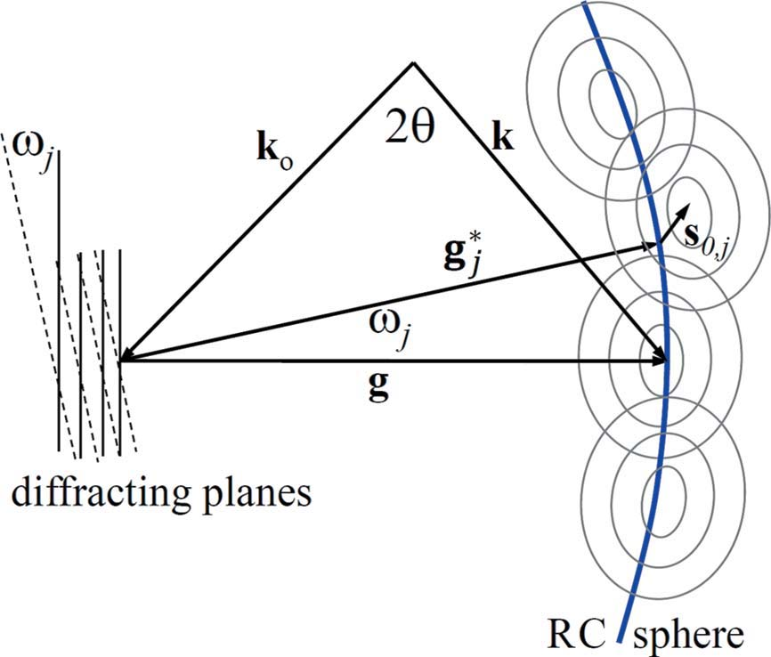Figure 1: Ewald triangle with schematic intensity distribution around the diffraction vector . and are the incident and diffracted wavevectors; is the corresponding diffraction angle. Two schematic sets of lattice planes are shown as thin parallel solid or dashed lines rotated against each other by the angle . The respective diffraction vectors are denoted as or .The intensity distributions corresponding to the rotated subregions or subgrains are indicated schematically as iso-intensity lines along the rocking-curve sphere (a solid blue line centered in the vicinity of with the radius ). The vector with no subscript could also be the average corresponding to the center of the fundamental Bragg reflection in reciprocal space. The rotated regions can be further strained relative to each other. The rotation and the strain components of the lattice distortion are shown schematically by the and vectors, respectively. [Zilahi et al. 2015]
Following up these evidences the method of polar-decomposition [Higham 1986] is applied to separate the effect of deformation into stretching and rigid-body rotation which finally allows decomposing diffraction peak broadening into line profiles and rocking curves, parallel and perpendicular to the diffraction vectors, respectively. It will be shown that separating diffraction peak broadening into RCB and LB can be connected to the concept of dividing the total dislocation density into the sum of geometrically necessary and redundant dislocation densities. The theoretical results will be discussed in terms of experiments on single crystals or synchrotron experiments on single grains in bulk polycrystalline specimens [Zilahi et al. 2015].
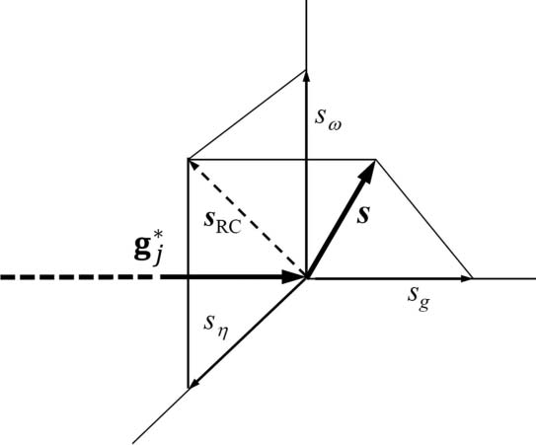
Figure 2: Schematic drawing and notations of the components of the vector in the reciprocal coordinate system around the tip of the vector.[Zilahi et al. 2015]

A uniform theory for the description of line-broadening and rocking-curves [Zilahi et al. 2015]

Separating the shape function from the density function of a crystal
At first, the effect of size and strain on diffraction patterns is described assuming that the specimen is a large imperfect single crystal. Despite assuming a large single crystal kinematical scattering theory is applied since it is further presumed that the crystal contains lattice defects in large enough density for no dynamical scattering to be substantial. In such a specimen size effect is produced by subgrains disrupting the coherency of scattering and strain is usually produced by dislocations, chemical inhomogeneities or planar defects. The scattered amplitude, , of any radiation can be written as the Fourier transform () of the density function, , of the scattering object [James 1962]:
, (2.1)
where and are the reciprocal and direct space coordinates, respectively. In the case of X-ray scattering is the electron density of the material; for nuclear scattering of neutrons it is the spatial distribution function of the centers of atoms. For X-rays, the scattering intensity, , is proportional to the square of the absolute value of [Warren 1969]:
, (2.2)
where is the magnetic susceptibility of a vacuum, and are the charge and mass of the electron, is the distance between the specimen and the detector, and the expression in brackets with is the polarization factor. is a proportionality factor comprising the terms in front of
in the central section of the equation. Similar factors are available for neutron scattering [Bacon 1962]. In the following the scattering intensity will be given in units of the appropriate factor:
(2.3)
where and stand for multiplication and convolution, respectively. We introduce the shape function, : inside and outside the scattering object. With this notation
, (2.4)
where is the density function of scattering material extending to infinity. With this definition of , the autocorrelation of becomes:
. (2.5)
It can be shown that the autocorrelation of the shape function, , is the volume of the overlapping parts of the illuminated volume and this volume shifted by [Guinier 1963]. Since defines the non-vanishing region of the integral in (2.5) the autocorrelation of can be expressed as the integral over :
(2.6)
I would like to express the Fourier transform of the scattered intensity as the product of the autocorrelation functions of the shape and density functions, and , respectively. In Eq. 2.5 the two functions appear within the same integral. They can only be separated into separate integrals if the following homogeneity condition is fulfilled:
(2.7)
where is the illuminated volume and is an arbitrary volume inside . The smaller the can be selected, the more the homogeneity condition is fulfilled. Using the homogeneity criterion can be written as:
(2.8)
Since is the autocorrelation function of ,
(2.9)
The second integral on the right hand side is the Patterson function, , of the crystal [Patterson 1934]. With this the autocorrelation function becomes:
, (2.10)
and the scattered intensity and its Fourier transform can be written as
(2.11)
and
, (2.12)
respectively. Eq. 2.12 means that when the Patterson function is homogeneous the Fourier transform of the scattered intensity becomes the product of the autocorrelation functions of the shape and density functions.

Lattice distortion
In the following it is assumed that the crystal lattice has translational symmetry and the crystal symmetry can be well represented by a unit cell. Denoting the density distribution function within the unit cell by , can be written as:
(2.13)
where is the position of the nth unit cell and n runs over all unit cells in the crystal. With this the Patterson function becomes:
(2.14)
where the sum is over all n, m unit cell pairs. The Fourier transform of will be:
(2.15) where is the structure factor corresponding to the Bragg reflection and is the strain-profile function. Here it is assumed that lattice distortions effect the positions of the unit cells while the unit cells remain almost undistorted. A note about this assumption is added here. Assume that distortion in a copper crystal is produced by a relatively large dislocation density of . Only those unit cells which are positioned directly at the core of dislocations will be distorted substantially. For the rest of the crystal is assumed to be almost uniform. The cross-section of the dislocation core is about , where is the Burgers vector length. For copper and the volume fraction of the dislocation core material with the above dislocation density is: .
In the following, the function is elaborated. Scattered intensity provides information solely on pair-correlation of positions in the crystal. Therefore is analyzed first in the distorted crystal. can be written as:
, (2.16)
where and are the positions of the nth and mth unit-cells in the undistorted perfect crystal and and are the displacements of the nth and mth unit-cells in the distorted real crystal. can be developed around :
(2.17)
Here is a nonlocal distortion tensor and is the unity tensor. The correspondence between and the infinitesimal distortion tensor, can be given as [Wilkens 1970]:
(2.18)
Lattice distortions are considered as the superposition of stretching and rigid-body rotations. In order to separate stretching and rigid-body rotations we replace in Eq. 2.17 by a single deformation tensor :
(2.19)
where is transforming into . The tensor can be factorized into the product of the rigid-body rotation and the stretching tensors, and according to polar decomposition [Higham 1986]:
(2.20)
where has been written as . I introduce the vector for the exact Bragg position in reciprocal space corresponding to the reference lattice . There is experimental evidence that rigid-body rotation affects small regions in the material as mentioned at the beginning of this chapter before. To each such small region I define a diffraction vector, . I define the deviation vector, around each position in reciprocal space:
(2.21)
Here it is noted that the absolute values of the and vectors are and , where and are the diffraction and the exact Bragg angles and is the wavelength of the radiation, respectively. The strain-profile defined in Eq. 2.15, i.e. the function, can be written as:
(2.22)
where was replaced by . Using notations introduced above,
(2.23)
The last term is omitted since . In a similar manner as , I introduce , which is the rigid-body rotation of corresponding to . With this,
(2.24)
where the inner summation over is carried out within those regions of the material that suffered the same rigid-body rotation: . Subregions rotated against each other by rigid-body rotations are usually called subgrains. Note that subgrains corresponding to the same might be anywhere in the crystal. In other words, the th fraction of the material can consist of more than one subgrain lying apart from each other. Since and are mutual reciprocal lattices, the first exponential term in Eq. 2.24 becomes unity. The second exponential term stands for the Fourier transformation whose variable is instead of , allowing one to introduce the strain profile, , corresponding to the th subgrain as a function of :
(2.25)
The summation over can be written as times the spatial mean:
(2.26)
where is the number of atoms in the th region and the angle bracket with the subscript denotes averaging over the th region. Eq. 2.26 indicates that a diffraction experiment provides a spatial average over the illuminated region. Replacing the summation over by an integral,
(2.27)
Eq. 2.27 is a Fourier transform where and are the variables of the reciprocal and crystal space, respectively, corresponding to the th region of the crystal. The integration is carried out over the illuminated volume, , containing atoms and is the unit-cell volume. The Fourier transform of can be written as
. (2.28)
It is noted that Eq. 2.28 is similar to Eq. 2.5 of Wilkens [1970]. With this formalism the rigid-body rotations and the stretch-type deformations are separated. The lattices and the corresponding reciprocal lattices represent an ensemble of reference lattices which are rotated relative to each other by rigid-body rotations, but are distorted only by stretching not involving rigid-body rotation. The purpose of separating deformation into stretching and rigid-body rotation is to describe line broadening and rocking-curve broadening by a unified mathematical formalism.

Series expansion of the Fourier coefficients of lattice distortion
In order to describe the strain part of diffraction profiles the exponential in Eq. 2.28 can be Taylor expanded:
. (2.29)
Krivoglaz [1996] has shown that lattice defects can be sorted into three fundamental categories on the basis of the spatial dependence of their strain fields: lattice defects with (i) short-range, (ii) long-range and (iii) homogeneous strain fields. The prototypes of these lattice defect types are (a) point defects, (b) dislocations or linear defects, and (c) planar defects, e.g. twin boundaries or stacking faults. The corresponding diffraction patterns are (1) diffuse scattering or Huang scattering varying slowly in reciprocal space, (2) line broadening, and (3) peak shifts along with broadening. It is noted that neither the categorization nor the description here is complete. A more detailed discussion of lattice defect types can be found elsewhere [Macherauch et al. 1973; Krivoglaz 1996; Ungár 2008]. The categorization of lattice defect types indicates that the most important source of strain broadening is dislocations. The effect of the strain field of dislocations was discussed in detail by Krivoglaz and Ryaboshapka [1963], Wilkens [1970], Krivoglaz et al. [1983], Gaál [1984], Groma et al. [1988] and Groma [1998]. Wilkens [1970] has shown that the higher order terms in the series expansion can be approximated by a second order expression by rescaling the length dependence of the deformation field of dislocations. The fundamental steps of the rescaling procedure in the second-order term are summarized briefly.
Krivoglaz and Ryaboshapka [1963] and Krivoglaz [1996] have shown that the Taylor series of can be transformed into the exponential form
. (2.30)
Here the terms are given as a recursive expression of the moments of the deformation distribution, , where are positive integers. Since Eqs. 2.30 up to 2.38 may concern any part of the material, the index is not indicated here. The term is
, (2.31)
where is the length of the vector. Wilkens [1970] has shown that can be given as
, (2.32)
where and are the magnitude of the Burgers vector and the density of dislocations, is the contrast of dislocations depending on the relative orientation between diffraction, line and Burgers vectors, and is the effective outer cutoff radius of dislocations. The factor comprises the dependence of . The concept of the effective outer cutoff radius, , here is similar to that in the elastic stored energy of dislocations [Kocks & Scattergood 1969; Wilkens 1969]. Wilkens [1970] calculated the function and has shown that for small or large values of it has the logarithmic or hyperbolic form, respectively. For a straight parallel screw dislocations with the restrictedly random distribution, is given explicitly by Eq. A.8 of Wilkens [1970]. Inserting Eq. 2.32 into Eq. 2.31,
. (2.33)
Wilkens [1970] investigated the higher-order terms in Eq. 2.30 (see Eq. 5.9 of Wilkens [1970]) and approximated them as
. (2.34)
It has shown that depends on the contrast of dislocations and varies between about 1 and 3, as shown in Fig. 2 of Wilkens [1970]. On the basis of these considerations the sum of terms in Eq. 2.30 can be written as
. (2.35)
By defining a modified effective outer cutoff radius, , the above equation can be approximated (see Eqs. 6.2 – 6.4 of Wilkens [1970]):
. (2.36)
The right hand side has the same form as in Eq. 2.33. The only difference is the modified effective outer cutoff radius, . This means that the higher order terms in Eq. 2.30 can be approximated by the second moment of a rescaled strain distribution, :
, (2.37)
where . According to Eq. 19 of Groma [1998] the effect of the rescaling of the deformation field on can be written as
. (2.38)
The above considerations justify the assumption that the strain effect of dislocations can be well approximated by a second order term. In accordance with this, in the following the expansion in Eq. 2.29 is terminated at the second order term. However, it is noted that the separation of lattice distortion into stretching and rigid-body rotations does not impede the analysis of the stretching part by taking into account higher order terms: as, for example, done by Groma et al. [1988] and Groma [1998], where strain profile asymmetries were described by the third order term in the series expansion. Using the above formalism, the experimental second moment, , has to be rescaled as given in Eq. 2.38. For the sake of brevity in the following I shall write instead of .

Line profile and rocking curves
Using the above formalism based on the polar decomposition of deformation into stretching and rigid body rotation, the line broadening is described in the direction parallel to the vector and rocking-curve broadening along the RC sphere normal to the g vector. It is noted here that the somewhat simpler and more frequently applied decomposition of the nonlocal strain tensor by separating it into the sum of a symmetrical and an antisymmetrical tensor component does not comply with the microstructure of plastically deformed crystals. In the procedure of symmetrical–antisymmetrical decomposition, strain is decomposed into three orthogonal components: one parallel and two orthogonal to the diffraction vector of the fundamental reciprocal lattice point. This decomposition procedure assumes that the elements of the strain tensor are infinitesimal. Experiments suggest that the mutual misorientation of subgrains need not be infinitesimal. On top of that, the misorientations of adjacent subgrains can add up to larger distances over several subgrains. The most adequate description of this type of microstructure evolution is provided by polar decomposition.

Line profile or line broadening
In line with Eqs. 2.25 and 2.29, the total intensity scattered by the illuminated volume is
(2.39)
The line profile in the conventional notation is the radial intensity distribution of a diffraction peak. In an experiment, this is obtained by summing the intensities along the RC sphere around the average direction, where, as discussed before, the averaging covers the entire illuminated region, i.e. summation over both and . In the present section the radial component of the intensity distribution is discussed. The following notations are introduced: , and , where and
are unit vectors in reciprocal and crystal space, respectively, both parallel to , and . The radial intensity distribution, , i.e. the line profile, is obtained by adding up the radial intensity distributions of the subgrain intensities, , where is the radial component of the vector corresponding to the th subgrain. Note that was introduced before and is shown schematically in Fig. 2. With these notations,
(2.40)
where it is assumed that . The summation is equivalent to averaging over the entire illuminated region, which is indicated by angle brackets without the index outside the brackets:
, (2.41)
where is the number of atoms corresponding to the total illuminated volume. As discussed before, the most important types of lattice defects producing substantial lattice strains but no change in the average lattice constant are dislocations. In accordance with the classification of strains with different length scales given by Macherauch et al. [1973], I shall call these strains micro-strains. At this point the anharmonic effect of dislocations is neglected. Alternatively, in an absolutely general case, the , , , , and lattice parameters of the lattice, in the illuminated volume of the crystal, can always be defined in such a manner that :
(2.42)
Transforming back into the exponential form and denoting the Fourier transform as ,
. (2.43)
The expression no longer depends on , but only on . It is usually called the mean-square strain and is denoted as [Warren 1969; Wilkens 1970; Krivoglaz 1996]:
. (2.44)
Eq. 2.44 is the fundamental equation of diffraction line broadening. A more detailed elaboration of the mean-square strain for dislocated crystals, outlined briefly in section 2.1.3, is given by Krivoglaz and Ryaboshapka [1963], Wilkens [1970], Groma et al. [1988], Groma [1998] and Borbély and Groma [2001].

Rocking-curve broadening
The RC is the intensity distribution that can be obtained when, for example, an open detector is positioned in the direction of an Bragg reflection and the single crystal specimen is turned for this reflection around axes perpendicular to . These directions are denoted as and in Fig. 2. In the case of a texture-free polycrystalline or powder specimen, especially when many grains are illuminated simultaneously by the beam, the RC of any Bragg reflection would be . Recently, however, with very fine X-ray beams at a synchrotron, it has become possible to readily measure RCs corresponding to individual crystallites even in polycrystalline specimens [Barabash et al. 2003; Jakobsen et al. 2006; Jensen et al. 2006; Levine et al. 2006; Oddershede et al. 2010; Lienert et al. 2017]. One of these methods is developed within the framework of the current PhD research for analyzing dislocation structure of single grains in polycrystalline aggregates. It will be presented in detail in the next chapters [Ungár et al. 2014].
Starting from Eq. 2.29 I describe the RC of the th subregion. The same transformations are carried out as in the case of line profiles in the previous section. Transforming back into the exponential form as in Eq. 2.43 and introducing the vector , the projection of the vector onto the plane normal to , gives
. (2.45)
The first exponential produces a shift, , in the Fourier transform of :
, (2.46)
where the subscript/superscript indicates the vector components normal to . By introducing the shear component of the mean-square strain within the th region, , one can write Eq. 2.46 as
. (2.47)
By taking into account the fact that the th subpeaks are shifted by , the total scattering intensity, , can be written as
(2.48)
In a dislocated crystal the major contribution to the RC is produced by the twists and tilts caused by dislocations [Wilkens et al. 1987]. Therefore the RCB is mainly determined by the rotations. The mean square rotation of subgrains, , can be defined by the angle between and , i.e. , and can be written as
(2.49)
Eqs. 2.47 and 2.49 can be considered as the fundamental expressions for RCB. Experimental evidence shows that RCs can disintegrate into more than one or several subpeaks [Barabash et al. 2003; Nyilas et al. 2004; Levine et al. 2006; Jakobsen et al. 2007]. In such cases, one single mean square rotation value may not be sufficient for fully characterizing the shape of RCs. Specific dislocation models need to be developed to connect RCB with the substructure of the crystal, as was done, for example, by Wilkens et al. [1987] and Barabash and Klimanek [1999], and as is discussed briefly in the next section.

Correlation between rocking-curve broadening and the geometrically necessary dislocation density
The total dislocation density, , is often divided into geometrically necessary, , and redundant,, densities, where [Hughes & Hansen 1993, 2000; Barabash et al. 2001, 2009]. Typical examples for geometrically necessary dislocations (GNDs) are small-angle grain boundaries or interface dislocations aligned along phase boundaries, e.g. in Ni-based monocrystalline superalloys [Gao 1991; Kuhn et al. 1991; Pollock & Argon 1992; Zhang & Purdy 1993; Vattré & Demkowicz 2013], or between regions of strongly different dislocation densities, e.g. dislocation cells [Mughrabi 1983; Mughrabi et al. 1986].
GNDs are unpaired dislocations separating two regions in a crystal that are tilted or twisted against each other. The idea of GNDs was suggested by Nye [1953] and further developed by Ashby [1970]. Nye’s dislocation density tensor can be defined as a line integral along all dislocation lines within a reference volume [Arsenlis & Parks 1999]:
(2.50)
where and are elements of the Burgers vectors and the unit vectors parallel to the line vector of dislocations and the integration is carried out along the total length, , of the dislocation lines in the volume element . Dislocation loops entirely residing within do not contribute to [Nye 1953; Arsenlis & Parks 1999]. The nonvanishing part of is the dislocation density tensor corresponding to the geometrically necessary fraction, , of the total dislocation density related to the reference volume . This definition makes it clear that the density of GNDs is always related to a reference volume. The vector form of Eq. 2.50 is
(2.51)
where stands for dyadic product. For certain dislocation type, , of one specific Burgers vector,
(2.52)
where the integration is only along the -type dislocations and is the dislocation density of the -type dislocations in the volume element. The total Nye tensor is the sum of all the tensors:
. (2.53)
If is zero for the reference volume, then all dislocations are redundant. The nonvanishing value of provides the GND density, , for the reference volume .
For the interpretation of the rotation part of the distortion tensor, , in terms of GNDs, a simple model, similar to the approach taken in Fig. 1 of Huang et al. [2008] or by Barabash and Klimanek [1999], is conceived in Fig. 3. The total tilt produced by the six dislocations is . The simple geometry based on Fig. 3 provides
, (2.54)
where is the size of the tilted regions. In determining the GND density the value of is crucial. In the recently developed technique of EBSD imaging the local lattice orientation is measured with high spatial resolution along the specimen surface, cf. [Field et al. 2005; Zaefferer et al. 2008]. The diameter of the reference volume is the distance between two sampling positions, as shown schematically in Fig. 1 of Pantleon [2008]. The spatial orientation distribution can be converted into a GND distribution map, as shown in Fig. 2 of Field et al. [2005] for two Al samples deformed in different modes. Considering the material surrounded by the heavy black line in Fig. 3 a), the RC of such a grain would be wide. An EBSD scan, with the step size , of such a virtual sample would provide the density for as defined in Eq. 2.54. RCB can only provide the same value for if the grain size, , is known. Fig. 3 b) shows another typical arrangement of possible tilting where the first tilted regions, the ones in Fig. 3 a), are tilted back by dislocations of opposite sign. For this type of dislocation arrangement an EBSD scan with the step size would provide the same as for the case in Fig. 3 a). The RC, however, for the grain in Fig. 3 b) is identical to that for the grain in Fig. 3 a). Therefore, an attempt to determine from the RC breadth with the new grain size would provide half of the previous value. This simple example shows that RCs alone cannot give unambiguous values for GNDs unless there are reliable data for the size of the tilted or twisted regions. More rigorous treatments of the relations in Eq. 2.54 would be possible on the basis of descriptions by Arsenlis and Parks [1999] and Pantleon [2008].
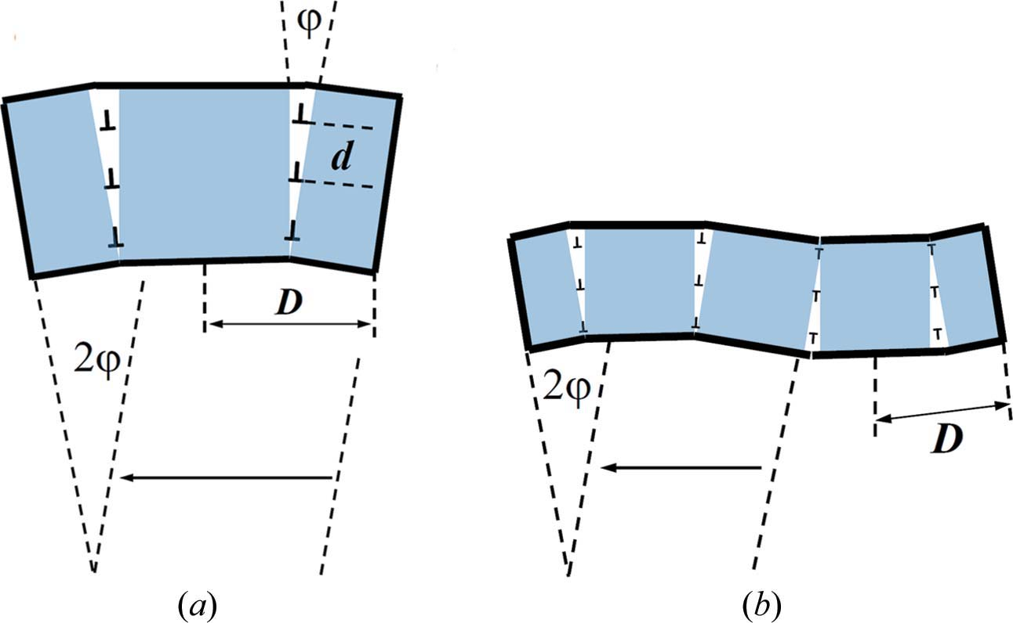
Figure 3: Two simple and representatively different schematic arrangements of GNDs for the interpretation of rocking-curve broadening. a) Six GNDs of the same sign arranged as dislocation walls. The total tilt produced in a grain of 2D diameter is . b) The tilt and the GND density are the same as in a) but the crystal size is 4D and the dislocations are of alternating signs.[Zilahi et al. 2015]
Eq. 2.54 can also be rationalized in the following manner. According to the definition of GNDs in Nye’s dislocation density tensor, if all dislocations of a total density of are unpaired, as shown schematically in Fig. 3 a), then the size of the whole crystal can be written as
, (2.55)
where the subscript RC indicates that this size value was obtained from the RC broadening, . can be called the average length of lattice curvature. It is the length in the crystal along which can bend the crystal to , provided that all dislocations are GNDs of the same sign. For this dislocation arrangement the sizes of the subgrains, i.e. the sizes of the rigid-body-rotated regions of the crystal, , are smaller than , and
. (2.56)
In the Taylor lattice of edge dislocations, all dislocations are redundant dipoles and there are no rotated parts of the crystal. Therefore, the broadening of the RC is small and the RCB and LB are of the same order of magnitude. The value of can be considerably smaller than the size of the crystal, , assuming that the entire crystal is a single subgrain:
(2.57)
The ratio in Eqs. 2.56 and 2.57 provides qualitative information about the arrangement of dislocations in terms of the relation between GNDs and redundant dislocations in the same crystal. The above inequalities are discussed in the next section for experimental cases where RCs and LPs were determined in the same crystals.

Relation between line broadening and RC broadening
The LB summarized in Eq. 2.44 is directly related to the dispersion of atomic distances, whereas the RCB described in Eqs. 2.47 to 2.49 depends on the misorientation between regions in the crystal. The misoriented regions are denoted consequently and throughout the theoretical description as th regions of the specimen. In dislocated crystals and in the literature of plastic deformation these regions are usually called subgrains. Intuition suggests that LB requires a larger total enthalpy increment of the crystal than the same RCB. Therefore, scaled in reciprocal space units, LB is expected to be smaller than RCB, in correlation with theoretical considerations about subgrain misorientations [Galindo-Nava & del-Castillo 2012]. A number of experiments prove this behavior of the scattering intensity where the two broadening effects were measured at the same specimen. In the following, a few of the most relevant and important experimental results are reviewed that support the theoretical considerations in sections 2.1 and 2.2.

Tensile-deformed copper single crystals
Line profiles and rocking curves were measured on the same [001]-oriented and tensile-deformed Cu single crystal by Ungár et al. [1984] and Wilkens et al. [1987]. The essence of the results is summarized in Fig. 4. TEM micrographs were taken on specimen sections parallel (side view) and perpendicular (axial view) to the tensile axis [Mughrabi et al. 1986]. The axial view, shown in Fig. 4 a), indicates that the dislocation cells form cell blocks. Block formation of dislocation cells was also observed, cf. in Ni [Hughes & Hansen 1993, 2000], Ni–Co [Hughes & Nix 1989] or cyclically deformed Cu [Zhang & Jiang 2005]. Within the blocks the adjacent dislocation cells are almost of the same crystal orientation, whereas the cell blocks are tilted or twisted by a few tenths to one or two degrees. The RCs in Fig. 4 b) show that the net average misorientations measured as the Full Width at Half Maximum (FWHM) in the axial and side sections of the [001] Cu crystal, i.e. after tensile deformation to shear deformation, are about 0.8(1)° and 1.6(1)°, respectively. The FWHM values of the RCB, , for the two RCs and the LB, , are , and , respectively. The same breadth data scaled in reciprocal space coordinate values are , and , respectively. The ratios of the RCB and LB for axial and side sections are 12(2) and 24(3), respectively. The average total dislocation density, , was obtained by the Wilkens [1970] theory: [Ungár et al. 1984]. Lower and upper bounds for the GND density, , can be given according to Eq. 2.56 by determining from the TEM micrograph in Fig. 4 a). For the average dislocation, the cell or cell-block size or , respectively. From this the lower and upper bounds for GNDs are . The lower and upper bounds for the ratio of redundant to GND dislocation densities are
. (2.58)
On the basis of the composite model of long-range internal stresses, Mughrabi [2006] evaluated the GND density , where the superscript indicates that this GND density is related to the long-range internal stresses. Assuming a subgrain size of , the GND density was obtained to be : see (ii) below Eq. 14 of Mughrabi [2006]. The value of is within the lower and upper bounds given above, but much closer to the lower bound, the value obtained from the size of the cell blocks, i.e. . The GND densities obtained as the lower bound from the RC with the cell-block size or from the long-range internal stresses with the average dislocation cell size are in good correlation with the TEM micrograph in Fig. 4 a). The TEM image shows that the characteristic length scale of crystal misorientations is the size of the cell blocks, i.e. about . The length scale, however, for the heterogeneity of the dislocation distribution, the basis for the long-range internal stresses in the composite model, is the dislocation cell size, i.e. about . The two dislocation types, i.e. the ones causing lattice rotations and those producing the long-range internal stresses, are both of GND type. Since, however, they play different roles in the substructure of the material the corresponding densities need not be the same.
Figure 4: a) TEM micrograph of the dislocation cell structure in a [001]-oriented Cu single crystal tensile deformed up to = 75.6 MPa resolved shear stress [Mughrabi et al. 1986]. b) Rocking curves measured on the same tensile deformed Cu single crystal, once with the tensile axis in the plane of incidence of the X-ray beam (the narrower RC) and once with the tensile axis normal to the plane of incidence of the X-ray beam (the wider RC) [Wilkens et al. 1987]. c) Line profiles of [001]-oriented Cu single crystals tensile deformed to different resolved shear stress values [Ungár et al. 1984].

Compression-deformed Ge single crystals
RCs and LPs of the 331 reflection were measured on Ge single crystals oriented for single slip and compression deformed at 850 K [Nyilas et al. 2004, 2010]. The imaging plate micrographs and the reciprocal space mapping image are shown in Fig. 5. The FWHM values of the RCs, , and LPs, , in the central and lower parts of the specimen as indicated in Fig. 5 e) are , and , , respectively. The average total dislocation density, , was obtained by using the CMWP procedure [Ribárik & Ungár 2010]: and [Nyilas et al. 2004, 2010]. The value of for the GNDs is estimated on the basis of TEM micrographs [Dupas et al. 2002] as . From this and . The ratio of redundant to GND dislocations becomes
and . (2.59)
The dislocation mechanism occurring in the compression deformed Ge specimen is shown schematically in Fig. 5 e). Though friction was almost eliminated by applying thin teflon plates between the compression platens and the specimen surfaces, the specimens barreled along the sides given by the active single slip direction, as indicated schematically in Fig. 5 e). Slip traces on the barreled surfaces indicated that a considerable quantity of edge-type dislocations are gliding out of the crystal. This cannot happen on the surfaces directly in touch with the compression platens of the testing machine. As a consequence, in the lower and upper parts of the specimen those ends of the slip planes ending at the compression platens keep the plane orientation, whereas the ones ending at the free surfaces are curved as half of the dislocation loop exits from the specimen. In the central part of the crystal the surfaces at the opposite ends of the slip planes are symmetrical and edge type dislocations leave the crystal at both ends. Here the slip plane orientations rotate almost uniformly throughout the entire slip plane. The schematic model explains qualitatively the larger RCB and the larger total dislocation density in the regions closer to the compression platens of the testing machine. The GND densities have to be considered as estimated values because of the uncertainty in the values obtained from TEM images.
Figure 5: RCs of Ge single crystals oriented for single slip and 10% compression deformed at 850 K. Color coded a) and c) or iso intensity lines b) and d) of different reflections. a) and b) correspond to the center region, while c) and d) were measured close to the compression platens in the specimen. e) Schematic graph of dislocation slip in the center and upper/lower regions of the crystal.[Zilahi et al. 2015]

Tensile-deformed CoTi alloy
A novel synchrotron-based technique presented in chapter 3 in detail is developed within the framework of the current PhD research for grain by grain assessment of dislocation densities, slip modes (SM) and slip systems (SS) within bulk polycrystalline materials [Ungár et al. 2014]. Three-dimensional diffraction data were obtained from single grains in bulk polycrystals using high energy synchrotron radiation and two dimensional detectors for the measurement of CoTi and CoZr intermetallics of B2 structure. See chapter 4 for the details of the experiment. Large number of single crystal Bragg reflections were measured in all three directions of reciprocal space with signed indices corresponding to a large number of single grains. The thin rod-like specimen was rotated around the angle in step-by-step mode by , over a range of , and at each step the detector images were saved. The thickness of the specimen and the beam size were adjusted to have well separated single crystal diffraction spots on each detector frame. The scattered radiation was recorded by a GE high-resolution fast amorphous Si detector at a distance of 1.838 mm from the specimen. The relatively long distance from the specimen was selected for having a good enough angular resolution for line profile analysis. The reflection of the #17 grain in the CoTi specimen was selected to analyze the three dimensional intensity distribution. Twelve frames are shown in Fig. 6 a). Note that the intensity scale is logarithmic and for the sake of saving space not all consecutive frames are shown from to . The RCs are elongated along the Debye–Scherrer ring denoted as the direction in reciprocal space. In the theoretical derivations in sections 2.1 and 2.2 it was shown that the shear components of the mean square strain spread the scattering intensity along a plane surface perpendicular to the vectors. However, the rotation components of the non-local distortion tensor, i.e. in Eq. 2.17, scatter the intensity along a spherical surface of radius . The diffraction images in Fig. 6 a) and Figs. 20 and 21 in chapter 4 show clearly that the peaks are broadened along spheres rather than planes. This shows that RCB is caused primarily by local rotations which cannot be considered infinitesimally small, in perfect correlation with separating into rotations and stretching. The generally applied procedure to calculate LPs by integrating the scattering intensity along the RC sphere cf. [Wilkens 1970; Groma 1998] is fully supported by both (i) the structure of and (ii) the fact that the effect of rotations is considerably larger than that of shear.
Accordingly, the LP was obtained by integrating the scattering intensity along and , as shown in Fig. 6 b). The iso intensity lines of the – intensity distribution, which is the two dimensional image of the RC, are shown in logarithmic scale in Fig. 6 c). The FWHM of the RC is about in both the and directions. The ratio of the FWHM values of the RCs and the LP is about 35. The total dislocation density of grain #17 in CoTi was obtained by the CMWP procedure [Ribárik & Ungár 2010]: [Ungár et al. 2014]. The lower and upper bounds of in Eq. 2.54 can be taken as the subgrain size and the grain size, which are 200 nm and 30 μm, respectively [Ungár et al. 2014]. With these values the lower and upper bounds of are
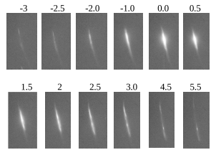 a)

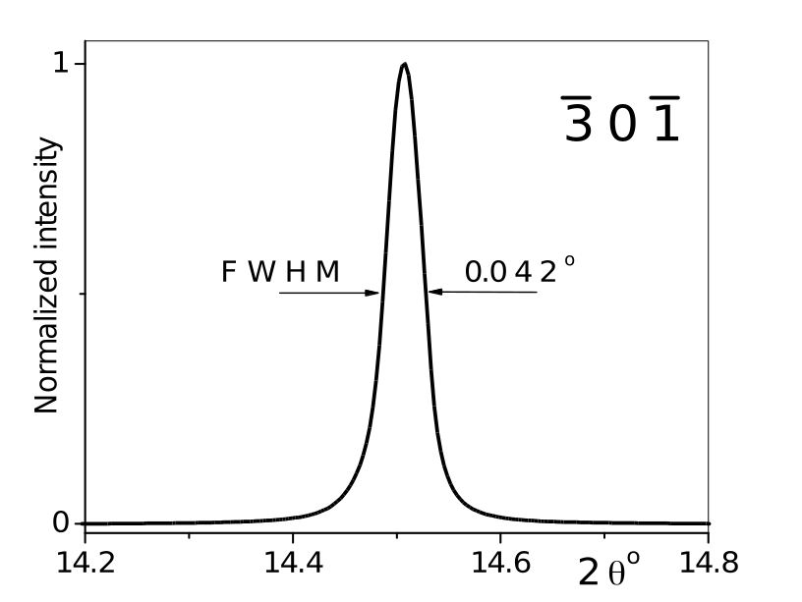
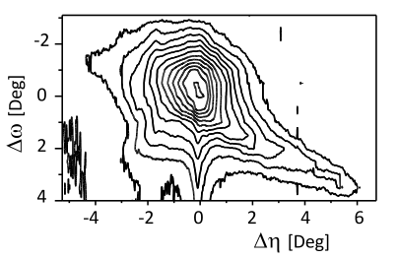 Figure 6: Typical frames a), line profile b) and iso intensity lines c) of the RC on the – surface corresponding to the reflection of a particular single grain (#17) in a bulk polycrystalline CoTi specimen 2% tensile deformed. a) Twelve frames with logarithmic intensity scale; note that not all consecutive frames are shown between and . c) The iso intensity lines are in logarithmic scale in arbitrary units from 5 to 1500 in steps of factor 1.6 [Zilahi et al. 2015].
b)
c)
. (2.60)
The upper bound is larger than the total dislocation density, which is not possible, cf. [Pantleon 2008]. This means that the value must be larger than the average subgrain size.
The values of the ratio in Eqs. 2.56 and 2.57 were evaluated for the crystals discussed above and are summarized in Table 1. For tensile deformed Cu and compression deformed Ge the ratio is smaller than unity, indicating that the majority of dislocations are redundant dipoles. This result is in good correlation with TEM observations of cell-forming materials, where the overwhelming part of the dislocations reside within cell walls consisting of redundant dislocation dipoles, cf. [Mughrabi 1983; Hughes & Hansen 1993; Zhang & Jiang 2005]. TEM micrographs of the dislocation structure in compressed Ge show also that the dislocations are arranged in bundles of dipoles not producing considerable tilting or twisting of the crystal [Dupas et al. 2002]. In the case of the CoTi and CoZr alloys the ratio is larger than unity, indicating that a significant fraction of the dislocations are producing lattice rotations extending to longer distances than the average dislocation distance. The TEM micrographs in Figs. 5–8 and 14 of Mulay and Agnew [2012] show that most of the dislocations, in both the CoTi and the CoZr alloy, are either unpaired or such that the dislocation dipoles are rather separated apart from each other. The dislocation arrangement in these TEM micrographs suggests that a substantial part of the dislocations might be considered to be GNDs.
crystal |  | [radians]
Cu  [001] | 2.5(±1) | 0.025(±0.01) | 280(±110) | 3.5(±0.2) | 0.11(±0.09)
Ge  (lower part) | 0.3(±0.1) | 0.02(±0.006) | 125(±40) | 4(±1) | 0.42(±0.26)
Ge  (center part) | 0.3(±0.1) | 5.6×10⁻³  (±1.5×10⁻³) | 47(±13) | 3(±0.8) | 0.16(±0.09)
-
CoTi  Gr-#9 | 0.35(±0.1) | 8.8×10⁻³  (±2×10⁻³) | 1100(±250) | 0.27(±0.05) | 3.1(±1.6)
CoTi  Gr-#17 | 0.16(±0.03) | 0.025(±0.01) | 460(±185) | 1.8(±0.4) | 2.9(±1.7)
CoZr  Gr-#n2/2 | 0.23(±0.04) | 0.026(±0.01) | 800(±300) | 1.0(±0.2) | 3.5(±2)
CoZr  Gr-#n1/1 | 0.22(±0.04) | 0.037(±0.015) | 570(±230) | 2.0(±0.4) | 2.6(±1.5)
Table 1: The average subgrain size, , the mean width of RCs, , the average length of lattice curvature, , as introduced by Eq. 2.55, the average total dislocation density, , and the ratio, , for Cu and Ge single crystals and CoTi and CoZr individual grains.[Zilahi et al. 2015]

Laue asterism
In Laue patterns each image point corresponds to the orientation of one specific set of parallel lattice planes, where the size of an image point is determined by the instrumental effect. This means that the lengthening or broadening of Laue spots, called Laue asterism, yields similar information to RCs [Chung & Ice 1999; Barabash & Ice 2014; Tamura 2014]. White beam synchrotron microdiffraction can provide the density distribution of GNDs. In Eq. 4.19 of Tamura [2014] it was shown that lengthened or broadened Laue spots can be evaluated in the same manner as RCs by Eq. 2.54:
, (2.61)
where is the magnitude of the Burgers vector of dislocations, is the beam size of the X-rays and is the contrast factor, depending on the relative orientation of Burgers, line and diffraction vectors [Barabash et al. 2002]. A scanning technique using a white beam synchrotron microbeam for determining Laue asterism can provide the spatial distribution of misorientations and , as shown in Fig. 3 of Magid et al. [2004] and Fig. 4.8 of Tamura [2014], respectively. The density of GNDs in Fig. 4.8 of Tamura [2014] is scaled between zero and .

GNDs from lattice rotations in microbeam Laue asterism
Microbeam Laue asterism was measured in the vicinity of iridium welds [Barabash et al. 2003]. The Laue spots were simulated by assuming the presence of unpaired parallel edge dislocations in a single slip system. Some of the dislocations were grouped into dislocation walls and some were distributed randomly. The Laue spots were broadening along specific directions, also called streaking. It was shown that the direction of streaking depends on the relative orientation of Burgers, line and diffraction vectors. The dislocation structure was tuned for matching between the Laue patterns and the simulated intensity distributions, as shown in Figs. 6 and 7 of [Barabash et al. 2003].

Direct observation of stretching and rotations of subgrains in diffraction experiments
The rigid body rotated regions of the crystal are the subgrains or, in cell-forming materials like, for example, copper or stainless steel, the dislocation cells [Mughrabi 1983]. The strains between subgrains or dislocation cells and cell walls are the basis for the long range internal stresses in the composite model of Mughrabi [1983] and Mughrabi et al. [1986]. Jakobsen et al. [2006], Jakobsen et al. [2007] and Levine et al. [2006] carried out high resolution synchrotron experiments on plastically deformed copper. The extremely enlarged image of one of the reflections corresponding to a single grain revealed sharp diffraction maxima of several subgrains. The radial positions of these subgrain reflections are plotted in Fig. 7 of Jakobsen et al. [2007]. The figure shows that (i) the positions of the subgrains scatter beyond the experimental error, (ii) the average of the positions is above the median of the entire peak and (iii) there are several subgrains with the same position. Observation (ii) is a direct support of Mughrabi’s composite model [Mughrabi 1983] for asymmetric line broadening [Ungár et al. 1984; Mughrabi et al. 1986] and long range internal stresses in materials with dislocation-cell structures [Mughrabi et al. 1986]. The local strains in the subgrains, as pointed out in Mughrabi’s composite model [Mughrabi 1983], are produced by stresses exerted on each other by the cell-interior and cell-wall regions. Groma et al. [1988] and Groma [1998] pointed out that these stresses are the consequence of the net dipole polarization of heterogeneously distributed dislocation structures. There is ample evidence for the fluctuating nature of both the size of subgrains and the dislocation structure of the cell walls separating them, cf. [Mughrabi et al. 1986; Sevillano & Aernoudt 1987; Hughes & Hansen 1993; Estrin et al. 1998; Huang et al. 2001; Gan et al. 2002; Jakobsen et al. 2006; Huang & Winther 2007; Mayama et al. 2008; Landau et al. 2011; Galindo-Nava & del-Castillo 2012]. It is obvious from both the experimental evidence and the theoretical concepts of heterogeneous dislocation distributions that the strains prevailing in subgrains must fluctuate, as it was shown in Fig. 2 of Levine et al. [2006] and in Fig. 7 of Jakobsen et al. [2007] and pointed out in a note of Mughrabi [2006]. This fluctuation means that need not be zero, as was discussed in detail in relation to Eq. 2.46. However, when averaging is carried out over the entire crystal, the shifts add up to zero, i.e. . This latter property was used in deriving the line broadening in Eq. 2.42 from Eq. 2.41.

Tracing reciprocal space in 3D
Strain anisotropy in X-ray diffraction has proven to be a powerful method to determine slip systems (SSs) at the average level in polycrystalline materials [Klimanek & Kužel 1988; Kužel & Klimanek 1988; Ungár & Borbély 1996; Ungár et al. 1999; Dragomir & Ungár 2002]. If slip systems with different Burgers vectors of different lattice vector types are conceivable, as, for example, in orthorhombic or hexagonal materials (chapter 5) or in intermetallics like the B2 structure (chapter 4), averaging over the different Burgers vector types or over the different grain orientations mixes up contributions from the different SS types in the same Bragg reflections. Therefore, powder diffraction methods are not suitable to determine the different prevalent SSs and their corresponding dislocation densities, especially when the SSs are of different types, as in orthorhombic or hexagonal materials, or in intermetallics like the B2 structure. Any reasonable characterization of the prevalent SSs and their dislocation densities in such types of material can only be done at the grain level, for which powder diffraction is not suitable.
In the past few years a novel synchrotron method has been developed for determining the substructure in single grains of polycrystalline aggregates in terms of SSs, dislocation densities and twinning [Ungár et al. 2010; Ribárik & Ungár 2010; Nisr et al. 2012; Lienert et al. 2017]. As a basis for the current thesis, the evaluation procedure for this novel X-ray diffraction method has been further improved in several ways and applied for plastically deformed polycrystalline CoTi, CoZr [Ungár et al. 2014] and Mg [Zilahi et al. 2017b] specimens. This chapter presents the experimental setup for the X-ray diffraction measurement and the evaluation steps.

Experimental setup
The method is based on the synchrotron procedure developed jointly by the Danish Risø group of material science and the beam-line scientists of ID11 at the ESRF synchrotron in Grenoble to determine the single grain structure, grain orientation and grain shape in polycrystalline aggregates [Lauridsen et al. 2001; Poulsen et al. 2001; Poulsen 2004; Jensen et al. 2006; Sørensen Henning et al. 2011]. A thin tapered needle shaped specimen is mounted in a one-axis goniometer and rotated around the needle axis by an angle while illuminated by a thin parallel monochromatic X-ray beam. Number of grains in the illuminated volume of the specimen can be adjusted by changing the thickness of the beam, or moving the specimen along the needle direction compared to the beam, i.e. illuminating different parts of the tapered shape specimen. Fig. 8 shows a typical specimen shape with the cross section of the beam hitting on it. In the case of mechanically deformed samples usually 50-100 grains can be measured in one run in order to avoid overlapping reflections from different grains along RC directions. The experiment can be repeated for several different parts (sections) of the same specimen, in order to increase the number of measured grains. Once the preferred section is selected, the specimen is rotated around the axis, while transmission diffraction images are taken using a 2D planar detector. One image is taken in every small turn. Usually . During rotation, reflections of single crystals of the specimen appear and disappear on the detector images, as lattice planes are turning into and out of the ideal Bragg angle compared to the incident beam, depending on the , X-ray wavelength and the distance between neighboring lattice planes. If a large enough number of images with a large enough number of reflection positions are available, it is possible to identify and index certain groups of reflections, with each of these reflection groups corresponding to different grains in the specimen. At a specific orientation of the specimen, the detector takes an image of a two dimensional section of the reciprocal space. By scanning the , a large portion of the 3 dimensional reciprocal space can be probed, therefore the method is commonly called 3 Dimensional X-Ray Diffraction (3D-XRD).
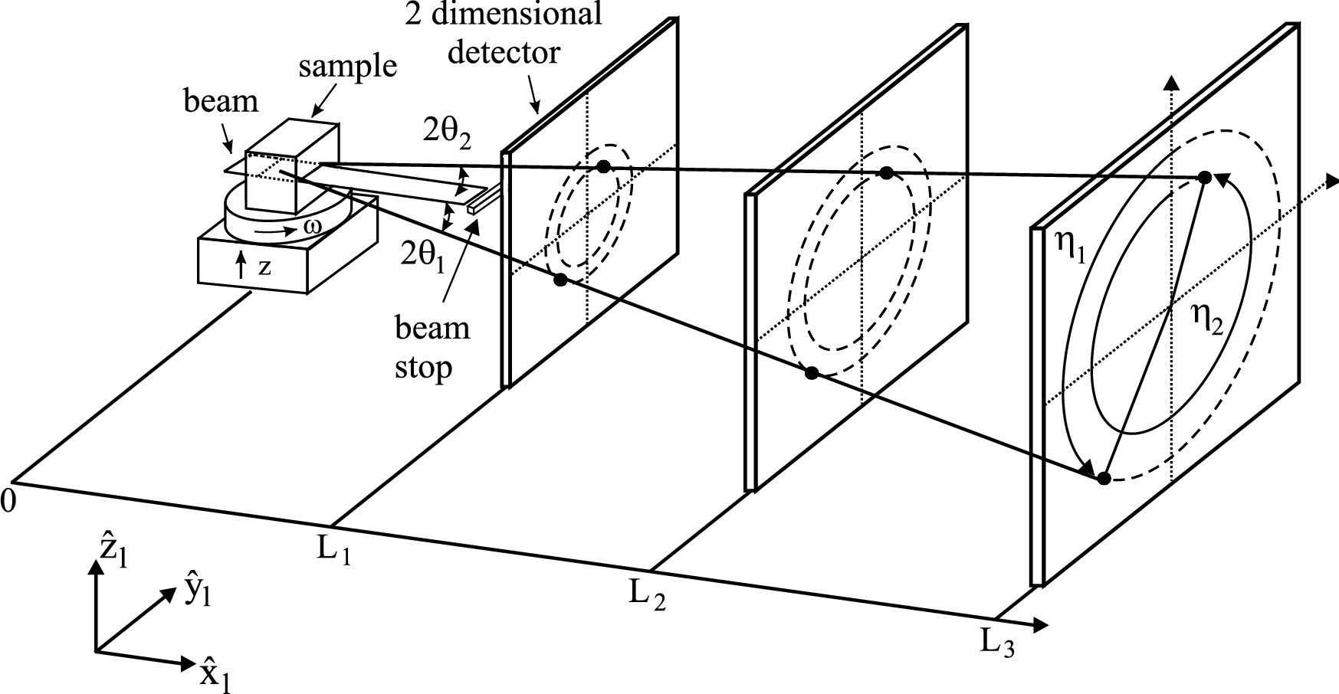
Recently it has been shown by the group of Ungár [Ribárik & Ungár 2010; Ungár et al. 2010; Nisr et al. 2012] that, by increasing the angular resolution of the 3D-XRD experiment, line profile analysis can be done by using the groups of single crystal diffraction peaks. High angular resolution is achieved by a large sample to detector distance. To cover sufficiently large portions of reciprocal space, either i) the detector is moved to several different positions, and in each position the measurement with a full turn is repeated, or ii) a detector array of four detectors is used to measure four different detector positions at the same time [Alvarez et al. 2016]. Fig. 9 shows two possible detector arrangements for line profile measurement. Since the data are obtained from individual crystals in a polycrystalline aggregate, no assumptions are necessary concerning the sample textures, i.e. randomness, that are typically employed in powder diffraction. Instead, composition of the dislocation structure i.e. densities and ratios of different types of dislocations has to be determined based on the measured strain broadening contrast of different reflections. For this purpose, a new Monte-Carlo type fitting algorithm has been developed, that will be presented in section 3.2.10.
Figure 7: Original setup as published by Lauridsen et al. [2001] .
Once, partial densities of different dislocation types have been determined, the prevalent slip-systems might be analyzed. This data is comparable to that one can obtain from TEM or EBSD based dislocation analysis [Mulay & Agnew 2012; Ungár et al. 2014]. The results from different experimental techniques can well complement each other to obtain a more complete image of the dislocation structure of polyrcystalline materials. While TEM can provide a very detailed image of microstructure on the level of individual dislocations, only a small piece of material can be analyzed in ten to few hundred nanometers thin slices. It is impractical to analyze more than a few grains, and hard to obtain quantitative values for dislocation densities from a volume, which is statistically representative for the macroscopic volume of a bulk specimen. In EBSD, large number of grains can be scanned, and GND densities can be obtained as discussed in 2.2.3, however, only a 2D section of the grains are analyzed, and the connection between GND and total dislocation densities are not well known for the most cases. The present synchrotron based method provides information about the total dislocation densities of different dislocation types in the entire volume of single grains of a polycrystalline specimen, and several hundred grains can be analyzed in one experiment.
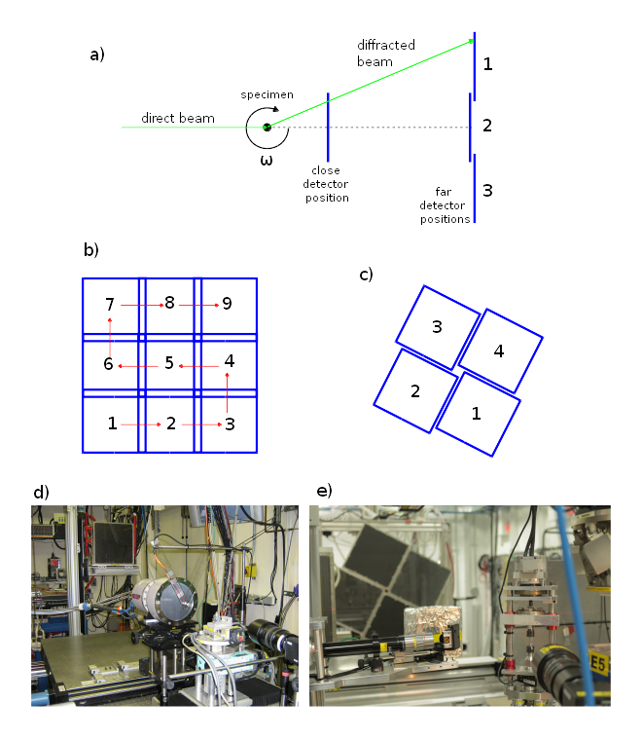Figure 9: a) Several different detector positions are used at far distance in order to cover approximately the same spatial angle as the close detector. Either one detector is moved to several adjacent positions (b), or a detector array is used to measure more than one detector positions at the same time (c). Fig. d) and e) are photographs of the experimental setup using one single far detector and an array of four far detectors respectively.
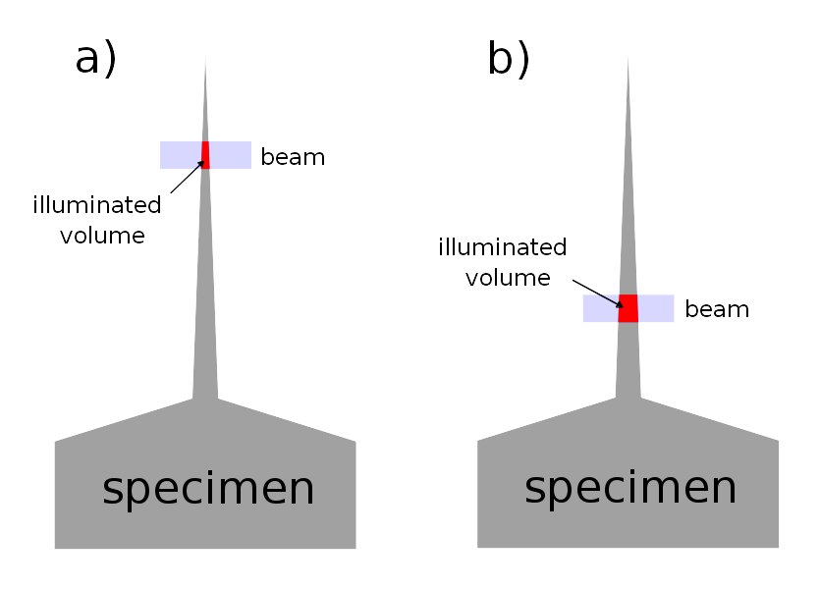Figure 8: Typical shape of the specimen. The thick base is for holding it in the goniometer. Thin needle is for X-ray diffraction. Tapered shape allow us to adjust the size of the illuminated volume by moving the specimen along needle direction compared to the beam, thus optimal number of illuminated grains can be set.

Evaluation procedure
In a 3D-XRD experiment, during one full turn usually several hundred images (frames) are taken in one detector position. In the case of a high resolution measurement for line profile analysis usually 5 to 8 different detector positions are recorded including one close detector position. Measurement is normally repeated for several sections of the same specimen. Altogether, few times ten thousand images are recorded for one specimen, that makes a few hundred gigabytes of data. The total number of measured single crystal reflections is in the order of . Highly automated tools are absolutely essential for dealing with such amount of data. During my PhD research, I learned how to use several elements of the FABLE workbench [Sørensen Henning et al. 2011] for analyzing 3D-XRD data, as well as I made several additional tools both for making evaluation of data from multiple detector setup more automatic and for the purpose of microstructure analysis. In Fig. 10 a flow chart shows the steps of the evaluation procedure starting from the raw detector images and experimental parameters to the determination of the dislocation structure of single grains. In the following sections, these evaluation steps will be presented. Regarding the laboratory, sample and crystal coordinate systems, the same convention is used as defined in chapter 3.2 of Poulsen [2004] unless otherwise stated, which is the convention generally used by FABLE software. See also Fig. 7 for the basic laboratory directions and angles, and the FABLE documentation for more details.

Peaksearch
Identifying diffraction peaks on detector images is done by using the peakserch.py script of ImageD11 software [Wright 2005-2016], which is part of the FABLE workbench. The peaksearch software runs on a set of detector images corresponding to subsequent orientations of the specimen. The program identifies areas, where the intensity is larger than a given threshold. Such areas of connected pixels are interpreted as diffraction spots, and listed in the output files with their , pixel and , rotation coordinates. Multiple thresholds can be given, the software runs the peaksearch for each one, and writes the results in separate output files. Fig. 11 shows an example of the raw identified peaks on a detector image. The peaksearch software is capable of merging spots that appear on subsequent images at an overlapping area, and calculates several statistical properties of the spots, e.g. the values and the positions of the maximum intensity pixel, center of mass positions, integrated intensities, number of pixels in the spot, and limits, etc. This information might be useful to filter the result for false spots, that can result from bad detector pixels, statistical noise, locally high background or artifacts near overexposed peaks. See Fig. 12 for examples. Using built-in options, it is possible to correct images for (i) dark background, (ii) geometric distortion, (iii) variation of sensitivity among detector pixels, (iv) changes of beam intensity during measurement, before identifying peaks. Peaksearch documentation is packaged with the graphical user interface (GUI) of FABLE workbench, or it can be found online, and user can get the available command line options by typing “peaksearch.py --help” in the terminal as well.

Figure 10: Flow chart of the evaluation process.
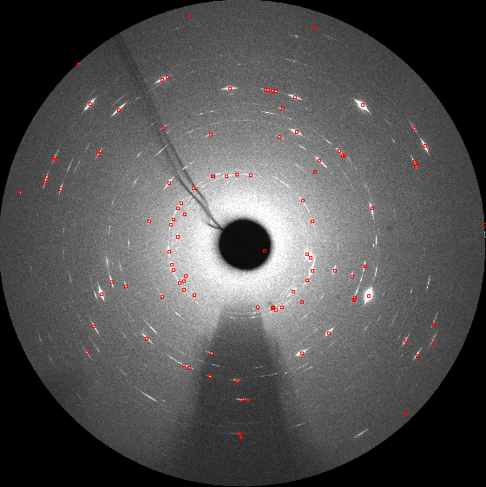Figure 11: An example output of peaksearch.py.
Diffraction vectors
Detector
images
Search for peaks on
far detectors
Search for peaks on
close detector
Peak positions in close
detector coordinates
Peak positions
on far detectors
Experimental
parameters:
sample orientation,
detector positions,
wavelength,
lattice parameters
Calculate diffraction vectors and
refining experimental parameters
Refining far
detector positions
Index peaks
Set of grains with orientations
and indexed reflections
Refine grains
Simulate peak positions on far detectors
Grain orientations, positions,
average stress states,
volume fractions
List of indexed peak
positions on far detectors
2θ peak profiles
Integrate peak profiles on far detectors
Checking and selecting peak profiles
Fitting single grain reflections
by CMWP
Pseudo-patterns of single
grain peak profiles
Measured contrast factors
Partial dislocation densities
of different type of dislocations
in each grain
Fitting dislocation composition
to the measured contrast factors

Techniques to improve peaksearch results
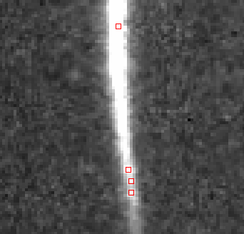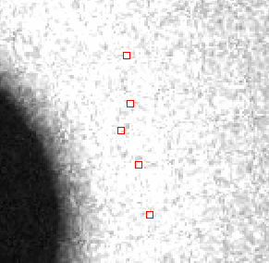a) b)

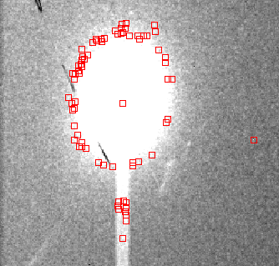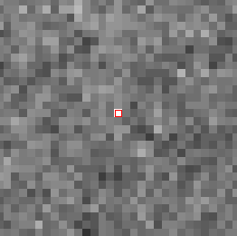c) d)

Figure 12: Examples of false false hits in peaksearch, that do not correspond to diffraction spots: a) at large background areas; b) at the slope of a diffraction peak due to statistical noise around threshold level; c) bright dead pixel on detector; d) artifacts around overexposed spot

Dark image correction
Dark images can be taken at the beamline with closed shutter, and subtracted from the images during a preprocessing, or using the built-in dark image correction in peaksearch.py. This kind of dark image is used for correcting the detector's own background level. Background image also can be produced from the series of diffraction images by calculating for example the minimum, or the median of intensity values of each detector pixel for the whole series of images recorded during turning the specimen around axis. These background image estimation procedures are based on the assumption, that during rotation of the specimen, a specific pixel or a small area of the detector gets only the background radiation from diffuse scattering most of the time, and there are only a few images, where diffraction spots occur at that specific point. From ImageD11, bgmaker.py can calculate the minimum values of pixels for image series, and it also provides a Kalman filter based background determination method. From FABIAN [Sørensen & Knudsen 2006-2013], median.py can calculate the median of pixel values. Although, these tools are not available from GUI, there is some guide available online or in the docs directory of the source distribution of ImageD11, and the command line options can be listed using the “--help” switch.
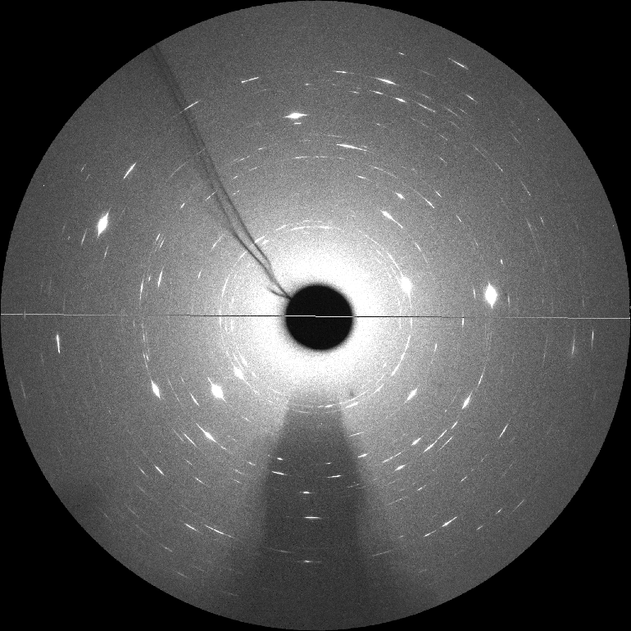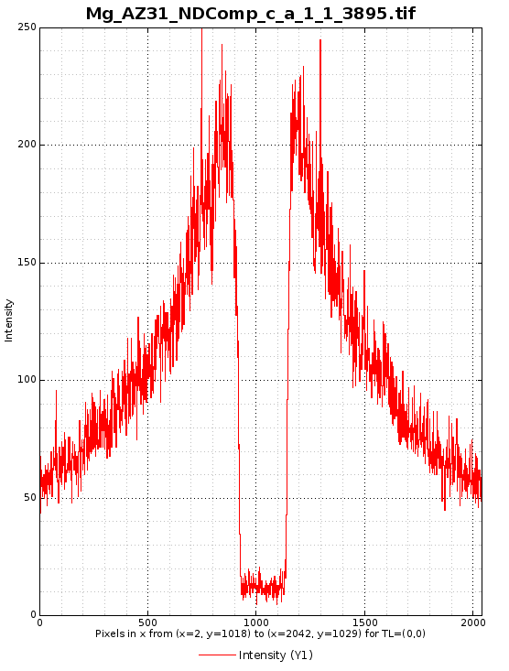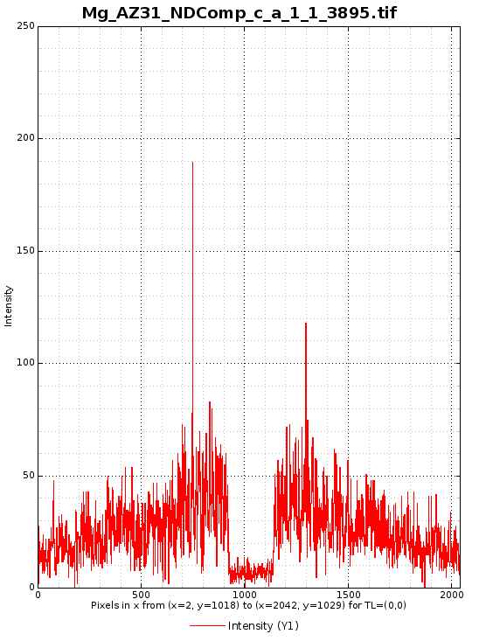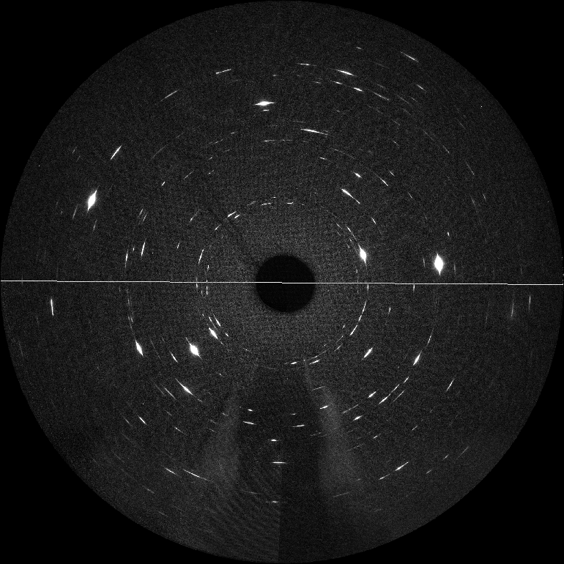
b)
a)
c)
d)
Figure 13: Background levels before and after subtraction of minimum pixel values. a) and b) are the original and the background corrected images respectively. c) and d) are the intensity profiles along the gray lines as shown in Fig. a) and b). Note, that statistical noise has increased after background subtraction.
These latter type of background images might be useful to remove air scattering, radiation scattered from the beam stop, background from an amorphous phase, or a “powder component” of the specimen consisting of large number of very small grains. If the background level changes strongly between different areas of the detector, e.g. if there is strong air scattering from the direct beam, determining and subtracting the diffuse background is inevitable. The peaksearch software is based on a constant threshold applied globally to the full area of the detector. This is not appropriate in case of a very steep background, that is changing much from place to place. It is important to note, however, that this kind of background subtraction is not always desirable. It increases the background noise, because the statistical noise of the background image is, in fact, added to the detector image. Therefore, it can be useful only in the cases, where systematic differences in background level are significantly larger than the statistical noise of the background. Fig. 13 shows the effect of subtracting a diffuse background, which has been made by taking the minimum pixel values from an image series.
Also, in case of a deformed specimen with broad rocking-curves, the assumption, that the minimum or median pixel values can represent the constant diffuse background might not be completely true. Fig. 14 shows an example of a background image, where the traces of the rings at the Bragg angles can be seen even though the minimal pixel values were chosen from the image series. In these cases, subtraction of background, might still improve peaksearch effectiveness, however it is not advisable to use such background image for integrating line profiles, as these traces of reflection rings would distort the shape of the peaks. Therefore, in the integration software, a different kind of peak identification and background subtraction methods have been implemented, which enables to recognize the exact position and limits of a peak within a small environment of a given coordinate, irrespective of the local level of diffuse background. See section 3.2.7 for more details.

Filtering peaks
Once peaksearch finished, the output can be filtered by several criteria in order to skip false hits. The simplest filtering is based on the number of pixels. Usually it is a good idea to keep only peaks, that have more than 3 or 4 pixels. This filter will skip most of the background noise, glances from environmental radiation and similar artifacts. Although it also skips some real diffraction spots, that have small intensity, these weak spots are not very useful for the evaluation anyway. The calculated center of mass positions based on only 2 or 3 pixels are not very reliable, nor the quality of line profiles obtained from these peaks would be sufficient for further evaluation. Grains can be identified based on only a fraction of the total measurable reflections [Schmidt 2014], however, we want to avoid assigning false peaks to grains. Fig. 15 shows an example for the effect of such filtering. Although, pixel defects usually affect single separated pixels, they remain bright constantly. Since number of pixels is summed up for every image, they probably can not be filtered out based on this quantity, but most of them can be filtered out by skipping peaks with one pixel breath in both detector coordinate. Sometimes false spots coming from different sources are merged together into a larger spot. In such a case they are really hard to filter out.
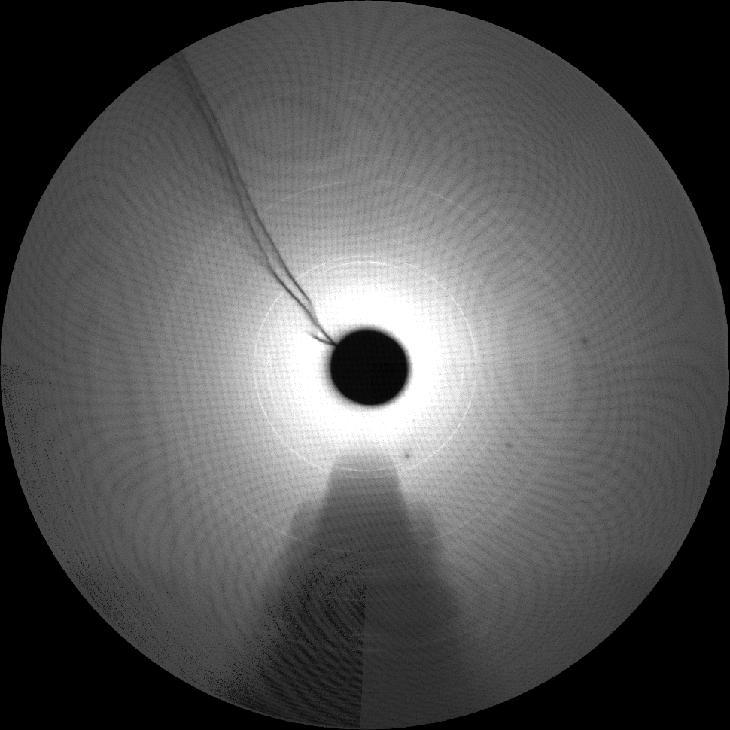Figure 14: An example of a background image calculated by taking the minimal pixel values in an image series for each pixel. Note the traces of the rings at the Bragg angles, where the reflections of the specimen occur.
Another filtering strategy might be to filter out spots, that are very broad in , i.e. appear on many subsequent images in the series. Bright points appearing constantly are usually pixel defects, or maybe reflections not coming from the specimen, but from somewhere else. However, it is important to note, that direction of diffraction vectors almost parallel to the specimen rotation axis changes very little during rotation, therefore, if these reflections have broad rocking-curves, they might easily appear on large portion of the images in a series.
Filtering peaks can be done using python tools included in ImageD11. Any other filtering tool, working on a simple ASCII space separated column file, can also be used.
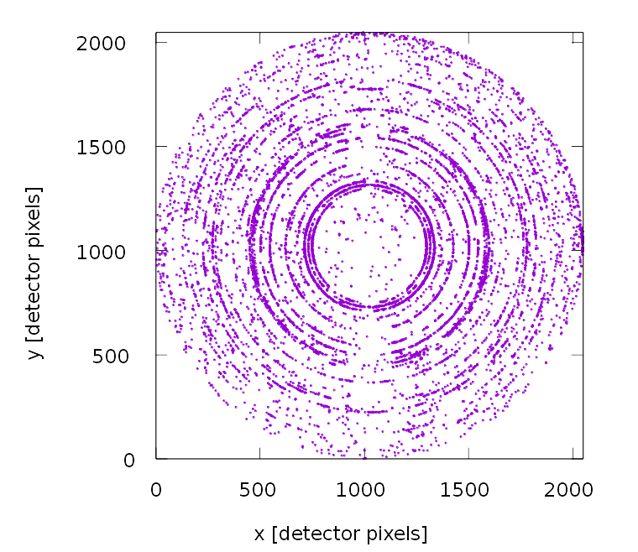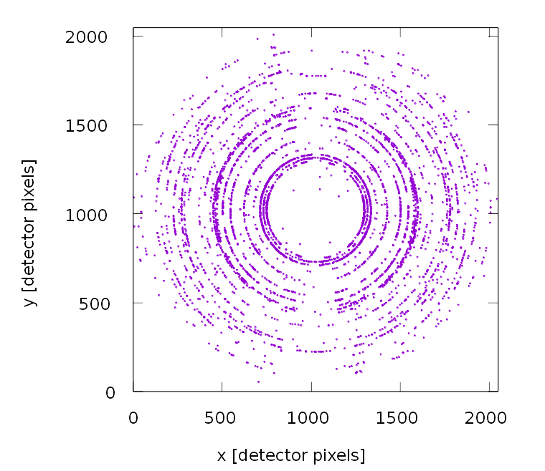
Figure 15: Effect of filtering: a) All spots identified by peaksearch.py script. b) Spots with more than 4 pixels and larger than one pixel breadth in at least one detector coordinate.
a)
b)

Merge spots from several different threshold levels
In case of deformed specimens, when peaks have broad rocking-curves, they sometimes slightly overlap in rocking-curve directions. Using low threshold levels might result in merging of neighboring peaks. If two or more peaks are merged together, the common center of mass position is given as peak coordinates, which does not correspond to any real peak position. Therefore, such peaks can not be assigned to any grains during the indexing procedure. This phenomena can seriously deteriorate indexing efficiency if it happens frequently. One can choose higher threshold levels to avoid merging peaks, however this might impede the recognition of weak peaks either occurring at large Bragg angles or coming from small grains. In general, using high thresholds means only the few largest grain can be identified and indexed. Usually it is not possible to choose one single threshold appropriate for all reflections.
This problem is addressed by merge_flt.py script of ImageD11, which can merge together several peaksearch results run on the same set of images with different thresholds. First, it takes the peaks from the highest threshold level, then compares them to the peaks from the next lower threshold level. New peaks are added to the output. If the same peak found on both threshold level, it calculates how much the center of mass position changed compared to the higher threshold level. If the difference is larger than a user supplied tolerance, the position from the higher threshold will be kept, and the value from lower threshold is omitted. If the difference is below tolerance, than position from the lower threshold will be accepted. Then the procedure continues until the lowest threshold. If two peaks are merged together on a certain threshold, but they are separate at a higher threshold, the center of mass position will be very different at the two threshold levels because of merging. This case, the merge_flt.py script will keep the positions from the higher threshold, where the peaks are correctly identified as separate, and omit the value from the lower threshold.
The merge_flt.py script is not accessible from the FABLE nor ImageD11 GUI, neither the online wiki documentation mentions it. A short description is available entering merge_flt.py in command line without any argument. For deformed samples with broad rocking curves, it is advisable to run peaksearch with 10 or more different threshold levels starting from just above the background noise up to a level comparable to the intensity of the few brightest peaks, with more threshold levels in the low range, and merging the outputs using merge_flt.py. This procedure can dramatically improve the quality of peaksearch results, and thus the efficiency of grain identification.

Refining experimental parameters and calculating diffraction vectors
In order to identify groups of reflections corresponding to single grains, diffraction vectors in sample coordinate system have to be calculated first from the measured peak detector coordinates and rotation values. The following parameters are necessary for the calculation: Lattice space group, lattice constants, X-ray wavelength, sample-detector distance, pixel order for the detector images, pixel size, beam center on the detector and sample rotation direction. Additional parameters can be supplied for special detector or sample arrangements like detector tilts or sample rotation axis, if not perpendicular to the incident beam. For more information on the possible experimental parameters and their meaning the reader is referred to the FABLE GUI documentation. ImageD11 implements a fitting algorithm for refining experimental parameters based on the measured positions of the spots. First, the program calculates the and values of the spots based on the initial parameters supplied by the user. Diffraction spots should appear close to one of the ideal Bragg angles, therefore on a plot one should observe, that most of the spots lie along straight, vertical lines at the Bragg angles corresponding to the sample lattice parameters. If the initial coordinates are not exact, the lines are shifted, tilted or curved. Using ImageD11 the experimental parameters can be fitted to minimize the deviation of the measured diffraction angles from the Bragg positions. Fig. 16 shows an example of plot of the peak positions before and after the optimization process. The initial parameters should be close enough to the actual values in order to perform a successful fit. If the initial estimation is too far from the ideal one, manual tweaking of parameters might be necessary before starting a fit.
Once the correct experimental parameters have been determined, peaks lying too far from the Bragg angles can be filtered out, diffraction vectors can be calculated for the remaining spots and saved to a vectors file, which will be the input of the GrainSpotter software for indexing. Filtering out peaks with bad values can be made using a histogram based method available on the graphical frontend. Within the framework of current PhD research a calc_gv script has been developed for filtering peaks for values, and calculating the diffraction vectors using ImageD11 python modules. It requires a precalibrated parameter set, and a user supplied threshold for filtering. This script is particularly useful when the same detector setup has been used for many different data sets e.g. large number of layers has been measured for several different specimens, therefore, filtering peaks on the graphical frontend and saving diffraction vector files one-by-one for each layer would be inconvenient.
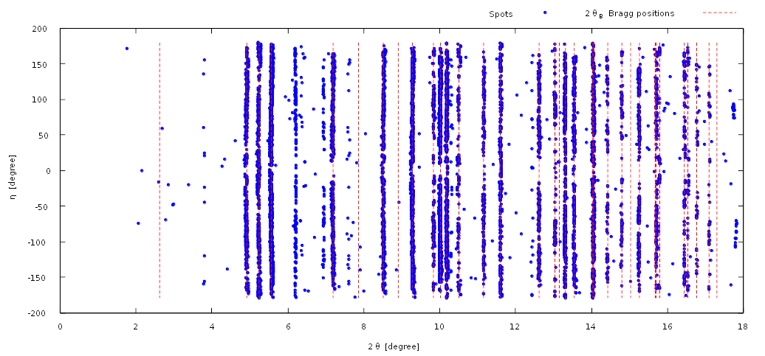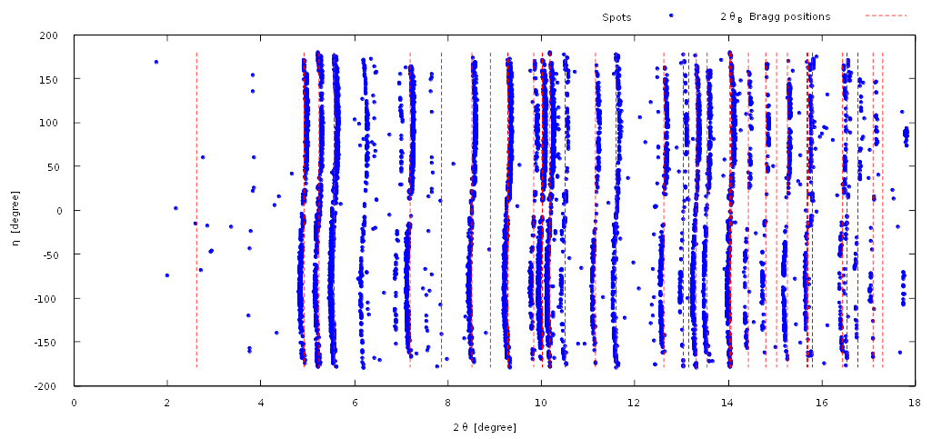Figure 16: plot of the spot positions. In Fig. a) the beam center position parameter is slightly shifted from the actual value, therefore the constant lines are distorted. In Fig. b) after fitting the experimental parameters, the correct values has been set, and the spots lie along vertical lines at the Bragg angles plotted by red dashed lines.
a)
b)

Identifying grains
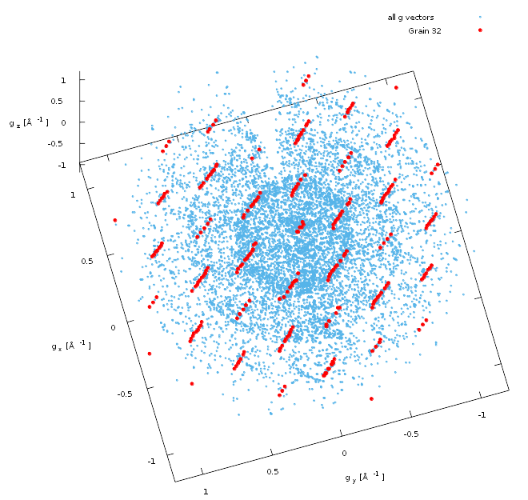Figure 17: Representation of the reflections in the reciprocal space. Small blue dots represent all 9089 measured diffraction vectors in one slice of a polycrystalline Mg AZ31 specimen. 252 reflections assigned to grain 32 by GrainSpotter has been highlighted by larger red dots. With 393 expected reflections it gives a completeness of 64%. Altogether, 50 grains have been identified by GrainSpotter in this slice.
Once the list of measured diffraction vectors is available, we need to find groups of reflection spots corresponding to the same grain orientation. Assuming we haven’t got too many grains in the illuminated volume of the specimen, and texture is not too strong, the chance for having two or more different grains with the same orientation becomes negligible, and these groups of spots can be regarded as different reflections of individual grains. The (hkl) Miller indices of reflections can be determined. This procedure is called indexing.
GrainSpotter is a software for indexing far-field 3D-XRD data [Schmidt 2014]. It can be applied if the product of sample-detector distance, , and the Bragg angle, , i.e. is much larger than the size of the diffracting volume of the specimen. In this case, the positions of the diffraction spots on the detector images are mainly determined by the orientations of the grains and the grain positions have little effect on the measured diffraction images. In case of the present method of line profile analysis measurement this condition is well satisfied both for the close and far detector positions.
GrainSpotter uses a hybrid representation of the orientation space using quaternions for large scale steps and Rodrigues vectors (cf. 2.5.2 in [Amirouche 2007]) for local searching of possible orientations in a small environment of a given orientation. There are two modes of operation: I) The program can step through the orientation space systematically and look for possible grains in each step in local Rodrigues space around the initial orientations given by the step, or II) it can generate initial orientations randomly, and search grains around the randomly generated orientations. In the first case, the user only has to supply the step size, that determines the size of the local Rodrigues spaces and the number of steps. In the second case, the user has to set the size of the local Rodrogues spaces and the number of steps to perform. In case of random steps there is no guarantee that the whole volume of the orientation space is covered. If the number of random steps is set to significantly lower than it would be in the case of systematic scan for the same Rodrigues space volume, than it is likely, that not every grain will be found, and the result will vary much from run to run. If the number of random steps is larger than in the case of a systematic scan, the result become more stable and it is more likely that every possible grain orientation is found, however it takes more time than the systematic scan.
In one step, only those reflections are considered, that are compatible with the orientations within the local Rodrigues space. Therefore, it is important to set the size of local Rodrigues space larger than the expected uncertainties of single reflection angles, otherwise not all of its reflections can be assigned to a grain, and if the number of assigned reflections is too small, even the grain identification may become uncertain or impossible. In case of deformed specimens with very broad rocking-curves, uncertainties can be as large as . Therefore, it is advisable to set the size of local Rodrigues space to at least or more. This also means that in case of a systematic scan, a very fine step size will not improve the determination of grain orientations, as a naive user might think, but on the contrary, it deteriorates the grain identification efficiency. For more details of GrainSpotter's algorithm the reader is referred to Schmidt [2014].
The other important input parameters for GrainSpotter are the maximum allowed difference of fitted and measured peak positions in , and , the minimum number of assigned reflections to accept a grain and the minimum completeness. Latter is the ratio between the number of assigned reflections and the expected number of measurable reflections for a grain. The expected number of reflections is calculated based on the user supplied , and ranges. Optionally, grain positions can be fitted. In this case, fitting is carried out in alternating steps. First, the grain orientation is fitted, than the position. After each orientation fit, outlier removal is carried out, based on the user supplied tolerances and the average . The fitting continues until a stable solution is found. Fig. 17 shows an example with reflections of a grain as indexed by GrainSpotter.

Refining grain orientations, positions, internal stresses, volume fractions
The proposed method of fitting the center of mass positions, orientations and average strain tensors of the grains is to feed the output of GrainSpotter into FitAllB [Oddershede et al. 2010] fitting software. It can also further refine the experimental setup parameters, calculate stresses from strain, with the user supplied elastic constants, estimate volume fractions of grains based on the intensities of the peaks and estimate standard deviations of all refined parameter. Usually, in case of a line profile analysis measurement, we use large pixel size detectors with large sample to detector distances, therefore, the center of mass positions as fitted by FitAllB gives only a rough estimate of the grain positions. However, if the positions of the grains within the sample are of special interest, it can be improved by using a very close detector with high spatial resolution. In case of deformed polycrystalline metallic samples measured ex-situ after deformation, the grain level residual stresses are rather small and are in the order of experimental uncertainties. In the simplest of our case, the main purpose of running FitAllB after GrainSpotter is, to get the volume fractions of the grains, and to sightly improve the quality of the fitting of the grains provided by GrainSpotter. It can also be used to revise the reflection assignments of GrainSpotter using the built-in error estimation and outlier rejection mechanisms, and even reject grains in case of poor quality fits.

Simulate peak positions on far detectors
Until this point, the grains have been identified and fitted on close detector data, and now we would like to use far detector data for the purpose of line profile analysis. The integration software for calculating the line profiles from series of 2D far detector images, require a list of indexed peak positions on the far detectors. The initial peak positions provided to the integration software should be close enough to the peak maximum to unambiguously identify the peak.
Several different approaches are possible to make such lists of peak positions. Peaksearch results from different far detector positions can be merged together to one large virtual far detector area, and indexing can be carried out on this data set. However, calibration errors for the different detector positions can be different, and these differences introduce a new kind of uncertainty in the indexing and grain fitting procedure. Moreover, FitAllB can not deal with this kind of multi-detector data, therefore, it can not be used to refine detector calibrations, center of mass positions, strain tensors. Even volume fraction estimation becomes unreliable if, for example, the exposure time differs from one far detector position to another.
An other possibility would be to run the peaksearch and detector calibration for the far detector images, and then correlate the far detector peaks with the indexed peaks on the close detector. This method works, however, only for those peaks, that have been successfully measured and identified on both the close and the far detectors, and indexed on the close detector.
A third possibility to get the grain orientations, positions, strain tensors from FitAllB results, and simulate the peak positions on the far detectors. It is still necessary to run peaksearch and detector calibration processes for the far detectors as described in sections 3.2.1 and 3.2.3 using data from a measured standard or from the specimen itself in order to precisely calibrate far detector positions. This method makes possible to run the full refinement of grains using FitAllB on close detector data, and it works even if the angular regions measured by the close detector and the far detectors do not match, or if some of the reflections have not been identified or indexed on close detector. FABLE package includes a 3D-XRD pattern simulator called PolyXSim. Unfortunately, the output of FitallB can not be fed directly to PolyXSim simulator, therefore a polyXsim_inp_maker script has been developed to create the necessary input file for the simulation. It takes the detector calibration file for the far detector, the GrainSpotter initialization file for reading lattice spacegroup number and the output from FitAllB to generate PolyXSim input file. User has to supply the omega_start, omega_end and omega_step parameters for the rotation of the specimen while measuring far detector images, and the detector pixel dimensions. Additional scaling parameters should be set for i) detector size and distance, ii) lattice distances and wavelength, iii) grain size and iv) grain positions before running script to convert every quantity to the appropriate unit of measure. Lattice constants and wavelength should be in Ångström, the other length dimension parameters should be in millimeter for PolyXSim simulation. We use the 'flt' output of PolyXSim, which can be directly fed to the integration software.

Integrating diffraction peaks
In the present method, the , radial profiles of the single grain reflections are analyzed using the CMWP [Ribárik et al. 2001, 2004] line profile analysis software. An integration software was first developed by Ribárik [Ribárik & Ungár 2010] for summing up the intensities of the measured peaks along rocking-curve directions ( and ) to get the required 1D intensity distributions as a function of . As it was mentioned before, due to the large number of measured reflections, it is inevitable to automatically identify the right integration area without needing to set the correct values manually for each single peak. During the present PhD research, the integration software was further developed in order to improve the efficiency of the automatic peak integration algorithm. The present version of the software runs on a list of indexed peaks compiled in an 'flt' file, which is the common output format of the elements of FABLE software package, therefore, it can be directly run on the output of PolyXSim (sect. 3.2.6), FitAllB (sect. 3.2.5) or GrainSpotter (sect. 3.2.4) software. It automatically checks for overexposure, determines the integration limits for each peak based on the measured intensities, checks for overlapping peaks and it subtracts a linear baseline from the resulting line profiles so, that the background intensity approaches zero far from the peak. Finally, it saves each peak profile in separate files named by serial numbers of grains and Miller indices. Once, the input parameters are correctly set, the integration software runs automatically for the full set of peaks. Detailed description of the integration software's algorithm and usage is presented in Appendix A. The output of the software can be used to construct patterns for the CMWP software as described in the next sections.

Creating single grain pseudo-patterns for CMWP line profile analysis
As the CMWP [Ribárik et al. 2001, 2004] software is developed primarily for powder diffraction patterns, it accepts one single pattern of peaks as a function of or the radial reciprocal space coordinate . In order to use CMWP for evaluating single crystal patterns, all integrated reflections of a grain should be merged to a single, one dimensional pattern. Single crystals have more than one reflections occurring at approximately the same , but at different and angles. They can only put together in such pattern, if the peak centers are shifted in or , so that they do not overlap with each other. Therefore, in this step we stitch the integrated profiles together in one single pattern, where the scattered intensity is plotted against a pseudo- value, where each peak center is shifted by different quantities in order to be some empty space between the profiles, but the peak shapes itself are not altered. The peak profiles first are transformed to space from space using their real values, then shifted in in order to put them one after the other on one single axis. We use space instead of , because CMWP accepts the instrumental profiles in , and transforms them to if the pattern is given in . However, if the values of the peak centers in the pattern are not the real values of the peaks, then the transformation gives an incorrect instrumental broadening. This problem can be circumvented by transforming the profiles into space first and then shift them in space.
This transformation can be easily done automatically, however, the integrated profiles are not always ready for line profile analysis. As already mentioned in the previous section, other peaks may appear near the edge of the integrated profiles, that can also mislead the baseline subtraction method. Profiles may become corrupted also if the edge of the detector image is reached during integration, or if there are pixel errors, other artifacts on the detector images, or if somehow the integration limits where not correctly identified, etc. Some of these profiles might be repaired by applying small corrections after integration. However, some have to be omitted from the whole procedure. Fig. 45 shows examples, where the raw output of the integration software is not ready to include in the pattern, but additional checking and modification is needed. There is certainly room for improvement in the evaluation procedure at this step, but at the this moment, this final check of the peak profiles has to be done manually. A software, seqKPatternCreator.sh is under developement to make this manual checking and correction process as fast as possible for creating the single grain patterns for CMWP. The software together with the manual checking procedure, automatically creates the 1D single grain pseudo-patterns and other input files for the CMWP software. The usage of seqKPatternCreator.sh software is described in Appendix B.

Fitting line profiles by CMWP
CMWP [Ribárik et al. 2001, 2004] stands for Convolutional Multiple Whole Profile fitting. It is a software for fitting theoretical model functions to the measured line profiles in order to determine microstructure parameters. This section summarize the theoretical background of the CMWP fitting procedure, and explains how can it be used to analyze the dislocation structure of single grains in a polycrystalline aggregate. Technical details about how to run the CMWP software automatically for all grains of the specimen are discussed in Appendix C.
It is assumed, that the measured intensity profiles are the result of several different broadening effects coming both from different microstructure features and from instrumental effects, and should be calculated as a convolution of profile functions stemming from the different individual broadening effects:
, (3.1)
where the star symbol, , stands for convolution, is the measured intensity profile, , and are the physically based, theoretical profile functions related to coherently scattering domain size, strain (distortion) caused fundamentally by dislocations, and planar faults (stacking faults and twinning). is the measured or calculated instrumental profile and is the background modelled by a spline function.
The size profile was calculated on the basis of the average column length corresponding to the coherently scattering domain size. Assuming spherical shape and log-normal size distribution the size profile is [Ungár et al. 2001; Scardi & Leoni 2002]:
, (3.2)
where is the complemetary error function, and are the median and standard deviation of the distribution of the logarithm domain size, is the column length, and is the value measured from the peak center.
Based on the Eqs. 2.44 and 2.37 the strain profile function, , can be given by its Fourier transform (FT):
(3.3)
where and the contrast factor get the indices in order to note that it depends on the diffraction vector. Since the value of depends on the actual value of the dislocation density, Wilkens introduced a dimensionless parameter, for characterizing the dipole character of dislocations [Wilkens 1970]:
. (3.4)
In the present case, each crystallite or grain in the polycrystalline aggregate behaves like a single crystal. Each line profile correspond to different directions within the crystallite (i.e. those directions normal to the diffracting planes). Therefore, the dislocation contrast factors, in Eq. 3.3 are not averaged over the permutations of the indices, as they would have to be if they corresponded to a powder diffraction pattern [Ungár & Borbély 1996; Ungár & Tichy 1999]. Since they can be different for each signed value and for each diffraction peak in the same grain, they are called individual dislocation contrast factors here. This means that in the last term in Eq. 3.3 there are two unknowns, the dislocation density and the dislocation contrast factor, and which appear as a product. Therefore, in a first step, only one of these can be determined. We start the evaluation procedure by using a formal value of the dislocation density, , and write the logarithm of the Fourier transform of the size and distortion part of the measured profile as:
(3.5)
where is the Fourier transform of the size profile, the second term on the right-hand side is the logarithmic Fourier transform of the strain profile () and is the diffraction vector corresponding to the undistorted lattice given by the Miller indices. Here it is noted that is the Fourier transform of in Eq. 3.2, the explicit form of which was given in Eqs. 26 and 27 in Ungár et al. [2001]. In this step the CMWP algorithm is used to obtain values of the product in . The aim is to obtain the dependent broadening of the peaks in terms of dislocation contrast factors. The CMWP algorithm provides the dependence of the above product by fitting individual contrast factors to the measured peak profiles. Technically, it requires to set predefined, fixed values for and , that will not be changed during the fitting procedure. Here is also regarded as a formal input value for CMWP, because crystal lattice can contain several different type of dislocations with different Burgers vector length, but CMWP allows only one input value for . In principle, these factors can be any numbers, but it is convenient to use ones which are close to physically realistic ones so that the fitted values are within the same order of magnitude as the theoretical contrast factor values. At this point, the selection of the values of and has no physical meaning, as they are both auxiliary formal input parameters for running CMWP. The output of the CMWP procedure are the unscaled, measured individual dislocation contrast factor values, . At this stage they carry the information about the variation of dislocation broadening, though without the appropriate scaling. The scaling procedure, and matching them to the theoretical contrast factors corresponding to the prevalent dislocations, are described in the next section.

Fitting dislocation structure to the measured contrast factors
As it has been shown in the previous section, CMWP fitting gives one single value of the product for every reflection of a single crystal. In a grain of a polycrystalline material, however, several different types of dislocations can exist and contribute to the strain profile. When, for example, plastic deformation is considered at least five independent slip systems are necessary to accommodate arbitrary strains on a crystallite [Mises 1928; Taylor 1938]. Even in single crystal experiments, one or more slip-systems are activated depending on the orientation of the grain relative to the acting stress [Diehl 1956a,b]. Dislocation strain-broadening contrast depends on the Burgers vector, dislocation line vector, the elastic constants, and the direction we look at the dislocations, i.e. the diffraction vector. Slips systems are characterized by the slip direction and slip plane normal, and the operating slip systems are related to the generated dislocation types by and . Therefore, if more then one slip systems are activated in a crystallite, several type of dislocations are formed.

Matching the measured strain broadening contrasts with the theoretical contrast factors of different possible dislocation types
When we calculate the simultaneous effect of several different dislocation types, we use the same assumption as in Eq. 3.1. This means that the resultant profile of several different line broadening effects is the convolution of the profiles corresponding to the different individual effects. In the Fourier transform of the intensity profile, the convolution becomes multiplication. The exponents in the Fourier transforms are summed up. Therefore, the logarithm of the Fourier transform stemming from from size and distortion effects can be written as:
(3.6)
where are the fractional dislocation densities corresponding to the different dislocation types, are the theoretically calculated dislocation contrast factors corresponding to these dislocations and is the Fourier transform of the true size profile. Taking into account that the left-hand sides of Eqs. 3.5 and 3.6 have to be equal, we obtain:
(3.7)
The almost-equal sign indicates that there can be small fluctuations between the two sides caused by the experimental errors penetrating through the CMWP procedure. Assuming that the true and the fitted size Fourier coefficients are equal, i.e. , the left-hand side of Eq. 3.7 becomes zero and we obtain the equation for matching and scaling of the contrast factors:
. (3.8)
Introducing the scaling factor between the CMWP fitted and the theoretical dislocation contrast factors, and , the following can be written:
(3.9)
Eq. 3.9 is a system of equations where each equation corresponds to one of the measured vectors. The solution of the equation yields the values of for the different dislocation types in which the partial dislocation densities are:
(3.10)

Refining the effect of size broadening
In a true powder-diffraction experiment the diffraction peaks, corresponding to different orientations but the same lattice spacing, are summed up as an averaged single peak. Line broadening for this type of patterns can be described schematically in the Williamson – Hall [Williamson & Hall 1953] or modified Williamson – Hall [Ungár & Borbély 1996] plot, where the extrapolation of line breadth to is a measure of the size broadening. The same concept is incorporated into the sophisticated whole-powder-pattern fitting or modeling procedures when applied to powder diffraction patterns [Ribárik et al. 2001; Ungár et al. 2001; Scardi & Leoni 2002]. In the present evaluation procedure the individual contrast factors, , for different line profiles are totally independent of each other. Therefore, it can happen that a part of strain broadening can be attributed to size broadening, or vice versa. Technically this is manifested by the appearance either of too many contrast factors of zero value or all contrast factor values shifting uniformly to too large values. In the corresponding peaks the size broadening part of the entire broadening is either over- or underestimated. We correct for this effect by allowing a systematic difference between the true and the formal size Fourier coefficients, and . Now the left-hand side of Eq. 3.7 cannot be considered to be zero, but can be written as:
(3.11)
Here, since the right-hand side is independent of , the left-hand side must also be independent of Assuming that size broadening is isotropic, i.e. it does not depend on , the left-hand side of Eq. 3.11 becomes a constant, which we denote as . With this, Eq. 3.9 obtains an extra term:
. (3.12)
Eq. 3.12 is the same system of equations as Eq. 3.9, but with the additional unknown of . The solution provides the values of for different dislocation types, from which the fractional dislocation densities can be calculated as in Eq. 3.10.

Direction dependence of dislocation broadening contrast [Zilahi et al. 2017a]
Until this point we regarded the theoretical contrast factors, , as an arbitrary function of the diffraction vector, , or the miller indices. However, the theoretical contrast factors of different reflections are not completely independent of each other. In fact, the contrast factors depend only on the direction of the diffraction vector, but not on the length or the sign, e.g. the contrast factor corresponding to the reflection is the same as the contrast factor of the or reflections. But even the contrast factors corresponding to different directions are not completely independent of each other.
The contrast factor of any dislocation can be written as the product of two 4-rank tensors [Klimanek & Kužel 1988; Kužel & Klimanek 1988]:
, (3.13)
where and are called the geometrical and the elastic parts, respectively. The elastic part depends only on the dislocation properties , , and the elastic constants, while the geometrical part depends only on the direction of the diffraction vector, :
, (3.14)
where are the direction cosines of the angles between and the coordinate system axis, and are the basis vectors of an orthonormal coordinate system fixed to the dislocation line and slip plane. Latter is the so called slip coordinate system, , where is parallel to slip plane normal, is parallel to dislocation line vector and [Klimanek & Kužel 1988; Kužel & Klimanek 1988; Martinez-Garcia et al. 2009].
When we want to calculate the resultant effect of several different types of dislocations, the elements of can not be summed up directly, as they are given in different coordinate systems, i.e. they have to be multiplied by different direction cosines. First, the tensors, corresponding to different dislocation types, have to be transformed to a common coordinate system. Let's call the tensor , that transforms a vector given in the , slip coordinate system to an other orthonormal coordinate system, , fixed with respect to the crystal lattice:
. (3.15)
are the coordinates of the unit vector parallel to in , and are the coordinates of the same vector in . Since transforms between two orthonormal system, it is a rotation tensor, therefore its inverse is the transpose matrix:
. (3.16)
Now using Eqs. 3.13, 3.14 and 3.16, we express the contrast factor with the direction cosines in the common, , crystal coordinate system:
(3.17)
where and elements are zeros. We can introduce the following notations:
(3.18)
and
. (3.19)
With these, Eq. 3.17 becomes:
. (3.20)
It has the same form as Eq. 3.13, but the direction cosines of the diffraction vectors are given in the common, , crystal coordinate system instead of the , slip coordinate system. and are the geometrical and the elastic part of the contrast factor in the , crystal coordinate system respectively.
When summing up contrast factors in Eq. 3.12, the geometrical parts are the same for all dislocation types, therefore, they can be taken out from the sum, and the elastic parts can be summed up. It means, that the direction dependence of the contrast of any dislocation type, or any combination of dislocation types can be described by the same set of parameters. By reformulating the sum in Eq. 3.20, one can find these parameters in the following form:
(3.21)
where the set of indices in curly brackets at the bottom of the sums, like , mean summation for all permutations of the listed indices. The last terms in each line of Eq. 3.21 are the coefficients of the different combinations of the direction cosines. The numbers in square brackets indicate how many different combination of direction cosines are included in that line, i.e. the number of terms in the first sum of the line. Altogether 15 different combinations of the direction cosines are possible, and the 15 coefficients of these combinations fully determine the direction dependence of the dislocation contrast. It means that the set of equations in Eq. 3.12 are usually not completely independent of each other, but actually maximum 15 of them can be independent.

Fitting fractional dislocation densities by Monte-Carlo type method
The fractional dislocation densities in a crystal, can be determined by finding the optimal values of the coefficients by minimizing the difference between the two sides of Eq. 3.12. However, if the number of independent equations is less than the number of unknown parameters, the solution becomes ambiguous. The unknown parameters are the fractional dislocation densities of each dislocation type and the one parameter for correcting size effect. As it was shown in the previous section, the number of independent equations is maximum 15. The number of measured reflections can either be smaller or larger.
The number of dislocation types to be considered can depend on the crystal structure, physical conditions of sample processing, like temperature or hydrostatic pressure, and many other circumstances. In face centered cubic (fcc) crystals the most commonly considered slip systems are the types of which there are 12. For dislocation contrasts, the dislocation line is an additional free parameter within each slip system. If only pure edge and screw dislocations are considered, then 12 different edge dislocation types correspond to the 12 slip systems, while screw dislocations cannot be unequivocally assigned to slip systems as they can slip in any slip plane containing the line vector. Therefore, screw dislocations can only be distinguished by Burgers vectors of which 6 are different. Altogether there are conceivable dislocation types in the most typical fcc case.
In body centered cubic (bcc) crystals the slip direction is usually type, and and type slip planes are the most typical depending on the material, cf. [Hirth & Lothe 1982]. If only type slip systems are considered, there are 16 different dislocation types, 12 edge for 12 slip systems and 4 screw. The type slip planes result 12 more edge dislocation types.
In hexagonal close packed (hcp) metals there are 30 different conceivable slip systems as listed in Table 10 of Partridge [1967], although it depend on the material, which ones can be activated.
As the above examples show, usually there are more possible dislocation types, than that is possible to fit simultaneously on the measured dislocation contrast factors. Therefore, further conditions have to be applied to restrict the possible solutions for Eq. 3.12. First of all, we are only interested in solutions, where all the fractional dislocation densities are non-negative values. That is the reason why we choose the fore-factors of -s to be the square of a number, . Second, general experience in plasticity shows, that the number of prevailing slip systems in individual grains of a polycrystalline aggregate is usually much lower than about 10 [Bay et al. 1992]. Although there are a large number of possible dislocation types, the number of dislocation types actually present in a single grain is usually much smaller than that. So the problem of finding the general solution of Eq. 3.12 can be reduced to find the combination of a few dominant dislocation types among the many possible ones, which is characteristic to that specific grain, i.e. capable to reproduce the measured dislocation broadening contrast.
As a first approach, in case of tensile tested CoTi and CoZr B2 structure ordered alloys presented in chapter 4, possible dislocation types were grouped into smaller groups based on the physical criteria of plastic deformation of the B2 alloy system and earlier TEM observations [Wollmershauser et al. 2010; Mulay et al. 2011; Mulay & Agnew 2012]. Care was taken to deliberately mix different Burgers vector types in each group. The analysis revealed that whatever the grouping, there were always abundant dislocation types which finally turned out to have close to zero contribution to the fitted dislocation contrast, i.e. their fractional dislocation densities were negligible compared to the prevailing dislocation types.
Based on this experience, a Monte-Carlo type procedure has been developed to solve Eq. 3.12 which does not require a fixed preliminary grouping of dislocation types. The iteration begins with a random selection of dislocation types from all conceivable ones. Difference between the two sides of Eq. 3.12 is minimized by a Levenberg–Marquardt least squares algorithm, and the convergence is monitored by checking changes of the weighted sum of squared residuals (WSSR). When decrement of WSSR drops below a certain limit, the least square algorithm is stopped and partial dislocation densities are calculated from the fitted coefficients. Dislocation types with very low partial dislocation density values are replaced randomly by other dislocation types from the pool of all conceivable types, and the least square fitting is restarted with the new set of dislocation types. By repeating this procedure many times, the iteration converges to a solution, where dislocation types with large values remain stable without having to be discarded. In the remaining places, other dislocation types with very low are continuously replacing each other without much effect on the values of the dominant dislocation types.
To perform the Monte-Carlo type contrast factor fitting procedure described here, a software called Cfit has been developed. The list of conceivable dislocation types and the corresponding theoretical contrast factor values has to be supplied for all measured reflections. The number of dislocation types fitted simultaneously and the threshold for replacing dislocation types with low dislocation densities are parametrized by the user. Detailed description and usage of Cfit software is given in Appendix D.

Checking efficiency of Cfit software to reproduce dislocation composition
In order to validate the performance of the Monte-Carlo type fitting method, a simulated data set of 'measured' contrast factors has been created. The list of grains and measured diffraction vectors were taken from a real measurement of a Mg AZ31 alloy specimen. Contrast factors were calculated for 5671 reflections of 115 grains using randomly generated coefficients. The values of were selected between 0 and 1 for five randomly chosen dislocation types in each grain. 39 different dislocation types were considered for the Mg AZ31 alloys and used in this simulation as listed in Table 6. The number of reflections of the single grains varied from 13 to 159. A random noise with amplitude of has been added to the simulated values of the 'measured' contrast factors, which result typically in a 3% to 5% experimental error. The Cfit software was run on the simulated data set by fitting 12 dislocation types simultaneously and using 0.02 threshold for replacing low density dislocation types. The results are summarized in Table 2. The histogram of the differences between the simulated and the fitted values is shown in Fig. 18. The Monte-Carlo type fitting procedure was able to reproduce approximately 90% of the simulated values of within tolerance, and there was about 10% false positive result, when the value was larger than 0.1 for a dislocation type, which was not included in the simulated data set. The ratios of correctly reproduced coefficients are slightly better in grains with large number of measured reflections.
 | No. of simulated values | Fitted within tolerance | False positive with >0.1
All 115 grains | 537 | 470 (87.5%) | 58 (10.8%)
100 grains with more than 20 reflections | 409 | 374 (91.4%) | 34 (8.3%)
70 grains with more than 30 reflections | 268 | 252 (94%) | 17 (6.3%)
Table 2: Measured efficiency of Cfit software in reproducing the simulated dislocation arrangement.
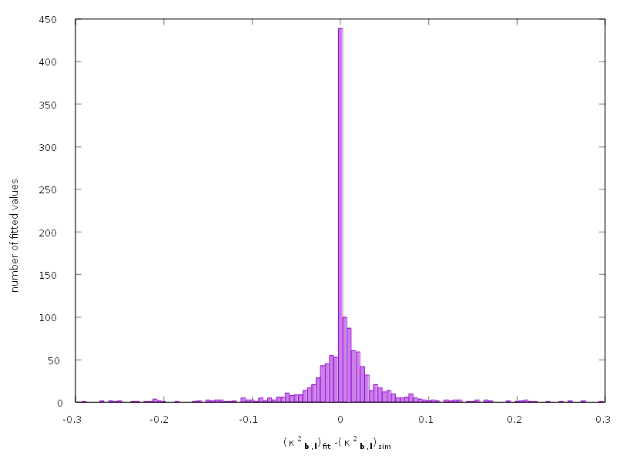Figure 18: Histogram of the differences between the fitted and simulated values of .

Measurement of uniaxially tensiled polycrytalline CoTi and CoZr alloys
The grain-by-grain dislocation type analysis method presented in chapter 3 has been applied to tensile deformed polycraystalline CoTi and CoZr B2 structured intermetallic alloy specimens. The results are discussed in comparison with earlier TEM, EBSD, neutron diffraction and polycrystal plasticity modeling results. The details of the information got on slip systems (SSs) on single grain level are comparable to what one can obtain by electron microscope based methods, however the number of grains analyzed is far much higher, than in the earlier elector microscope studies, and in terms of Burgers vector and dislocation type population, the statistics are much better. The results are reported in Ungár et al. [2014].

Deformation mechanisms in CoTi and CoZr B2 structured intermetallic alloys
Intermetallic compounds have always been promising candidates for high temperature creep resistant structural materials. The brittle nature of the elastic plastic response is, however, a limiting factor of application for many of these compounds [Sauthoff 1995]. The intermetallics CoTi and CoZr of the B2, CsCl-type structure with a high anti-phase boundary energy are known to deform plastically via the slip systems (SSs) [Sauthoff 1995; Potter 1970; Miracle 1993; Baker 1995; Mulay et al. 2011; Wollmershauser et al. 2010]. In B2 intermetallics the slip mode (SM) is often observed to be soft, hence the notation Soft-M is used. However, the Soft-M provides only three independent SSs As it was mentioned before, at least five independent SSs is required to accommodate arbitrary strains on a crystallite, which is a prerequisite for homogeneous polycrystalline ductility [Mises 1928; Taylor 1938]. Despite the limited number of Soft-M SSs in CoTi and CoZr, the polycrystalline specimens of these two alloys exhibit significant ductility [Mulay et al. 2011; Wollmershauser et al. 2010]. Lattice strain measurements by in-situ neutron diffraction experiments supported by polycrystal plasticity modeling have shown that during deformation of polycrystalline CoTi and CoZr the Soft-M SSs are accompanied by the activation of and/or SSs [Wollmershauser et al. 2010]. However, when single crystalline samples of the same alloys are oriented for slip on these latter SSs, the straining experiments lead to early brittle fracture [Takasugi et al. 1990]. Therefore, these SSs are denoted as hard-mode (Hard-M). It has been suggested that Hard-M SSs can relieve the high incompatibility stresses that develop between differently oriented crystals [Wollmershauser et al. 2010]. In particular, strains parallel to the cube directions can be sustained by Hard-M SSs but not by Soft-M ones. Earlier TEM studies and single crystal slip trace analyses carried out on CoTi and CoZr unambiguously identified the presence of Soft-M SSs, especially involving dislocations of type Burgers vectors [Takasugi et al. 1990, 1992; Yoshida & Takasugi 1993; François & Veyssière 1994]. The apparent contradiction between previous TEM studies and the recent conclusion was reconciled by recognizing that dislocations associated with the Hard-M will only be observed at higher levels of strains than those used in earlier experiments. A recent study of CoTi by TEM and scanning electron microscope based electron backscattered diffraction confirmed the presence of dislocations with and Burgers vectors [Mulay & Agnew 2012]. However, only a small number of grains were analyzed and no quantitative dislocation density information was obtained.

Experimental

Materials
Cobalt, titanium and zirconium were obtained from Alfa Aesar (Ward Hill, MA) with purities of 99.9+, 99.98 and 99.5 wt.%, respectively. The CoTi and CoZr alloys were arc melted and drop cast as cylinders of 24.5 mm diameter in an Ar atmosphere at the Oak Ridge National Laboratory. The cast rods were preheated to 1000 °C and extruded to a final sample diameter of ~12.7 mm. Tensile specimens of 15.75 mm gauge length and 1.1 mm diameter were cut with the loading axis along the extrusion direction using electro-discharge machining. More details about alloy and tensile sample preparation can be found in Wollmershauser et al. [2010] and Mulay and Agnew [2012]. The stress–strain curves of the CoTi and CoZr samples are shown in Fig. 19. The flow curve of CoZr reveals a fast initial strain hardening followed by a slowing down beyond about 250 Mpa [Wollmershauser et al. 2010; Mulay et al. 2011]. The behavior is typical for these ductile B2 transition metal alloys [Wollmershauser et al. 2010]. The transition point for CoTi would be about 350 MPa, which was not reached in the present specimen. The specimens for the synchrotron experiments were prepared from CoTi and CoZr samples tensile deformed to and true strain, respectively. The tensile specimens were cut and electropolished into thin tapered needles, as shown in Fig. 8. Details regarding the electropolishing conditions can be found in [Mulay et al. 2011; Mulay & Agnew 2012]. The thicker lower part and the tapered thinner upper part of the specimens were prepared for holding and for diffraction measurements, respectively.

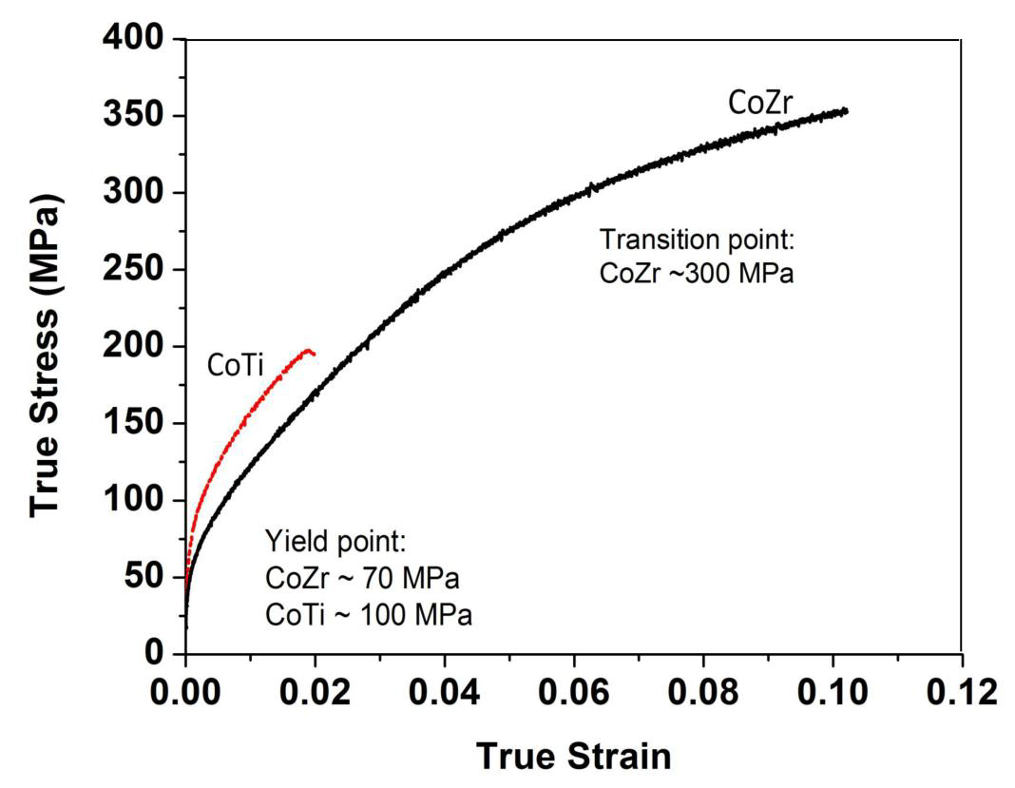
X-ray diffraction experiments
Figure 19: True stress vs. true strain curves of the CoTi and CoZr samples [Ungár et al. 2014].
The experiments were carried out at the 1-ID beamline of the Advanced Photon Source (APS) synchrotron of Argonne National Laboratory, Argonne, Illinois. The tapered rod-like samples, shown schematically in Fig. 8, were mounted in a one-axis goniometer for incremental rotation around the angle during X-ray exposure. The 52 keV monochromatic X-ray beam was focused by a compact refractive lens to an ellipsoidal footprint of the beam on the specimen with a horizontal length of about 1 mm and a height of about 40 μm. The scattered radiation was recorded either by a fast high-resolution MAR-CCD camera in the close position at a distance of 500 mm from the specimen or by a GE high-resolution fast amorphous Si detector in the far position at a distance of 1.838 mm from the specimen. The close detector was used in the first run. The specimen was rotated in step-by-step mode by over a range of ±90°, and the detector images were recorded at each step. In the second run the close detector was moved out of the beam and the diffraction patterns were recorded in the far-detector position by the GE detector. The specimen was rotated again over by the same strategy. The schematic arrangement of the beam, the detectors and the specimen is shown in Fig. 9 a). In the far-detector position the detector was moved successively into six adjacent positions with small overlaps, similarly as indicated schematically by the arrows in Fig. 9 b), except that the 3 bottom detector positions were not measured. In each of the detector positions the measurement required a complete rotation of the specimen over . One full measurement cycle consisted of one full scan with the close detector and six full scans with the far detector. The full scans took about 0.5 h beam-time in the close-detector position and about 6–8 h beam-time in the far-detector position. In order to increase the number of grains investigated, the specimens were measured at different heights. Each specimen was measured at four different sections. Thus, each sample required approximately 30 h of beam-time.

Evaluation of the X-ray diffraction experiments
The detailed description of the evaluation procedure is given in chapter 3, here only the information specific to this experiment is provided. Typical close detector images corresponding to CoTi and CoZr specimens and a montage of six far detector images of the CoZr specimen are shown in Figs. 20 and 21, respectively. Peak positions were determined based on a single threshold value for each detector position, which was selected just above the background noise levels. For peaksearch, diffuse background was reduced for both close and far detector images by subtracting the minimal pixel value images extracted from the image series of full turns as described in 3.2.2.1. During the after-peaksearch filtering, the following peaks were discarded: (i) corresponding only to a single pixel; (ii) that appeared on a single frame; or (iii) that extended in to more than 6°. Spots lying far away from the theoretical values were also discarded. GrainSpotter indexing procedure was run on the close detector data, and the indexed reflections were correlated with the far detector peaksearch results. The integration was done on the list of correlated peak positions using the far detector images with dark image correction, but without subtraction of the diffuse background calculated from minimal pixel values.
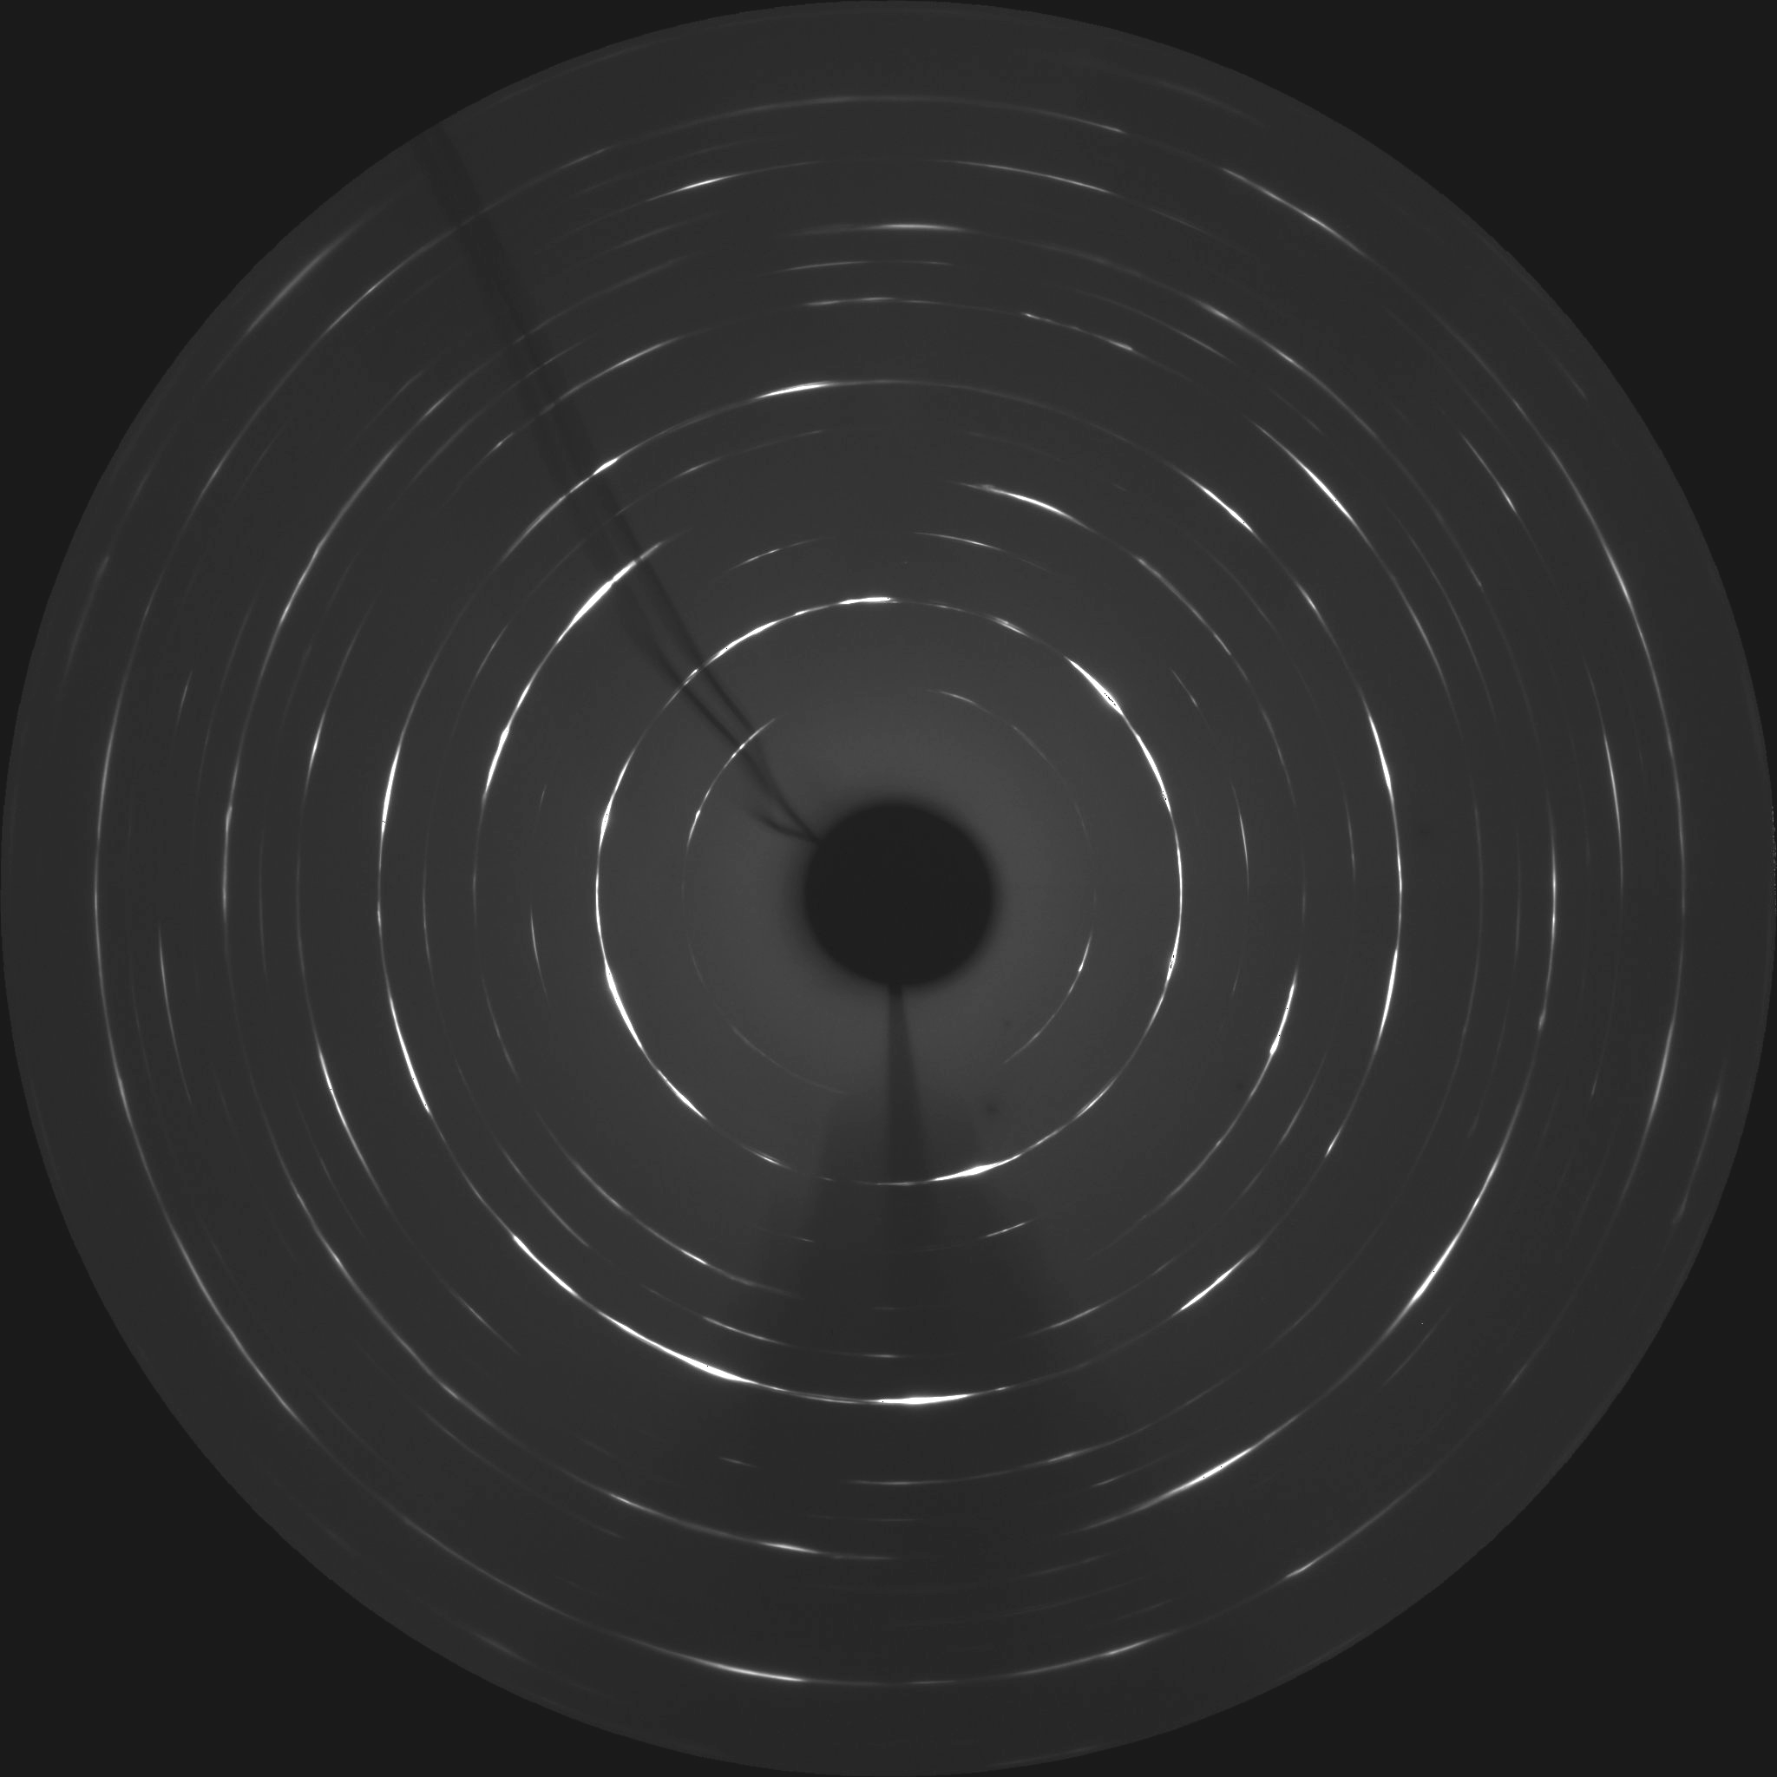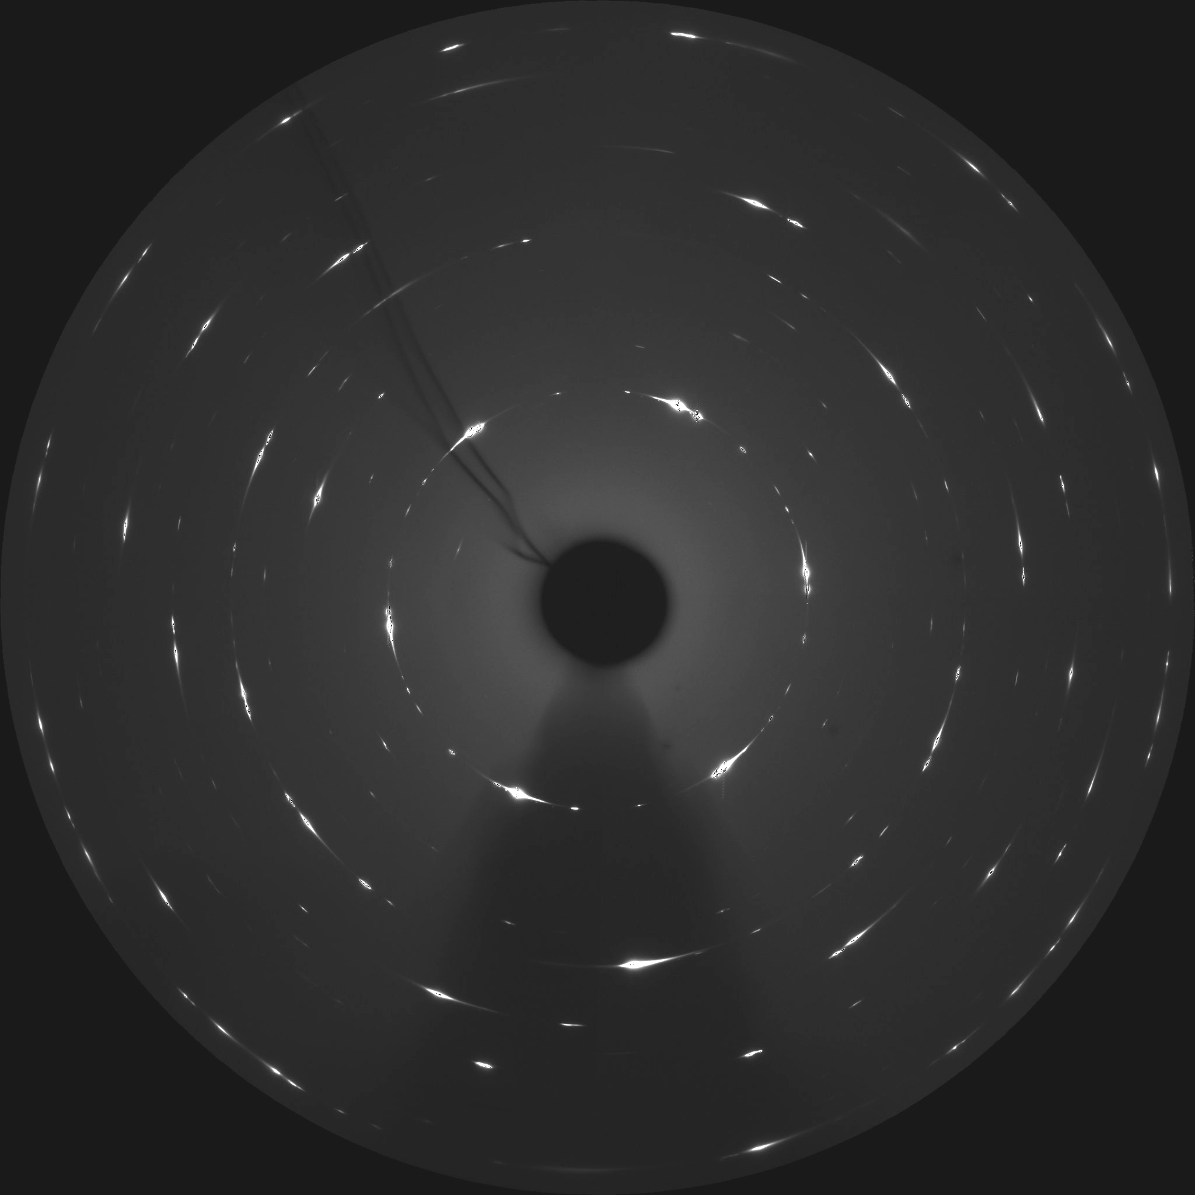Figure 20: Typical close detector images of the (a) Co–Ti and (b) Co–Zr specimens.
a)
b)
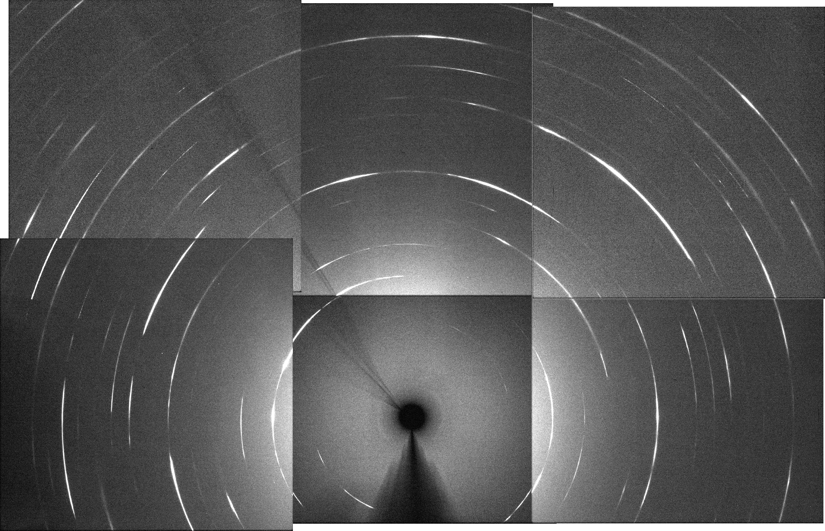Figure 21: Montage of far detector images constructed from single frame far detector images of the Co–Zr specimen (for the purpose of illustration only).
During the evaluation procedure, about 50,000 diffraction maxima were spotted at the very first step in each of the two alloy systems. Filtering according to the thresholds for the extension of the , and coordinates reduced these numbers to about 10,000 and 4000 in CoTi and CoZr, respectively. Further filtering according to the positions left about 8700 and 3500 peaks in the two alloys. The numbers of indexed reflections on the close-detector were 7700 and 1370, respectively, and about 125 and 30 grains were identified for CoTi and CoZr. Finally, the pair correlation for the close and far detector data and the manual filtering of bad profiles left 2377 and 412 reflections for the two alloys, with about 12–40 different reflections for each grain.
The CMWP procedure was carried out on these final numbers of reflections. The smaller number of reflections for the CoZr specimen is caused by the wider rocking curves, as can be seen qualitatively in Fig. 20. The larger broadening in the and directions in the CoZr specimen is in correlation with the larger applied plastic strain shown in Fig. 19 and with the anisotropic broadening in the – vs. direction as discussed in chapter 2 in detail. In order to have well separated peaks in the detector images, the tapered specimen had to be lowered to a thinner position in the X-ray beam so that a smaller volume is illuminated and a smaller number of grains participate in diffraction.
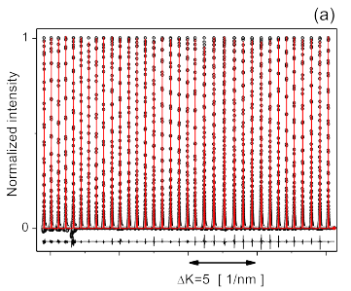
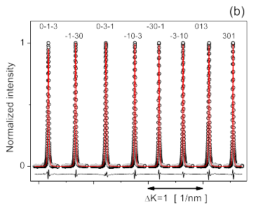
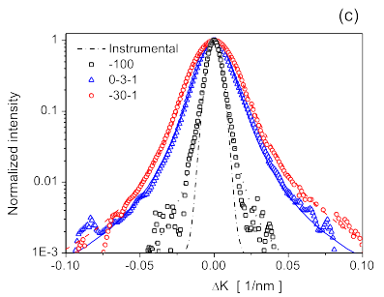
Figure 22: (a) Typical measured diffraction profiles (open circles) corresponding to one particular grain in the Co–Ti specimen. The continuous red lines hows the profiles calculated using the CMWP software package. The black line at the bottom is the difference between the measured and fitted intensities. (b) An enlarged part of the pattern in (a) showing eight -type reflections and the corresponding indices. (c) Three selected profiles of the pattern in (a) with logarithmic intensity scale vs. , where is the exact Bragg reflection. The dashed (red), solid (blue) and black (dotted) lines are the intensity distributions calculated by the CMWP procedure. The and are the narrowest and broadest reflections in the pattern in (a), respectively. [Ungár et al. 2014]

Typical measured (open circles) and calculated (red line) line profiles of 35 peaks corresponding to the same grain in section 4-1 of the CoTi specimen are shown in Fig. 22 a). The black line at the bottom of the figure is the difference between the measured and calculated intensities. Eight -type reflections from Fig. 22 a) are shown enlarged in Fig. 22 b). The signed values of the different single crystal reflections are indicated in the figure. The , and reflections are shown in logarithmic intensity scale vs. in Fig. 22 c). The is one of the widest and the peak one of the narrowest peaks, respectively, corresponding to Gr#10 in section 4-1 in this specimen.
The list of conceivable SSs for CoTi and CoZr alloys are listed in Table 3. A number code has been assigned to each dislocation type for the purpose of easier numerical representation. 15 Soft-M, 30 and 28 type Hard-M dislocation types were considered, which is altogether 73 different dislocation types. The theoretical contrast factors for the dislocation types listed in Table 3 were calculated by the contrast factor calculation software written by Florian Spieckermann [Spieckermann 2010]. Dislocation composition in single grains has been determined using the Cfit software as described in section 3.2.10 and Appendix D. 12 dislocation types were fitted at once and the threshold for replacing dislocation types were set to 0.05.

Results and discussion

Cross-checking of the CMWP method and the procedure of matching measured and theoretical contrast factors
Dislocations affect line profiles fundamentally in the intensity region below half the intensity maximum, , down into the lowest measured intensity ranges, possibly down to to , where is the maximum of the profile [Warren 1959; Wilkens 1970; Krivoglaz 1996; Groma 1998; Borbély & Groma 2001]. The quality of the intensity distribution is shown in Fig. 22 c), where the intensity is in logarithmic scale for the , and reflections vs. . The solid (blue), the dashed (red), and the dotted (black) lines in Fig. 22 c) are the CMWP calculated intensities which fit the measured data-points down to below . In the lower intensity range the measured intensities follow the power law with . The theoretical asymptotic value of is [Borbély & Groma 2001]. The value indicates that there are correlations in the dislocation system [Wilkens 1970].
The qualitative features of line broadening are best seen in the Williamson-Hall (WH) [Williamson & Hall 1953] and modified Williamson-Hall (mWH) [Ungár & Borbély 1996] plots of the integral breadths, of peak profiles, scaled in . The traditional WH and mWH plots were designed to show line broadening in powder or bulk polycrystalline specimens. In the present case, the diffraction peaks correspond to single crystals. It was shown in several cases [Cordier et al. 2004; Ungár et al. 2010; Nisr et al. 2012], that the comparison of the WH and mWH plots for peaks corresponding to one single grain provides a valuable measure for the quality of the matching between measured and fitted dislocation contrast factors, and , as defined in Eqs. D.1 and D.2. Two sets of WH and mWH plots are shown in Figs. 23 and 24 for grains #21 and #22 in section 1-1 and grains #18 and #26 in section 4-1 of the CoTi specimen, respectively. The measured and calculated contrast factors, and , are also compared to each other and shown in the figures. The apparently irregular behavior of in Figs. 23 a) and 24 a) shows the profound strain anisotropy even for values corresponding to the same value, also indicating that well defined, specific SSs are prevailing in the grains. The SSs prevailing in the grains, according to the present evaluation, are listed in Table 4. In the grains presented in Figs. 23 and 24 the type Soft-M and the or type Hard-M SSs are present to relative levels of 50:20:30, 10:35:55, 15:30:55 and 15:35:50 %, respectively.
Soft-mode |  | Hard-modes
No. code | Slip-systems | No. code | Slip-systems | No. code | Slip-systems
101 | [100]{001}_{90} | 216 | [110]{1-10}_{90} | 346 | [111]{1-10}_{90}
102 | [100]{010}_{90} | 217 | [1-10]{110}_{90} | 347 | [111]{01-1}_{90}
103 | [010]{100}_{90} | 218 | [011]{01-1}_{90} | 348 | [111]{10-1}_{90}
104 | [010]{001}_{90} | 219 | [01-1]{011}_{90} | 349 | [1-11]{110}_{90}
105 | [001]{100}_{90} | 220 | [10-1]{101}_{90} | 350 | [1-11]{011}_{90}
106 | [001]{010}_{90} | 221 | [101]{10-1}_{90} | 351 | [1-11]{10-1}_{90}
107 | [100]{011}_{90} | 222 | [110]{1-11}_{90} | 352 | [-111]{101}_{90}
108 | [100]{01-1}_{90} | 223 | [110]{-111}_{90} | 353 | [-111]{110}_{90}
109 | [010]{101}_{90} | 224 | [1-10]{111}_{90} | 354 | [-111]{01-1}_{90}
110 | [010]{10-1}_{90} | 225 | [1-10]{11-1}_{90} | 355 | [11-1]{011}_{90}
111 | [001]{110}_{90} | 226 | [011]{11-1}_{90} | 356 | [11-1]{101}_{90}
112 | [001]{1-10}_{90} | 227 | [011]{1-11}_{90} | 357 | [11-1]{1-10}_{90}
113 | [100]_{0} | 228 | [01-1]{111}_{90} | 358 | [111]{11-2}_{90}
114 | [010]_{0} | 229 | [01-1]{-111}_{90} | 359 | [111]{1-21}_{90}
115 | [001]_{0} | 230 | [10-1]{111}_{90} | 360 | [111]{-211}_{90}
 |  | 231 | [10-1]{1-11}_{90} | 361 | [1-11]{-112}_{90}
 |  | 232 | [101]{11-1}_{90} | 362 | [1-11]{121}_{90}
 |  | 233 | [101]{-111}_{90} | 363 | [1-11]{21-1}_{90}
 |  | 234 | [110]{001}_{90} | 364 | [-111]{1-12}_{90}
 |  | 235 | [1-10]{001}_{90} | 365 | [-111]{12-1}_{90}
 |  | 236 | [011]{100}_{90} | 366 | [-111]{211}_{90}
 |  | 237 | [01-1]{100}_{90} | 367 | [11-1]{112}_{90}
 |  | 238 | [10-1]{010}_{90} | 368 | [11-1]{-121}_{90}
 |  | 239 | [101]{010}_{90} | 369 | [11-1]{2-11}_{90}
 |  | 240 | [110]_{0} | 370 | [111]_{0}
 |  | 241 | [1-10]_{0} | 371 | [1-11]_{0}
 |  | 242 | [011]_{0} | 372 | [-111]_{0}
 |  | 243 | [01-1]_{0} | 373 | [11-1]_{0}
 |  | 244 | [10-1]_{0}
 |  | 245 | [101]_{0}
Table 3: SSs considered in the evaluation of the CoTi and CoZr specimens. For the purpose of numerical calculations, the numbering starts as 1.., 2.. and 3.. for the Soft-M, and the and type Hard-M SSs, respectively. The last numbers in curly brackets following the underscores denote the angle in degrees between Burgers vector and line vector, i.e. ..._{90} means an edge dislocation and ..._{0} means a screw dislocation.
Since the number of conceivable SSs is fairly large, the suspicion might by raised that any set of peak profiles could be evaluated with the present procedure. The WH and mWH plots of grain #4 in section 1-1 of the CoTi specimen are shown in Fig. 25. There is nothing obviously wrong with the data, as presented in the WH plot in Fig. 25 a). The mWH plot in Fig. 25 b) indicates, however, that the procedure was not working successful in the case of this grain. It is very likely that something went wrong during the indexing of the peaks, but still the data slipped through even the most careful checking and filtering. Note that this grain was omitted from Table 4. The failure of the mWH plot in Fig. 25 b) indicates that when the mWH plot behaves properly, the evaluation is correct.

Figure 25: Cross-checking the procedure by showing that it does not work with any peak broadening. The WH (a) and the mWH (b) plots of grain #4in section 1-1 of the CoTi specimen. It is important to note that this grain was omitted from the valuable data and from Table 4. [Ungár et al. 2014]
Figure 24: The WH (a) and mWH (b) plots of the integral breadth, b, of peak profiles corresponding to grains #18 and #26 in section 4-1 of the CoTi specimen. The and values in the mWH plots are the measured and calculated dislocation contrast factors, as defined in Eqs. D.1 and D.2, respectively. The SSs contributing to are listed in Table 2a. (c) The measured versus calculated contrast factors, and , along with the values of grain#22. [Ungár et al. 2014]
Figure 23: The WH (a) and mWH (b) plots of the integral breadth, , of peak profiles corresponding to grains #21 and #22 in section 1-1 of the CoTi specimen. The and values in the mWH plots are the measured and calculated dislocation contrast factors, as defined in Eqs. D.1 and D.2, respectively. The SSs contributing to are listed in Table 2a. (c) The measured versus calculated contrast factors, and . [Ungár et al. 2014]

Prevalent SSs and dislocation densities in the individual grains of CoTi
The SSs with larger than 5 % fraction in the different grains of the CoTi specimen are listed for section 1-1 in the fourth column of Table 4. The number codes of the SSs, as defined in Table 3, are shown in a sequence of descending fraction values. Fractions of the Soft-M and the and type Hard-M dislocations are listed in the fifth to seventh columns. Similar detailed data for the other sections in CoTi are shown in figures. The dislocation densities in the three different slip-modes in the sections 2-1, 2-2 and 4-1 of CoTi are shown as bar diagrams vs. the serial numbers of grains in Fig. 26. It is noted that to avoid repetition the results of section 1-1 are only presented in Table 4, whereas the results of the other three sections are only shown in Fig. 26. The results in Table 4 and Fig. 26 indicate that in 99 of the 123 analyzed grains, i.e. in about 80 % of all grains, Soft-M dislocations are present.

Prevalent SSs and dislocation densities in the individual grains of CoZr
The SSs with larger than about 5 % fraction in the different grains of the CoZr specimen are listed in the fourth columns of Table 5. The number codes of the SSs, as defined in Table 3, are shown in a sequence of descending fraction values. Fractions of the Soft-M and the and type Hard-M dislocations are listed in the fifth to seventh columns. In 19 of altogether 35 grains, the dislocation densities of the Soft-M dislocations are substantial. However, no grain was found where the density of Hard-M dislocations is not considerable. It is concluded here again that though the presence of Soft-M dislocations is considerable, there are no grains where the prevalence of Hard-M dislocations is not substantial. The average dislocation densities were also determined in the two alloys by laboratory X-ray diffraction experiments using a dedicated high resolution diffractometer as in Ungár et al. [1982], Ungár and Borbély [1996] and Ribárik and Ungár [2010]. For CoZr and CoTi the values were obtained to be: and , respectively, in good correlation with the values obtained for the individual grains.

Secondary vs. primary slip
The fractions of dislocation densities in the Soft-M type dislocations are shown in Fig. 27 a) and b) for CoTi and CoZr, respectively. In CoTi, the fraction of the soft-M dislocation density is larger than 0.8 and 0.7 in grains #5 and #10, respectively. In CoZr, however, there is only a single grain in which the fraction of the soft-M dislocation density is larger than 0.7. This gives ratios of grains with substantial primarily soft-M dislocation activity of 0.12 and 0.03 for CoTi and CoZr, respectively. The correlation between elastoplastic self-consistent (EPSC) modeling and stress–strain curves as well as lattice strain measurements in CoTi and CoZr was discussed by Wollmershauser and co-workers [Wollmershauser et al. 2010]. In their Fig. 5, EPSC modeling was compared to macroscopic stress–strain curves and lattice strain data when solely using either or slip. The analysis showed that slip gives better agreement for the stress–strain curves (see the left-hand side in Fig. 5 a) in Wollmershauser et al. [2010]), whereas slip is better for lattice strain data (see the right-hand side in Fig. 5 b) in Wollmershauser et al. [2010]). The results shown in Fig. 27 a) and b) suggest that, in CoTi that is not strained above the transition stress of 350 MPa, Soft-M slip dominates in about 15% of the grains. In CoZr, however, which was strained above the transition stress of 250 MPa, Hard-M slip dominates in practically all of the grains. The average fraction of the Hard-M dislocation density in those grains where the Soft-M fraction was lower than 0.7, i.e. the average Hard-M fraction, corresponding to grains marked as crosses in CoTi or open-triangles in CoZr in Fig. 12, was obtained to be 0.75 or 0.86 for CoTi or CoZr, respectively. This shows again that secondary slip increases with strain. At the same time, Fig. 27 a) and b) indicates that the two slip modes, i.e. Soft-M and Hard-M, have to be allowed across the entire deformation range, most probably allowing for increasing activity of secondary slip with strain.

Figure 27: Grain orientations shown in the SST for CoTi (a) and CoZr (b). In the case of CoTi (a), the data are sectioned into grains with Soft-M fractions larger than 0.8 (open red circles), between 0.8 and 0.7 (open blue triangles) and below 0.7 (black crosses). In the case of CoZr (b), the data are sectioned into grains with Soft-M fractions larger than 0.7 (open red circles) and below 0.7 (open blue triangles). [Ungár et al. 2014]
Figure 26: Dislocation densities in the grains of CoTi from #1 to #13 (a) and #14 to #26 (b) in section 2-1, from #1 to #16 (c) and #17 to #33 (d) in section2-2 and from #1 to #13 (e), #14 to #26 (f) and #27 to #40 (g) in section 4-1 in the Soft-M (first red bar in each group of three bars), and the - and -type Hard-Ms (second blue and third green bars in each group of three bars), respectively. [Ungár et al. 2014]
a) CoZr section 1:
Grain Nr. | SST coordinates |  | SS | Fractions of SMs
 | x | y |  | SM | HM-1 | HM-2
Gr1 | 0.292 | 0.213 | 373/372/108/370/245/371/221 | 0.20 | 0.16 | 0.64 | 24
Gr2 | 0.310 | 0.138 | 111/244/372/243/371 | 0.53 | 0.27 | 0.21 | 23
Gr3 | 0.257 | 0.054 | 104/218/241/373/370 | 0.41 | 0.37 | 0.22 | 20
Gr4 | 0.324 | 0.201 | 242/105/244/232/373 | 0.25 | 0.68 | 0.06 | 25
Gr5 | 0.173 | 0.172 | 106/112/245/105/243/373/370 | 0.59 | 0.25 | 0.16 | 31
Gr6 | 0.266 | 0.223 | 244/245/218/235/370 | 0.00 | 0.90 | 0.10 | 51
Gr7 | 0.304 | 0.015 | 109/103/242 | 0.93 | 0.06 | 0.00 | 21
Gr8 | 0.283 | 0.253 | 241/231/221 | 0.00 | 1.00 | 0.00 | 16
Gr9 | 0.327 | 0.142 | 242/373/230/245 | 0.00 | 0.82 | 0.18 | 22
b) CoZr section L-1:
Grain Nr. | SST coordinates |  | SS | Fractions of SMs
 | x | y |  | SM | HM-1 | HM-2
Gr1 | 0.363 | 0.309 | 370/102/371/101/108/245/373 | 0.39 | 0.11 | 0.50 | 42
Gr2 | 0.294 | 0.210 | 240/110/370/109 | 0.40 | 0.37 | 0.23 | 29
Gr3 | 0.232 | 0.197 | 372/373/370/220/112 | 0.07 | 0.10 | 0.83 | 20
Gr4 | 0.298 | 0.129 | 242/371/220/354/372 | 0.00 | 0.53 | 0.47 | 25
Gr5 | 0.180 | 0.164 | 106/112/242/243/373/105/371 | 0.50 | 0.29 | 0.22 | 42
c) CoZr section n-1:
Grain Nr. | SST coordinates |  | SS | Fractions of SMs
 | x | y |  | SM | HM-1 | HM-2
Gr1 | 0.161 | 0.141 | 106/373/371/370/372/243 | 0.39 | 0.10 | 0.51 | 20
d) CoZr section n-2:
Grain Nr. | SST coordinates |  | SS | Fractions of SMs
 | x | y |  | SM | HM-1 | HM-2
Gr1 | 0.241 | 0.163 | 372/107/242/371/245/222/  360/216 | 0.17 | 0.45 | 0.38 | 33
Gr2 | 0.166 | 0.150 | 106/371/372/219/373 | 0.36 | 0.14 | 0.51 | 10
Gr3 | 0.320 | 0.235 | 371/372/104/373/370/103 | 0.28 | 0.01 | 0.70 | 49
e) CoZr section n-3:
Grain Nr. | SST coordinates |  | SS | Fractions of SMs
 | x | y |  | SM | HM-1 | HM-2
Gr1 | 0.276 | 0.217 | 360/240/372 | 0.00 | 0.33 | 0.67 | 59
Gr2 | 0.235 | 0.225 | 237/245 | 0.00 | 1.00 | 0.00 | 8
Gr4 | 0.208 | 0.175 | 115/242/348/227/226/230 | 0.47 | 0.40 | 0.14 | 31
Gr6 | 0.212 | 0.173 | 240/241 | 0.00 | 1.00 | 0.00 | 133
Gr9 | 0.195 | 0.097 | 218/234/370 | 0.00 | 0.80 | 0.20 | 13
Gr10 | 0.270 | 0.244 | 114/366 | 0.51 | 0.00 | 0.49 | 59
Gr13 | 0.369 | 0.189 | 240/241/373/102 | 0.08 | 0.84 | 0.08 | 52
Gr14 | 0.272 | 0.256 | 234/244/216 | 0.00 | 1.00 | 0.00 | 65
Gr15 | 0.313 | 0.278 | 228/229/231/103 | 0.05 | 0.95 | 0.00 | 32
Gr16 | 0.287 | 0.243 | 365/371 | 0.00 | 0.00 | 1.00 | 16
Gr17 | 0.219 | 0.032 | 236/103/235/369 | 0.22 | 0.71 | 0.07 | 61
Table 5: Number-codes of the prevalent SSs as defined in Table 3, the fractions of dislocation densities in the three different SMs and the total dislocation densities in the grains of (a) section 1, (b) section L-1, (c) section n-1, (d) section n-2 and (e) section n-3, respectively, in CoZr. The number-codes of the prevalent SSs with dislocation densities larger than 5 % are listed in descending sequence. The (x,y) coordinates of grain-orientations in the SST are denoted in the second and third columns.

CoTi  Sect. 1-1 | SST coordinates |  | SSs | Fractions of SMs
 | x | y |  | SM | HM-1 | HM-2
Gr1 | 0.164 | 0.074 | 370/244/364/352 | 0.00 | 0.35 | 0.65 | 6.1
Gr2 | 0.359 | 0.253 | 245/348/358/373/356 | 0.00 | 0.56 | 0.44 | 11.7
Gr3 | 0.392 | 0.068 | 242/359/113/236/370/223 | 0.16 | 0.54 | 0.30 | 8.6
Gr5 | 0.385 | 0.192 | 245/373/240/244/219/371 | 0.00 | 0.71 | 0.29 | 14.3
Gr6 | 0.275 | 0.118 | 235/113/114/372/217 | 0.42 | 0.44 | 0.13 | 6.9
Gr7 | 0.396 | 0.005 | 244/228/371 | 0.00 | 0.88 | 0.12 | 6.0
Gr8 | 0.165 | 0.131 | 114/231/238 | 0.80 | 0.18 | 0.02 | 7.1
Gr9 | 0.174 | 0.041 | 108/244/245/370/230/243/101 | 0.34 | 0.52 | 0.14 | 2.7
Gr10 | 0.073 | 0.066 | 115/361/228/363/362/113/ | 0.37 | 0.18 | 0.45 | 39.7
Gr11 | 0.351 | 0.098 | 230/115/114/352/366/244 | 0.45 | 0.35 | 0.20 | 2.9
Gr12 | 0.239 | 0.188 | 107/101/372/371/241/370/373/244 | 0.40 | 0.17 | 0.43 | 4.3
Gr13 | 0.307 | 0.004 | 235/114/113/217 | 0.49 | 0.51 | 0.00 | 17.8
Gr14 | 0.283 | 0.167 | 239/373/351/362/103 | 0.05 | 0.54 | 0.41 | 9.2
Gr15 | 0.246 | 0.074 | 371/113/353/108/356/107/370 | 0.44 | 0.00 | 0.56 | 5.9
Gr16 | 0.142 | 0.135 | 107/218/243/347 | 0.53 | 0.41 | 0.06 | 4.8
Gr17 | 0.290 | 0.189 | 219/372/240/370/356 | 0.03 | 0.53 | 0.44 | 18.3
Gr18 | 0.282 | 0.108 | 103/371/244/353/114/225/352 | 0.49 | 0.21 | 0.30 | 4.2
Gr19 | 0.077 | 0.054 | 372/239/243/230/241 | 0.04 | 0.54 | 0.42 | 1.7
Gr20 | 0.177 | 0.136 | 225/104/373/372/370/218 | 0.19 | 0.36 | 0.45 | 2.5
Gr21 | 0.345 | 0.005 | 110/370/240/368 | 0.51 | 0.17 | 0.31 | 14.9
Gr22 | 0.349 | 0.255 | 370/371/216/240/102/355/372 | 0.11 | 0.34 | 0.55 | 1.6
Gr23 | 0.394 | 0.091 | 373/370/241/240/372/357 | 0.04 | 0.27 | 0.69 | 3.7
Gr24 | 0.284 | 0.124 | 115/237/245/373/229/363 | 0.31 | 0.49 | 0.20 | 2.7
Gr25 | 0.303 | 0.024 | 243/370/219/372/348/364/371/245 | 0.00 | 0.45 | 0.55 | 6.6
Table 4: Number-codes of the prevalent SSs as defined in Table 3, the fractions of dislocation densities in the three different SMs and the total dislocation densities in the grains of section-1-1 in CoTi. The number-codes of the prevalent SSs with dislocation densities larger than 5 % are listed in descending sequence. The (x,y) coordinates of grain-orientations in the standard stereographic triangle (SST) are denoted, where (0,0), (0,0.414) and (0.366,0.366) correspond to the , and directions, respectively.
a)
b)

Correlation between the Schmid factors and the prevalence of slip systems
The activation of slip systems with respect to externally applied stresses is commonly considered in the literature as being due to the Schmid factor. In the present study, the grain orientations were determined in the coordinate system with the axis parallel to the tensile direction of deformation. The Schmid factors of edge-type dislocations (those for which the slip plane is defined, as required for Schmid factor calculation), 60 in total, were calculated for both the CoTi and CoZr specimens. The SSs were ranked in sequence of descending Schmid factor values for each single grain individually, and the identified prevailing SSs in each grain were registered and counted at one of the ranked Schmid-factor values. The ranking is individual for each grain, i.e. the numbers from 1 to 12 for the Soft-M SSs and from 1 to 48 for the Hard-M SSs do not relate to a particular SS, but give only a rank in terms of Schmid factor values. Within a particular grain, the largest and smallest Schmid-factor values correspond to 1 and 12 for the Soft-M SSs and to 1 and 48 for the Hard-M SSs, respectively. Obviously, the largest and smallest Schmid-factor values depend on the particular orientation of the specific grain. The number of grains containing Soft-M or Hard-M SSs as a function of the Schmid-factor ranking are shown in Fig. 28 a) and b), respectively. The figure indicates that there is a pronounced positive correlation between the prevailing Soft-M SSs and the corresponding Schmid factor values in CoTi, whereas there is practically no correlation between the Hard-M SSs and the Schmid factors, as revealed in Fig. 28 b). A similar trend was found for CoZr, but with less statistical confidence.
In drawing conclusions from this analysis of Schmid factors, it is important to remember that the individual grains in a polycrystal do not experience a stress state equivalent to the macroscopically imposed boundary conditions. Assuming they do is equivalent to the lower bound assumption that stress equilibrium between the grains dominates the response. The in-situ neutron diffraction work of Wollmershauser et al. [2010] provides definitive evidence that the stresses strongly vary from grains of one orientation to another within the two materials, CoTi and CoZr, under evaluation in this study. Thus, the stress state is influenced by the surrounding grains. Therefore, deviations from the simple Schmid factor analysis should not be surprising.
CoTi and CoZr are nearly elastically isotropic, so the variation in lattice strain from one grain orientation to another can be attributed entirely to plastic anisotropy. This plastic anisotropy is due to the geometric disposition of SSs and their relative crystal resolved shear stresses. The fact that the EPSC model can describe the variations in stress levels between various grain orientations fairly well [Wollmershauser et al. 2010] suggests that there is no rigid interaction between the grains and the surrounding, as would be imposed by a full-constraints Taylor model [Houtte et al. 2005], and that it does not appear to be necessary to model interactions between the grains and their immediate neighbors. In summary, even though the stress states vary from one grain to another, the Schmid factor still does a reasonably good job of predicting the activity of the Soft-M SSs, i.e. when the Schmid factor is large for a given SS, it is observed to be active. However, it appears that the activation of the Hard-M SSs is due to variations of the grain stress state from that of the aggregate, i.e. due to intergranular stresses. Most likely, when the Schmid factors for the Soft-M SSs are small, the Hard-M SSs take over and operate more frequently.

Figure 28: The number of grains in CoTi containing Soft-M (a) or Hard-M(b) SSs vs. the descending ranking of only the Soft-M or only Hard-M SSs, respectively. [Ungár et al. 2014]
Finally, there is an important fact to bear in mind in all ex situ analyses of dislocation densities: the dislocations observed ex situ do not represent all of the dislocations which accommodated the plastic deformation [Essmann & Mughrabi 1979; Kocks & Mecking 2003]. Rather, they are the dislocations which were “left behind” [Ungár et al. 2011]. Many of the dislocations which accommodated the strain will have been annihilated due to recovery processes that take place during (or even after) the deformation. Certainly the strain hardening behavior is controlled by the dislocations which are left behind. However, it would be wrong to conclude that the ratios of dislocation densities between various slip systems are representative of the relative activities of those slip systems during the deformation, since it is entirely possible that the recovery rates of the different dislocation types are different. The results of the present investigation show unequivocally that plastic deformation in CoTi and CoZr with the B2 structure is caused by the combined activation of Soft-M and Hard-M SSs, in correlation with previous TEM observations.
Though the results show that the Hard-M activity is larger in CoZr than in the CoTi, which is consistent with the considerably larger deformation applied to CoZr, the relatively large Hard-M activity in CoTi, especially below the transition stress of 350 MPa, still requires discussion. More refined consideration of the elastic anisotropy for CoTi and CoZr shows that the recombination of dislocations into and dislocations is more energetically favorable in CoTi than in CoZr, which could explain the unexpectedly large Hard-M activity in CoTi. In CoTi, which is more anisotropic [Yasuda et al. 1991] than CoZr [Agosta et al. 2002], screw dislocations have twice the energy of screw dislocations and screw dislocations have one-and-a-half times the energy of screw dislocations [Mulay & Agnew 2012]. On the other hand, since CoZr is elastically isotropic [Agosta et al. 2002], screw dislocations have three times the energy of screw dislocations and screw dislocations have twice the energy of screw dislocations.
The present experiments were performed on ex situ specimens, but it is nevertheless possible to draw conclusions about some limited aspects of the dynamics of how secondary slip would interplay along with primary slip to increase the ductility of these fundamentally brittle alloys. The possibility of obtaining detailed quantitative data on the dislocation densities prevailing in the different slip systems, and in such abundance, goes beyond the possibilities of TEM. At the same time, this investigation shows how well these two distinct experimental techniques, TEM and synchrotron X-ray line profile analysis, enhance each other in a synergetic manner. The potentials of the present X-ray technique do not exclude the possibility of carrying out the same experiment in-situ.

Measurements on uniaxially deformed polycraystalline Mg AZ31 alloy specimens

Experimental

Specimens
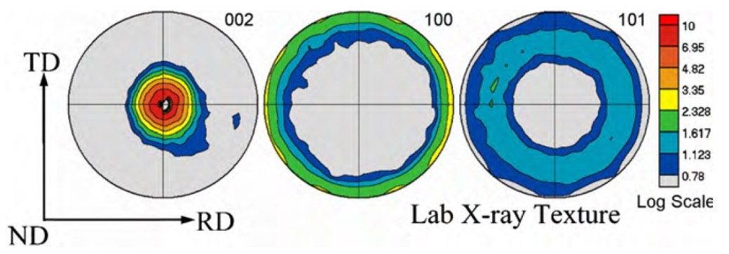
The samples were cut from commercially rolled magnesium AZ31B alloy plate with H24 temper (strain hardened and partially annealed). The composition of the alloy is 3.0 wt% Al, 1.0 wt% Zn, 0.2 wt% Mn with Mg as balance [Wu et al. 2010]. Pole figures of the initial texture of the material are shown in Fig. 29. A typical rolling texture in magnesium [Styczynski et al. 2004]. Most of the grains are oriented with their basal planes almost parallel to the rolled surface, and the distribution of the prismatic poles are essentially uniform within the plate plane. Samples were cut from the plate by electro-discharge machining (EDM) for compression and tension tests. One specimen was compressed in the normal direction (ND), an other in the rolling direction (RD) and a third one was tensile tested in RD. Therefore, the three specimens are denoted in short form as ND-C, RD-C and RD-T, respectively. The compression samples were deformed up to 4% true strain and the tensile specimen was deformed up to 10%. The corresponding stress-strain curves are shown in Fig. 30.
Figure 29: Initial texture for the as-received strain-free AZ31B sample. Measured crystallographic texture using ex situ synchrotron diffraction. Pole densities are expressed in multiples of a random distribution (mrd). [Wu et al. 2010]

X-ray diffraction experiments
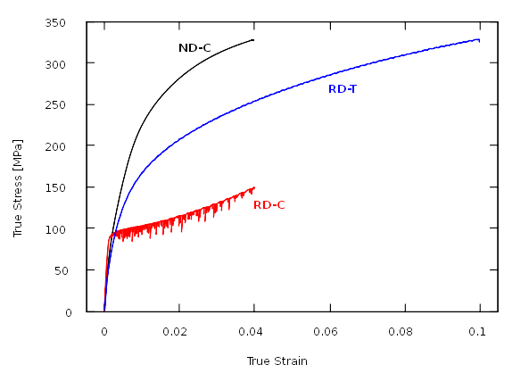Figure 30: Stress-strain curves of ND compressed (ND-C), RD compressed (RD-C) and RD tensiled (RD-T) magnesium AZ31B alloy specimens.
Synchrotron samples were cut from the mechanically tested specimens by EDM and electropolishing with the rotation axis parallel to the deformation axis. The geometry of the synchrotron specimens were a tapered needle shape similar to the one is shown in Fig. 8, with an average thickness of a few times . The experiments were carried out at the 1-ID beamline of the Advanced Photon Source (APS) synchrotron of Argonne National Laboratory, Argonne, Illinois. The same setup was used as was presented in section 4.2.2 for the CoTi and CoZr samples.

Evaluation of the X-ray diffraction experiments
Four slices were measured for the ND-C and RD-C specimens each and five slices for the RD-T. Dark images were measured at the beginning and the end of each rotation, and the diffraction images were dark image corrected with the closest measured dark image. For the peaksearch, a background image calculated as the minimum pixel values in the full series was further subtracted from the detector images. Peakserch was run with 12 different thresholds ranging from 100 to 2000, and the results were merged using merge_flt.py script as written in section 3.2.2.3. The peaksearch results were filtered to keep only peaks with more than one pixel breadth in both and detector directions, and containing more than 10 pixels. After the refinements of the geometrical parameters, peaks lying farther than from the Bragg positions were discarded. GrainSpotter indexing was run with a systematic scan in the Euler orientation space using steps. Fitting the positions of the grains was disabled. Grains with larger than 0.15 completeness were accepted, that required 57 or more assigned reflections. The allowed uncertainties of the reflections in , and were , and for the ND-C, , and for the RD-C, and , and for the RD-T specimens, respectively.
54711, 33821 and 67433 peaks were included in the peaks file merged from the 12 different peaksearch thresholds for the ND-C, RD-C and RD-T specimens respectively. 52290, 32468 and 65729 remained after filtering based on values. 26716, 17872 and 37856 reflections have been indexed by the GrainSpotter. 238, 183 and 371 grains were identified in the three specimens. The number of reflections assigned to a grain by GrainSpotter varied between 57 and 276. Later, during the refinement procedure by FitAllB, 2 grains were filtered out from each of the ND-C and the RD-C specimens.
Peak positions were simulated on the far detectors based on the grain orientations obtained from the indexing procedure on the close detector images. 18784, 10156 and 38956 peak profiles were integrated by the integration software on the far detector images. 13081 and 7636 profiles were included in the single grain patterns after the manual checking in the case of the ND-C and RD-C specimen respectively. Number of profiles corresponding to one grain varies between 15 and 179 for the ND-C and between 11 and 161 for the RD-C specimen.

Results

Textures of the deformed specimens
As the number of grains analyzed in this 3D-XRD experiment is a few hundred for each specimen, the three dimensional orientation distribution function (ODF) can not be determined with such statistical significance, as in the case of a dedicated texture measurement (cf. [Kocks et al. 2000]), however some important features of the texture can be can be recognized by plotting the grain orientations on pole figures (PFs) or inverse pole figures (iPFs).
PFs of the grain orientations are shown in Fig. 31 for the three specimens. The origin of the PFs are always the rotation axis of the X-ray diffraction measurement, which coincides with the deformation axis of the specimens. Volume fractions of the grains were determined based on the integrated intensities of the reflections using the FitAllB grain refinement software (sect. 3.2.5), and are shown on the PFs by the circle sizes.
In the ND-C specimens, the large grains lie in the center of the PF, which is in good correlation with the initial texture of the rolled plate (fig. 29). However, there are smaller grains residing at the edge region of the PF with their axis nearly perpendicular to the ND deformation axis.
In the RD-C specimen, most of the grains are oriented with axis around one specific direction perpendicular to the axis of deformation, and there are some small grains in the center region of the PF, which means their axis are almost parallel to the deformation axis. In this specimen at the beginning of the deformation the texture is such, that the axis of the grains are close to the ND, which is perpendicular to the deformation axis. During the compression, activation of twinning is expected, which changes the initial texture by rotating the axis by into the deformation axis. The PF in Fig. 31 b) suggests, that only a few twins were formed and most of the grains are still oriented with their axis perpendicular to the deformation axis supposedly around the ND direction of the original rolled plate.
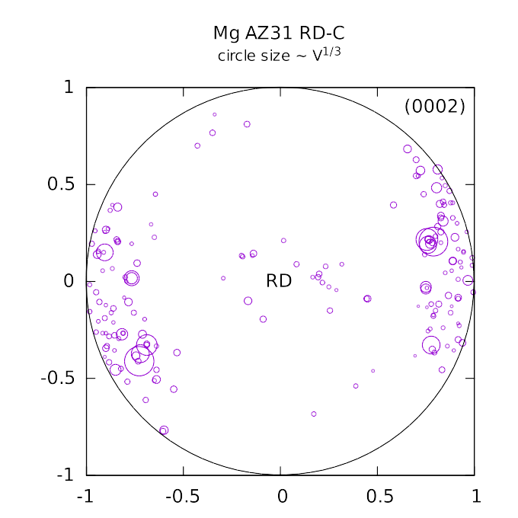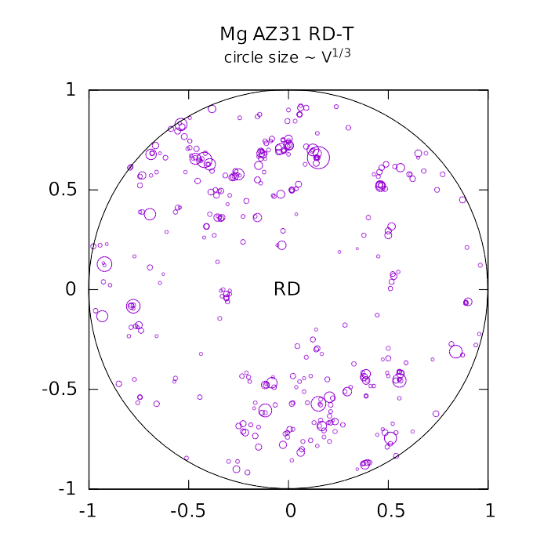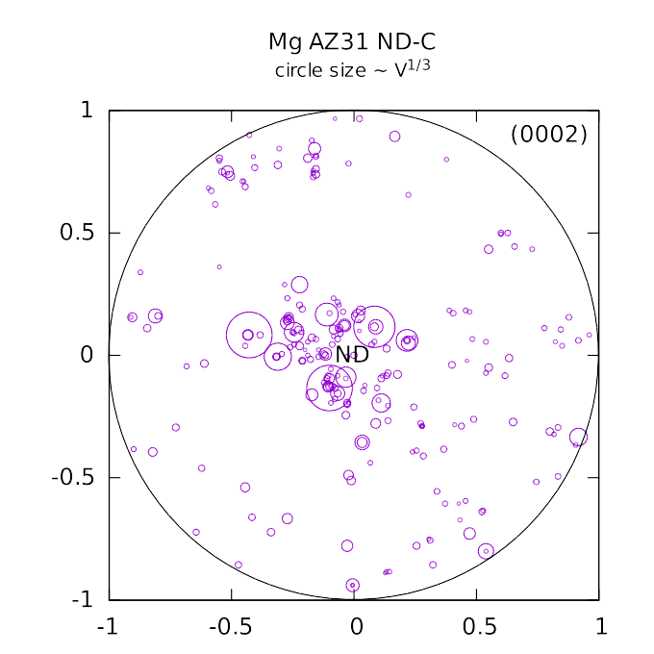
Figure 31: pole figure of grain orientations in the a) ND-C, b) RD-C and c) RD-T specimens. The diameter of the circles are proportional to the cubic root of the volume fractions of the grains as determined from the peak intensities by the FitAllB grain fitting software. The origin is the deformation axis on each pole figure.
a)
b)
c)
In the case of RD-T specimen, the initial texture is the same as for RD-C, i.e. the ND direction, the initial direction of the axis are perpendicular to the deformation axis. However, the texture shown in Fig. 31 c) after the deformation is much weaker than in the case of ND-C or RD-C specimens. The axis are more equally distributed on the whole area of the PF. Only a small portion at the center is empty. The initial rolling texture most probably has been weakened by the applied tensile deformation. The grains originally lying in the center of the PF, if there were any, turned out from the center by the activation of the tensile twinning. The grains are distributed on the PF in small bunches. The orientations of the grains within these bunches are very close to each other, the typical misorientation between them is about . This most probably indicates that the grains began to break up and a domain structure started to form due to the higher applied deformation than in the case of the ND-C and RD-C specimens. It is also shown by the misorientation distribution of the grains in Fig. 32. There is a small peak on the misorientation distribution below in the case of the RD-T specimen shown in Fig. 32 c). No such peak can be found in the misorientation distributions of the other two specimens. It is noted here, that due to the small misorientation between these grains in the bunches, their reflections are often slightly overlap in RC directions. The separation of these very close peaks was made possible by the multi-threshold peak searching that was described in section 3.2.2.3 and mentioned in section 5.2.
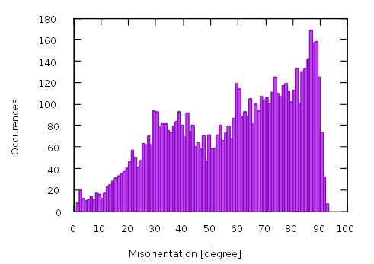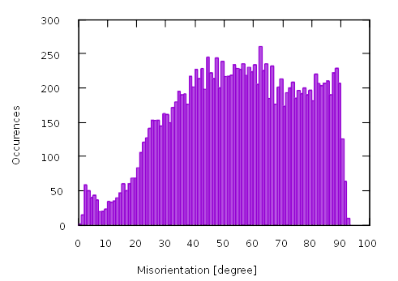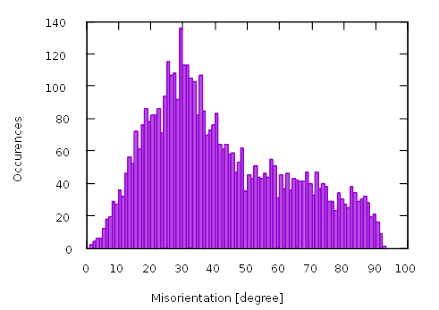
a)
b)
Figure 32: Misorientation distributions of the grains in the a) ND-C, b) RD-C and c) RD-T specimens.
c)

Identifying twinning
Twin boundary and stacking fault density can be determined in powder diffraction based on their effect on line profiles if the density of planar defects is larger than about [Balogh et al. 2006, 2009]. In a 3D-XRD experiment, however, the grains in a polycrystalline aggregate are measured as group of distinct single crystal reflections. By twinning, completely new crystal orientations are formed, that did not exist before. Therefore, in a 3D-XRD experiment, the original (parent) and the twin part of a partially twinned crystallite appear as two completely different crystals. There is a well defined orientation relation between the parent and the twin crystals determined by the crystal structure and the twinning system. Twinning can be well identified by the three dimensional misorientation distribution of the grains [Zhang et al. 2011]. If one type of twin crystals occur frequently in the specimen, then a peak appear in the three dimensional misorientation distribution around the point corresponding to the specific misorientation typical to that type of twins.
In the present study, the misorientation of two grains represented by three angles: , and . The meaning of these coordinates is shown in Fig. 33. is the angle between the axis of the two grains, and , is the angle between and , and is the angle between and , where and are the axis of the first and the second crystallite, respectively, and stands for vector multiplication.
The most commonly occurring twinning mode in magnesium is the tensile twins, cf. [Partridge 1967; Christian & Mahajan 1995; Niewczas 2010]. The characteristic angles corresponding to this twinning mode are and . The twinning mode is expected to play a role in both the formation of the initial texture of the rolling plate and in the uniaxial deformation of the RD-C specimen. When a compression stress is applied to a grain perpendicular to its axis, the diameter of the grain can be reduced by approximately a factor of in the direction of the compression (cf. [Partridge 1967]), therefore, a compression strain in this direction can be accommodated by twinning.
In order to detect twinning in the specimens, the misorientations of any two the grains within the same sections of the specimens were calculated and plotted in the , , coordinate system. As for the moment we are interested in the identification of twins, for which

Figure 33: The , and coordinate angles used to represent misorientation of two arbitrary grains. , , , are the and axis of the two grains.
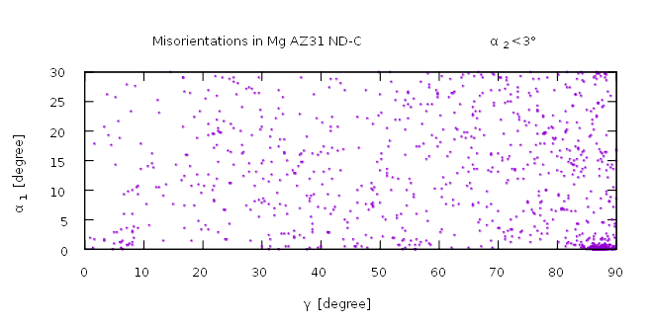
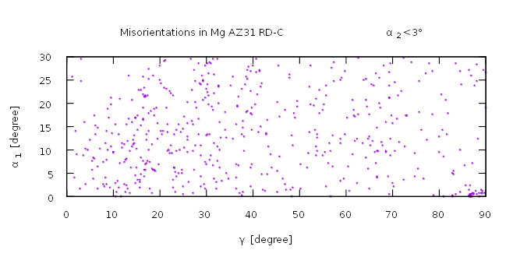
b)
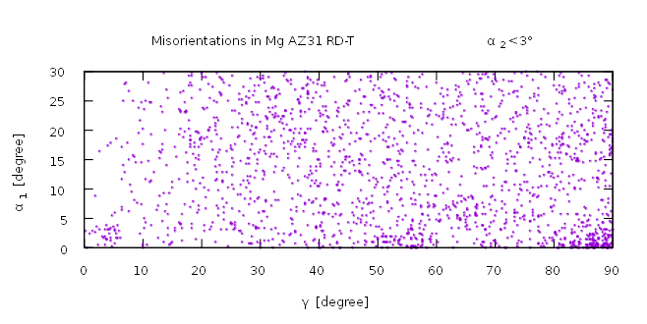
c)
Figure 34: sections of the 3D misorientation distributions of the a) ND-C, b) RD-C and c) RD-T specimens.
a)
, only the sections of the three dimensional misorientation space are plotted in Fig. 34 for the three specimens. On all three graph there is a densely populated area of misorientations in the bottom left corner of the plots around the point corresponding to the twins: , . This peak in the three dimensional misorientation distribution is surprisingly the sharpest and strogest in the case of ND-C specimen, which indicates a strong presence of type parent-twin pairs in this specimen. This peak also exists in the RD-C specimen, however, much smaller number of grain pairs can be found with this specific orientation relation. The same peak can be found in the RD-T specimen too, but it is much more diffuse in the misorientation space, than in the case of the other two specimens. It is most probably because of the breaking up of the grains into a domain structure due to the higher applied deformation as it was already mentioned in section 5.3.1.
Grain pairs lying within this peak in the misorientation space can be regarded as potential twin pairs. In the current experiment there is no enough spatial resolution of the grains to determine neighborhood relations, therefore it can not be ruled out, that two grains residing far from each other within the specimen are oriented relative to each other by chance as, if they were twins. Comparing the density of the points within the peak corresponding to the type parent-twin misorientation and elsewhere in the misorientation space in Fig. 34, one can conclude that most of the grain pairs lying around the , point corresponding to the type twin pairs are likely to be actual twins.

Twin pairs in the ND-C specimen
Based on the consideration about misorientation values typical to the type twinning in magnesium presented in the previous paragraph, the potential twin pairs are connected by straight lines on the PFs and plotted in Fig. 35. In the ND-C specimen the potential twin pairs are always such, that one of the grains is in the center of the PF, i.e. their axis is close to ND, and the other is close to the edge of the PF, i.e. their axis is nearly perpendicular to ND. During rolling or ND compression or tension these pairs of grain orientations can transform into each other by type twinning. Which member of the grain pair is the parent and which one is the twin depends on the direction of the deformation. It is true for all potential twin pairs identified in the ND-C specimen, that one of the grains of the twin pair has axis not farther than from the center of the PF, i.e. the ND, and the other has axis not closer than from the center (ND). Based on this criteria the grains can be divided into two groups, the ”center” and the “periphery” grains, and all twin pairs consist of one center and one periphery grain. There is one grain in the specimen with axis from ND. This grain has several pairs and one of them has axis closer than from the center and the others have axis farther than from the center. This one grain is regarded either as “center” or “periphery” depending on which of their pairs are considered.
Altogether there are 117 “periphery” and 118 “center” grains in the ND-C specimen, and there is one which can be either “center” or “periphery”. So the numbers of grains are practically the same in the center that on the periphery. However, the largest grains are in the center of the PF. The periphery grains have zero or one potential twin pairs, while in the center, many grains have more than one potential twin pairs. One of the center grains have potential pairs for all the six variants of the type twinning system. 42 “center” and 84 “periphery” grains have at least one potential twin pair, so on the average, there are two “periphery” twin pairs for one “center” grain. The “center” grain of a twin pair is typically much larger than the “periphery” grain as it is shown in Fig. 36. The grains with one or more potential twin pairs and the grains without identified potential twin pairs are plotted in Fig. 37 a) and b), respectively. While on the periphery most of the grains have identified potential twin pairs, in the center only the large grains have identified potential twin pairs and there is a large number of small grains without any identified twin pairs. Since the “periphery” grains of the identified twin pairs are typically much smaller than the center grains, it is possible that the small grains in the center of the PF have even smaller twin pairs on the periphery, but they can not be seen by the current method due to their very small volume fraction, as their very weak diffraction peaks can not be identified on the detector.
Since within the identified potential twin pairs, one center grain has typically more than one pairs on the periphery, it is very likely that “center” grains are the parent grains and “periphery” grains are the twins. Otherwise it would be very unlikely that more than one parent grain on the periphery can twin into exactly the same orientation in the center. During the rolling process, it is expected that the “periphery” grains are turning into ND by twinning and this way the rolling texture shown in Fig. 29 is formed. During the ND compression, grains can not twin further, as they already turned into ND, so they expected to deform by dislocation slip. On the contrary, tensile stress is needed to turn the center grains onto the periphery by twinning. So there is an apparent contradiction between the expected deformation mechanism and the large number of identified twin pairs within the specimen. It might be resolved by the assumption, that the experienced twin pairs are formed during the unloading of the specimen due to the intergranular stresses. Agnew and Duygulu [2005] reported that the commercially rolled Mg AZ31B alloy plate with H24 temper contains a significant volume fraction of deformation twins. Therefore, it is also possible, that the large number of identified type twin pairs originate from the rolling process, and some of these grains were still not completely twinned to ND during the compression test, but a small portion remained in their original orientation corresponding to the periphery region of the PF. These grains might start to de-twin during the unloading of the specimen.
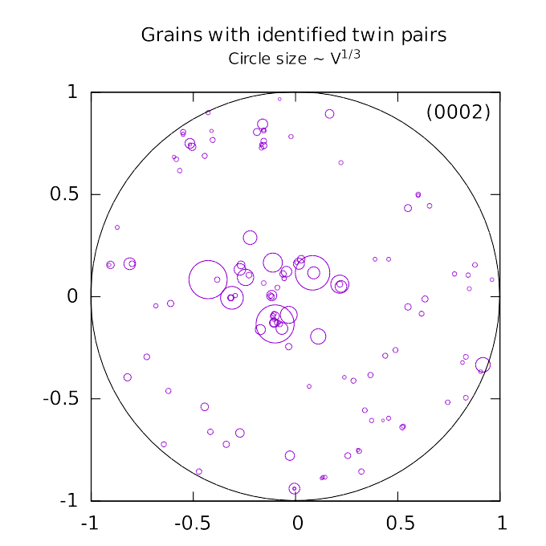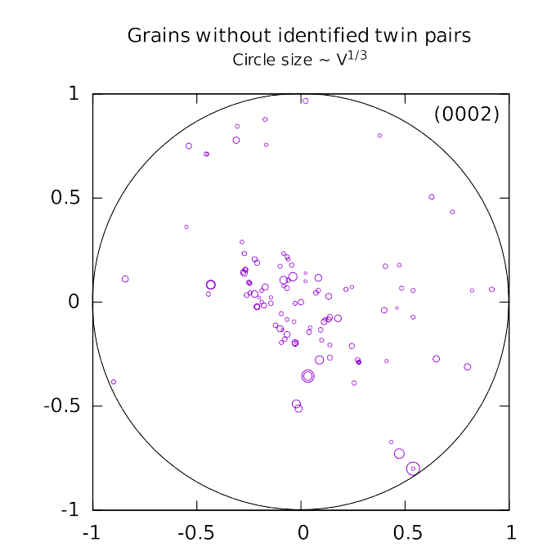
Figure 37: Grains a) with and b) without identified potential twin pairs in the ND-C specimen plotted on PFs.
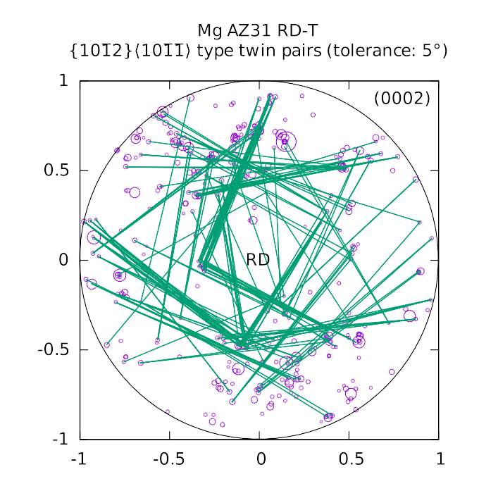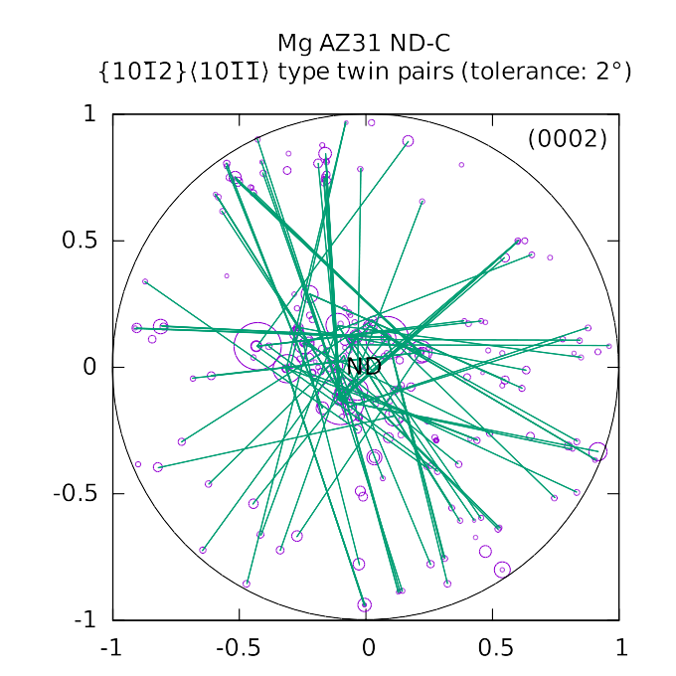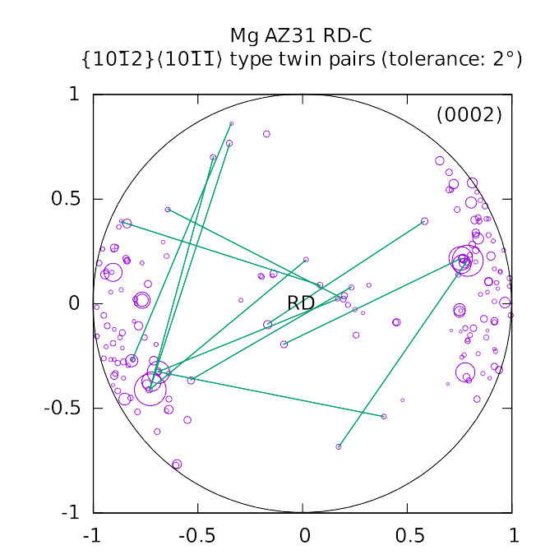Figure 35: Potential type twin pairs determined by their misorientation connected by straight lines on the PFs for the a) ND-C, b) RD-C and c) RD-T specimens. Tolerances for the parent-twin misorientation are 2° for the ND-C and RD-C specimens and 5° for the RD-T specimen.
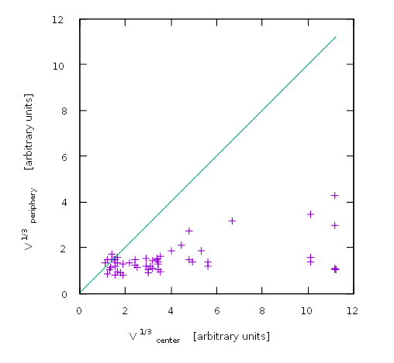Figure 36: The cubic root of the volume fractions (i.e. the mean linear size) of the "center" and the "periphery" members of the potential twin pairs in the ND-C specimen. The "center" members of the twin pairs are typically much larger than the corresponding "periphery" grains.
b)
a)

Twin pairs in the RD-C specimen
As it was already mentioned in section 5.3.1, the initial texture for the RD-C specimen is such, that axis are close to ND, which is perpendicular to RD, and during the compression deformation grains are expected to turn into RD by twinning. Most of the grains on the PF in Fig. 35 b) are still lying approximately in the east-west direction, which corresponds to the initial texture, and there is an other group of smaller grains lying near RD, the center of the PF. The number of identified potential twin pairs is much smaller for this specimen, than in the case of ND-C, it is only 12. Some of these pairs are indeed connecting grains in the center with grains in the east and west side of the PF. These twins are probably formed during the compression deformation of the specimen, however, it seems, the deformation was not large enough to rotate the full grains in the center, but only a small portion was twinned. It is also possible, that the twins formed during compression are partially de-twinned to the original orientation during unloading. There is also a very few grains in approximately the north-south direction of the PF, and these grains are also connected to the east-west grains by twin orientation relation. These twins most probably remained from the rolling. They were not completely twinned to ND during rolling, but a small portion of the grains remained in their original orientation before rolling, and these twin pairs may still exist in the specimen after the RD compression deformation.

Twin pairs in the RD-T specimen
In the case of RD-T specimen due to the higher applied deformation and the formed domain structure, the texture and the misorientation distribution is not so sharp than in the case of the other two specimens. Therefore, a higher tolerance was chosen for twin identification: 5° instead of the 2° for the other two specimens. The number of identified possible twin pairs is 169, which is the largest among the three specimen. However, often there are group of twin pairs between the small bunches of grains with very similar orientations. As twinning is not expected to occur during the RD tension deformation, most probably these twins remained from the rolling. During the RD tension deformation both member of these twin pairs are started to break up and form a domain structure. As their orientations are slightly changed, the ideal twin misorientation relation between them corresponding to the type twins was somewhat impaired, but using a higher tolerance, they still can be connected to each other. It is important to note however, that the number of identified grains is the largest for this one among the three specimens. Compared to the other specimens, due to the large number of grains and the higher applied tolerance for twin identification, there is a higher chance that some of the identified pairs are not actual twins.

Dislocation analysis of the ND-C specimen
CMWP line profile fitting was run for the patterns created from the manually checked profiles, and the the unscaled, measured individual dislocation contrast factors have been determined. Dislocation types used for the dislocation structure fitting are listed in Table 6. 30 edge and 9 screw dislocation types were considered. Slip system analysis can be done based on the edge dislocations, where the slip plane is defined by the Burgers and the line vectors. The considered slip plane types are listed by indices and names in the third column of Table 6. SS types are named based on slip plane and Burgers vector types. The five SS types considered in this magnesium alloy are the basal, prismatic, pyramidal ⟨a⟩, pyramidal ⟨c+a⟩/A and pyramidal ⟨c+a⟩/B. For the basal and the prismatic SSs only the ⟨a⟩ type Burgers vectors are considered, therefore, the Burgers vector type is omitted from the SS type name for the sake of brevity.
The total dislocation densities in individual grains and the dislocation densities of the edge dislocations corresponding to the different SS types are plotted in ND iPFs in Fig. 38. The total dislocation density is more or less equally distributed within the area of the iPF. The values scatter between about and , although they tend to be slightly higher near the corner of the iPF. The most apparent gradients can be seen in the iPFs of the prismatic and pyramidal ⟨c+a⟩/A type dislocation densities in Fig. 38 c) and e). Prismatic dislocations are much more frequent near the corner of the iPF then elsewhere, which corresponds to the “center” region in the PF in Figs. 31 a) and 35 a). The pyramidal ⟨c+a⟩/A dislocations are typically measured near the right side of the iPF, which corresponds to the periphery region of the PFs. Although, the pyramidal ⟨c+a⟩/A dislocation density is much lower within the overall measured volume of the specimen than the prismatic one. In the case of basal and pyramidal ⟨a⟩ dislocations it is hard to discover trends on the iPFs. The latter tends to increase slightly toward the “periphery” region on the right hand side of the iPF, although the local scatter of the values is large everywhere: between about zero and . The density of pyramidal ⟨c+a⟩/B dislocations is negligible in almost every measured grain of the specimen.
character | Burgers vector type | slip plane type | number of dislocation types | dislocation types
edge | a | basal | 3 | [-100](001)_{90}; [-1-10](001)_{90};  [010](001)_{90}
edge | a | prismatic | 3 | [010](100)_{90}; [110](1-10)_{90};  [100](0-10)_{90}
edge | a | pyramidal A | 6 | [010](101)_{90}; [110](1-11)_{90};  [100](0-11)_{90}; [0-10](-101)_{90};  [-1-10](-111)_{90}; [-100](011)_{90}
edge | c+a | pyramidal A | 12 | [-101](101)_{90}; [-101](1-11)_{90};  [101](-101)_{90}; [101](-111)_{90};  [0-11](-111)_{90}; [0-11](011)_{90};  [011](1-11)_{90}; [011](0-11)_{90};  [111](0-11)_{90}; [111](-101)_{90};  [-1-11](011)_{90}; [-1-11](101)_{90}
edge | c+a | pyramidal B | 6 | [111](-1-12)_{90}; [101](-212)_{90};  [0-11](-122)_{90}; [-1-11](112)_{90};  [-101](2-12)_{90}; [011](1-22)_{90}
screw | a | - | 3 | [100]_{0}; [110]_{0}; [010]_{0}
screw | c+a | - | 6 | [-101]_{0}; [-10-1]_{0}; [0-11]_{0};  [0-1-1]_{0}; [111]_{0}; [11-1]_{0}
Table 6: The 39 different dislocation types considered in case of the Mg AZ31 alloy specimens.

Dislocation densities in the twin pairs of the ND-C specimen
The orientation dependence of the different dislocation types were studied on the iPFs in the previous section. For some of the dislocation types a correlation can be found between the orientation of the grain on the iPF and the measured dislocation densities, although the local scatter of the measured dislocation density values are large everywhere and it is often hard to discover the gradients on the color coded iPFs. The parent-twin relation of the grains can also affect the dislocation structure. When dislocations and twin boundaries traversing on each other, they interact and dislocations in the parent grain can transform into different types in the twin crystals (cf. [Christian & Mahajan 1995; Niewczas 2010]). The present method of identifying parent-twin pairs by their specific misorientation relation does not provide direct information on the parent or twin nature of the crystals, only their parent-twin relationship is revealed. The members of the parent-twin pairs were labeled as “center” and “periphery” grains instead in section 5.3.3. This grouping well fits the physical condition of the ND deformation. In case of a ND compression, the deformation forces the grains to twin from the “periphery” orientation to the “center” orientation, and in case of ND tension, it forces backward to twin from “center” to “periphery”.

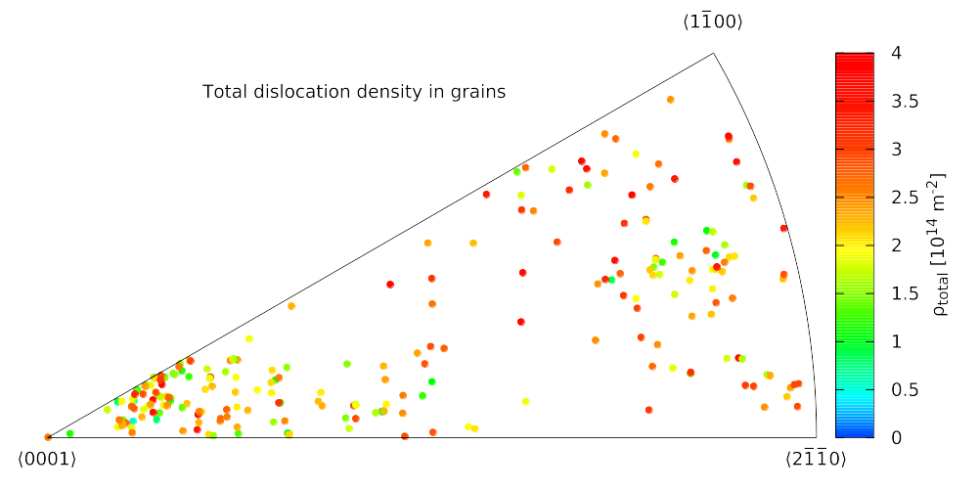
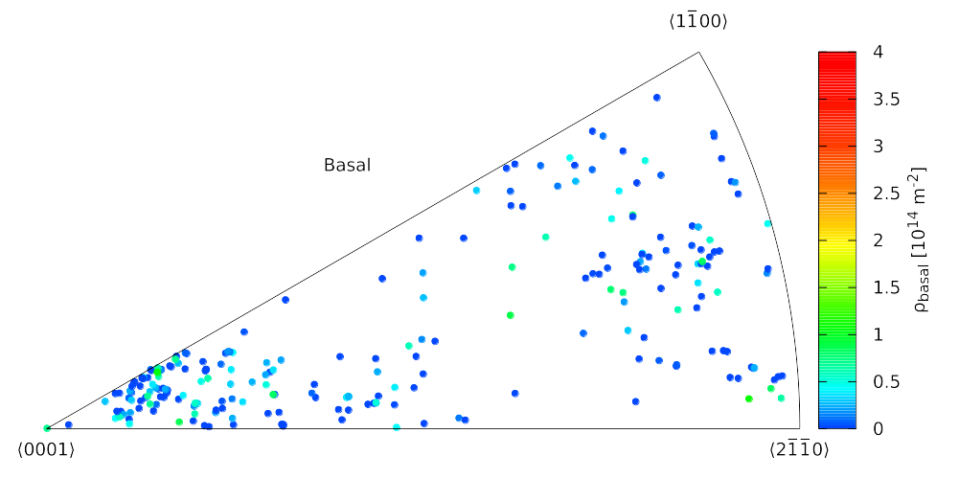
b)
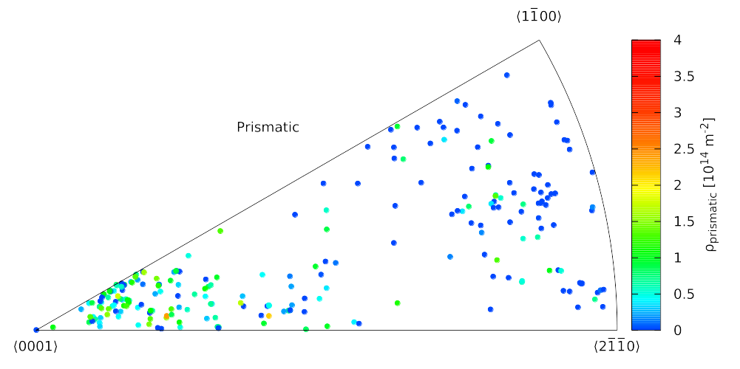
c)
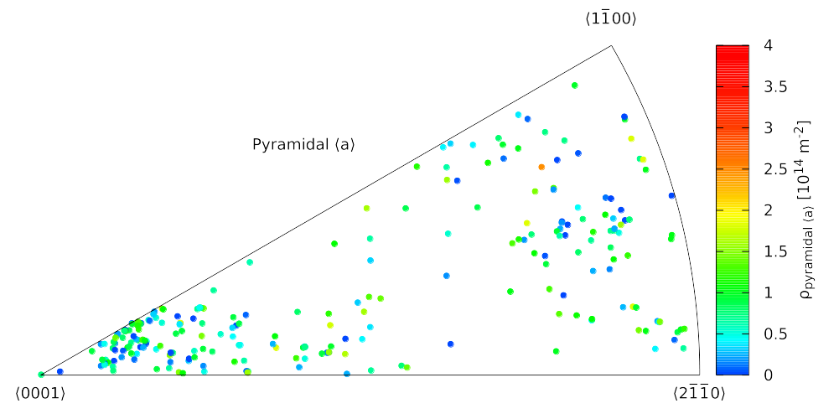
d)
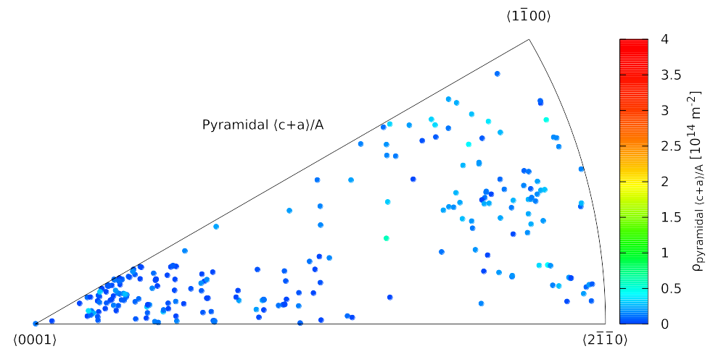
e)
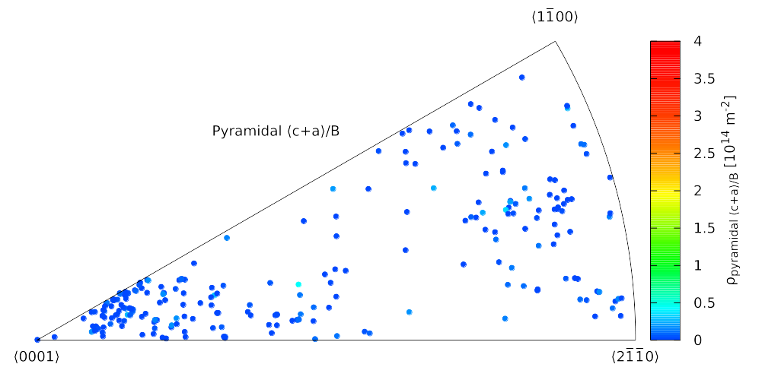
f)
Figure 38: a) Total dislocation density and b)-f) dislocation densities of the edge dislocations corresponding to different SS types in the ND-C specimen plotted on ND iPFs.
a)
Total dislocation densities and the dislocation densities of the edge dislocations corresponding to the different SS types in the “center” versus the “periphery” members of the parent-twin pairs are plotted in Figs. 39 a)-f). The figures reveal major differences between the dislocation structure of the parent and the twin grains. The total dislocation density in most of the twin pairs is larger in the “periphery” grain. The typical difference between the dislocation density of the “periphery” and the “center” grain is about . Prismatic dislocations are much more frequently present in the “center” grains of the pairs than in the “periphery” grains. The prismatic dislocation density is zero in most of the “periphery” grains and there is only one pair, where it is larger in the “periphery” than in the “center”. Pyramidal ⟨a⟩ and pyramidal ⟨c+a⟩/A dislocation densities are typically larger in the “periphery” grains. There is no significant differences in the basal and pyramidal ⟨c+a⟩/B dislocation densities of the “center” and the “periphery” grains in the pairs.
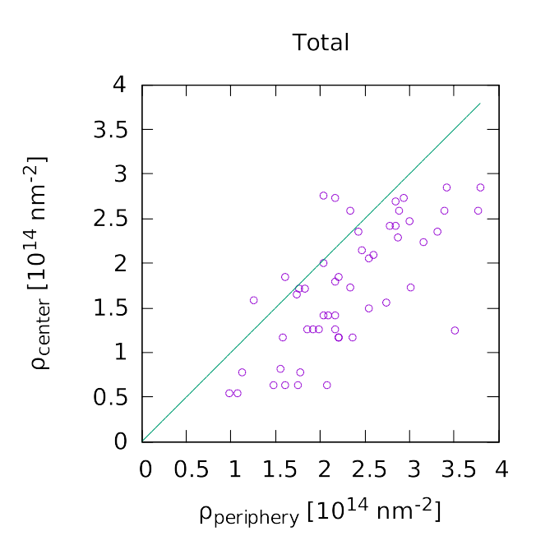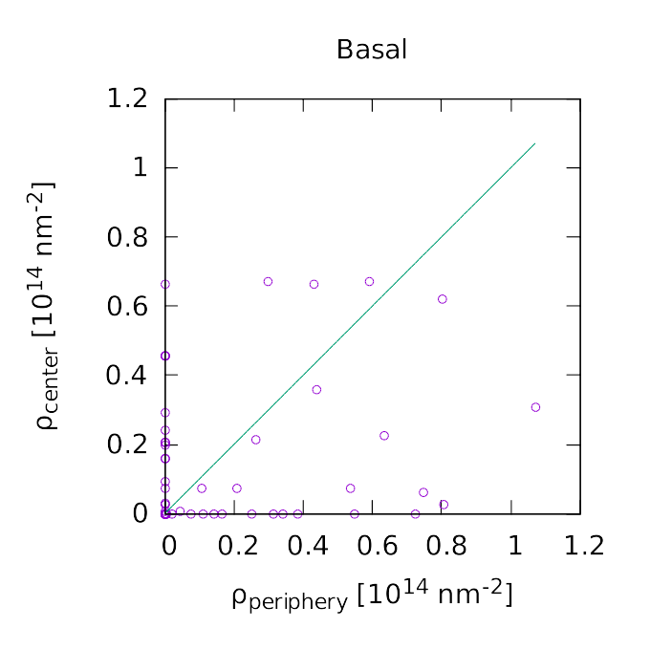
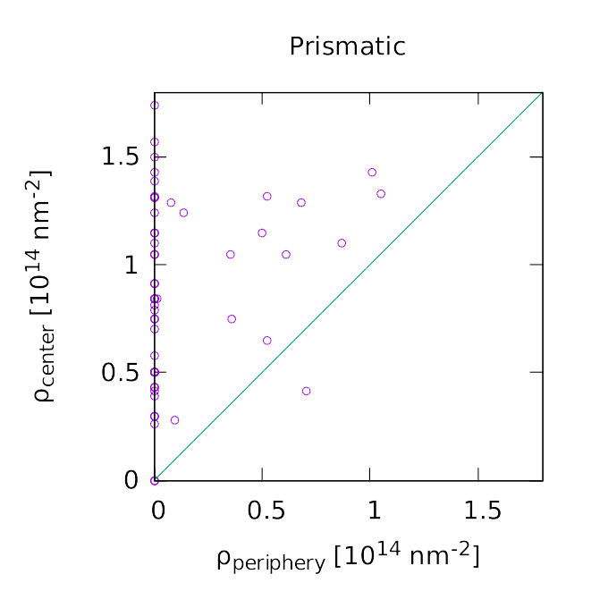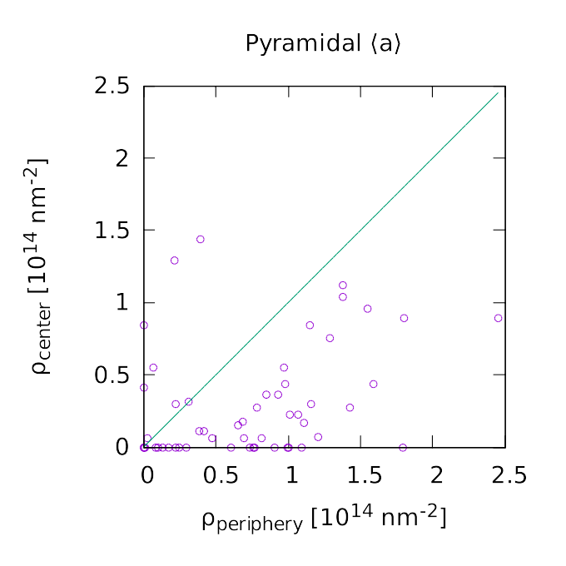
c)
d)
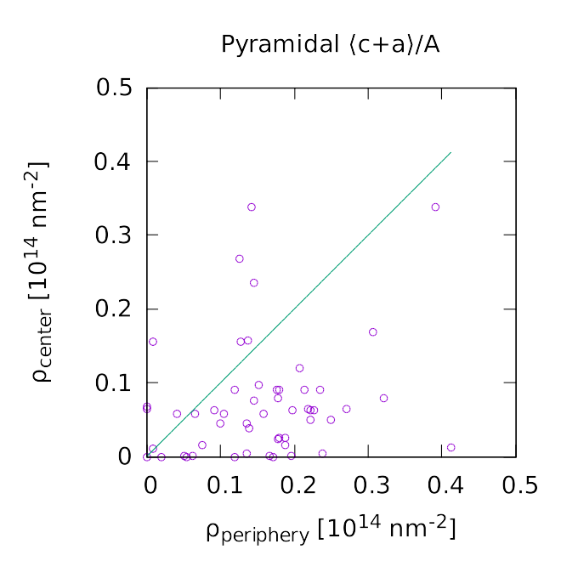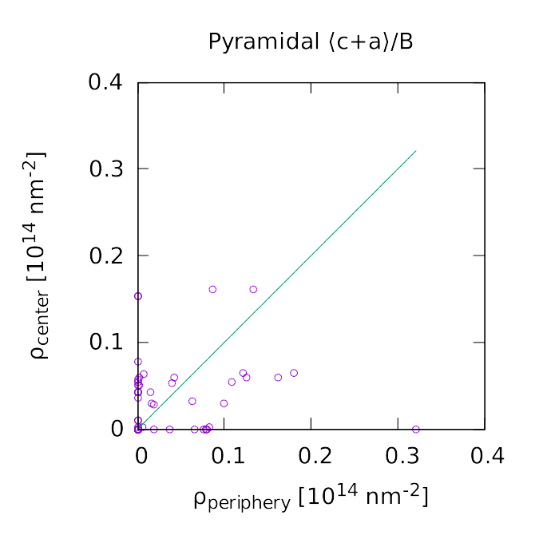
f)
e)
Figure 39: a) Total dislocation density and b)-f) dislocation densities of the different SS types in the "center" vs. the "periphery" members of the type parent-twin pairs in the ND-C specimen.

b)
a)

Dislocation analysis of the RD-C specimen
The total dislocation densities and the edge dislocation densities corresponding to different SS types in the measured grains f the RD-C specimen are plotted on RD iPFs in Fig. 40 a)-f). Texture is stronger in this specimen than in the ND-C, therefore the middle of the iPFs are almost empty. Grains are residing either on the right-hand side of the iPF or around the corner on the left side. Total dislocation density values scatter between about and , however, the lowest dislocation density grains are all residing on the right-hand side of the iPF. Grains with the highest basal, prismatic and pyramidal ⟨c+a⟩/A dislocation density values are also residing on the right side. It is difficult to find any gradients on the pyramidal ⟨a⟩ dislocation density iPF and the pyramidal ⟨c+a⟩/B values are negligible in most of the grains similarly to the ND-C specimen.

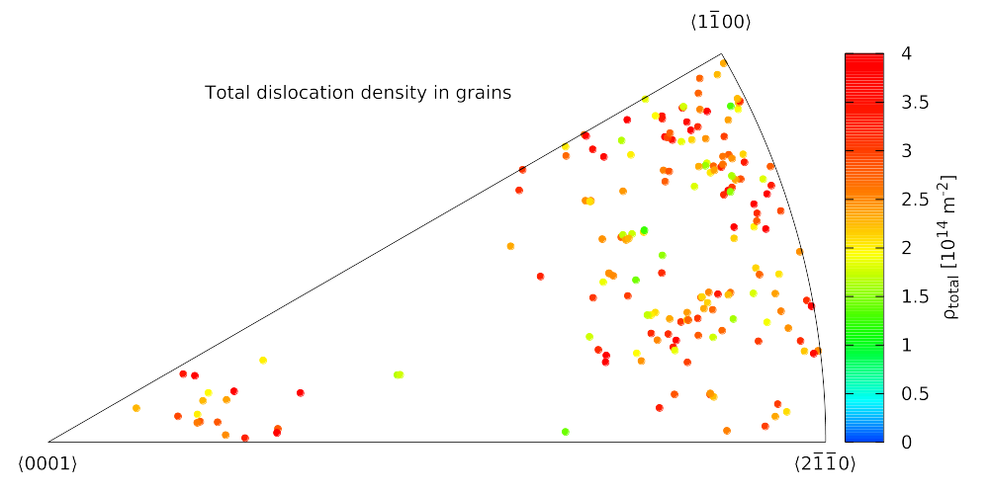
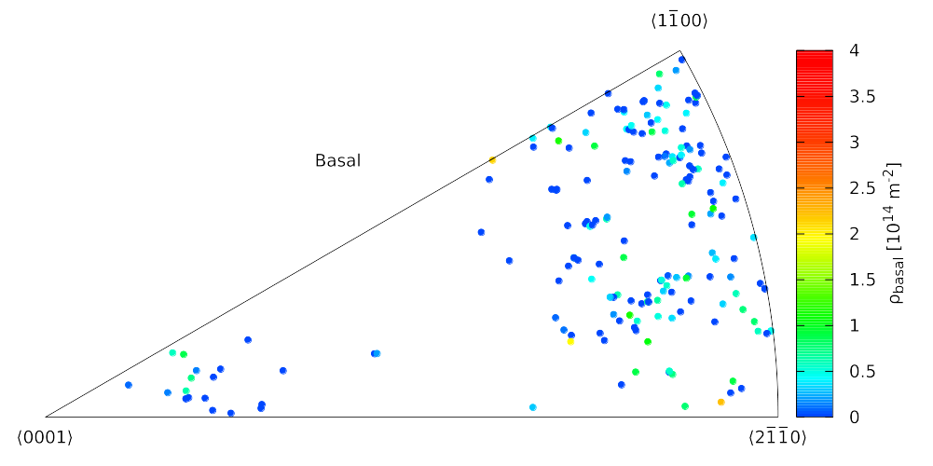
b)
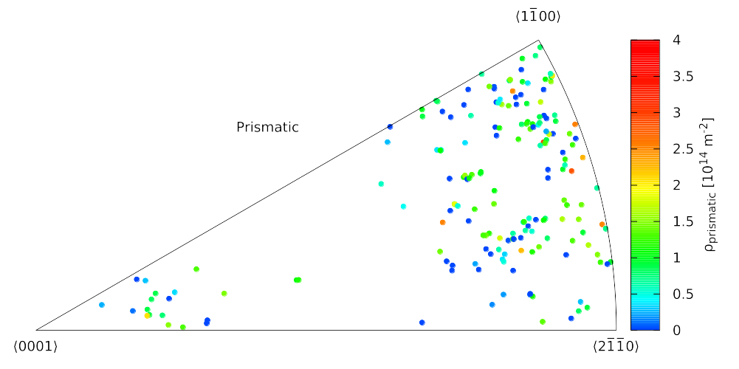
c)
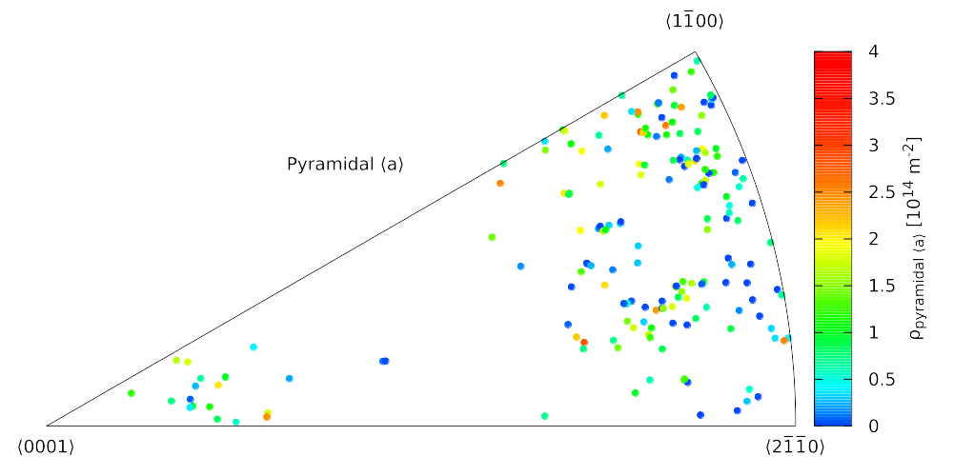
d)
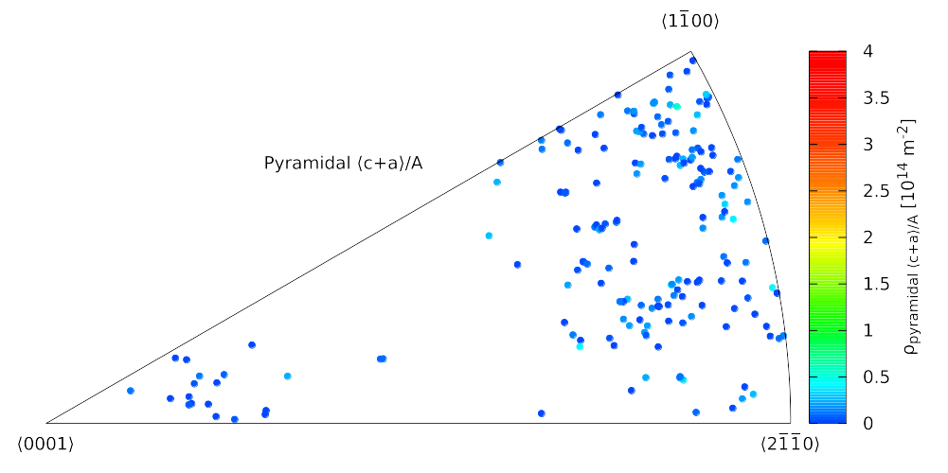
e)
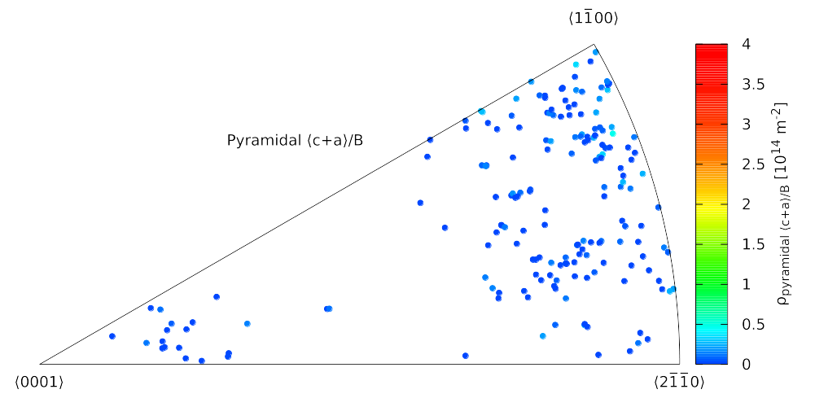
f)
Figure 40: ) Total dislocation density and b)-f) dislocation densities of the edge dislocations corresponding to different SS types in the RD-C specimen plotted on RD iPFs.
a)

Dislocation densities in the twin pairs of the RD-C specimen
As it was mentioned in sections 5.3.1 and 5.3.4, most of the grains of the RD-C specimen residing in approximately the east-west (EW) direction of the PF in Figs. 31 b) and 35 b). Therefore, I shall call this group of grains EW. More precisely the average direction of this EW group of grains is rotated by about anti-clockwise compared to the EW direction. All identified potential twin pairs in this specimen connecting one EW grain with an other grain outside of the EW group. There is a smaller group of grains around the center of the PF, which corresponds to RD, therefore this group is called RD. There are also a few grains that neither belong to EW nor RD. These are residing approximately in the north-south direction of the PF, therefore I shall call them NS. To make this grouping unequivocal, the groups are plotted with different colors on the PF in Fig. 41.
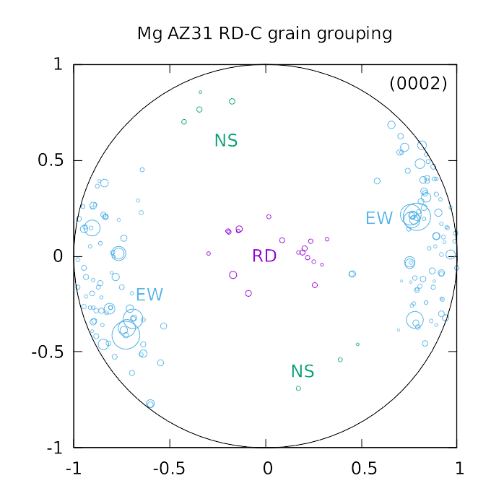Figure 41: Grouping of the grains of RD-C specimen based on their position on the PF. The largest group of the grains are approximately in the East-West (EW) direction of the PF (but tilted by about 9°). This direction is most probably the original ND of the rolled plate. The other group is around RD, which is the direction of the compression for this specimen. There are a few more grains that neither belong to the EW nor the RD groups. They are more or less in the North-South direction, therefore, this third group is called NS.
With this grouping, all twin pairs in the RD-C connect one EW grain with either one RD grain or one NS grain. Therefore, the total dislocation densities and the partial edge dislocation densities of the different SS types are now plotted in the RD or NS grains versus in the corresponding EW grains for each twin pairs in Figs. 42 a)-f). The RD and NS grains are distinguished by the point style. RD and NS grains are plotted by purple circles and green squares respectively. The total dislocation density is larger in the RD or NS grains than in the corresponding EW pairs in each identified twin pairs. The prismatic dislocation density is usually much larger in the EW grains than in their RD or NS pairs. There is one exception of this among the NS grains. Basal dislocation density is larger in EW grains than in their NS pairs, but there is no significant difference between the members of the EW-RD pairs. The pyramidal ⟨c+a⟩/A dislocation density in EW-RD pairs is usually larger in the EW grains and for EW-NS pairs the relation seems to be the opposite, but the differences are not very significant in either of cases.
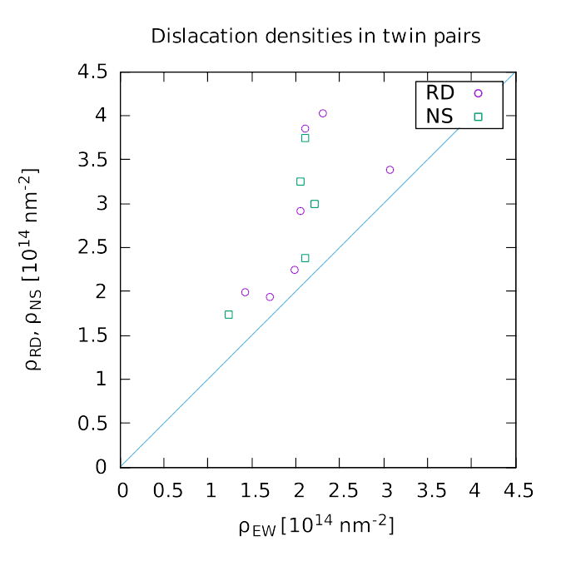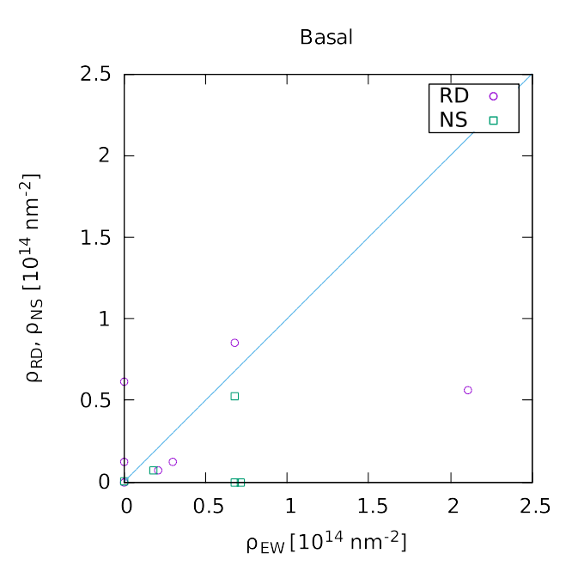
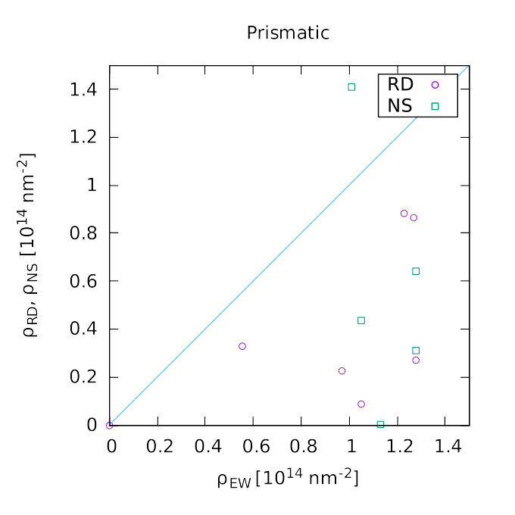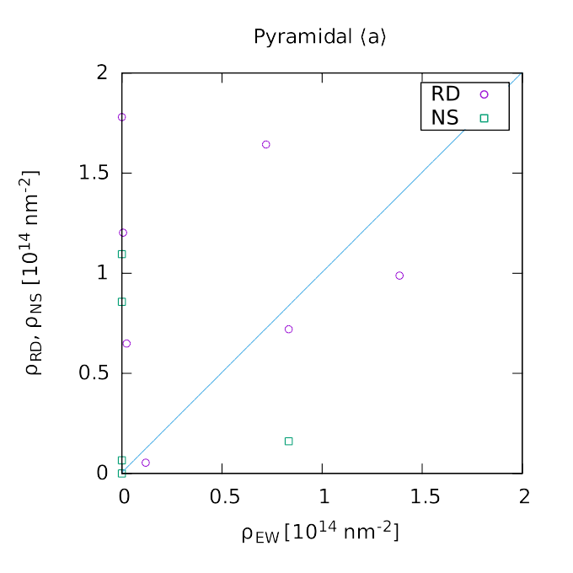
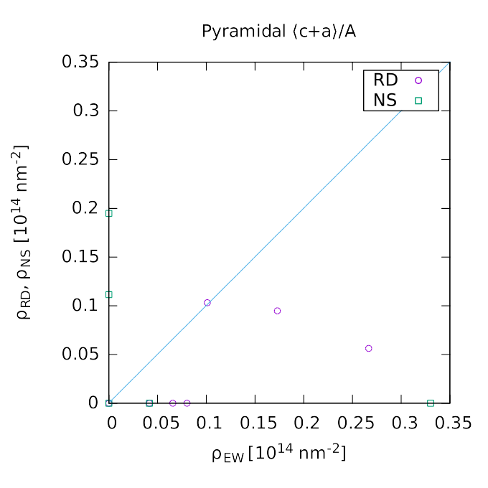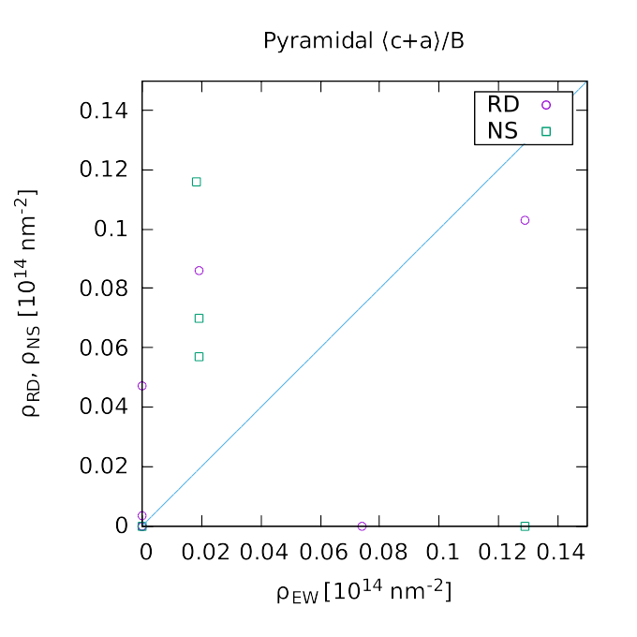
Figure 42: a) Total dislocation density and b)-f) dislocation densities of the different SS types in the RD or NS vs. the EW members of the type parent-twin pairs in the RD-C specimen. Grain pairs consisting of one EW and one RD grains are denoted by purple circles. Grain pairs consisting of one EW and one NS grains are denoted by green squares.

Conclusion
Sample textures were analyzed based on the measured grain orientations and volume fractions. Texture of the ND-C and RD-C specimens resembles the rolling texture of the original plate. In the case of RD-C specimen, rotation of the axis are expected by 86.3° due to activation of type twinning systems. Measurement shows that only a small fraction of the grains were twinned. Grains might partially de-twinned during the unloading of the specimen. Texture of the RD-T specimen is weaker, most probably due to the higher applied deformation. Bunches of small grains on the PF with nearly equal orientations and a peak on the one dimensional misorientation distribution below suggest that domain structure started to form.
The three dimensional misorientation distributions show that type twin pairs are present in all three specimens. Large number of twin pairs identified in ND-C specimen might originate from the rolling process or from de-twinning during unloading. Smaller number of twin pairs in RD-C specimen suggests again, that only a small fraction of the grains were twinned during the compression test. Large number of potential twin pairs in the RD-T specimen are connecting the bunches of grains on the PF, that confirms again the domain structure formation in this specimen.
Orientation dependence of the prevailing SSs were analyzed by plotting the densities of the corresponding edge dislocation types on iPFs. The most pronounced orientation dependence is found in the case of prismatic and pyramidal ⟨c+a⟩/A dislocations. In the ND-C specimen, prismatic dislocation density is the largest near the corner and pyramidal ⟨c+a⟩/A dislocation density is increasing towards the and corners. In RD-C specimen both the prismatic and the pyramidal ⟨c+a⟩/A dislocation densities are increasing towards the and corners. Dislocation analysis of the RD-T specimen is still to be completed.
Dislocation densities of the different dislocation types were also analyzed in connection with the parent-twin relationship of the grains. Since the misorientation based twin pair identification does not provide direct information on which grain is the parent, and which one is the twin, grains were grouped based on their orientations. The most probable parents and the most probable twins were grouped into the same groups. In the ND-C specimen, the total dislocation density is typically larger in the “periphery” grain of the twin pair, which have axis nearly perpendicular to ND or the compression direction. Prismatic dislocation density is typically larger in “center”, while pyramidal ⟨a⟩ and pyramidal ⟨c+a⟩/A in the “periphery” grains. Similar relations can be found in RD-C specimen, but with less statistical significance due to the smaller number of identified twin pairs.

Summary and conclusions
Mathematical description of the diffraction peak broadening is presented in chapter 2. A new unified formalism is proposed to describe line broadening (LB) and rocking-curve broadening (RCB). Experimental techniques to measure line profiles (LP) and rocking-curves (RC) are reviewed. Physical models for describing LB and RCB are briefly outlined and applied for experiments, where LPs and RCs were measured on the same single crystals or individual grains of bulk polycrystalline specimens.
Synchrotron X-ray diffraction method has been developed for measuring dislocation densities and dislocation types in individual grains of polycrystalline aggregates. The evaluation steps are described in detail in chapter 3 and in the appendices. Direction dependence of the dislocation line broadening contrast factor is discussed. A Monte-Carlo type fitting is proposed to find the dislocation configuration best describing the measured line broadening contrasts.
The experimental method and the evaluation tools presented in chapter 3 were applied to plastically deformed polycrystalline CoTi, CoZr and Mg AZ31 alloy specimens, and the results are presented in chapters 4 and 5. It is demonstrated, that the prevailing slip systems and dislocation types can be determined in individual grains of bulk polycrystalline specimens, and this data can be analyzed in connection with the grain orientations and parent-twin relations.
Most important results of my work:
- Unified mathematical description of line profiles and rocking curves was constructed based on the polar decomposition of nonlocal strain tensor into a rotation and a stretching part [Zilahi et al. 2015]. Is was shown through experimental examples that the rotation part need not be infinitesimal. The infinitesimal decomposition of the strain tensor into symmetrical and antisymmetrical components fails to account for the non-infinitesimal rotations of subgrains in plastically deformed crystals. It was shown that the rocking-curve broadening is produced by both rigid-body rotations and the shear components of strain. In dislocated crystals, however, the major contribution stems from rigid-body rotations.
- X-ray diffraction technique was developed for grain-by-grain assessment of dislocation density within polycrystals [Ungár et al. 2014]. The technique can discriminate between the dislocation densities of different Burgers vector types and dislocation characters (edge or screw) because the dislocation density, Burgers vector and line direction enter into the determination of -dependent line broadening directly. The single-grain-based approach is free of assumptions inherent in previously published line-broadening studies based upon powder diffraction. Data which was formerly relegated to the transmission electron microscope is now available from X-ray diffraction. This is useful for the assessment of deformation mechanism activity within plastically anisotropic materials, such as CsCl structured ordered alloys or non-cubic metals.
- It was shown, that the direction dependence of dislocation line broadening contrast of any dislocation configuration can be described by 15 parameters, that are the coefficients for the 15 independent combinations of the direction cosines, where the direction cosines are calculated in the orthonormal coordinate system fixed with respect to the crystal lattice [Zilahi et al. 2017a]. An important consequence of this finding is that if more than 15 different dislocation types are present in the diffracting volume of a single grain, then it is not possible to unequivocally determine the dislocation configuration based on the measured dislocation broadening contrast factors.
- A new Monte-Carlo type fitting algorithm was developed for determining the dislocation configuration best describing the measured dislocation broadening contrasts [Ungár et al. 2014]. It essentially solves a set of linear equations, but it makes use of extra conditions stemming from the physical properties of the dislocation structure: (i) The solution has to be non-negative for all dislocation types and (ii) although the total number of possible dislocations types is fairly large, during the plastic deformation of a grain, usually only a few slip systems are active, therefore, only a few different types of dislocations are generated and remain present in the grain after plastic deformation. The method was verified on a simulated data set. It was able to reproduce about 90% of the simulated dislocation types with reasonable accuracy, when 5 different dislocation types were present in each single grains of the simulated data set and about 3% to 5% random noise were added to the simulated contrast factors as experimental errors.
- The newly developed method was applied to plastically deformed polycrystalline CoTi and CoZr B2 structured intermetallic alloys [Ungár et al. 2014]. Over 150 grains were analyzed within the two samples examined. It was concluded that plastic deformation in CoTi and CoZr with the B2 structure is caused by the combined activation of Soft-M () and Hard-M ( and ) dislocations, in agreement with former TEM observations of a small number of grains. The results provide a satisfactory explanation for the moderate ductility exhibited by these two CsCl-structured ordered intermetallic compounds. The level of ductility exhibited by these compounds was previously considered anomalous, based upon an understanding of the available deformation mechanisms developed from single crystal experiments.
- The newly developed method was applied to plastically deformed polycrystalline Mg AZ31 alloy specimens [Zilahi et al. 2017b]. Sample textures were analyzed based on the measured grain orientations and volume fractions. Parent-twin relations were determined based on the three dimensional misorientation distribution of the grains. Slip system types were analyzed in connection with the grain orientations on the inverse pole figures and the parent-twin relationships of the grains. The analysis revealed substantial differences between the dislocation structure of the parent and the twin crystals. Within the twin pairs of the ND-C specimen, total dislocation density is lower in the “center” grain of the pair, which has axis closer to ND. Prismatic dislocation density is typically larger in “center”, while pyramidal ⟨a⟩ and pyramidal ⟨c+a⟩/A in the “periphery” grains. Similar relations can be found in RD-C specimen, but with less statistical significance due to the smaller number of identified twin pairs.
- Integration software
  - Mains steps of the integration
The main procedures performed by the integration software are presented in this first section. A lot of parameters are introduced that can be used to change the behavior of the software. For more information on how to set these parameters, and the complete list of the parameters accepted by the software see the A.2 Input files part.
    - Finding local maximum
The software reads the pixel coordinates of the peak from data file, and first tries to find a local maximum around the given position. It checks the intensity values in a small square around starting position (,). The size of the square is determined by the user specified dist parameter. The area within the -dist, +dist and -dist, +dist limits will be scanned. If the position of the maximum intensity pixel in this area differs from the starting position, then the starting position is set to the maximum, and the search is repeated around the new starting position. It continues until a stable solution is found, i.e. a local maximum, where there is no larger intensity pixel value in the square around. This position will be checked (see point b)) if a good enough diffraction peak can be identified there. The program continues checking the neighboring frames too in both directions until it finds the spot around the initial coordinate. At the end, the maximum intensity frame is selected for starting position.
A large dist value means that the program does not accept local maximums were there are larger local maximums in the vicinity. Too large dist value may cause that starting position changes to a more intense peak in the vicinity. Too small dist values may cause, that program stops at a very small local maximum stemming only from statistical noise. Very small dist values do not guarantee, however, that the starting position will not go far away from the initial given position. If the final local maximum is found too far away, it means there is no well enough separated local maximum in the vicinity of the initial position, therefore, the peak can not be identified. Such positions have to be skipped by adjusting the tth_maxdiff, eta_maxdiff and omega_maxdiff parameters.
    - Checking peak
After finding the local maximum, the program has to decide, whether it looks like the top of a valid diffraction peak, or something else, like a local extremity of the background noise or a pixel defect etc. The following checks are performed in order to decide whether to accept the found position or not:

Sharpness:
A small initial area given by eta_range and tth_range parameters is integrated. The area is divided into four equal part in . Average intensity is calculated for both the two inner and the two outer quarters. The difference of the outer and inner average is called the sharpness of the peak in the following. If sharpness is not larger than the user specified thres parameter, the position is not accepted on that frame, and no further frames are checked in that direction.

Overexposure:
At very strong peaks, sometimes the intensity saturates, which means the peak tops are clipped at the maximum intensity value, which the detector can represent at all. When the peak shape is corrupted by overexposure, these peaks can not be used for line profile analysis. The simplest strategy to detect overexposure is to check whether the peak maximum reached the largest intensity which the detector can measure at all. There are, however, several problems with this approach: I) The maximum representable value is not known by the integration software. The software can determine the maximum value representable by the detector image file, but it is not necessarily the same as the maximum representable intensity of the detector. Some detectors for example can discriminate only intensity values, but they store the values in 2 bytes integers, that can represent values up to . II) If for example dark image or flood correction has been applied to the detector images before they are given to the integration software, then the intensity values are modified by these corrections, and the extent of correction can vary from pixel to pixel. No general maximum value can be defined anymore for these images.
Therefore, instead of looking for a given threshold, integration software use an other, heuristic, but more generally working method to identify overexposed peaks. It looks for a flat plateau around the peak maximum. If more than three pixels have intensity values larger than 99.9% of the maximum intensity within the square used for local maximum search (see point a)), then it skips the integration of the whole peak as it is most probably overexposed.

Position:
If the found starting position is outside of the user specified tth_maxdiff and eta_maxdiff range of the initial coordinates, the position is not accepted on that frame, and no further frames are checked in that direction. If the maximum intensity frame is farther then omega_maxdiff from initial , then the whole peak is ignored.
    - Integration
The peak integration is done by stepping along and coordinates, and summing up intensities along constant lines in . As these positions are not coincide with pixel position, a bicubic interpolation is used to calculate intensity at a given position between pixel coordinates. The constant and step sizes are calculated automatically based on the following geometry considerations:
, (A.1)
. (A.2)
and are the size of a pixel in two directions, signs the smallest value among the arguments, is the sample-detector distance, and are the initial peak coordinates read from peaks file, and are the beam center coordinates. These step sizes result in an approximately two times oversampling of the detector intensity data.
Intensity value read from a detector pixel is proportional to the number of photons hitting the surface of the pixel. At the end of integration we want to get peak profile as a function of , i.e. a value proportional to the number of photons coming in a region, which is summed up far all values in a single grain diffraction spot. Therefore, we have to scale the intensity from a number of photons per pixel area quantity to a number of photons per quantity. Fist, we need to calculate the area on the detector corresponding to radial and tangential angular step sizes. The length of the radial, , and tangential, , steps on the detector surface are denoted by and respectively. These lengths can be calculated based on simple geometrical considerations as shown in Fig. 43:
(A.3)
and
. (A.4)
The area corresponding to one sampling point on the detector can be calculated as the product of the radial and tangential step lengths:
. (A.5)
The solid angle covered by this area is
. (A.6)
Number of photons coming to area:
(A.7)
and the radiant intensity:
. (A.8)
Thus, the intensity scattered to a region:
(A.9)
where is the intensity value get from the cubic interpolation of the values of the nearest pixels.
    - Determine integration limits
Figure 43: Calculation of the area corresponding to the radial, , and tangential, , step sizes. is calculated as the product of the , radial and , tangential step lengths on the detector surface corresponding to the radial, and tangential angular step size respectively.
The main purpose of making a specialized integration software for single grain line profile analysis is to find automatically the right areas on the detector images to integrate single grain diffraction spots. It makes possible to run the integration for all spots of all grains without any user interaction during run time. It is a relatively simple task when peaks are well separated, but it is getting more and more complicated when the peaks start to overlap.
This integration software includes a heuristic method for separating slightly overlapping peaks, which can be adjusted by the sep, stopI and skipI parameters. It is important to note, however, that experimenters conducting 3D-XRD experiment should always take care to measure as well separated peaks as possible. Peak overlap can happen if for example two peaks are accidentally close to each other in rocking-curve directions, or if there is a 'powder component' consisting of large number of very fine grains in the sample, besides a fewer number of larger grains giving single crystal reflections. Chances of overlapping is increasing with the number of grains. The peak separation algorithm presented here is intended for dealing with only small amount of occasional overlaps. According to my experience, if peak overlapping occurs frequently then it becomes almost impossible to evaluate the data by using the 3D-XRD tools.
The following methods are used to determine integration ranges for single grain spots:

In :
At the beginning, the program tries to find a local maximum in each frame, as mentioned in point a), starting from the center frame and proceeding first in the decreasing, then in the increasing direction. It includes more and more frames until it finds a local maximum, that meets the conditions specified in point b). The following additional conditions can also stop the further extension:

If the omega limit specified in domega_max parameter of the initialization file, or in Min_o and Max_o columns of peaks file is reached.

If the first or the last detector frame is reached.

If suspicion of an overlapping peak is raised.
The overlapping peak detection in is based on monitoring the variation of the maximum intensity from frame to frame. Normally the intensity decreases as going further from center position. If an overlapping peak appear, it can increase again. The sep parameter regulates how much two neighboring peak should be separated in order to treat them as distinct reflections, and stop the integration at the saddle point between them. Until the intensity does not drop below sep , where is the maximum intensity at the center frame, the integration does not stop at saddle points, but everything will be integrated together. It is useful, if there is some oscillation around the top of the diffraction spot due to a domain structure for example, but these very close local maximums should not be separated as they come from the same grain.
Once the intensity drops below sep , the program starts to check, whether it continues to go down as going away from peak center, or it starts to increase again. If it goes down further, it continues to include more frames until it meets the conditions in point b). If it increases again, it stores the minimum intensity value, , and if the intensity increases above stopI , it will not include the new frame, and stop checking further frames in that direction.

In :
In each frame, the starting position is determined by the local maximum search algorithm as described in point a), and the sharpness, , is checked in that position as described in point b). Then the program extends the integration range by checking neighboring eta_range by tth_range size areas in both directions. The sharpness is calculated for the new area, and it is accepted and appended to the integration range if the sharpness is above thres parameter, the edge of detector image is not passed, and there is no suspicion of overlapping peak. Please note, that the integration range can be also limited by adding a deta_lim column to the peaks file, however this is not used in 3D-XRD evaluation. The overlapping peak checks are very similar to that in , however instead of intensities, the sharpness values are checked, and beside sep and stopI, there is a third parameter for one more type of check:
The skipI parameter is for cases, where sharpness never goes below sep , but the integration runs over a neighboring peak with larger intensity, than the original local maximum. If the sharpness increases above skipI , no profile will be produced for that peak, but it will be skipped completely. This is for filtering out cases, where two peaks are overlapping so much, that no reliable separation can be made.
As sharpness is always calculated based on the integration of an eta_range by tth_range size area, these parameters have important effect on peak identification and the integration limit determination. If the probed area is too small, statistical noise has large effect on peak identification, if it is too large, the precision of integration limit determination will be too rough. Ideally the tth_range should be approximately two times the typical FWHM of the peaks, and eta_range should be slightly smaller than the width of the finest rocking-curve features the user wants to trace, i.e. the width of the narrowest peaks in .
The thres parameter determines how sharp a peak portion should be in order to include the corresponding area in the integration range. By increasing thres parameter, one can automatically skip small intensity peaks with poor statistics, although it also affects how far the peak tails will be integrated in .

In :
The integration limits are determined on the largest intensity frame after determining the range on that frame, then the same limits are applied for all other frames.
The limits are determined based on an estimation of the peak width. For line profile analysis, it is essential to catch the long tails of the peaks far from the large intensity area around the center [Warren 1959; Wilkens 1970; Krivoglaz 1996; Groma 1998; Borbély & Groma 2001]. Therefore, in one should use very conservative integration limits in order to avoid cutting off peak tails. The integration starts from the center of the peak, and the program checks the width of the integrated peak at the FW_max_frac part of the maximum intensity. This can be regarded as a generalization of FWHM, i.e. full with at a given fraction of the maximum. At the beginning, when only a small range around the center is integrated, the program checks that small integrated part for the maximum intensity, , and its position , then it start checking the minimum intensity, , left from the maximum point. This is regarded as a fist estimation of background level at the left side of the peak. Then it checks the first point left from , where intensity drops below FW_max_frac . The distance of this point and is a first estimation of the peak width on the left side of the maximum point. This width is multiplied by W_factor to get first estimation of the left integration limit in . The integration continues until this limit, then the same check repeated with this larger integrated portion. If the new estimation of the integration limit is farther from the center than the previous one, the integration continues until the new limit, and the procedure is repeated until the integration limit does not change any farther, or the edge of detector image is reached. Then the same kind of iteration is applied to the right side of the peak.
The smaller the FW_max_frac parameter, the more the peak tails are checked for peak width, however, if the parameter is too small, the peak tails are lost in the background noise, and the width values become unreliable. Therefore, FW_max_frac parameter is recommended to be set as low as possible without having largely varying integration limits due to background noise. If the FW_max_frac can not be lowered more, the integration ranges can be widened by increasing the W_factor. If the automatic range does not perform well, because for example the peaks have very long tails, but the peak width estimation is not reliable due to detector noise, the user can also try to force a minimum integration range using min_dtth parameter.
    - Baseline correction
Beside diffraction peaks, diffuse background is always present on an X-ray diffraction image even after the most careful background subtraction (see 3.2.2.1), therefore, intensity of the integrated profiles do not go to zero far from the peak center. Since integration of a single grain reflection is done in a relatively small range, it is assumed, that the diffuse background can be well approximated by a linear function locally. From the final integrated peak profile, a linear baseline is automatically subtracted in the following way: The average intensity in the 20 outermost point is calculated at each end of the integrated profile, and the baseline is determined based on the two average value.
In simple cases this method works perfectly, sometimes however, an other peak lies right at the edge of the integrated profile, which can completely corrupt the calculated background line. If a wrong linear baseline is subtracted, it still can be corrected afterwards by manually subtracting an other linear baseline. However, the background can be made even more uneven by subtracting a bad baseline, than it would be without any baseline correction. Therefore we want to skip baseline subtraction if there is a suspicion, that the calculated baseline is not correct. If the difference between the two average intensities calculated for the two ends of the profile is larger than bg_corr_thresbg_corr_thres, than baseline subtraction will be skipped, where and are the maximum and minimum intensity values in the integrated profile respectively. Fig. 45 a) shows an example where an other peak appearing at the edge of integration interval mislead the background subtraction algorithm, and a wrong baseline was subtracted. Fig. 45 b) shows an other example, where the peak at the edge was detected by the software and baseline correction was skipped.
  - Input files
    - Initialization file
To run the integration, one single initialization file should be given as command line argument to the software. This has to contain all necessary information, including the location of files containing the experimental data and the parameters for the integration. Each line in initialization file contains a key-value pair separated by one or more whitespace characters. The value can be a character string or a numerical value depending on the parameter. The angular values usually should be given in degrees. The parameters in can be given in other units, but they should be the same everywhere, including the values in the peaks file (point b)) and omega list file (point d)). File paths can be given as absolute paths or relative paths pointing from the working directory, where the integration software will be invoked.
The following parameters are mandatory in the initialization file:
peaks | Location and name of 'flt' file containing the list of indexed peaks. See point b) for details.
detpars | Location and name of the file containing geometrical parameters of the experimental setup. See point c) for details.
omegalist | Omega list file name and path. See point d) for details.
dist | Distance parameter in pixels for the initial local maximum search. See point a) Finding local maximum for more details.
tth_maxdiff  eta_maxdiff  omega_maxdiff | Limits for the difference between the initial position given in peaks file and the found local maximum. See b) for more details.
eta_range  tth_range | Small ranges for testing sharpness for peak identification and integration range determination. See b) and d).
thres | A sharpness threshold for peak identification and integration limit determination. See b) and d).
sep  stopI  skipI | Parameters for tuning peak overlap detection. See point d) for more details.
The following parameters are optional:
out_dir | Directory where the output files should be stored. If not given, the current working directory is used, where the integration program is invoked.
dark | Name with path of a dark file to be subtracted from each detector image.
domega_max | Maximum distance in omega, until the software goes in integration from the initial omega position. If not specified, the program will try to use the limits read from the 'Min_o' and 'Max_o' columns of the peaks file. If these columns are not exist in the peaks file, the program will exit with an error message.  It is also useful to limit the memory usage of integration software, as it loads all detector images into the memory, that are necessary for integrating one single peak.  For example if domega_max is set to , and the detector images are taken in every , then program will never load more than images into the memory at once. If the detector images are 2048 pixel x 2048 pixel, one image taxes 2048 x 2048 x 4 B = 16 MB of memory, 81 images take 1296 MB of memory.
min_dtth | If specified, the integration will continue at least that far from the center in both direction in , except if image border reached. The automatic integration limit determination can still extend it further. If not specified, zero default value will be used, and limits are determined solely by the automatic algorithm.
FW_max_frac | Fraction of maximum intensity to determine peak width. Default: 0.2  See d) for more details.
W_factor | W_factor is used to multiply the width determined using the FW_max_frac parameter to calculate the integration limit. Default: 10  See d) for more details.
bg_corr_thres | Threshold for skipping baseline subtraction in case of badly determined background due to other peak at the edge of the integrated peak profile. See e) for more details.  Default value: 0.05
anim_size | Size of gif animations. Default: 512
gamma_fact | Gamma factor for gif animations. Default: 1  See c) Gif animation for more details.
anim_delay | Delay between images of gif animation in 0.01 second units. Deafult: 50
grainNRheader | Header name for the column containing grain number in the peaks file.  Default: 'labels'
    - Peaks file
The file containing list of indexed peak coordinates is expected to be in the space separated ASCII column file format, which is the common output for many of the FABLE programs. When it contains a set of peaks, the '.flt' file name extension is used. The first line expected to be a header starting with a '#' symbol followed by one or more white-spaces, followed the name of the columns. The number and the order of columns can be anything, the columns are identified by their name, read from the header line. The following columns should exist in the peaks file for running integration:
omega | Center of the peak in .
s_raw  f_raw | Position of the peak center in raw detector pixel coordinates, i.e. without spatial distortion correction. Please note, that at the time of writing, integration software does not support spatial distortion correction.
h  k  l | Miller indices of the reflections. It is used for the output file names, and they will be used later in dislocation structure fitting. See 3.2.10.
Other optional columns can be utilized if exist:
labels | Grain numbers.  If the header name of the column containing grain numbers is different, it can be changed in the initialization file by the grainNRheader parameter.  If this column exist, the grain number read from this column will be used for output file naming. See A.3 Output files part for more details.
Min_o  Max_o | Minimum and maximum values of detector images, where the peak can be found. The program uses them to limit the interval, where the peak is checked. If domega_max is specified in the initialization file, it overrides the values read from this file. When using a PolyXSim output (sect. 3.2.6) to feed the integration software, it is important to use the domega_max parameter to override these values, since the PolyXSim software is not able to correctly simulate peak widths. If neither domega_max is specified, nor these columns exist, the program exits with an error message.
deta_lim | If deta_lim column exists, the program use the values read from here to limit the integration area in to deta_lim, where is the value corresponding to the center position given in the peaks file. This column does not exists in a normal FABLE peaksearch or PolyXSim output files, and it is only used in special applications, like integrating predefined sections of a powder pattern. Not for the conventional 3D-XRD evaluation.
    - Geometrical parameters file
This is the file containing geometrical parameters of the experimental setup and the crystal lattice, that one can get from the ImageD11 parameter optimization (sect. 3.2.3) or FitAllB global parameter optimization (sect. 3.2.5). The integration program uses the following parameters from this file:
distance | Sample to detector distance.
y_size  z_size | Detector pixel size in both directions.
y_center  z_center | Beam center position in pixel coordinates.
At the time of writing this paragraph, the integrate software only supports those setups where the plane of the detectors are normal to the incident beam. Furthermore, it does not use any or values calculated by FABLE, but it reads only the the detector pixel coordinates from the data files (s_raw, f_raw, y_center, z_center) and calculates its own intrinsic and parameters, where is fixed to the raw detector coordinates. Therefore it does not use the image orientation parameters either.
    - Omega list file
An ASCII file containing the set of measured values and the location and name of corresponding detector images. Each line should contain one value in the first column and the detector image file name with the path in the second column. Columns are separated by whitespace characters. File name paths can be absolute paths, or relative paths pointing from the working directory, where integration software will be invoked. The file should not contain any header.
Beamlines implement different strategies where to store values, e.g. some store in image headers, some store in separate log files. Therefore I decided not to try to implement all possible sources, but leave it to the user to create the appropriate omega list file from the right source. There is no general way of automatically creating omega list files for each case, but it is a rather simple task using any scripting language, or even a spreadsheet software.
    - Detector image files
At the time of writing this paragraph, the integration program supports the European Data Format (EDF) and Tagged Image File Format (TIFF) images. It determines the file format based on extension, and tries to read the pixel dimensions and format from the image files. If it fails, the program exits with an error message.
For EDF files, only 2 bytes, little endian and unsigned integer pixels are supported.
TIFF reading routine uses libtiff library. It supports single channel (grayscale) TIFF files with 1 byte, 2 bytes and 4 bytes unsigned and signed integer, and 4 bytes floating point pixels. If the value of 'SampleFormat' tag is not recognized, then the program falls back to interpret data as unsigned integer. It helps in some cases, where the beamline's software does not store a valid 'SampleFormat' tag. Photometric interpretation can be minimum is black or minimum is white. It supports only single image TIFF files. If more than one image is stored in one file, then only the first image is read. Integration software uses 4 bytes floating point representation of pixel values inside in any case.
  - Output files
The file naming scheme for output files is <h><k><l>.<ext> if no grain numbers are read from the peaks file, and Grain<labels>_<h><k><l>.<ext> if grain numbers are read. In the place of <h>, <k>, <l>, the Miller indices, and in the place of <labels>, the grain number are substituted as read from the peaks file. The <ext> is the extension of the output file. If a file already exists with the same name, then '-<n>' is added to the end of the new file name, where <n> is an increasing integer number starting from zero, so if the same reflection is measured more than once, the profile files will be named like <h><k><l>.<ext>, <h><k><l>.<ext>-0, <h><k><l>.<ext>-1, etc.
    - Peak profiles
Two column, space separated ASCII files containing the integrated peak profiles. Fist column is in degrees, second column is the integrated intensity. Peak profile files have 'dat' extension.
    - Meta data file
An ASCII file containing the path and name of the peaks file and geometrical parameters file, that are used to integrate the peak, the Miller indices, and the detector pixel coordinates of the center of the peak. This information can be used to locate the peak on the original detector images. Meta data files have 'inf' extension.
    - Gif animation
An animated image of the peak is made from the series of detector images with a graphical representation of peak center position and integration limits. Integration limits are drawn with solid lines. A big cross signs the initial peak coordinate as read from peaks file. A small square signs the position of the local maximum found by the integration software. See Fig. 44 for an example image.
The animated image is a 1 pixel to 1 pixel map of a square portion of the detector images around the given peak position. The default size of the animation is 512 pixel by 512 pixel, which can be changed using the anim_size parameter in the initialization file.
X-ray detectors usually can discriminate at least or more intensity levels. When making gif animations, this intensity scale has to be remapped to the 256 level scale of a gif file, that can be easily displayed on a normal computer monitor by any common image viewer software. The integration software uses a power function to transform the intensity values, so that the low intensity features of the detector images, like peak tails, background noise, can still be represented, but even the highest intensity peaks are not overflown. The exponent of the power function is commonly called gamma in image processing. The intensity values are transformed in the following way: If the difference of maximum and minimum intensity is not larger than , where is the user specified gamma_fact scaling parameter, then a linear scaling is used:
(A.10)
where is the original intensity value read from the detector image, is the pixel value to be stored in gif animation, the function means rounding to the nearest integer value.
If , then a power function is used, where the exponent is automatically calculated, based on and :
(A.11)
This automatic scaling ensures, that will be always scaled to 0, will be scaled to 255, and will be scaled to , which is 1 for the default case. This means, the sensitivity of the transformation curve will be about the same for all images in the low intensity region. If the background is too dark on the animated images, and the peak tails are not visible, then transformation function can be set to more non-linear by decreasing , to be more sensitive to the low intensity region, and less sensitive in high intensity region. If the background is too bright and contrasts of the peaks are weak, then should be increased, to make the transformation curve closer to linear.
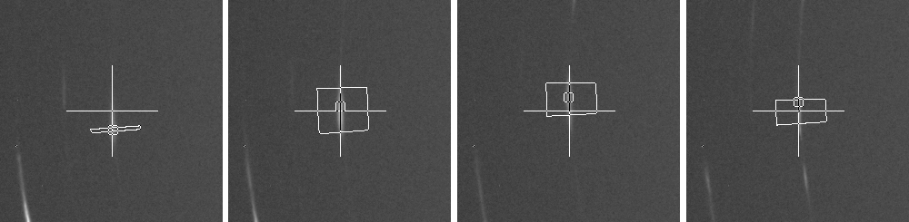
Figure 44: Four example frame from an animated gif image of an integrated reflection. Big cross signs the initial position read from peaks file. Small square signs the local maximum intensity found by the software. The integration limits are drawn with solid lines.
- Manual checking of the peak profiles using the seqKPatternCreator.sh software
The seqKPatternCreator.sh software runs under Linux operating system on a Z shell and uses Gnuplot for displaying the integrated profiles and GraphicsMagick for displaying the animated gif images of the spots with the integration limits and peak centers. The integration output files should be sorted in separate directories by grains, and named using the naming scheme without grain numbers. See A.3 Output files in Appendix A. The directory names should be 'Grain<N>', where <N> is replaced by the grain numbers. If the integration software was running using one single peaks file for all grains, then all output files of every grain is stored in one directory, and the output file names include grain numbers. They should be sorted before invoking seqKPatternCreator.sh on any of the grains. Utility script named sort_profiles.sh has been created to make this process automatic. It should be invoked without any argument in the directory where the output files of the integration are stored. It sorts the output files in separate Grain<N> directories and change the naming as required by seqKPatternCreator.sh. Then the seqKPatternCreator.sh can be invoked with the name of the directory of the grain to be processed as argument. Before invoking seqKPatternCreator.sh, the 'lambda' wavelength parameter should be edited at the beginning of the script file, which is used for transforming profiles from to . It has to be given in nanometers.
The software displays the peak profiles together with the corresponding animated images sequentially, and the user has to decide what to do with the profiles. Profile operations are initiated in the Gnuplot graph window by left mouse button or mouse wheel clicks optionally pressing modification buttons together. The command line terminal displays short information about the available options, and the operations done. Right mouse clicks and standard Gnuplot keyboard shortcuts always can be used to change the graph, e.g. the user can zoom in by right click and drag, switch back to auto scale by pressing 'a', switch between logarithmic and linear scale on vertical axis by pressing 'l' etc. After applying some modification to the profile, the modified profile is plotted, and further modifications can be done until the profile is finally accepted or skipped by the user. The following options are available for selecting and modifying profiles:
- If more than one integrated profile is available for the same reflection, at first the user has to decide which one to include in the pattern. The number button corresponding to the selected profile has to be pressed, then the graph window has to be clicked. The user can skip all these profiles by shift+left+click on the graph window.
- Accept profile by alt+click or ctrl+shift+click.
- Skip profile by shift+click.
- Start a linear baseline correction by clicking on one point on the graph. This point is used as the first point of the baseline. Then the program asks for a second click on an other point of the graph. The program subtracts the linear baseline defined by the two points, and keeps only the part of the profile lying between the two points in . This cutting is done together with baseline correction. The reason for that is when the automatic baseline subtraction done by the integration software fails, it means there is some unwanted feature at the edge of the profile, which should be removed, as it is shown in Fig. 45 a) and b). The first point always should be the lower point. If the second point is lower in than the first, the program prints a message and does not modify the profile.
- Cut out an interval by ctrl+click on a point on the graph. After the first click, the program asks for a second click. The values between the two point in will be removed from the profile. The first point should be the lower point. This is useful when an unwanted feature like a pixel defect, or an other small peak disturbs only a small portion of the profile, and by removing it, the remaining part can be used for line profile analysis. Examples are shown in Fig. 45 c) and d).
- The user can reset the peak to the original state of output of the integration software by ctrl+alt+click.
Once the user checked all reflections, the program creates the full pattern of the grain, where peaks are transformed to space, shifted to be stitched together, normalized to unit maximum intensity, and a constant background value is added to avoid negative intensity values due to detector noise, which is not accepted by CMWP. The newly created pattern is plotted, it can be checked once more and modified if necessary. Following options are available when checking the full pattern:
- Accept pattern by alt+click or ctrl+shift+click.
- Start editing one peak by clicking on it. It will display that single peak again with the same editing options as before.
- Remove one peak from the pattern by shift+clicking on it.
- Reset one peak to the original state by ctrl+clicking on it.
The program can be interrupted by pressing ctrl+c in the command line at any time. The modifications are saved and when the user starts the software again for the same grain, it will not ask for editing the already finished peaks.
The original profiles are stored in <h><k><l>.dat files, and the software does not modify them in any case. The modified profiles are stored under Grain<N>_<h><k><l>.dat names. All modification can be reset by removing Grain<N>_<h><k><l>.dat files. The final pattern is stored in a Grain<N>.dat file. The software also creates a Grain<N>.peak-index.dat file containing the Miller indices, positions, and intensities of the peaks, and a Grain<N>.bg-spline.dat containing points for the added constant background. These files are necessary to run CMWP on the created patterns.
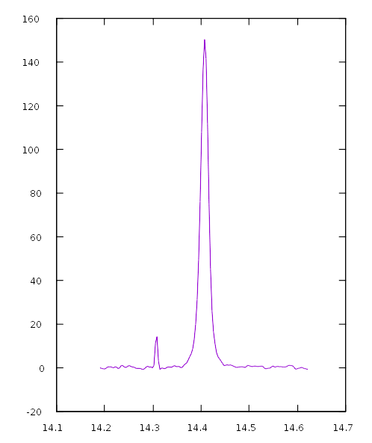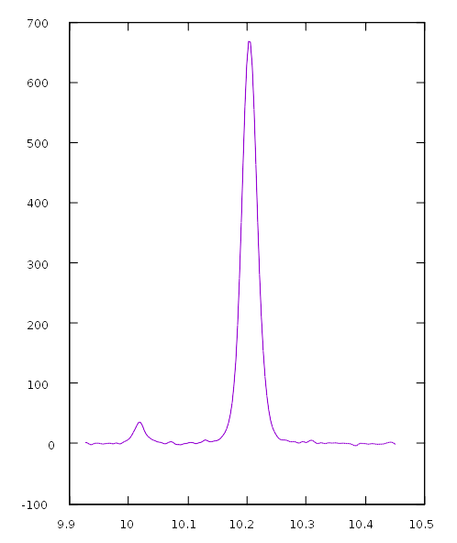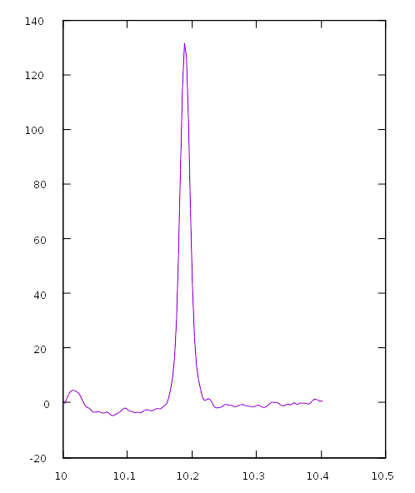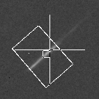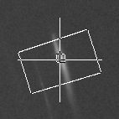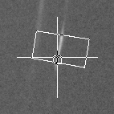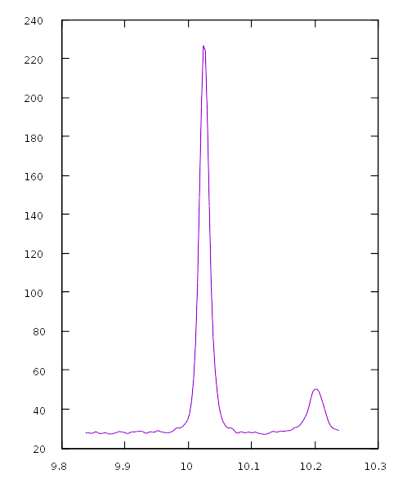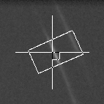Figure 45: Examples of integrated profiles where the raw output of integration software needs additional checking and corrections before the profile fitting procedure. The horizontal axis is in degrees and the vertical axis is intensity in arbitrary units. Small portion of 2D detector images around the peak centers are shown in the upper right corners of the profile plots together with the integration area on one of the detector frames close to the center position. In Fig. a) there is an other small peak at the edge of the integrated area, which mislead the automatic baseline correction method. The baseline has to be corrected and the small peak at the left end of the profile has to be cut. In Fig. b) a stronger peak appeared at the edge, which has been detected by the baseline correction algorithm, therefore, automatic baseline correction was skipped. Please note that the intensity on the vertical axis does not start from 0. In Fig. c) an other small peak appeared, but not at the edge of integration limit, therefore, the baseline subtraction is correct, but the small peak has to be cut from the profile. In Fig. d) there is a pixel error within the integration area, which result in a sharp spike at the left side of the profile. This spike has to be cut. In Fig. e) edge of the detector is reached during integration. Only a part of the diffraction spot was measured and integrated. Moreover, the left tail of the profile was deteriorated by the darkening edge region of the detector image. This profile can not be corrected. It has to be omitted from the pattern.
d)
c)
b)
a)

At the end when the user accepts the pattern, the software creates a file named 'satisfied' in the grain's directory. When invoking the software again for the same directory, it only prints a message, that it skips the already finished grain. By removing 'satisfied' file, the pattern can be edited again.
- Batch running CMWP for all grains of the specimen
The CMWP software can run directly on patterns created by seqKPatternCreator.sh (Appendix B), however, the necessary initialization files need to be created for all grains. Grain-Kini-create.sh utility script is developed to automatize the creation of initialization files. Template initialization files should be created first and placed to a GrainF-template subdirectory of the script's directory. The template file names are Grain1.dat.fit.ini, Grain1.dat.fit_params.ini, Grain1.dat.ini and Grain1.dat.q.ini. They follow the same rules as regular CMWP initialization files. Grain-Kini-create.sh is designed to work with the 18 December 2015, and later versions of CMWP, that is able to use Fast Fourier Transform (FFT), and FFT should be switched on in initialization file. Grain-Kini-create.sh has to be invoked with the pattern files as arguments. Many pattern files can be given in a short form using shell wildcards, e.g. 'Grain-Kini-create.sh Grain<->/Grain<->.dat' command in Z shell will create initialization files for all patterns in Grain<N> subdirectories of the current working directory. Grain-Kini-create.sh copies all template initialization file to the pattern file locations with the correct file names, i.e. 'Grain1' is replaced by the correct grain numbers in each file name, and it automatically adjusts the value of FFT_CUT parameter in Grain1.dat.q.ini file based on the ratio of the widths of the single profiles and the full pattern.
Once all necessary data input and initialization file are set by seqKPatternCreator.sh and Grain-Kini-create.sh software, CMWP can be run with the auto option by giving ‘auto’ as second command line argument after the pattern file name. In this case, every parameter is read from the data files and the fit runs without any user interaction. It should be invoked one by one for each grain, however the linux shell environment necessary for running CMWP enables to write simple loops to run it automatically for every grain.
In order to make the convergence faster CMWP fit is usually carried out in two passes. In the first run, only the average scattering domain size, the individual contrast factors and the parameter of the dislocation arrangement are fitted. In the second run, we also fit the peak positions and intensities. This method accelerates the fitting procedure because the initial estimates for peak positions and intensities are rather close to the optimal values, as they are the positions and intensities of the peak maximums as read and normalized by the seqKPatternCreator.sh and saved in Grain<N>.peak-index.dat file. The initial estimates for the other, physical parameters, however, are much rougher, as they are usually only a general and typical value given by the user, and the default initial value for all individual contrast factor is 1. They can be quite far from the optimal solution. Therefore, in the first run, we only try to find a near optimal value for the initially roughly estimated physical parameters, without letting the software to change (and possibly move far away) the already near optimal values of peak positions and intensities. Then in the second run, we fine tune everything by fitting the physical parameters together with peak positions and intensities.
The two pass fitting can be carried out by running the first pass with the appropriate settings, then change the necessary parameters in template initialization files and regenerate ini files by running Grain-Kini-create.sh again. This, however, resets the already fitted values of the physical parameters and individual contrast factors to the default initial values. Therefore, set_init_b_e.sh and set_indC.sh scripts are developed to restore values of the domain size, parameter and individual contrast factors from the previous run. They should be invoked after Grain-Kini-create.sh and before starting the second CMWP run. The necessary command line arguments for set_init_b_e.sh and set_indC.sh are the list of Grain<N>.sol files, that are one of the CMWP output files containing the values of the fitted parameters, and stored in the same directory as pattern files. For the first run it is enough to use a relatively large limit for stopping the fit, typically for the relative change of WSSR in one step, then in the second run the default value, can be used.
The initial values of domain size and parameter are quite critical to the time required for fitting and the quality of the final solution. If they are too far from the optimal values, the fitting might take very long time, and even it is possible, that a sub-optimal solution is found in the end. Therefore, it is advisable to try to run CMWP on a few grains first with different initial values and check the quality of the fitted curves before running the fit automatically for each grain of the specimen. This initial parameter adjustment is especially important if the user has no good guess for the values typical to the specimen.
- Cfit software
The Cfit.sh software runs under Z shell in a standard linux environment, and uses Gnuplot to perform Levenberg–Marquardt least squares minimization. Therefore, Gnuplot 5.0 or newer version is required to be installed on the system.
  - Command line arguments
Cfit.sh has to be executed from command line with four arguments. First is the directory containing Grain<N> subdirectories with the CMWP fitting results. Second is the directory containing the calculated theoretical contrast factors and other important information on dislocation types. Third is the number of dislocation types fitted at once. If the number of measured reflections of a grain is not sufficient to fit as many dislocation types simultaneously as specified by the user, the program decreases the number of simultaneously fitted dislocation types for that grain to the maximum possible. The fourth argument is the threshold for replacing dislocation types with very low dislocation densities. The last one is given as a factor of total dislocation density, i.e. 0.05 means dislocation types with lower partial densities than 5% of the total dislocation density will be replaced by other ones.
  - Structure of the theoretical contrast factor data required for Cfit
In the directory, there should be an SSgroups.txt file containing the names of the dislocation type groups. Now, with the Monte-Carlo type fit, one group containing all dislocation types is enough. If SSgroup.txt file contains more than one name in separate lines, the software threats them as different groupings of dislocation types, and runs the fit sequentially for all groups. This is mainly for historical reason, when dislocation types were divided to predefined groups.
For each dislocation type group, one ASCII file has to be given containing the names of dislocation types included in the group. The name of these files are the names listed in SSgroups.txt with .txt extension. The dislocation type names are listed in separate lines in a similar manner as group names in SSgroups.txt. Dislocation type names can be virtually anything, but usually the [uvw](hkl)_{phi} scheme is used, where [uvw] are the elements of Burgers vector, (hkl) are the Miller indices of the slip plane, and phi is the angle between the Burgers vector and line vector, i.e. the dislocation character.
Ccalc.txt contains the theoretical contrast factors of all dislocation types and measured diffraction vectors. It is a whitespace separated ASCII column file containing the hkl indices of the diffraction vectors written together without space between them, dislocation type names as listed in dislocation group file(s), square length of the Burgers vector in nm², the theoretical contrast factor and the square length of diffraction vector in nm⁻² in the five columns of the data file.
  - Monitoring convergence
Providing these data, the software runs automatically for all grains without the need of any user interaction. The convergence is monitored by the value of WSSR at the end of each Levenberg–Marquardt fit. The WSSR does not necessarily decrease between each subsequent fit, since replacing dislocation types with small partial densities by other ones might result in a worse combination of dislocation types. However, replacing the small density types and keeping the large density ones the iteration tends to keep the dislocation types that are useful to reconstruct the measured contrast factors. The current minimal WSSR solution is always stored, and the program continues to make further iterations to check whether a better solution can be found or not. The remaining steps before accepting the last found minimum WSSR solution is determined based on the number of free places , i.e. the number of dislocation types that can be replaced, and the number of dislocation types not included in the fit, . If a new solution is found with smaller WSSR, than the last minimum, the following procedure is applied: The software checks whether the dislocation composition changed significantly with respect to the last minimum WSSR composition. The dislocation types are sorted by partial density values, and only the ones above the threshold for replacing dislocation types are kept. If the composition and the order of dislocation types are the same as in the last minimum WSSR solution, then the iteration continues without recalculating the remaining steps. If the order or the composition changed, then the software updates the number of remaining steps by , rounded upward. Once the number of remaining steps reaches zero, the last minimum WSSR solution is accepted and saved.
If, during the Monte-Carlo fitting procedure, the number of free places for dislocation types decreases to zero, the software increases the threshold by a factor of two, and tries to continue the fit with the increased threshold. This might result in a very poor quality fit. The log file should be checked for the final threshold for each grain, and the very poor quality grains might need to be discarded from further analysis.
  - Output files
The software creates a Cfit directory at the same level as the Grain<N> grain directories, and all output is written there. The main outputs are the Grain<N>_<groupname>.txt files, where <groupname> is the name of dislocation type group, that we normally have only one in Monte-Carlo type fit. This file contains the dislocation type names, square lengths of the Burgers vectors in nm², the coefficients and the partial dislocation densities in nm⁻² in four columns. Grain<N>_<groupname>.pdf are column plots of these dislocation density values.
Grain<N>_<groupname>.Cfactors files contain the hkl indices of diffraction vectors, and the measured and the fitted contrast factor values in three columns. They are corrected for the fitted size parameter, and normalized in the following way:
, (D.1)
. (D.2)
This normalization comes from the rearrangement of the terms in Eq. 3.12.
Grain<N>_<groupname>.gpt files contain the output of the Gnuplot fit for the minimum WSSR dislocation composition.
Grain<N>.Cmeas files contain the unscaled, measured contrast factors as read from the CMWP fit solution files.
Cfit.log file contains information about the fits. Grain number, name of dislocation type group, number of measured reflections, number of simultaneously fitted dislocation types, degrees of freedom, threshold, number of above threshold dislocation types and number of free places in the last step and in the step with the lowest WSSR value. This file is not overwritten when the user rerun the software, but the new data is appended to the end.

Own publications related to the thesis
Zilahi, G.; Ungár, T. and Tichy, G. (2015). A common theory of line broadening and rocking curves, Journal of Applied Crystallography 48 : 418-430.
Ungár, T.; Ribárik, G.; Zilahi, G.; Mulay, R.; Lienert, U.; Balogh, L. and Agnew, S. (2014). Slip systems and dislocation densities in individual grains of polycrystalline aggregates of plastically deformed CoTi and CoZr alloys, Acta Materialia 71 : 264-282.
Zilahi, G.; Ribárik, G. and Ungár, T. (2017a). Direction dependence of dislocation broadening contrast, in preparation.
Zilahi, G.; Ungar, T.; Ribárik, G.; Toth, L. S.; Balogh, L.; Wu, W.; Lienert, U. and Agnew, S. (2017b). Slip systems and dislocation densities in individual grains and parent-twin pairs of polycrystalline Mg AZ31 alloys, in preparation.

References
Abbey, B.; Hofmann, F.; Belnoue, J.; Rack, A.; Tucoulou, R.; Hughes, G.; Eve, S. and Korsunsky, A. M. (2011). Mapping the dislocation sub-structure of deformed polycrystalline Ni by scanning microbeam diffraction topography, Scripta Materialia 64 : 884-887.
Agnew, S. R. and Duygulu, Ö. (2005). Plastic anisotropy and the role of non-basal slip in magnesium alloy AZ31B, International Journal of Plasticity 21 : 1161 - 1193.
Agosta, D. S.; Hightower, J. E.; Foster, K.; Leisure, R. G. and Gavra, Z. (2002). Elastic moduli of polycrystalline ZrCo as a function of temperature, Journal of Alloys and Compounds 346 : 1 - 5.
Alvarez, M. A. V.; Santisteban, J. R.; Vizcaíno, P.; Ribárik, G. and Ungar, T. (2016). Quantification of dislocations densities in zirconium hydride by X-ray line profile analysis, Acta Materialia 117 : 1 - 12.
Amirouche, F. (2007). 2.5.2 Rigid-Body Kinematics In: Fundamentals of Multibody Dynamics, Birkhäuser Boston.
Arsenlis, A. and Parks, D. M. (1999). Crystallographic aspects of geometrically-necessary and statistically-stored dislocation density, Acta Materialia 47 : 1597-1611.
Ashby, M. F. (1970). The deformation of plastically non-homogeneous materials, Philosophical Magazine 21 : 399-424.
Bacon, G. E. (1962). Neutron diffraction, Clarendon Press, Oxford.
Baker, I. (1995). A review of the mechanical properties of B2 compounds, Materials Science and Engineering: A 192-193 : 1-13.
Balogh, L.; Ribárik, G. and Ungár, T. (2006). Stacking faults and twin boundaries in fcc crystals determined by x-ray diffraction profile analysis, Journal of Applied Physics 100 : 023512.
Balogh, L.; Tichy, G. and Ungár, T. (2009). Twinning on pyramidal planes in hexagonal close packed crystals determined along with other defects by X-ray line profile analysis, Journal of Applied Crystallography 42 : 580-591.
Barabash, R.; Ice, G. E.; Larson, B. C.; Pharr, G. M.; Chung, K.-S. and Yang, W. (2001). White microbeam diffraction from distorted crystals, Applied Physics Letters 79 : 749-751.
Barabash, R. I. and Ice, G. E. (2014). 1 Diffraction Analysis of Defects: State of the Art In: Barabash, R. I. & Ice, G. E. (Ed.), Strain and Dislocation Gradients from Diffraction, Imperial College Press.
Barabash, R. I.; Ice, G. E.; Larson, B. C. and Yang, W. (2002). Application of white x-ray microbeams for the analysis of dislocation structures, Review of Scientific Instruments 73 : 1652-1654.
Barabash, R. I.; Ice, G. E.; Liu, W. and Barabash, O. M. (2009). Polychromatic microdiffraction characterization of defect gradients in severely deformed materials, Micron 40 : 28-36.
Barabash, R. I.; Ice, G. E. and Walker, F. J. (2003). Quantitative microdiffraction from deformed crystals with unpaired dislocations and dislocation walls, Journal of Applied Physics 93 : 1457-1464.
Barabash, R. I. and Klimanek, P. (1999). X-ray scattering by crystals with local lattice rotation fields, Journal of Applied Crystallography 32 : 1050-1059.
Bay, B.; Hansen, N.; Hughes, D. A. and Kuhlmann-Wilsdorf, D. (1992). Overview no. 96 evolution of f.c.c. deformation structures in polyslip, Acta Metallurgica et Materialia 40 : 205-219.
Borbély, A. and Groma, I. (2001). Variance method for the evaluation of particle size and dislocation density from x-ray Bragg peaks, Applied Physics Letters 79 : 1772-1774.
Christian, J. W. and Mahajan, S. (1995). Deformation twinning, Progress in Materials Science 39 : 1 - 157.
Chung, J.-S. and Ice, G. E. (1999). Automated indexing for texture and strain measurement with broad-bandpass x-ray microbeams, Journal of Applied Physics 86 : 5249-5255.
Cordier, P.; Ungar, T.; Zsoldos, L. and Tichy, G. (2004). Dislocation creep in MgSiO3 perovskite at conditions of the Earth's uppermost lower mantle, Nature 428 : 837-840.
Diehl, J. (1956a). Zugverformung von Kupfer-Einkristallen: I. Verfestigungskurven und Oberflächenerscheinungen, Zeitschrift für Metallkunde 47 : 331-343.
Diehl, J. (1956b). Zugverformung von Kupfer-Einkristallen: II. Dehnungsinhomogenitäten und Reproduzierbarkeit der Verfestigungskurve, Zeitschrift für Metallkunde 47 : 411-416.
Dragomir, I. C. and Ungár, T. (2002). Contrast factors of dislocations in the hexagonal crystal system, Journal of Applied Crystallography 35 : 556-564.
Dupas, C.; Zuodar, N.; Coddet, O.; Kruml, T. and Martin, J.-L. (2002). Dislocation multiplication, exhaustion and mechanical behaviour for Ge single crystals, Journal of Physics: Condensed Matter 14 : 12989-12995.
Essmann, U. and Mughrabi, H. (1979). Annihilation of dislocations during tensile and cyclic deformation and limits of dislocation densities, Philosophical Magazine A 40 : 731-756.
Estrin, Y.; Tóth, L.; Molinari, A. and Bréchet, Y. (1998). A dislocation-based model for all hardening stages in large strain deformation, Acta Materialia 46 : 5509-5522.
Field, D. P.; Trivedi, P. B.; Wright, S. I. and Kumar, M. (2005). Analysis of local orientation gradients in deformed single crystals, Ultramicroscopy 103 : 33-39.
François, A. and Veyssière, P. (1994). A TEM investigation of the deformation microstructure of CoZr and Co40Ni10Zr50 ordered alloys, Intermetallics 2 : 9-22.
Gaál, I. (1984). Effect of Dislocation Distribution on the X-Ray Scattering from Deformed Metals, : 249-254.
Galindo-Nava, E. I. and del-Castillo, P. E. J. R.-D. (2012). A thermodynamic theory for dislocation cell formation and misorientation in metals, Acta Materialia 60 : 4370-4378.
Gan, J.; Vetrano, J. S. and Khaleel, M. A. (2002). Microstructure Characterization of Dislocation Wall Structure in Aluminum Using Transmission Electron Microscopy, Journal of Engineering Materials and Technology 124 : 297-301.
Gao, H. (1991). A boundary perturbation analysis for elastic inclusions and interfaces, International Journal of Solids and Structures 28 : 703-725.
Groma, I. (1998). X-ray line broadening due to an inhomogeneous dislocation distribution, Physical Review B 57 : 7535-7542.
Groma, I.; Ungár, T. and Wilkens, M. (1988). Asymmetric X-ray line broadening of plastically deformed crystals. I. Theory, Journal of Applied Crystallography 21 : 47-54.
Guinier, A. (1963). X-ray diffraction in crystals, imperfect crystals, and amorphous bodies, W.H. Freeman, San Francisco.
Higham, N. J. (1986). Computing the Polar Decomposition—with Applications, SIAM Journal on Scientific and Statistical Computing 7 : 1160-1174.
Hirth, J. P. and Lothe, J. (1982). Theory of dislocations, Krieger Pub. Co
Houtte, P. V.; Li, S.; Seefeldt, M. and Delannay, L. (2005). Deformation texture prediction: from the Taylor model to the advanced Lamel model, International Journal of Plasticity 21 : 589 - 624.
Huang, E.-W.; Barabash, R.; Jia, N.; Wang, Y.-D.; Ice, G. E.; Clausen, B.; Horton, J. and Liaw, P. K. (2008). Slip-System-Related Dislocation Study from In-Situ Neutron Measurements, Metallurgical and Materials Transactions A 39 : 3079-3088.
Huang, X.; Borrego, A. and Pantleon, W. (2001). Polycrystal deformation and single crystal deformation: dislocation structure and flow stress in copper, Materials Science and Engineering: A 319-321 : 237-241.
Huang, X. and Winther, G. (2007). Dislocation structures. Part I. Grain orientation dependence, Philosophical Magazine 87 : 5189-5214.
Hughes, D. A. (2001). Microstructure evolution, slip patterns and flow stress, Materials Science and Engineering: A 319–321 : 46-54.
Hughes, D. A. and Hansen, N. (1993). Microstructural evolution in nickel during rolling from intermediate to large strains, Metallurgical Transactions A 24 : 2022-2037.
Hughes, D. A. and Hansen, N. (2000). Microstructure and strength of nickel at large strains, Acta Materialia 48 : 2985-3004.
Hughes, D. A. and Nix, W. D. (1989). Strain hardening and substructural evolution in NiCo solid solutions at large strains, Materials Science and Engineering: A 122 : 153-172.
Jakobsen, B.; Poulsen, H. F.; Lienert, U.; Almer, J.; Shastri, S. D.; Sørensen, H. O.; Gundlach, C. and Pantleon, W. (2006). Formation and Subdivision of Deformation Structures During Plastic Deformation, Science 312 : 889-892.
Jakobsen, B.; Poulsen, H. F.; Lienert, U. and Pantleon, W. (2007). Direct determination of elastic strains and dislocation densities in individual subgrains in deformation structures, Acta Materialia 55 : 3421-3430.
James, R. W. (1962). Bragg, W. L. (Ed.), The optical principles of the diffraction of x-rays, G. Bell & Sons, London.
Jensen, D. J.; Lauridsen, E. M.; Margulies, L.; Poulsen, H. F.; Schmidt, S.; Sørensen, H. O. and Vaughan, G. B. M. (2006). X-ray microscopy in four dimensions, Materials Today 9 : 18-25.
Klimanek, P. and Kužel Jnr, R. (1988). X-ray diffraction line broadening due to dislocations in non-cubic materials. I. General considerations and the case of elastic isotropy applied to hexagonal crystals, Journal of Applied Crystallography 21 : 59-66.
Kocks, U. F. and Mecking, H. (2003). Physics and phenomenology of strain hardening: the FCC case, Progress in Materials Science 48 : 171 - 273.
Kocks, U. F. and Scattergood, R. O. (1969). Elastic interactions between dislocations in a finite body, Acta Metallurgica 17 : 1161-1168.
Kocks, U. F.; Tomé, C. N. and Wenk, H. R. (2000). Texture and Anisotropy: Preferred Orientations in Polycrystals and Their Effect on Materials Properties, Cambridge University Press
Krivoglaz, M. A. (1996). X-Ray and Neutron Diffraction in Nonideal Crystals, Springer-Verlag, Berlin Heidelberg.
Krivoglaz, M. A.; Martynenko, O. V. and Ryaboshapka, K. P. (1983). Effect of dislocation distribution correlation on x-ray diffraction by deformed crystals, Fizika Metallov i Metallovedenie 55 : 5-17.
Krivoglaz, M. A. and Ryaboshapka, K. P. (1963). Theory of x-ray scattering by crystals containing dislocations. Case of random distribution of screw and edge dislocations in the crystal, Fizika Metallov i Metallovedenie 15 : 18-31.
Kuhn, H.-A.; Biermann, H.; Ungár, T. and Mughrabi, H. (1991). An X-ray study of creep-deformation induced changes of the lattice mismatch in the upgamma′-hardened monocrystalline nickel-base superalloy SRR 99, Acta Metallurgica et Materialia 39 : 2783-2794.
Kužel Jnr, R. and Klimanek, P. (1988). X-ray diffraction line broadening due to dislocations in non-cubic materials. II. The case of elastic anisotropy applied to hexagonal crystals, Journal of Applied Crystallography 21 : 363-368.
Landau, P.; Makov, G.; Shneck, R. Z. and Venkert, A. (2011). Universal straintextendashtemperature dependence of dislocation structure evolution in face-centered-cubic metals, Acta Materialia 59 : 5342-5350.
Lauridsen, E. M.; Schmidt, S.; Suter, R. M. and Poulsen, H. F. (2001). Tracking: a method for structural characterization of grains in powders or polycrystals, Journal of Applied Crystallography 34 : 744-750.
Levine, L. E.; Larson, B. C.; Yang, W.; Kassner, M. E.; Tischler, J. Z.; Delos-Reyes, M. A.; Fields, R. J. and Liu, W. (2006). X-ray microbeam measurements of individual dislocation cell elastic strains in deformed single-crystal copper, Nat Mater 5 : 619-622.
Lienert, U.; Ribárik, G.; Ungár, T.; Wejdemann, C. and Pantleon, W. (2017). High-Resolution Single-Grain Diffraction of Polycrystalline Materials, Synchrotron Radiation News 30 : 35-40.
Liu, Q. (1995). A simple and rapid method for determining orientations and misorientations of crystalline specimens in TEM, Ultramicroscopy 60 : 81-89.
Lloyd, G. E.; Farmer, A. B. and Mainprice, D. (1997). Misorientation analysis and the formation and orientation of subgrain and grain boundaries, Tectonophysics 279 : 55-78.
Macherauch, E.; Wohlfahrt, H. and Wolfstieg, U. (1973). Wolfstieg. Zur zweckmäßigen Definition von Eigenspannungen, Härterei-Tech. Mitt 28 : 201-2011.
Magid, K. R.; Lilleodden, E. T.; Tamura, N.; Florando, J. N.; Lassila, D. H.; LeBlanc, M. M.; Barabash, R. I. and Morris, J. W. (2004). X-ray Microdiffraction Characterization of Deformation Heterogeneities in BCC Crystals, MRS Proceedings 840 : Q7.2.
Martinez-Garcia, J.; Leoni, M. and Scardi, P. (2009). A general approach for determining the diffraction contrast factor of straight-line dislocations, Acta Crystallographica Section A 65 : 109-119.
Mayama, T.; Sasaki, K. and Kuroda, M. (2008). Quantitative evaluations for strain amplitude dependent organization of dislocation structures due to cyclic plasticity in austenitic stainless steel 316L, Acta Materialia 56 : 2735-2743.
Miracle, D. B. (1993). Overview No. 104 The physical and mechanical properties of NiAl, Acta Metallurgica et Materialia 41 : 649-684.
Mises, R. V. (1928). Mechanik der plastischen Formänderung von Kristallen, ZAMM - Journal of Applied Mathematics and Mechanics / Zeitschrift für Angewandte Mathematik und Mechanik 8 : 161-185.
Mughrabi, H. (1983). Dislocation wall and cell structures and long-range internal stresses in deformed metal crystals, Acta Metallurgica 31 : 1367-1379.
Mughrabi, H. (2006). Deformation-induced long-range internal stresses and lattice plane misorientations and the role of geometrically necessary dislocations, Philosophical Magazine 86 : 4037-4054.
Mughrabi, H.; Ungár, T.; Kienle, W. and Wilkens, M. (1986). Long-range internal stresses and asymmetric X-ray line-broadening in tensile-deformed [001]-orientated copper single crystals, Philosophical Magazine A 53 : 793-813.
Mulay, R. P. and Agnew, S. R. (2012). Hard slip mechanisms in B2\ CoTi, Acta Materialia 60 : 1784-1794.
Mulay, R. P.; Clausen, B. and Agnew, S. R. (2011). In-Situ Neutron Diffraction Study of the Bauschinger Effect in B2 Structured CoZr, Metallurgical and Materials Transactions A 42 : 60-70.
Niewczas, M. (2010). Lattice correspondence during twinning in hexagonal close-packed crystals, Acta Materialia 58 : 5848 - 5857.
Nisr, C.; Ribárik, G.; Ungár, T.; Vaughan, G. B. M.; Cordier, P. and Merkel, S. (2012). High resolution three-dimensional X-ray diffraction study of dislocations in grains of MgGeO3 post-perovskite at 90 GPa, Journal of Geophysical Research: Solid Earth 117 : B03201.
Nye, J. F. (1953). Some geometrical relations in dislocated crystals, Acta Metallurgica 1 : 153-162.
Nyilas, K.; Dupas, C.; Kruml, T.; Ungar, T. and Martin, J. L. (2010). The Taylor relation in compression deformed Ge single crystals, Journal of Physics: Conference Series 240 : 012025.
Nyilas, K.; Dupas, C.; Kruml, T.; Zsoldos, L.; Ungár, T. and Martin, J. L. (2004). Dislocation structures and mechanical behaviour of Ge single crystals deformed by compression, Materials Science and Engineering: A 387–389 : 25-28.
Oddershede, J.; Schmidt, S.; Poulsen, H. F.; Sørensen, H. O.; Wright, J. and Reimers, W. (2010). Determining grain resolved stresses in polycrystalline materials using three-dimensional X-ray diffraction, Journal of Applied Crystallography 43 : 539-549.
Pantleon, W. (2008). Resolving the geometrically necessary dislocation content by conventional electron backscattering diffraction, Scripta Materialia 58 : 994-997.
Partridge, P. G. (1967). The crystallography and deformation modes of hexagonal close-packed metals, Metallurgical Reviews 12 : 169-194.
Patterson, A. L. (1934). A Fourier Series Method for the Determination of the Components of Interatomic Distances in Crystals, Physical Review 46 : 372-376.
Pollock, T. M. and Argon, A. S. (1992). Creep resistance of CMSX-3 nickel base superalloy single crystals, Acta Metallurgica et Materialia 40 : 1-30.
Potter, D. I. (1970). Prediction of the operative slip system in CsCl type compounds using anisotropic elasticity theory, Materials Science and Engineering 5 : 201-209.
Poulsen, H. F. (2004). Three-Dimensional X-Ray Diffraction Microscopy: Mapping Polycrystals and Their Dynamics, Springer-Verlag, Berlin Heidelberg.
Poulsen, H. F.; Nielsen, S. F.; Lauridsen, E. M.; Schmidt, S.; Suter, R. M.; Lienert, U.; Margulies, L.; Lorentzen, T. and Juul Jensen, D. (2001). Three-dimensional maps of grain boundaries and the stress state of individual grains in polycrystals and powders, Journal of Applied Crystallography 34 : 751-756.
Ribárik, G.; Gubicza, J. and Ungár, T. (2004). Correlation between strength and microstructure of ball-milled Al–Mg alloys determined by X-ray diffraction, Materials Science and Engineering: A 387–389 : 343-347.
Ribárik, G. and Ungár, T. (2010). Characterization of the microstructure in random and textured polycrystals and single crystals by diffraction line profile analysis, Materials Science and Engineering: A 528 : 112-121.
Ribárik, G.; Ungár, T. and Gubicza, J. (2001). MWP-fit: a program for multiple whole-profile fitting of diffraction peak profiles by ab initio theoretical functions, Journal of Applied Crystallography 34 : 669-676.
Sauthoff, G. (1995). Intermetallics, VCH, Weinheim; New York. pp. 1-5.
Scardi, P. and Leoni, M. (2002). Whole powder pattern modelling, Acta Crystallographica Section A 58 : 190-200.
Schmidt, S. (2014). GrainSpotter: a fast and robust polycrystalline indexing algorithm, Journal of Applied Crystallography 47 : 276-284.
Sevillano, J. G. and Aernoudt, E. (1987). Low energy dislocation structures in highly deformed materials, Materials Science and Engineering 86 : 35-51.
Spieckermann, F. (2010). Investigation of Deformation Induced Changes of the Microstructure of Semicrystalline Polymers and their Impact on Mechanical Properties, Universität Wien.
Styczynski, A.; Hartig, C.; Bohlen, J. and Letzig, D. (2004). Cold rolling textures in AZ31 wrought magnesium alloy, Scripta Materialia 50 : 943 - 947.
Sørensen Henning, O.; Søren, S.; Wright Jonathan, P.; Vaughan Gavin B., M.; Simone, T.; Garman Elspeth, F.; Jette, O.; Jav, D.; Paithankar Karthik, S.; Carsten, G. and Poulsen Henning, F. (2011). Multigrain crystallography, Zeitschrift für Kristallographie Crystalline Materials 227 : 63.
Sørensen, H. O. and Knudsen, E. (2006-2013). Fabian, https://svn.code.sf.net/p/fable/code/fabian/trunk/ Accessed on 2017-07-11.
Takasugi, T.; Tsurisaki, K.; Izumi, O. and Ono, S. (1990). Plastic flow of B2-type CoTi single crystals, Philosophical Magazine A 61 : 785-800.
Takasugi, T.; Yoshida, M. and Kawabata, T. (1992). The effect of temperature and orientation on dislocation microstructures in b2-type coti single crystals, Philosophical Magazine A 65 : 29-40.
Tamura, N. (2014). 4 XMAS: A Versatile Tool for Analyzing Synchrotron X-ray Microdiffraction Data In: Barabash, R. & Ice, G. (Ed.), Strain and Dislocation Gradients from Diffraction, Imperial College Press.
Taylor, G. I. (1938). Plastic strain in metals, Journal of the Institute of Metals 62 : 307-324.
Ungár, T. (2008). Dislocation model of strain anizotropy, Advances in X-ray Analysis 51 : 76-87.
Ungár, T. and Borbély, A. (1996). The effect of dislocation contrast on x‐ray line broadening: A new approach to line profile analysis, Applied Physics Letters 69 : 3173-3175.
Ungár, T.; Dragomir, I.; Révész, Á. and Borbély, A. (1999). The contrast factors of dislocations in cubic crystals: the dislocation model of strain anisotropy in practice, Journal of Applied Crystallography 32 : 992-1002.
Ungár, T.; Gubicza, J.; Ribárik, G. and Borbély, A. (2001). Crystallite size distribution and dislocation structure determined by diffraction profile analysis: principles and practical application to cubic and hexagonal crystals, Journal of Applied Crystallography 34 : 298-310.
Ungár, T.; Li, L.; Tichy, G.; Pantleon, W.; Choo, H. and Liaw, P. K. (2011). Work softening in nanocrystalline materials induced by dislocation annihilation, Scripta Materialia 64 : 876 - 879.
Ungár, T.; Mughrabi, H.; Rönnpagel, D. and Wilkens, M. (1984). X-ray line-broadening study of the dislocation cell structure in deformed [001]-orientated copper single crystals, Acta Metallurgica 32 : 333-342.
Ungár, T.; Mughrabi, H. and Wilkens, M. (1982). An X-Ray line-broadening study of dislocations near the surface and in the bulk of deformed copper single crystals, Acta Metallurgica 30 : 1861 - 1867.
Ungár, T.; Ribárik, G.; Balogh, L.; Salem, A. A.; Semiatin, S. L. and Vaughan, G. B. M. (2010). Burgers vector population, dislocation types and dislocation densities in single grains extracted from a polycrystalline commercial-purity Ti specimen by X-ray line-profile analysis, Scripta Materialia 63 : 69-72.
Ungár, T. and Tichy, G. (1999). The Effect of Dislocation Contrast on X-Ray Line Profiles in Untextured Polycrystals, physica status solidi (a) 171 : 425-434.
Vattré, A. J. and Demkowicz, M. J. (2013). Determining the Burgers vectors and elastic strain energies of interface dislocation arrays using anisotropic elasticity theory, Acta Materialia 61 : 5172-5187.
Warren, B. E. (1959). X-ray studies of deformed metals, Progress in Metal Physics 8 : 147 - 202.
Warren, B. E. (1969). X-ray diffraction, Addison-Wesley Pub. Co.
Warren, B. E. and Averbach, B. L. (1952). The Separation of Cold‐Work Distortion and Particle Size Broadening in X‐Ray Patterns, Journal of Applied Physics 23 : 497-497.
Wilkens, M. (1969). Das mittlere Spannungsquadrat 〈σ2〉 begrenzt regellos verteilter Versetzungen in einem zylinderförmigen Körper, Acta Metallurgica 17 : 1155-1159.
Wilkens, M. (1970). Theoretical Aspects of Kinematical Diffraction Profiles from Crystals Containing Dislocation Distributions. pp. 1195-1221 In: Simmons, A.; DeWitt, R. & Bullough, R. (Ed.), Fundamental Aspects of Dislocation Theory Vol. II., NBS (U.S.) Special Publication No. 317., U.S. National Bureau of Standards, Washington , DC.
Wilkens, M.; Ungár, T. and Mughrabi, H. (1987). X-ray rocking-curve broadening of tensile-deformed [001]-orientated copper single crystals, physica status solidi (a) 104 : 157-170.
Williamson, G. K. and Hall, W. H. (1953). X-ray line broadening from filed aluminium and wolfram, Acta Metallurgica 1 : 22-31.
Wollmershauser, J. A.; Neil, C. J. and Agnew, S. R. (2010). Mechanisms of Ductility in CoTi and CoZr B2 Intermetallics, Metallurgical and Materials Transactions A 41 : 1217-1229.
Wright, J. (2005-2016). ImageD11, https://github.com/jonwright/ImageD11/ Accessed on 2017-07-11.
Wu, L.; Agnew, S. R.; Ren, Y.; Brown, D. W.; Clausen, B.; Stoica, G. M.; Wenk, H. R. and Liaw, P. K. (2010). The effects of texture and extension twinning on the low-cycle fatigue behavior of a rolled magnesium alloy, AZ31B, Materials Science and Engineering: A 527 : 7057 - 7067.
Yasuda, H.; Takasugi, T. and Koiwa, M. (1991). Elastic Constants of Co<SUB>3</SUB>Ti and CoTi Intermetallic Compounds, Materials Transactions, JIM 32 : 48-51.
Yoshida, M. and Takasugi, T. (1993). Transmission electron microscopy study of the activated slip systems and the dislocation structures in B2-type CoZr and CoHf polycrystals, Philosophical Magazine A 68 : 401-417.
Zaefferer, S.; Wright, S. I. and Raabe, D. (2008). Three-Dimensional Orientation Microscopy in a Focused Ion Beam--Scanning Electron Microscope: A New Dimension of Microstructure Characterization, Metallurgical and Materials Transactions A 39 : 374-389.
Zhang, J. and Jiang, Y. (2005). An experimental investigation on cyclic plastic deformation and substructures of polycrystalline copper, International Journal of Plasticity 21 : 2191-2211.
Zhang, W.-Z. and Purdy, G. R. (1993). A TEM study of the crystallography and interphase boundary structure of α precipitates in a Zr-2.5 wt% Nb alloy, Acta Metallurgica et Materialia 41 : 543-551.
Zhang, Z.; Ming-pu, W.; Zhu, S. and Jiang, N. (2011). A method based on Euler space for twinning analyses in magnesium alloy, Materials Characterization 62 : 647 - 650.

Acknowledgement
I would like to express my gratitude to my parents and my family for supporting me during all my studies.
I am grateful to my supervisors: Prof. Tamás Ungár, for guiding and encouraging my scientific work, providing me with great oppotunities to measure at world-class synchrotron and neutron source facilities, make research at foreign institutes in international environment, and sometimes even helping me with my everyday life, and Dr. Gábor Ribárik for massively supporting me with the programming aspects of my PhD topic at the beginning and for encouraging me to realize my ideas. I am grateful to both of my supervisors for carefully reading my thesis and providing me with valuable advices.
I would like to say tanks to the co-authors of our papers: Prof. Géza Tichy, for his guidance and advices on the mathematical description of diffraction peaks, Prof. Sean Agnew for sharing his great experience on CoTi, CoZr and Mg alloys and TEM and EBSD studies, Dr. Levente Balogh for helping us with the Schmidt factor analysis and advising me on pole figure and inverse pole figure representations, Mulay Rupalee and Wei Wu for prepairing samples for the synchrotron measurements, and Dr. Ulrich Lienert for helping us with the beamline instruments.
I am grateful to Prof. László Tóth for the opportunity to work at the University of Lorraine, Metz, France and for introducing me into the polycrystal plasticity modeling and texture analysis.
I am grateful to Prof. Xun-Li Wang for the opportunity to work at the City University of Hong Kong, for introducing me into the neutron diffraction and small angle scattering methods, and for the opporunity to visit and measure at state of the art spallation neutron sources.
I thank to Prof. István Groma for the opportunity to work at the Eötös Loránd University, Budapest.
Finally I would like to say thanks to all my office mates and friends, especially to Dániel Tüzes, Szilvia Kalácska, Bertalan Jóni, Cai Chen, Vu Quoc Viet, Yajun Zhao, Jing Wen, Si Lan, Bing Wang and the others who I do not mention here by name, who were continuously making me feel comfortable during my PhD studies both at home and abroad.

Köszönetnyilvánítás
Először is szüleimnek és családomnak szeretnék köszönetet mondani, akik tanulmányaim alatt mindvégig támogattak.
Hálás vagyok témavezetőimnek: Ungár Tamás professzornak a tudományos munkámban való iránymutatásért és bátorításért, hogy világszínvonalú szinkrotron és neutron sugárforrásoknál mérhettem, és hogy külföldi intézeketben, nemzetközi környezetben kutathattam, ha pedig úgy adódott, a mindennapi életemben is segítséget kaptam tőle, valamint dr. Ribárik Gábornak, aki rengeteget segített a doktori munkám elején a programozást igénylő feladatokban, később pedig az ötleteim megvalósítására sarkallt. Mindkét témavezetőmnek hálás vagyok a disszertációm gondos átolvasásáért és az értékes észrevételeikért.
Köszönetet szeretnék mondani a közös cikkeink társszerzőinek, Tichy Géza professzornak a diffrakciós profilok matematikai leírásában való hasznos iránymutatásáért és tanácsaiért, Sean Agnew professzornak, amiért megosztotta velünk a CoTi, CoZr, és Mg ötvözetekről, valamint a TEM és EBSD vizsgálatokról szerzett hatalmas tapasztalatát, dr. Balogh Leventének a Schmidt-faktor analízisben nyújtott segítségéért, és a pólusábra és inverz pólusábra ábrázolásokkal kapcsolatos tanácsaiért, Mulay Rupalee-nak és és Wei Wu-nak a szinkrotronos minták elkészítéséért, valamint dr. Ulrich Lienert-nek a szinkrotronos berendezésekhez nyújtott támogatásáért.
Hálás vagyok Tóth László professzornak, amiért a kutatási lehetőséget biztosított számomra a Lotaringiai Egyetemen, Metzben, és hogy bevezetett engem a polikristály képlékenység modellezésébe és a textúra vizsgálatba.
Hálás vagyok még Xun-Li Wang professzornak a Hongkongi Városi Egyetemen biztosított kutatási lehetőségért, a neutronszórási módszerekbe és a kisszögű szórásba való bevezetésért, és hogy élvonalbeli spallációs neutronforrásokat látogathattam meg.
Köszönöm továbbá Groma István professzornak, amiért az Eötvös Loránd Tudományegyetemen dolgozhatok.
Végezetül köszönetet mondok minden irodatársamnak és barátomnak, különösképpen Tüzes Dánielnek, Kalácska Szilviának, Jóni Bertalannak, Chen Cai-nak, Viet Quoc Vu-nak, Zhao Yajun-nak, Wen Jing-nek, Lan Si-nek, Wang Bing-nek és mindenki másnak is, akit név szerint nem említettem, amiért folyamatosan gondoskodtak róla, hogy jól érezzem magam a bőrömben a doktori tanulmányaim alatt itthon és külföldön egyaránt.
Háromdimenziós Röntgen vonalprofil analízis
Zilahi Gyula
Doktori disszertáció összefoglalója:
Doktori disszertációmban egy új 3D Röntgendiffrakciós (3D-XRD) eljárást fejlesztettem, ami polikristályos anyagokban szemcsénkénti diszlokációszerkezet meghatározást tesz lehetővé. Egy nem tökéletes kristály diffrakciós csúcsa három dimenzióban kiszélesedett a reciprok térben. A kiszélesedett csúcsok vizsgálatával értékes információ nyerhető a kristályos anyagok mikroszerkezetéről. A hagyományos diffrakciós eljárások a kiszélesedett csúcsoknak vagy csak a sugár irányú, vagy az érintő irányú intenzitás eloszlását vizsgálják. Az előbbit vonalprofilnak, az utóbbit „rocking-curve”-nek szokás nevezni az irodalomban.
Egységes matematikai leírást dolgoztam ki a vonalprofil és a „rocking-curve” jellemzésére, ami a nem lokális deformáció tenzor forgatás és alakítás részre való poláris felbontásán alapul. Megmutattam, hogy a „rocking-curve” kiszélesedéshez a forgatás rész és az alakítás rész nyíró komponense is hozzájárul, képlékenyen alakított kristályokban azonban a forgatás rész adja a fő járulékot.
Megmutattam, hogy bármely diszlokáció konfiguráció vonalszélesedési kontrasztjának irányfüggése 15 paraméterrel írható le. Egy új, Mone-Carlo típusú illesztő algoritmust fejlesztettem a mért diszlokáció vonalszélesedési kontrasztokat legjobban leíró diszlokáció konfiguráció megtalálására. Az algoritmust egy szimulált adatsoron ellenőriztem. Nagyjából az esetek 90 százalékában megfelelő pontossággal visszaadta a szimulált diszlokáció típusokat, amikor minden szimulált szemcse 5 különböző típusú diszlokációt tartalmazott, és nagyjából 3 – 5 százaléknyi zajt adtam a szimulált kontrasztfaktorokhoz a mérési bizonytalanság imitálásaként.
Az új mérési eljárást képlékenyen alakított polikristályos CoTi és CoZr B2 rácsszerkezetű ötvözetekre alkalmaztam. Több mint 150 szemcse diszlokációszerkezetét értékeltem ki a két mintában. Azt a következtetést vontam le az eredményekből, hogy a CoTi és CoZr ötvözetek képlékeny deformációja az ún. lágy () és kemény ( és ) módusok együttes aktivációjával megy végbe, ami összhangban van a korábbi, kis számú szemcsén végzett TEM vizsgálatokkal. Az eredmény kielégítő magyarázatot nyújt ezen két CsCl szerkezetű ötvözet közepes alakíthatóságára.
Az eljárást képlékenyen alakított polikristályos Mg AZ31 ötvözetekre is alkalmaztam. A csúszási rendszer típusokat az inverz pólusábrán ábrázolt szemcse orientációk, valamint az ikerszemcse orientáció viszonyok függvényében vizsgáltam. Lényeges különbségeket fedeztem fel az ikerszemcse párok tagjai között mind a teljes diszlokációsűrűség, mind pedig az egyes diszlokációtípusok részleges diszlokációsűrűsége tekintetében.
Three dimensional line profile analysis
Gyula Zilahi
Summary of PhD thesis:
In the present thesis a new 3 Dimensional X-ray Diffraction (3D-XRD) method was developed for analyzing the dislocation structure of individual grains in polycrystalline aggregate. Diffraction peak of an imperfect crystal is broadened in three dimensions in reciprocal space. Analysis of the broadened reflections can provide valuable information on the microstructure of the crystalline materials. Traditional diffraction methods are focusing either on the radial or the tangential components of the peak intensity distribution, that are commonly called line profile and rocking curve, respectively.
Unified mathematical description of line profiles and rocking curves was constructed based on the polar decomposition of nonlocal strain tensor into a rotation and a stretching part. It was shown that the rocking-curve broadening is produced by both rigid-body rotations and the shear components of strain. In dislocated crystals, however, the major contribution stems from rigid-body rotations.
It was shown, that the direction dependence of dislocation line broadening contrast of any dislocation configuration can be described by 15 parameters. A new Monte-Carlo type fitting algorithm was developed for determining the dislocation configuration best describing the measured dislocation broadening contrasts. The method was verified on a simulated data set. It was able to reproduce about 90% of the simulated dislocation types with reasonable accuracy, when 5 different dislocation types were present in each single grains of the simulated data set and about 3% to 5% random noise were added to the simulated contrast factors as experimental errors.
The newly developed method was applied to plastically deformed polycrystalline CoTi and CoZr B2 structured intermetallic alloys. Over 150 grains were analyzed within the two samples examined. It was concluded that plastic deformation in CoTi and CoZr with the B2 structure is caused by the combined activation of Soft-M () and Hard-M ( and ) dislocations, in agreement with former TEM observations of a small number of grains. The results provide a satisfactory explanation for the moderate ductility exhibited by these two CsCl-structured ordered intermetallic compounds.
The newly developed method was applied to plastically deformed polycrystalline Mg AZ31 alloy specimens. Slip system types were analyzed in connection with the grain orientations on the inverse pole figures and the parent-twin relationships of the grains. It has been shown that there are substantial differences between the two members of the twin pairs in terms of total dislocation density and prevailing dislocation types.
ADATLAP

a doktori értekezés nyilvánosságra hozatalához*

I. A doktori értekezés adatai
A szerző neve: Zilahi Gyula
MTMT-azonosító: 10045373
A doktori értekezés címe és alcíme: Three dimensional line profile analysis
DOI-azonosító: 10.15476/ELTE.2017.121
A doktori iskola neve: Fizika Doktori Iskola
A doktori iskolán belüli doktori program neve: Anyagtudomány és szilárdtestfizika
A témavezető neve és tudományos fokozata: Ungár Tamás, MTA doktora
A témavezető munkahelye: ELTE
II. Nyilatkozatok
1. A doktori értekezés szerzőjeként
a) hozzájárulok, hogy a doktori fokozat megszerzését követően a doktori értekezésem és a tézisek nyilvánosságra kerüljenek az ELTE Digitális Intézményi Tudástárban. Felhatalmazom a Természettudományi kar Dékáni Hivatal Doktori, Habilitációs és Nemzetközi Ügyek Csoportjának ügyintézőjét, hogy az értekezést és a téziseket feltöltse az ELTE Digitális Intézményi Tudástárba, és ennek során kitöltse a feltöltéshez szükséges nyilatkozatokat.
b) kérem, hogy a mellékelt kérelemben részletezett szabadalmi, illetőleg oltalmi bejelentés közzétételéig a doktori értekezést ne bocsássák nyilvánosságra az Egyetemi Könyvtárban és az ELTE Digitális Intézményi Tudástárban;
c) kérem, hogy a nemzetbiztonsági okból minősített adatot tartalmazó doktori értekezést a minősítés (dátum)-ig tartó időtartama alatt ne bocsássák nyilvánosságra az Egyetemi Könyvtárban és az ELTE Digitális Intézményi Tudástárban;
d) kérem, hogy a mű kiadására vonatkozó mellékelt kiadó szerződésre tekintettel a doktori értekezést a könyv megjelenéséig ne bocsássák nyilvánosságra az Egyetemi Könyvtárban, és az ELTE Digitális Intézményi Tudástárban csak a könyv bibliográfiai adatait tegyék közzé. Ha a könyv a fokozatszerzést követőn egy évig nem jelenik meg, hozzájárulok, hogy a doktori értekezésem és a tézisek nyilvánosságra kerüljenek az Egyetemi Könyvtárban és az ELTE Digitális Intézményi Tudástárban.
2. A doktori értekezés szerzőjeként kijelentem, hogy
a) az ELTE Digitális Intézményi Tudástárba feltöltendő doktori értekezés és a tézisek saját eredeti, önálló szellemi munkám és legjobb tudomásom szerint nem sértem vele senki szerzői jogait;
b) a doktori értekezés és a tézisek nyomtatott változatai és az elektronikus adathordozón benyújtott tartalmak (szöveg és ábrák) mindenben megegyeznek.
3. A doktori értekezés szerzőjeként hozzájárulok a doktori értekezés és a tézisek szövegének plágiumkereső adatbázisba helyezéséhez és plágiumellenőrző vizsgálatok lefuttatásához.

Kelt: Budapest, 2017 július 12.

……………………………………
a doktori értekezés szerzőjének aláírása

*ELTE SZMSZ SZMR 12. sz. melléklet

https://sourceforge.net/p/fable/wiki/Home/ Accessed on 2017-07-11
https://pythonhosted.org/ImageD11/peaksearching.html Accessed on 2017-07-11.
https://pythonhosted.org/ImageD11/_downloads/com_guide.pdf Accessed on 2017-07-11
https://github.com/jonwright/ImageD11/tree/master/docs Accessed : 2017-07-11
https://pythonhosted.org/ImageD11/filtering.html Accessed: 2017-07-11
https://pythonhosted.org/ImageD11/fileformats.html Accessed: 2017-07-11

