Electrical characterization
Once the micro-LEDs are bonded, each populated coupon is characterized electrically to confirm that the joints carry current and to quantify joint quality independently of the optical result. Five quantities are extracted on the same ENIG substrate and, where possible, on the same coupon: daisy-chain bond resistance and yield, the LED forward voltage and current–voltage (I–V) characteristic, the specific contact resistivity from transmission-line structures, the sheet resistance from van der Pauw cloverleaves, and the junction-to-substrate thermal resistance from forward-voltage thermometry. Impedance spectroscopy is an optional sixth measurement that resolves the joint into an equivalent circuit. All structures are contacted with four-wire (Kelvin) probes to remove lead and contact resistance from the reading. Table I lists the instruments and the structure used for each quantity.
Table I. Measurement setup: quantity, on-board test structure, instrument, and excitation.
Quantity | Test structure | Instrument | Excitation / conditions
Bond / chain resistance | Daisy chains DCL6, DCL12 | Not usable (layout fault) | —
Forward voltage, series resistance | D1–D8, south header pins | Arduino UNO R3, 6-branch binary current source, 14-bit oversampled ADC | Pulsed DC, 63 levels, 0.5–15.9 mA, 5 ms on / 250 ms off
Channel screening and failure mode | D1–D8 probe pads | Handheld DMM, diode test | ≈1 mA forward
Sense resistor calibration | R_EIS_LOAD, 100 Ω 0.1 % | Handheld DMM, 600 Ω range, REL | DC
Specific contact resistivity | TLM ladders | Not measured | —
Sheet resistance | van der Pauw cloverleaves | Not measured | —

A. Daisy-chain bond resistance and yield
The daisy chains DCL6 and DCL12 place 6 and 12 LEDs in series through the red cathode, so a single I–V sweep across the chain endpoints exercises 2N bonds (N LEDs, two bonds each). The mean resistance per bond follows from the measured chain resistance:
R_{bond} = R_{chain} / (2N)
A defective bond appears either as a discontinuity in the chain I–V curve or as a chain forward voltage that overshoots N × V_{F,nom}. Yield is reported as the number of conducting bonds over the total. For reference, the v1 board reported chain resistances of 0.199–0.380 Ω across die finishes and mounting conditions [ref]; values of that order indicate well-formed joints.
The chains could not be used. Both DCL6 and DCL12 read open in forward and reverse on every coupon, and gave no photovoltage under illumination. The cause is a layout fault rather than a bonding failure: the chain routes each die's top-left pad to its top-right pad, and with the dice rotated 90 degrees those two pads are the red and blue cathodes. Every element in the chain is therefore a pair of back-to-back diodes, and the real anode on the bottom-left corner connects to nothing. No chain resistance or chain yield can be extracted from this coupon revision.
Table II. Daisy-chain bond resistance and yield.
Sample / condition | Chain | N (LEDs) | R_{chain} (Ω) | R_{bond} (mΩ) | Bonds OK / total | Yield (%)
all | DCL6 | 6 | open | n/a | 0 / 6 | n/a
all | DCL12 | 12 | open | n/a | 0 / 12 | n/a

B. Forward voltage and current–voltage characteristics
Each addressable LED is read across its four bonded contacts. The forward voltage at the 10 mA operating point, V_{F}(10 mA), is the primary number; for WL-SFCC red the nominal value is ≈ 2.05 V [ref], so a joint that adds appreciable series resistance shows up as an elevated V_{F}. A least-squares fit of the high-current branch gives the joint series resistance R_{s}, and the reverse branch at −5 V gives the leakage current I_{leak}, which flags damaged or contaminated dies.
Each channel was swept over 63 current levels between 0.5 and 15.9 mA using a binary-weighted resistor bank on six digital pins, with the current pulsed for 5 ms and off for 250 ms to hold the duty cycle fixed. Series resistance comes from a three-parameter least-squares fit of V = V0 + n·VT·ln(I) + I·Rs over all points above 0.5 mA.
Only the red channels give physical fits. Green and blue return ideality factors of 3.2 to 4.0, which no LED has. With a forward voltage near 2.8 V the 5 V rail leaves only a 20-fold current range, over which V0, n and Rs trade off against each other and the fit becomes degenerate. Red spans 30-fold and returns ideality 1.60 to 2.06. All series resistance results below are red only.
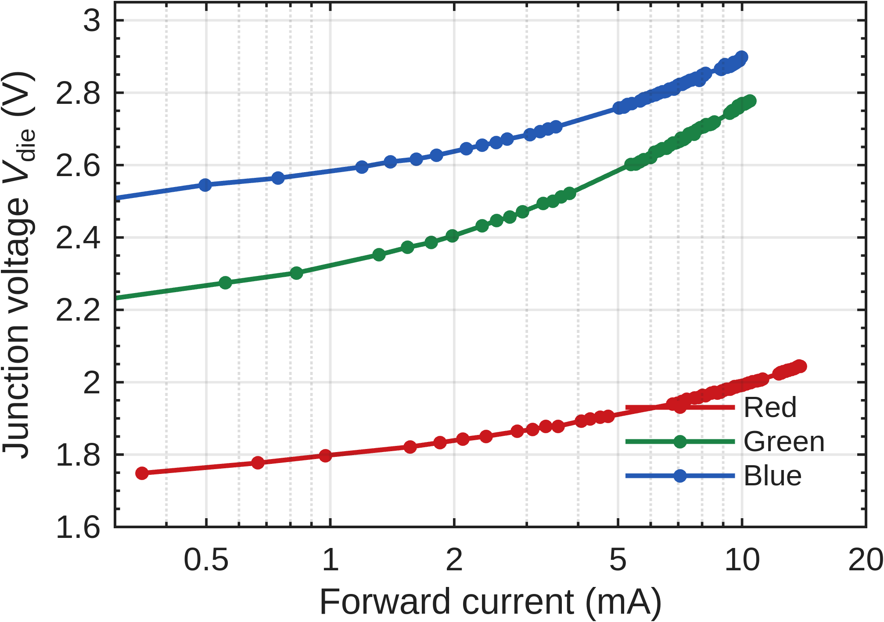
Fig. 1. Forward characteristics of one die (S1 D1) in all three colours. Red reaches 13.9 mA; green and blue are limited to about 10 mA by the 5 V supply.
Across 29 red channels the mean series resistance is 11.43 Ω with a standard deviation of 0.99 Ω. One-way ANOVA across the eight conditions gives F(7,21) = 1.73, p = 0.16. Forward voltage at 10 mA behaves the same way: 2.0104 V mean, 12.9 mV standard deviation, p = 0.24. Neither quantity separates the assembly conditions.
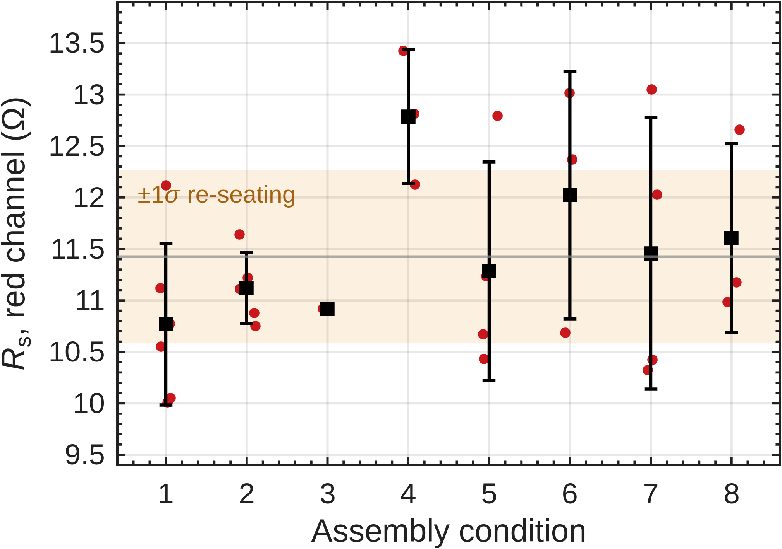
Fig. 2. Series resistance by condition. Red points are individual channels, squares are condition means, bars are ±1 standard deviation. The shaded band is the ±1σ measurement repeatability from Fig. 4.
The limit is the fixture rather than the dice. Because this build takes both voltage taps from the breadboard instead of the Tier-1 probe pads, the two female-male jumpers and their header contacts sit inside the measured loop. Re-seating the same two jumpers on an unchanged channel moves Rs by 0.84 Ω (pooled standard deviation, three channels, three seatings each), which accounts for 85 % of the variance otherwise read as die-to-die spread. Every re-seating also lands at or above the channel minimum, as contact resistance can only add, so the true red series resistance is near the mean of the minima, 10.6 Ω. Bond resistances are 10 to 100 mΩ. The smallest difference this arrangement can resolve at n = 4 is 1.4 Ω, so the null result above is a statement about the instrument and not about the bonds.
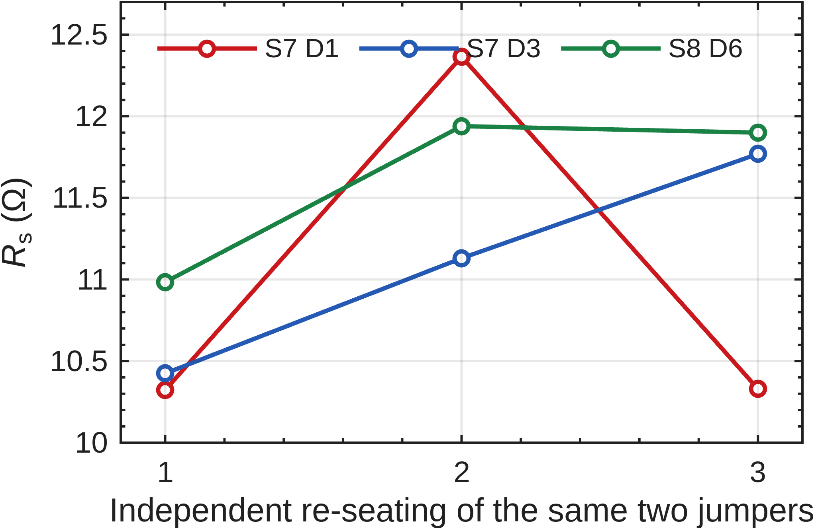
Fig. 3. Three channels, each measured after three independent re-seatings of the two jumpers. Nothing else changed between points.
The sweep did find one defect the diode test missed. Channel S3 D1 red fits to an ideality of 13.0 and a negative series resistance, which is unphysical. Below 3 mA the junction sits at 1.21 V, under a red LED's turn-on, while 0.42 mA still flows: a parallel path of roughly 2.9 kΩ carries the current around the die. A diode test at 1 mA reads 1.781 V and passes the channel. Any fit falling outside ideality 1.2 to 2.4 flags this condition, which makes the sweep a screen for shunts as well as a measurement.
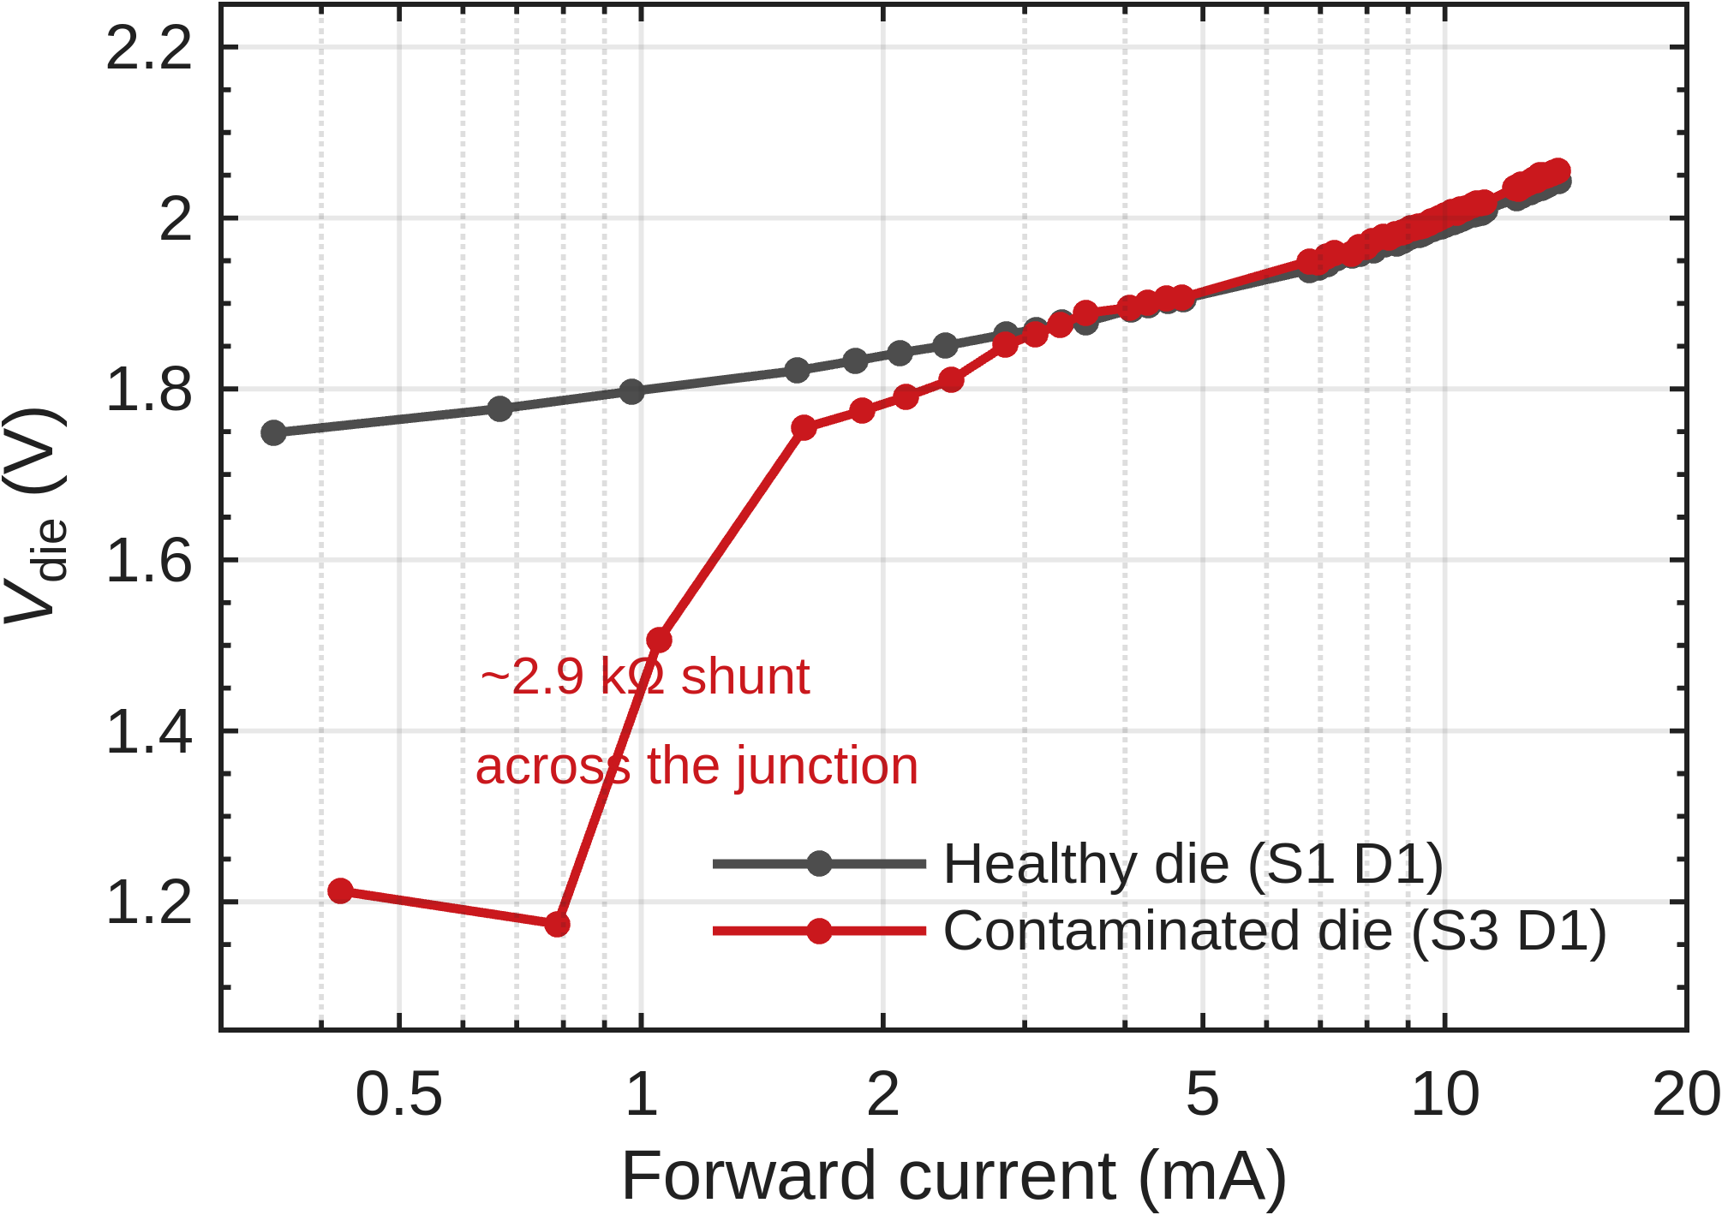
Fig. 4. A contaminated die (S3 D1) against a healthy one. The curves agree above 3 mA and diverge by 540 mV at the bottom of the sweep.
Table III. Per-LED forward voltage, series resistance, and leakage. Colours: R = red, G = green, B = blue.

C. Channel yield and failure mode
Every addressable channel on all five coupons was screened with a DMM diode test before any sweep: 120 channels, 8 conditions. A channel counts as passing if it shows a forward junction voltage and lights. The remaining verdicts record how it failed.
This is the measurement that separates the conditions. A chi-square test on the 120 channels gives p = 2.2 × 10⁻⁴. Conditions 5 and 7 lost nothing at all. Condition 3 lost 9 of 12 channels, and its failures are shorts and cross-lit pairs, which is what excess solder and pad-to-pad bridging look like. Conditions 1, 2 and 6 fail the other way, through detached dice and open cathodes, which is the signature of insufficient wetting or a weak bond. Condition 8 shows two shorts and nothing else.
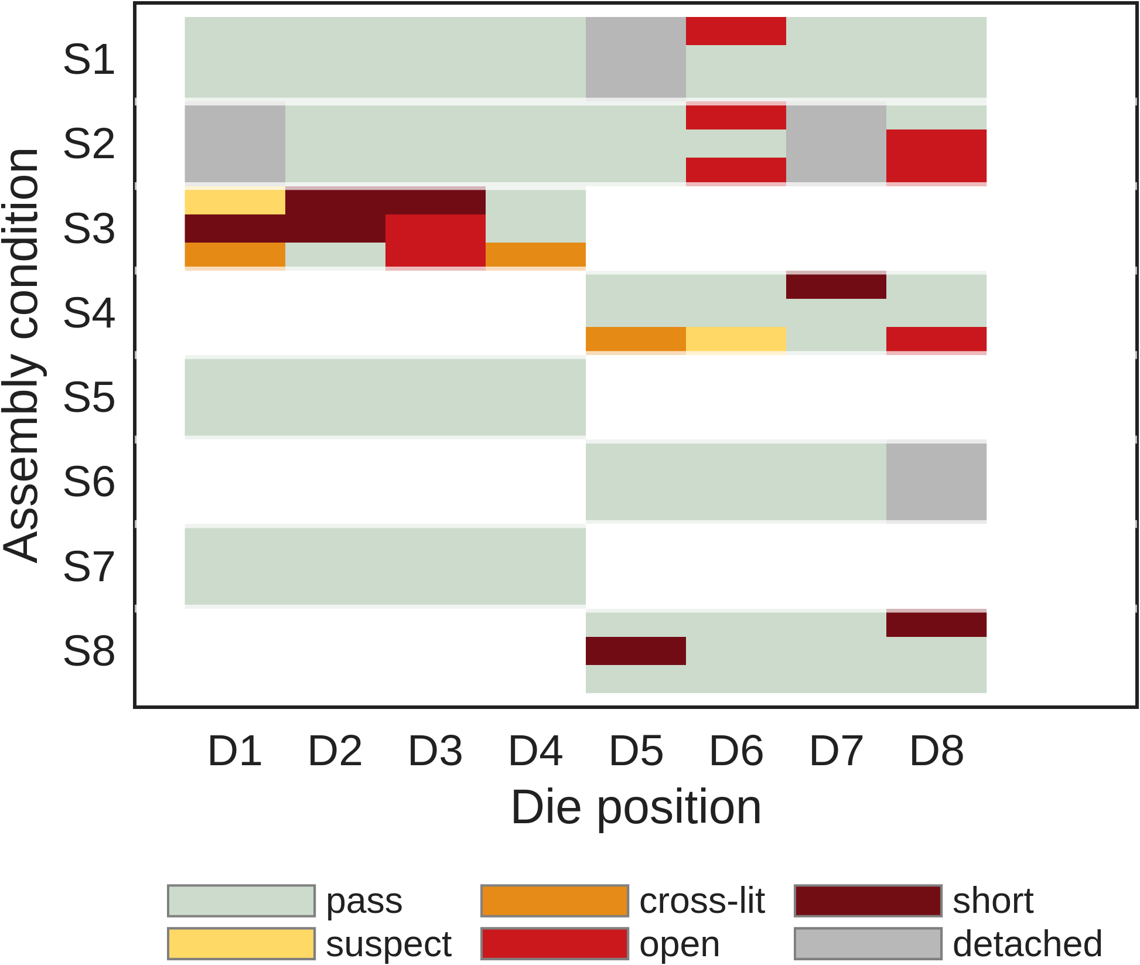
Fig. 5. Channel-level screening result. Three rows per condition (red, green, blue), one column per die position. Blank cells are die positions the condition does not own.
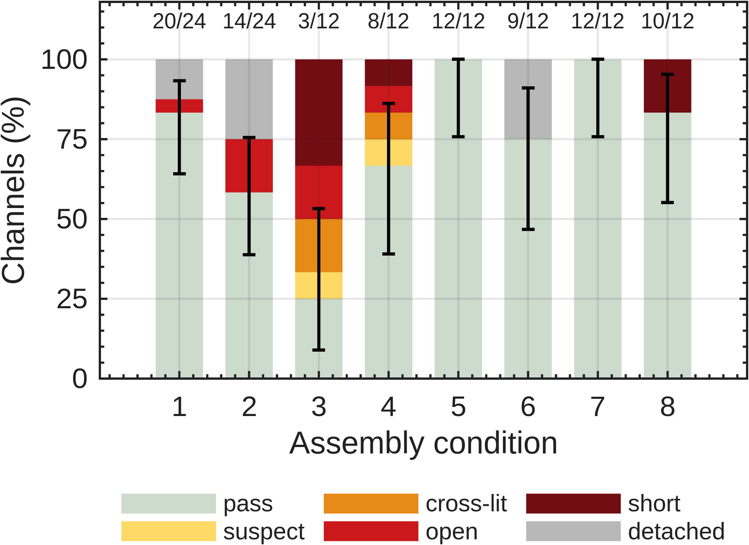
Fig. 6. Yield and failure mode by condition. Error bars are 95 % Wilson intervals on the pass fraction. Counts above each bar are passing channels over total.
The failure mode carries more information than the yield number. Conditions splitting into an over-bonded group (3, 4, 8: shorts and bridges) and an under-bonded group (1, 2, 6: opens and detachment) puts conditions 5 and 7 inside the process window and the others on one side of it or the other. That ordering is consistent across 120 channels and does not depend on the fixture problem that limits the series-resistance comparison.
Sample / condition | Channels n | Colour | V_{F} at 10 mA (V) | R_{s} from I–V (Ω) | I_{leak} at −5 V (µA) | Notes
1 | 6 | R | 2.0021 ± 0.0105 | 10.77 ± 0.79 | not measured | ideality 1.67–1.81
2 | 5 | R | 2.0048 ± 0.0058 | 11.12 ± 0.34 | not measured | ideality 1.66–1.80
3 | 1 | R | 1.9989 | 10.92 | not measured | ideality 1.65–1.65
4 | 3 | R | 2.0224 ± 0.0029 | 12.79 ± 0.65 | not measured | ideality 1.69–1.81
5 | 4 | R | 2.0109 ± 0.0129 | 11.28 ± 1.06 | not measured | ideality 1.70–1.92
6 | 3 | R | 2.0137 ± 0.0170 | 12.02 ± 1.20 | not measured | ideality 1.67–1.80
7 | 4 | R | 2.0132 ± 0.0170 | 11.46 ± 1.32 | not measured | ideality 1.76–1.87
8 | 3 | R | 2.0208 ± 0.0158 | 11.61 ± 0.92 | not measured | ideality 1.75–2.06

D. Specific contact resistivity (transmission-line method)
The TLM ladders give the sheet resistance R_{sh} and the specific contact resistivity ρ_{c} from the total resistance measured between successive finger pairs at known gaps d. For identical contacts of width W, length L, and transfer length L_{T},
R_{tot}(d) = (R_{sh} / W) · d + 2R_{c}
R_{c} = (R_{sh} · L_{T} / W) · coth(L / L_{T})
A linear fit of R_{tot} versus d gives R_{sh} from the slope and 2R_{c} from the intercept; the specific contact resistivity then follows as ρ_{c} = R_{c} · W · L_{T} · tanh(L / L_{T}). The three finger widths in the ladder make the width dependence of L_{T} directly measurable.
The TLM ladders were not measured. They require a four-wire source-measure unit on bare-ENIG structures, which was outside the instrument set used here.
Table IV. TLM extraction per finger width.
Sample / condition | Width W (mm) | R_{sh} (Ω/sq) | 2R_{c} (Ω) | L_{T} (µm) | ρ_{c} (Ω·cm²)
not measured

E. Sheet resistance (van der Pauw)
Each symmetric cloverleaf gives the sheet resistance directly, with no contact-geometry correction, from the implicit van der Pauw relation
exp(−π R_{A} / R_{sh}) + exp(−π R_{B} / R_{sh}) = 1
where R_{A} and R_{B} are the transverse four-point resistances measured at 90° rotation. For R_{A} ≈ R_{B} ≡ R this collapses to R_{sh} = (π / ln 2) · R. The cloverleaves cross-check the TLM slope and surface any width-dependent edge effects. The v1 board reported an effective sheet resistivity of 2.94 × 10⁻⁵ Ω·m for the ENIG pads [ref], a useful sanity check on the new readings.
The van der Pauw cloverleaves were not measured, for the same reason as the TLM ladders.
Table V. van der Pauw sheet resistance per cloverleaf.
Sample / condition | Cloverleaf W (mm) | R_{A} (Ω) | R_{B} (Ω) | R_{sh} (Ω/sq) | ρ_{sheet} (Ω·m)
not measured

F. Junction-to-substrate thermal resistance (forward-voltage thermometry)
The LED forward voltage at a fixed low sense current falls almost linearly with junction temperature, so the diode is its own thermometer. With the temperature-sensitive parameter S ≡ −∂V_{F}/∂T_{J} calibrated once,
T_{J}(t) = T_{J,0} − (1/S) · [ V_{F}(t) − V_{F,0} ]
The substrate temperature is read from the interleaved NTCs (TH1–TH4) through the Steinhart-B relation 1/T = 1/T₀ + (1/B) · ln(R/R₀), with T₀ = 298.15 K and R₀ = 10 kΩ. To suppress self-heating bias the sense current is pulsed (100 µA, 1 ms, 10% duty). The bond-joint thermal resistance is the steady-state ratio of the junction-to-substrate temperature difference to the dissipated power:
R_{th,bond} = [ T_{J}(∞) − T_{NTC}(∞) ] / P_{op}
Full thermometry was not run, since it needs a calibrated temperature stage to obtain the slope S. The pulse-length study below bounds the self-heating that would enter it. One red channel was swept three times with only the integration length changed, giving current-on times of 5, 20 and 80 ms per point.
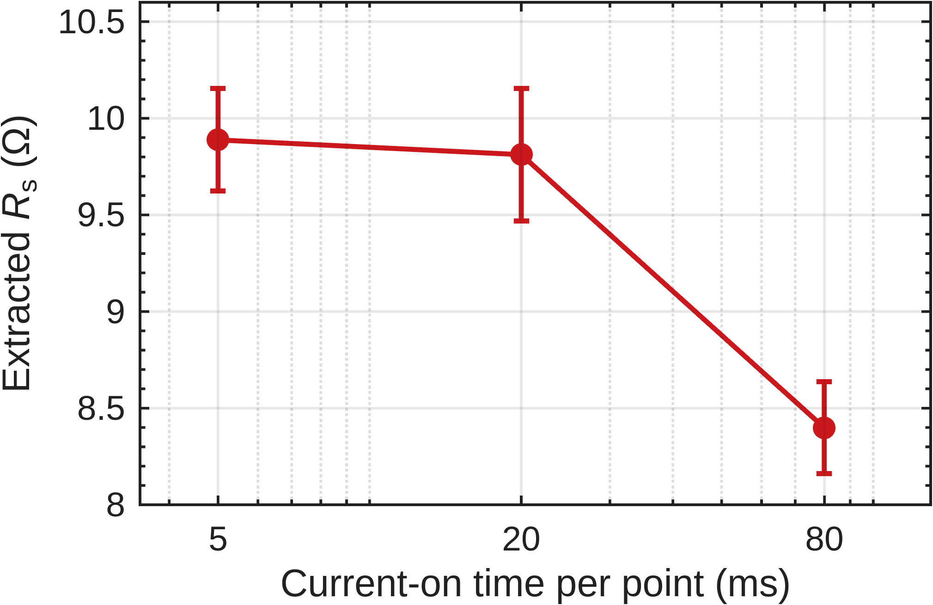
Fig. 7. Extracted series resistance against current-on time, same channel throughout. Error bars are the standard error of the fit.
Between 5 and 20 ms the extracted resistance is unchanged within the fit error. At 80 ms it falls by 1.49 Ω. The die dissipates 28.4 mW at 13.9 mA, and a junction-to-board thermal resistance of order 200 K/W gives about 6 K of rise; with dVF/dT near −2 mV/K that appears as roughly −1.2 Ω of apparent series resistance, which matches the measurement to within 25 %. All campaign data was taken at the 5 ms setting. The thermal time constant of the package therefore lies between 20 and 80 ms.
Table VI. Forward-voltage thermometry: calibrated slope and extracted junction-to-substrate thermal resistance.
Sample / condition | LED ID | S = −∂V_{F}/∂T_{J} (mV/K) | P_{op} (mW) | ΔT (K) | R_{th,bond} (K/W)
1–8 | S7 D1 R | not calibrated | 28.4 | ≈6 (inferred) | ≈200 (order of magnitude)

G. Impedance spectroscopy (optional)
Sweeping a 10 mV AC excitation from 0.1 Hz to 1 MHz and recording the complex impedance Z(jω) = Z′ + jZ″ separates the series bond resistance (the high-frequency intercept, Z′ → R_{s} as ω → ∞) from the diode’s parallel RC dynamics. For the standard LED equivalent circuit (R_{s} in series with R_{p} ∥ C_{j}),
Z(jω) = R_{s} + R_{p} / (1 + jω R_{p} C_{j})
The on-board EIS OPEN, SHORT, and LOAD references (the 100 Ω 0.1% resistor) calibrate the fixture before the LED is measured.
Impedance spectroscopy was not performed. No LCR meter was available for this campaign.
Table VII. EIS equivalent-circuit parameters.
Sample / condition | LED ID | R_{s} (Ω) | R_{p} (Ω) | C_{j} (nF) | f_{peak} (kHz)
not measured

H. Summary of electrical results
Table VIII collects the headline number from each method into a single per-condition comparison. Cross-condition variance is the figure of merit: it captures how wide each assembly process window actually is.
Two results survive. Yield and failure mode separate the eight conditions at p = 2.2 × 10⁻⁴, and place conditions 5 and 7 ahead of the rest with no failures in 12 channels each. Series resistance does not separate them, and the reason is measured: the fixture repeatability of 0.84 Ω exceeds the bond resistances by more than an order of magnitude.
Recovering series resistance as a discriminator needs the sense connections moved to the Tier-1 probe pads so that the jumper contacts fall outside the measured loop. Nothing about the dice or the bonding prevents it; the round 2 wiring simply placed both taps on the wrong side of the connectors.
Table VIII. Summary of electrical characterization across assembly conditions (one row per condition).
Condition | Yield (%) | Rbond (mΩ) | V_{F} at 10 mA (V) | Rs red (Ω) | Dominant failure mode | ρc / Rsh
1 | 83.3 | n/a (chain fault) | 2.002 | 10.77 | detached | not measured
2 | 58.3 | n/a (chain fault) | 2.005 | 11.12 | detached / open | not measured
3 | 25.0 | n/a (chain fault) | 1.999 | 10.92 | short / cross-lit | not measured
4 | 66.7 | n/a (chain fault) | 2.022 | 12.79 | mixed | not measured
5 | 100.0 | n/a (chain fault) | 2.011 | 11.28 | none | not measured
6 | 75.0 | n/a (chain fault) | 2.014 | 12.02 | detached | not measured
7 | 100.0 | n/a (chain fault) | 2.013 | 11.46 | none | not measured
8 | 83.3 | n/a (chain fault) | 2.021 | 11.61 | short | not measured

