Contactless Die Attach Methods Via Solder Paste

Ahmed Abdelwahab  TU Delft  Delft, Netherlands  a.n.m.k.abdelwahab@tudleft.nl | Zohreh Farmani  Delft University of Technology Delft, Netherlands  zfarmani@tudelft.nl | Daniel Tyukov  Delft University of Technology Delft, Netherlands  D.A.Tyukov@student.tudelft.nl | Hans Kuipers  ITEC  Nijmegen, Netherlands  j.j.kuipers@itecequipment.com

Jiajie Fan  Delft University of Technology  Delft, Netherlands  J.Fan-3@tudelft.nl | Willem  Delft University of Technology  Delft, Netherlands  @tudelft.nl | Marcel Tichem  Delft University of Technology  Delft, Netherlands  @tudelft.nl
Massimo
Delft University of Technology
Delft, Netherlands
@tudelft.nl
G. Q. Zhang
Delft University of Technology
Delft, Netherlands
G.Q.Zhang@tudelft.nl

Abstract—This work presents two novel contactless and fully pressure-less die-attach processes using solder paste and a controlled pick-and-release mechanism. Unlike conventional die-attach processes, the proposed methods eliminate externally applied mechanical loading during both die placement and solder reflow. In the first process, a liquid droplet is dispensed onto stencil-printed solder paste before die release. The droplet acts as a damping medium that facilitates die entrapment and promotes passive self-alignment. The reflow profile was optimized to control the evaporation of the dispensed liquid and prevent rapid vaporization, which could result in gas entrapment, void formation, and subsequent bond failure.
In the second process, the substrate is heated before die placement to transform the solder paste into a molten state, such that the molten solder itself acts as the liquid droplet for die entrapment and passive self-alignment. This approach eliminates the additional droplet-dispensing step and avoids the potential influence of an externally introduced liquid on the resulting bond quality. Both processes are benchmarked against reference assemblies produced using conventional pick-and-place and previously developed contactless pick-and-release methods. Die-landing, entrapment, and self-alignment dynamics are investigated using high-speed camera imaging and Multiphysics simulations, with particular attention to the effects of the liquid and molten-solder properties, including surface tension, density, and viscosity.
The resulting bond quality is comprehensively evaluated through die-shear testing, X-ray and computed tomography imaging for void detection, die-tilt and bond-line-thickness measurements, electrical characterization, and bond-interface and fracture-surface analyses. Failure analysis is further performed to distinguish between cohesive, adhesive, and mixed failure mechanisms. This study aims to demonstrate the feasibility of contactless solder-based die attachment and provide a fundamental understanding of the physical mechanisms governing die entrapment, passive self-alignment, and final bond quality.
Keywords—component, formatting, style, styling

Introduction

Die-entrapment concept

Experimental

Solder paste And Material Deposition

Substrate and Dies Fabrication

Droplet Dispensing

Molten Solder

Die Attachment

Geometrical characterization

Die Tilt

Bond Line Thickness (BLT)

Confinement and Pre-alignment

Final alignment Position

Results

X-Ray and CT Scans

Die-shear Strength

Failure Analysis

Bond interface cross-section

Electrical Characterization
A simple PCB was designed and fabricated to verify the electrical continuity of dies attached under the different conditions. As shown in Fig. XX, the DC test structure consisted of a daisy chain incorporating six 1 × 1 mm² Au-coated dummy dies. The sheet resistance of the 4-inch Au-coated wafer was measured using a CDE ResMap 178 multiprobe station, and the corresponding effective resistivity of the Au surface finish was 2.86× 10⁻⁸ Ω·m. The total daisy-chain resistance measured for each assembly condition is summarized in Fig. XX.

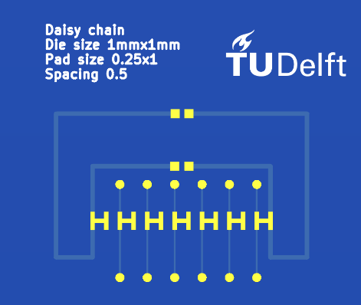
Figure 1 PCB Design including only DC test structures for 1mmx1mm dummy dies
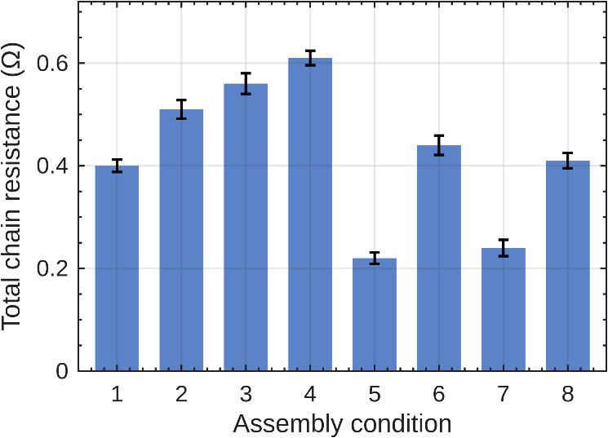
Figure 2 Total chain resistance for all assembly conditions
After electrical continuity was verified using dummy dies, functional devices were evaluated to further assess the performance of dies assembled using the proposed methods. Commercially available RGB LEDs were attached to a PCB specifically designed for their electrical characterization.
Figure XX shows the PCB design used to characterize the attached LEDs. The selected RGB LEDs had a square footprint, with a side length of 0.95±0.10 mm and a thickness of 0.25±0.10 mm. Figure XX presents the RGB LED used in this study: (a) a schematic of its package design and dimensions and (b) a 3D scan of the LED.
Each populated coupon was electrically characterized to evaluate the bond quality obtained under the different assembly conditions. The characterization was conducted in two stages. First, every addressable channel was screened using a handheld digital multimeter (DMM) to classify it as functional or failed and to identify the corresponding failure mode. Second, a current sweep was applied to each functional channel, and the resulting current–voltage characteristics were fitted using the diode equation to extract the series resistance, which includes the electrical contribution of the die-attach bond. The initial continuity screening clearly differentiated the eight assembly conditions, whereas the extracted series resistance showed no distinct separation. The reasons for this behavior are discussed in Section D.

Channel screening and yield
All 120 addressable channels across the five coupons were probed through the gold contact pads using the diode-test mode of a digital multimeter (DMM). A channel was classified as functional when it exhibited a forward junction voltage and produced the expected light output. Failures were categorized as open circuit (no conduction), short circuit (junction voltage below 0.15 V), cross-lighting (activation of one color caused another color to illuminate, indicating a bridge between cathodes), detached die (the die was physically absent), or suspect behavior.
The resulting electrical yield clearly differentiated the assembly conditions. A chi-square test applied to all 120 channels confirmed a statistically significant association between assembly condition and channel p = 2.2 × 10⁻⁴.
Conditions 5 and 7 achieved 100% channel yield, whereas Condition 3 exhibited the poorest performance, with 9 of its 12 channels failing.

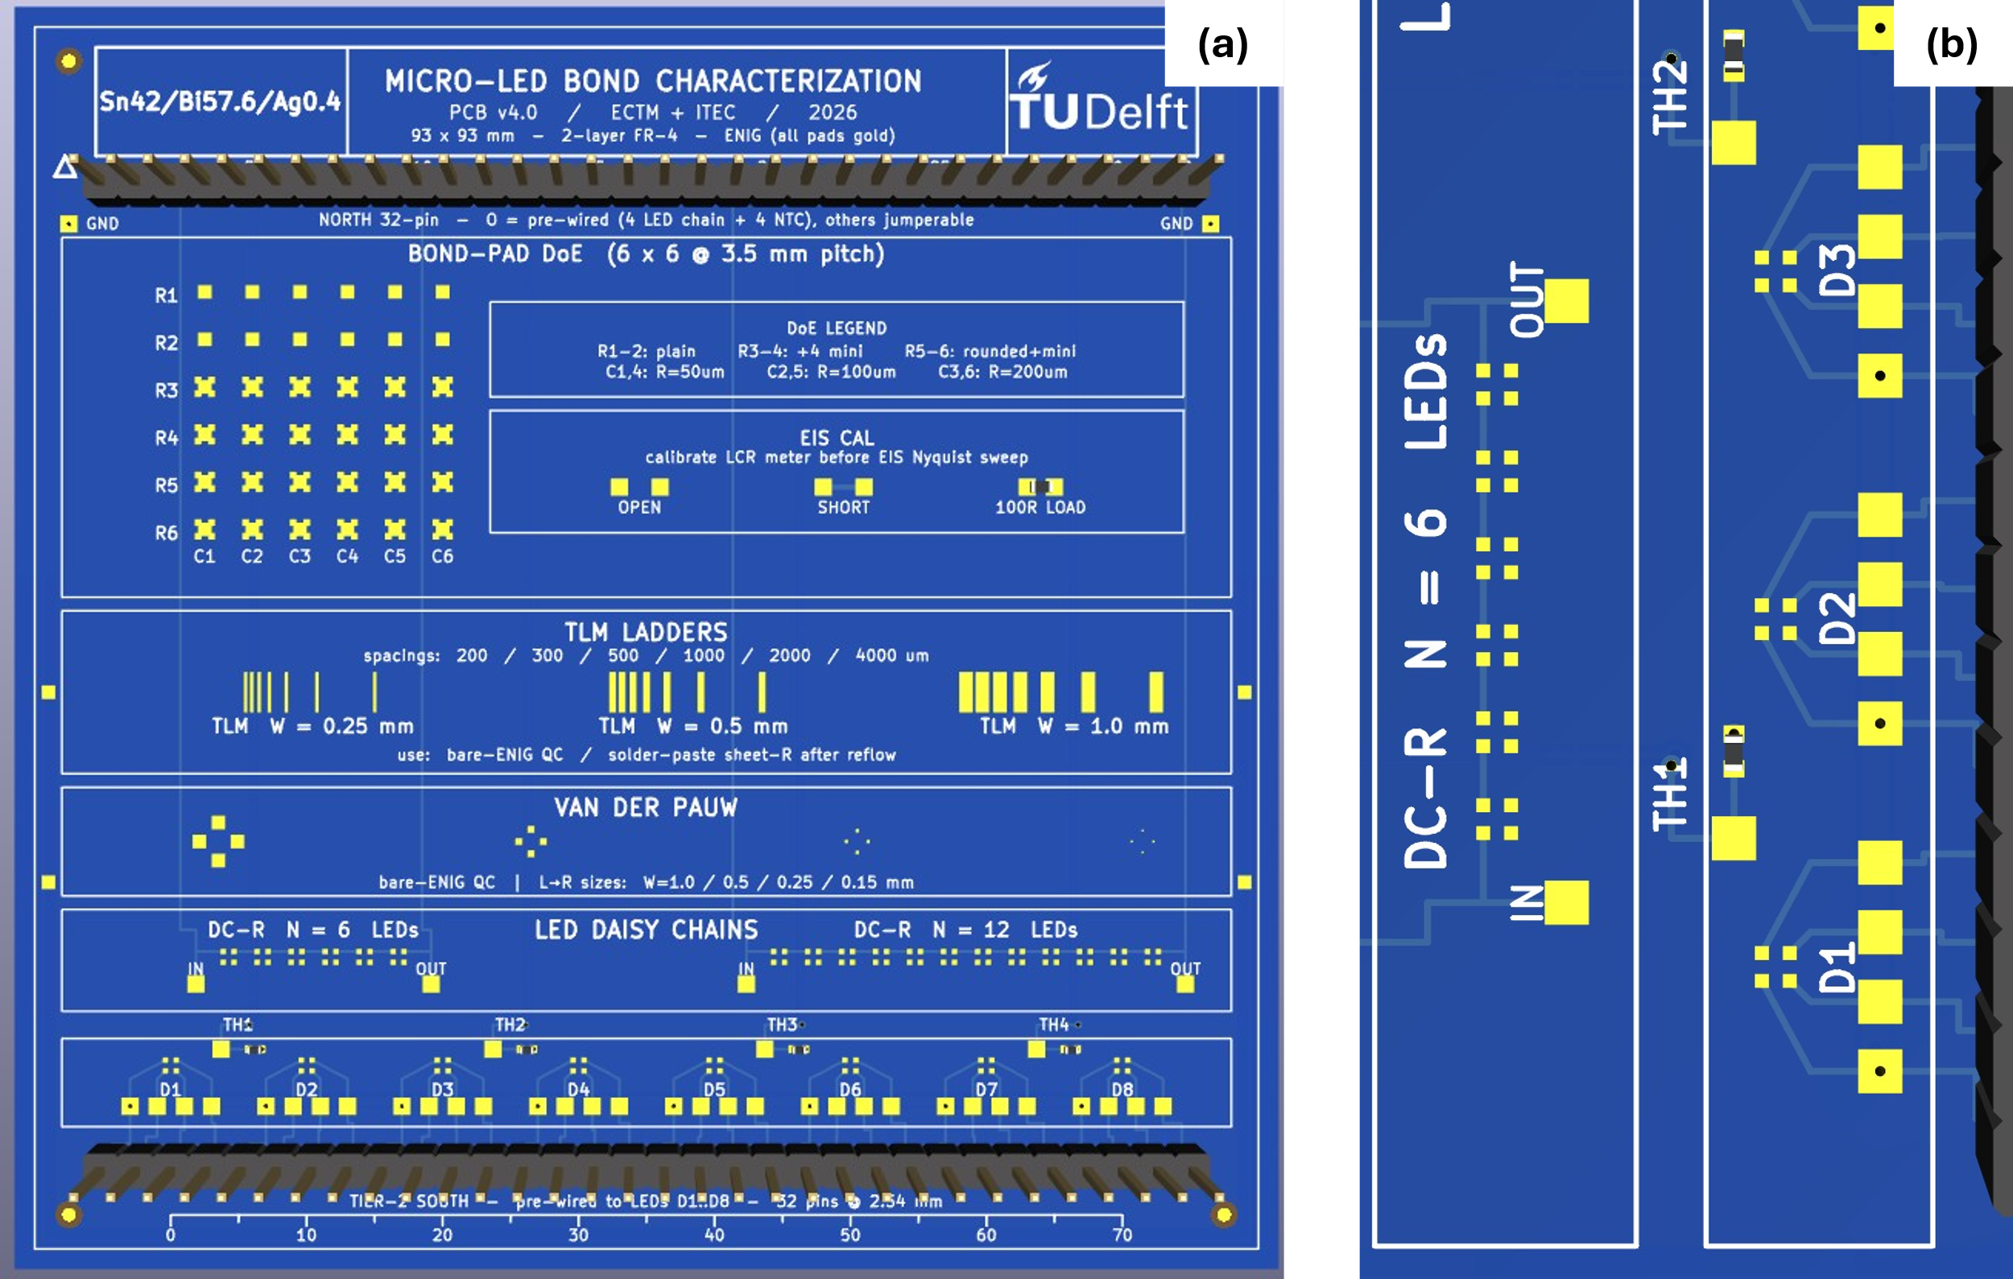
Figure 3 PCB design used for LEDs electrical characterization (a) PCB layout (b) RGB-LED footprint

Table 1 Measurement setup.
Quantity | Test structure | Instrument | Excitation
Channel state and failure mode | D1–D8 gold probe pads | Handheld DMM, diode test | ≈1 mA forward
Forward voltage, series resistance | D1–D8, south 32-pin header | Arduino UNO R3, six-branch binary current source, 14-bit oversampled ADC | Pulsed DC, 63 levels, 0.5–15.9 mA, 5 ms on / 250 ms off
Sense-resistor calibration | R_EIS_LOAD, 100 Ω 0.1 % | Handheld DMM, 600 Ω range, REL | DC
Substrate temperature | NTC pads TH1–TH4 | Handheld DMM, resistance | DC

The observed failure modes provide greater insight into the assembly quality than the electrical yield alone. Conditions 3, 4, and 8 predominantly exhibited short circuits and cross-lighting, consistent with excessive solder deposition and bridging between adjacent pads. In contrast, Conditions 1, 2, and 6 primarily exhibited detached dies and open-circuit cathodes, indicating insufficient wetting or weak solder joints. Neither type of failure was observed for Conditions 5 and 7. These results suggest that Conditions 5 and 7 lie within the acceptable process window, whereas the remaining six conditions represent either insufficient or excessive soldering conditions.

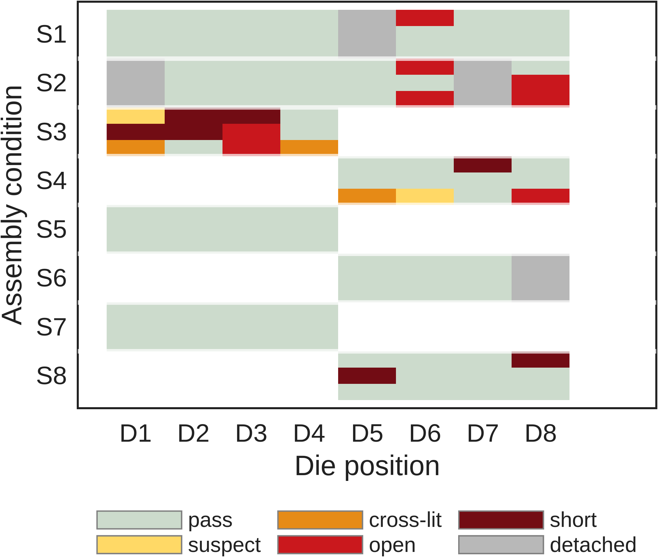
Figure 4 Channel-level screening result. Three rows per condition (red, green, blue), one column per die position. Blank cells are die positions the condition does not own

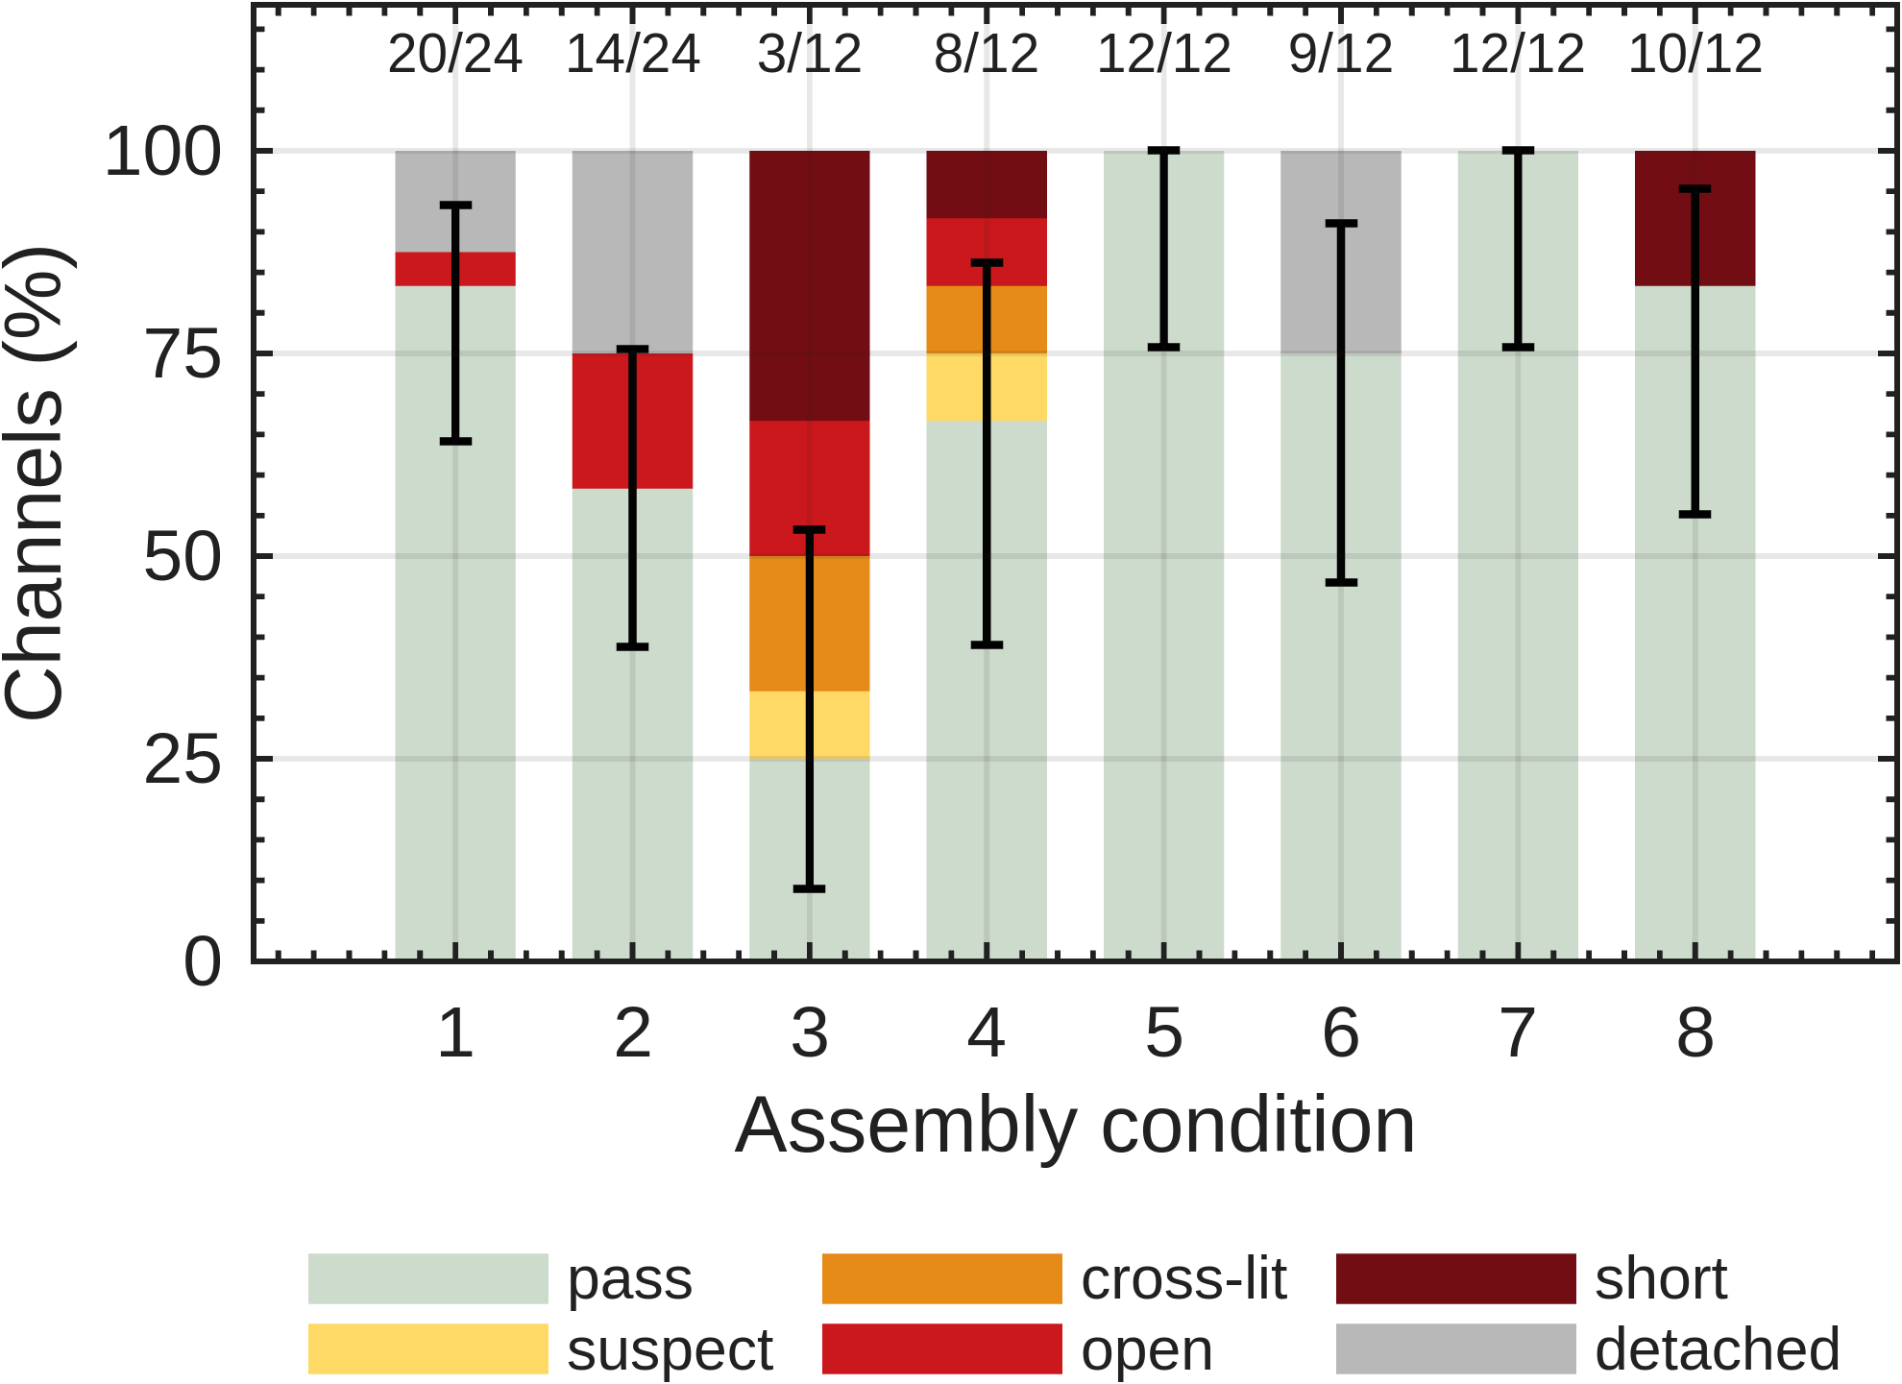
Figure 5 Yield and failure mode by condition. Error bars are 95 % Wilson intervals on the pass fraction; counts above each bar are passing channels over total.

Table 2 Channel yield and failure mode by assembly condition.
Condition | Pass / total | Yield (%) | Failure modes | Interpretation
1 | 20 / 24 | 83.3 | open 1, detached 3 | under-bonded
2 | 14 / 24 | 58.3 | open 4, detached 6 | under-bonded
3 | 3 / 12 | 25.0 | suspect 1, cross-lit 2, open 2, short 4 | over-bonded
4 | 8 / 12 | 66.7 | suspect 1, cross-lit 1, open 1, short 1 | over-bonded
5 | 12 / 12 | 100.0 | none | in window
6 | 9 / 12 | 75.0 | detached 3 | under-bonded
7 | 12 / 12 | 100.0 | none | in window
8 | 10 / 12 | 83.3 | short 2 | over-bonded

Forward characteristics and series resistance
Each functional channel was characterized at 63 current levels ranging from 0.5 to 15.9 mA. The current was supplied through six binary-weighted resistors connected to digital output pins, providing (2⁶−1 =63) non-zero current combinations. To minimize self-heating and ensure a consistent thermal history across all measurement points, the current was pulsed for 5 ms followed by an off-time of 250 ms. The series resistance was extracted using a three-parameter nonlinear least-squares fit applied to all data points above 0.5 mA:

$$\begin{aligned}V\left(I\right)=V_{0}+n⋅V_{T}⋅\ln\left(I\right)+I⋅R_{s} \#\left(1\right)\end{aligned}$$

where $V\left(I\right)$ is the terminal voltage, $V_{0}$ is the voltage offset, $n$ is the ideality factor, $V_{T}$ is the thermal voltage, $I$ is the current, and $R_{s}$ is the series resistance. which is the sum of the die's internal resistance, both bonds, and the board traces inside the sense loop, meaning that since all dice come from one reel, a shift in mean $R_{s}$ between conditions would indicate a shift in bond resistance.

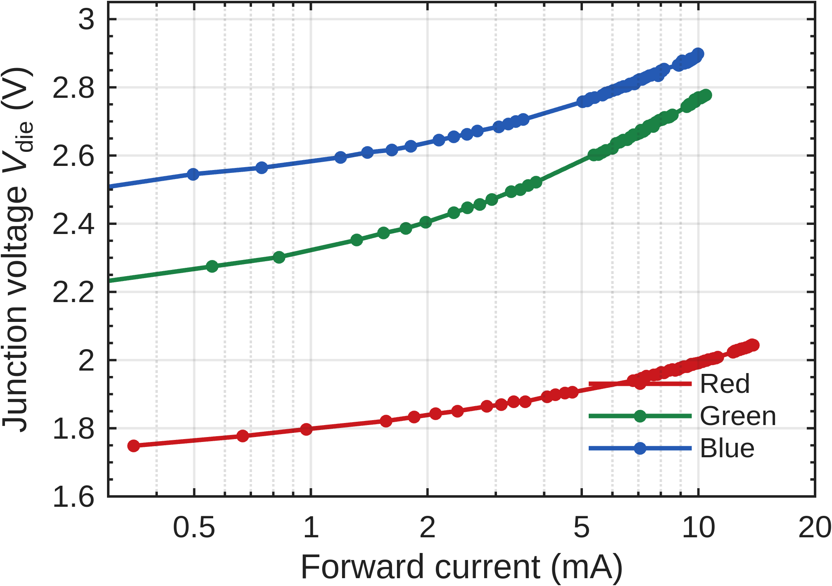
Figure 6 Forward current–voltage characteristics of the red, green, and blue channels of a single RGB LED (S1–D1). The red channel reaches 13.9 mA, whereas the green and blue channels are limited to approximately 10 mA because their higher forward voltages reduce the available headroom from the 5 V supply.
Only the red channels produced physically meaningful fits. The green and blue channels yielded ideality factors between 3.2 and 4.0, outside the expected range for the applied diode model. At forward voltages near 2.8 V, the 5 V supply provided only an approximately 20-fold current range. Over this limited range $V_{0}$, $n$, and $R_{s}$ were strongly correlated, making the fit poorly identifiable. In contrast, the red channels covered an approximately 30-fold current range and yielded ideality factors between 1.60 and 2.06. Therefore, the subsequent series-resistance analysis is restricted to the red channels.

Table 3 Table III. Red-channel forward voltage and extracted series resistance for each assembly condition. Uncertainties represent the standard deviation across the measured channels.
Condition | Channels n | V_F at 10 mA (V) | R_s (Ω) | Ideality n | Reverse check
1 | 6 | 2.0021 ± 0.0105 | 10.77 ± 0.79 | 1.67–1.81 | 6 clean
2 | 5 | 2.0048 ± 0.0058 | 11.12 ± 0.34 | 1.66–1.80 | 5 clean
3 | 1 | 1.9989 | 10.92 | 1.65–1.65 | 1 clean, 1 shunted
4 | 3 | 2.0224 ± 0.0029 | 12.79 ± 0.65 | 1.69–1.81 | 3 clean
5 | 4 | 2.0109 ± 0.0129 | 11.28 ± 1.06 | 1.70–1.92 | 4 clean
6 | 3 | 2.0137 ± 0.0170 | 12.02 ± 1.20 | 1.67–1.80 | 3 clean
7 | 4 | 2.0132 ± 0.0170 | 11.46 ± 1.32 | 1.76–1.87 | 4 clean
8 | 3 | 2.0208 ± 0.0158 | 11.61 ± 0.92 | 1.75–2.06 | 3 clean

Across the 29 functional red channels, the mean series resistance was 11.43 Ω, with a standard deviation of 0.99 Ω. A one-way ANOVA comparing the eight assembly conditions showed no statistically significant difference in series resistance, F(7, 21) = 1.73, p = 0.16. A similar result was obtained for the forward voltage at 10 mA, which had a mean of 2.0104 V and a standard deviation of 12.9 mV, with no significant difference among the conditions (p = 0.24). Thus, neither the extracted series resistance nor the forward voltage at 10 mA reliably differentiated the assembly conditions.

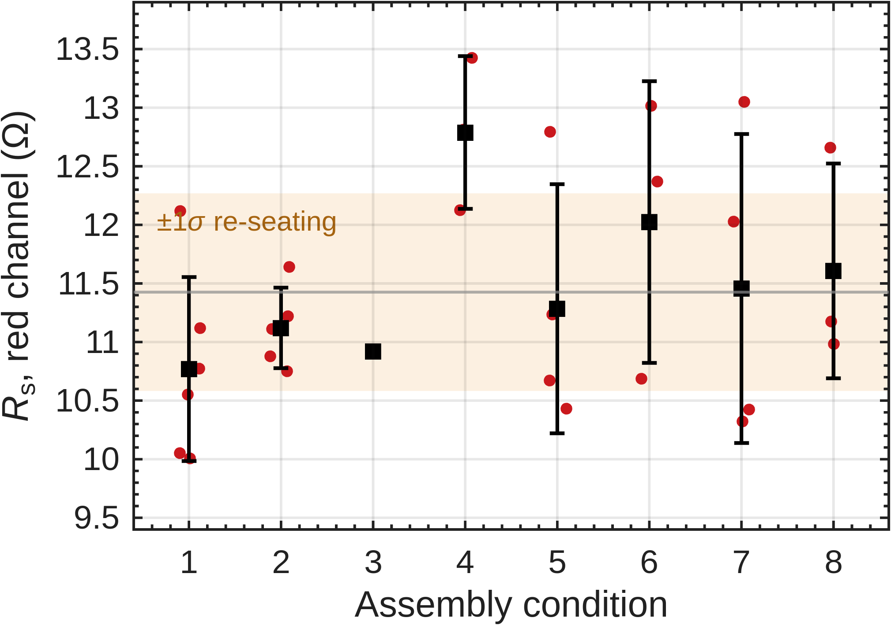
Figure 7 Series resistance by condition. Points are individual channels, squares are condition means, bars are ±1 standard deviation. The shaded band is the measurement repeatability established in Section D.
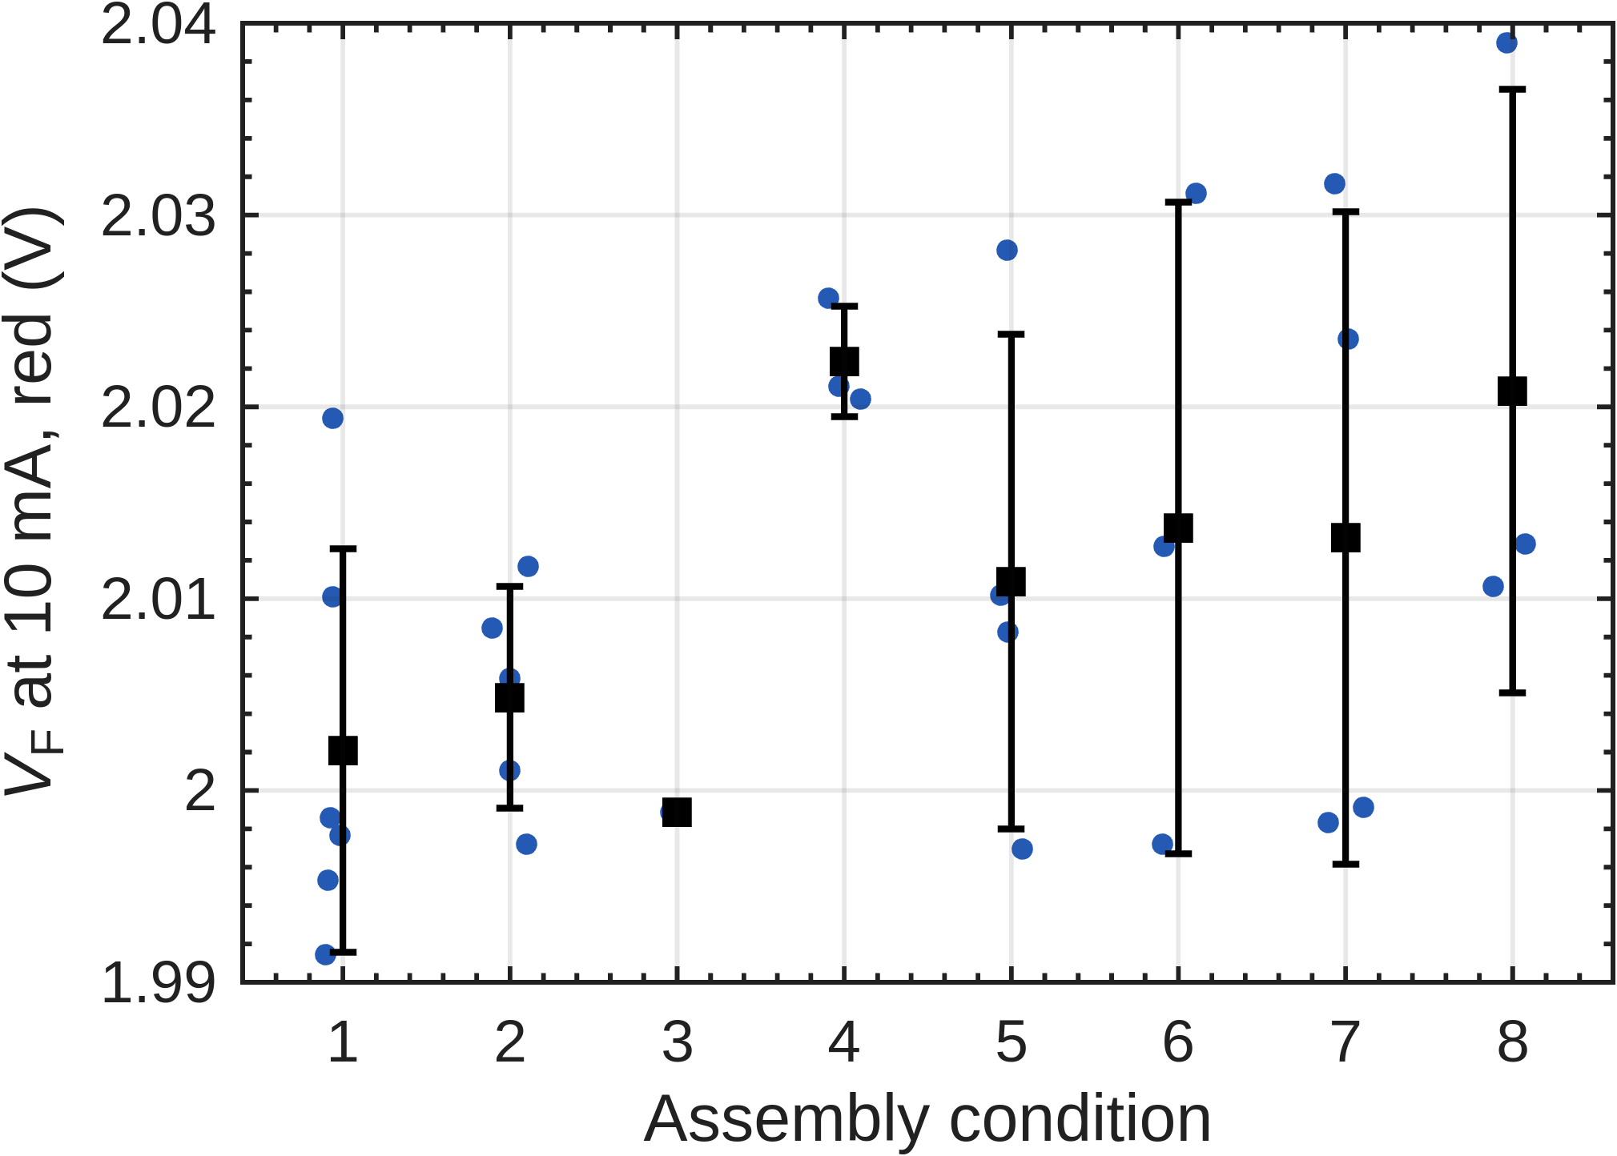
Figure 8 Forward voltage at 10 mA by condition. The full spread across all 29 channels is 13 mV, which is consistent with dice drawn from one reel.

Defect detection from the sweep
One red channel (S3–D1) produced a non-physical fit, with an ideality factor of 13.0 and a negative series resistance. Below 3 mA, the channel conducted 0.42 mA at approximately 1.21 V, which is below the typical turn-on voltage of a red LED. This behavior indicates the presence of a parallel leakage path with an estimated resistance of approximately 2.9 kΩ, allowing current to bypass the LED junction. Above 3 mA, however, its current–voltage characteristic became nearly indistinguishable from that of a functional channel. The channel also passed the initial DMM screening, showing a forward voltage of 1.781 V at approximately 1 mA, demonstrating that a conventional diode test may not reliably detect this type of parallel leakage.
The fitted ideality factor therefore provides a useful additional screening parameter for identifying channels with abnormal conduction paths, even when their current–voltage characteristics appear normal at typical operating currents. For the present dataset, physically plausible fits were defined by ideality factors between 1.2 and 2.4. All 29 red channels retained for further analysis fell within this range, whereas S3–D1 did not and was consequently excluded. Notably, this anomalous channel was located on the coupon that had already shown evidence of solder contamination during the initial electrical screening.
One numerical correction: I removed the statement that the shunt carries “only one-third” of the current at 1 mA. A 2.9 kΩ parallel path at 1.781 V would carry approximately 0.61 mA, which is closer to 61% of the total current.

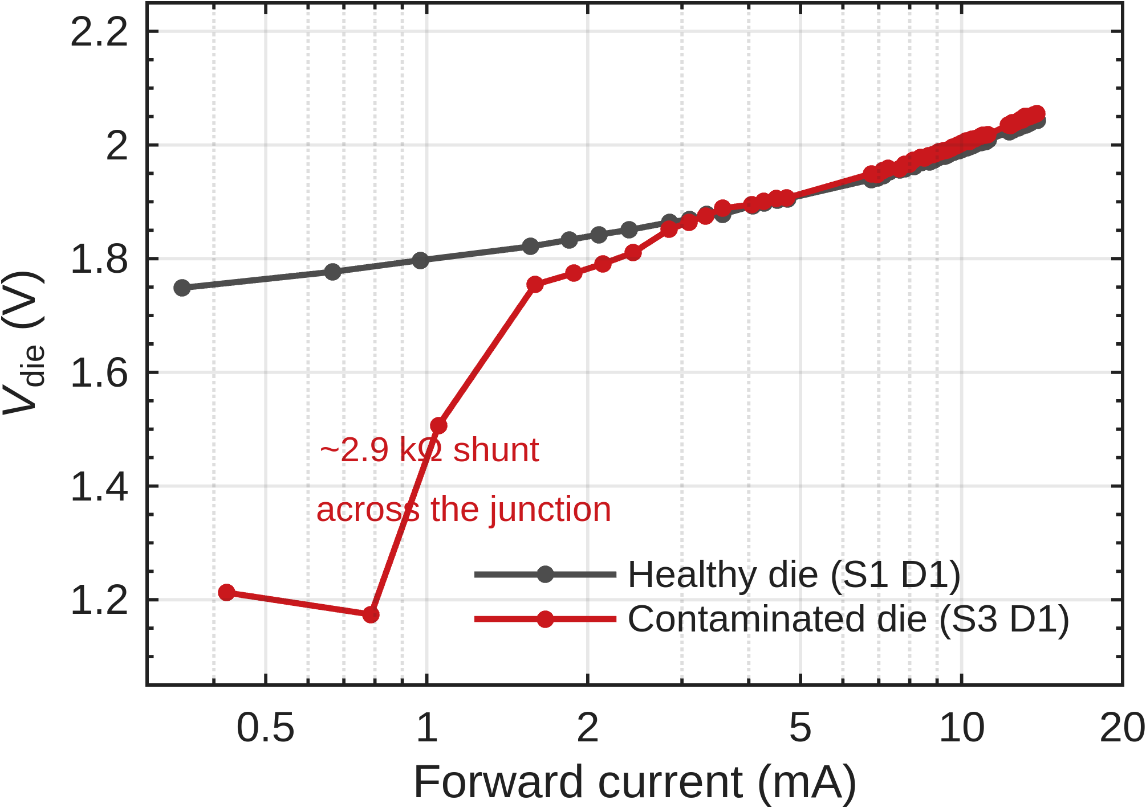
Figure 9 Forward current–voltage characteristics of a contaminated channel (S3–D1) and a healthy reference channel. The curves are nearly identical above 3 mA but diverge by 540 mV at the lowest current level.

Measurement repeatability and detection limit
The series-resistance comparison was primarily limited by the measurement fixture rather than by die-to-die variation. In the present setup, both voltage-sensing connections were taken from the breadboard instead of directly from the Tier-1 probe pads. Consequently, the resistance contributions of two female-to-male jumper wires and their header contacts were included in the measured loop.
To quantify this contribution, three channels were measured three times each. Between successive measurements, the same two jumper wires were disconnected and re-seated, while all other experimental parameters remained unchanged. The resulting pooled standard deviation was 0.84 Ω, compared with a within-condition standard deviation of 0.92 Ω. Based on the corresponding variances, jumper re-seating accounted for approximately 83%—or about 85%—of the variation that might otherwise have been interpreted as die-to-die resistance variation.

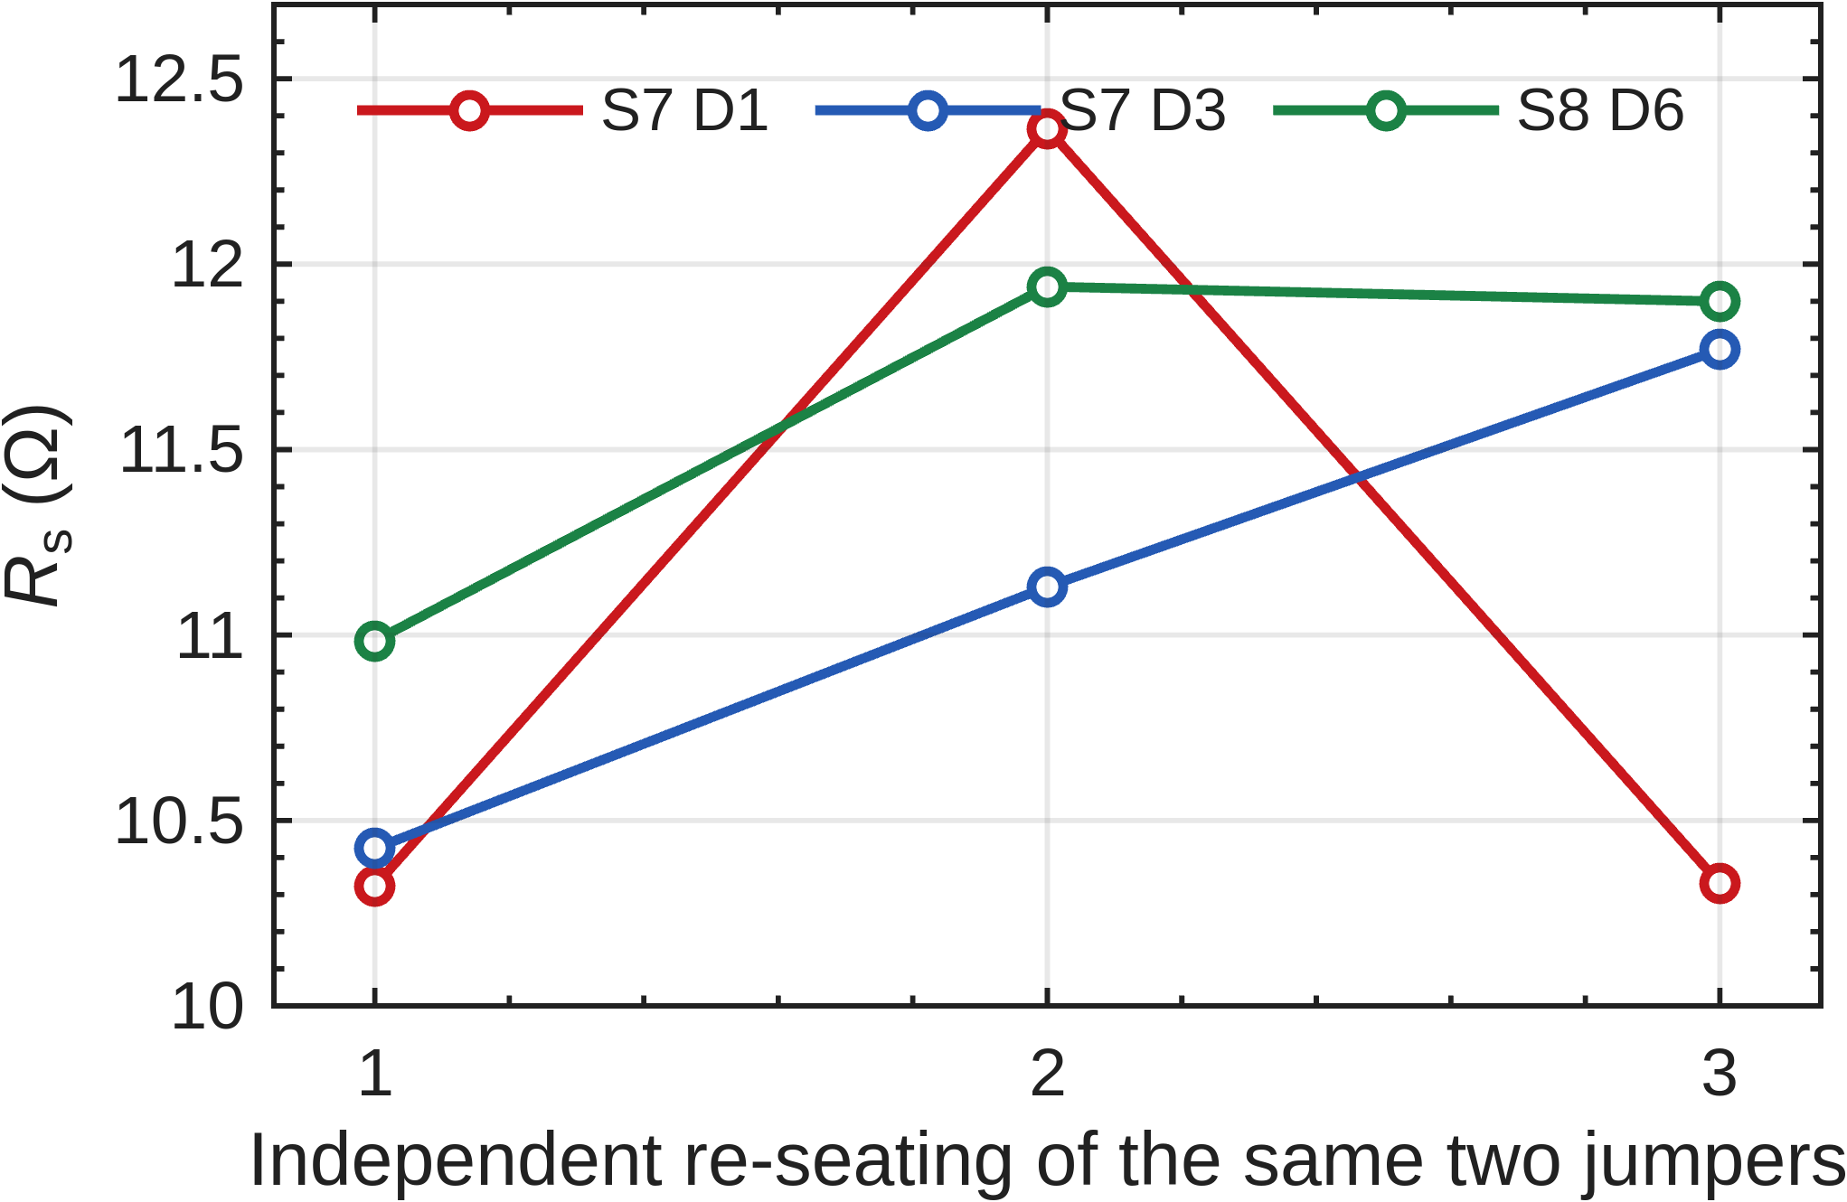
Figure 10 Repeatability measurements for three channels following three independent re-seatings of the two jumper connections. All other measurement conditions remained unchanged.
Each re-seating produced a resistance equal to or greater than the minimum measured for that channel, consistent with the fact that contact resistance contributes only positively to the measured value. The minimum values obtained for the three channels were 10.32, 10.42, and 10.98 Ω, giving an estimated intrinsic red-channel series resistance of approximately 10.6 Ω. Comparison with the overall mean indicates that approximately 0.85 Ω of the reported resistance originated from the wiring and connector contacts.
Typical bond resistances are on the order of 10–100 mΩ. With n = 4 channels per condition, the smallest difference in mean series resistance detectable by the present setup was approximately 1.4 Ω, more than one order of magnitude greater than the expected bond-resistance differences. Therefore, the absence of a statistically significant difference in Section B reflects the resolution of the measurement arrangement rather than equivalent electrical performance of the bonds. Relocating the voltage-sense connections to the Tier-1 probe pads would exclude the jumper and header contact resistances from the measured loop and enable a more sensitive comparison of the die-attach bonds.

Self-heating
At 13.9 mA, the die dissipated 28.4 mW. Junction self-heating reduces the forward voltage at higher currents, thereby flattening the I–V characteristic and potentially biasing the extracted series resistance, Rₛ, towards lower values. The current-pulse duration must therefore be selected based on its thermal influence rather than assumed to be negligible. To evaluate this effect, one channel was swept three times while changing only the measurement integration time, corresponding to current-on durations of 5, 20, and 80 ms per measurement point.

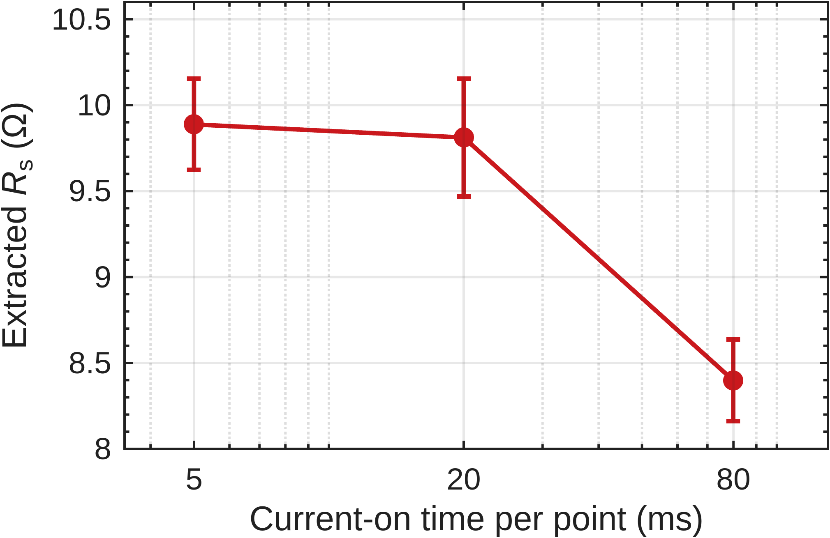
Figure 11 Extracted series resistance against current-on time, same channel throughout. Error bars are the standard error of the fit.
The extracted series resistance remained unchanged within the fitting uncertainty when the current-on time was increased from 5 to 20 ms. At 80 ms, however, it decreased by 1.49 Ω. Assuming a junction-to-board thermal resistance of approximately 200 K/W, a power dissipation of 28.4 mW produces an estimated junction-temperature rise of about 6 K. Using a forward-voltage temperature coefficient of approximately −2 mV/K, this temperature increase corresponds to an apparent reduction in series resistance of roughly 1.2 Ω, which agrees with the measured decrease to within 25%.
These results indicate that junction heating becomes significant between 20 and 80 ms. Accordingly, all measurements used in the main experimental campaign were performed with a current-on time of 5 ms, for which no measurable thermal bias was observed.

Reverse bias check
Every surviving red channel was additionally characterized under reverse bias to identify possible conduction paths parallel to the LED junction. The die was connected in series with a 100 kΩ resistor across a 5 V supply, and the voltage across the die was measured. A healthy reverse-biased junction produced a voltage close to the open-circuit limit, whereas a parallel leakage path reduced the measured voltage. Measuring the voltage across the series resistor was unsuitable with the handheld meter because the expected signal at nanoampere-level leakage currents was comparable to the instrument noise.
Among the 34 channels tested, 30 produced reverse-bias voltages between 4.988 and 4.989 V, corresponding to the experimentally observed open-die limit and indicating that their leakage was below the resolution of the measurement arrangement. Three channels produced readings of 0 V, confirming the short circuits identified during the initial screening. The remaining channel, S3–D1 red, produced a voltage of 0.085 V, corresponding to an estimated parallel resistance of approximately 1.7 kΩ.
This was the same channel previously identified as anomalous from its forward I–V characteristic in Section C, which indicated a parallel resistance of approximately 2.9 kΩ. Thus, measurements under opposite bias polarities independently identified the same leakage defect and estimated its resistance within a factor of two, despite the channel passing the initial 1 mA diode test. The channel had been classified as “suspect” during the first screening based on the operator’s observation; the reverse-bias measurement confirmed this classification. Condition 3’s reported yield is therefore based on a confirmed defect rather than an estimated failure.
The remaining reverse-bias results were effectively null but still informative. Although Condition 8 lost two channels through short circuits, its surviving channels were indistinguishable from those of Conditions 5 and 7. Its failures therefore appear to be isolated defects rather than evidence of coupon-wide solder contamination. No partial conduction path was detected under any condition other than Condition 3. Reverse-bias characterization consequently corroborated the yield ranking obtained during the initial screening but did not provide an additional metric for distinguishing among the surviving channels.

Summary
Three main findings emerge from the electrical characterization. First, channel yield and failure-mode distribution significantly differentiated the eight assembly conditions (p = 2.2 × 10⁻⁴).
Conditions 5 and 7 achieved the best performance, with no failures among the 12 channels tested under each condition. Second, the extracted series resistance did not distinguish between the conditions. This limitation was experimentally attributed to the measurement fixture: the 0.84 Ω repeatability variation introduced by the jumper connections was substantially greater than the expected bond resistance of 10–100 mΩ. Third, reverse-bias characterization identified only one partial shunt among the 34 channels tested. The reverse-bias results therefore corroborated the yield ranking rather than providing an additional means of differentiating the conditions.
The observed failure modes provide both a ranking of the assembly conditions and an indication of the underlying process behavior. Conditions 1, 2, and 6 predominantly exhibited detached dies and open circuits, indicating insufficient wetting or weak joint formation and suggesting under-bonded conditions. In contrast, Conditions 3, 4, and 8 exhibited short circuits and pad-to-pad bridging, indicating excessive solder and suggesting over-bonded conditions. Conditions 5 and 7 exhibited neither type of failure and therefore appear to lie within the acceptable process window. Reverse-bias testing further showed that, with the exception of Condition 3, the surviving channels under all conditions were free from detectable partial conduction paths. This finding narrows the performance difference between Condition 8 and the two failure-free conditions: the failures under Condition 8 appear to be isolated short circuits rather than evidence of coupon-wide contamination.
Series resistance remains the principal electrical parameter requiring improved measurement resolution. Relocating the voltage-sense connections from the breadboard to the Tier-1 probe pads would exclude the jumper and header contact resistances from the measured loop. This modification is expected to reduce the repeatability limitation from 0.84 Ω toward the fitting precision of 0.16 Ω achieved after correction of the measurement firmware. Such an improvement would increase the sensitivity of the method and may allow differences in die-attach bond resistance to be resolved.

Table 4 Summary of electrical characterization results for the eight assembly conditions.
Condition | Yield (%) | Failure modes | V_F at 10 mA (V) | R_s (Ω) | Reverse | Assessment
1 | 83.3 | open 1, detached 3 | 2.002 | 10.77 | clean | under-bonded
2 | 58.3 | open 4, detached 6 | 2.005 | 11.12 | clean | under-bonded
3 | 25.0 | suspect 1, cross-lit 2, open 2, short 4 | 1.999 | 10.92 | 1 shunt | over-bonded
4 | 66.7 | suspect 1, cross-lit 1, open 1, short 1 | 2.022 | 12.79 | clean | over-bonded
5 | 100.0 | none | 2.011 | 11.28 | clean | in window
6 | 75.0 | detached 3 | 2.014 | 12.02 | clean | under-bonded
7 | 100.0 | none | 2.013 | 11.46 | clean | in window
8 | 83.3 | short 2 | 2.021 | 11.61 | clean | over-bonded

