DELFT UNIVERSITY OF TECHNOLOGY  Faculty of Electrical Engineering, Mathematics and Computer Science | 

Final assignment
Microsystems Design and Modelling (ET4260)
Part 2/3

Instructions:
Document your calculations properly with derivations and screenshots when needed.
Please submit your files in word format to facilitate feedback. Latex-generated PDF files are also accepted but not preferred. All equations should be typeset – photographs of handwritten work will not be graded.
Deadline for first submission of Part 2: 10th June 2026
Deadline for final report submission: 24th June 2026
Please, mark corrections made after the first submission in blue.

________________________________________________________________
State here your NAME and STUDENT NUMBER.
________________________________________________________________

FEM modelling of optical phase shifter for quantum applications
Consider the same system described in Part 1, BUT NOW the fingers on the ends of the Comb Drive are wider than the center ones by a factor of 3 as shown in the updated image:
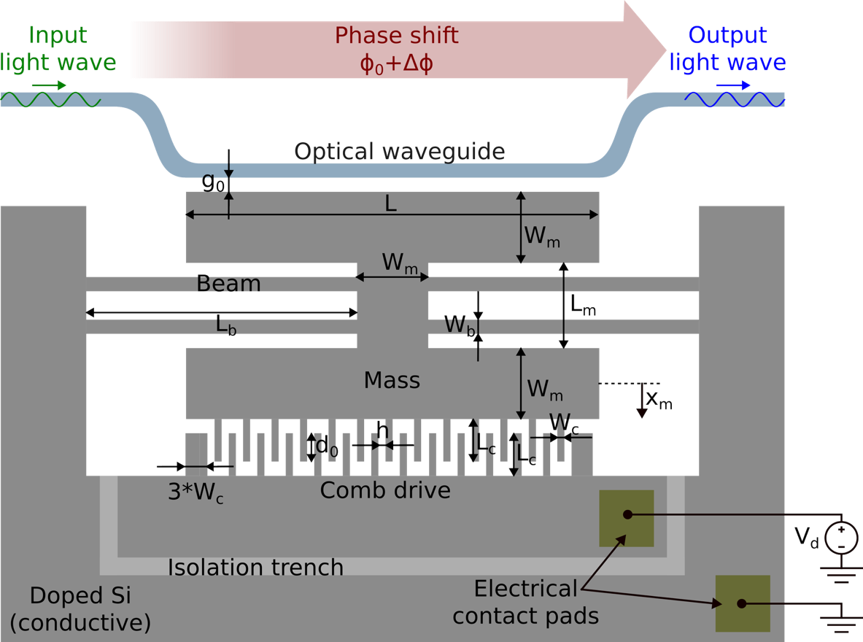

*Some dimensions are not drawn on scale for better visualization.
Length of modulation section | $$L$$ | 100 μm
Modulation gap at rest | $$g_{0}$$ | 200 nm
Length of beams | $$L_{b}$$ | 75 μm
Width of beams | $$W_{b}$$ | 5 μm
Length of mass central section | $$L_{m}$$ | 40 μm
Width of mass sections | $$W_{m}$$ | 30 μm
Comb-drive gap | $$h$$ | 1 μm
Comb-drive overlap length at rest | $$d_{0}$$ | 19 μm
Comb-drive finger length | $$L_{c}$$ | 20 μm
Comb-drive finger width | $$W_{c}$$ | 1 μm
Bottom Comb-drive fingers on each end | $${3*W}_{c}$$ | 3 μm
Thickness of suspended parts | $$t$$ | 200 nm
Number of gaps in comb-drive | $$N$$ | 40
Young’s modulus of Si | $$E_{Si}$$ | 170 GPa
Density of Si | $$ρ_{Si}$$ | 2330 kg/m³

Mechanical model and dynamics
Build a 2D FEM model in COMSOL, including the relevant elements for the system dynamics: the suspended mass, the beams and comb-drive structure. Exclude the optical waveguide from the model.
Initially, include only the Solid Mechanics physics and neglect the electrostatic transduction. For Silicon, assume an isotropic model.

Question 1) Perform a stationary (DC) analysis to determine the spring constant of the system. Compare the result with the estimation obtained in Part 1 and discuss any differences.

Question 2) Perform an eigenfrequency analysis. Determine the fundamental resonance frequency of the system and obtain 2D maps of the modal displacement of the first 5 modes.

Now, include damping in the solid mechanics physics such that the system has a quality factor of 83. Hint: Use the Rayleigh damping model in COMSOL.
Question 3) Perform a time-domain analysis to obtain the step response of the system, using a force applied at the suspended mass as input. Compare the result with the analytically predicted settling time from part 1.
Electrostatic transduction
Now include the Electrostatics Physics in your model. You will need to leverage the moving mesh from the COMSOL tutorial part 2 (4th June Class), slides found on Brightspace. Similar tutorial found on COMSOL’s website: https://www.comsol.com/model/electrostatically-actuated-cantilever-444,

Question 4) Perform a stationary (DC) analysis to obtain the displacement of the mass as a function of the voltage applied to the comb-drive actuator.
- Simulate several voltages in the range from 0 to 150 V and compare the results with the analytical prediction from Part 1 by plotting both results on the same graph. Hint: Use a parametric sweep.
- Increase the actuation voltage until pull-in occurs. Compare the obtained pull-in voltage with the analytical approximation from Part 1. Hint: Follow this pull-in Voltage tutorial from the COMSOL website, due to the challenges with instability in solving this physical tradeoff: https://www.comsol.com/model/download/1377461/models.mems.biased_resonator_2d_pull_in.pdf
Question 5) Perform a stationary (DC) analysis to determine the maximum acceleration the system can withstand without contact between the suspended mass and the waveguide. Consider accelerations applied along the direction of motion of the mass for bias voltages $V_{d}\text{=}$ 0, 1 V, 10 V and 50 V.
Question 6) Perform a time-domain analysis to obtain the step response of the system using a voltage applied to the comb-drive as input, with values of 1V and 50V. Compare the results with that obtained in Question 3 and discuss any differences in the dynamic response.
---------- END OF PART 2 ----------

