DELFT UNIVERSITY OF TECHNOLOGY  Faculty of Electrical Engineering, Mathematics and Computer Science | 

Final assignment
Microsystems Design and Modelling (ET4260)
Part 1/3

Instructions:
Document your calculations properly with derivations and screenshots when needed.
Please submit your files in word format to facilitate feedback. Latex-generated PDF files are also accepted but not preferred.
Deadline for first submission of Part 1: 13th May 2026
Deadline for final report submission: 24th June 2026
Please, mark corrections made after the first submission in blue.

________________________________________________________________
State here your NAME and STUDENT NUMBER.
________________________________________________________________

Optical phase shifter for quantum applications
Photonic integrated circuits are increasingly used in quantum information processing, where precise control of the optical phase is required to manipulate quantum states of light. One approach to achieve this control is through MEMS-based optical phase shifters, where mechanical motion modifies the effective refractive index experienced by light propagating in a waveguide.
The MEMS photonic phase shifter shown in the figure operates by coupling the evanescent field of light propagating through an optical waveguide to a silicon structure located at a small distance from the waveguide. By changing the gap $g$ between the suspended silicon mass and the waveguide, the effective refractive index of the guided optical mode is modified, producing a phase shift in the transmitted light.
If the phase shift for the device at rest is denoted by $ϕ_{0}$, a change in the gap $g$ introduces an additional phase shift (unit in rad) given by
$$Δϕ\left(g\right)\text{=}\frac{2πL}{λ} \left(n_{eff}\left(g_{0}\right)\text{-}n_{eff}\left(g\right)\right)$$
where $λ\text{=}1550$ nm is the wavelength of the light, $L$ is the length of the modulation section, $n_{eff}\left(g\right)$ is the effective refractive index across the modulation section, and $g_{0}$ is the gap at rest (corresponding to $V_{d}\text{=}0$). The effective refractive index and the gap are related by the following exponential equation:
$$n_{eff}\left(g\right)\text{=}\left(η_{eff,0}\text{-}η_{eff,∞}\right) e^{\text{-}bg}\text{+}η_{eff,∞}$$
where $b\text{=}0.3 {μm}^{\text{-}1}$ is a constant, $η_{eff,0}\text{=}2.6$ is the effective refractive index at $g\text{=}0$ and $η_{eff,∞}\text{=}2.4$ is the effective refractive index of the isolated waveguide (i.e., when $g→∞$).
The mechanical displacement of the suspended mass $x_{m}$ is controlled using an electrostatic comb-drive actuator, which produces a force on the suspended mass when a voltage is applied. The main geometrical dimensions and material properties of the device are summarized in the table on page 3.
Below is a real fabricated device as an example:
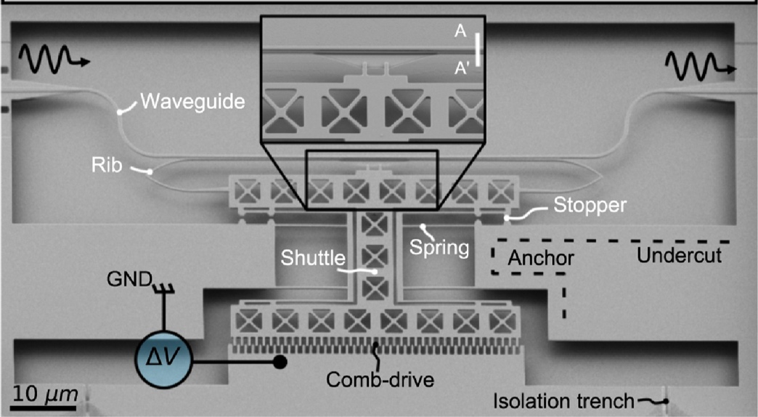
A SEM image of a fabricated device. Ref: Pierre Edinger, Alain Yuji Takabayashi, Carlos Errando-Herranz, Umar Khan, Hamed Sattari, Peter Verheyen, Wim Bogaerts, Niels Quack, and Kristinn B. Gylfason, "Silicon photonic microelectromechanical phase shifters for scalable programmable photonics," Opt. Lett. 46, 5671-5674 (2021)
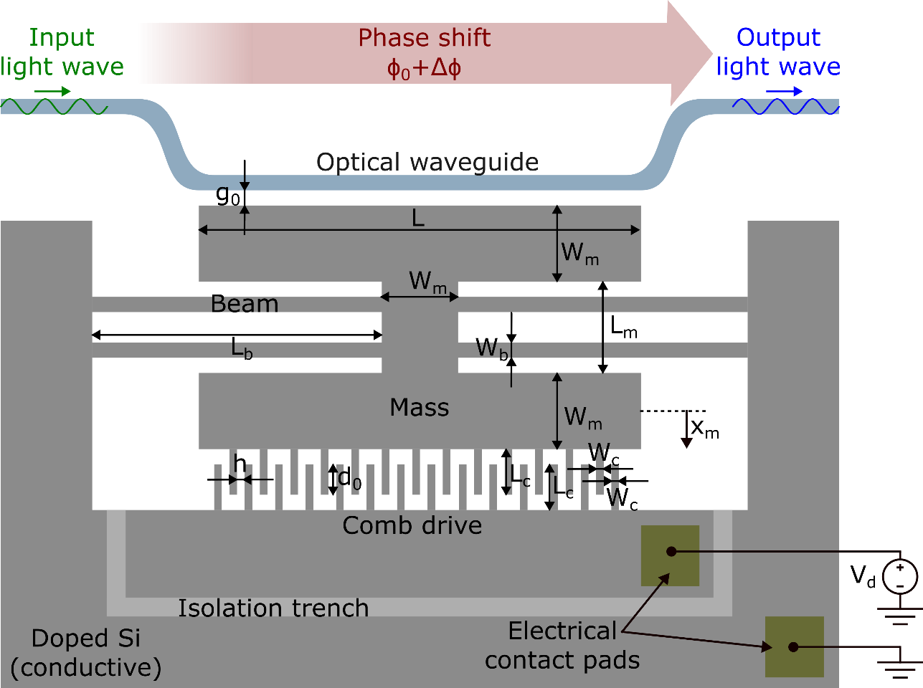
*Some dimensions are not drawn to scale for better visualization.

Length of modulation section | $$L$$ | 100 μm
Modulation gap at rest | $$g_{0}$$ | 200 nm
Length of beams | $$L_{b}$$ | 75 μm
Width of beams | $$W_{b}$$ | 5 μm
Length of mass central section | $$L_{m}$$ | 40 μm
Width of mass sections | $$W_{m}$$ | 30 μm
Comb-drive gap | $$h$$ | 1 μm
Comb-drive overlap length at rest | $$d_{0}$$ | 19 μm
Comb-drive finger length | $$L_{c}$$ | 20 μm
Comb-drive finger width | $$W_{c}$$ | 1 μm
Thickness of suspended parts | $$t$$ | 200 nm
Number of gaps in comb-drive | $$N$$ | 40
Young’s modulus of Si | $$E_{Si}$$ | 170 GPa
Density of Si | $$ρ_{Si}$$ | 2330 kg/m³

Mechanical model and dynamics
Initially, assume the device operates in vacuum and neglect any damping effects.
Question 1) Write the lumped-element differential equation of motion for the suspended mass. Consider the electrostatic force generated by the comb-drive actuator $F_{e}$ as the system input and the displacement of the mass $x_{m}$ as the system output.
Question 2) Estimate the fundamental resonance frequency. For this calculation:
- Neglect the compliance of the central mass when estimating the stiffness of the system.
- Neglect the mass of the beams when estimating the effective mass of the system.
Question 3) Using the system constants estimated in Question 2, calculate the displacement of the suspended mass $x_{m}$ due to gravity, assuming that gravity acts along the direction of mass displacement.

In what follows, assume that the device operates in air. The surrounding air exerts a damping force $F_{d}$ proportional to the velocity of the suspended mass ${\overset{˙}{x}}_{m}$ and its top-side area $A_{m}$ according to the following expression. This simplified model neglects viscous damping contributions from the sidewalls of the structure.
$$F_{d}\text{=}c_{air}⋅A_{m}⋅{\overset{˙}{x}}_{m}$$
where $c_{air}\text{=}$ $16.15 N s\text{/}m^{3}$is the air damping coefficient. Additionally, energy losses at the beam anchors can be accounted for using a quality factor $Q_{clamping}\text{=}500$.
Question 4) Considering both damping mechanisms, calculate the settling time of the device for a step input force. The settling time is defined as the time it takes for the mass displacement to settle within ±5% of its final value.
Question 5) Mechanical vibrations can damage the device if the suspended mass comes into contact with the optical waveguide. These vibrations can be modelled as harmonic accelerations at a given frequency.
- Derive an expression for the maximum acceleration amplitude, as a function of frequency, that the device can withstand without the suspended mass touching the waveguide, assuming $V_{d}\text{=}0$. Assume the acceleration is applied in the direction of motion of the suspended mass.
- Using this expression, determine the maximum DC acceleration that the system can withstand.
- Using this expression, determine the maximum AC acceleration that the system can withstand at the worst-case frequency.

Electrostatic transduction and sensitivity
Question 6) Express the gap $g$ as a function of a DC applied voltage $V_{d}$ and plot the resulting phase shift $Δϕ$ for a range of $V_{d}$ from $\text{-}50 V$ to $50 V$. For this calculation, neglect fringing effects and consider only the electric field component perpendicular to the comb-drive fingers.
Question 7) Discuss the pull-in instability of the comb-drive actuator and, if applicable, derive an expression for the pull-in voltage under the following modelling assumptions:
- Consider only the electric field component perpendicular to the comb-drive fingers, neglecting fringing fields. (Meaning: consider only the capacitance generated by the overlapping area of the fingers).
- Include the field component along the direction of the comb-drive fingers. (Meaning: consider the parallel-plate capacitance between the finger tips and the opposing anchors, in addition to the overlapping capacitance).
To implement phase modulation at a frequency $f_{m}$, the applied voltage is composed of a DC component and a small AC modulation component:
$V_{d}(t)\text{=}V_{DC}\text{+}V_{AC}sin\left(2π f_{m}t\right)$, with $V_{AC}≪V_{DC}$
Question 8) Model the modulation response of the system by following these steps:
- Using a linearized small-signal model, derive the frequency response of the mass displacement $x_{m}$ with respect to the modulation voltage amplitude $V_{AC}$, leaving the bias voltage $V_{DC}$ as a variable. For the comb-drive model, neglect fringing effects and consider only the electric field component perpendicular to the comb-drive fingers.
- Obtain the sensitivity of the phase shift $Δϕ$ to the mass displacement $x_{m}$ at the bias point set by $V_{DC}$, using a first-order Taylor expansion. Recall that the general first-order Taylor expansion for a function $f(x)$ around an operating point $x_{0}$ for a small change $δx$ is:
$$f\left(x_{0}+δx\right)≈f\left(x_{0}\right)+\frac{df}{dx}{\left.​\right|}_{x_{0}}⋅δx$$
- Combine both results to obtain the small-signal transfer function of the system $\frac{Δϕ\left(s\right)}{V_{AC}\left(s\right)}$. Sketch the corresponding Bode diagram using $V_{DC}=10V$and give expressions for the main performance metrics:
  - Low-frequency modulation sensitivity, or $\left|\frac{Δϕ\left(s\right)}{V_{AC}(s)}\right|$ as $f_{m}→0$.
  - Highest modulation sensitivity, or $\left|\frac{Δϕ\left(s\right)}{V_{AC}\left(s\right)}\right|$ at the device resonance frequency.
  - Slope of the roll-off.
- Plot the low-frequency modulation sensitivity as a function of $V_{DC}$ ovr the range from 0 to 5 kV and discuss the observed trends.
Geometric scaling
Question 9) Assume that all the dimensions in the design are multiplied by a factor of 1000. Discuss how the following main device characteristics scale with this change:
- System stiffness.
- System mass.
- Resonance frequency.
- Mass displacement due to gravity.
- Maximum AC acceleration that the system can withstand.
- Electromechanical coupling constant ($η$) of the comb-drive for a given bias voltage level, assuming the number of gaps in the comb-drive $N$ stays unchanged.

---------- END OF PART 1 ----------

