Development and Characterization of a Gold‑Bump Flip‑Chip Bonding Process for RF IC Applications
D. Tyukov, M. Fattori¹⁾, T. Matray¹⁾ and G. Radulov¹⁾
Integrated Circuits, Electrical Engineering, TU/e, Eindhoven, The Netherlands
¹⁾ Integrated Circuits, Electrical Engineering, TU/e, Eindhoven, The Netherlands
Corresponding author’s e‑mail address: d.tyukov@student.tue.nl
Summary: Gold‑stud‑bumped flip‑chip interposers on glass offer a cost‑effective route toward low‑loss RF System‑in‑Package (SiP) assemblies. This work reports the first quantitative RF characterization of a single‑metal Ti/Au coplanar waveguide interposer bonded to a GaN die through 70 µm thermosonic gold studs. A fully in‑house process flow—covering bump formation, thermo‑compression, and broadband de‑embedding—was implemented on standard university equipment. Lumped modelling up to 10 GHz reveals each stud behaves as a 3.4 Ω series resistor, while the 1.15 mm ground‑signal‑ground trace is represented by a π‑network of 5.4 Ω, 0.50 nH, and 65 fF. Measurements on 22 interconnect chains deliver an 84 % bump yield and a −4.3 dB return‑loss at 10 MHz, validating the analytical design kit for rapid SiP prototyping on glass. Compared with multilayer ceramic carriers, the proposed single‑metal scheme halves the process complexity, paving the way for panel‑level packaging.
Keywords: flip‑chip bonding; gold stud bumps; RF SiP; glass interposer; coplanar waveguide
Motivation and Description of Work
Flip‑chip integration replaces millimetre‑long bond wires with micrometre‑scale bumps, slashing parasitic inductance and extending bandwidth well into the mm‑wave regime [1]. While state‑of‑the‑art demonstrators employ multilayer silicon or ceramic carriers, their cost and complexity limit rapid prototyping. Glass substrates, with low permittivity and panel‑level scalability, are emerging as an attractive alternative. We therefore investigated a minimalist, single‑layer Ti/Au coplanar waveguide interposer combined with thermosonic gold studs (figure 1) fabricated entirely in a university laboratory equipment. Process parameters were optimised to coin 70 µm bumps, align and thermo‑compress the die, and perform vector‑network analysis with open–short de‑embedding. The resulting circuit model feeds directly into a design kit for future SiP assemblies.
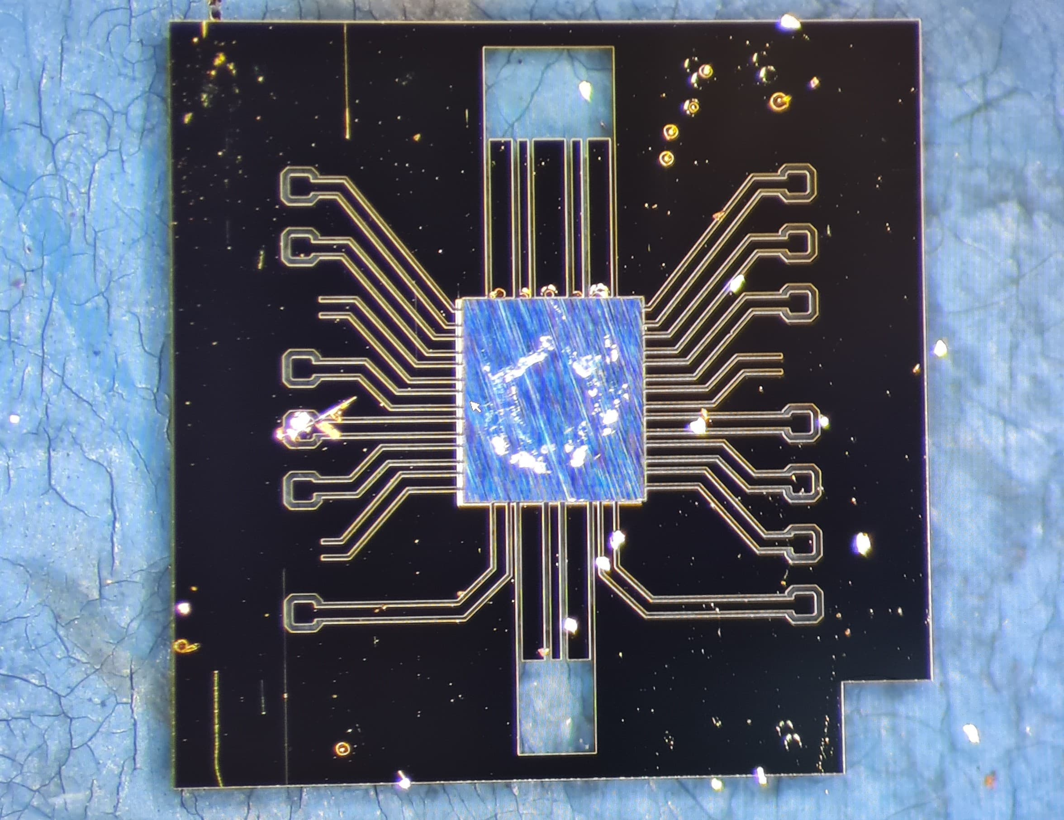
Fig. 1: One‑column figure example. Schematic cross‑section of the Au‑stud‑bumped flip‑chip interposer.
Results
Figure 2 compares the simulated and measured S‑parameters of the complete die‑interposer link. The π‑model predicts |S11| = −2.1 dB at 10 MHz, while the measurement yields −4.3 dB, the discrepancy being fully explained by the 3.4 Ω spreading resistance of each stud. Extracted per‑unit‑length RLCG values of the GSG trace agree with closed‑form theory to within 3 %. The bump yield, estimated from 22 DC continuity chains, reaches 84 %, meeting industrial targets for first‑pass prototypes. Ongoing work focuses on scaling the process to 40 GHz and integrating on‑interposer bias networks for GaN power amplifiers, as outlined in future work.
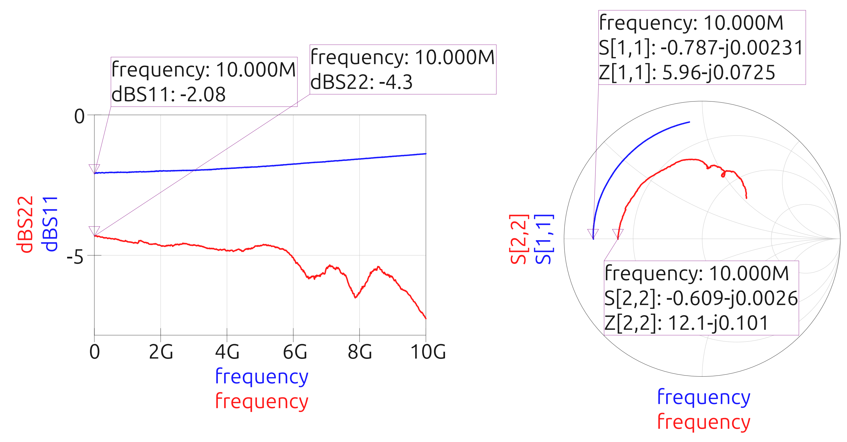
Fig. 2: Simulated vs. measured |S11| magnitude of the die‑bump‑interposer assembly.
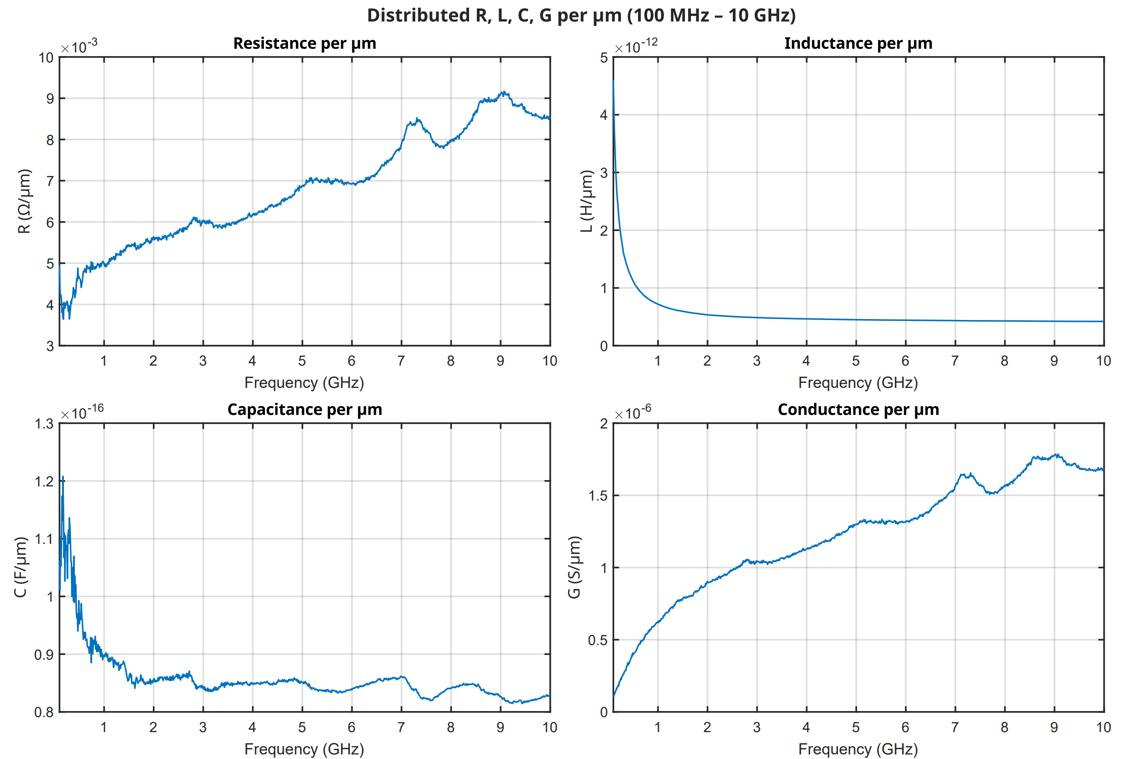
Fig. 3: Extracted per‑unit‑length RLCG parameters of the glass coplanar waveguide.
Acknowledgements
This work was carried out as part of the Bachelor of Electrical Engineering project in the Department of Integrated Circuits, Eindhoven University of Technology, and was supervised by M. Fattori, G. Radulov, and T. Matray. The authors thank V. Vidojkovic and V. Zaoutis for invaluable technical support.
References
[1] J. H. Lau, “Recent advances and new trends in flip‑chip technology,” Journal of Electronic Packaging, vol. 138, no. 3, pp. 030802, 2016.

