**Climate Change**

**Citizens**

**For Our Children’s Future**

**What is Climate Change?**

Climate is the average or typical weather in a region1. Countries near the equator have a climate that is warm while countries near the North or South Pole have a climate that is cooler.

**Climate change is the change in Earth’s overall climate due to an increase in temperature**2. The planet is warming and it is being caused by human related activities.

**The Impact on You**

Climate change affects every person in the world and will affect our children and their children to follow. People in America are noticing longer summers with higher temperatures and shorter winters. Others are experiencing heavier rainfalls that are causing floods more often than before. Signs of climate change are becoming more abundant in the atmosphere and in the oceans. There are increasing concentrations of carbon dioxide in the atmosphere due to the burning of coal, oil, and gas3. The rise in carbon dioxide in the atmosphere is preventing the heat from the sun from leaving Earth, thus affecting the temperatures all over the world. Not only is the carbon dioxide preventing heat from escaping but it is also interacting with ocean water and making it more acidic (see figure 1). This in turn makes the water more corrosive and prevents life forms with shells or skeletons from growing and reproducing normally3. The danger these life forms face will affect the marine food chain.

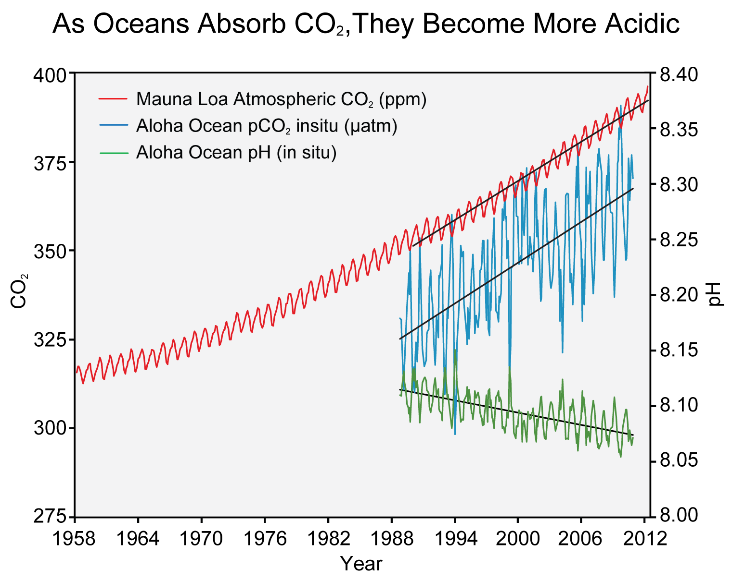

**Figure 1.** Mauna Loa CO2 in atmosphere (red), rising CO2 levels (blue), falling pH means more acidic (green)3

**What You Can Do**

You can start by spreading the word about climate change. Not enough people are aware that human activity is the cause of our planet warming. A Pew Study conducted in 2014 concluded that about half of the elderly surveyed disagree that scientist think the Earth is getting warmer due to human activities (see figure 2).

Another action you can take is using other methods of transportation. Instead of navigating around with a car, you can ride a bike or ride the local public transportation system. Not only does this decrease the amount of traffic in the road but also reduced the amount of pollution coming from vehicles that is strengthening climate change.

**Figure 2.** Number of people who had an opinion about human-driven climate change by age group