Optimized stratified random surveys best estimate multispecies abundance in a rapidly changing ecosystem
Vilas, Barnett, Punt, Oyafuso, DeFilippo, Siple, Zacher, Kotwicki — ICES Journal of Marine Science, 2024, Vol. 82, Issue 6, fsae158. DOI 10.1093/icesjms/fsae158
Corrigendum markup — published text affected by the RRMSE-of-CV formula correction is shown struck through in red, immediately followed by the corrected replacement highlighted in yellow. A sentence that is newly added (not a replacement) is highlighted in green. A point still needing the author’s own input is marked XXXX in cyan. Each correction is keyed to its item ID (C1–C7) in the corrigendum correction table. Unaffected text is reproduced for context only where directly relevant — this is not a full reprint of the manuscript.

Abstract
Data from fishery-independent surveys are critical inputs to stock assessments, ecosystem-based fishery management, and applied ecological research. However, environmental change may affect species distributions and their availability to surveys, with consequences for the consistency and precision of abundance estimates over time. We investigated whether defining survey stratum boundaries by environmental conditions improves the precision and accuracy of abundance estimates in a multispecies survey. We fitted univariate spatiotemporal species distribution models to 16 stocks (14 species) using historical observations of fishery-independent bottom trawl survey catch-per-unit-effort and sea bottom temperature in the eastern and northern Bering Sea from 1982 to 2022. These spatiotemporal models were used to simulate species distributions and survey observations under a variety of environmental conditions and survey designs. The predicted density of each species at each location and time was passed to a multivariate optimization routine to determine whether this could increase the accuracy of estimates of abundance per unit of survey effort across species relative to traditional survey designs. Historical and projected future abundances for 10 of the 16 stocks were estimated more precisely under optimized designs–up to 4× as precise as the existing design.
[C6 — RESOLVED EXACTLY. This “10 of 16 stocks” / “about 63%” figure counts stocks by CV magnitude (precision), not by RRMSE of CV (accuracy); it is a different metric from the RRMSE formula bug, confirmed unaffected by it — the same is true of Fig. 6 and Supplementary Figs S11, S14, S15 (all CV distribution plots, not RRMSE) and Supplementary Tables S1/S3 themselves. Checked directly against the manuscript’s own source tables: Supplementary Table S1 (historical CV, existing vs. optimized, by stock) shows 10 of 16 TRUE; Table S3 (projected) shows 11 of 16 TRUE, differing from Table S1 only in Hippoglossoides robustus (Bering flounder). The Abstract’s “historical and projected … for 10 of 16” is the intersection of the two tables’ TRUE stocks — exactly 10 of 16, an exact match to the published figure, not an approximation. No correction needed.]
The accuracy of the estimate of abundance precision was always lowest for systematic sample allocation and highest for random or balanced random sampling within strata, The accuracy of the estimate of abundance precision was lowest for systematic sample allocation and highest for random or balanced random sampling within strata under historical conditions; under projected future conditions this ranking reversed, with random sampling becoming the least accurate and systematic and balanced random sampling statistically indistinguishable from each other and most accurate, suggesting that designs optimized with historical biological and environmental data lead to a better ability to quantify survey precision. under historical, but not necessarily future, conditions. The approach developed here can be applied in other ecosystems experiencing change to support the design of flexible survey designs that could increase the efficiency of sampling marine resources under current and future climates.
[C7 — suggested rewrite for author review, derived from the corrected Results-section ranking (C4); not yet approved by co-authors.]

Results — Historical performance of optimized and traditional survey designs
Published (C1, C2, C5):
Accuracy of the CV was highest (RRMSE lowest) for the optimized survey designs using random station allocation (<0.2), followed by balanced random, while systematic sampling provided the least accurate CVs. Sampling stations for the existing systematic survey design are fixed so they are resampled in each simulated survey and RRMSEs of CV for the existing systematic survey design were 1.
Corrected:
Accuracy of the CV was highest (RRMSE lowest) for the optimized survey designs using random station allocation (median RRMSE 0.16–0.17), followed by balanced random, while systematic sampling provided the least accurate CVs (mean RRMSE 0.51 vs. 0.48 for balanced random and 0.32 for random, pooled across stratifications). For the existing systematic survey design, RRMSE of CV ranged from 0.12 to 1.85 across stocks and years (mean 0.74, median 0.62), reflecting real variability rather than a fixed value.
[C1, C2, C5 — formula fix: RRMSE was computed as mean(sqrt(·)) instead of sqrt(mean(·)); the historical ranking of allocation methods is unchanged, but the “<0.2” and “=1” figures were not real.]
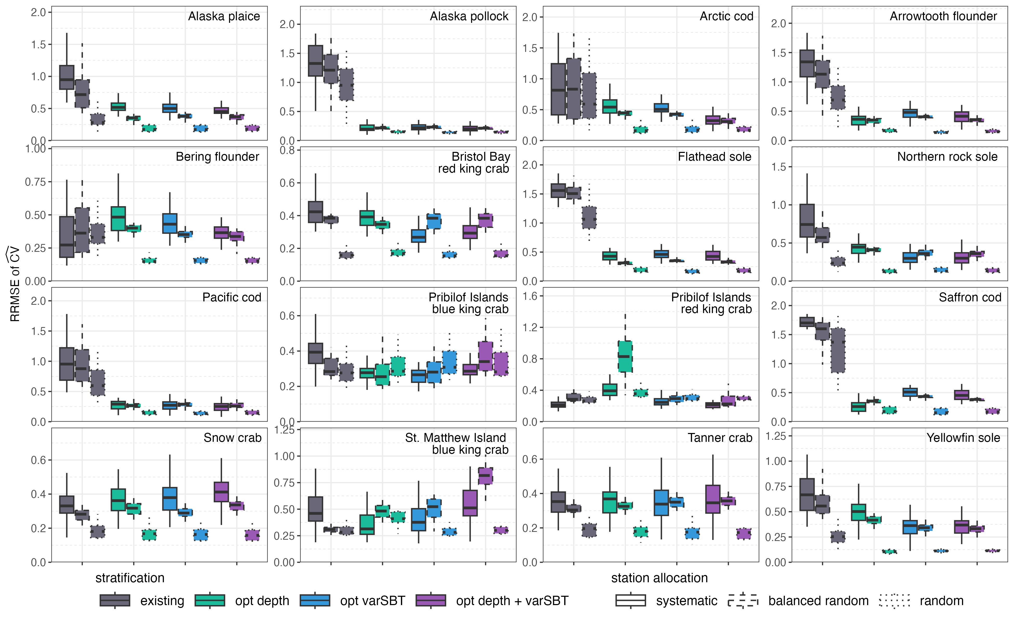
Figure 7 (corrected). Distribution of the accuracy (RRMSE) of ĈV for each survey design and stock, historical period. Random (dotted) is consistently lowest across all 16 stocks; systematic (solid) is consistently highest.

Results — Future performance of optimized and traditional survey designs
Published (C3, C4):
Patterns of the accuracy of CVs (RRMSE of CVs) were also similar to the historical CVs results (Supplementary Figs S16 and S17). Optimized survey designs typically led to similar or slightly lower RRMSEs than the existing survey design. More striking were the differences in RRMSE among station allocation methods, where random sampling within strata led the greatest accuracy (lowest RRMSE), while systematic sampling provided the least accurate CVs, but not much worse than balanced random sampling.
Corrected:
Patterns of the accuracy of CVs (RRMSE of CVs) differed from the historical results (Supplementary Figs S16 and S17). Optimized survey designs showed higher (less accurate) RRMSEs than the existing survey design under projected conditions (mean RRMSE ~0.80–0.82 for optimized designs vs. ~0.74–0.77 for the existing design, pooled across allocation methods). The ranking among station allocation methods also differed from the historical period: random sampling within strata, which was most accurate historically, was the least accurate under projected conditions (mean RRMSE 0.79), while systematic and balanced random sampling were statistically indistinguishable from each other (mean RRMSE 0.78 each) and both more accurate than random. This reversal is likely connected to the substantially higher uncertainty in the projected abundance indices relative to the historical period (Supplementary Figs S13 and S14).
[C3, C4 — this is the most substantive correction: the design-ranking claim for the projected period is reversed, not just re-numbered.]
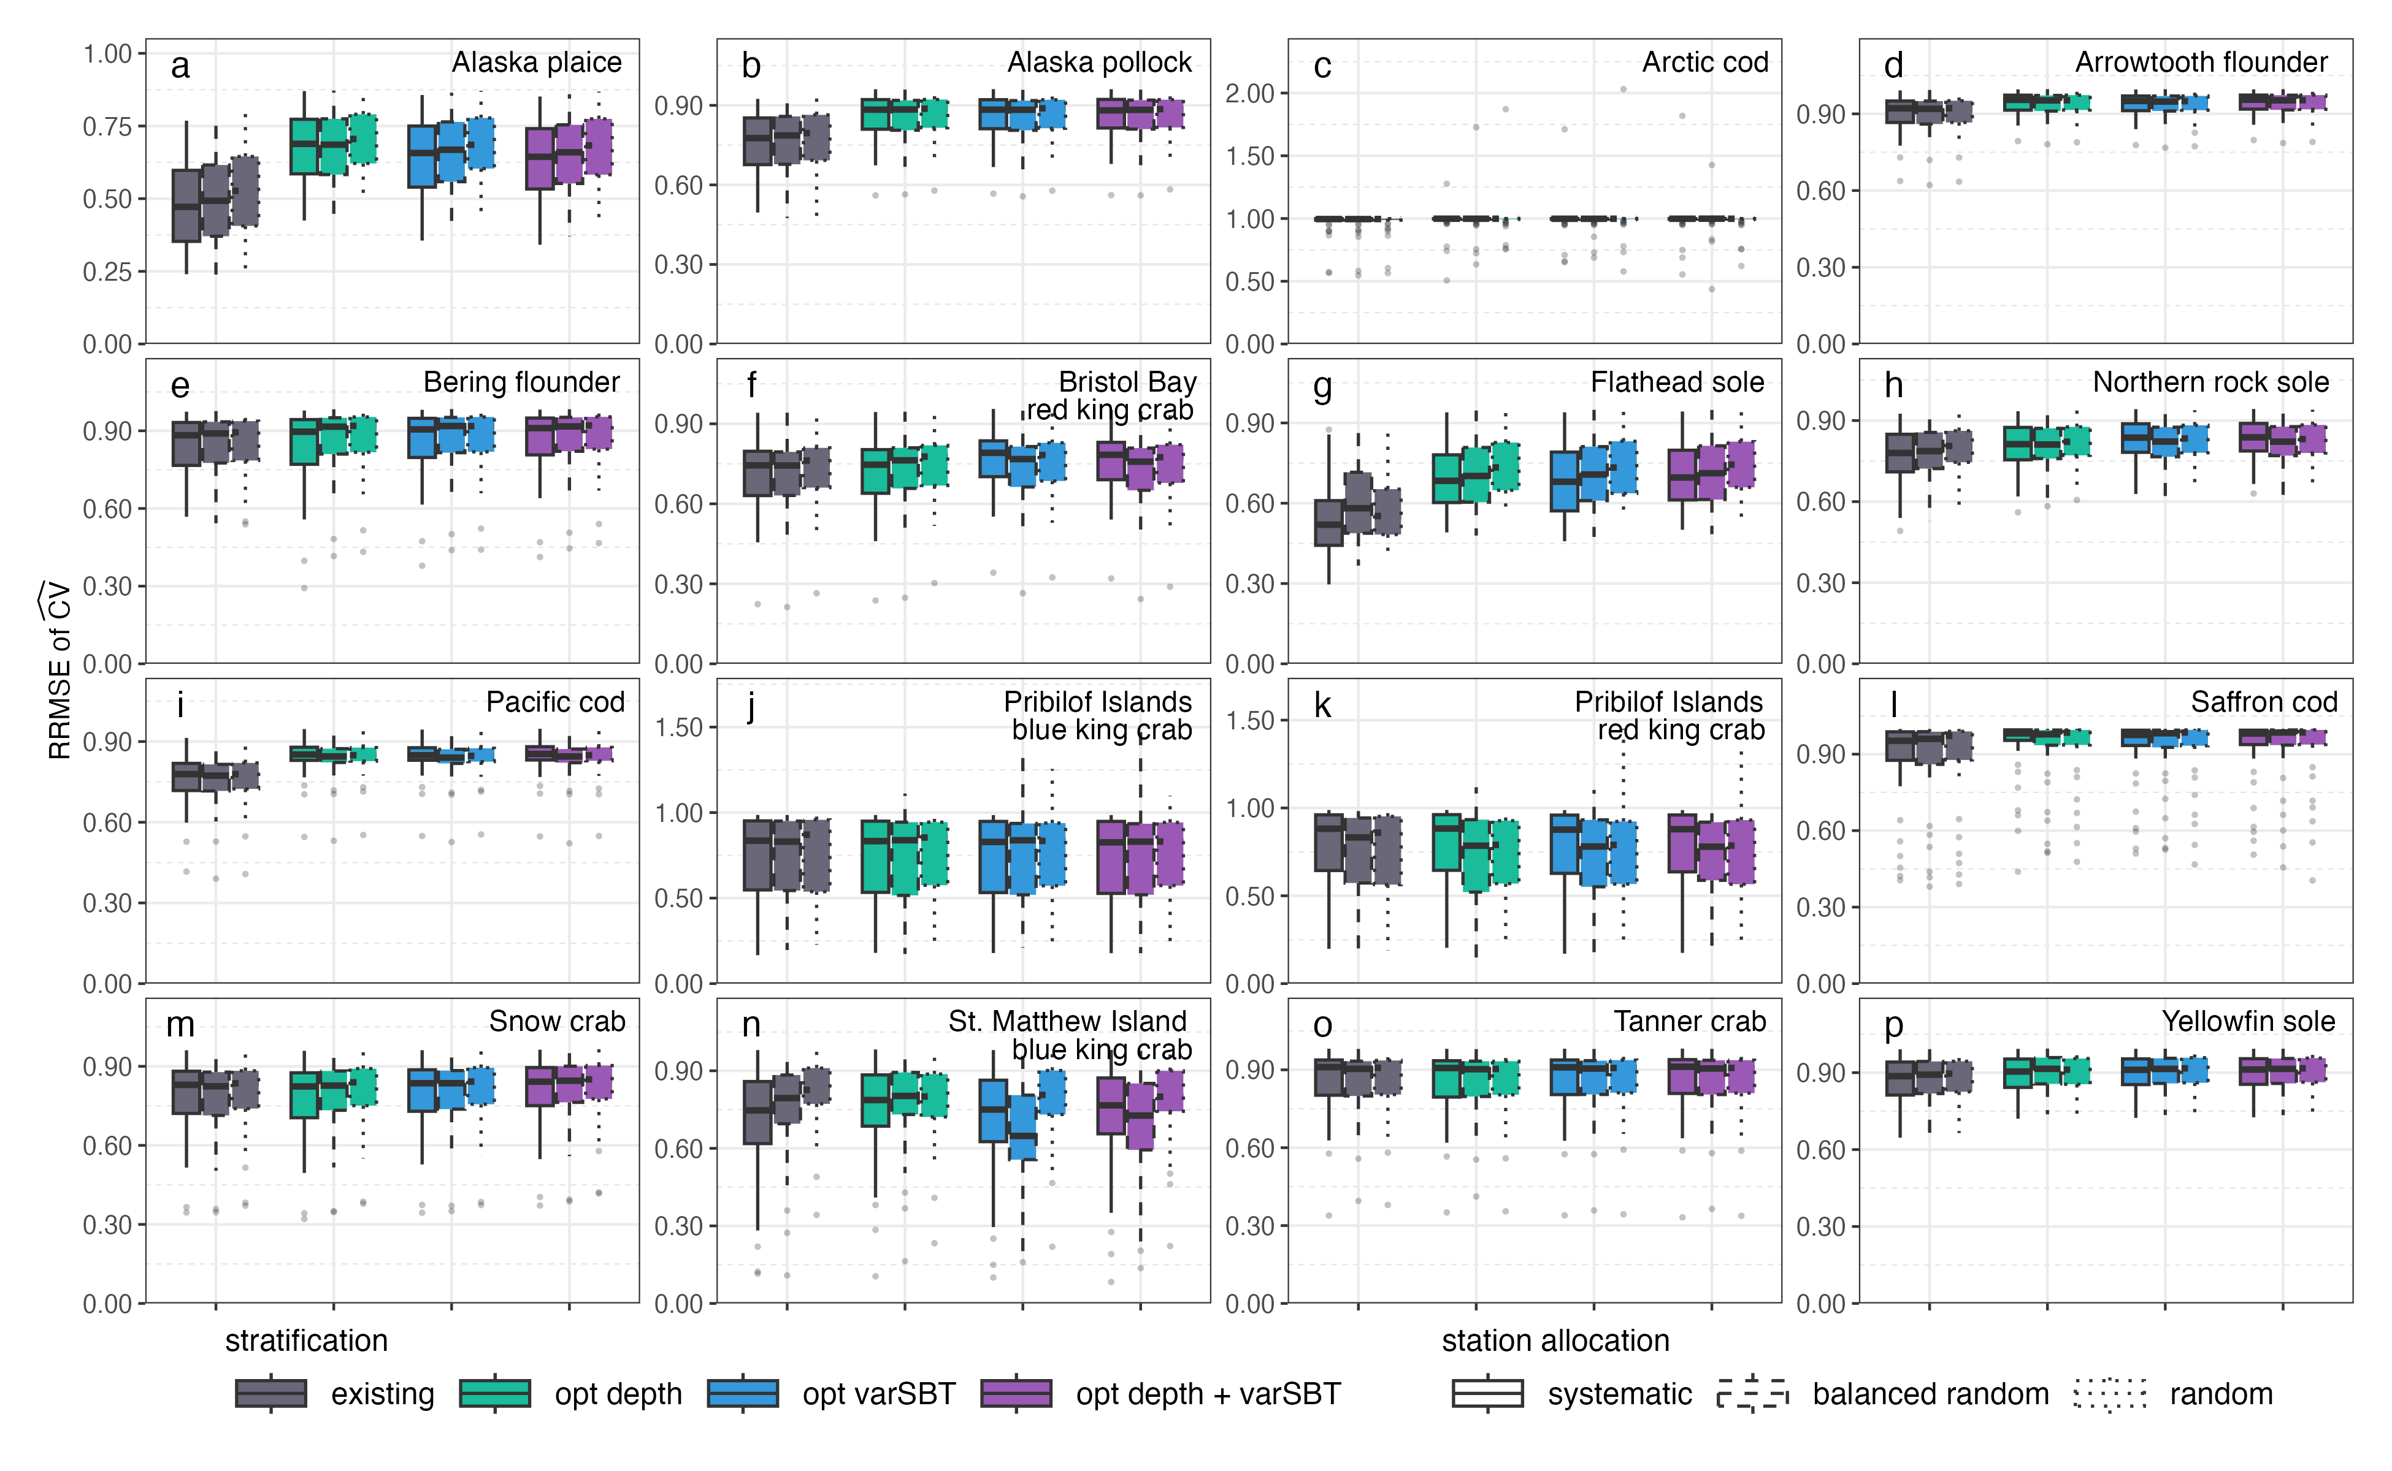
Figure S16 (corrected). Projected RRMSE of ĈV by stock. The historical separation between allocation methods narrows and partly reverses: random (dotted) is at or near the highest RRMSE for most stocks, with systematic and balanced random close to each other and lower.
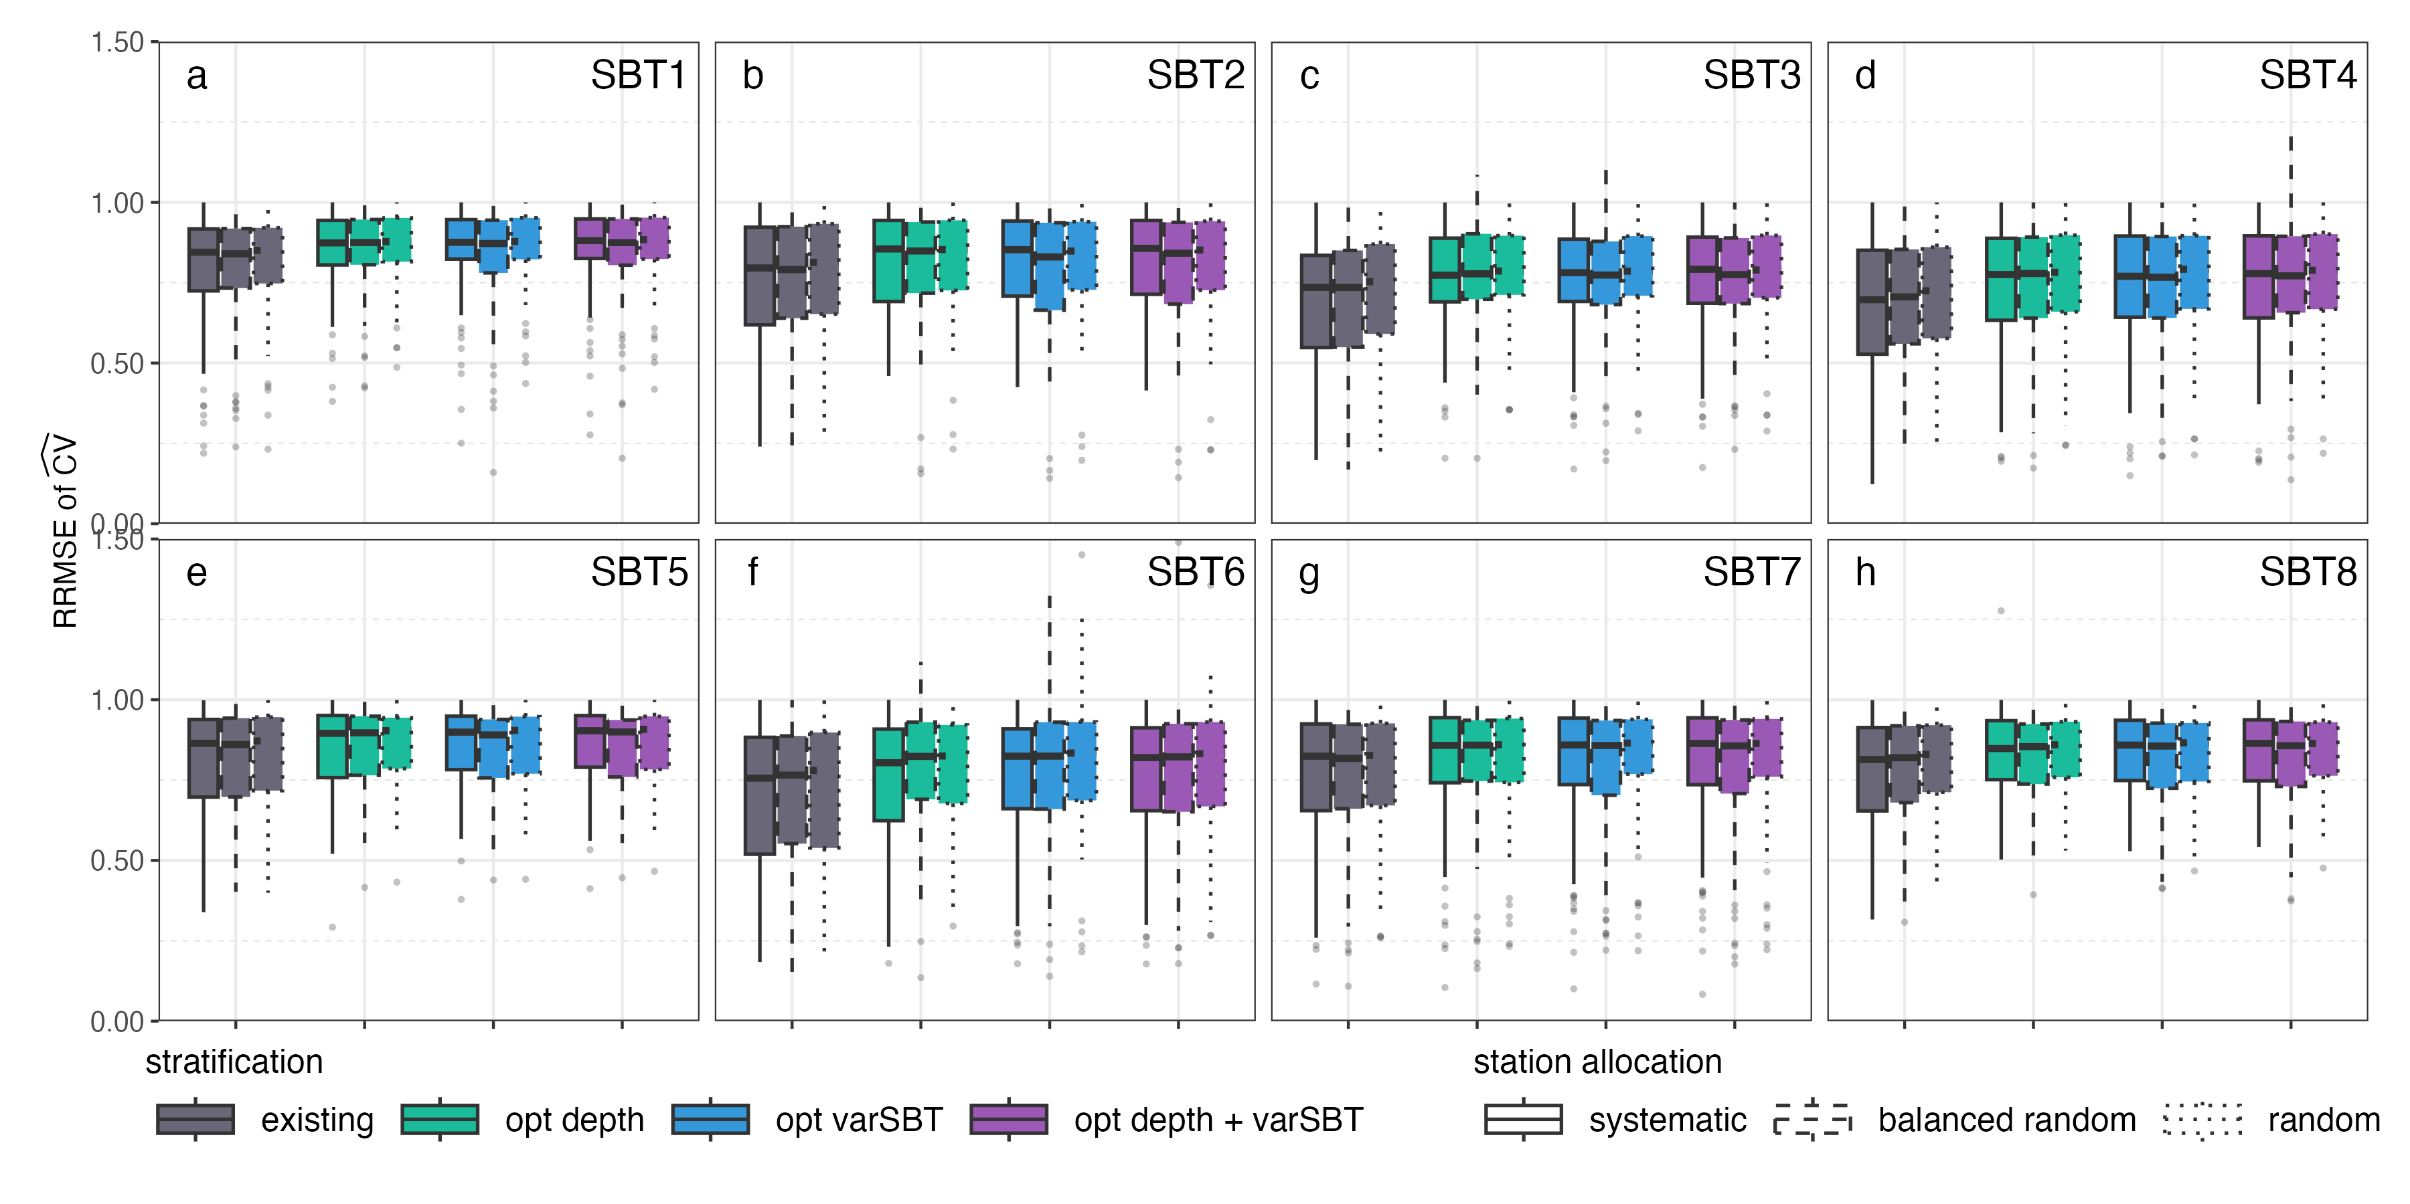
Figure S17 (corrected). Projected RRMSE of ĈV by SBT scenario, pooled across stocks. Allocation methods are nearly indistinguishable within each design, consistent with the small published gap (mean RRMSE ~0.777–0.794).

Discussion
The existing paragraph on systematic sampling’s known lack of a valid design-based variance estimator (citing von Szalay et al. 2023; Strand 2017) remains applicable and requires no change.
Suggested addition: “The reversal of the station-allocation ranking under projected conditions, relative to the historical period, suggests that the relative performance of station allocation methods may itself be sensitive to the magnitude of underlying biomass projection uncertainty, warranting further investigation.”
[New text, not a correction of an existing sentence — flags the C3/C4 reversal as an open scientific question rather than leaving it unremarked.]

Conclusions
Published (C6):
A new optimization approach can provide a similar or higher degree of precision and accuracy than the existing survey design for historical conditions and under future climate scenarios for about 63% of the stocks examined.
[C6 — RESOLVED EXACTLY. The “about 63%” / “10 of 16 stocks” figure is a CV-magnitude (precision) count, a different metric from the RRMSE formula bug — the same is true of Fig. 6, Supplementary Figs S11/S14/S15, and Supplementary Tables S1/S3 themselves, none of which are RRMSE figures. Checked directly against the manuscript’s own source tables: Supplementary Table S1 (historical CV, existing vs. optimized, by stock) shows 10 of 16 TRUE; Table S3 (projected) shows 11 of 16 TRUE, differing from Table S1 only in Hippoglossoides robustus (Bering flounder). The Abstract’s “historical and projected … for 10 of 16” is the intersection of the two tables’ TRUE stocks — exactly 10 of 16, an exact match to the published figure. The historical-conditions portion of this sentence does not need correction. The “under future climate scenarios” clause, however, is contradicted by the corrected C3/C4 results and cannot stand as worded.]
Suggested corrected text (for author review): A new optimization approach can provide a similar or higher degree of precision and accuracy than the existing survey design for historical conditions for about 63% of the stocks examined; under projected future conditions, however, the relative accuracy of station-allocation methods reverses, and optimized designs do not reduce RRMSE of CV relative to the existing design.
XXXX — co-authors to review and finalize this replacement wording.

