JUNIOR MIDDLE SCHOOL | ROBOTICS AND MATHEMATICS
Math Behind the Moving Robot
20 mathematics problems from designing and controlling a walking humanoid robot, with detailed step-by-step answers
This booklet is for junior middle school students who are building a moving, human-like robot from an assembly kit of servo motors, brackets, a controller board and a battery. Every time you design a part, connect a joint or write a line of control code, you are really solving a mathematics problem. The 20 questions follow the order in which a team builds a robot: designing the body, building the joints, making it balance, making it walk, and finally programming and testing it.
How to use this booklet
- Try each question yourself first, using the figures and a calculator, before you read the answer.
- Every question uses the same robot (described on the next page), and some answers are used again in later questions.
- Questions 11(c) and 13 use trigonometry (sine and cosine). If you have not learned it yet, you can solve them with an accurate scale drawing instead.
- Answers are rounded sensibly, usually to one decimal place, so small differences in the last digit are fine.

Meet Our Robot
All of the questions are about one robot, built from a typical humanoid robot kit. These are the parts and numbers the team starts with; everything else is worked out in the questions.
Item | Specification
Planned height | 36 cm
Servo motors | 16 planned (5 in each leg, 3 in each arm), 40 g each
Servo movement range | 0° to 180° (90° is the middle, or "neutral", position)
Servo speed | 0.12 s per 60° of turn
Servo strength (torque) | 2.5 kg·cm
Battery | 7.4 V, 1000 mAh, 150 g
Controller board | 50 g
Frame, brackets, screws and feet | 300 g in total
Foot size | 10 cm long × 6 cm wide

The 20 Questions at a Glance
No. | Question | Mathematics used | Robot stage
1 | Body Proportions | Ratio and proportion | Designing the body
2 | Making a Scale Drawing | Scale factor, length and area | Designing the body
3 | Symmetry on the Coordinate Plane | Reflection, coordinates, midpoints | Designing the body
4 | The Weight Budget | Linear inequalities | Choosing parts
5 | Telling a Servo Where to Go | Linear functions | Controlling the joints
6 | How Fast Does a Servo Turn? | Rates and unit conversion | Controlling the joints
7 | Gears for the Waist | Gear ratios | Building the joints
8 | Can the Robot Reach the Ball? | Pythagoras' theorem, triangle inequality | Planning arm movements
9 | Is the Shoulder Servo Strong Enough? | Levers and moments (torque) | Choosing servos
10 | Finding the Balance Point | Weighted mean | Making the robot stable
11 | Crouching Without Falling | Angles in triangles, Pythagoras' theorem | Making the robot stable
12 | Staying Inside the Feet | Coordinates, area, inequalities | Making the robot stable
13 | How Long Is One Step? | Trigonometry: sine and cosine (Challenge) | Planning the walk
14 | The Robot Race | Speed, distance and time | Planning the walk
15 | Turning Corners and Walking in Circles | Angles and circumference | Planning the walk
16 | Smooth Movements | Linear interpolation | Programming the robot
17 | The Walking Loop | Patterns and remainders | Programming the robot
18 | Seeing the Wall | Rates and linear equations | Using sensors
19 | How Long Will the Battery Last? | Rates and percentages | Powering the robot
20 | Testing and Fixing the Walk | Statistics and percentage error | Testing the robot

Part 1 · Designing the Body
Before a single screw is turned, the team must decide how big the robot will be, how its parts fit together and how much it can weigh. These questions use ratio, scale, symmetry and inequalities.

Question 1. Body Proportions
Mathematics: Ratio and proportion Robot stage: Designing the body
THE PROBLEM
Your team wants the robot to look like a small person, so you decide to copy human-like proportions. The robot will be 36 cm tall. The head, the torso and the legs (from the hip down to the floor) should be in the ratio 1 : 3 : 4.
(a) How tall should the head, the torso and the legs be?
(b) Each leg has a foot-and-ankle block 2 cm high, plus a thigh and a shin of equal length. How long are the thigh and the shin?
(c) Each arm should be 7/9 as long as the leg, with the upper arm and the forearm in the ratio 3 : 4. Find the length of the arm, the upper arm and the forearm.

Detailed Answer
A ratio of 1 : 3 : 4 tells us how the total height is shared out, not the actual lengths. To turn a ratio into real lengths, we first add the parts of the ratio together: 1 + 3 + 4 = 8 parts. The whole robot is 36 cm tall, so one part is worth 36 ÷ 8 = 4.5 cm.
1 part = 36 cm ÷ 8 = 4.5 cm
Part (a). Now we multiply each number in the ratio by 4.5 cm. The head is 1 × 4.5 = 4.5 cm, the torso is 3 × 4.5 = 13.5 cm, and the legs are 4 × 4.5 = 18 cm. We can check our work by adding the three lengths: 4.5 + 13.5 + 18 = 36 cm, which matches the planned height.
Part (b). The leg is 18 cm long, but the bottom 2 cm is taken up by the foot-and-ankle block. That leaves 18 − 2 = 16 cm for the thigh and the shin together. Because the thigh and the shin are equal, we split 16 cm into two equal pieces, so each is 8 cm.
thigh = shin = (18 − 2) ÷ 2 = 8 cm
Part (c). The arm must be 7/9 of the leg length, so the arm is 7/9 × 18 = 14 cm. Next, the ratio 3 : 4 has 3 + 4 = 7 parts, so one part is 14 ÷ 7 = 2 cm. The upper arm is 3 × 2 = 6 cm and the forearm (including the hand) is 4 × 2 = 8 cm.
arm = 7/9 × 18 = 14 cm
upper arm = 3 × 2 = 6 cm, forearm = 4 × 2 = 8 cm
Let us also check that the arms hang in a natural place. If the shoulder joint sits about 29 cm above the floor, the hands hang down to 29 − 14 = 15 cm, which is in the upper part of the thigh (the thigh runs from 10 cm to 18 cm above the floor), just like on a real person. Making the thigh and shin equal is also a smart engineering choice, because it makes the leg calculations in later questions much simpler. These lengths (thigh 8 cm, shin 8 cm, upper arm 6 cm, forearm 8 cm) are used throughout the rest of this booklet.
Key idea: To share a quantity in a ratio: add the parts, find the value of one part, then multiply.

Question 2. Making a Scale Drawing
Mathematics: Scale factor, length and area Robot stage: Designing the body
THE PROBLEM
Before cutting or assembling anything, the team draws a front-view plan of the 36 cm robot on an A4 sheet of paper, which is 29.7 cm tall.
(a) Explain why a full-size (1 : 1) drawing will not fit, and show that a scale of 1 : 2 will fit.
(b) At a scale of 1 : 2, the shoulder width on the drawing measures 7 cm. What is the real shoulder width? How long should the 8 cm thigh be drawn?
(c) The chest plate is drawn as a rectangle 4 cm wide and 3 cm tall. Find the area of the drawn rectangle and of the real chest plate. How many times larger is the real area?

Detailed Answer
A scale of 1 : 2 means that 1 cm on the drawing stands for 2 cm on the real robot. Part (a). In a full-size drawing, the robot would be drawn 36 cm tall, which is taller than the 29.7 cm sheet, so it cannot fit. With a scale of 1 : 2, the drawing is 36 ÷ 2 = 18 cm tall. Since 18 cm is less than 29.7 cm, the drawing fits, and there is even room left over for labels and measurements.
Part (b). To change a drawing length into a real length, we multiply by 2, so the real shoulder width is 7 × 2 = 14 cm. To change a real length into a drawing length, we do the opposite and divide by 2, so the 8 cm thigh is drawn 8 ÷ 2 = 4 cm long.
real length = drawing length × 2
drawing length = real length ÷ 2
Part (c) contains a surprise that many students miss. The drawn rectangle has an area of 4 × 3 = 12 cm². The real chest plate is twice as wide and twice as tall, so it measures 8 cm × 6 cm and its area is 48 cm². The real area is 48 ÷ 12 = 4 times bigger, not 2 times bigger.
drawing: 4 × 3 = 12 cm² real: 8 × 6 = 48 cm²
48 ÷ 12 = 4 = 2²
This happens because area is found by multiplying two lengths, and each of those lengths was doubled, so the area is multiplied by 2 × 2 = 4. In general, if every length is multiplied by a scale factor k, areas are multiplied by k². For solid parts, volume (and therefore mass, if the material is the same) is multiplied by k³, so a part that is twice as big in every direction is about 8 times as heavy. This matters when you want to "scale up" a robot: doubling its size makes it about 8 times heavier, but its servos are not 8 times stronger. The k² rule also helps you estimate how much cardboard, plastic or aluminum sheet you need to buy for the body panels.
Key idea: If lengths are multiplied by k, areas are multiplied by k² and volumes by k³.

Question 3. Symmetry on the Coordinate Plane
Mathematics: Reflection, coordinates, midpoints Robot stage: Designing the body
THE PROBLEM
The team draws the robot's front view on a coordinate grid (1 unit = 1 cm), as in Figure 1. The y-axis runs up the middle of the robot and the floor is the x-axis. The joints on the left half of the drawing are: shoulder (−7, 29), elbow (−7, 23), hand (−7, 15), hip (−4, 18), knee (−4, 10) and ankle (−4, 2).
(a) The robot must be symmetric about the y-axis. Write the coordinates of the matching joints on the right half.
(b) Find the distance between the two shoulders, the two hips and the two ankles.
(c) Explain how the midpoint of a pair of joints can be used to check that they have been placed symmetrically.

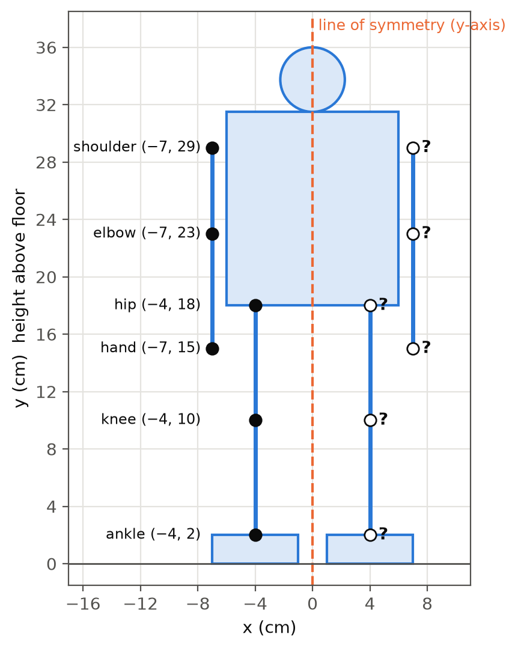
Figure 1. Front view of the robot on a coordinate grid. The right-hand joints (?) must be found.
Detailed Answer
The y-axis acts as a mirror line, or line of symmetry, for the robot. When a point is reflected in the y-axis, its distance from the mirror stays the same but it moves to the other side, so the x-coordinate changes sign while the y-coordinate stays the same.
reflection in the y-axis: (x, y) → (−x, y)
Part (a). Using this rule, the right-side joints are: shoulder (7, 29), elbow (7, 23), hand (7, 15), hip (4, 18), knee (4, 10) and ankle (4, 2). Notice that the heights (the y-values) did not change, which makes sense, because a robot's left knee should be exactly as high as its right knee.
Part (b). The two shoulders lie on the same horizontal line, y = 29, so the distance between them is simply the difference of their x-coordinates: 7 − (−7) = 14 cm. In the same way, the distance between the hips is 4 − (−4) = 8 cm, and the distance between the ankles is also 8 cm. These match our design: the 14 cm shoulder width from Question 2, and feet placed 8 cm apart (center to center), which we will need again in the balance questions.
shoulders: 7 − (−7) = 14 cm hips: 4 − (−4) = 8 cm ankles: 4 − (−4) = 8 cm
Part (c). The midpoint of two points is found by averaging their coordinates. For the two knees, the midpoint is ((−4 + 4) ÷ 2, (10 + 10) ÷ 2) = (0, 10), which lies on the y-axis.
midpoint = ( (x₁ + x₂) ÷ 2 , (y₁ + y₂) ÷ 2 )
Whenever a pair of joints is truly symmetric, the midpoint has an x-coordinate of 0 and the two points have the same y-coordinate. If a teammate measures the right knee at (4, 11) instead, the y-values no longer match, which means one leg is 1 cm longer than the other and the robot will lean to one side. Symmetry matters for a walking robot because an unbalanced body pulls the robot sideways and makes it walk in a curve instead of a straight line. Checking midpoints is therefore a quick and reliable way to find building mistakes before the robot takes its first step.
Key idea: Reflecting in the y-axis: (x, y) → (−x, y). A symmetric pair of points has its midpoint on the mirror line.

Question 4. The Weight Budget
Mathematics: Linear inequalities Robot stage: Choosing parts
THE PROBLEM
The leg servos can safely support a robot with a total mass of at most 1200 g. The fixed parts are: frame, brackets and feet 300 g; battery 150 g; controller board 50 g. Each servo motor has a mass of 40 g.
(a) Write an inequality for the number of servos, n, and solve it. What is the greatest number of servos the robot can have?
(b) The team plans to use 16 servos (5 in each leg and 3 in each arm). What is the total mass, and how much spare mass is left?
(c) The team wants to add a 70 g sensor pack. Is this allowed? Suggest a change that would make it possible.

Detailed Answer
First we find the mass of the parts that do not depend on the number of servos: 300 + 150 + 50 = 500 g. Each servo adds 40 g, so n servos add 40n grams. The total mass is therefore 40n + 500 grams, and this must be less than or equal to 1200 g.
40n + 500 ≤ 1200
Part (a). We solve an inequality in the same way as an equation. Subtracting 500 from both sides gives 40n ≤ 700, and dividing both sides by 40 gives n ≤ 17.5. Because we cannot use half a servo, n must be a whole number, so the greatest number of servos is 17. Notice that here we round down, not up, because 18 servos would give 40 × 18 + 500 = 1220 g, which is over the limit.
40n ≤ 700 → n ≤ 17.5 → greatest n = 17
Part (b). With 16 servos, the total mass is 40 × 16 + 500 = 640 + 500 = 1140 g. The spare mass is 1200 − 1140 = 60 g. This is a small safety margin, and engineers like to keep some margin because extra wires, screws and glue always add a little weight.
Part (c). Adding the 70 g sensor pack gives 1140 + 70 = 1210 g, which is 10 g over the limit, so it is not allowed with the current design. One option is to replace the 150 g battery with a lighter 100 g battery, which brings the total down to 1160 g, within the limit (although the robot will then run for a shorter time, as Question 19 shows). Another option is to remove one servo, for example a wrist or head servo, which saves 40 g and gives a total of 1170 g. Engineers call a list like this a "weight budget", and they keep track of every gram before anything is built, because it is much cheaper to fix a problem on paper than on a finished robot.
Key idea: Solve an inequality like an equation, then think carefully about whether the answer should be rounded up or down.

Part 2 · Joints, Servos and Arms
Every joint of the robot is driven by a servo motor or a geared motor. These questions show how linear functions, rates, gear ratios, Pythagoras' theorem and levers decide what each joint can do.

Question 5. Telling a Servo Where to Go
Mathematics: Linear functions Robot stage: Controlling the joints
THE PROBLEM
A servo motor is controlled by an electrical pulse. The length of the pulse, measured in microseconds (μs; 1 μs is one millionth of a second), tells the servo which angle to turn to. For our servo, a 500 μs pulse means 0°, a 2500 μs pulse means 180°, and the relationship is linear (Figure 2).
(a) Find the equation linking the pulse width P (μs) and the angle θ (degrees).
(b) What pulse widths are needed for 45°, 90° and 135°?
(c) The program sends a pulse of 1800 μs. Which angle will the servo turn to?
(d) To protect the gears, the team decides only to send pulses between 600 μs and 2400 μs. What range of angles can the servo reach?

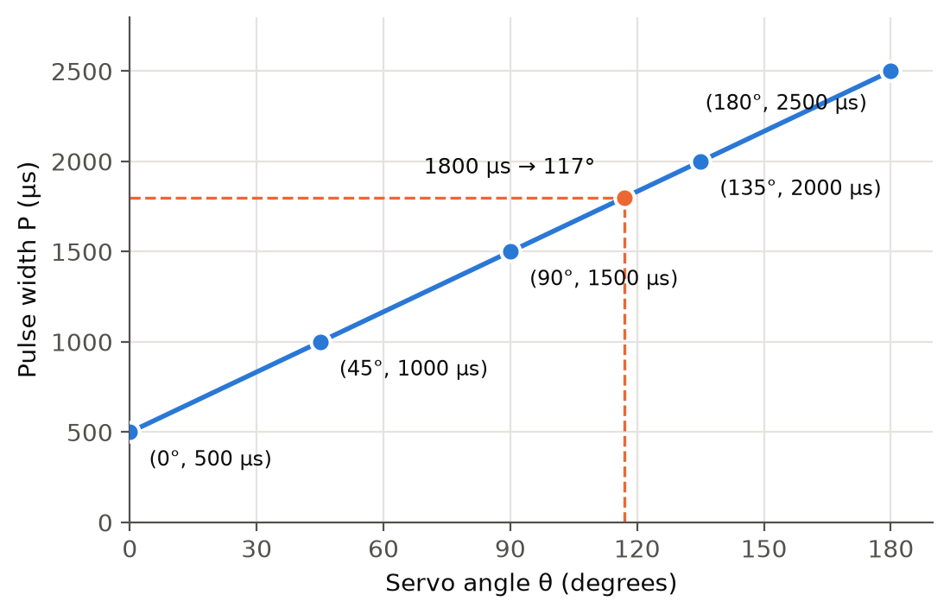
Figure 2. Pulse width needed for each servo angle. The relationship is a straight line.
Detailed Answer
Part (a). A linear relationship has the form P = mθ + c, where m is the slope (the rate of change) and c is the value of P when θ = 0. When θ = 0°, the pulse is 500 μs, so c = 500. The slope is the change in pulse width divided by the change in angle: (2500 − 500) ÷ (180 − 0) = 2000 ÷ 180 = 100/9, or about 11.1 μs per degree.
P = 500 + (100/9) × θ
The slope tells us something useful: every extra degree of turn needs about 11.1 μs more pulse time. Part (b). We substitute each angle into the equation. For 45°, P = 500 + (100/9) × 45 = 500 + 500 = 1000 μs. For 90°, P = 500 + 1000 = 1500 μs, and for 135°, P = 500 + 1500 = 2000 μs. The value 1500 μs is called the "center" or "neutral" pulse, and robot builders usually assemble each joint while its servo sits at 90°, so that the joint can move equally far in both directions.
Part (c). We work backwards by solving the equation for θ. Starting from 1800 = 500 + (100/9)θ, we subtract 500 to get 1300 = (100/9)θ, and then multiply both sides by 9/100 to get θ = 117°.
θ = (P − 500) × 9/100 = (1800 − 500) × 0.09 = 117°
Part (d). We substitute the two limits into the same formula. A 600 μs pulse gives θ = (600 − 500) × 0.09 = 9°, and a 2400 μs pulse gives θ = (2400 − 500) × 0.09 = 171°. So the safe range is 9° ≤ θ ≤ 171°, which still allows 162° of movement. Because the relationship is a straight line, you can also read angles straight off the graph in Figure 2, which is a quick way to check your answers. Be aware that different servo brands use different pulse ranges (many use 1000–2000 μs), so always check your kit's data sheet and find the equation for your own servos.
Key idea: In P = mθ + c, c is the starting value and m is the rate of change. To go from a pulse back to an angle, solve the equation for θ.

Question 6. How Fast Does a Servo Turn?
Mathematics: Rates and unit conversion Robot stage: Controlling the joints
THE PROBLEM
The servo's data sheet gives its speed as "0.12 s / 60°".
(a) Write the servo's speed in degrees per second.
(b) How long does the servo take to turn 90°? How long does it take to move from 30° to 150°?
(c) A program tells the servo to move from 30° to 150°, but sends the next command only 0.2 s later. Where is the servo when the next command arrives?
(d) Convert the speed into revolutions per minute (rpm).

Detailed Answer
"0.12 s / 60°" means the servo needs 0.12 seconds to turn through 60 degrees. Part (a). To find the speed in degrees per second, we divide the angle by the time: 60 ÷ 0.12 = 500 degrees per second.
speed = angle ÷ time = 60° ÷ 0.12 s = 500 °/s
Part (b). We use time = angle ÷ speed. To turn 90°, the time is 90 ÷ 500 = 0.18 s. Moving from 30° to 150° is a turn of 150 − 30 = 120°, so the time is 120 ÷ 500 = 0.24 s. Another way to see this is that 120° is two lots of 60°, so the time is 2 × 0.12 = 0.24 s.
Part (c). In 0.2 s the servo can only turn 500 × 0.2 = 100°. Starting at 30°, it has reached only 30 + 100 = 130° when the next command arrives, which is 20° short of the 150° target.
angle turned = speed × time = 500 × 0.2 = 100° → position = 30° + 100° = 130°
This is a very common reason why a robot's movements look jerky or why it loses its balance: the program "thinks" the leg is at 150°, but it is really at 130°. Also, the data-sheet speed is measured with no load, and a servo that is lifting part of the robot's body usually moves more slowly, so it is wise to allow extra time, for example 30% more than the calculation gives.
Part (d). One revolution is 360°, so 500° per second is 500 ÷ 360 ≈ 1.39 revolutions per second. There are 60 seconds in a minute, so the speed is about 1.39 × 60 ≈ 83.3 rpm.
500 ÷ 360 × 60 ≈ 83.3 rpm
Most servos cannot turn a full circle, but rpm is a standard unit that lets us compare servos with ordinary motors. Rates like "degrees per second" connect three quantities (angle, time and speed), and if you know any two of them you can always calculate the third.
Key idea: speed = angle ÷ time; time = angle ÷ speed; angle = speed × time.

Question 7. Gears for the Waist
Mathematics: Gear ratios Robot stage: Building the joints
THE PROBLEM
The robot's waist is turned by a small DC motor through a set of gears. The motor gear has 12 teeth and meshes with a gear that has 36 teeth.
(a) What is the gear ratio? If the motor spins at 240 rpm, how fast does the 36-tooth gear turn?
(b) To slow it down further, the team fixes a 10-tooth gear on the same axle as the 36-tooth gear and meshes it with a 40-tooth gear. What is the total gear ratio and the final speed?
(c) Does the final gear turn in the same direction as the motor? How long does the waist take to turn 90°?

Detailed Answer
When two gears mesh, their teeth pass each other one by one, so both gears move the same number of teeth in the same time. If the small 12-tooth gear makes one full turn, 12 teeth pass, so the 36-tooth gear turns only 12 ÷ 36 = 1/3 of a turn. This means the motor gear must turn 3 times for the big gear to turn once, so the gear ratio is 36 : 12 = 3 : 1.
gear ratio = driven teeth ÷ driver teeth = 36 ÷ 12 = 3
Part (a). The output speed is the input speed divided by the ratio, so the 36-tooth gear turns at 240 ÷ 3 = 80 rpm. At the same time, the turning force (torque) is multiplied by about 3, minus a little that is lost to friction. This is why gears are so useful in robots: a small, fast motor becomes a slow but strong joint.
Part (b). The 10-tooth gear is on the same axle as the 36-tooth gear, so it also turns at 80 rpm. The second pair has a ratio of 40 ÷ 10 = 4, so the 40-tooth gear turns at 80 ÷ 4 = 20 rpm. The total ratio of a gear train is found by multiplying the ratios of each pair: 3 × 4 = 12, so the total ratio is 12 : 1, and we can check that 240 ÷ 12 = 20 rpm.
total ratio = 3 × 4 = 12 final speed = 240 ÷ 12 = 20 rpm
Part (c). Each time two gears mesh, the direction of rotation reverses. The first mesh reverses the direction and the second mesh reverses it again, so the final gear turns in the same direction as the motor. Gears on the same axle do not reverse, because they are fixed together and turn as one.
To find the time for a 90° turn, we first change 20 rpm into degrees per second. Twenty revolutions per minute is 20 × 360 = 7200° per minute, which is 7200 ÷ 60 = 120° per second. A 90° turn therefore takes 90 ÷ 120 = 0.75 s, which is a smooth, natural speed for a robot turning its upper body.
20 rpm = 20 × 360 ÷ 60 = 120 °/s time = 90 ÷ 120 = 0.75 s
Key idea: Gear ratio = driven teeth ÷ driver teeth. Multiply the ratios in a gear train. Each mesh reverses the direction.

Question 8. Can the Robot Reach the Ball?
Mathematics: Pythagoras' theorem, triangle inequality Robot stage: Planning arm movements
THE PROBLEM
The robot's arm has an upper arm of 6 cm and a forearm of 8 cm (Question 1). Look at the arm from the side and put the shoulder at the origin (0, 0) of a grid, with 1 unit = 1 cm (Figure 3).
(a) The upper arm points straight forward and the elbow is bent at 90°, so the forearm points straight up. How far is the hand from the shoulder?
(b) What are the greatest and the smallest possible distances between the shoulder and the hand?
(c) Three balls are placed at A (6, 8), B (5, 12) and C (9, 12). Which balls can the robot reach without walking?

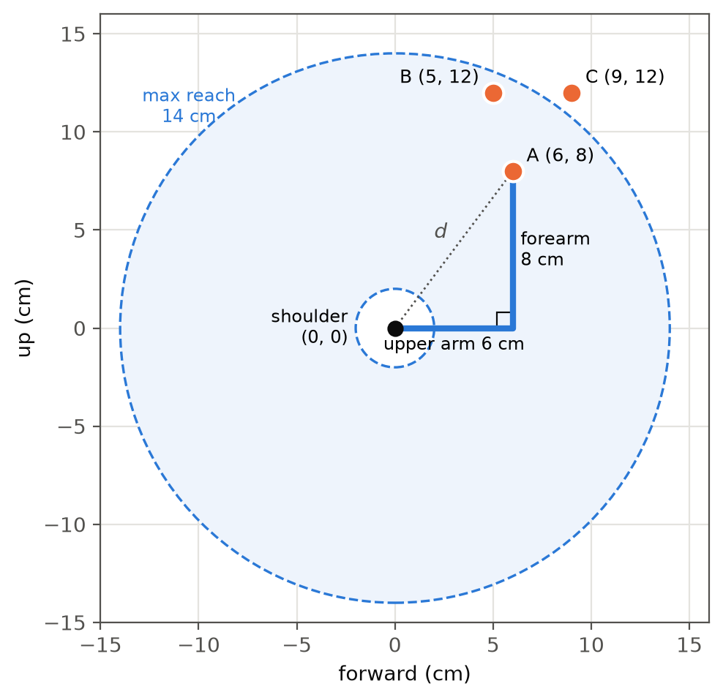
Figure 3. The arm seen from the side. The shaded ring shows every point the hand can reach.
Detailed Answer
Part (a). The upper arm, the forearm and the straight line from the shoulder to the hand form a right-angled triangle, with the right angle at the elbow. The line from the shoulder to the hand is the hypotenuse, the longest side, opposite the right angle. Pythagoras' theorem says that the square of the hypotenuse equals the sum of the squares of the other two sides.
d² = 6² + 8² = 36 + 64 = 100 → d = √100 = 10 cm
So the hand is 10 cm from the shoulder. This is the well-known 3–4–5 right triangle with every side doubled, a pattern that is worth remembering.
Part (b). The hand is farthest away when the arm is completely straight, so the greatest reach is 6 + 8 = 14 cm. The hand is closest when the elbow folds completely and the forearm doubles back along the upper arm, so the smallest distance is 8 − 6 = 2 cm. For any other elbow angle the three lengths form a triangle, and the triangle inequality says that one side of a triangle must lie between the difference and the sum of the other two sides. So the hand can reach every point whose distance d from the shoulder satisfies 2 ≤ d ≤ 14, which is the ring between the two circles in Figure 3 (in practice, the brackets may stop the elbow from folding all the way).
8 − 6 ≤ d ≤ 8 + 6 → 2 cm ≤ d ≤ 14 cm
Part (c). We use Pythagoras to find the distance from the shoulder (0, 0) to each ball. For A (6, 8), the distance is √(6² + 8²) = √100 = 10 cm, which is reachable; in fact, it is exactly the hand position from part (a). For B (5, 12), the distance is √(25 + 144) = √169 = 13 cm, which is also reachable. For C (9, 12), the distance is √(81 + 144) = √225 = 15 cm, which is more than 14 cm, so the robot cannot reach it and must first step at least 1 cm closer.
distance from (0, 0) to (x, y) = √(x² + y²)
Robot programmers make exactly this check before every grab, because sending an arm towards an unreachable point can make it over-stretch, strain the servos or even tip the robot over.
Key idea: The distance from (0, 0) to (x, y) is √(x² + y²). A two-part arm can reach any distance from (long − short) to (long + short).

Question 9. Is the Shoulder Servo Strong Enough?
Mathematics: Levers and moments (torque) Robot stage: Choosing servos
THE PROBLEM
The shoulder servo has a rated torque of 2.5 kg·cm, which means it can hold 2.5 kg at a distance of 1 cm from its axle, or 1 kg at 2.5 cm, and so on. The robot holds its arm straight out horizontally. The moving part of the arm has a mass of 100 g, and its balance point is 6 cm from the shoulder axle. The hand holds a 100 g ball at 14 cm from the shoulder.
(a) Calculate the torque the shoulder servo must provide. Is the servo strong enough?
(b) What is the heaviest ball the robot could hold with its arm straight out?
(c) The robot bends its elbow so that the ball is only 6 cm (horizontally) from the shoulder, and the arm's balance point moves to 4 cm. What torque is needed now?

Detailed Answer
Torque, also called the moment of a force, measures how strongly a weight tries to turn something around a pivot. It is calculated as mass × distance from the pivot, so a weight far from the pivot has a much bigger turning effect than the same weight close to it. This is the same idea as a see-saw, where a light child sitting far from the middle can balance a heavier child sitting close to it.
Part (a). We calculate the turning effect of each mass and add them together. The arm gives 100 g × 6 cm = 600 g·cm, and the ball gives 100 g × 14 cm = 1400 g·cm. The total is 2000 g·cm, and since 1000 g = 1 kg, this equals 2.0 kg·cm.
torque = 100 × 6 + 100 × 14 = 600 + 1400 = 2000 g·cm = 2.0 kg·cm
Because 2.0 kg·cm is less than 2.5 kg·cm, the servo is strong enough, but it is working at 2.0 ÷ 2.5 = 80% of its maximum. Servos that work close to their limit get hot, use more battery current and wear out faster, so many builders try to stay below about 70%.
Part (b). Let the mass of the ball be m grams. The total torque must not be more than 2500 g·cm, so 600 + 14m ≤ 2500. Subtracting 600 gives 14m ≤ 1900, and dividing by 14 gives m ≤ 135.7, so the heaviest ball is about 135 g.
600 + 14m ≤ 2500 → m ≤ 1900 ÷ 14 ≈ 135.7 g
Part (c). The new torque is 100 × 4 + 100 × 6 = 400 + 600 = 1000 g·cm = 1.0 kg·cm, which is only half the torque from part (a). This shows why people (and robots) carry heavy things close to their bodies: the closer the load is to the pivot, the less effort the joint needs. The same calculation explains why the hip and knee servos need to be the strongest in the whole robot, because they hold up almost the entire body at a distance from their axles.
bent elbow: 100 × 4 + 100 × 6 = 1000 g·cm = 1.0 kg·cm
Key idea: Torque = mass × distance from the pivot. Halving the distance halves the torque.

Part 3 · Balance and Stability
A humanoid robot stands on two small feet, so it falls over easily. These questions use weighted averages, angle facts and coordinates to keep the robot upright.

Question 10. Finding the Balance Point
Mathematics: Weighted mean Robot stage: Making the robot stable
THE PROBLEM
The robot's total mass is 1140 g (Question 4). The table below shows the mass of each body section and the height of that section's own balance point above the floor.
(a) Find the height of the center of gravity (CoG) of the whole robot.
(b) The 150 g battery is moved from the chest (24 cm) down into the hips (15 cm). Find the new height of the center of gravity.
(c) Explain why a lower center of gravity helps the robot.

Body section | Mass (g) | Height of its balance point (cm)
Legs (10 servos, brackets, feet) | 520 | 9
Torso (frame, controller, battery) | 300 | 24
Arms (6 servos, brackets) | 290 | 22
Head | 30 | 33
Total | 1140 | ?

Detailed Answer
The center of gravity is the single point where all of the robot's weight seems to act; if you could balance the robot on a pin, it would balance at this point. Its height is a weighted mean: each part's height is "weighted" by its mass, so heavy parts pull the center of gravity towards them more strongly than light parts. To calculate it, we multiply each mass by its height, add these products, and then divide by the total mass.
CoG height = (m₁h₁ + m₂h₂ + m₃h₃ + m₄h₄) ÷ (m₁ + m₂ + m₃ + m₄)
Part (a). The products are: legs 520 × 9 = 4680, torso 300 × 24 = 7200, arms 290 × 22 = 6380, and head 30 × 33 = 990. Their sum is 4680 + 7200 + 6380 + 990 = 19 250 (in g·cm). Dividing by the total mass gives 19 250 ÷ 1140 ≈ 16.9 cm.
CoG height = 19 250 ÷ 1140 ≈ 16.9 cm
Notice that this is not the ordinary average of the four heights, which would be (9 + 24 + 22 + 33) ÷ 4 = 22 cm. The real answer is lower because the heavy legs count much more than the light head.
Part (b). Only the battery moves, so only its share of the sum changes. The battery's contribution changes by 150 × (15 − 24) = −1350, so the new sum is 19 250 − 1350 = 17 900. The new height of the center of gravity is 17 900 ÷ 1140 ≈ 15.7 cm, which is about 1.2 cm lower than before.
new CoG height = (19 250 − 1350) ÷ 1140 = 17 900 ÷ 1140 ≈ 15.7 cm
Part (c). A lower center of gravity makes the robot more stable, because the robot has to tilt further before its center of gravity moves outside its feet, which is the moment when it falls over. A low center of gravity also means that small wobbles, bumps and pushes are less likely to tip the robot. This is why racing cars are built low to the ground and why tightrope walkers bend their knees. For a walking robot, placing heavy parts such as the battery low and close to the middle is one of the easiest ways to make walking more reliable.
Key idea: Weighted mean = (sum of mass × position) ÷ (total mass). Heavy parts have the biggest effect.

Question 11. Crouching Without Falling
Mathematics: Angles in triangles, Pythagoras' theorem Robot stage: Making the robot stable
THE PROBLEM
Many humanoid robots walk with slightly bent knees. Figure 4 shows one leg from the side. The thigh and the shin are each 8 cm. The torso must stay upright, the foot must stay flat on the floor, and the hip stays directly above the ankle.
(a) The hip servo tilts the thigh forward by α = 25° from the vertical. By how many degrees must the knee bend and the ankle tilt?
(b) The team wants to lower the hip so that it is 12 cm above the ankle instead of 16 cm. How far forward of the hip–ankle line does the knee move?
(c) Challenge (if you have learned cosine): find the angle α for the crouch in part (b).

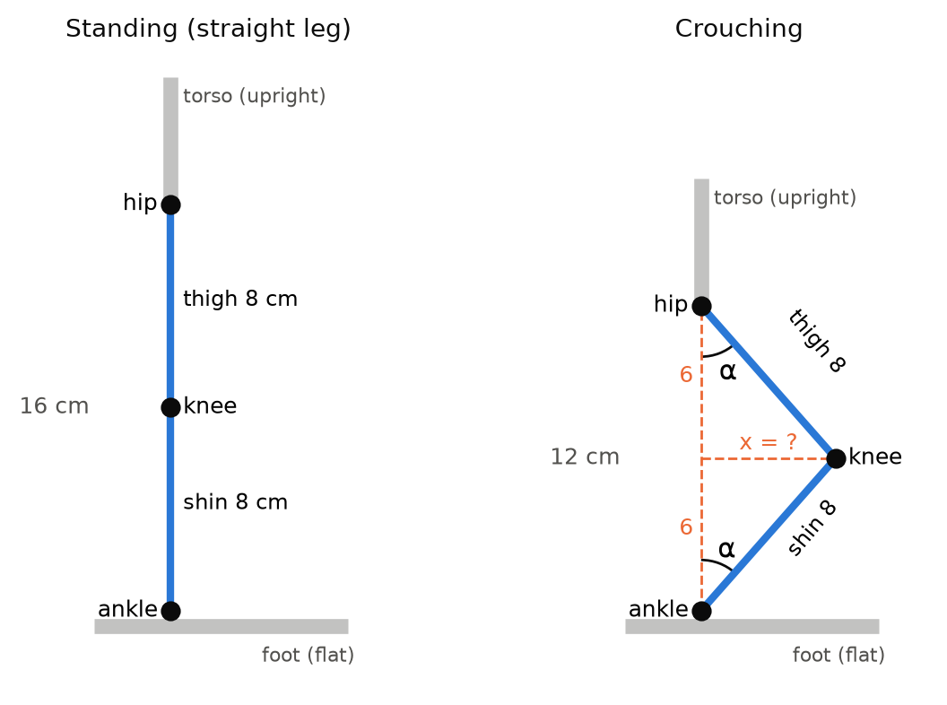
Figure 4. A leg standing straight (left) and crouching with an upright torso and a flat foot (right).
Detailed Answer
Because the hip is directly above the ankle, the hip, the knee and the ankle form a triangle whose base is the vertical line from the hip to the ankle. The thigh and the shin are both 8 cm, so this triangle is isosceles, and its two base angles (at the hip and at the ankle) are equal. So if the thigh makes an angle α with the vertical at the hip, the shin also makes an angle α with the vertical at the ankle.
Part (a). Since α = 25°, the ankle servo must tilt the shin by 25° to keep the foot flat. The angles in a triangle add up to 180°, so the angle inside the knee is 180° − 25° − 25° = 130°. A straight leg has a knee angle of 180°, so the knee has bent by 180° − 130° = 50°, which is exactly 2α.
knee angle = 180° − 2α = 130° knee bend = 2α = 50° ankle tilt = α = 25°
This gives robot builders a simple rule: when crouching with an upright body and a flat foot, the knee must bend twice as much as the hip and the ankle. If the ankle servo does not tilt by the same amount as the hip, the foot ends up resting on its toe or its heel, and the robot rocks and falls.
Part (b). The hip is now 12 cm above the ankle, and because the triangle is isosceles, the knee sits at half that height, 6 cm above the ankle. A horizontal line from the knee to the hip–ankle line splits the shape into two right-angled triangles, each with a hypotenuse of 8 cm (the thigh or the shin) and a vertical side of 6 cm. By Pythagoras' theorem, the horizontal distance x satisfies x² + 6² = 8², so x² = 64 − 36 = 28 and x = √28 ≈ 5.3 cm.
x = √(8² − 6²) = √28 ≈ 5.3 cm
So the knee moves about 5.3 cm forward, and the whole robot becomes 4 cm shorter (32 cm instead of 36 cm). Its center of gravity also drops by a little less than 4 cm, because the upper body drops the full 4 cm while the legs drop less, so the crouching robot is more stable.
Part (c). In either right-angled triangle, cos α = adjacent ÷ hypotenuse = 6 ÷ 8 = 0.75, so α ≈ 41.4°. The knee then bends 2 × 41.4° ≈ 82.8°, almost a right angle, which is a deep crouch that needs strong knee servos.
cos α = 6 ÷ 8 = 0.75 → α ≈ 41.4°
Key idea: An isosceles triangle has equal base angles. In an upright crouch, knee bend = 2 × hip tilt = 2 × ankle tilt.

Question 12. Staying Inside the Feet
Mathematics: Coordinates, area, inequalities Robot stage: Making the robot stable
THE PROBLEM
Figure 5 shows the robot's feet seen from above (1 unit = 1 cm). Each foot is 10 cm long and 6 cm wide. The left foot covers −7 ≤ x ≤ −1 and the right foot covers 1 ≤ x ≤ 7, both with −5 ≤ y ≤ 5 (the y-direction points forward). The robot stays standing as long as the point directly below its center of gravity (its "CoG point") is inside the support area.
(a) Find the area of the support region when the robot stands on both feet, and when it stands on the left foot only.
(b) Is the robot stable in each case? A (0, 0) on both feet; A (0, 0) on the left foot only; B (−4, 1) on the left foot; C (−4, 6) on the left foot; D (−0.5, 0) on the left foot.
(c) Before lifting its right foot, how far sideways must the robot shift its CoG point at least? What distance is safer, and why?

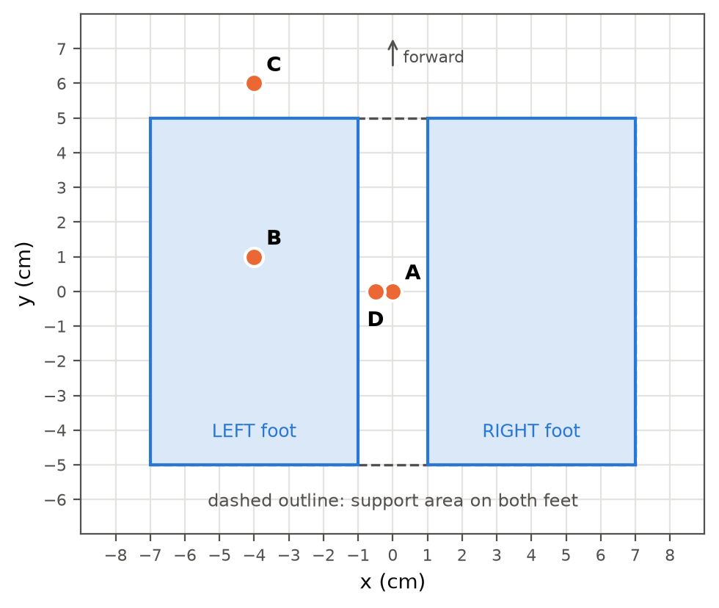
Figure 5. The feet seen from above, with four possible CoG points A, B, C and D.
Detailed Answer
When a robot stands on both feet, its support region is the shape you get by stretching a rubber band around both feet. Here that shape is a rectangle from x = −7 to x = 7 and from y = −5 to y = 5, which is 14 cm wide and 10 cm long. Part (a). Its area is 14 × 10 = 140 cm², even though the feet themselves only cover 2 × 60 = 120 cm², because the 2 cm gap between the feet also counts as support.
both feet: 14 × 10 = 140 cm² left foot only: 6 × 10 = 60 cm²
When the robot stands on its left foot only, the support region is just that foot, with an area of 6 × 10 = 60 cm², which is less than half as much. A smaller support region means the robot tips over much more easily, which is why standing on one foot is the hardest moment in walking.
Part (b). We check whether each point satisfies the inequalities that describe the region. Point A (0, 0) is inside the two-foot rectangle, so the robot is stable on both feet. However, on the left foot alone, x must satisfy −7 ≤ x ≤ −1, and x = 0 is not in this range, so the robot would fall towards its right. Point B (−4, 1) satisfies −7 ≤ −4 ≤ −1 and −5 ≤ 1 ≤ 5, so it is inside the left foot and the robot is stable; in fact, it is right in the middle of the foot's width. Point C (−4, 6) has y = 6, which is greater than 5, so the CoG point is 1 cm in front of the toes and the robot will fall forwards. Point D (−0.5, 0) is outside by only half a centimeter, because −0.5 is greater than −1, so the robot will fall even though the point looks very close to the foot.
Part (c). The CoG point starts at A (0, 0) and must move onto the left foot, whose inner edge is at x = −1, so the minimum shift is 1 cm. A shift of only 1 cm, however, puts the CoG point exactly on the edge, where the smallest wobble would cause a fall. A safer target is the middle of the foot at x = −4, which is a shift of 4 cm and leaves a 3 cm margin on each side.
minimum shift = 0 − (−1) = 1 cm safe shift = 0 − (−4) = 4 cm
This sideways shift, made just before each step, is the "sway" you can see when humanoid robots walk. During a walk, the robot sways back and forth between the middles of its two feet, once for every step.
Key idea: The robot is stable only when its CoG point is inside the support region. Aim for the middle, not the edge.

Part 4 · Walking and Moving
Now the robot starts to move. These questions use trigonometry, speed, angles and circles to plan each step and each turn.

Question 13. How Long Is One Step?
Mathematics: Trigonometry: sine and cosine (Challenge) Robot stage: Planning the walk
THE PROBLEM
With straight legs, the distance from the hip to the ankle is 16 cm. To take a step, the front leg swings 15° forward from the vertical while the back leg swings 15° backward (Figure 6).
If you have not learned trigonometry yet, solve parts (a) and (b) by making an accurate scale drawing with a protractor and a ruler.
(a) How far apart are the two ankles? This is the step length.
(b) By how much does the hip drop when the legs are spread like this?
(c) What swing angle would give a step length of 10 cm?

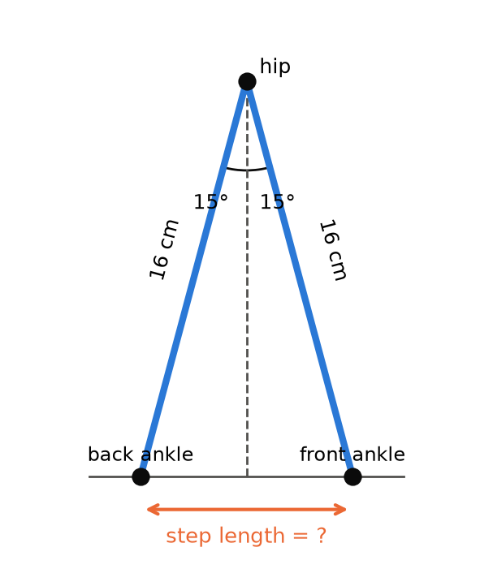
Figure 6. Each leg swings 15° away from the vertical line under the hip.
Detailed Answer
Each leg, the vertical line below the hip and the floor form a right-angled triangle. The leg is the hypotenuse (16 cm), the angle at the hip is 15°, the horizontal distance from the vertical line to the ankle is the side opposite this angle, and the height of the hip above the ankle is the adjacent side. The sine ratio links the opposite side to the hypotenuse, and the cosine ratio links the adjacent side to the hypotenuse.
sin θ = opposite ÷ hypotenuse cos θ = adjacent ÷ hypotenuse
Part (a). Each ankle is 16 × sin 15° ≈ 16 × 0.2588 ≈ 4.14 cm from the vertical line through the hip, one in front and one behind. The step length is the total distance between them, which is 2 × 4.14 ≈ 8.3 cm.
step length = 2 × 16 × sin 15° ≈ 2 × 4.14 ≈ 8.3 cm
Part (b). The height of the hip above the ankles is now 16 × cos 15° ≈ 16 × 0.9659 ≈ 15.45 cm. Before the step it was 16 cm, so the hip drops by 16 − 15.45 ≈ 0.55 cm, a little more than half a centimeter.
hip drop = 16 − 16 × cos 15° ≈ 16 − 15.45 ≈ 0.55 cm
This small up-and-down movement happens on every step, and it is one reason why real humanoid robots walk with slightly bent knees: the knees can straighten a little to keep the hips at a steady height, which gives a smoother walk.
Part (c). A 10 cm step means each ankle must be 5 cm from the vertical line, so sin θ = 5 ÷ 16 = 0.3125. Using the inverse sine key (sin⁻¹) on a calculator gives θ ≈ 18.2°. So increasing the swing angle by only about 3° makes each step about 1.7 cm longer. However, a bigger swing also makes the hip drop more (16 − 16 × cos 18.2° ≈ 0.80 cm) and makes the robot less stable, so the team must test the change carefully. A good habit is to change one setting at a time and measure the result, which is exactly what the testing questions in Part 5 practice.
sin θ = 5 ÷ 16 = 0.3125 → θ = sin⁻¹(0.3125) ≈ 18.2°
Key idea: For a leg of length L swung θ each way: step length = 2 × L × sin θ, and hip height = L × cos θ.

Question 14. The Robot Race
Mathematics: Speed, distance and time Robot stage: Planning the walk
THE PROBLEM
In the class robot race, the track is 3 m long. The robot's step length is 8 cm, and each step takes 0.8 s.
(a) What is the robot's walking speed in cm/s?
(b) How long will it take to finish the race, and how many steps will it take?
(c) The fastest robot last year finished in 24 s. Describe two ways the team could change the walk to finish in 24 s.

Detailed Answer
Speed tells us the distance traveled in each unit of time. Part (a). In 0.8 s the robot travels 8 cm, so its speed is 8 ÷ 0.8 = 10 cm/s.
speed = distance ÷ time = 8 cm ÷ 0.8 s = 10 cm/s
Part (b). First we must make the units match: 3 m is 300 cm. The time is distance ÷ speed = 300 ÷ 10 = 30 s. The number of steps is 300 ÷ 8 = 37.5, but the robot cannot be programmed to take half a step, so it needs 38 steps to cross the finish line (after 37 steps it has only gone 37 × 8 = 296 cm). It crosses the line at 30 s, partway through its 38th step.
time = 300 cm ÷ 10 cm/s = 30 s steps = 300 ÷ 8 = 37.5 → 38 steps
Part (c). To finish in 24 s, the new speed must be 300 ÷ 24 = 12.5 cm/s. Because speed = step length ÷ step time, the team can either make the steps longer or make them quicker.
Option 1: longer steps. Keep the step time at 0.8 s and make each step longer. The new step length must be 12.5 × 0.8 = 10 cm, which needs a leg swing of about 18.2° (Question 13).
Option 2: quicker steps. Keep the 8 cm step and make each step faster. The new step time must be 8 ÷ 12.5 = 0.64 s, which means the servos must move 0.8 ÷ 0.64 = 1.25 times as fast, or 25% faster.
Option 1: step = 12.5 × 0.8 = 10 cm Option 2: step time = 8 ÷ 12.5 = 0.64 s
Both options have risks: longer steps make the robot less stable, while quicker steps may be too fast for the servos (remember from Question 6 that each servo needs time to reach its target). A third option is to combine two smaller changes, for example 9 cm steps that take 0.72 s each, which also gives 9 ÷ 0.72 = 12.5 cm/s. Engineers call this choosing between trade-offs: there is usually more than one way to reach a goal, and mathematics lets you compare them before you start testing.
Key idea: speed = distance ÷ time. For walking robots, speed = step length ÷ step time, so there are two "levers" to change.

Question 15. Turning Corners and Walking in Circles
Mathematics: Angles and circumference Robot stage: Planning the walk
THE PROBLEM
The robot turns by twisting its hip servos. Each turning step rotates the robot by 15°.
(a) How many turning steps are needed to turn 90°, 180° and 360°? What happens if the robot needs to turn 100°?
(b) The robot walks around a circular path. The center of its body follows a circle of radius 50 cm, and its feet are 8 cm apart (center to center), as in Figure 7. Find the length of the path followed by the inner foot, the center of the body and the outer foot.
(c) If the robot takes 40 steps to go around the circle once, by how many degrees must it turn on each step?

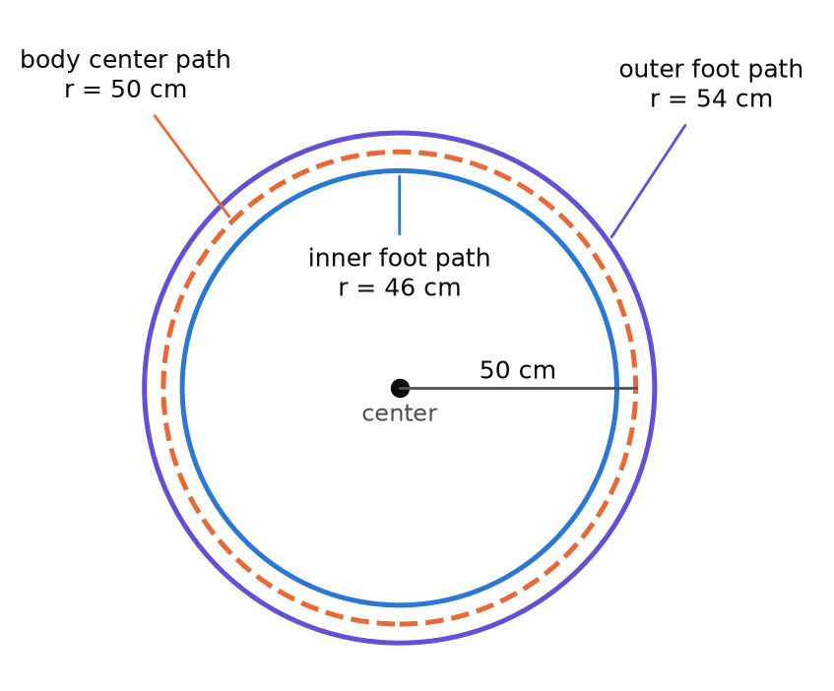
Figure 7. When the robot walks in a circle, its two feet follow circles of different sizes.
Detailed Answer
Part (a). The number of turning steps is the total angle divided by 15°. A right-angle turn of 90° needs 90 ÷ 15 = 6 steps, a half turn of 180° needs 12 steps, and a full turn of 360° needs 24 steps.
90° ÷ 15° = 6 180° ÷ 15° = 12 360° ÷ 15° = 24
For a 100° turn, 100 ÷ 15 ≈ 6.67, which is not a whole number. Six steps give 90° (10° too little) and seven steps give 105° (5° too much), so the robot needs six normal turning steps plus one small 10° step, or the programmer must accept a 5° error. Small errors like this add up: after four 100° turns of seven steps each, the robot would be facing 20° away from the intended direction.
Part (b). The circumference of a circle is C = 2πr. The center of the body travels 2 × π × 50 ≈ 314.2 cm. The feet are 4 cm on either side of the body's center, so the inner foot follows a circle of radius 46 cm and the outer foot a circle of radius 54 cm.
inner foot: 2π × 46 ≈ 289.0 cm body center: 2π × 50 ≈ 314.2 cm outer foot: 2π × 54 ≈ 339.3 cm
So the inner foot travels about 289.0 cm and the outer foot about 339.3 cm. The outer foot travels 339.3 − 289.0 ≈ 50.3 cm farther in one lap, which is exactly 2π × 8. This means that, when walking in a curve, the outer leg must take longer steps than the inner leg, about 54 ÷ 46 ≈ 1.17 times as long, or 17% longer. It is the same reason why the outside wheels of a car turn faster than the inside wheels when it goes around a corner.
Part (c). The robot turns a full 360° during one lap, so each of the 40 steps must turn 360 ÷ 40 = 9°. Each step of the body's center is 314.2 ÷ 40 ≈ 7.85 cm, which is very close to the robot's normal 8 cm step. Adding a small turn to every step, instead of stopping to turn, lets the robot walk in a smooth curve.
turn per step = 360° ÷ 40 = 9° distance per step = 314.2 ÷ 40 ≈ 7.85 cm
Key idea: Circumference = 2πr. One lap of a circle is always a 360° turn. Outer paths are longer than inner paths.

Part 5 · Programming and Testing
Finally, the robot needs a program, a sensor, a battery and plenty of testing. These questions use interpolation, remainders, linear equations, rates and statistics.

Question 16. Smooth Movements
Mathematics: Linear interpolation Robot stage: Programming the robot
THE PROBLEM
If a servo is told to jump straight from 60° to 120°, it moves at full speed and the robot shakes. Instead, the program moves it a little at a time. The program updates the servo every 20 milliseconds (ms), and the whole move should take 1.5 s.
(a) How many updates are there, and how many degrees does the servo move in each update?
(b) Write a formula for the angle θ after t seconds. What is the angle after 0.5 s and after 1.2 s?
(c) At the same time, the knee must move from 90° to 130° and the hip from 90° to 110°, both in 1 s, so that they arrive together. How many degrees per update must each servo move?

Detailed Answer
Part (a). First we make the units the same: 1.5 s = 1500 ms. The number of updates is 1500 ÷ 20 = 75. The servo must turn 120° − 60° = 60° altogether, so in each update it turns 60 ÷ 75 = 0.8°.
updates = 1500 ÷ 20 = 75 step = 60° ÷ 75 = 0.8° per update
Part (b). The servo turns 60° in 1.5 s, which is a rate of 60 ÷ 1.5 = 40° per second. It starts at 60°, so the angle after t seconds is θ = 60 + 40t, for t from 0 to 1.5. This is a linear function, just like the one in Question 5, with a starting value of 60 and a rate of change of 40.
θ = 60 + 40t (0 ≤ t ≤ 1.5)
After 0.5 s, θ = 60 + 40 × 0.5 = 80°, and after 1.2 s, θ = 60 + 40 × 1.2 = 108°. We can check the formula at the end of the move: at t = 1.5, θ = 60 + 60 = 120°, which is the target. Finding the values between a starting value and an ending value like this is called linear interpolation, and robot animation software uses it to fill in the motion between the "key poses" that you design.
Part (c). There are 1000 ÷ 20 = 50 updates in 1 s. The knee must turn 40°, so it moves 40 ÷ 50 = 0.8° per update, and the hip must turn 20°, so it moves 20 ÷ 50 = 0.4° per update.
knee: 40° ÷ 50 = 0.8° per update hip: 20° ÷ 50 = 0.4° per update
Even though the knee moves twice as far as the hip, both servos start and finish at the same moment, because the knee moves twice as fast. If both servos moved at the same speed instead, the hip would arrive early and wait, and the foot would follow a strange, unnatural path. Some advanced programs go one step further and use "ease-in, ease-out" motion, in which the servo starts slowly, speeds up in the middle and slows down at the end, which looks even more natural and is gentler on the gears.
Key idea: Change per update = total change ÷ number of updates. Linear interpolation: θ = start + rate × t.

Question 17. The Walking Loop
Mathematics: Patterns and remainders Robot stage: Programming the robot
THE PROBLEM
The robot's walk is a repeating cycle of 8 poses, P1 to P8: poses P1–P4 make a step with the left leg and P5–P8 make a step with the right leg. Each pose lasts 0.2 s, and the cycle repeats over and over.
(a) Which pose is the robot's 50th pose? Which is its 64th pose?
(b) Which pose is the robot in 25.3 s after it starts walking?
(c) How long does one cycle take, how many steps does it contain, and how many complete cycles happen in the 30 s race from Question 14?

Detailed Answer
Because the poses repeat every 8, we can find any pose by division with a remainder. If we divide the pose number by 8, the remainder tells us where we are in the cycle: a remainder of 1 means P1, a remainder of 2 means P2, and so on. There is one catch: a remainder of 0 means the cycle has just finished, so that pose is P8, not "P0".
Part (a). 50 ÷ 8 = 6 remainder 2, because 6 × 8 = 48 and 50 − 48 = 2, so the 50th pose is P2, after 6 complete cycles. For the 64th pose, 64 ÷ 8 = 8 remainder 0, so it is P8, the last pose of the 8th cycle.
50 = 8 × 6 + 2 → P2 64 = 8 × 8 + 0 → P8
Part (b). First we find how many poses have been completed. Each pose lasts 0.2 s, so in 25.3 s the robot has gone through 25.3 ÷ 0.2 = 126.5 poses; that means 126 poses are complete and the robot is halfway through its 127th pose. Next, 127 ÷ 8 = 15 remainder 7 (since 15 × 8 = 120), so the robot is in pose P7, which is part of the right-leg step.
25.3 ÷ 0.2 = 126.5 → 127th pose 127 = 8 × 15 + 7 → P7
Part (c). One cycle takes 8 × 0.2 = 1.6 s and contains 2 steps (one left and one right), so each step takes 0.8 s, which matches Question 14. In 30 s there are 30 ÷ 1.6 = 18.75 cycles, so 18 complete cycles (36 steps) happen, plus three quarters of another cycle.
cycle time = 8 × 0.2 = 1.6 s 30 ÷ 1.6 = 18.75 cycles
In a program, this is usually written as a loop such as "repeat 19 times: do poses P1 to P8", which is far shorter than writing out all 152 poses one by one. Remainders are used everywhere in programming, for example to test whether a number is even (the remainder is 0 when it is divided by 2) or to make lights blink in a repeating pattern.
Key idea: Position in a repeating cycle = the remainder after dividing by the cycle length (a remainder of 0 means the last item).

Question 18. Seeing the Wall
Mathematics: Rates and linear equations Robot stage: Using sensors
THE PROBLEM
An ultrasonic sensor on the robot's head sends out a short sound pulse and measures the time until the echo comes back. Sound travels at about 340 m/s.
(a) The echo returns after 2000 μs (0.002 s). How far away is the wall?
(b) The robot starts 150 cm from a wall and walks towards it at 10 cm/s. Write a formula for its distance from the wall after t seconds. When will it be 20 cm from the wall?
(c) The program should stop the robot when it is 20 cm from the wall. What echo time should the program look for?
(d) The sensor takes a reading every 0.1 s. How far can the robot move between two readings?

Detailed Answer
The sound has to travel to the wall and back again, so the total distance it travels is twice the distance to the wall. Part (a). First, we convert the speed of sound to centimeters per second: 340 m/s = 34 000 cm/s. In 0.002 s the sound travels 34 000 × 0.002 = 68 cm, so the wall is half of this distance away, 34 cm.
distance to wall = (speed × time) ÷ 2 = (34 000 × 0.002) ÷ 2 = 34 cm
Part (b). The robot starts at 150 cm and gets 10 cm closer every second, so its distance after t seconds is d = 150 − 10t. This is a linear function with a negative slope, because the distance gets smaller as time goes on. To find when the robot is 20 cm away, we solve 150 − 10t = 20, which gives 10t = 130 and t = 13 s.
d = 150 − 10t 150 − 10t = 20 → 10t = 130 → t = 13 s
Part (c). We work backwards: at a distance of 20 cm, the sound travels 2 × 20 = 40 cm in total. The time is 40 ÷ 34 000 ≈ 0.001 18 s, which is about 1180 μs. So the program can say: "if the echo time is less than 1180 μs, stop walking". Using "less than" rather than "equal to" is important, because a real sensor will almost never read exactly 1180 μs.
echo time = 40 cm ÷ 34 000 cm/s ≈ 0.001 18 s ≈ 1180 μs
Part (d). In 0.1 s the robot walks 10 × 0.1 = 1 cm, so it may stop anywhere between 19 cm and 20 cm from the wall. This is accurate enough for our robot, but a faster robot would need more frequent readings to stop safely. Also, sound travels a little faster in warm air and a little slower in cold air, so for precise work engineers adjust the speed of sound for the temperature.
Key idea: Echo distance = speed × time ÷ 2. With real sensors, use "less than" or "greater than" conditions instead of "equal to".

Question 19. How Long Will the Battery Last?
Mathematics: Rates and percentages Robot stage: Powering the robot
THE PROBLEM
The robot's battery is labeled 7.4 V, 1000 mAh. "1000 mAh" (milliamp-hours) means it can supply 1000 milliamps (mA) for 1 hour, or 500 mA for 2 hours, and so on. While walking, on average 6 servos are moving and use 250 mA each, while the other 10 servos are holding still and use 20 mA each. The controller board uses 80 mA.
(a) Find the total current used while the robot is walking.
(b) How long can the robot walk on a full battery? To protect the battery, only 80% of its capacity should be used. How long is that?
(c) Each competition run lasts 3 minutes. How many runs can the robot complete on one charge?
(d) The team wants 45 minutes of walking. What battery capacity do they need?

Detailed Answer
Current is the "flow" of electricity, and the total current is the sum of the currents used by all the parts. Part (a). The six moving servos use 6 × 250 = 1500 mA, the ten holding servos use 10 × 20 = 200 mA, and the controller uses 80 mA, so the total is 1780 mA.
total current = 6 × 250 + 10 × 20 + 80 = 1500 + 200 + 80 = 1780 mA
Part (b). The time a battery lasts is its capacity divided by the current. A full battery gives 1000 ÷ 1780 ≈ 0.562 hours, and to change hours into minutes we multiply by 60: 0.562 × 60 ≈ 33.7 minutes. Using only 80% of the capacity means we can use 0.8 × 1000 = 800 mAh, which lasts 800 ÷ 1780 ≈ 0.449 hours, or about 27 minutes.
time = capacity ÷ current = 800 mAh ÷ 1780 mA ≈ 0.449 h ≈ 27 min
Part (c). 27 ÷ 3 = 9, so the robot can complete about 9 runs on one charge. The team should still recharge before the battery goes completely flat, because servos become weak and unreliable when the voltage drops.
Part (d). 45 minutes is 45 ÷ 60 = 0.75 hours. The usable capacity needed is 1780 × 0.75 = 1335 mAh. Since only 80% of the label capacity is usable, the label capacity must be 1335 ÷ 0.8 ≈ 1669 mAh, so the team should choose a battery of at least 1700 mAh (a common size is 2000 mAh).
label capacity needed = (1780 × 0.75) ÷ 0.8 ≈ 1669 mAh
However, a bigger battery is also heavier. If a 2000 mAh battery has a mass of 250 g instead of 150 g, the robot's mass rises by 100 g to 1240 g, which breaks the 1200 g weight budget from Question 4. This shows how the different parts of a robot design are connected: improving one thing (running time) can cause a problem somewhere else (mass and balance), and mathematics lets you see these effects before you spend any money.
Key idea: Battery time = capacity ÷ current. Capacity needed = current × time ÷ usable fraction.

Question 20. Testing and Fixing the Walk
Mathematics: Statistics and percentage error Robot stage: Testing the robot
THE PROBLEM
The robot is programmed to walk 15 steps of 8 cm, which should cover 120 cm. The team runs five trials and measures these distances in centimeters: 112, 117, 115, 121, 115.
(a) Find the mean, median, mode and range of the results.
(b) Find the percentage error of the mean compared with the planned 120 cm.
(c) Find the robot's real average step length. How could the team change the program so that the robot walks 120 cm?
(d) Why is it better to run five trials rather than just one?

Detailed Answer
Part (a). The mean is the sum of the results divided by the number of results: (112 + 117 + 115 + 121 + 115) ÷ 5 = 580 ÷ 5 = 116 cm. To find the median, we put the results in order (112, 115, 115, 117, 121), and the middle value is 115 cm. The mode is the value that appears most often, which is also 115 cm. The range is the largest value minus the smallest, 121 − 112 = 9 cm, and it shows how spread out the results are.
mean = 580 ÷ 5 = 116 cm median = 115 cm mode = 115 cm range = 9 cm
Part (b). The error is the difference between the planned distance and the actual distance: 120 − 116 = 4 cm. The percentage error compares this error with the planned value: 4 ÷ 120 × 100% ≈ 3.3%. So, on average, the robot walks about 3.3% less far than planned.
percentage error = (120 − 116) ÷ 120 × 100% ≈ 3.3%
Part (c). The real average step length is 116 ÷ 15 ≈ 7.73 cm instead of 8 cm, probably because the feet slip a little on the floor or the servos do not quite reach their target angles. One fix is to keep 15 steps but make each step longer by the factor 120 ÷ 116 ≈ 1.034, which gives a programmed step of about 8 × 1.034 ≈ 8.28 cm; interestingly, this is almost exactly the 8.3 cm step from the 15° leg swing in Question 13. Another idea is to change the number of steps, but 120 ÷ 7.73 ≈ 15.5 is not a whole number, and 16 steps would cover about 16 × 7.73 ≈ 123.7 cm (3.7 cm too far), so adjusting the step length is the more accurate fix. After changing the program, the team must run new trials to check that the fix really works.
new step length = 8 × (120 ÷ 116) ≈ 8.28 cm
Part (d). Every trial is a little different, because of small changes in the floor, the battery level and how the robot is placed at the start. A single trial might be unusually good or unusually bad, but the mean of several trials gives a much more reliable picture of the robot's true performance. The range tells the team how consistent the robot is: a range of 9 cm is 7.5% of the 120 cm target, so making the robot more consistent may be just as important as fixing its average. Scientists and engineers always repeat their measurements for exactly this reason.
Key idea: Mean, median and mode describe a typical result; the range describes the spread. Fix a steady error by scaling: new value = old value × (target ÷ actual).

Formula Summary
These are the main mathematical ideas used in this booklet. Keep this page next to you while you build and program your own robot.
Idea | Formula or rule | Questions
Sharing in a ratio | one part = total ÷ (sum of the ratio numbers) | 1
Scale factor k | lengths × k, areas × k², volumes × k³ | 2
Linear inequality | solve like an equation; round in the safe direction | 4, 9
Reflection in the y-axis | (x, y) → (−x, y) | 3
Midpoint | ((x₁ + x₂) ÷ 2, (y₁ + y₂) ÷ 2) | 3
Linear function | y = mx + c (m = rate of change, c = starting value) | 5, 16, 18
Rate (speed) | speed = distance ÷ time | 6, 14, 18
Gear ratio | driven teeth ÷ driver teeth; multiply ratios in a train | 7
Pythagoras' theorem | a² + b² = c² | 8, 11
Distance from the origin | d = √(x² + y²) | 8
Triangle inequality | (long − short) ≤ third side ≤ (long + short) | 8
Torque (moment) | torque = mass × distance from the pivot | 9
Weighted mean (center of gravity) | (sum of mass × height) ÷ (total mass) | 10
Angles in a triangle | the three angles add up to 180° | 11
Area of a rectangle | area = length × width | 2, 12
Sine and cosine | sin θ = opposite ÷ hypotenuse, cos θ = adjacent ÷ hypotenuse | 11, 13
Circumference | C = 2πr | 15
Remainders in cycles | position = remainder of (n ÷ cycle length); remainder 0 = last | 17
Echo distance | distance = speed × time ÷ 2 | 18
Battery time | time = capacity ÷ current | 19
Mean and range | mean = sum ÷ count; range = largest − smallest | 20
Percentage error | (target − actual) ÷ target × 100% | 20

