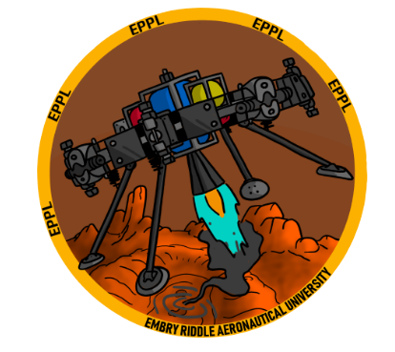

# **Integrated Spacecraft Autonomous Attitude Control (ISAAC)**

|  |  |  |  |
| --- | --- | --- | --- |
|  | NAME | MAJOR | JOB(S) |
| 1 | **Jacob Romeo** | **Astronomy and Astrophysics** | **Personal Investigator** |
| 2 | **Dylan Ballback** | **Mechanical Engineering** | **Mech/Electrical/Software** |
| 3 | **Kyle Fox** | **Electrical Engineering** | **Electrical/Software** |
|  | **Jacob Raynor** | **Aeronautical Engineering** | **Mechanical** |
| 4 | **Adam Duke** | **Aerospace Engineering** | **Software** |
| 5 | **Sergio Carli** | **Electrical Engineering** | **Electrical** |
| 6 | **Kamryn Hall** | **Aeronautical Engineering** | **Electrical/Software** |
| 7 | **Kya Sedelmeyer** | **Aeronautical Engineering** | **Electrical/Software** |

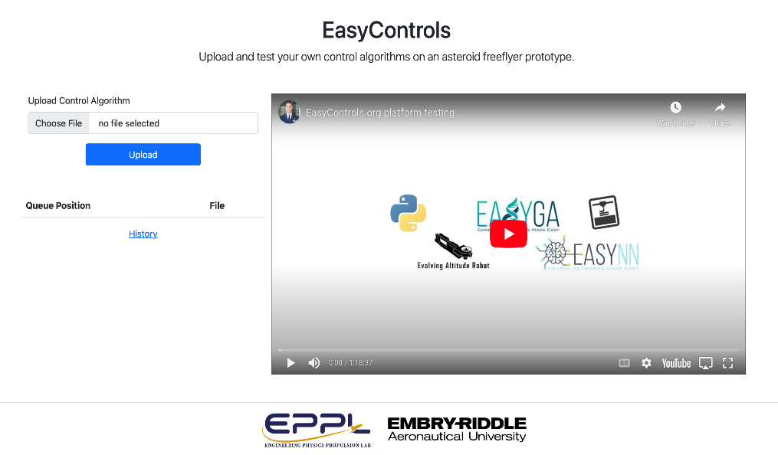Satellites are essential in today’s day in age, yet very expensive for a student, teacher, or  
researcher to make/buy for learning purposes and experiments. To bridge this connection from  
money to knowledge, we are developing ISAAC *(Fig. 1),* which will be available to the user via the  
*easycontrols.org* website *(Fig. 2 ).* This is an open-sourced, 3D-printed attitude controller that will  
sit inside a 3-axis gimbal ring. This setup simulates a microgravity environment, allowing the user  
to test their control algorithms. ISAAC uses a Raspberry Pi as the server to compile the code uploaded  
to *easycontrols.org* and compressed air as a means of propulsion. From  
the website, the user will be able to watch a live stream of the craft trying to stabilize itself and  
the data being processed all at once. This shows the user how the theory and computation are applied to a  
real-world system, simulating that of a satellite in space. Allowing curious minds to learn and teachers, like Dr. Drakunov and Dr. MacKunis, to teach the theory and have their students watch as it unfolds.

*Fig. 2: The easycontrols.org website homepage*

*Fig. 1: ISAAC in a 1D apparatus*