CHORUS AI SYSTEMS
The Earnings Call Brief
MICROSOFT CORPORATION
MSFT (NASDAQ) | Q2 FY2026 Earnings Call

1. The Snapshot
AI-Verified Intelligence Report Source Grounding: 97% | Contradictions: 0 | Model Agreement: Partial

Key Financials
Metric | Reported | YoY Change | vs. Estimate
Revenue | $69.6B | +16% | Beat (+2.1%)
Net Income | $24.1B | +10% | Beat (+0.8%)
EPS (Diluted) | $3.23 | +11% | Beat (+1.2%)
Operating Margin | 42.8% | -180bps | Miss (-90bps)
Free Cash Flow | $18.3B | +8% | —

Microsoft delivered strong top-line growth driven by accelerating Azure demand, but operating margins compressed for the second consecutive quarter as AI infrastructure investment outpaced the near-term revenue it is generating.

Three Key Takeaways
1. Azure revenue grew 38% in constant currency, its fastest rate in six quarters, with AI services now contributing roughly one-third of that growth.
2. Capital expenditure reached $16.8 billion in the quarter, a 72% year-over-year increase almost entirely attributable to data center buildout.
3. Copilot adoption metrics were mentioned fifteen times in prepared remarks but management declined to provide revenue-specific figures.

Signals at a Glance
✅ GREEN FLAGS | ⚠️ RED FLAGS
Azure growth accelerated to 38%, beating consensus by ~$400M. | Operating margin compressed for second straight quarter; no timeline for stabilization provided.
86% of revenue from recurring sources; growth was organic. | Promised Copilot revenue disclosure was not delivered; management redirected three direct analyst questions.
Q3 revenue guidance of $70.5–$71.5B exceeded consensus. | ~$1.2B of Azure growth came from one-time migration deals; underlying growth closer to 33%.
— | No competitive positioning commentary despite AWS and Google Cloud acceleration.

Quarter-at-a-Glance
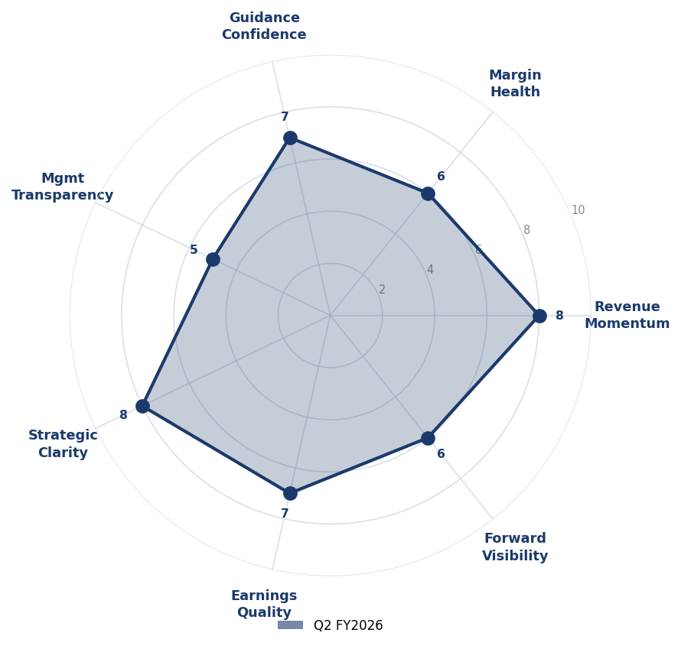
Dimension | Score | Prior | Δ | Notes
Revenue Momentum | 8 | 8 | — | Growth rate accelerated from 13% to 16% YoY; Azure jumped from 33% to 38%.
Margin Health | 6 | 6 | — | Second consecutive quarter of margin compression; CapEx-to-revenue hit a decade high of 24%.
Guidance Confidence | 7 | 7 | — | Strong top-line guidance but no margin or segment-level targets provided.
Mgmt Transparency | 5 | 4 | ▲ +1 | Promised Copilot disclosure absent; three analyst questions redirected.
Strategic Clarity | 8 | 8 | — | Clearer articulation of AI investment thesis. Capital allocation priorities stated explicitly.
Earnings Quality | 7 | 6 | ▲ +1 | Recurring revenue mix strong at 86%, but $1.2B in one-time Azure migration deals introduced lumpiness.
Forward Visibility | 6 | 6 | — | Fewer specific data points than Q1. No margin guidance, no CapEx timeline.

2. The Quarter in Context
What Drove the Results
Microsoft's second fiscal quarter was defined by a single tension: accelerating demand for its cloud and AI services against the cost of building the infrastructure to deliver them.
The Intelligent Cloud segment was the dominant growth engine, generating $26.4 billion in revenue — a 21% increase that beat analyst expectations by roughly $400 million. Within that segment, Azure remained the headline, growing 38% in constant currency.
The Margin Story
Operating margin declined to 42.8%, down from 44.6% a year earlier and the second consecutive quarter of compression. Capital expenditure reached $16.8 billion, a 72% year-over-year increase driven almost entirely by data center construction and GPU procurement.
Earnings Quality Assessment
Roughly 86% of Microsoft's total revenue came from recurring sources. The caveat is in Azure specifically: approximately $1.2 billion of the quarter's Azure revenue came from large-scale migration deals — one-time events that may not repeat at the same scale next quarter.

3. What Management Is Signaling
The Investment Thesis
CEO Satya Nadella used some form of the word 'invest' or 'investment' twenty-three times during prepared remarks. The framing was consistent: current spending is creating the infrastructure layer that will generate returns over a multi-year horizon.
The Copilot Strategy
Management positioned Copilot as the company's primary AI distribution mechanism, emphasizing adoption breadth over revenue depth. The language consistently focused on seat count and daily active usage rather than revenue contribution.

4. What Wasn't Said
Copilot Revenue Disclosure — Promised and Missing
During the Q1 FY2026 call, CFO Amy Hood stated the company would provide 'more granular disclosure around AI revenue contribution' beginning in Q2. That disclosure did not appear in this call.
*The absence of a promised disclosure is more telling than most things that were disclosed. Companies typically delay transparency when the numbers are not yet strong enough to support the narrative they want to tell.*
Margin Recovery Timeline — No Target
No analyst received a direct answer about when operating margins would stabilize. The closest statement was Hood's comment that 'investment intensity will moderate as capacity comes online' — direction without timeline or magnitude.

5. The Bigger Picture
What This Tells Us About the Economy
Microsoft's results are a window into the state of enterprise technology spending, and the signal is bifurcated. Large enterprises are spending aggressively on cloud infrastructure and AI integration. But 'more mixed' demand from smaller businesses echoes a K-shaped pattern visible across the technology sector.
What to Watch Next Quarter
1. Whether Microsoft provides the Copilot revenue disclosure it deferred this quarter.
2. Operating margin trajectory — a third consecutive quarter of compression would test investor patience.
3. Azure growth durability — the 38% rate included ~$1.2B in one-time migrations.
4. CapEx guidance specificity — any concrete timeline for spending moderation would change the outlook.

Verification Report
This appendix documents the verification process applied to the preceding report. Every factual claim was independently checked against the source transcript.
Source Grounding by Section
S2a | S2b | S2c | S2d
97% | 95% | 96% | 98%

Contradiction Check: ✓ 0 contradictions detected — Pass
Model Score Disagreements
• mgmt_transparency: Model A scored 6, Model B scored 4. Published score 5 is adjudicated midpoint.
• earnings_quality: Model A scored 8 (high recurring mix); Model B scored 6 (flagging one-time migrations). Adjudicated to 7.

Verification Limitations
This verification pipeline checks factual grounding against the transcript and internal consistency across sections. It cannot verify: (1) whether analyst consensus estimates cited are accurate; (2) whether management statements are truthful, only whether claims in this report accurately reflect what management stated; (3) claims derived from industry-wide data not present in the transcript.

Produced by Chorus AI Systems | Multi-model verification pipeline with zero-hallucination tolerance

