**CPAN 212 LAB 2**

**Lab Objective**

**Students will simulate a background task (like data fetching or file reading) using callbacks, promises, and async/await.**

1.Create a folder and init a Node.js project

2. Create Express server to accomplish the following tasks.

3. Use `setTimeout()` to simulate an API call that returns your data {id:value,name:’yourname’} after 1 second

3.Wrap the same logic in a Promise

4.Rewrite it using `async/await`

5. Use `fs.promises` to read a file asynchronously

6. Write a helper function called `simulateDelay(ms)` that returns a Promise that resolves after `ms` milliseconds. Use it to chain multiple steps like login, fetch data, and render and print respective messages.

7. Create endpoints for each step with error handling. /callback,/promise,/async,/file, /chain. Handle errors in each step.

8. Submit a `.js` file , GitHub link and images of your execution for endpoints in browser or curl/Postman:

/callback

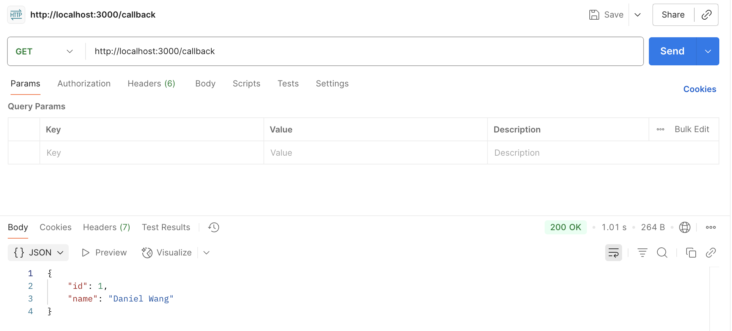

/promise

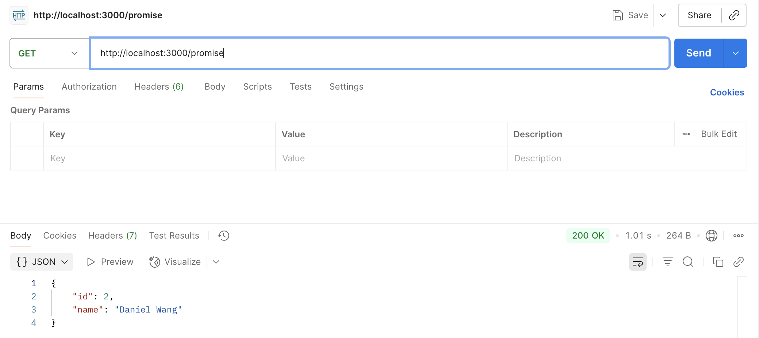

/async

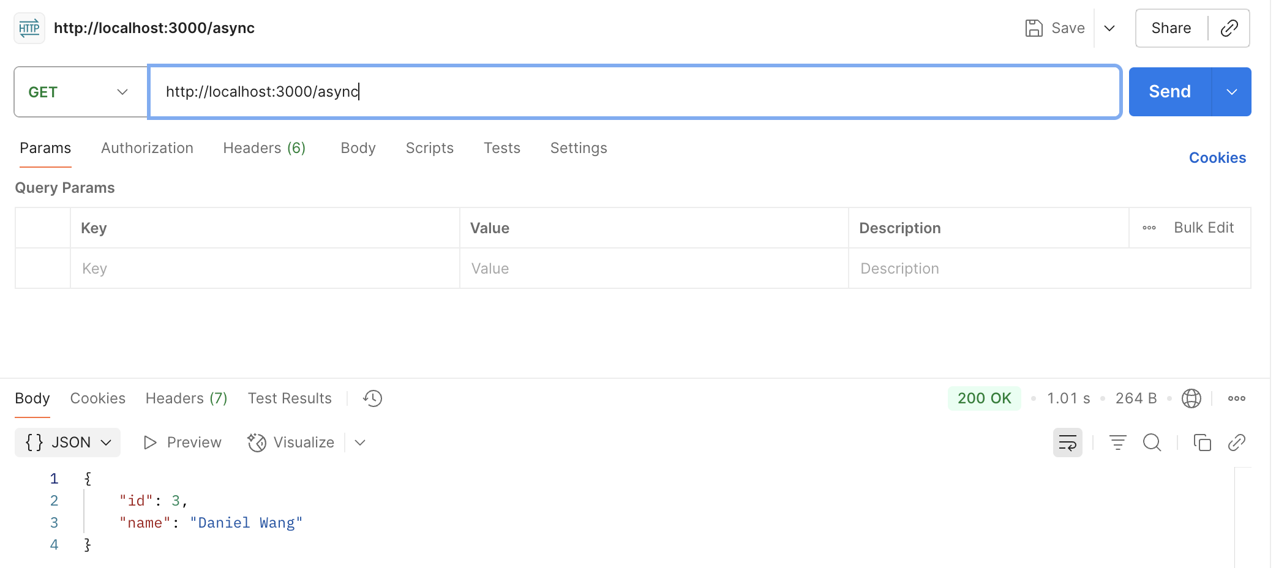

/file

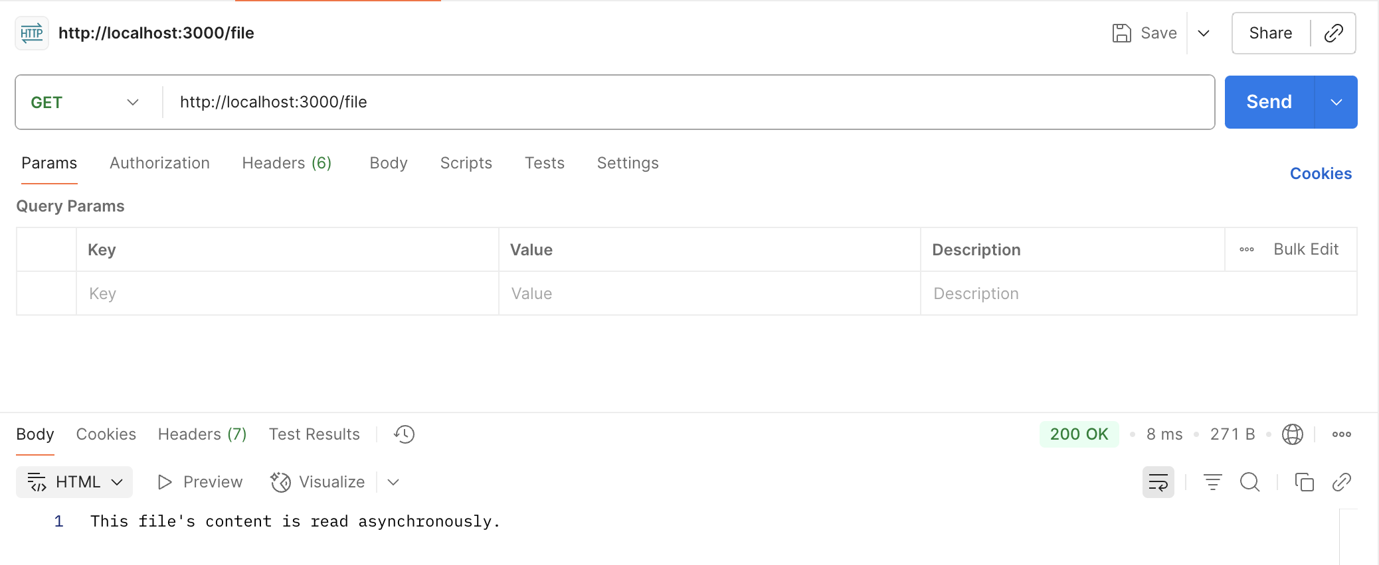

/chain

