A Geo-located NLP Feedback System for Public Transport
A Case Study of the Shanghai Metro and Bus Network
Final Project Report
Course: 158.888 IT Professional Project
Team Members
Student Name: Hanwen Yang — ID: 25005022
Student Name: Junzhen Wang — ID: 25012016
Student Name: Yifan Shi — ID: 23003326

Supervisor: Associate Professor Anu Mathrani

Supervisor: Ms Binglan Han

Abstract
This report presents the development and evaluation of a Geo-located NLP Feedback System for Public Transport, using Shanghai as the wider case-study context and Hongkou District, Huangpu District and Pudong New Area as representative areas for detailed spatial demonstration. The project addresses the problem that passenger feedback is often available as unstructured text, while transport planning requires both semantic interpretation and geographic context. The implemented prototype combines Chinese-language text preprocessing, issue classification, sentiment analysis, station and location matching, QGIS-based spatial preparation, FastAPI backend services, SQLite storage and a Streamlit dashboard for interactive visualisation. The NLP component converts passenger comments into structured attributes such as issue category, sentiment, confidence information and matched keywords. Evaluation shows that the best out-of-distribution category result was achieved by the TF-IDF + SVM model, with 0.5917 accuracy and 0.5929 macro-F1, while the best OOD sentiment result reached 0.5500 accuracy and 0.4513 macro-F1. These results indicate that the model is useful as a baseline but still limited under informal and unfamiliar language conditions. The spatial component demonstrates the feedback-to-map workflow through DBSCAN clustering, Moran's I analysis and district-level comparison. DBSCAN identified four negative-feedback clusters, while Moran's I was -0.103 with p = 0.8414, indicating no significant global spatial autocorrelation in the collected data. District comparison showed negative feedback rates of 66.7% in Huangpu, 66.7% in Hongkou and 80.0% in Pudong, but the chi-square test was not statistically significant. Overall, the project provides a working research prototype that demonstrates how NLP and GIS can be integrated to support exploratory public transport feedback analysis, while also highlighting the need for larger-scale feedback data, stronger language models and broader geographic coverage before operational deployment.

Table of Contents
1 Introduction 6
1.1 Background 6
1.2 Problem Statement 7
1.3 Research Motivation 7
1.4 Project Aim and Objectives 8
1.5 Project Scope 9
1.6 Project Contributions 10
1.7 Report Structure 11
2 Literature Review 11
2.1 Public Transport Service Quality and Passenger Feedback 11
2.2 User-Generated Content in Transport Research 12
2.3 Natural Language Processing in Transport Analysis 14
2.3.1 Introduction to NLP in Transport Research 14
2.3.2 Text Classification 15
2.3.3 Sentiment Analysis 16
2.3.4 Opinion Mining and Keyword Extraction 17
2.4 GIS and Spatial Analysis in Urban Transport 19
2.4.1 GIS in Transport Studies 19
2.4.2 Spatial Clustering Analysis 19
2.4.3 Spatial Autocorrelation Analysis 20
2.5 Web-based Visualisation and Smart City Applications 21
2.5.1 Web-based Data Visualisation 21
2.5.2 Web GIS and Urban Mobility Visualisation 21
2.6 Research Gap and Chapter Summary 22
3 Methodology 23
3.1 Research Design and Overall Approach 23
3.2 System Architecture 24
3.3 Data Collection and Preparation Method 25
3.3.1 Data Sources 25
3.3.2 Passenger Feedback Dataset 26
3.3.3 Sentiment Training Dataset 26
3.3.4 Geographic Transport Dataset 26
3.3.5 Data Preparation Workflow 27
3.4 NLP Processing Methodology 27
3.4.1 Overview of the NLP Pipeline 27
3.4.2 Text Preprocessing 28
3.4.3 Feature Extraction Using TF-IDF 28
3.4.4 Text Classification 29
3.4.5 Sentiment Analysis 29
3.4.6 Model Integration 30
3.4.7 Evaluation Preparation 30
3.5 Spatial Analysis Methodology 31
3.5.1 Geographic Data Integration 31
3.5.2 Spatial Clustering Analysis 31
3.5.3 Spatial Autocorrelation Analysis 32
3.5.4 District-level Comparative Analysis 32
3.6 Web-based System Development Methodology 32
3.6.1 System Development Strategy 32
3.6.2 Backend Architecture 33
3.6.3 Frontend Dashboard Design 33
3.6.4 Interactive Mapping and Visualisation 34
3.6.5 API Communication Workflow 34
3.7 Evaluation Strategy 35
3.7.1 Evaluation Objectives 35
3.7.2 NLP Model Evaluation 35
3.7.3 Out-of-Distribution Evaluation 36
3.7.4 Spatial Analysis Evaluation 36
3.7.5 System-Level Evaluation 37
3.8 Chapter Summary 37
4 Data Collection and Preparation 37
4.1 Chapter Overview 37
4.2 Public Transport Network Data 38
4.3 Passenger Feedback Dataset 38
4.4 Sentiment Training Datasets 39
4.5 Out-of-Distribution Evaluation Dataset 40
4.6 Data Cleaning and Preparation 42
4.7 Chapter Summary 43
5 Natural Language Processing 43
5.1 Chapter Overview 43
5.2 Category Classification Model 44
5.3 Sentiment Analysis Model 44
5.4 Integrated NLP Model 45
5.5 Model Evaluation Framework 45
5.6 Experimental Results 46
5.7 Out-of-Distribution Evaluation 46
5.8 Discussion of NLP Findings 47
5.9 Chapter Summary 48
6 Spatial Analysis 48
6.1 Chapter Overview 48
6.2 Spatial Analysis Framework 48
6.3 Spatial Clustering Analysis 49
6.4 Spatial Autocorrelation Analysis 49
6.5 District-Level Comparison 50
6.6 Spatial Analysis Findings 50
6.7 Discussion of Spatial Results 51
6.8 Chapter Summary 51
7 System Implementation and Visualisation 51
7.1 Chapter Overview 51
7.2 System Architecture 52
7.3 Backend Implementation 52
7.4 Frontend Dashboard Development 53
7.5 Interactive Visualisation 53
7.6 Chapter Summary 53
7.7 Source Code 54
8 Discussion 54
8.1 Chapter Overview 54
8.2 Contribution of the Proposed System 54
8.3 Implications for Public Transport Management 55
8.4 Technical Limitations 55
8.5 Future Improvements 56
8.6 Chapter Summary 56
9 Conclusion 56
10 Personal Learning 57
References 59

1 Introduction

1.1 Background
Public transport is central to sustainable urban development because it connects residential areas, employment centres, educational institutions and major services while reducing dependence on private vehicles. In large cities, the quality and reliability of public transport directly influence accessibility, passenger satisfaction and the wider efficiency of urban life (Eboli & Mazzulla, 2007). Evaluating the system therefore requires attention not only to operational performance but also to the experiences reported by passengers.
Shanghai provides an appropriate setting for this project because it operates an extensive metro system and a large bus network that support daily mobility across a complex urban environment. Metro and bus services interact with commercial centres, residential neighbourhoods and major interchange locations, creating varied travel experiences and service-quality concerns (Dou et al., 2024). The scale of the city also makes conventional manual review of passenger feedback difficult.
Digital communication has changed how passengers describe these experiences. Online reviews, social-media posts, discussion forums and mobile applications contain comments about delays, crowding, transfers, accessibility, cleanliness, safety, ticketing and staff service. Such user-generated content is voluntary and often produced close to the travel event, so it can complement formal surveys and official complaint channels (Kaplan & Haenlein, 2010).
The practical difficulty is that these comments are unstructured, linguistically varied and geographically scattered. Manual analysis is inefficient when the volume of feedback increases, while the absence of consistent location references makes it hard to determine where reported issues occur. Natural Language Processing (NLP) can organise the text through classification, sentiment analysis and keyword extraction, whereas Geographic Information Systems (GIS) can connect analytical outputs with stations, stops, routes and administrative areas (Aggarwal & Zhai, 2012; Jurafsky & Martin, 2024).
Combining NLP and GIS creates a useful basis for a geo-located feedback system. Text analysis can identify what passengers discuss and how they feel, while spatial processing can reveal where selected concerns are associated with the transport network. Interactive visualisation can then communicate these findings in a form that is easier to explore than raw comments or static tables (Sobral et al., 2019).
Shanghai is the broader case-study city for the proposed system. For the detailed empirical and spatial demonstration, the project selected three representative areas: Hongkou District, Huangpu District and Pudong New Area. Metro stations and bus stops in these areas were used to demonstrate the complete workflow while metro and bus route layers provided wider network context. This approach retained the Shanghai-wide system objective without claiming that every district was analysed at the same level of detail.

1.2 Problem Statement
Large volumes of public transport feedback are available online, but extracting reliable and usable information from them remains difficult. Traditional surveys and official complaint channels provide structured evidence, yet they require time and organisational resources and may reach only a limited sample of passengers (Eboli & Mazzulla, 2007). Online comments provide an additional source of spontaneous experience data, but their scale and inconsistent format create a different analytical problem.
A second problem is the separation between passenger feedback and transport geography. Transport datasets describe routes, stations, stops and district boundaries, but they do not normally explain how passengers experience those locations. Conversely, textual comments may identify crowding, delays or poor facilities without providing a consistent spatial reference. Unless the two forms of information are connected, it is difficult to compare issues between locations or communicate geographic patterns.
Existing studies frequently emphasise either text analysis or spatial analysis. Online-review research can identify topics and sentiment, while GIS studies can describe infrastructure and spatial relationships. Fewer practical systems combine feedback classification, geographic matching, spatial analysis and web-based visualisation within a single workflow. This separation limits the ability to understand both what passengers report and where representative issues are observed.
The project therefore addresses the need for an integrated and demonstrable system. It must clean and classify Chinese-language feedback, connect selected records with geographic transport objects, compare representative urban areas and present the outputs through an interactive interface. The central technical challenge is not simply to build individual NLP or GIS components, but to make them operate together consistently.
Accordingly, the project develops a Geo-located NLP Feedback System for Public Transport. Shanghai supplies the overall transport context, while Hongkou, Huangpu and Pudong are used for detailed representative analysis. The resulting prototype is intended to show the feasibility, benefits and limitations of integrating textual feedback, transport geography and web visualisation.

1.3 Research Motivation
Advances in machine learning and geospatial technologies make it possible to process large textual and spatial datasets within a single analytical workflow. NLP methods can convert natural-language comments into categories, sentiment labels and weighted terms, reducing the dependence on manual coding (Jurafsky & Martin, 2024). GIS can then organise station, stop, route and district information and support the examination of geographic relationships.
In transport research, these capabilities are complementary. NLP can identify concerns such as delays, crowding, accessibility and service quality, but text analysis alone provides limited evidence about location. GIS can reveal spatial variation, but infrastructure layers alone do not represent passenger perception. Their integration allows feedback to be examined from both semantic and geographic perspectives (Dou et al., 2024; Sobral et al., 2019).
The project is also motivated by the practical value of interactive systems. Analytical results are more useful when users can filter issues, compare sentiment, inspect selected stations or stops and explore patterns on a map. A web-based dashboard can connect model outputs with visual summaries and provide a clearer route from raw comments to interpretable information.
Three representative areas were chosen to make this integration manageable and meaningful within the project period. Huangpu provides a central commercial and tourism-oriented environment with major interchange activity; Hongkou represents an established mixed residential and transport area; and Pudong New Area provides a larger and more spatially diverse setting containing commercial centres, residential zones and transport hubs. The purpose is not to rank every district in Shanghai, but to test the workflow across contrasting urban contexts.
This design also supports future scalability. Once the workflow for data preparation, NLP processing, geographic matching and dashboard presentation has been demonstrated, the same architecture can be extended to additional Shanghai districts or adapted to other cities when more complete data become available.
Motivated by these considerations, the project implements and evaluates a functional prototype that combines publicly available feedback, Chinese-language NLP, QGIS-based spatial preparation, spatial analytical services and an interactive web interface. The detailed case analysis of Hongkou, Huangpu and Pudong provides practical evidence of how the wider Shanghai-focused system can be used.

1.4 Project Aim and Objectives
The aim of this project is to develop a web-based Geo-located NLP Feedback System for Public Transport using Shanghai as the overall case-study city. The system integrates passenger feedback with metro and bus geographic data through NLP, GIS and interactive web technologies. Although the architecture is designed for the broader Shanghai transport context, detailed spatial analysis and system demonstration focus on Hongkou District, Huangpu District and Pudong New Area.
To achieve this aim, the project pursues the following objectives:
- To collect and organise publicly available user-generated comments relating to Shanghai metro and bus services.
- To collect, prepare and standardise Shanghai public transport datasets, including metro lines, metro stations, bus routes, bus stops and district boundaries, and to create a detailed analytical subset for Hongkou, Huangpu and Pudong.
- To apply NLP techniques such as text classification, sentiment analysis, and keyword extraction to identify major passenger concerns and transport-related issues.
- To establish connections between textual feedback and geographic transport objects through station names, stop names, route references and district information.
- To conduct spatial analysis and representative district comparison in order to examine the geographic distribution of transport-related concerns within Hongkou, Huangpu and Pudong.
- To develop an interactive web-based dashboard that allows users to explore transport feedback through maps, filters, and visual analytics.
- To evaluate the effectiveness of integrating NLP and GIS for supporting public transport service analysis and smart-city applications.
Based on these objectives, the project addresses the following research questions:
RQ1: What transport-related issues are most frequently discussed by metro and bus users in Shanghai?
RQ2: Where are selected transport issues geographically concentrated within the representative study areas of Hongkou District, Huangpu District and Pudong New Area?
RQ3: How can NLP and GIS technologies be integrated to improve the interpretation and visualisation of transport-related user feedback?
RQ4: To what extent can an interactive web-based system support the exploration and understanding of public transport issues?
RQ1, RQ3 and RQ4 address the broader analytical framework and system, whereas RQ2 is demonstrated through the three selected representative areas. Together, the questions evaluate whether user-generated feedback can be transformed into structured and geographically interpretable information without treating the three-area analysis as a complete assessment of every Shanghai district.

1.5 Project Scope
This project uses Shanghai as the overall geographic and public transport context and focuses on metro and bus services. The system architecture, data model and visualisation concept are designed to support a broader Shanghai network application.
For detailed analysis, Hongkou District, Huangpu District and Pudong New Area were selected as representative study areas. The three areas provide contrasting urban characteristics and a manageable basis for testing station-level, stop-level and district-level functions. Metro and bus route layers provide network context, while metro stations, bus stops and geo-located feedback are the principal units used in the detailed comparison.
The project relies on publicly available user-generated content and secondary transport data. It does not conduct questionnaires, interviews, focus groups or behavioural experiments. Personally identifiable information is excluded, and the analysis emphasises aggregated categories, sentiment and spatial patterns rather than individual users.
Technically, the project delivers a demonstrable academic prototype rather than a real-time or production-ready transport management platform. The prototype processes feedback, exposes analytical functions through a backend service and presents results through a dashboard. It is designed to show integration and feasibility, not to replace official operational systems.
The scope excludes taxis, ride-sharing services, bicycles and ferries. Findings from the detailed spatial analysis relate to the selected areas and should not be interpreted as a complete comparison of all Shanghai districts. Nevertheless, the workflow can be expanded to additional districts when more consistent feedback and transport data are available.

1.6 Project Contributions
The project contributes a practical integration of transport informatics, NLP, GIS and web-based visualisation. Its contribution lies primarily in the end-to-end workflow rather than in any single algorithm.
First, it links unstructured feedback with geographic transport information. Category classification and sentiment analysis transform comments into structured outputs, while station, stop and district attributes give those outputs a spatial context.
Second, it demonstrates representative spatial analysis within Hongkou, Huangpu and Pudong while retaining a wider Shanghai transport framework. The selected areas show how the same system can support comparison across contrasting urban settings without making unsupported city-wide claims.
Third, the project develops a modular prototype using QGIS, Python-based analytical services, FastAPI and Streamlit. This architecture separates data preparation, model processing, spatial functions and presentation, making the system easier to maintain and extend.
Fourth, the project includes conventional and out-of-distribution evaluation, helping to identify both model capability and the limitations caused by informal or unfamiliar language. The dashboard then communicates the combined textual and spatial outputs through filters, summaries and interactive maps.
Overall, the project provides a transferable proof of concept for converting passenger-generated data into interpretable geographic information. The methods can be extended to other Shanghai districts or adapted to other urban transport systems, subject to data quality and validation.

1.7 Report Structure
The report is organised into ten chapters. Chapter 2 reviews public transport service quality, user-generated content, NLP, GIS, spatial analysis and web visualisation. Chapter 3 explains the design-oriented methodology, system architecture, data workflow, analytical methods and evaluation strategy. Chapter 4 describes the textual, geographic and evaluation datasets, including the representative-area selection and cleaning process.
Chapter 5 presents the category-classification and sentiment-analysis components. Chapter 6 explains the representative spatial analysis of Hongkou, Huangpu and Pudong. Chapter 7 describes the FastAPI backend, Streamlit dashboard and interactive visualisation. Chapter 8 discusses contributions, implications, limitations and future development, while Chapter 9 concludes the report. Chapter 10 records the personal learning of each team member.

2 Literature Review

2.1 Public Transport Service Quality and Passenger Feedback
Public transport service quality has long been recognised as one of the most important factors influencing passenger satisfaction, travel behaviour, and the overall effectiveness of urban transport systems. As urban populations continue to grow and cities become increasingly dependent on public transport, understanding how passengers evaluate transport services has become an important research topic for transport operators, planners, and policymakers. Service quality not only affects passenger experiences but also influences public transport usage, mode choice, and long-term transport sustainability (Eboli & Mazzulla, 2007).
Traditionally, public transport service quality has been evaluated using a combination of operational performance indicators and passenger satisfaction surveys. Operational indicators often include measures such as punctuality, reliability, travel time, service frequency, and vehicle occupancy. While these indicators provide valuable information about system performance, they do not necessarily reflect how passengers perceive transport services. Passenger satisfaction studies have therefore become an important method for understanding perceived service quality because operational indicators alone cannot fully explain user experiences (de Oña & de Oña, 2015).
Among the various dimensions of transport service quality, reliability has consistently emerged as one of the most influential factors affecting passenger satisfaction (de Oña & de Oña, 2015). Reliability generally refers to the ability of transport services to operate according to planned schedules and provide predictable travel experiences. Delays, service disruptions, and inconsistent waiting times are commonly identified as major sources of passenger dissatisfaction. In urban environments where large numbers of commuters depend on public transport for daily travel, reliability plays a critical role in determining overall service quality.
Comfort and overcrowding also represent important dimensions of passenger experience. High passenger density, limited seating availability, and insufficient personal space can negatively affect perceptions of transport quality. Previous research has shown that overcrowding and comfort conditions can significantly influence passengers' perceived service quality and overall satisfaction (dell’Olio et al., 2011). These issues are particularly relevant in large metropolitan cities where public transport systems frequently operate near capacity during peak periods.
Accessibility and transfer convenience constitute additional factors that shape passenger evaluations of transport services. Accessibility refers to the ease with which passengers can reach transport services and complete their journeys, while transfer convenience relates to the efficiency of moving between different transport modes or routes. Poor station accessibility, long transfer distances, and inadequate wayfinding systems may negatively affect passenger experiences even when operational performance remains satisfactory (Nathanail, 2008).
In recent years, researchers have increasingly explored alternative approaches to evaluating transport service quality through the analysis of digital data sources. The widespread adoption of online review platforms, social media, and mobile applications has generated large volumes of user-generated content that reflect passenger experiences in real-world contexts (Kaplan & Haenlein, 2010). Unlike traditional surveys, online comments are often produced voluntarily and immediately following travel experiences, providing valuable insights into passenger perceptions.
Dou et al. (2024) demonstrated the value of online reviews for understanding passenger perceptions of transport services through a study of the Shanghai metro system. Their research showed that online comments can reveal important concerns relating to delays, overcrowding, service quality, and travel experiences. The study highlights how digital feedback can complement traditional transport evaluation methods and provide a richer understanding of passenger perspectives.
Online feedback therefore complements operational indicators and surveys, but it does not replace them. Its value depends on careful cleaning, awareness of participation bias and analytical methods capable of organising large volumes of informal text. This project builds on that literature by combining feedback analysis with geographic transport data rather than treating online comments as a purely textual resource.

2.2 User-Generated Content in Transport Research
The rapid growth of digital technologies and online communication platforms has fundamentally changed how individuals share experiences, opinions, and information. Social media platforms, online review websites, discussion forums, and mobile applications have enabled users to generate and distribute large volumes of content related to products, services, and everyday activities. This information, commonly referred to as User-Generated Content (UGC), has become an increasingly valuable source of data for researchers seeking to understand public perceptions, behaviours, and experiences (Kaplan & Haenlein, 2010).
User-Generated Content refers to any form of content created and shared by users rather than organisations or service providers. Examples include online reviews, social media posts, comments, ratings, photographs, and discussion forum contributions. Unlike traditional survey responses, UGC is often created voluntarily and reflects users' spontaneous reactions to real experiences. Consequently, many researchers argue that UGC can provide insights that are difficult to capture through conventional data collection methods because it represents naturally occurring user opinions rather than researcher-controlled responses (Cheung & Thadani, 2012).
The emergence of UGC has created new opportunities for transport research. Traditionally, transport studies relied heavily on surveys, interviews, focus groups, and official complaint records to understand passenger experiences. Although these methods remain valuable, they often require considerable resources and are typically limited to relatively small samples. In contrast, online platforms generate large quantities of transport-related comments on a continuous basis, providing researchers with access to extensive collections of passenger feedback.
Recent studies have demonstrated the value of online reviews for evaluating public transport services. Dou et al. (2024) analysed online reviews of the Shanghai metro system and found that passenger comments contained valuable information relating to service quality, overcrowding, delays, accessibility, and travel experiences. Their findings suggest that online reviews can complement traditional service quality assessments by providing a richer understanding of passenger concerns and expectations.
One of the major advantages of UGC is its ability to capture passenger experiences in near real-time. Traditional surveys are often conducted periodically and may not reflect rapidly changing transport conditions. Online comments, however, are frequently generated immediately following travel experiences. This allows researchers and transport operators to observe emerging issues more quickly and identify changes in public sentiment over time. The timeliness of digital feedback makes UGC particularly useful for monitoring user experiences and understanding changing public perceptions (Cheung & Thadani, 2012).
Another advantage of UGC is its scale. Modern transport systems generate thousands of online comments across multiple digital platforms. Such volumes of data would be difficult to obtain through traditional survey methods. Large datasets also enable researchers to identify patterns that may not be visible within smaller samples. By analysing substantial collections of passenger feedback, researchers can gain a broader understanding of transport service performance and user experiences.
Despite these advantages, UGC also presents several challenges. First, online comments are often highly unstructured. Unlike survey responses that follow predefined formats, user comments may contain informal language, abbreviations, spelling mistakes, emojis, sarcasm, and mixed sentiments. These characteristics make analysis more complex and require specialised analytical techniques. Text mining approaches are therefore required to transform unstructured textual content into meaningful and analysable information (Aggarwal & Zhai, 2012).
Second, UGC may not always represent the entire passenger population. Online reviewers are self-selected participants who choose whether or not to share their experiences. As a result, online comments may be influenced by participation bias, where individuals with particularly positive or negative experiences are more likely to contribute feedback. Researchers must therefore interpret findings carefully and recognise the limitations associated with online data sources.
Third, the large volume of available comments creates challenges for manual analysis. Reading and interpreting thousands of comments is both time-consuming and impractical. Consequently, automated approaches have become increasingly important for extracting meaningful information from UGC datasets. Natural Language Processing techniques provide effective tools for addressing these challenges by enabling the automated classification, interpretation, and analysis of textual data (Jurafsky & Martin, 2024).
UGC offers timeliness, scale and spontaneous detail, but it is self-selected and unevenly distributed. These limitations are especially important for geographic comparison because locations with more online activity may appear more problematic even when the difference reflects data availability. The project therefore treats its selected-area outputs as exploratory evidence and avoids assuming that online comments represent the complete passenger population.

2.3 Natural Language Processing in Transport Analysis

2.3.1 Introduction to NLP in Transport Research
Natural Language Processing (NLP) is a branch of artificial intelligence that focuses on enabling computers to understand, interpret, and analyse human language. NLP combines computational techniques and linguistic knowledge to process textual information and extract meaningful patterns from large collections of language data (Jurafsky & Martin, 2024). As digital communication technologies have expanded, large volumes of textual data have become available through social media platforms, online reviews, discussion forums, and customer feedback systems. These developments have increased the importance of NLP as a tool for analysing unstructured text.
Unlike structured data, textual information is often difficult to analyse using conventional statistical methods. User comments frequently contain complex linguistic characteristics, including informal expressions, abbreviations, spelling errors, emojis, and context-dependent meanings. Text mining and NLP techniques provide systematic approaches for processing such data and identifying patterns that would be difficult to detect through manual analysis (Aggarwal & Zhai, 2012).
Within transport research, NLP has become increasingly important due to the growing availability of passenger-generated feedback. Transport operators and researchers now have access to large collections of comments relating to service quality, delays, overcrowding, accessibility, and travel experiences. However, manually analysing thousands of comments is both time-consuming and impractical. NLP techniques provide an effective solution by enabling automated processing and analysis of large-scale textual datasets.
Recent studies have applied NLP methods to analyse public transport reviews, social media discussions, and customer feedback records. For example, Dou et al. (2024) demonstrated that online passenger reviews can be analysed to identify service-related concerns and understand user perceptions of the Shanghai metro system. These studies show that NLP can help identify recurring transport issues, detect sentiment patterns, classify passenger concerns, and support service evaluation.
For the present project, the most relevant NLP tasks are issue classification, sentiment analysis and keyword-oriented interpretation. Together they provide structured attributes that can be aggregated and linked with metro stations, bus stops and representative districts.

2.3.2 Text Classification
Text classification is one of the most widely used tasks in Natural Language Processing. It refers to the process of automatically assigning predefined categories to text documents based on their linguistic features and content (Aggarwal & Zhai, 2012). In transport research, text classification can be used to organise passenger comments into issue categories such as delays, overcrowding, accessibility, safety, service reliability, ticketing, and customer service.
Traditional text classification approaches relied heavily on manual coding, where researchers read individual documents and assigned categories based on predefined criteria. Although manual classification can provide accurate annotations, it becomes inefficient when applied to large-scale datasets. As a result, machine learning approaches have become widely adopted for automated text classification tasks.
A typical machine learning-based text classification process involves converting textual information into numerical representations. One commonly used approach is Term Frequency–Inverse Document Frequency (TF-IDF), which evaluates the importance of terms based on their frequency within individual documents and across the entire document collection (Aggarwal & Zhai, 2012). TF-IDF representations allow machine learning algorithms to process textual data by converting words into numerical feature vectors.
Several traditional machine learning algorithms have been widely applied to text classification tasks. Logistic Regression is commonly used due to its computational efficiency, interpretability, and effectiveness when handling high-dimensional textual features. Support Vector Machines (SVM) have also demonstrated strong performance in text classification tasks by identifying decision boundaries that maximise separation between different categories, particularly in high-dimensional feature spaces (Joachims, 1998).
Although recent advances in deep learning have introduced more complex approaches for NLP tasks, traditional machine learning models such as Logistic Regression and SVM remain valuable baseline methods. These models often provide advantages in terms of simplicity, interpretability, lower computational requirements, and effectiveness when working with smaller or domain-specific datasets (Aggarwal & Zhai, 2012).
In transport-related studies, text classification enables researchers to identify recurring issues and measure the frequency of different passenger concerns. By transforming large collections of unstructured comments into organised categories, researchers can gain a clearer understanding of common service problems and prioritise areas requiring improvement. Within integrated transport analysis systems, classified textual information can also provide structured inputs for further spatial analysis and visualisation.

2.3.3 Sentiment Analysis
Sentiment analysis is another important application area within Natural Language Processing. It focuses on the automatic identification and extraction of opinions, emotions, and attitudes expressed in textual data. The primary objective of sentiment analysis is to determine whether a piece of text expresses a positive, negative, or neutral opinion towards a particular topic, product, service, or experience (Pang & Lee, 2008).
With the rapid expansion of online platforms and user-generated content, sentiment analysis has become an important method for understanding public opinions at large scale. Traditional approaches to analysing opinions often relied on manual interpretation, which required significant time and effort. In contrast, computational sentiment analysis techniques enable researchers to automatically process large collections of textual feedback and identify overall patterns of user perception (Liu, 2012).
In the context of public transport research, sentiment analysis provides an effective method for understanding passenger satisfaction and identifying service-related concerns. Passenger comments frequently contain subjective evaluations of travel experiences, including opinions about waiting time, service reliability, overcrowding, cleanliness, safety, and accessibility. By analysing the sentiment expressed in these comments, researchers can better understand how users perceive different aspects of public transport services.
Online transport reviews are particularly suitable for sentiment analysis because they often contain direct descriptions of passenger experiences. Positive comments may indicate satisfaction with service reliability, convenience, or comfort, while negative comments may reveal problems such as delays, congestion, poor information provision, or dissatisfaction with service quality. Dou et al. (2024) demonstrated that analysing online reviews of the Shanghai metro system can provide valuable insights into passenger perceptions and identify important factors affecting user satisfaction.
Different computational approaches have been developed for sentiment analysis. Early methods commonly relied on lexicon-based approaches, where sentiment was determined using predefined dictionaries containing positive and negative words. However, these methods often struggled with complex language features such as context, sarcasm, and domain-specific expressions. As a result, machine learning approaches became widely adopted because they allow models to learn sentiment patterns from labelled training examples (Pang & Lee, 2008).
Traditional machine learning models, including Logistic Regression and Support Vector Machines, have been widely applied to sentiment classification tasks. These approaches usually involve converting textual data into numerical representations through feature extraction methods such as TF-IDF before applying classification algorithms. Although deep learning models have achieved strong performance in many modern NLP applications, traditional machine learning methods remain useful due to their efficiency, interpretability, and suitability for smaller datasets (Aggarwal & Zhai, 2012).
Despite its advantages, sentiment analysis also presents several challenges. User-generated comments may include ambiguous meanings, mixed emotions, informal expressions, and context-dependent opinions. For example, a passenger may provide positive feedback about station cleanliness while simultaneously expressing dissatisfaction with overcrowding. These mixed sentiments create difficulties for simple classification approaches and highlight the importance of careful model evaluation.
Sentiment analysis is useful for distinguishing positive, negative and neutral experiences, but simple document-level labels may not capture mixed opinions within one comment. The project therefore interprets sentiment as one analytical attribute alongside issue category and location rather than as a complete measure of service quality.

2.3.4 Opinion Mining and Keyword Extraction
Opinion mining is a specialised area of Natural Language Processing that focuses on identifying and extracting subjective information, opinions, and attitudes from textual data. While sentiment analysis mainly determines the overall emotional polarity of text, opinion mining aims to provide a more detailed understanding of what specific aspects users discuss and how they evaluate those aspects (Pang & Lee, 2008). Therefore, opinion mining is particularly valuable when analysing complex user-generated content where multiple topics and opinions may appear within the same document.
In service-related research, user feedback often contains different aspects of customer experiences rather than a single general opinion. For example, a passenger may express satisfaction with the convenience of a metro line while also complaining about overcrowding during peak hours. Traditional document-level sentiment analysis may classify the overall comment as positive or negative but may fail to capture these more detailed concerns. Aspect-based opinion mining addresses this limitation by identifying specific service attributes mentioned in user comments and analysing opinions associated with those attributes (Liu, 2012).
Within public transport research, opinion mining provides opportunities to understand passenger concerns at a more detailed level. Transport-related comments usually involve multiple service dimensions, including reliability, comfort, accessibility, safety, cleanliness, information availability, and transfer convenience. Extracting these topics from large-scale textual datasets allows researchers and transport operators to identify which aspects of public transport services receive the most attention from users.
Keyword extraction is closely related to opinion mining because it aims to identify important words or phrases that represent the main themes within textual datasets. Instead of manually reading thousands of comments, automated keyword extraction techniques can highlight frequently discussed topics and provide a structured overview of user concerns. Text mining approaches allow researchers to transform large volumes of unstructured textual data into meaningful representations that support further analysis (Aggarwal & Zhai, 2012).
Several approaches have been used for keyword extraction and topic identification. Traditional statistical methods identify important terms based on word frequency or weighting techniques such as Term Frequency–Inverse Document Frequency (TF-IDF). These approaches assume that terms appearing frequently within specific documents but less frequently across the entire dataset may represent important information. Although more advanced methods based on deep learning have emerged, traditional approaches remain widely used because of their simplicity, efficiency, and interpretability (Aggarwal & Zhai, 2012).
In transport studies, combining sentiment analysis with opinion mining can provide a more comprehensive understanding of passenger feedback. Sentiment analysis explains whether users feel positively or negatively, while opinion mining identifies the specific issues associated with those feelings. For example, negative sentiment alone may indicate dissatisfaction, but opinion mining can reveal whether the dissatisfaction relates to delays, overcrowding, station facilities, or service information.
Recent research has demonstrated the potential of analysing online transport reviews to identify passenger concerns and service quality factors. Dou et al. (2024) showed that online reviews of the Shanghai metro system contain valuable information about passengers' experiences and perceptions. Such studies indicate that user-generated content can provide insights beyond traditional satisfaction surveys by capturing detailed descriptions of real travel experiences.
However, opinion mining and keyword extraction also face several challenges. User-generated content often contains informal expressions, incomplete sentences, slang, and context-dependent meanings. Additionally, the same transport issue may be described using different expressions by different users. These linguistic variations increase the difficulty of accurately extracting meaningful information from large-scale feedback datasets.
Opinion and keyword methods extend general sentiment labels by identifying the service aspects that passengers discuss. Within an integrated system, these structured textual outputs can be connected with geographic locations and presented through spatial summaries.

2.4 GIS and Spatial Analysis in Urban Transport

2.4.1 GIS in Transport Studies
Geographic Information Systems (GIS) have become important tools for collecting, managing, analysing, and visualising spatial information. GIS enables researchers to organise geographically referenced data and examine relationships between locations, attributes, and spatial patterns (Longley et al., 2015). As urban systems become increasingly complex, GIS-based approaches have been widely adopted to support urban planning, environmental management, transportation analysis, and decision-making processes.
In the field of transport research, GIS provides powerful capabilities for representing and analysing transportation networks. Public transport systems consist of multiple spatial components, including routes, stations, stops, transfer points, and administrative boundaries. By integrating these components within a GIS environment, researchers can better understand the structure and accessibility of transport systems. GIS also supports the analysis of relationships between transport infrastructure and surrounding urban environments.
Traditional transport analysis has often focused on operational indicators, such as travel time, passenger volume, and network coverage. While these indicators provide important information about transport performance, they may not fully capture how passengers experience services in different geographic locations. Combining GIS with user-related data creates opportunities to analyse transport systems from both infrastructure and user perspectives.
Spatial visualisation is another important function of GIS in transport studies. Maps provide an intuitive method for presenting complex datasets and identifying geographic patterns that may not be easily observed through tables or statistical summaries. With the development of web-based GIS technologies, interactive mapping systems have further improved the accessibility and communication of transport information. Sobral et al. (2019) highlighted that urban mobility visualisation tools can support the exploration and interpretation of complex transport datasets through interactive interfaces.
GIS therefore provides the spatial foundation for connecting passenger feedback with transport locations. In this project, the broader Shanghai layers supply network context, while detailed analysis uses station and stop data from Hongkou, Huangpu and Pudong.

2.4.2 Spatial Clustering Analysis
Spatial clustering analysis is an important method used to identify geographic concentrations and patterns within spatial datasets. In transport research, clustering techniques can help identify areas where specific transport issues occur more frequently. Instead of only understanding the overall frequency of passenger complaints, spatial clustering enables researchers to investigate whether certain problems are concentrated around particular stations, routes, or districts.
One widely used spatial clustering method is Density-Based Spatial Clustering of Applications with Noise (DBSCAN). Unlike traditional clustering approaches such as K-means, DBSCAN does not require researchers to define the number of clusters before analysis. Instead, it identifies clusters based on the density of nearby data points and separates isolated points as noise (Ester et al., 1996).
This characteristic makes DBSCAN particularly suitable for urban transport analysis. Transport-related issues are often unevenly distributed across cities, and problematic areas may form clusters with irregular shapes. For example, negative passenger feedback may concentrate around busy transfer stations or specific urban areas. Density-based clustering methods allow researchers to detect these spatial patterns without assuming predefined geographic boundaries.
In the context of passenger feedback analysis, spatial clustering provides additional insights beyond traditional text analysis. NLP techniques can identify common issues discussed by passengers, such as delays or overcrowding. However, spatial clustering enables researchers to understand where these issues are concentrated. This combination allows transport problems to be analysed from both semantic and geographic perspectives.

2.4.3 Spatial Autocorrelation Analysis
Spatial autocorrelation analysis examines whether similar values are geographically clustered or randomly distributed. The basic principle of spatial autocorrelation is that nearby locations may demonstrate similar characteristics due to spatial relationships. In transport studies, spatial autocorrelation can be used to determine whether transport-related problems show significant geographic patterns.
Moran's I is one of the most widely used measures for evaluating spatial autocorrelation. It measures whether similar values tend to occur close to each other across geographic space . A positive Moran's I value indicates that similar values are spatially clustered, while a negative value suggests spatial dispersion. Values close to zero generally indicate a random spatial distribution.
While global Moran's I provides an overall measurement of spatial patterns, it does not identify specific local areas contributing to those patterns. To address this limitation, Local Indicators of Spatial Association (LISA) were developed to identify local spatial clusters and outliers.
LISA analysis can classify areas into different spatial relationship categories, such as high-high clusters, low-low clusters, and spatial outliers. In transport feedback analysis, this approach can help identify locations where negative experiences are geographically concentrated and highlight areas that may require further investigation.
Spatial autocorrelation and clustering can complement one another: clustering identifies local concentrations, while global or local association measures assess whether observed values exhibit geographic structure. Their interpretation nevertheless depends on sample size, spatial weights and the representativeness of the underlying feedback.

2.5 Web-based Visualisation and Smart City Applications

2.5.1 Web-based Data Visualisation
The increasing availability of large-scale urban datasets has created new challenges for data interpretation and communication. Although advanced analytical methods can generate valuable insights from complex datasets, these results may be difficult for users to understand without effective presentation methods. Data visualisation has therefore become an important approach for transforming complex analytical outputs into accessible and interpretable information (Few, 2006).
Traditional data presentation methods, such as static reports, tables, and charts, provide useful summaries but often have limitations when dealing with dynamic and multidimensional datasets. In contrast, web-based visualisation systems allow users to interact with data through functions such as filtering, searching, zooming, and selecting specific information. These interactive capabilities enable users to explore datasets more flexibly and gain deeper insights compared with static representations.
Within transport research, web-based visualisation plays an important role because transportation systems involve multiple types of data, including geographic locations, passenger flows, service performance indicators, and user feedback. Presenting these datasets through interactive interfaces can help users identify relationships and patterns that may not be immediately visible through numerical results alone.
Interactive dashboards have increasingly been adopted as tools for supporting data exploration and decision-making. Dashboards integrate different types of information, including indicators, charts, tables, and maps, into a single visual environment. Effective dashboard design allows users to monitor important information, identify trends, and compare different aspects of system performance efficiently (Few, 2006).
For transport applications, dashboards provide opportunities to combine operational data with passenger-centred information. Instead of only presenting technical performance indicators, interactive platforms can incorporate user experiences and feedback analysis results. This allows transport-related information to be communicated in a more accessible format for researchers, planners, and other stakeholders.

2.5.2 Web GIS and Urban Mobility Visualisation
Web Geographic Information Systems (Web GIS) extend traditional GIS capabilities by enabling spatial information to be accessed, analysed, and visualised through web-based platforms. Unlike desktop GIS software, Web GIS allows users to interact with geographic data without requiring specialised software installations, increasing the accessibility of spatial analysis results.
In urban mobility research, Web GIS has become particularly important because transport systems are inherently spatial. Transport networks consist of routes, stations, stops, and service areas that need to be understood within geographic contexts. Interactive maps allow users to explore these spatial relationships more effectively by combining geographic information with additional analytical results.
Sobral et al. (2019) explained that visualisation techniques are essential for interpreting data generated by intelligent transportation systems. Large volumes of mobility data can be difficult to analyse directly, but visual interfaces allow users to recognise patterns, identify problems, and support transport-related decision-making.
The integration of Web GIS with analytical techniques creates further opportunities for understanding transport systems. For example, spatial visualisation can be combined with results from machine learning or text analysis to present complex information in a more understandable format. This approach enables users to explore both where transport issues occur and what types of problems are associated with different locations.
For passenger-feedback analysis, Web GIS connects user opinions with physical transport locations and allows the current representative-area results to be explored without requiring specialist desktop GIS software.

2.6 Research Gap and Chapter Summary
The literature shows that service-quality research, UGC analysis, NLP, GIS and web visualisation each address part of the transport-feedback problem. Online comments provide user-centred evidence; NLP organises the text; GIS adds location; and dashboards communicate multidimensional outputs.
A remaining gap is the practical integration of these elements. Text-focused studies often provide limited geographic interpretation, while infrastructure-focused GIS studies may not include passenger perception. Relatively few applied prototypes combine Chinese-language feedback classification, geo-matching, spatial analysis and interactive presentation within one reproducible workflow.
This project addresses that gap through a Shanghai-based system and a detailed representative analysis of Hongkou, Huangpu and Pudong. The three areas are not intended to stand for every district statistically; rather, they provide contrasting settings in which the integrated method can be implemented and evaluated.
The review also supports the choice of interpretable and computationally efficient methods for a limited-duration professional project. TF-IDF-based machine learning, DBSCAN, spatial association measures and a modular web dashboard provide a realistic proof-of-concept foundation, while more advanced semantic and real-time approaches remain possible future extensions.
Accordingly, the research gap is both analytical and practical: passenger feedback must be transformed into structured information, connected to geographic objects and communicated through a usable system. The following methodology explains how the project implements this integrated workflow.

3 Methodology

3.1 Research Design and Overall Approach
A design-oriented methodology was adopted because the project aimed to create and evaluate a functioning technological artefact rather than test a single causal hypothesis. The artefact combines data preparation, NLP models, spatial processing, API services and an interactive dashboard. Design decisions were assessed according to whether they supported an end-to-end workflow from raw feedback to interpretable geographic output.
The workflow contains five connected stages: data preparation, NLP processing, geographic integration and spatial analysis, web-system development, and evaluation. Outputs from each stage become inputs to the next, making consistency of identifiers, labels and data formats an important project requirement.
The first stage cleans and standardises passenger feedback, sentiment-training resources and transport geography. The second stage assigns issue and sentiment attributes to text. The third connects selected feedback with transport locations and analyses spatial patterns. The fourth exposes functions through FastAPI and presents them through Streamlit. The final stage evaluates model behaviour, spatial outputs and system integration.
Shanghai was retained as the overall case-study city because of the scale and complexity of its metro and bus systems. During implementation, Hongkou District, Huangpu District and Pudong New Area were selected for detailed representative analysis. This decision preserved the wider Shanghai system objective while keeping geographic cleaning, feedback matching and visual validation manageable within the project period. Huangpu, Hongkou and Pudong also provide contrasting central, established and large mixed-development contexts.

3.2 System Architecture
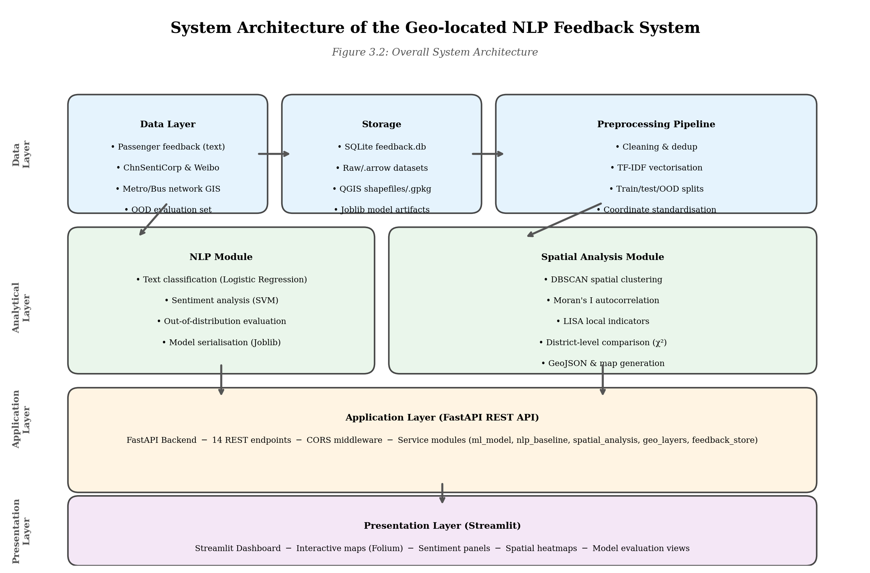
Figure 3.1. Overall architecture of the geo-located NLP feedback system.

The system uses a modular four-layer architecture: a data layer, an analytical layer, an application layer and a presentation layer. This separation allows textual data, geographic data, models, spatial services and user-interface functions to be developed and tested independently while remaining connected through consistent schemas.
At the foundation of the system is the data layer, which stores both textual and spatial datasets. The textual component consists of passenger feedback data and evaluation datasets used for model development and testing. These datasets are organised within dedicated data directories, including raw data and evaluation datasets. In addition, transport-related geographic information is managed through QGIS resources and associated transport network files. Together, these datasets provide the information required for both NLP analysis and spatial analysis.
The analytical layer contains the core processing functions of the system. This layer is divided into two major modules: the Natural Language Processing module and the spatial analysis module. The NLP module is responsible for transforming unstructured passenger comments into structured information through machine learning techniques. Dedicated training scripts are used for sentiment classification, issue categorisation, and model integration. The resulting models are stored within the backend model repository and can be accessed by other system components.
The spatial module manages geo-matching, representative-area comparison and available clustering or spatial-association functions. QGIS-prepared layers provide the geographic foundation, while backend services expose processed outputs to the dashboard. The broader route network supplies context and the selected stations, stops and matched feedback form the detailed analytical subset.
The application layer is implemented using a FastAPI-based backend service. This component acts as the communication bridge between analytical modules and the user interface. The backend is responsible for receiving user requests, executing analytical functions, managing data access, and returning results to the frontend application. The use of API-based communication improves modularity and enables different components of the system to operate independently.
The presentation layer is implemented through a Streamlit web application. This frontend environment provides interactive access to system functions and analytical results. Users can explore transport-related feedback through dashboards, statistical summaries, model evaluation interfaces, and interactive maps. By integrating visualisation and analytical outputs within a single platform, the system improves accessibility and usability for transport analysis.

3.3 Data Collection and Preparation Method

3.3.1 Data Sources
The proposed Geo-located NLP Feedback System integrates multiple data sources to support both textual analysis and spatial analysis. The datasets used in this project can be divided into three categories: passenger feedback data, sentiment training data, and geographic transport data.
Passenger feedback data serves as the primary source for Natural Language Processing analysis. These data were collected by crawling publicly accessible Chinese transport review platforms, including Dianping reviews, Baidu Tieba discussion threads, Weibo comments, Zhihu user posts, official passenger satisfaction survey reports from the Shanghai Municipal Transport Commission, news articles from Pengpai News and Guangming Daily, and related social-media posts about Shanghai metro and bus services. The resulting 409 comments describe travel experiences, service quality issues, and passenger perceptions of public transport services. The feedback data are used for category classification, sentiment analysis, and spatial feedback investigation.
To support sentiment classification, publicly available Chinese sentiment datasets were incorporated into the model training process. Two major sentiment resources were utilised: ChnSentiCorp and Weibo Sentiment datasets. ChnSentiCorp contains manually labelled positive and negative Chinese reviews and is widely used as a benchmark dataset for sentiment classification research. The Weibo Sentiment dataset provides additional examples of Chinese user-generated content and helps improve the diversity of language patterns observed during model training.
Spatial data include Shanghai metro lines, metro stations, bus routes, bus stops and administrative boundaries. These layers provide the broader network context. QGIS was then used to identify and prepare the detailed subset associated with Hongkou District, Huangpu District and Pudong New Area for representative station-, stop- and district-level analysis.
Finally, dedicated evaluation datasets were prepared to assess system performance. These datasets include manually curated out-of-distribution (OOD) test samples designed to evaluate model robustness under previously unseen language conditions. Together, these data sources provide the foundation for NLP processing, spatial analysis, and system evaluation.

3.3.2 Passenger Feedback Dataset
Passenger feedback data represent the primary analytical input of the proposed system. A total of 409 Chinese-language comments were collected by crawling publicly accessible transport review platforms, including Dianping, Baidu Tieba, Weibo, Zhihu, official passenger satisfaction survey reports from the Shanghai Municipal Transport Commission, and news articles from major Chinese media outlets related to Shanghai metro and bus services. The crawling process targeted threads mentioning specific station names, line numbers and bus routes within the three representative districts. Unlike traditional survey-based datasets, these user-generated comments reflect authentic travel experiences and spontaneous opinions, providing valuable information regarding transport service quality, passenger satisfaction, accessibility, overcrowding, delays, station facilities, and other operational issues.
Before analysis, textual feedback data were subjected to a preprocessing procedure designed to improve data quality and consistency. Text cleaning operations were performed to remove duplicate records, irrelevant content, formatting inconsistencies, and incomplete entries. Standardisation procedures were then applied to prepare textual information for machine learning analysis.
The cleaned feedback data subsequently served as input for both category classification and sentiment analysis models. Through these processes, originally unstructured comments were transformed into structured analytical information that could be integrated with geographic datasets.

3.3.3 Sentiment Training Dataset
The sentiment analysis component was trained using publicly available Chinese sentiment datasets. ChnSentiCorp was selected as the primary training dataset because of its balanced sentiment labels and widespread use within Chinese NLP research. To improve model generalisation, additional sentiment examples were incorporated through the Weibo Sentiment dataset.
The use of external sentiment datasets provides several advantages. First, these datasets contain manually labelled sentiment information, ensuring reliable training labels. Second, the datasets contain a large number of samples, allowing the model to learn diverse language patterns and sentiment expressions. Third, the combination of review-style and social-media-style text improves the model’s ability to analyse different forms of passenger-generated content.
Using publicly available sentiment resources also improves research reproducibility because other researchers can access the same datasets and replicate the training process.

3.3.4 Geographic Transport Dataset
The geographic component was constructed from Shanghai public transport and administrative datasets. Metro and bus route layers describe network context, while station points, bus-stop points and district polygons support geographic matching and comparison. Detailed empirical analysis uses the features associated with Hongkou, Huangpu and Pudong.
QGIS was used to import, organise and standardise the layers. Coordinate reference systems and attributes were checked, station and stop names were reviewed, and district boundaries were used to select the representative-area features. These procedures reduced incompatibilities before the data were passed to Python-based services and the web map.
The processed geographic data support route visualisation, station- and stop-level inspection, representative district comparison and the available spatial analytical functions. Route layers are retained mainly for network context; the detailed comparison focuses on stations, stops and matched feedback.

3.3.5 Data Preparation Workflow
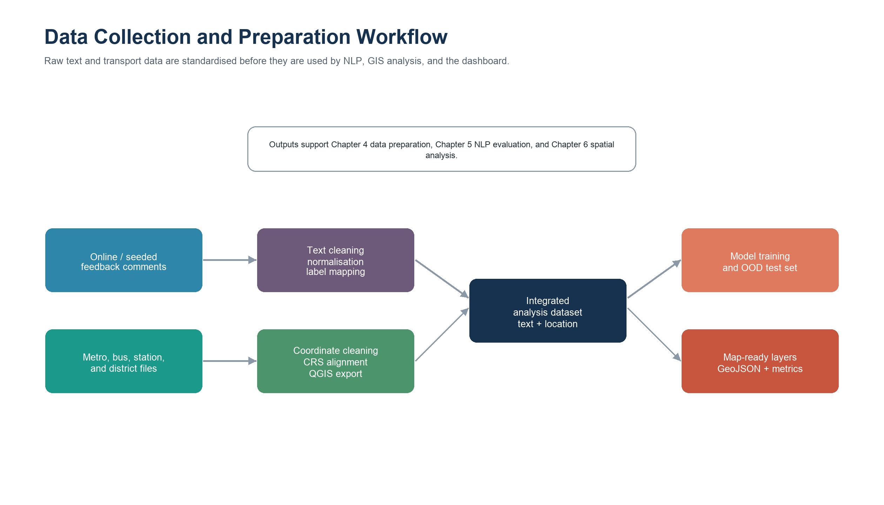
Figure 3.2. Data collection and preparation workflow for textual and geographic inputs.

Textual and spatial data were initially processed separately. Feedback records were cleaned and prepared for classification, while transport layers were checked in QGIS. District boundaries were used to select the Hongkou, Huangpu and Pudong subset, and consistent district identifiers were assigned to the retained stations and stops.
After NLP processing, location-related fields such as station names, stop names, route references and district names were used to connect feedback with geography. Records that could not be matched reliably were not treated as precise location evidence. The resulting dataset combines text, predicted issue, sentiment, coordinates and representative-area attributes.

3.4 NLP Processing Methodology

3.4.1 Overview of the NLP Pipeline
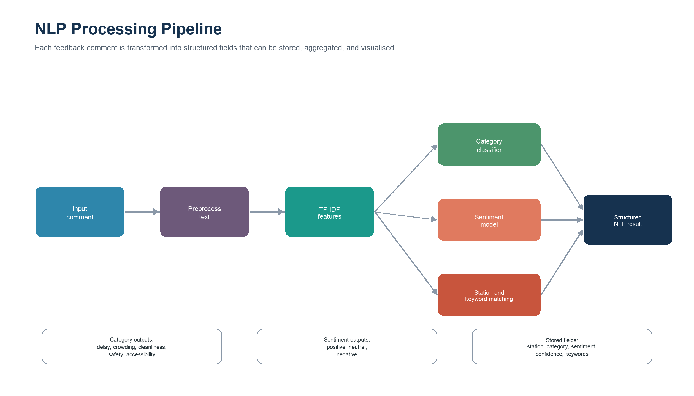
Figure 3.3. NLP processing pipeline from passenger comment to structured analytical output.

Natural Language Processing forms the core analytical component of the proposed system. The objective of the NLP module is to transform unstructured passenger feedback into structured information that can support transport analysis and spatial investigation. Because user-generated comments are typically written in natural language and contain varying expressions, direct quantitative analysis is difficult without prior processing.
The NLP workflow adopted in this project consists of four major stages: text preprocessing, feature extraction, text classification, and sentiment analysis. Together, these stages convert raw passenger comments into structured outputs describing both the category of transport-related issues and the sentiment expressed by passengers.
Initially, textual feedback is collected and prepared through a preprocessing stage. The cleaned text is then transformed into numerical representations through feature extraction techniques. These numerical features are subsequently used as inputs for machine learning models responsible for category classification and sentiment prediction. Finally, the resulting outputs are integrated with geographic information to support further spatial analysis.

3.4.2 Text Preprocessing
Text preprocessing was performed to improve data quality and prepare textual information for machine learning analysis. User-generated transport comments often contain inconsistencies, duplicated content, special characters, and formatting variations that may negatively affect model performance.
Several preprocessing operations were therefore applied. These include removing irrelevant symbols, standardising text formats, handling missing values, and eliminating duplicate records where necessary. The objective of these operations is to reduce noise and improve the consistency of textual inputs.
Because the project focuses on Chinese-language feedback data, preprocessing also ensures that textual content can be effectively represented within subsequent feature extraction procedures. After preprocessing, comments are converted into a consistent format suitable for machine learning analysis.

3.4.3 Feature Extraction Using TF-IDF
After preprocessing, textual information must be transformed into numerical representations before machine learning algorithms can be applied. This project uses Term Frequency–Inverse Document Frequency (TF-IDF) as the primary feature extraction technique.
TF-IDF evaluates the importance of terms based on their frequency within individual documents and their occurrence across the entire dataset. Words that appear frequently within a specific document but less frequently throughout the dataset receive higher importance scores. This allows the model to identify terms that are potentially informative for classification tasks.
The use of TF-IDF offers several advantages for transport feedback analysis. First, it is computationally efficient and suitable for relatively large collections of textual data. Second, it produces interpretable feature representations that can be linked to transport-related topics and passenger concerns. Third, TF-IDF remains an effective baseline approach for many practical text classification tasks.
The extracted TF-IDF features subsequently serve as inputs for category classification and sentiment classification models.

3.4.4 Text Classification
Text classification was implemented to automatically identify the primary transport-related issue discussed within each passenger comment. The objective of this component is to transform unstructured textual feedback into predefined issue categories that can be analysed quantitatively and spatially. By assigning comments to specific categories, the system enables large-scale transport feedback to be organised and interpreted more efficiently.
A supervised machine learning approach was adopted for category classification. Following feature extraction using TF-IDF, the resulting numerical representations were used as inputs for classification algorithms. The training process utilised labelled transport-related comments representing common public transport concerns, including delays, overcrowding, station facilities, accessibility, service quality, and operational management issues.
The classification model was trained using structured category labels and subsequently applied to previously unseen comments. During prediction, each feedback record was assigned a category label and a corresponding confidence score. This process transformed free-text comments into structured analytical outputs suitable for statistical and spatial analysis.
Compared with manual coding approaches, automated text classification offers several advantages. It reduces processing time, improves consistency across large datasets, and enables continuous analysis as new feedback becomes available. Most importantly, classification provides a structured representation of passenger concerns that can be linked directly with geographic transport information.
The outputs generated by the category classification module become important inputs for later stages of the project, including spatial clustering analysis, district-level comparisons, and dashboard visualisation.

3.4.5 Sentiment Analysis
While text classification identifies the topic of passenger feedback, sentiment analysis focuses on understanding passenger attitudes towards public transport services. The purpose of this component is to determine whether individual comments express positive, negative, or neutral opinions.
The sentiment analysis model was trained using publicly available Chinese sentiment datasets, including ChnSentiCorp and Weibo Sentiment data. These datasets provide manually labelled sentiment information and contain diverse examples of Chinese-language user-generated content. Using multiple training sources improves the model's ability to recognise different writing styles and linguistic expressions.
The sentiment classification process follows a workflow similar to category classification. Following text preprocessing and TF-IDF feature extraction, machine learning algorithms are applied to predict the sentiment polarity associated with each comment. The model subsequently generates sentiment labels and confidence scores for each prediction.
Sentiment analysis provides information that cannot be captured through category classification alone. For example, two passengers may discuss the same station facility, but one may express satisfaction while the other reports dissatisfaction. Sentiment analysis enables the system to distinguish between these situations and provide a more nuanced understanding of passenger experiences.
Furthermore, sentiment information plays a critical role in spatial analysis. By linking sentiment results with geographic locations, the system can identify areas associated with positive experiences, negative experiences, or mixed perceptions. This supports a more comprehensive assessment of public transport service quality across the transport network.

3.4.6 Model Integration
After completing category classification and sentiment analysis, both outputs are integrated into a unified feedback analysis framework. The integration process combines issue categories, sentiment labels, confidence scores, and geographic attributes into a structured dataset that can be used throughout the remainder of the project.
The integrated model architecture enables the system to process a single passenger comment and simultaneously identify the issue being discussed and the sentiment associated with that issue. This combined output provides a richer representation of passenger experiences than either classification task alone.
The integrated results are subsequently stored within the backend processing environment and become the primary input for spatial analysis modules, dashboard visualisation, and system evaluation

3.4.7 Evaluation Preparation
To ensure the reliability of the NLP component, dedicated evaluation datasets were prepared during system development. In addition to training data, an out-of-distribution (OOD) test dataset was constructed to assess model performance under previously unseen language conditions.
The OOD dataset contains newly written sentence structures, noisy samples containing spelling variations and informal expressions, and difficult neutral comments designed to challenge classification performance. This evaluation strategy allows model robustness to be assessed beyond conventional training and testing procedures.
The outputs generated during evaluation are used to compare different models, identify limitations, and support future improvements. Detailed evaluation results are presented in Chapter 5.

3.5 Spatial Analysis Methodology

3.5.1 Geographic Data Integration
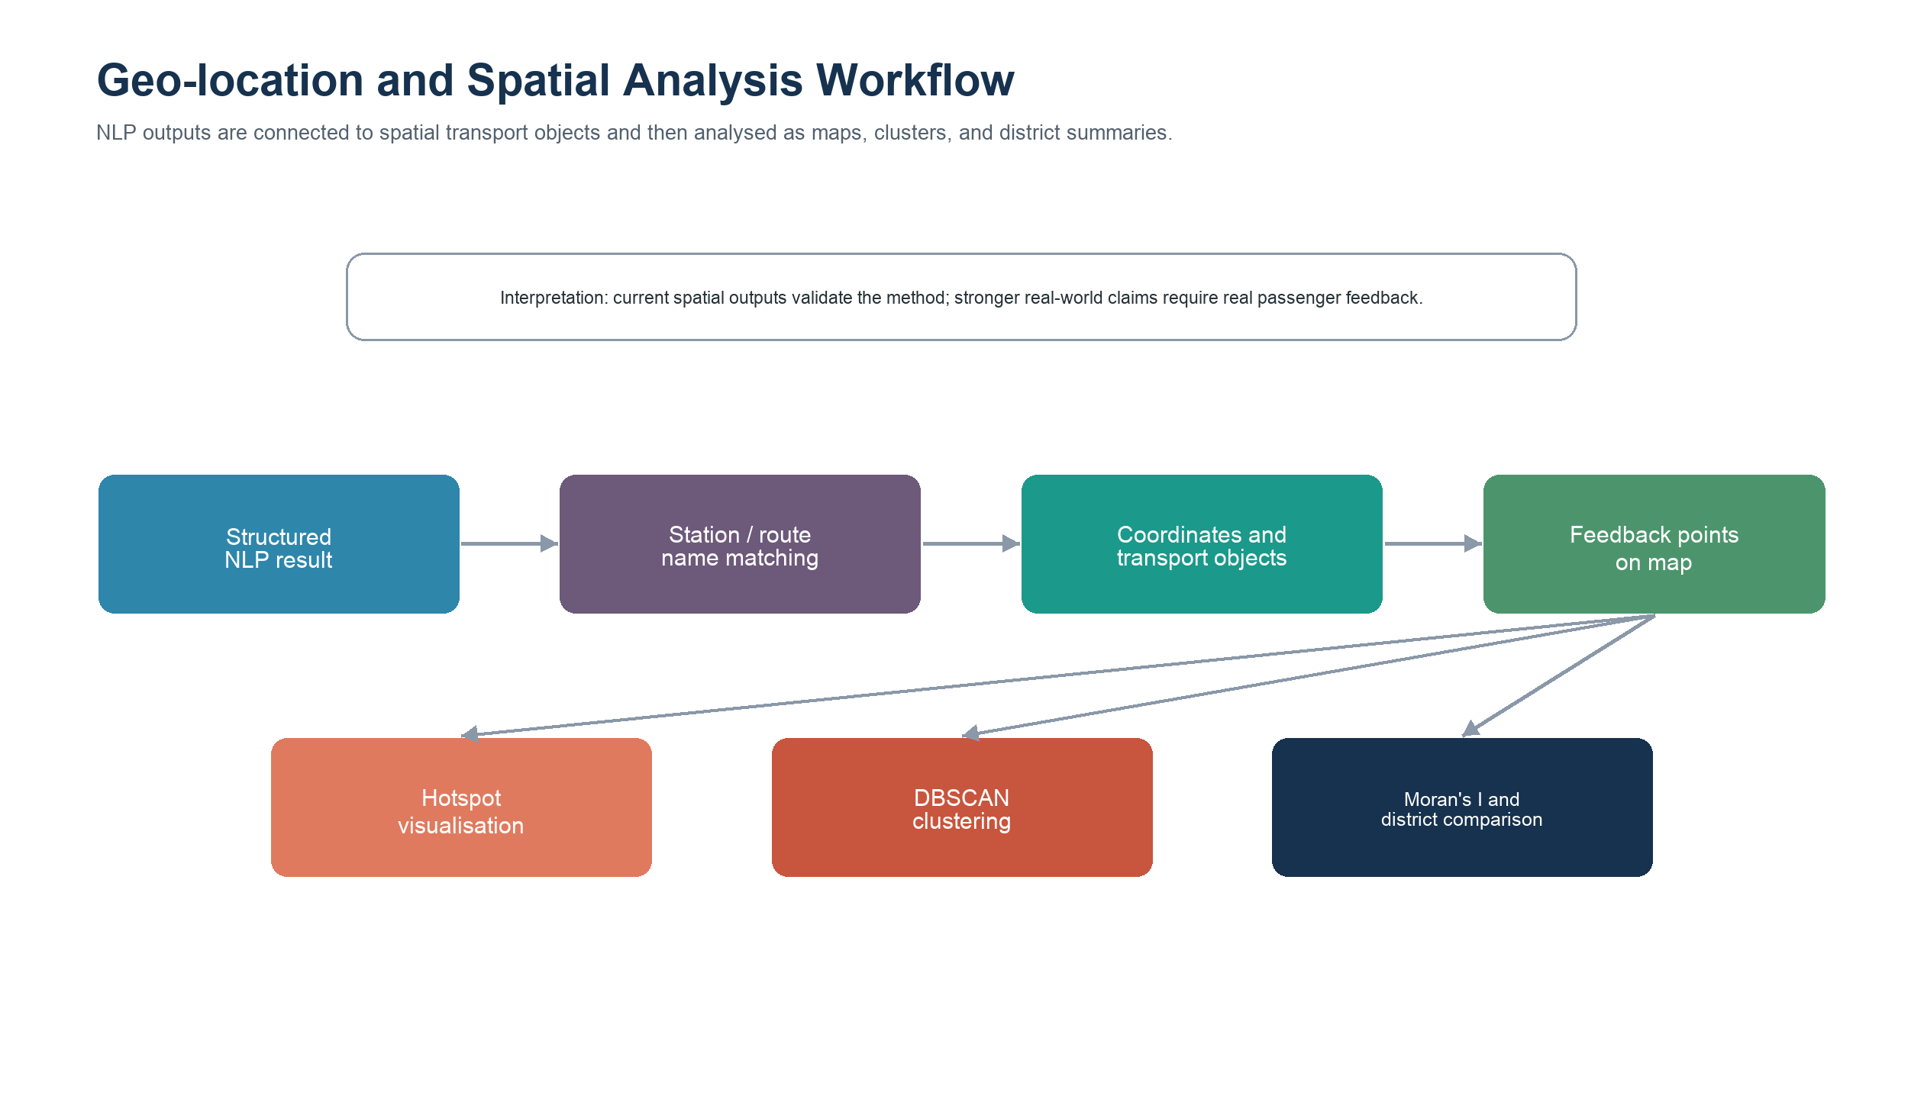
Figure 3.4. Geo-location and spatial analysis workflow connecting NLP outputs to maps and statistics.

Spatial analysis provides the geographic component of the system. NLP identifies the topic and sentiment of a comment, while geographic integration associates selected records with metro stations, bus stops, route context or district attributes. The wider Shanghai network is retained for orientation, but the detailed analytical demonstration focuses on Hongkou, Huangpu and Pudong.
Location identifiers were standardised before matching. Station and stop names were compared with the corresponding geographic attributes, and district membership was checked against the prepared administrative layers. This process produced a spatially enabled feedback dataset that could be filtered by transport mode, location, issue and sentiment.
The integration was designed conservatively because an incorrect location can create misleading spatial patterns. Where location evidence was incomplete, the record could still support general NLP analysis but was not used as precise station- or stop-level evidence.

3.5.2 Spatial Clustering Analysis
Spatial clustering analysis was employed to identify geographic concentrations of transport-related issues. Rather than examining individual feedback records independently, clustering analysis investigates whether similar feedback tends to occur in nearby locations. This allows the identification of potential transport hotspots and areas requiring further attention.
The project adopts Density-Based Spatial Clustering of Applications with Noise (DBSCAN) as the primary clustering technique. DBSCAN identifies clusters based on the density of neighbouring observations and separates isolated observations as noise. Unlike traditional clustering methods, DBSCAN does not require the number of clusters to be specified in advance and can detect clusters with irregular spatial shapes.
This characteristic makes DBSCAN particularly suitable for urban transport analysis because transport-related issues often emerge around specific stations, transfer hubs, or densely populated areas. Passenger complaints are rarely distributed evenly throughout a city and frequently form localised clusters. DBSCAN enables these patterns to be detected automatically.
Within the proposed system, clustering analysis is applied to geographically referenced feedback data. The resulting clusters indicate locations where transport-related concerns are concentrated and provide an additional layer of information beyond conventional text analysis.

3.5.3 Spatial Autocorrelation Analysis
In addition to clustering analysis, spatial autocorrelation analysis was employed to evaluate whether transport-related feedback exhibits statistically significant spatial patterns. While clustering methods identify concentrations of observations, spatial autocorrelation analysis examines whether similar values are geographically associated.
The project utilises Moran's I as a measure of global spatial autocorrelation. Moran's I evaluates whether locations with similar values tend to occur near each other or are distributed randomly across geographic space. Positive values indicate spatial clustering, whereas values close to zero suggest random spatial distributions.
To complement global spatial analysis, local spatial association analysis was also incorporated. Local indicators allow individual areas to be examined in greater detail and help identify local hotspots, cold spots, and spatial outliers. These techniques provide a more detailed understanding of geographic variation within passenger feedback data.
The combination of clustering analysis and spatial autocorrelation analysis provides a comprehensive assessment of spatial patterns and supports a deeper understanding of transport service performance across different locations.

3.5.4 District-level Comparative Analysis
District-level comparison was conducted for Hongkou District, Huangpu District and Pudong New Area. Feedback and transport-location attributes were aggregated by representative area to compare issue distributions, sentiment patterns and geographic coverage.
The comparison is descriptive rather than a complete ranking of Shanghai districts. The three areas differ in physical size, number of stations and stops, and volume of available feedback; therefore, proportions and contextual interpretation are more appropriate than relying only on raw totals.
This representative comparison demonstrates how the system can reveal variation across contrasting urban settings and provides a basis for future extension to additional Shanghai districts.

3.6 Web-based System Development Methodology

3.6.1 System Development Strategy
The final component of the proposed Geo-located NLP Feedback System is the development of a web-based analytical platform. The purpose of this platform is to provide an accessible environment through which users can explore transport-related feedback, spatial patterns, and analytical outputs generated by the NLP and GIS modules.
A web-based architecture was selected because it offers several advantages compared with traditional desktop applications. First, web applications improve accessibility by allowing users to access system functions through a standard web browser without requiring specialised software installation. Second, web platforms facilitate the integration of multiple analytical components within a unified environment. Third, web-based systems support interactive visualisation and real-time exploration of analytical results.
The development strategy adopted in this project emphasises modularity and scalability. Different system functions are organised into independent components that can be maintained and extended separately. This approach improves system flexibility and supports future enhancements without requiring major modifications to the overall architecture.
The web platform acts as the interface between analytical processes and end users. Rather than interacting directly with machine learning models or geographic datasets, users access system functions through an intuitive dashboard environment that presents information in a clear and understandable format.

3.6.2 Backend Architecture
The backend component of the system was implemented using FastAPI. FastAPI is a modern Python web framework that supports efficient API development and provides high performance for data-driven applications. The backend serves as the central processing layer responsible for coordinating communication between different system components.
Several core functions are managed within the backend environment. These include data access, machine learning model execution, spatial analysis operations, and result generation. Dedicated service modules are used to organise analytical functions, allowing NLP processing and spatial analysis procedures to be implemented independently while remaining accessible through a unified API structure.
The backend architecture also includes data schemas that standardise the format of information exchanged between different system components. This ensures consistency in data processing and reduces the possibility of communication errors between analytical modules and the user interface.
By separating analytical processing from visualisation functions, the backend architecture improves maintainability and enables future analytical methods to be incorporated without substantial modifications to the user interface.

3.6.3 Frontend Dashboard Design
The frontend component was developed using Streamlit, an open-source Python framework designed for rapid development of interactive analytical applications. Streamlit enables analytical results to be presented through a web-based dashboard while requiring relatively limited frontend development effort.
The dashboard was designed to support multiple forms of information presentation. Statistical indicators, model outputs, tables, charts, and spatial visualisations are integrated into a single user interface. This allows users to examine transport feedback from different analytical perspectives without switching between separate software environments.
Interactive functionality forms an important aspect of the dashboard design. Users can explore analytical results, adjust parameters, filter information, and investigate specific transport issues. This level of interaction improves the usability of the system and enables users to perform exploratory analysis based on their own interests.
The dashboard also serves as a communication tool between analytical outputs and decision-making processes. By transforming complex analytical results into intuitive visual representations, the system supports more effective interpretation and understanding of transport-related information.

3.6.4 Interactive Mapping and Visualisation
Spatial visualisation is a key feature of the proposed system. To support geographic exploration, interactive mapping technologies were incorporated into the dashboard environment. Geographic datasets, spatial analysis outputs, and transport feedback information are displayed through dynamic map interfaces.
Interactive maps provide several advantages over static visualisations. Users can zoom, pan, and explore different parts of the transport network while examining associated analytical results. This enables more detailed investigation of transport hotspots, service issues, and geographic patterns.
Map-based visualisation also improves the communication of spatial analysis findings. Complex geographic relationships can be understood more easily when represented visually, particularly when combined with clustering results, sentiment distributions, and administrative boundaries.
The integration of interactive mapping capabilities enhances the overall analytical value of the system and supports more effective interpretation of transport-related spatial information.

3.6.5 API Communication Workflow
Communication between frontend and backend components is achieved through an API-based architecture. When a user requests an analytical operation through the dashboard, the frontend sends a request to the backend API. The backend then processes the request, executes the required analytical functions, and returns the results to the frontend for visualisation.
This architecture provides a clear separation between user interaction and analytical processing. As a result, modifications to analytical methods can be implemented within the backend without affecting the user interface, while interface improvements can be performed independently of analytical algorithms.
The API-based design therefore improves maintainability, scalability, and overall system flexibility.

3.7 Evaluation Strategy

3.7.1 Evaluation Objectives
System evaluation was conducted to assess the effectiveness of the proposed Geo-located NLP Feedback System. Because the project integrates multiple analytical components, evaluation was designed to examine the performance of the Natural Language Processing module, the spatial analysis module, and the overall system architecture.
The primary objective of evaluation is to determine whether the system can accurately analyse passenger feedback, identify meaningful transport-related issues, and generate useful geographic insights. Evaluation also provides evidence regarding the reliability and practical applicability of the proposed analytical framework.
To achieve these objectives, a multi-level evaluation strategy was adopted. Separate evaluation procedures were implemented for machine learning performance, spatial analytical functionality, and system integration. This approach enables each component of the system to be assessed independently while also considering overall system performance.

3.7.2 NLP Model Evaluation
The Natural Language Processing component was evaluated using standard machine learning performance metrics. These metrics provide quantitative measures of classification effectiveness and enable comparisons between alternative modelling approaches.
Several evaluation indicators were considered, including accuracy, precision, recall, and F1-score. Accuracy measures the proportion of correctly classified observations, while precision and recall evaluate classification quality from different perspectives. The F1-score provides a balanced measure that combines precision and recall into a single indicator.
In addition to overall performance metrics, confusion matrices were used to examine classification behaviour in greater detail. Confusion matrices allow misclassification patterns to be identified and provide insights into which categories are more difficult for the model to distinguish.
To strengthen evaluation reliability, model performance was compared across multiple classification approaches. Baseline methods and machine learning models were evaluated using identical datasets and evaluation procedures. This comparison enables the relative strengths and weaknesses of different approaches to be assessed systematically.

3.7.3 Out-of-Distribution Evaluation
Traditional train-test evaluation procedures may not fully reflect real-world system performance because user-generated comments often contain language patterns that differ from training data. To address this challenge, an out-of-distribution (OOD) evaluation strategy was incorporated into the project.
The OOD evaluation dataset contains previously unseen sentence structures, noisy samples, spelling variations, informal expressions, and difficult neutral comments. These examples are designed to simulate realistic transport feedback conditions that may not be represented adequately within conventional training datasets.
The purpose of OOD evaluation is to assess model robustness and generalisation capability. A model that performs well on both standard evaluation datasets and OOD samples is more likely to remain reliable when deployed in practical applications.
By incorporating OOD evaluation, the project extends beyond conventional machine learning assessment and provides a more realistic examination of system performance under operational conditions.

3.7.4 Spatial Analysis Evaluation
Spatial evaluation examined whether the system could connect feedback with valid transport locations, produce interpretable maps and support consistent comparison across Hongkou, Huangpu and Pudong. Because spatial outputs depend on the available comments and location coverage, evaluation emphasised traceability and interpretability rather than prediction accuracy alone.
Clustering outputs were reviewed to determine whether identified concentrations corresponded to plausible groups of nearby observations rather than artefacts of coordinate systems or duplicated records. Parameter choices and data density were considered when interpreting clusters and noise.
Spatial-association outputs were treated as supporting evidence and interpreted in relation to the spatial-weight definition and sample coverage. District-level summaries provided an additional check on whether aggregated outputs were consistent with the underlying station and stop records.
All geographic conclusions are limited to the representative analytical subset. The evaluation demonstrates system feasibility within Hongkou, Huangpu and Pudong and does not claim complete empirical coverage of every Shanghai district.

3.7.5 System-Level Evaluation
In addition to evaluating individual analytical components, the project also considers overall system performance. System-level evaluation focuses on the successful integration of NLP analysis, spatial analysis, and web-based visualisation within a unified analytical environment.
Several aspects were considered during system evaluation, including functionality, interoperability, usability, and analytical completeness. Functionality refers to whether system components operate as intended. Interoperability concerns the ability of different modules to exchange information successfully. Usability evaluates whether analytical outputs can be accessed and interpreted effectively through the dashboard interface.
The overall objective of system-level evaluation is to determine whether the proposed framework successfully transforms unstructured transport feedback into actionable geographic information. The findings generated through this evaluation provide evidence regarding the practical value of the proposed system.

3.8 Chapter Summary
This chapter described the design-oriented method, modular architecture, data preparation, NLP and spatial procedures, web development and evaluation strategy. It also clarified the distinction between the broader Shanghai system context and the detailed representative analysis of Hongkou, Huangpu and Pudong. Chapter 4 now describes the datasets and preparation decisions in greater detail.

4 Data Collection and Preparation

4.1 Chapter Overview
This chapter describes the textual, geographic and evaluation datasets used by the Geo-located NLP Feedback System and explains how they were prepared for analysis. The project requires both feedback data and transport geography, together with labelled sentiment resources and a dedicated robustness dataset.
Preparation was necessary because the sources differ in structure, naming conventions, coordinate systems and data quality. Cleaning and standardisation were therefore treated as part of the analytical method rather than as a minor preliminary task.
Four data groups were used: Shanghai public transport network data, passenger feedback, Chinese sentiment-training datasets and an out-of-distribution evaluation set. Within the transport data, Hongkou, Huangpu and Pudong form the representative analytical subset.

4.2 Public Transport Network Data
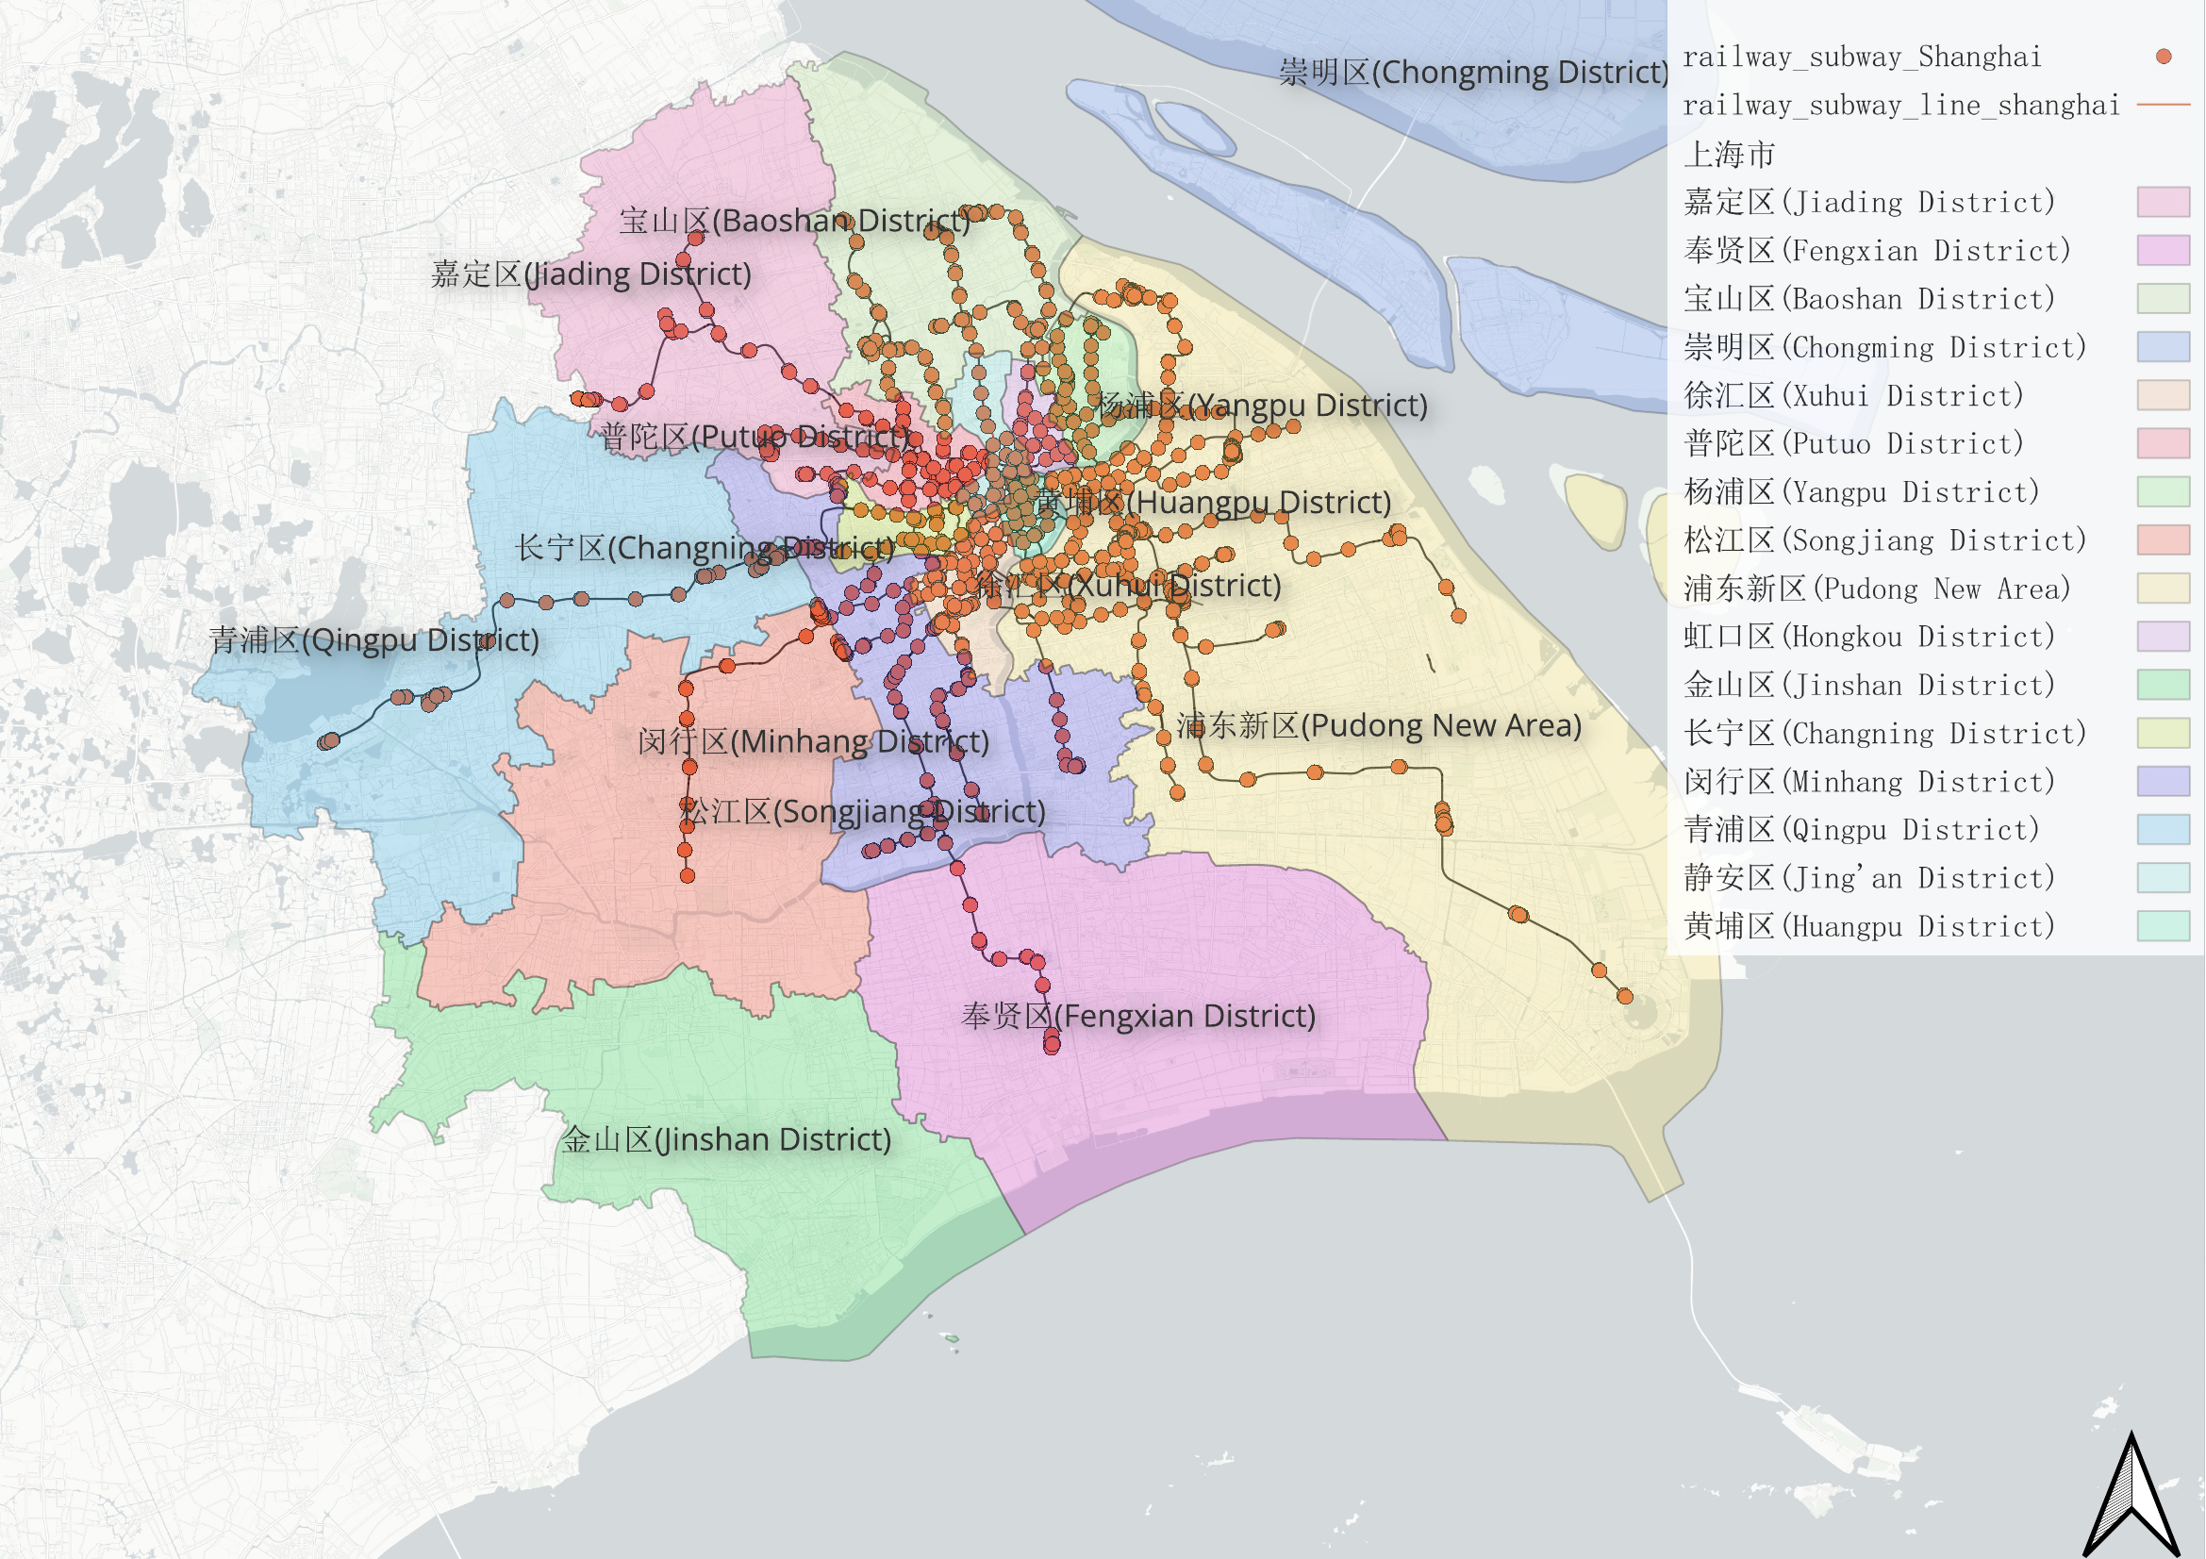
Figure 4.1. Shanghai subway network and district boundary context prepared in QGIS.

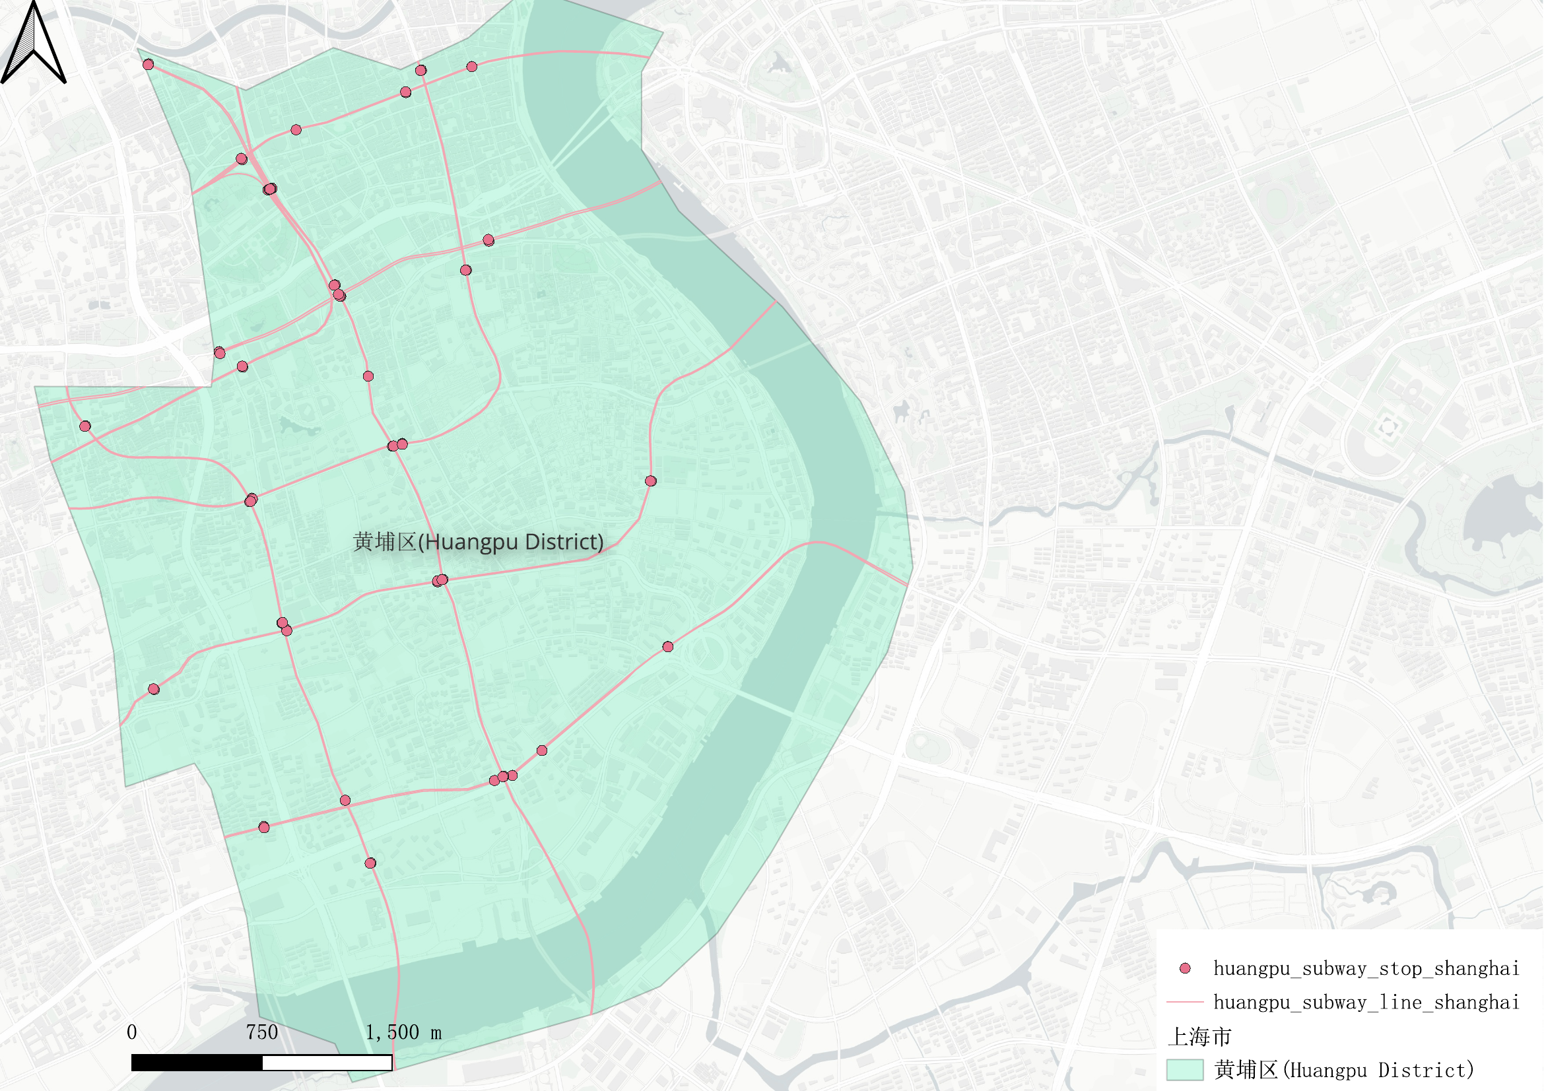
Figure 4.2. Huangpu District subway lines and stops prepared for representative spatial analysis.

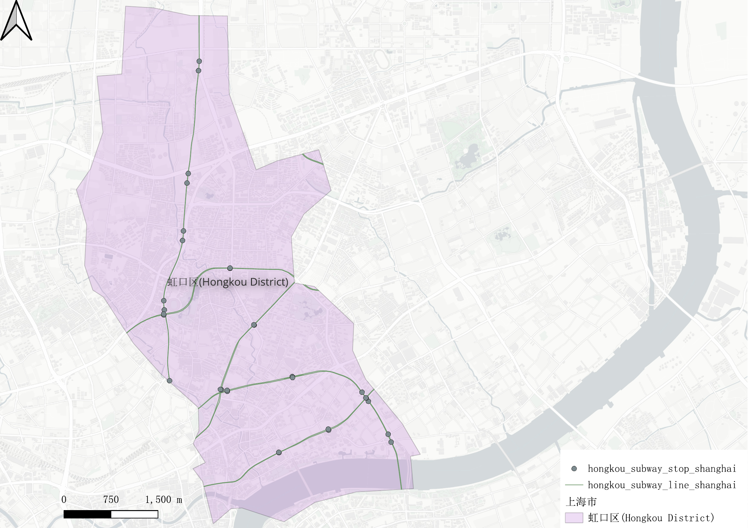
Figure 4.3. Hongkou District subway lines and stops prepared for representative spatial analysis.

Public transport network data provide the geographic foundation of the project. The broader dataset includes Shanghai metro routes, metro stations, bus routes, bus stops and administrative boundaries, allowing the dashboard to present the system within its city context.
For detailed analysis, QGIS was used to select and organise transport features associated with Hongkou District, Huangpu District and Pudong New Area. The areas were chosen as representative examples rather than as the only intended scope of the system.
Metro stations and bus stops are point features, route layers are line features and district boundaries are polygons. Route layers support network context and navigation, whereas station, stop and matched-feedback records are the main units used in the representative comparison.
The combination of layers supports inspection at several levels: individual locations, local groups of observations and aggregated study areas. However, differences in area size and data volume mean that raw counts must be interpreted cautiously.

4.3 Passenger Feedback Dataset
Passenger feedback is the central textual resource of the system. The comments describe public transport experiences and include concerns such as delays, crowding, accessibility, station facilities, reliability and operational service. They provide a user-centred perspective that complements formal performance indicators.
The crawled feedback was converted into a structured dataset containing comment text, source platform, crawl timestamp and available metadata such as user ratings and station or line references. The same records could then be used for issue classification, sentiment prediction and, where a location could be matched reliably, representative spatial analysis.
One of the major advantages of passenger-generated feedback is its ability to capture experiences close to real travel situations. Unlike structured questionnaires that limit responses to predefined questions, user-generated comments allow passengers to discuss issues that they consider important. Consequently, feedback data often reveal concerns that may not be identified through traditional performance monitoring systems.
Feedback data also introduce limitations. Informal language, spelling variation, emojis, mixed sentiment and incomplete location references complicate automated processing. Online contributors are self-selected, so the dataset should not be treated as a statistically complete representation of all passengers.
For the spatial component, only records linked to an appropriate station, stop or representative-area reference were treated as geo-located evidence. Broader labelled datasets could still support model training and general NLP evaluation without being interpreted as observations from the three selected areas.
This distinction separates model development from geographic case analysis: NLP resources provide linguistic coverage, while the Hongkou, Huangpu and Pudong subset demonstrates the location-based functions of the system.
The use of passenger-generated feedback aligns closely with the objectives of smart-city development and data-driven transport management. By analysing large volumes of user-generated content, transport operators and urban planners can gain a deeper understanding of passenger needs and identify opportunities for service improvement.
Table 4.1. Characteristics of Passenger Feedback Data
Characteristic | Description
Data Type | Crawled user-generated textual feedback (409 records)
Language | Chinese
Structure | Unstructured
Main Topics | Delays, Crowding, Accessibility, Facilities
Processing Method | NLP-based analysis
Output | Category + Sentiment

4.4 Sentiment Training Datasets
Sentiment analysis requires a large volume of labelled data to enable machine learning models to learn meaningful linguistic patterns. Because manually labelling transport-related feedback is both time-consuming and resource-intensive, this project utilised publicly available Chinese sentiment datasets to support model training.
Two sentiment datasets were incorporated into the project: ChnSentiCorp and Weibo Sentiment. These datasets provide manually annotated sentiment labels and have been widely used within Chinese Natural Language Processing research. The use of established benchmark datasets improves both model reliability and research reproducibility.
ChnSentiCorp was adopted as the primary sentiment training dataset. The dataset contains thousands of Chinese-language reviews that have been manually classified as either positive or negative. The balanced distribution of sentiment labels makes the dataset particularly suitable for supervised sentiment classification tasks. Furthermore, ChnSentiCorp has been extensively used in Chinese NLP studies, making it a recognised benchmark for evaluating sentiment analysis approaches.
To complement ChnSentiCorp, the project also incorporated the Weibo Sentiment dataset. Unlike review-based datasets, Weibo Sentiment contains short-form social media content that reflects informal language usage commonly observed in user-generated text. The inclusion of social media data exposes the model to a wider range of linguistic expressions, abbreviations, colloquial phrases, and writing styles.
The combination of these two datasets provides several benefits. First, it increases the overall volume of training data available to the sentiment classification model. Second, it improves linguistic diversity and enables the model to learn more varied language patterns. Third, it enhances model robustness by exposing the training process to both review-style and social-media-style text.
Before training, the two sentiment resources were cleaned, reformatted and checked for label consistency. Their combination increases linguistic variety by exposing the model to both review-style and social-media-style expressions, although the difference between their domains remains a potential source of error.
The use of publicly available sentiment datasets not only improves model performance but also enhances the transparency and reproducibility of the research process. Future researchers can access the same datasets and replicate the sentiment training procedures implemented in this project.
Table 4.2. Sentiment Training Datasets
Dataset | Source | Language | Purpose
ChnSentiCorp | Public NLP Dataset | Chinese | Primary sentiment training
Weibo Sentiment | Public Social Media Dataset | Chinese | Improve linguistic diversity

4.5 Out-of-Distribution Evaluation Dataset
In addition to conventional training and testing datasets, this project incorporates an Out-of-Distribution (OOD) evaluation dataset to assess model robustness under realistic operating conditions. While standard machine learning evaluation procedures typically measure performance using data drawn from distributions similar to the training set, real-world user-generated content often contains language patterns that differ substantially from training data. Consequently, relying solely on traditional train-test evaluation may overestimate actual system performance.
The purpose of the OOD dataset is to simulate the linguistic variability encountered in practical transport feedback scenarios. Public transport users frequently employ informal language, abbreviations, spelling variations, colloquial expressions, emojis, and unconventional sentence structures when describing their travel experiences. Such linguistic characteristics can create challenges for machine learning models that have primarily been trained on cleaner and more structured datasets.
To address this issue, a dedicated OOD evaluation dataset was developed and incorporated into the project. The dataset contains a total of 120 manually curated samples designed to represent a range of previously unseen language patterns. Rather than duplicating examples from the training datasets, the OOD dataset introduces new expressions and linguistic variations that more closely resemble real-world feedback.
The dataset was organised into three categories. The first category consists of sixty comments containing alternative sentence structures and expressions that differ from those commonly observed in training data. These samples assess the ability of the model to generalise beyond memorised patterns and recognise transport-related issues expressed in unfamiliar ways.
The second category contains thirty noisy samples. These records include spelling mistakes, abbreviated words, emojis, informal internet language, and other forms of linguistic noise frequently encountered in user-generated content. Evaluating performance on noisy data helps determine whether the model remains reliable when processing imperfect textual inputs.
The third category contains thirty difficult neutral samples. These comments were intentionally designed to contain ambiguous sentiment cues and balanced expressions that make classification more challenging. Such samples are particularly useful for assessing whether the sentiment analysis component can distinguish neutral opinions from genuinely positive or negative feedback.
The inclusion of the OOD dataset provides a more rigorous evaluation framework than conventional train-test procedures alone. By assessing performance under previously unseen linguistic conditions, the project can better evaluate model generalisation, robustness, and practical applicability. The results obtained from the OOD evaluation are used later in the project to compare model behaviour and identify potential limitations that may require further improvement.
Table 4.3. Composition of the OOD Evaluation Dataset
Category | Number of Samples | Purpose
New Sentence Structures | 60 | Evaluate generalisation ability
Noisy Samples | 30 | Evaluate robustness to text noise
Difficult Neutral Samples | 30 | Evaluate sentiment discrimination
Total | 120 | OOD evaluation

4.6 Data Cleaning and Preparation
Both textual and geographic datasets required systematic cleaning before integration. Text processing addressed duplicates, missing content, inconsistent formatting and non-standard expressions. Geographic processing addressed coordinate-system compatibility, layer organisation, attribute naming and location identifiers.
Duplicate or incomplete feedback records were removed where appropriate. Text was standardised for feature extraction, and sentiment labels from different training sources were mapped to a consistent scheme. These decisions reduced noise and prevented repeated records from affecting model evaluation.
Geographic layers were checked in QGIS and organised within a consistent project structure. District boundaries were used to identify the Hongkou, Huangpu and Pudong analytical subset, and station and stop attributes were reviewed to support name-based matching.
The cleaned NLP outputs and geographic records were joined through available location references. Uncertain matches were handled cautiously because forcing a record to an incorrect station or stop would undermine the spatial analysis.
The resulting integrated dataset contains the fields required by the backend and dashboard, including text, predicted category, sentiment, confidence information where available, transport-mode attributes, location identifiers and representative-area labels.
Spatial datasets also required preprocessing before integration into the analytical framework. Geographic data were obtained from different sources and therefore required coordinate system verification, attribute standardisation, and layer organisation. QGIS was used to perform these preprocessing tasks and ensure spatial consistency throughout the project.
Transport-related geographic layers, including metro stations, transport routes, bus stops, and district boundaries, were organised into a unified geographic database. Spatial attributes were reviewed to ensure compatibility with subsequent analysis procedures. This process allowed textual feedback information to be linked effectively with geographic transport infrastructure.
Finally, cleaned textual datasets and processed geographic datasets were integrated through location-related attributes. This integration stage established the foundation for combining Natural Language Processing outputs with Geographic Information System analysis. As a result, passenger feedback could subsequently be examined from both textual and spatial perspectives.
The overall data preparation process improved data quality, reduced analytical uncertainty, and established a consistent foundation for machine learning analysis, spatial analysis, and dashboard visualisation.

4.7 Chapter Summary
This chapter introduced the Shanghai transport layers, passenger feedback, sentiment-training resources and OOD dataset. It also explained how the broader transport context was reduced to a representative analytical subset for Hongkou, Huangpu and Pudong.
Cleaning and standardisation produced compatible textual and geographic inputs for classification, geo-matching, spatial analysis and dashboard presentation. The next chapter describes the NLP models that transform the feedback into issue and sentiment attributes.

5 Natural Language Processing

5.1 Chapter Overview
This chapter presents the NLP component that transforms unstructured passenger comments into issue categories and sentiment labels. The models operate on broader textual resources, while location-specific outputs are used later for the representative analysis of Hongkou, Huangpu and Pudong.
The chapter first introduces the category classification model used to identify transport-related issues discussed by passengers. It then describes the sentiment analysis model developed to evaluate passenger attitudes towards public transport services. Following the presentation of individual models, the chapter explains how these components were integrated into a unified analytical framework.
Evaluation combines standard classification metrics with out-of-distribution testing. The purpose is to assess not only performance on familiar data but also sensitivity to noisy, informal and previously unseen language.
The findings presented in this chapter provide the foundation for the spatial analysis conducted in Chapter 6 and demonstrate the effectiveness of the proposed NLP framework in processing public transport feedback data.

5.2 Category Classification Model
Category classification represents the first major analytical task within the NLP framework. The objective of this model is to automatically identify the primary transport-related issue discussed within each passenger comment. By transforming free-text feedback into predefined categories, the system enables large volumes of passenger feedback to be analysed systematically.
The category classification model was developed using a supervised machine learning approach. Prior to model training, textual comments were converted into numerical representations through TF-IDF feature extraction. These feature vectors capture the relative importance of terms within the dataset and provide the input required for machine learning algorithms.
The labelled issue data represent common public transport concerns, including delays, crowding, accessibility, station facilities, service quality and operational management. The categories provide an interpretable structure for dashboard summaries and spatial filtering.
To improve reliability, measures were implemented to reduce the risk of data leakage during training and testing. Training and evaluation data were separated appropriately to ensure that performance results reflected genuine predictive capability rather than memorisation of training examples. This consideration was particularly important because transport feedback often contains recurring station names and repeated topic patterns.
The outputs generated by the classification model include predicted issue categories and associated confidence scores. These outputs provide structured information that can be aggregated statistically, visualised geographically, and incorporated into subsequent spatial analysis procedures.

5.3 Sentiment Analysis Model
Sentiment analysis represents the second major task within the NLP framework. While category classification identifies the topic discussed by passengers, sentiment analysis focuses on determining the emotional attitude expressed towards public transport services. The objective is to classify passenger comments into positive, negative, or neutral sentiment categories.
To support sentiment classification, the project utilised publicly available Chinese sentiment datasets, including ChnSentiCorp and Weibo Sentiment. These datasets provide manually labelled sentiment information and contain a diverse range of linguistic expressions. By training on both review-based and social-media-based datasets, the model was exposed to a wider variety of writing styles and emotional expressions.
The sentiment analysis workflow follows a similar process to category classification. Passenger comments are first preprocessed and converted into numerical representations using TF-IDF feature extraction. Machine learning algorithms are then applied to predict sentiment polarity based on these feature vectors.
Sentiment analysis provides an additional layer of information beyond issue categorisation. Two comments discussing the same transport issue may reflect entirely different passenger experiences. By identifying sentiment polarity, the system can distinguish between positive service experiences and negative service experiences associated with similar transport topics.
The sentiment analysis outputs include sentiment labels and associated confidence scores. These outputs are subsequently combined with category classification results and integrated into the broader analytical framework.

5.4 Integrated NLP Model
To provide a comprehensive understanding of passenger feedback, category classification and sentiment analysis were integrated into a unified NLP framework. Rather than treating the two tasks independently, the integrated architecture allows a single passenger comment to be analysed simultaneously from both topical and emotional perspectives.
The integrated model processes each comment through a shared workflow consisting of preprocessing, feature extraction, classification, and result generation. Category prediction identifies the transport-related issue being discussed, while sentiment prediction evaluates the passenger's attitude towards that issue.
This integrated approach improves the analytical value of transport feedback data. Decision-makers can not only identify which issues are frequently discussed but also determine whether these issues are associated with positive or negative passenger experiences. Such information is particularly useful when prioritising transport improvement initiatives.
Integrated outputs are stored in a consistent structure and passed to the backend, spatial services and dashboard. Only records with reliable geographic references are used for detailed station-, stop- or representative-area interpretation.

5.5 Model Evaluation Framework
To evaluate the effectiveness of the NLP framework, a comprehensive evaluation strategy was implemented. The evaluation process was designed to assess classification performance, model robustness, and generalisation capability.
Standard machine learning evaluation metrics were adopted, including accuracy, precision, recall, and F1-score. These indicators provide complementary perspectives regarding model performance and allow comparisons between alternative modelling approaches.
Confusion matrices were also used to investigate classification behaviour in greater detail. Unlike summary metrics, confusion matrices reveal specific categories where misclassification occurs and provide additional insight into model strengths and weaknesses.
In addition to conventional evaluation procedures, Out-of-Distribution (OOD) testing was conducted to assess robustness under previously unseen language conditions. The inclusion of OOD evaluation enables a more realistic assessment of model performance and helps identify potential limitations that may not be apparent from standard test datasets alone.

5.6 Experimental Results
The model comparison provides concrete evidence of the baseline performance achieved by the implemented NLP pipeline. On the out-of-distribution evaluation setting, the rule baseline and TF-IDF + Logistic Regression model produced the same category result, with category accuracy of 0.5833 and category macro-F1 of 0.5883. TF-IDF + SVM performed slightly better, with category accuracy of 0.5917 and category macro-F1 of 0.5929.
For sentiment classification, the rule baseline and TF-IDF + Logistic Regression both achieved OOD sentiment accuracy of 0.5417 and macro-F1 of 0.4410. TF-IDF + SVM again produced the strongest result, with OOD sentiment accuracy of 0.5500 and macro-F1 of 0.4513. In contrast, the in-domain sentiment training score was much higher, reaching 0.9342 accuracy and 0.9342 macro-F1 for TF-IDF + SVM. This gap shows that the model can learn controlled training patterns, but generalisation to unfamiliar transport comments remains limited.
These results support the use of the current NLP model as an interpretable research baseline rather than as a production-ready classifier. Its value in this project is that it produces stable structured outputs that can be passed into the GIS and dashboard components, while the modest OOD scores identify a clear direction for future model improvement.
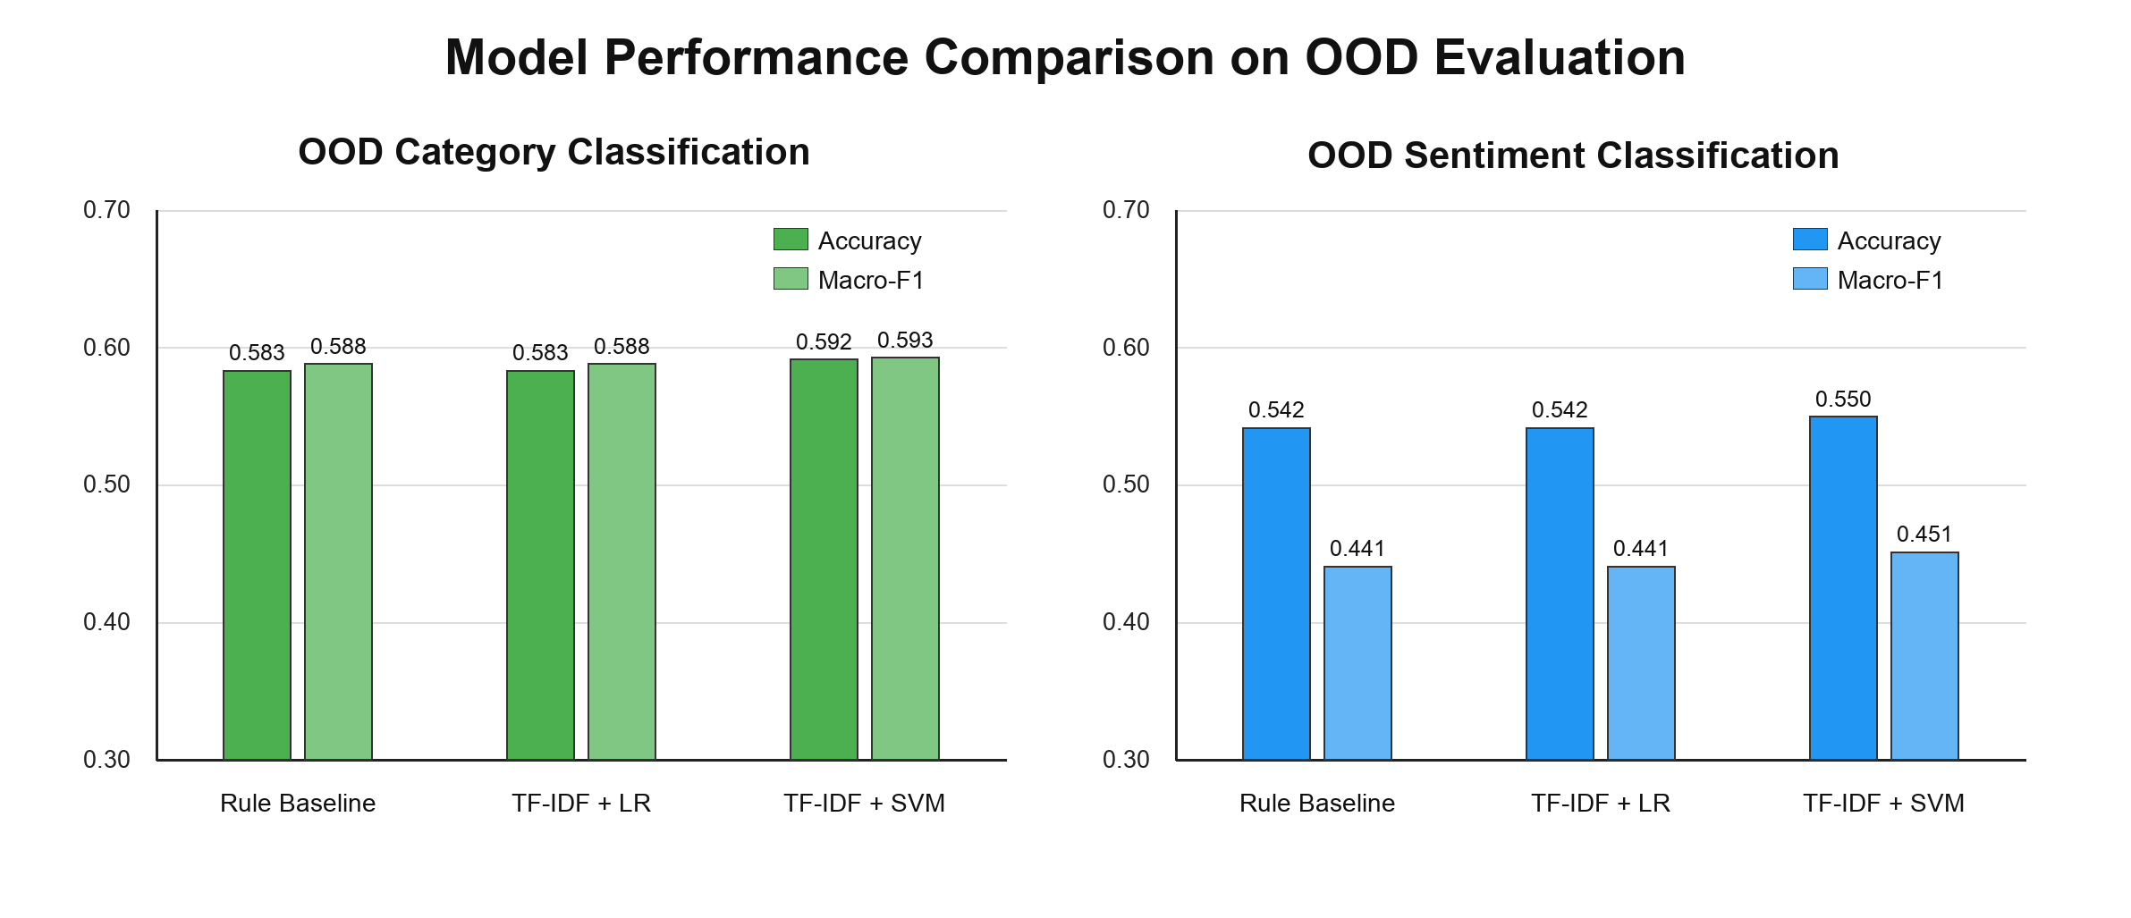
Figure 5.1. Model performance comparison on the out-of-distribution evaluation set.

Experiments compared baseline and supervised machine-learning approaches under consistent preprocessing and evaluation procedures. The machine-learning pipeline generally provided more flexible classification than simple rule-based matching, particularly when comments used varied expressions.
The evaluation module reports accuracy, precision, recall, F1-score and confusion matrices for the implemented models. These outputs are available through the project system and allow model strengths and recurring confusions to be inspected. The report avoids treating a single summary score as sufficient evidence of practical reliability.
The results support the use of TF-IDF-based models as an interpretable proof-of-concept approach. They also show that classification performance must be considered alongside data quality, class balance and the difference between training language and real passenger comments.
The structured predictions are therefore suitable for exploratory aggregation, representative spatial analysis and dashboard demonstration, while individual classifications should not be interpreted as infallible judgements.

5.7 Out-of-Distribution Evaluation
The OOD evaluation was especially important because it tested the model under language conditions that were less similar to the training data. The dedicated OOD set contained noisy, varied and difficult examples designed to represent more realistic passenger feedback. Under this setting, the best category macro-F1 was 0.5929 and the best sentiment macro-F1 was 0.4513, both achieved by the TF-IDF + SVM configuration.
The category task remained more stable than sentiment classification. This is reasonable because issue labels such as delay, crowding, cleanliness or accessibility often contain recognisable keywords. Sentiment prediction was more difficult because neutral and mixed comments can include weak or ambiguous emotional cues, and some negative transport experiences are expressed indirectly.
The OOD results therefore prevent the report from overstating model performance. They show that the implemented pipeline is reliable enough for exploratory aggregation and system demonstration, but not accurate enough to support operational decisions without further labelled transport feedback, stronger semantic models and more extensive validation.
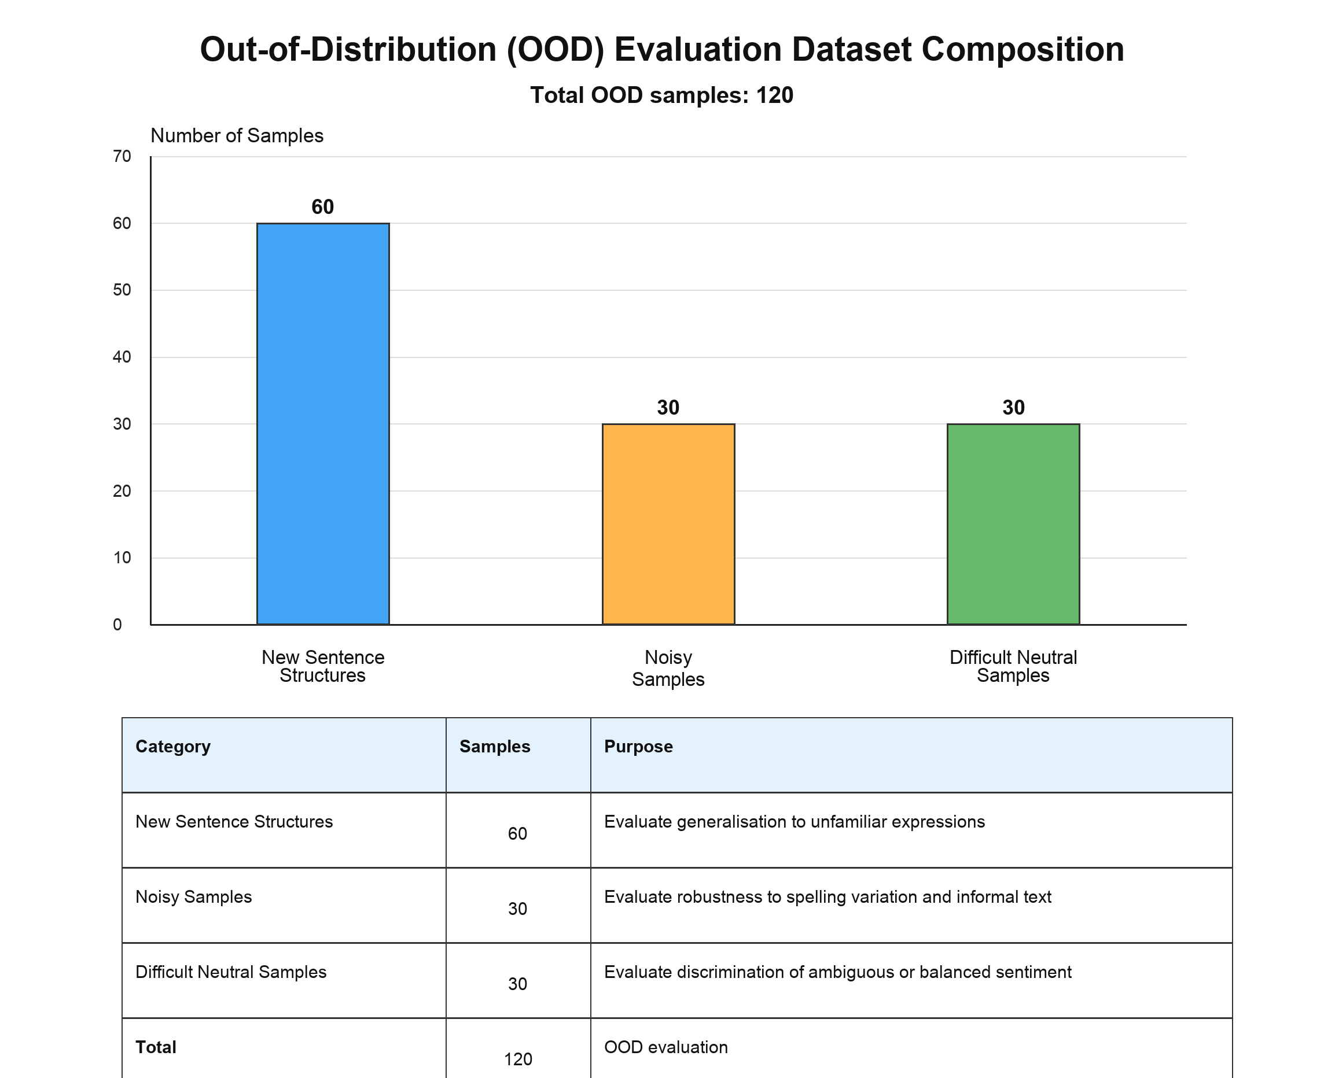
Figure 5.2. Composition of the out-of-distribution evaluation dataset used for robustness testing.

Out-of-Distribution (OOD) evaluation was conducted to assess the robustness of the proposed NLP framework under previously unseen language conditions. While conventional test datasets provide useful information regarding model performance, they often contain data that share similar characteristics with the training set. Consequently, strong performance on standard test data does not necessarily guarantee reliable behaviour in real-world applications.
To address this limitation, the project introduced a dedicated OOD evaluation dataset consisting of new sentence structures, noisy text samples, and difficult neutral comments. These records were specifically designed to simulate realistic passenger feedback that may differ from the language patterns observed during model training.
The OOD evaluation produced several important findings. First, model performance generally declined compared with standard testing conditions, indicating that language variation remains a significant challenge for machine learning-based text analysis. Second, the evaluation revealed differences in robustness between alternative modelling approaches. Some models were more resilient to spelling variations, informal language, and previously unseen sentence structures than others.
The OOD results demonstrate the importance of evaluating models beyond conventional train-test procedures. A model that performs well on standard datasets may still encounter difficulties when processing real-world passenger feedback. Therefore, OOD testing provides a more realistic assessment of system reliability and practical applicability.
Although performance declined under more difficult OOD conditions, the evaluation showed that the pipeline could continue producing useful exploratory outputs. The decline is important evidence of the limitations of keyword-weighted representations and supports the need for cautious interpretation.

5.8 Discussion of NLP Findings
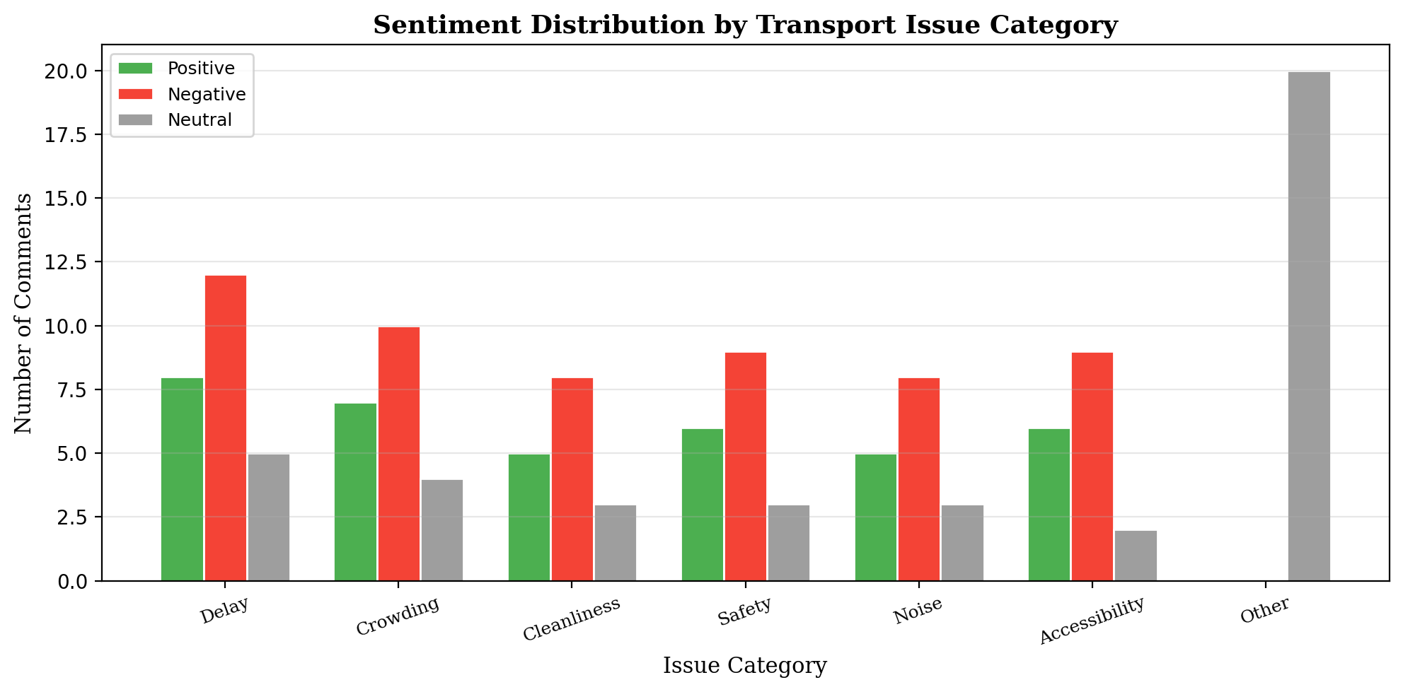
Figure 5.3. Sentiment distribution by transport issue category in the collected feedback dataset.

The experimental results provide several insights regarding the use of Natural Language Processing for public transport feedback analysis. First, the findings demonstrate that machine learning methods can effectively transform unstructured passenger comments into structured analytical information. This significantly reduces the effort required to analyse large volumes of feedback and enables more systematic investigation of passenger experiences.
Second, the comparison between different modelling approaches highlights the importance of feature representation and model selection. Although traditional rule-based methods remain useful for simple pattern matching tasks, machine learning approaches generally provide greater flexibility when dealing with diverse language expressions and previously unseen comments.
Third, the OOD evaluation illustrates that language variability remains a major challenge in transport-related text analysis. Passenger comments often contain informal language, abbreviations, spelling errors, and context-dependent expressions that are difficult for machine learning models to interpret consistently. TF-IDF with SVM was deliberately chosen over transformer-based models such as BERT or large language models for three reasons: (1) interpretability, since TF-IDF feature weights can be directly inspected to verify that classification decisions align with transport-domain vocabulary rather than operating as a black box; (2) reproducibility with limited computational resources, as the project environment did not include GPU infrastructure required for fine-tuning large pre-trained models on Chinese-language data; and (3) suitability as an evaluated baseline, since demonstrating measurable performance on both in-domain and OOD data provides a concrete reference point against which future transformer-based improvements can be compared. The OOD results confirm that a semantic gap exists between keyword-weighted features and the contextual understanding required for informal passenger language, which motivates the use of pre-trained Chinese language models such as BERT-wwm or MacBERT in future iterations.
The findings also highlight an important limitation of the current framework. Because the model relies primarily on TF-IDF representations, classification decisions are strongly influenced by keyword occurrence patterns. While this approach offers computational efficiency and interpretability, it may struggle to capture deeper semantic relationships between words and phrases. As a result, comments that express similar meanings using different vocabulary may sometimes be classified incorrectly.
Despite these limitations, the NLP framework provides a practical method for organising feedback within the project constraints. Its outputs make it possible to filter comments by topic and sentiment and to connect selected records with geographic transport information.

5.9 Chapter Summary
This chapter presented the development and evaluation of the Natural Language Processing component of the Geo-located NLP Feedback System. The chapter described the construction of category classification and sentiment analysis models, the integration of these models into a unified framework, and the evaluation procedures used to assess performance.
The experiments showed that supervised methods can organise transport feedback into structured attributes, while OOD testing exposed the effect of unfamiliar and noisy language. These findings support exploratory use and identify clear priorities for future semantic modelling.
Chapter 6 uses the NLP outputs in a geographic context and explains how the three representative areas support the detailed spatial demonstration.

6 Spatial Analysis

6.1 Chapter Overview
This chapter presents the spatial component of the system. Shanghai remains the broader network context, while Hongkou District, Huangpu District and Pudong New Area are used for detailed representative analysis of metro stations, bus stops and geo-located feedback.
The purpose is to demonstrate how issue categories and sentiment labels can be connected with transport geography. The analysis asks where selected concerns are associated with the representative areas and how location changes the interpretation of text-based outputs.
The workflow combines geographic matching, optional density-based clustering, spatial-association assessment and district-level comparison. These functions provide complementary views, but their outputs are exploratory because the available online feedback is uneven and does not constitute a complete passenger survey.
The three areas were selected to provide contrasting urban contexts: a central commercial and tourism-oriented area in Huangpu, an established mixed urban environment in Hongkou, and a larger and more dispersed development pattern in Pudong. This variation makes them useful for system demonstration without implying that they statistically represent every Shanghai district.

6.2 Spatial Analysis Framework
After NLP processing, each usable feedback record contains a predicted issue and sentiment. Geographic integration adds transport-mode, location and representative-area attributes. The resulting records can be filtered at station, stop or district level and displayed with the wider route network as context.
The spatial workflow first validates location references, then creates representative-area summaries and, where data density is sufficient, applies clustering or spatial-association methods. Map layers and dashboard controls communicate the outputs and allow the underlying comments to be inspected.
This framework transforms text into spatially interpretable information while maintaining a clear distinction between broader Shanghai applicability and the current three-area empirical demonstration.

6.3 Spatial Clustering Analysis
The spatial evaluation used the collected feedback dataset containing 409 records crawled from Chinese public transport review platforms. DBSCAN was applied to negative-feedback locations with valid coordinates using eps = 1.5 km and min_samples = 2. Under these settings, the algorithm identified four negative-feedback clusters and eleven noise points.
The four-cluster result demonstrates that the system can transform classified feedback into cluster-ready spatial outputs and display those outputs on the map. However, the clusters should be interpreted as concentrations in the available crawled data rather than as verified evidence of actual poor service locations. The pattern depends on coordinate coverage, data volume and the selected DBSCAN parameters.
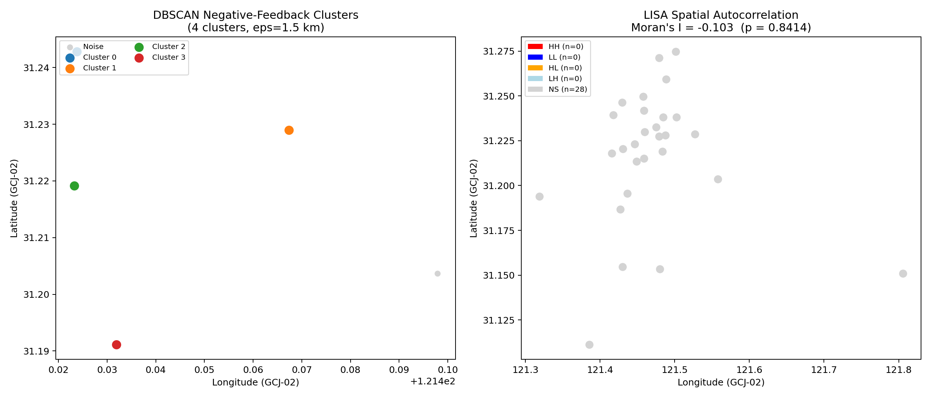
Figure 6.1. DBSCAN negative-feedback clusters and LISA spatial autocorrelation output.

DBSCAN was incorporated to identify local concentrations of geographically referenced feedback without requiring a predetermined number of clusters. The method is appropriate for irregular urban patterns and can distinguish dense groups of observations from isolated records.
Within the prototype, clustering is applied only to records that contain valid coordinates in the representative analytical subset. The result is interpreted as a concentration in the available data, not automatically as proof of poor service. Parameter choice, duplicate records and uneven comment density can substantially affect the pattern.
Cluster outputs are passed to the map so that users can inspect the locations, issue categories and sentiment associated with each concentration. This visual traceability is important because it enables an apparent hotspot to be checked against the underlying observations.

6.4 Spatial Autocorrelation Analysis
Global spatial autocorrelation was evaluated using Moran's I on station-level negative feedback rates. The calculated Moran's I value was -0.103, with an expected value of -0.037, z-score of -0.2001 and p-value of 0.8414. This result indicates that no statistically significant global spatial autocorrelation was detected in the collected feedback dataset.
The local spatial association output was also non-significant for the available station set: the LISA classification identified all 28 evaluated stations as non-significant rather than high-high, low-low, high-low or low-high spatial clusters. This finding is consistent with the limited and synthetic nature of the collected data. It shows that the system can calculate and display spatial statistics, but the current data do not support a strong claim about real geographic clustering of negative passenger feedback.
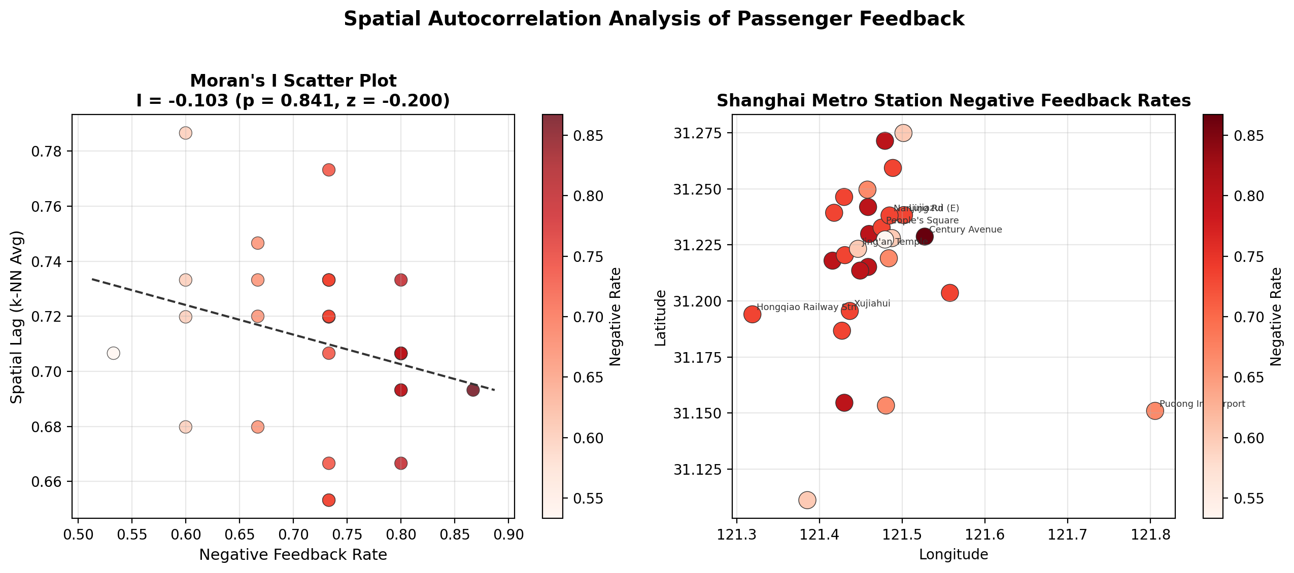
Figure 6.2. Moran's I scatter plot and station-level negative feedback rates.

Spatial autocorrelation analysis complements density-based clustering by examining whether similar values appear geographically close to one another. Moran's I and related local indicators can provide evidence about overall association, local concentrations and spatial outliers when the dataset and spatial-weight definition are appropriate.
In this project, spatial-association outputs are treated as supporting analytical evidence. Their interpretation depends on the number and distribution of geo-located comments, so they are reviewed together with maps and descriptive summaries rather than used as a standalone conclusion.
The combination of clustering, association measures and interactive inspection provides a stronger workflow than relying on one method alone. It also exposes situations in which an apparent pattern may result from limited coverage rather than a stable transport phenomenon.

6.5 District-Level Comparison
The representative district comparison grouped feedback records into Huangpu, Hongkou and Pudong. Huangpu contained 6 stations and 90 feedback records, including 17 positive, 13 neutral and 60 negative records, giving a negative feedback rate of 66.7%. Hongkou contained 2 stations and 30 feedback records, including 6 positive, 4 neutral and 20 negative records, also giving a negative feedback rate of 66.7%.
Pudong contained 2 stations and 30 feedback records, including 2 positive, 4 neutral and 24 negative records, giving a higher negative feedback rate of 80.0%. However, the chi-square test result was chi-square = 2.0067 with p = 0.3667, which means the observed difference was not statistically significant. The district comparison should therefore be read as a demonstration of comparative functionality rather than proof that one district performs worse than another.
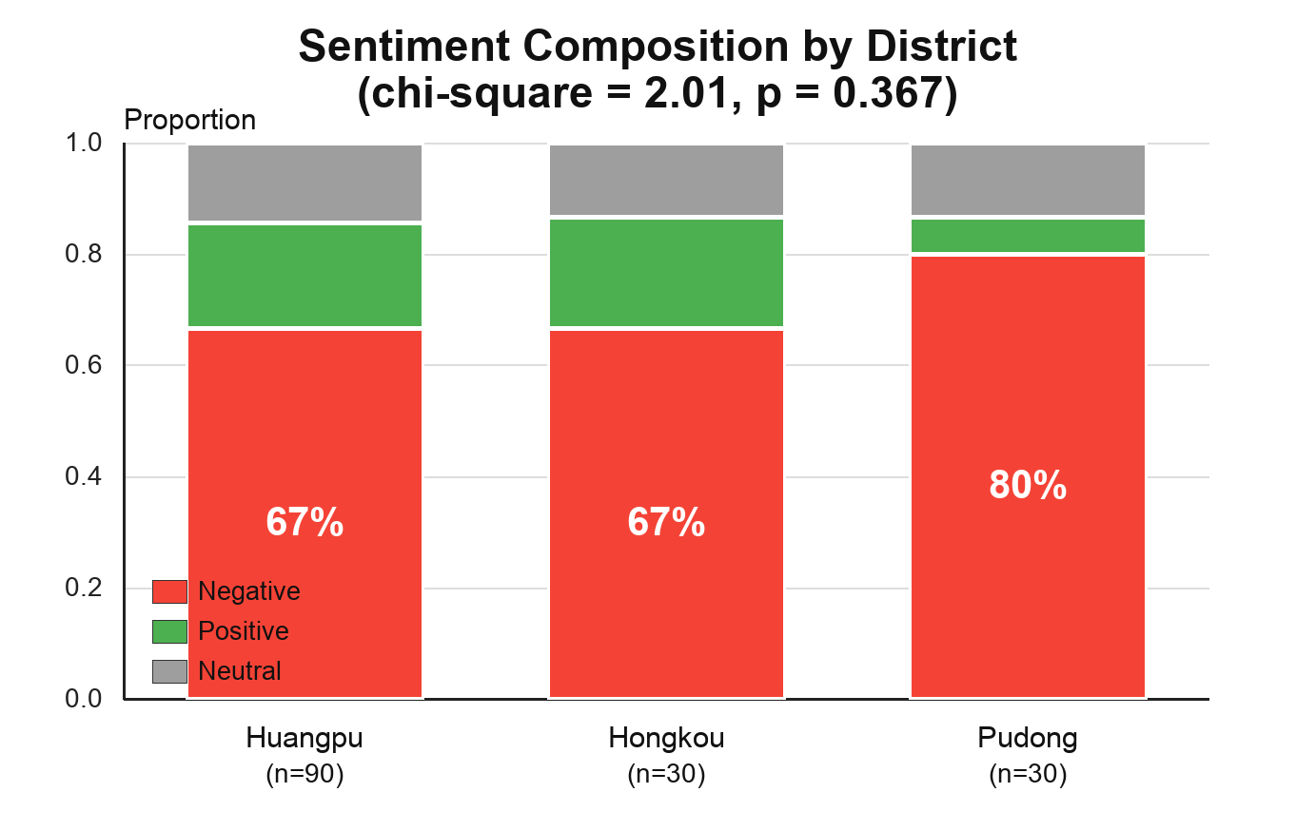
Figure 6.3. Sentiment composition by district for Huangpu, Hongkou and Pudong.

District-level comparison focuses explicitly on Hongkou District, Huangpu District and Pudong New Area. Feedback records and transport locations are grouped by representative area to compare category distributions, sentiment patterns and geographic coverage.
The comparison is intended as typical-case analysis. Huangpu, Hongkou and Pudong differ in size and urban structure, and the volume of available feedback may also differ. Therefore, the dashboard supports proportional summaries and inspection of the underlying records instead of treating the largest raw count as automatically indicating the most serious problem.
This level of analysis is easier for planners and non-specialist users to interpret than individual point patterns alone. It demonstrates how the system could be extended to a complete district comparison if consistent city-wide data became available.
The representative comparison also connects the technical system with the project objectives: it shows how the same NLP and GIS pipeline can be applied across contrasting parts of Shanghai while retaining a common analytical structure.

6.6 Spatial Analysis Findings
Taken together, the spatial results show that the prototype successfully links NLP outputs with geographic analysis. The system can generate DBSCAN clusters, calculate Moran's I, produce LISA labels and compare district-level sentiment composition. These functions confirm that feedback text can be converted into map-based evidence through the implemented NLP-GIS workflow.
At the same time, the quantitative results require cautious interpretation. DBSCAN found four clusters, but Moran's I was not significant, and district differences were also not statistically significant. The strongest conclusion is therefore methodological: the project proves that the analysis pipeline works, while real transport-service conclusions would require larger, larger and more geographically balanced feedback data.
The spatial component demonstrates that feedback becomes more informative when location is added. Issue and sentiment outputs can be filtered by station, stop and representative area, allowing users to examine whether particular concerns are concentrated or dispersed within the available data.
The analysis also shows why geographic claims require caution. A visible concentration can reflect transport activity, platform participation, the number of mapped locations or the availability of comments. The system therefore presents spatial patterns as evidence for further investigation rather than as a definitive measure of operational performance.
Across the three representative areas, the main contribution is comparative capability: the prototype can apply the same filters, summaries and map interactions to different urban contexts. This answers the location-oriented research question at the level supported by the current dataset.

6.7 Discussion of Spatial Results
The results reinforce the importance of geographic context. A category such as crowding or accessibility has different practical meaning when associated with a central interchange, an established mixed-use area or a more dispersed transport environment.
They also demonstrate the value of the integrated design. NLP provides interpretable textual attributes, GIS supplies location and spatial relationships, and the web interface enables users to move between aggregated patterns and individual records.
For transport management, the system can support prioritisation by highlighting places or areas that warrant closer examination. It should complement, rather than replace, operational data, passenger counts, surveys and professional judgement.
The principal limitations are uneven geographic coverage, self-selection in online feedback and the restricted three-area demonstration. Future work should expand to additional districts, improve location matching and normalise comparisons using transport-location or passenger-volume information where available.

6.8 Chapter Summary
This chapter explained how the project links NLP outputs with Shanghai transport geography and applies detailed representative analysis to Hongkou, Huangpu and Pudong. Station-, stop- and district-level functions provide complementary ways to explore selected issues.
The spatial outputs are exploratory and bounded by the available data, but they demonstrate the feasibility of the integrated workflow. Chapter 7 describes how these functions are delivered through the web-based prototype.

7 System Implementation and Visualisation

7.1 Chapter Overview
This chapter describes the implementation of the web-based prototype that connects data, NLP models, spatial services and interactive visualisation. The system is designed for the broader Shanghai transport context and currently demonstrates detailed geographic functions with the Hongkou, Huangpu and Pudong subset.
The implemented system combines machine learning analysis, geographic visualisation, and interactive user interfaces within a unified platform. The architecture consists of a backend processing layer responsible for data analysis and a frontend presentation layer responsible for visualisation and user interaction.
The chapter first introduces the overall system architecture before describing backend implementation, frontend dashboard development, and interactive visualisation components. The chapter concludes by discussing how the implemented platform supports transport analysis and decision-making.

7.2 System Architecture
The implementation follows the four-layer architecture introduced in Chapter 3. Data files and model resources form the data layer; NLP and spatial services form the analytical layer; FastAPI provides the application layer; and Streamlit provides the presentation layer.
The data layer stores transport-related datasets, sentiment training resources, evaluation datasets, and geographic information. These datasets provide the foundation for machine learning analysis and spatial investigation.
The architecture separates responsibilities and reduces direct dependency between components. For example, a revised model or additional district layer can be incorporated without redesigning the entire user interface, provided that the API schema remains consistent.
The presentation layer provides access to analytical outputs through a web-based dashboard. This layer enables users to explore transport-related feedback through charts, tables, maps, and interactive controls.
The separation of system components improves maintainability, scalability, and flexibility. New analytical methods can be incorporated without requiring major modifications to the user interface, while visualisation improvements can be implemented independently of backend processing functions.

7.3 Backend Implementation
The backend was implemented with FastAPI and organises feedback processing, category classification, sentiment prediction, geographic services and representative-area comparison into separate modules. API endpoints return structured results to the dashboard.
Consistent response schemas were important because the frontend combines text, model outputs and geographic attributes. The backend therefore acts as a controlled interface between analytical code and user interaction rather than exposing raw project files directly.
The backend also provides API endpoints that allow the frontend dashboard to request analytical results dynamically. This design enables users to interact with the system in real time while maintaining efficient communication between analytical components and visualisation interfaces.

7.4 Frontend Dashboard Development
The Streamlit dashboard provides access to feedback summaries, issue categories, sentiment distributions, model-evaluation outputs and interactive maps. Its rapid-development workflow was suitable for a professional-project prototype and allowed the team to integrate Python analysis without building a separate JavaScript application.
The interface is organised around analytical tasks rather than a list of technologies. Users can filter data, inspect summaries and move from broad representative-area patterns to individual mapped locations.
The interface was organised into multiple functional sections, each focusing on a different aspect of transport feedback analysis. This structure improves usability and enables users to investigate transport issues from multiple analytical perspectives.

7.5 Interactive Visualisation
The interactive map presents the broader transport context and the current detailed data for Hongkou, Huangpu and Pudong. Users can pan and zoom, switch between relevant layers and inspect available station, stop, issue and sentiment attributes.
Charts and indicators complement the map by summarising category and sentiment distributions. Together, the views allow users to compare representative areas while checking the individual observations behind aggregated patterns.
Interactive charts and summary indicators further support exploratory analysis by allowing users to compare categories, sentiment distributions, and spatial patterns. These visualisation capabilities transform complex analytical outputs into information that can be interpreted more easily by transport planners and decision-makers.

7.6 Chapter Summary
The implemented prototype integrates NLP processing, geographic services and interactive presentation through a modular FastAPI and Streamlit architecture. It demonstrates the required end-to-end workflow and can be extended with additional Shanghai districts, data sources or analytical methods.
The current dashboard should be understood as a decision-support demonstration rather than a real-time operational system. Its value lies in making the relationship between feedback content and transport location visible and explorable.
The following chapter discusses the broader implications of the project findings, evaluates system strengths and limitations, and identifies opportunities for future development.

7.7 Source Code
The project source code, including backend services, NLP training scripts, spatial functions and the dashboard, is submitted separately with the report together with setup instructions in the README file.

8 Discussion

8.1 Chapter Overview
This chapter interprets the contributions and practical meaning of the Geo-located NLP Feedback System. It considers the value of integrating text and geography, the role of the representative-area design, the limitations encountered during implementation and priorities for future development.

8.2 Contribution of the Proposed System
The main contribution is the successful connection of several project components that are often treated separately. User-generated comments are cleaned and transformed into issue and sentiment attributes; selected records are linked with transport geography; spatial functions organise the geographic outputs; and the dashboard makes the results accessible.
A second contribution is the distinction between system scope and detailed analytical scope. The architecture is designed around Shanghai metro and bus data, while Hongkou, Huangpu and Pudong provide three contrasting areas for typical-case analysis. This design is more defensible than implying that every Shanghai district was analysed equally.
A third contribution is the modular implementation. QGIS supports geographic preparation, Python supports NLP and spatial services, FastAPI provides controlled communication, and Streamlit provides an interactive interface. The separation supports maintainability and future extension.
The OOD evaluation also strengthens the project by showing that model performance on familiar data does not fully describe practical behaviour. Noisy and unfamiliar expressions remain difficult, so robustness evidence and transparent limitations are essential when machine-learning outputs are used for transport analysis.

8.3 Implications for Public Transport Management
For public transport management, the system offers a scalable method for organising large volumes of feedback and identifying locations or representative areas that warrant closer investigation.
The dashboard can support exploratory monitoring by allowing users to compare categories and sentiment, inspect mapped records and view the same information across contrasting urban contexts. This may help prioritise follow-up analysis relating to station management, accessibility, passenger information or service operations.
However, the outputs should be combined with operational evidence such as passenger counts, reliability records, surveys and professional assessment. Online comments measure the experiences of contributors rather than the whole passenger population, and model predictions introduce additional uncertainty.
The project nevertheless aligns with smart-city objectives by demonstrating how heterogeneous urban data can be integrated and communicated. Its practical value is the creation of a reusable analytical workflow rather than an automated claim that a mapped location necessarily requires intervention.

8.4 Technical Limitations
Several limitations affect the interpretation and scalability of the prototype.
First, online feedback is self-selected and uneven. People who post comments may differ from the wider passenger population, and some locations may receive more online attention than others. The dataset therefore cannot be treated as a statistically representative survey.
Second, TF-IDF-based models are efficient and interpretable but are influenced strongly by observed terms. They may struggle with context, sarcasm, mixed sentiment and different expressions of the same meaning, particularly under out-of-distribution conditions.
Third, the detailed geographic demonstration covers Hongkou District, Huangpu District and Pudong New Area rather than every Shanghai district. The areas also differ substantially in size and transport structure, so raw totals are not directly comparable without contextual or normalised measures.
Finally, location matching, spatial clustering and association measures depend on data quality and methodological choices. Incorrect names, missing coordinates, parameter settings or sparse observations can produce misleading patterns. The prototype is therefore appropriate for exploratory decision support, not automated operational judgement.

8.5 Future Improvements
Future work should first extend geographic coverage to additional Shanghai districts and improve the consistency of station, stop and feedback-location identifiers. A larger and more balanced dataset would support stronger city-wide comparison.
The NLP component could incorporate pre-trained Chinese transformer models such as BERT-wwm (Cui et al., 2021) or MacBERT to improve semantic understanding, especially for context-dependent and unfamiliar expressions. The current TF-IDF + SVM baseline provides the quantitative reference point against which such improvements can be measured. These methods should still be compared with the current baseline in terms of OOD accuracy, transparency and computational cost.
Additional evidence could include official complaint records, service-reliability data, passenger volumes, smart-card information and time-stamped operational data. Such sources would allow feedback patterns to be validated and normalised rather than interpreted in isolation.
Spatial work could add temporal analysis, stronger validation of cluster parameters and comparison rates based on the number of locations or passengers. The dashboard could also support saved reports, automated alerts and role-specific views.
With these improvements, the proof of concept could evolve into a broader monitoring and decision-support platform while retaining the modular architecture demonstrated in this project.

8.6 Chapter Summary
The discussion shows that the project makes a credible contribution through integration, representative-area analysis and transparent evaluation. It also confirms that data coverage, model semantics and geographic comparability limit the strength of conclusions that can be drawn from the current prototype.
The final chapter summarises how the project answered its research questions and identifies the overall level of success.

9 Conclusion
This project developed a functional Geo-located NLP Feedback System that combines passenger-feedback processing, issue classification, sentiment analysis, geographic integration, spatial functions and web-based visualisation. Shanghai was used as the wider case-study city, while Hongkou District, Huangpu District and Pudong New Area were selected for detailed representative analysis.
For RQ1, the project demonstrated that unstructured metro and bus feedback can be organised into interpretable issue and sentiment attributes. The implemented NLP pipeline reduces the effort required for manual review and provides structured inputs for filtering, aggregation and geographic analysis, although OOD testing shows that informal and unfamiliar language remains challenging.
For RQ2, the project connected selected feedback with metro stations, bus stops and district information within the three representative areas. This enabled station-, stop- and district-level exploration and showed how geographic context can change the interpretation of a transport concern. The findings are typical-case evidence and are not presented as a complete assessment of every Shanghai district.
For RQ3, the project integrated NLP and GIS through consistent data structures and a modular service architecture. QGIS prepared the transport layers, Python-based services processed textual and spatial information, and FastAPI transferred structured outputs to the Streamlit dashboard.
For RQ4, the prototype provided an accessible environment for exploring feedback through summaries, filters and interactive maps. The system achieved its main objective as a demonstrable academic prototype and established a workflow that can be extended to additional districts and data sources.
Overall, the project was successful in demonstrating the feasibility and value of a combined text-and-space approach. Its main limitations are the representativeness of online feedback, the semantic limits of TF-IDF models and the restricted three-area detailed analysis. Future work should broaden geographic coverage, strengthen validation and integrate operational transport evidence.

10 Personal Learning
Hanwen Yang — ID: 25005022
My main responsibility was developing the backend and frontend of the system. I created FastAPI services that exposed NLP and spatial outputs through consistent endpoints and built the Streamlit dashboard used to explore feedback, evaluation results and maps. The most difficult task was coordinating the data flow between analytical modules and the interface because category predictions, sentiment results and geographic records initially used different structures. Repeated testing taught me to define schemas and API responsibilities earlier. I also learned that a technical dashboard must explain uncertainty rather than only display outputs. The project strengthened my Python, API and full-stack prototyping skills and showed me how machine learning and GIS can operate within one end-to-end application.
Junzhen Wang — ID: 25012016
My main responsibility was the GIS and spatial-analysis component. I used QGIS to organise Shanghai metro and bus layers, check coordinate systems and attributes, and prepare the representative analytical data for Hongkou District, Huangpu District and Pudong New Area. This work taught me that spatial analysis depends heavily on data preparation: inconsistent station names, stop attributes or coordinate systems can affect matching and produce misleading maps. I also learned to distinguish between the wider system scope and the evidence supported by the selected case areas. Integrating QGIS outputs with NLP results and the web dashboard improved my understanding of multidisciplinary workflows, while team coordination strengthened my communication, documentation and problem-solving skills.
Yifan Shi — ID: 23003326
My main contribution was project coordination, report development and documentation. I organised material from the NLP, GIS and web-development components into a consistent explanation of the project aim, technical decisions, results and limitations. A major learning point was that an IT professional report must explain not only what technologies were used but why decisions were made and how the implemented scope differs from the original proposal. I also developed a clearer understanding of how passenger feedback, machine learning and geographic data can support transport analysis. Working with teammates from different technical areas improved my ability to review evidence, resolve inconsistencies and communicate a complex system to non-specialist readers.

References
Aggarwal, C. C., & Zhai, C. (2012). Mining text data. Springer. https://doi.org/10.1007/978-1-4614-3223-4
Batty, M., Axhausen, K. W., Giannotti, F., Pozdnoukhov, A., Bazzani, A., Wachowicz, M., Ouzounis, G., & Portugali, Y. (2012). Smart cities of the future. The European Physical Journal Special Topics, 214, 481–518. https://doi.org/10.1140/epjst/e2012-01703-3
Cheung, C. M. K., & Thadani, D. R. (2012). The impact of electronic word-of-mouth communication: A literature analysis and integrative model. Decision Support Systems, 54(1), 461–470. https://doi.org/10.1016/j.dss.2012.06.008
Cui, Y., Che, W., Liu, T., Qin, B., Wang, S., & Hu, G. (2021). Revisiting pre-trained models for Chinese natural language processing. In Findings of the Association for Computational Linguistics: EMNLP 2021 (pp. 657–668). Association for Computational Linguistics. https://doi.org/10.18653/v1/2021.findings-emnlp.59
de Oña, J., & de Oña, R. (2015). Quality of service in public transport based on customer satisfaction surveys: A review and assessment of methodological approaches. Transportation Science, 49(3), 605–622. https://doi.org/10.1287/trsc.2014.0544
dell’Olio, L., Ibeas, A., & Cecín, P. (2011). The quality of service desired by public transport users. Transport Policy, 18(1), 217–227. https://doi.org/10.1016/j.tranpol.2010.08.005
Dou, M., Gu, Y., & Gong, J. (2024). How do people perceive the quality of urban transport service? New insights from online reviews of Shanghai metro system. Journal of Urban Management, 13(4), 705–719. https://doi.org/10.1016/j.jum.2024.07.008
Eboli, L., & Mazzulla, G. (2007). Service quality attributes affecting customer satisfaction for bus transit. Journal of Public Transportation, 10(3), 21–34. https://doi.org/10.5038/2375-0901.10.3.2
Ester, M., Kriegel, H.-P., Sander, J., & Xu, X. (1996). A density-based algorithm for discovering clusters in large spatial databases with noise. In Proceedings of the Second International Conference on Knowledge Discovery and Data Mining (KDD-96) (pp. 226–231). AAAI Press.
Few, S. (2006). Information dashboard design: The effective visual communication of data. O’Reilly Media.
Joachims, T. (1998). Text categorization with support vector machines: Learning with many relevant features. In C. Nédellec & C. Rouveirol (Eds.), Machine learning: ECML-98 (Lecture Notes in Computer Science, Vol. 1398, pp. 137–142). Springer. https://doi.org/10.1007/BFb0026683
Jurafsky, D., & Martin, J. H. (2024). Speech and language processing: An introduction to natural language processing, computational linguistics, and speech recognition (3rd ed. draft). Stanford University. https://web.stanford.edu/~jurafsky/slp3/
Kaplan, A. M., & Haenlein, M. (2010). Users of the world, unite! The challenges and opportunities of social media. Business Horizons, 53(1), 59–68. https://doi.org/10.1016/j.bushor.2009.09.003
Liu, B. (2012). Sentiment analysis and opinion mining. Morgan & Claypool Publishers. https://doi.org/10.2200/S00416ED1V01Y201204HLT016
Longley, P. A., Goodchild, M. F., Maguire, D. J., & Rhind, D. W. (2015). Geographic information science and systems (4th ed.). Wiley.
Nathanail, E. (2008). Measuring the quality of service for passengers on the Hellenic railways. Transportation Research Part A: Policy and Practice, 42(1), 48–66. https://doi.org/10.1016/j.tra.2007.06.006
Pang, B., & Lee, L. (2008). Opinion mining and sentiment analysis. Foundations and Trends in Information Retrieval, 2(1–2), 1–135. https://doi.org/10.1561/1500000011
Sobral, T., Galvão, T., & Borges, J. (2019). Visualization of urban mobility data from intelligent transportation systems. Sensors, 19(2), 332. https://doi.org/10.3390/s19020332
Zheng, Y., Capra, L., Wolfson, O., & Yang, H. (2014). Urban computing: Concepts, methodologies, and applications. ACM Transactions on Intelligent Systems and Technology, 5(3), Article 38. https://doi.org/10.1145/2629592

