**Appointments**

Create an Appointment application that allows the logged user to see, edit and delete all of his/her appointments for the current date. Adding of appointments are also allowed.

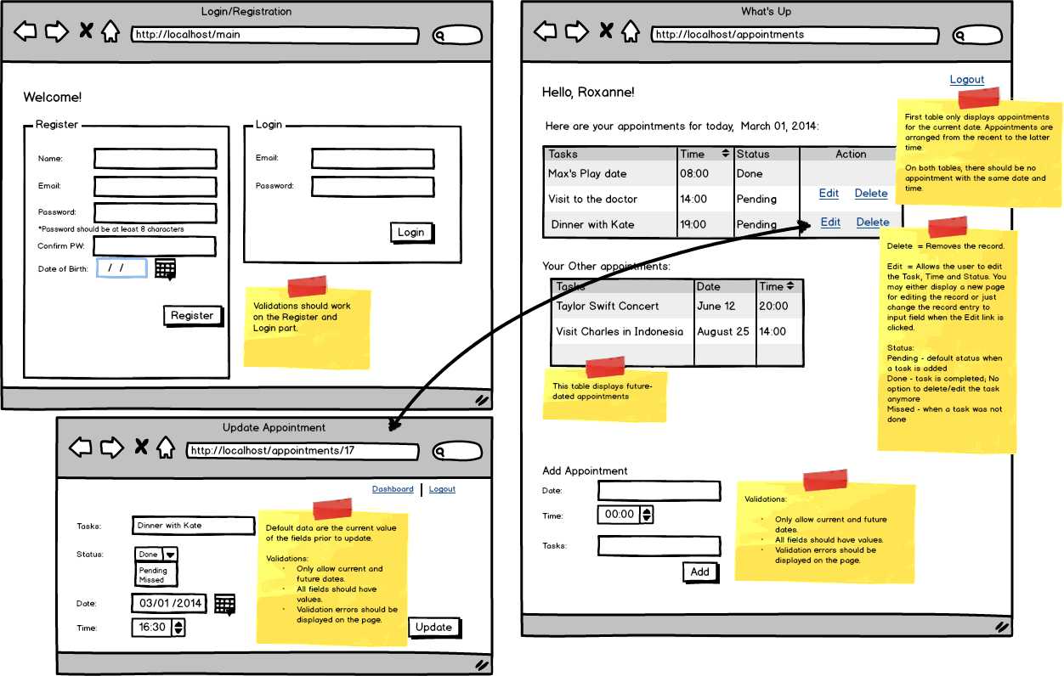de

**Features required:**

1. Login and Registration with validations. Validation errors should appear on the page.
2. Display appointments on two tables (current and future-dated appointments)
3. Edit and Delete record for an appointment.
4. Add an appointment for current and future dates. Displays error when the date is before the current date
5. Logout
6. You must be able to deploy your work to Amazon EC2 and provide the IP address or subdomain/domain name to where your work has been deployed. Please note that Heroku deployment is not honored.

**Submission Requirement:**Your code, exported database file, a text file with the IP address or subdomain/domain name for the deployed work and short video demo link.

**Notes:**

* The wireframe is available for download [here](http://s3.amazonaws.com/General_V88/boomyeah/company_209/chapter_4216/handouts/chapter4216_7886_d-appointments.png).
* Create a 2-3 minute video showing what you have built. On the video, show the functionality of the page you have built at localhost (not what was deployed). You may download a trial version of Jing, Snag-it or QuickTime for video creation. You may save it in Dropbox public folder and copy the public link.
* To prevent other students from copying your work, please make sure your video demo is set to unlisted or with a password, and code is not saved on GitHub.
* To minimize score deduction, please make sure you upload the complete requirements (database file, video demo).
* If you are having trouble uploading files on the Exam App, please DO NOT unlock another exam. Please email the file to your instructor and CC remote-instructors@codingdojo.com.