Here is a guide book for how to use pyTracker on Mac machine.

Before we start, we can use handbrake to convert .avi file to be .mp4 file (Really spend time, but able to run multi handbrake window parallel at the same time to do it faster).

When I tried to do the .mp4 files merge step, several software request to pay for it. Then I decided to write my own code to do the merge stuff.

It will check each folders in current working directory and find the .mp4 files to convert them be .m4s files and merge them be a large .mp4 file.

Change the working directory to the folder where you place your video folders (Here CH1 CH2 CH3 CH4 all contains mp4 files).

To get the directory of the folder, write click on the folder/file, click “Get info” button, you will see this like below:

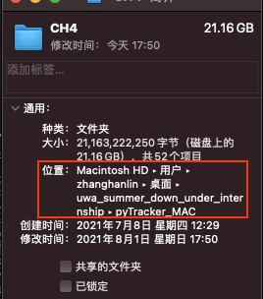

Use your mouse to select the location, then click ‘control + c’.

Then:



Before run the python file, make sure your python file stay at the same level in your folder:

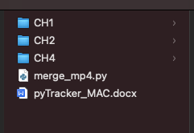

Try to type ‘ls’ like above in the terminal, then if you can see the folders which contains mp4 and python file together, you do all correct up to now.

When you run the python file, it might get an warning like this:

[mpegts @ 0x7fe917818c00] DTS 149760 < 324179760 out of order

[mp4 @ 0x7fe91700aa00] Non-monotonous DTS in output stream 0:0; previous: 5509178820, current: 5509171860; changing to 5509178821. This may result in incorrect timestamps in the output file.

I tried to fix it, but not able to fix. Anyway, after checking the timestamp, I did not find any issues (error) with the output .mp4 file. So, I decide to ignore it.

After merge your .mp4 files, please check your videos have the correct order (from 0 o’clock to 24 o’clock).

After doing the prepare stuff, we can start to use pyTracker.

1. Download the pyTracker on your machine and place it at the same level with the .mp4 video.

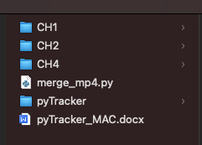

Try to type ‘ls’ like above in the terminal, then if you can see the folders which contains mp4 and pyTracker folder together, you do all correct up to now.

截屏2021-08-01 18.34.14

1. Run the ‘rc_setupROI.py’ first



python3 ‘path_of_rc_setupROI.py’ ‘path_of_video’

You will see something similar like this:

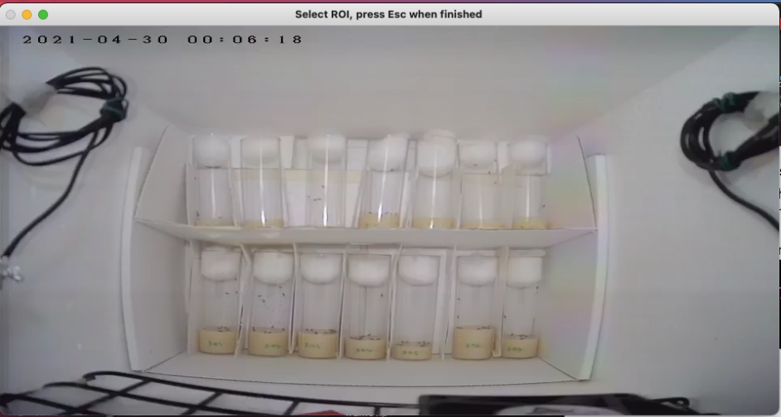

Click and scroll your mouse from left top corner to right bottom corner (if you are doing 2 * 7). Otherwise, modify ‘rc_setupROI.py’ to match your situation. numROI means how many ROI you have, here is 2*7=14. rowsCols means how many rows any columns you have. Do not worry about roiShape.

截屏2021-08-01 18.39.46

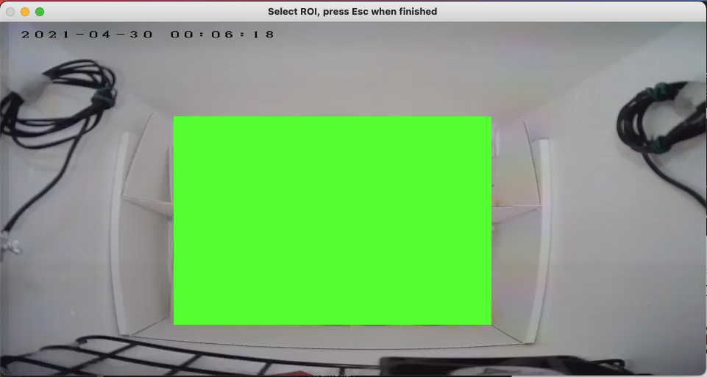

(After you click and scroll the mouse)

3. Next, click ‘esc’ button on your keyboard. You will get an output like below:

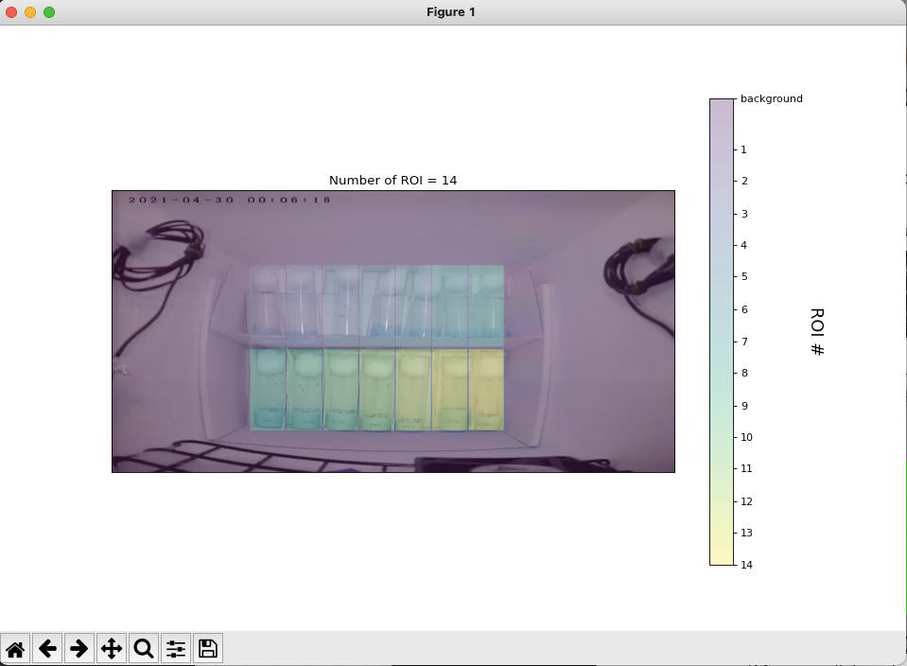

If the output is not similar like above (out of your expect), repeat the step 3 above.

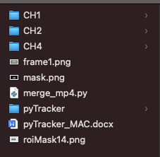

Above is the output of the step3, get three .png files.

1. Start analysis the .mp4 files.

This is an update version of the previous one. You can use ‘n’ or ‘a’ for new experiment or append data. It means ‘n’ will remove all the .npy file from the target folder (CH1 folder here), then ‘a’ will keep the .npy file which inside of the target folder. Usually use ‘n’ since each experiment is independent.

‘15’ means the pixThreshold you want to use here.

截屏2021-08-01 19.01.09

You will see:

截屏2021-08-01 19.06.21

Wait until it finished (not stuck, it still running. For a .mp4 file which contains 24 hrs recording, might need 3-6 hrs to finish running).

Don’t worry about or confused what is .npy file, it is a kind of numpy file which contains data.

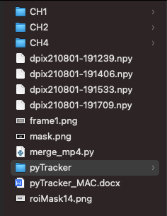

Numbers of the .npy file will depends on the length of the .mp4 file.

1. Get data from .npy file and export as .csv file(Optional)



You will get a .csv file which contains the data which inside of the .npy files. If the .csv file is too large (movie length too long), Excel might not able to open it.

1. Get the output (result) image

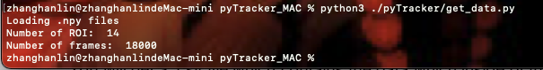

Here not offer the result, since the result have some problems inside.

Beta version here! Yeah!!!!!!!!!!!!!!!

Try to make your code auto run for each folder which contain many .mp4? Need to run dPix.py multi time makes you boring?

Don’t worry, try beta version!

If you get confused with how to do the beta version, you can ignore it. Sometimes might have some technique issues that hard to fix if no enough python knowledge. That is fine, just use the original version.

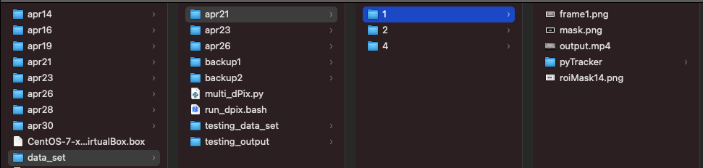

Make sure your folders looks like this order (level). Each day has multi cameras (1, 2, 4). Each camera folder contains the .mp4 file (the .mp4 file after merge), the pyTracker folder. Remember, you have to follow this format (each folder need to have a pyTracker folder, 3 of .png images and output.mp4)!

Or you can also place like this, daily ch1 ch2 ch4 separately:

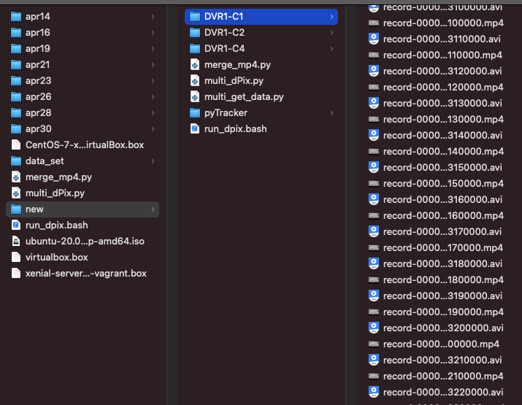

Unfortunately, you still need to repeat the step2 shows at the top of this guide book for each experiment (apr21 ch1, apr21 ch2 etc.), since each experiment is independent (How many boxes inside of each experiment and so on).

Make sure your folder looks like this:

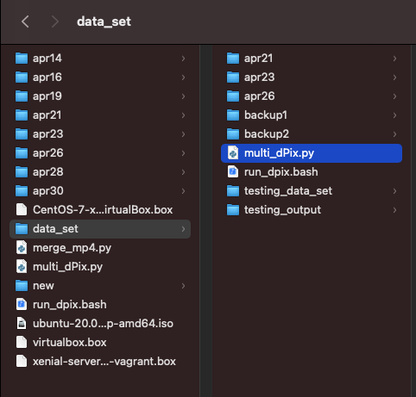

Try to run multi_dPix.py file like below. Remember, before u run it, please change the PATH variable at the top of the multi_dPix.py file to be your target folder.



Please make sure your working directory in terminal looks like this above! Multiple folders which contains .mp4 files inside, and multi_dPix.py also in current working directory. **Also, please make sure the .mp4 file you gonna to analysis named as ‘output.mp4’.**

The folder which contains video folders, the folder which names ‘data_set’. It will auto process each folder inside of the ‘data_set’ folder. Then you will see a .bash file inside of current folder.

Something similar like this:

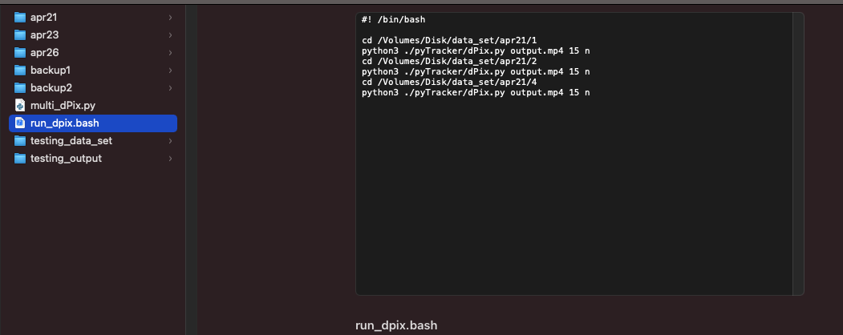

Run the command below to start analysis (way2 need less command):



Or just:

截屏2021-08-09 00.20.21

It is only for ‘n’ (make new experiment)!

For single folder only, try this below (above two ways is for the situation that you need to process multi folders):

截屏2021-08-01 19.01.09

Try to change to ‘a’ (append current experiment)?

Open the ‘multi_dPix.py’ file, and change the line below:

截屏2021-08-01 20.22.18

Change this ‘n’ to be ‘a’. Do not add quotation mark!!!

This is how my folder looks like:

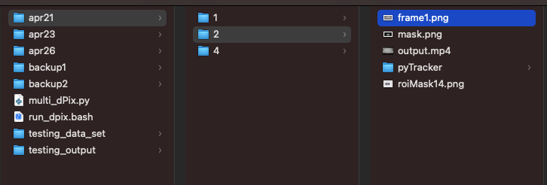

And etc.

Just waiting for the analysis finished, do not shut down your machine before it finished! Did not try to print something in terminal, so it might looks like the terminal get stuck, but it is working! You will see in the folders, it is generating the .npy files. Please pay attention, for each folder which contains 24 hr .mp4 video, need 5-6 hrs to process. Sometimes, the process time will be increasing.

Here is a screen shot of my folder:

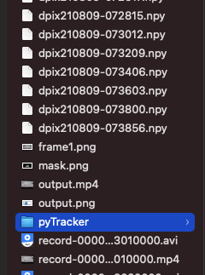

Now, I will introduce how ‘multi_get_data.py’ works. Here I use another folder, since my previous folders has no .npy files inside

You see many .npy files right?

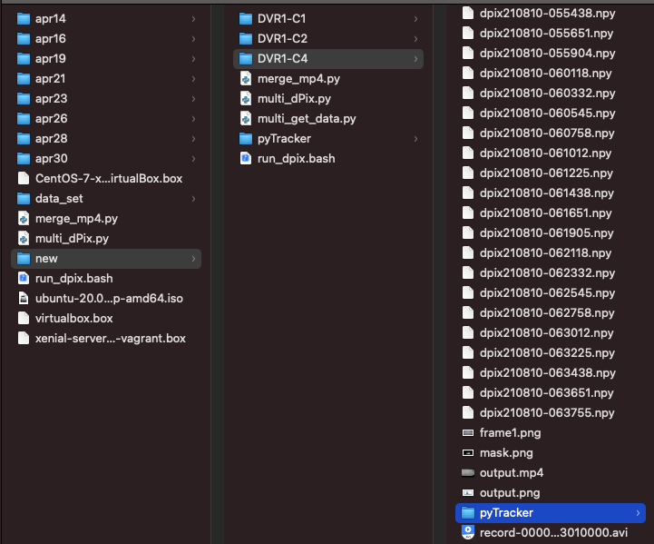

Put ‘multi_get_data.py’ at the directory like above, at the same level with the folders which contains .mp4 file (.npy files also in this folder). Then run:

截屏2021-08-10 16.35.07

Wait for few seconds, you will see the ‘output.png’ file inside of each folder.

Finally, if you get confused with how to do the beta version, you can ignore it. Sometimes might have some technique issues that hard to fix if no python knowledge. That is fine, just use the original version.