|  |  |  |
| --- | --- | --- |
| **Problem Chosen** A | **2020 MCM/ICM Summary Sheet** | **Team Control Number** 1111111 |

Title: Add your paper title

Summary

Add your summary here.

**Keywords:** keyword1; keyword2; keyword3; (list three to ten pertinent keywords specific to the article)

Content

Title: Add your paper title 1

Summary 1

Content 1

1 Introductions 1

1.1 Problem Background 1

1.2 Our Work 1

2 Assumptions 1

3 Notations 1

4 The Model 2

4.1 XXXX 2

4.2 XXXX 2

4.3 Improved Model 2

*4.3.1* *Extra Symbols* 2

*4.3.2* Additional *Assumptions* 3

*4.3.3* *The Foundation of Model* 3

5 Solution and Result 3

6 Model Analysis 4

6.1 Sensitivity Analysis 4

6.1.1 XXXX 4

6.1.2 XXXX 4

6.2 Strengths and Weaknesses 4

7 Conclusions 4

7.1 Conclusions of the problem 4

7.2 Methods used in our models 4

7.3 Applications of our models 4

8 Future Work 5

8.1 Another model 5

8.1.1 The limitations of XXX theory 5

8.1.2 5

8.1.3 5

8.1.4 5

8.2 Another XXX of 6

References 6

Appendix  I

1. Introductions
   1. Problem Background

Add your text here.

* 1. Our Work

Add your text here.

1. Assumptions

Add your text here.

1. Notations

Add your text here. We use the nomenclature in Table 1.

Table 1.XXXX

|  |  |  |
| --- | --- | --- |
| **Symbol** | | **Definition** |
| *N* | Planned working years for a dam | |
| M | Overall water management | |

Add your text here.

1. The Model
   1. XXXX

Add your text here. The result is shown in Fig. 1.

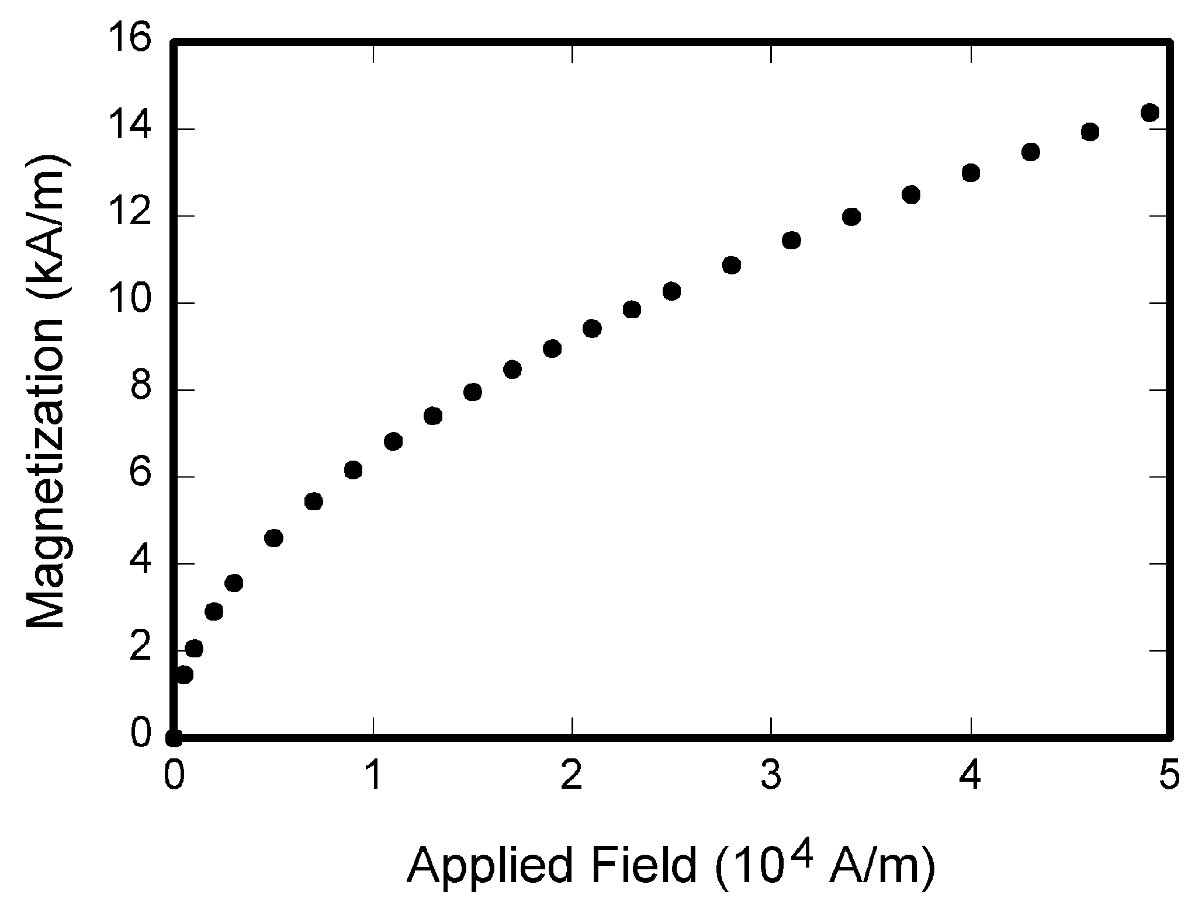

Fig. 1. XXXX

Add your text here.

* 1. XXXX

Add your text here.

 (1)

Add your text here.

 (2)

Add your text here. *v* is the cross-sectional average velocity, *k* is a conversion factor between SI and English units, is the gap between *i*th andth cross section.

* 1. Improved Model
     1. *Extra Symbols*

Signs and definitions indicated above are still valid. Here are some extra signs and definitions.

* + 1. **Additional** *Assumptions*
  + Assumptions concerning the process are the same as the Basic Model.
    1. *The Foundation of Model*

**1) How do we determine the optimal number?**

As we have concluded from the Basic Model,

1. Solution and Result

**1) Simulation algorithm**

Based on the analysis above, we design our simulation arithmetic as follows.

* + **Step1:**
  + **Step2:**
  + **Step3:**

* + **Step4:**
  + **Step5:**
  + **Step6:**
  + **Step7:**
  + **Step8:**
  + **Step9:**

**2) Flow chart**

The figure below is the flow chart of the simulation.

**3) Solution**

1. Model Analysis
   1. Sensitivity Analysis
      1. **XXXX**

Add your text here.

* + 1. **XXXX**

Add your text here.

* 1. Strengths and Weaknesses
* **Strength:** The Improved Model aims to make up for the neglect of . The result seems to declare that this model is more reasonable than the Basic Model and much more effective than the existing design.
* **Weakness:** . Thus the model is still an approximate on a large scale. This has doomed to limit the applications of it.

1. Conclusions
   1. Conclusions of the problem

* 1. Methods used in our models
* 1. Applications of our models

1. Future Work
   1. Another model
      1. The **limitations** of XXX theory











**1)**

**2)**

**3)**

**4)**

* 1. Another XXX of

References

1. 1111
2. 111111
3. 11111111111
4. 1111

[Appendix](http://www.baidu.com/link?url=QM38lAb_h46B7gWV9bW_ZP4-WZOzws_bRkUPCNWO39iu7itLZBCaeQrt1kRixs1KqNJG0WRZswoBNLk-RWL9I3vnBU29ap_A3FWUmggDHwO)